Jenkins-Assignment-2

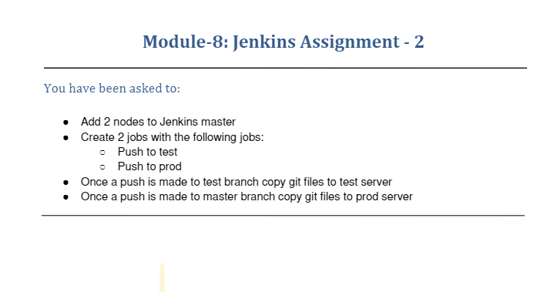

Code Used

* Added two nodes to Jenkins test and prod via ssh connection in manage nodes screenshot of connected nodes

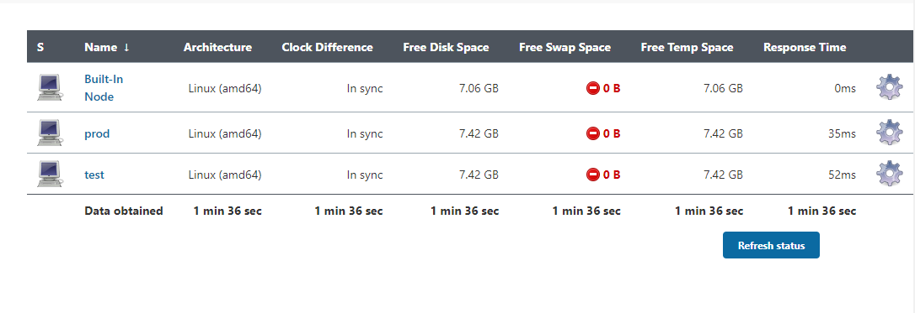

* Created two git branch in assignment-2 repository named master and test

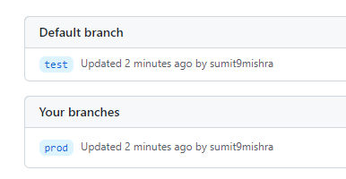

* Jenkins file for test

pipeline {

agent {

label 'test'

}

tools {

// Install the Maven version configured as "M3" and add it to the path.

maven "M3"

}

stages {

stage('Build') {

steps {

// Get some code from a GitHub repository

git branch: 'test', url: 'https://github.com/sumit-mishra27/jenkins-assignment-2.git'

// Run Maven on a Unix agent.

sh "mvn -Dmaven.test.failure.ignore=true clean package"

// To run Maven on a Windows agent, use

// bat "mvn -Dmaven.test.failure.ignore=true clean package"

}

}

}

}

* Screenshot after executing the job

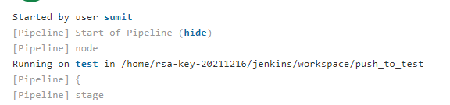

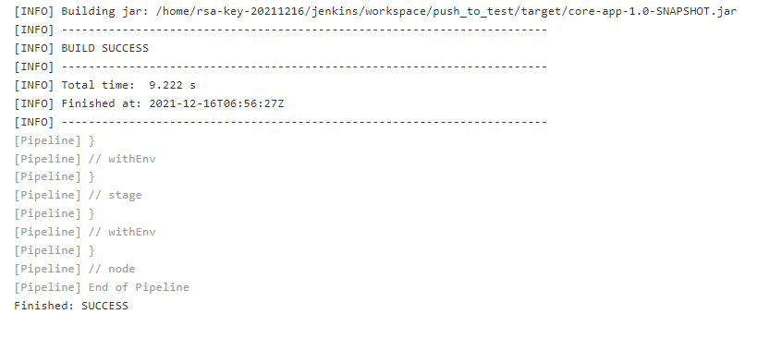

* As the job is running on test node the workspace will be created on test and the files will be created on test server



As from the above Jenkins file and screenshot it can be seen it is saved on test server

------------------------------------------------------------------------------------------------

* Jenkins file for prod(master)

pipeline {

agent {

label 'prod'

}

tools {

// Install the Maven version configured as "M3" and add it to the path.

maven "M3"

}

stages {

stage('Build') {

steps {

// Get some code from a GitHub repository

git branch: 'master', url: 'https://github.com/sumit-mishra27/jenkins-assignment-2.git'

// Run Maven on a Unix agent.

sh "mvn -Dmaven.test.failure.ignore=true clean package"

// To run Maven on a Windows agent, use

// bat "mvn -Dmaven.test.failure.ignore=true clean package"

}

}

}

}

* Screenshot after executing the job

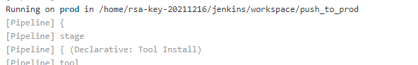

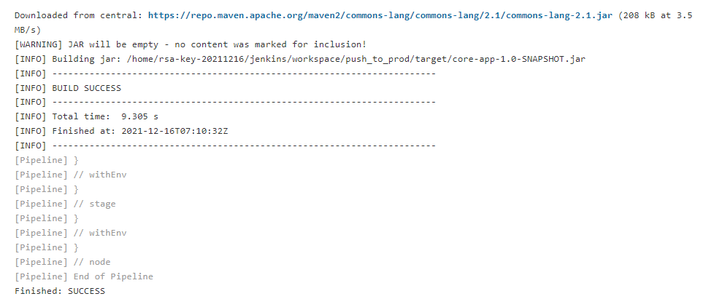

* As the job is running on prod node the workspace will be created on prod and the files will be created on prod server



* As from the above Jenkins file and screenshot it can be seen it is saved on prod server