Jenkins-Assignment-3

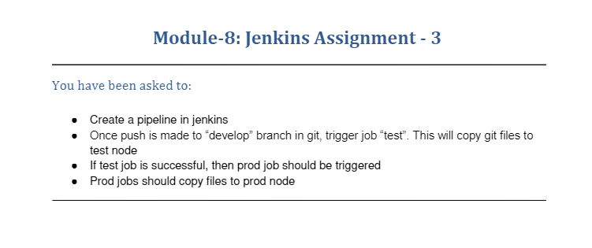

Code used

* Used pipeline to complete the assignment
* Jenkinsfile

pipeline {

    agent {

        label 'test'

    }

    tools {

        // Install the Maven version configured as "M3" and add it to the path.

        maven "M3"

    }

    stages {

        stage('test') {

            steps {

                // Get some code from a GitHub repository

               git branch: 'devlop', url: 'https://github.com/sumit-mishra27/jenkins-assignment-3.git'

                // Run Maven on a Unix agent.

**sh** "mvn -Dmaven.test.failure.ignore=true clean package"

                // To run Maven on a Windows agent, use

                // bat "mvn -Dmaven.test.failure.ignore=true clean package"

            }

    }

    stage('prod'){

        agent{

                label 'prod'

            }

        steps{

             git branch: 'prod', url: 'https://github.com/sumit-mishra27/jenkins-assignment-3.git'

                // Run Maven on a Unix agent.

**sh** "mvn -Dmaven.test.failure.ignore=true clean package"

                // To run Maven on a Windows agent, use

                // bat "mvn -Dmaven.test.failure.ignore=true clean package"

        }

    }

    }

}

* Used two agent test agent for test derver and test branch which copied the file in test server
* After building the project

The build was started on test agent and git branch devlop

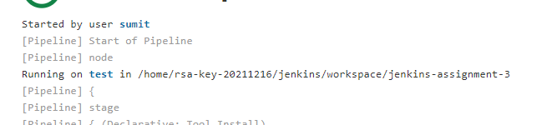

Copied the file to test server

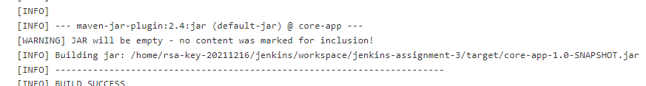

* Than the prod server started as agent was given prod and git branch was prod

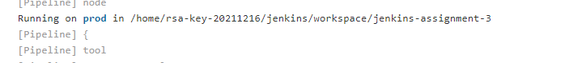

Copied the file to prod server

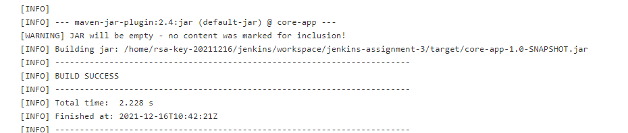

Thank you