**INCOGNITO MONITOR**

INDEX

|  |  |  |  |
| --- | --- | --- | --- |
| SR. NO. | TOPIC | | Pg. No. |
| 1. | INTRODUCTION | | 14 |
| 2. | LITERATURE REVIEW | | 16 |
| 3. | REQUIREMENTS ANALYSIS | | 18 |
| 4. | FEASIBLITY REPORT | | 20 |
| 5. | PERFORMANCE EVOLUTION AND TESTING | | 22 |
| 6. | APPLICATION | | 25 |
| 7. | Expected Result | | 27 |
| 8. | CONCLUSION AND FUTURE SCOPE | | 29 |
| 9. | | BIBLIOGRAPHY & REFFERENCE | 32 |

**INCOGNITO MONITOR**

**Abstract:**

The issue of security is very paramount in any organisation, especially such organisation as a bank. Therefore, we intend to aid in security of the bank by bringing a privacy screen monitor that involves an individual to wear the correct specs/glasses to view the contents on the screen. This system ensures that the confidential data on the screen is visible only to the person wearing the glasses.

This is achieved by understanding the method in which the LCD displays the contents on its screen. The standard RGB lights hit the display and then the polarizing filter. The polarizing filter makes it possible for the human eye to see the contents of the screen. We remove the polarizing filter from the screen so we get only a plain white screen. While with the polarizing filter, we can make glasses that the user can wear. In this process the RGB light is not processed until it hits the glasses and hence people passing by cannot see your confidential data and hence keeping it safe and secure from everyone but the user. From this project, we hope to build an alternative security system.

Keywords: Polarizing filter, monitor, glasses

**CHAPTER – 01**

**INTRODUCTION**

1. Introduction

An incognito monitor is a special type of monitor designed specifically to provide maximum privacy to an individual. The system is flexible to be used and reduces the risk of leaking confidential data. Usually corporate users make sure to secure their data but there is always a chance for error. They only think about securing the file during their absence but not how to secure the data while working on it. Hence the monitor is developed to provide them an easy way for securing their private data.

# Purpose:

The amount of data that people create and handle on daily basis is staggering high. It is very obvious that the data is private to most people. Also, there are many hackers who will try every possible way to access or damage your data. Thankfully there are numerous software which helps to secure the data on the computer from the attacker. But still there is a possibility that the person sneaks up behind an individual and sees the files and its contents which the user does not want to see. To overcome this issue, we have developed the Incognito Monitor.

# Scope:

As the main purpose of this project is privacy and security, it can be used in many corporate offices. It is very beneficial for people who work in banks, companies, etc. for transactions of bank account, sales of product, profit and loss of companies.

# Overview:

**Hardware overview**

This project is user-friendly and requires minimum human intervention. Individuals just have to setup a computer like they normally do with a normal monitor. Then the user only has to wear the specially designed glasses to view the content on the screen. There is no requirement for any kind of software installation. Hence it also helps the system to run efficiently by not using any system resources at all.

**CHAPTER - 02**

**Literature Review**

Security should be always in the upper portion of the priority list. Code updates, security practices, vulnerability profiles, intrusion attempts – all things that should always be kept in mind.

Suggested remedies by CSA to lessen this threat:

* Disclosure of applicable logs and data.
* Partial/full disclosure of infrastructure details (e.g., patch levels, firewalls, etc.).
* Monitoring and alerting on necessary information.

Be it by deletion without a backup, by loss of the encoding key or by unauthorized access, data is always in danger of being lost or stolen. This is one of the top concerns for businesses, because they not only stand to lose their reputation, but are also obligated by law to keep it safe.

The issue of security is very paramount in any organization, especially such organization as a bank. There is always a possibility that a person is waiting quietly behind the user and watching all the confidential data on the user’s screen and memorizing it without any knowledge of the user. The person can then leak the info or can do anything with the memorized data. Such a condition is very critical as the user cannot find out the source of data leak nor can he trace the person who stole the info by sneaking. Therefore, we intend to aid in security of the bank by bringing a privacy screen monitor that involves an individual to wear the correct specs/glasses to view the contents on the screen. This system ensures that the confidential data on the screen is visible only to the person wearing the glasses.

This is achieved by understanding the method in which the LCD displays the contents on its screen. The standard RGB lights hit the display and then the polarizing filter. The polarizing filter makes it possible for the human eye to see the contents of the screen. We remove the polarizing filter from the screen so we get only a plain white screen. While with the polarizing filter, we can make glasses that the user can wear. In this process the RGB light is not processed until it hits the glasses and hence people passing by cannot see your confidential data and hence keeping it safe and secure from everyone but the user. From this project, we hope to build an alternative security system.

**CHAPTER – 03**

**Requirement Analysis**

1. Requirement Analysis

# Hardware requirements

* TFT LCD Monitor
* CPU
* INPUT DEVICES
* POLARIZING FILTER

**CHAPTER NO: 04**

**Feasibility Report**

**TECHNICAL FEASIBILITY**

* 2 AC power supply points of 240V.

**OPERATIONAL FEASIBILITY**

The staff members are willing to operate, use & support the proposed system. There will be only one person to operate on the proposed system. Which does not require any specialized technical skills in the absence of that person another person can take over the operations as and when required any time of the day and will able to work as the regular worker as the operation carried out to be very simple

**CHAPTER - 05**

**Performance Evolution and Testing**

**Testing:**

For testing our we have used different types of polarizing filters of LCD monitor, we have also used the camera lens (polarized).

We can use either a polarizing film or CPL Polarised Camera lens. We have used here the camera filter i.e. Circular Polarised lens (CPL).

We have purchased different CPL filter for the testing.

**CPL:**

A **circular** **polarizing / polarising filter** is often placed in front of the camera lens in photography in order to darken skies, manage reflections, or suppress glare from the surface of lakes or the sea. Since reflections (and sky-light) tend to be at least partially linearly-polarized, a linear polarizer can be used to change the balance of the light in the photograph. The rotational orientation of the filter is adjusted for the preferred artistic effect. For modern cameras, a circular polarizer is typically used; this comprises firstly a linear polarizer which performs the artistic function just described, followed by a quarter-wave plate which further transforms the now-linearly polarized light into circularly-polarised light before entering the camera. This additional step avoids problems with auto-focus and light-metering sensors within some cameras, which otherwise may not function reliably with a simple linear polariser.

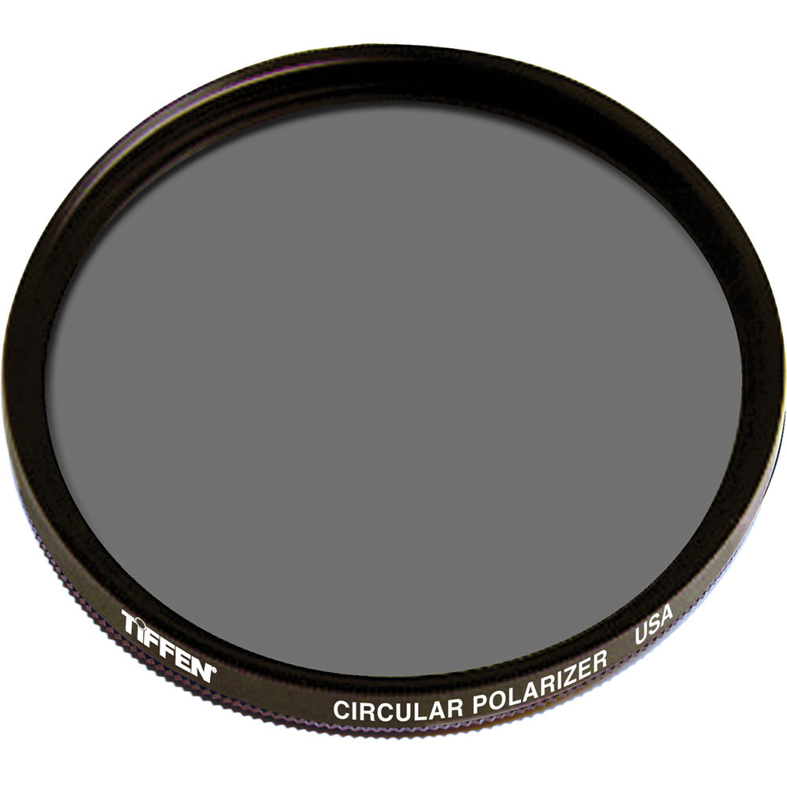

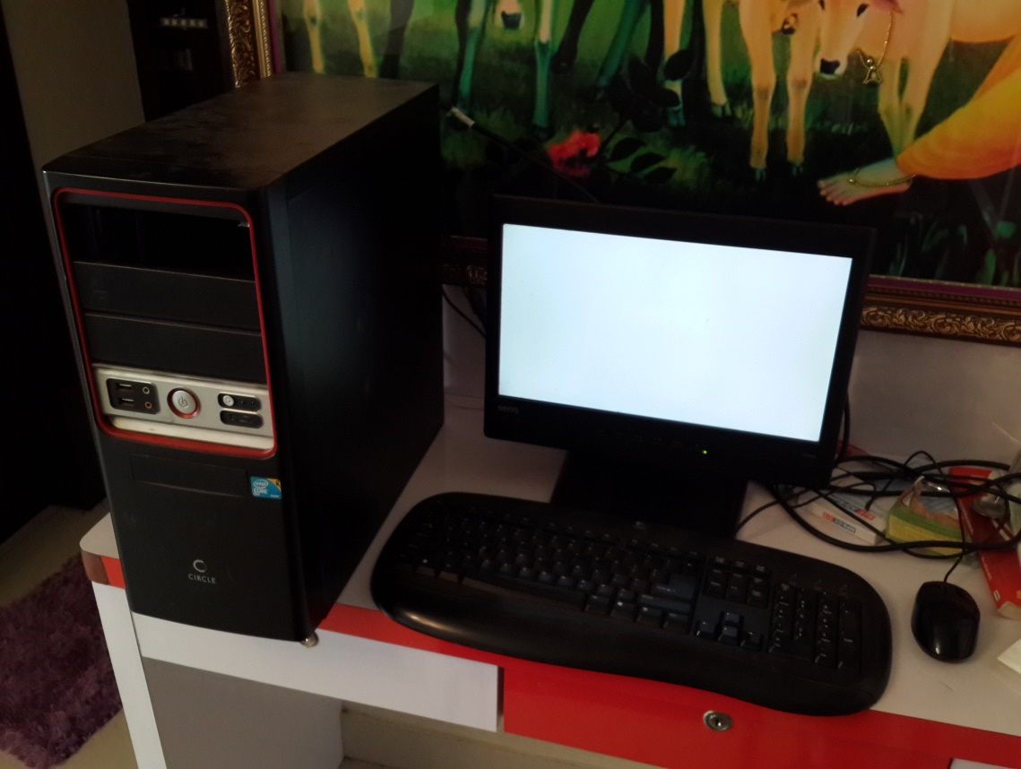

**CHAPTER NO.06**

**Applications**

**Applications:**

In this topic, the applications and the fields where it can be implemented are discussed.

As the main of this project is privacy and security. It can be used in many corporate offices. It is very beneficial for people who work in banks, companies, etc. transactions of bank account, sales of product, profit and loss of companies.

**CHAPTER NO: 07**

**Expected Result**

**Expected Results**

All liquid crystal displays (LCD) operate on the principle of being able to 'twist' polarized light as it passes through a 'nematic' liquid crystal. The orientation of each liquid crystal in a display is governed by an electric field applied to a transparent electrode, through an array of thin-film transistors (TFT). The liquid crystal is normally 'sandwiched' between two polarizing filters at 90 degrees to each other. Polarized light enters the back of the liquid crystal from the back-lit LED. When the nematic crystal is not energized, it 'twists' the polarized light by 90 degrees so that it passes through the second polarizing filter. When an electric field is applied to the liquid crystal, the light does not get twisted so gets blocked by the second polarizing filter.

By taking out the second polarizing filter and placing them on a pair of glasses, the display appears 'invisible' (white) to the naked eye because all of the light from the LED backlight that passes through the first polarizing filter gets through the TFT section to the naked eye, regardless of its orientation (polarization) so the naked eye sees it as 'white'. It's not until the second polarizing filter is applied to 'filter' the light from specific pixels which have 'twisted' their light (with respect to the other pixels) that we can distinguish between the pixels.

The polarizing filter removed from the screen and used on the glasses. The screen looking completely white as the light is not hitting the polarizer. When the user wears the glasses, the light coming out from the screen hits the polarizer on the glasses and the user can see everything on the monitor.

Output:

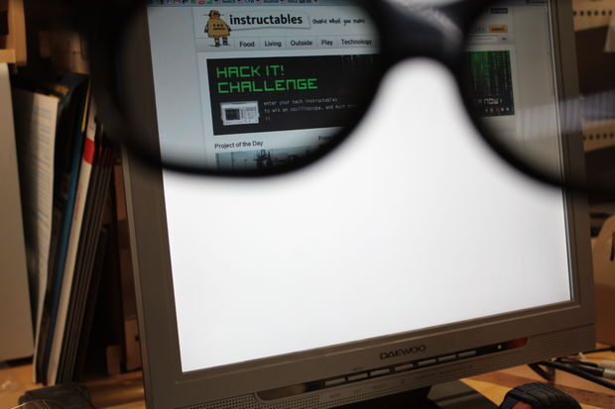

**CHAPTER - 08**

**Conclusion and Future scope**

**Future Scope:**

In this section, the future modifications and enhancements that can be done are discussed.

* Monitor:

The main monitor needed for this project is a TFT type and it cannot be done on a IPS or a AMOLED unit as of now because of the different layout and components merged together in a complex manner as compared to a TFT.

* Glasses:

The thin polarizing sheet filters will lose the weight from the glasses by a considerable margin and this means that we can used light weight glasses instead of heavy ones made from glass.

* Viewing angles:

By getting a IPS display to work on this project idea, the viewing angles from the glasses will be improved drastically.

Conclusion

The design of the Incognito Monitor has been completed. A prototype was build and was confirmed functional. By tear down of the monitor and removing the polarizing filter and glue from the glass panel, we achieve a monitor display that is only emitting white light for anybody looking at it. But when the person wears the glasses that are made by using the polarizing filter, that person can instantly see all the content on the monitor just like on any normal monitor. This system would make it easier for all industries to work with their data without the fear of piggybanking..

**CHAPTER NO: 9**

**Bibliography and References**

**BIBLIOGRAPHY AND REFERENCES**

**Bibliography**

**References**

1. www.google.com

2. www.wikipedia.com

3. www.instructables.com