

Marketing Requirements for ExpressLink Program

|  |  |
| --- | --- |
| **Document #:** |  |
| **Date:** | **August 2009** |
| **Version:** |  |
| **Authors:** | **Erin Martin-Serrano** |

CONFIDENTIAL

The information contained herein is confidential and shall not be revealed to any third party without the expressed written consent of . The document and all copies shall be returned to Icron promptly upon request by Icron.

|  |  |
| --- | --- |
| Approved by:   Name Title | Reviewed by:   Name Title |
| Approved by:   Name Title | Reviewed by:   Name Title |
|  | Reviewed by:   Name Title |
|  | Reviewed by:   Name Title |

# Introduction

The ExpressLink program is used for remote programming and debug of LionsGate IC based products including Robson and the LionsGate Development Kit. It runs on a PC and offers a seamless interface for the customer.

**ExpressLink’s Results**

* Save QA and engineering time debugging systems
* Save time and shipping costs when units have to be sent back to Icron for programming
* Increase customer satisfaction which directly correlates to increased revenue

# Use Case

**Must Have**

* The customer/end user receives an application to update programming and no internet connection is required
* If a new FW version is released, the user receives a new application
* No driver is required to run the application
* Ability to have multiple instances of the application open at the same time
* Able to resize and minimize the application
* Able to run on the Windows platform
* Communication is through a serial COM port
  + For Robson products, the current TTL-232R-3V3 USB to serial chip will be used.
  + For the Development Kit, the FT232 USB to serial chip is on board and thus any mini USB cable is ok to use.

**Strong Want**

* Able to run on the Mac platform

# Interface

## GUI Interface

|  |  |
| --- | --- |
| Interface | Priority |
| Application Version | Must Have |
| Connect & Select COMM Port | Must Have |
| Current Software | Must Have |
| Update Software | Must Have |
| Verify Software | Must Have |
| Generate Debug Log | Strong Want |
| Help | Must Have |

## Application Version

A version of the application is shown in the GUI.

## Current Software

When selected, the version of software loaded on the Robson product or development board is read and reported.

**Must Have**

* + Has an error case if there is no software loaded or the software is corrupt

## Verify Software

When selected, the current version loaded on the device is read and compares it to the version released with the application. If the versions do not match, an error is reported.

## Generate Debug Log – Priorities When Implemented

When selected, this function retrieves vital information (listed below) and stores it into a log file. The user receives confirmation that a log file was generated and where it is stored.

**Must Have – When Implemented**

* + CLM Configuration
  + CTM PLL Configuration
  + CRM PLL Configuration
  + Selected Speed
  + Accumulated errors and health of the cache
  + Snapshot of what state the system ended at

**Strong Want – When Implemented**

* + Configuration of HOST
    - * OS, SP, Motherboard/Bios Information

## Help

A help button is included in the GUI and marketing will write the help content.

# Design

**User Interface**

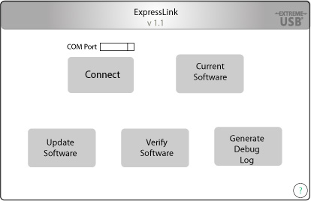

**User Interface – Successful Operation**

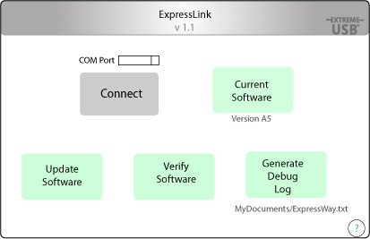

**User Interface – Operation Error**

