

ExpressLink User Guide

|  |  |
| --- | --- |
| **Document #:** | 90-00676 |
| **Date:** |  |
| **Version:** |  |
| **Authors:** | Jackson Hong |

CONFIDENTIAL

The information contained herein is confidential and shall not be revealed to any third party without the expressed written consent of . The document and all copies shall be returned to Icron promptly upon request by Icron.

# Quick Step Reference Guide

|  |  |  |
| --- | --- | --- |
| 1. | Launch ExpressLink |  |
| 2. | Connect programming cable to computer |  |
| 3. | Select COM Port from drop-down menu and click ‘Connect’ button |  |
| 4. | Connect programming cable to ExtremeUSB Device |  |
| 5. | Power-on ExtremeUSB Device |  |
| 6. | Confirm that boot-loader detected successfully |  |
| 7. | Click ‘Update Software’ button to program the device |  |
| 8. | Confirm that download is completed successfully.  To program another device repeat steps 4-8 |  |

# System Requirements

In order to program ASIC units using ExpressLink, the host computer must have the following:

* Windows Operating System
* USB connector
* .NET Framework 3.5
* FTDI driver if using TTL-R232R-3V3 cable, driver can be found at
* [http://www.ftdichip.com/Drivers/CDM/CDM 2.06.00 WHQL Certified.zip](http://www.ftdichip.com/Drivers/CDM/CDM%202.06.00%20WHQL%20Certified.zip)

NOTE: When programming Ranger 2204 REX, Tx/Rx pins on the cable must be reversed. Refer to <https://shamrock.icron.local/bugzilla/show_bug.cgi?id=1905> for more details.

# Using ExpressLink

Up on launching ExpressLink, the user will see the following screen, given that .NET Framework 3.5 is properly installed.

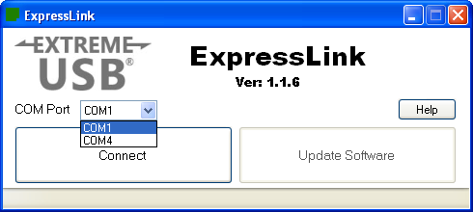

NOTE:

The red circle in the picture above shows the version of the ASIC firmware the current ExpressLink software application has. If this is NOT the expected version, please contact Icron Technical Support.

Take a look at the COM Port options and remember the existing ports. Then, after connecting the programming cable to the USB port on the computer, check the drop down menu for a new COM port that shows up. This is the port that the user will be using to program the unit.

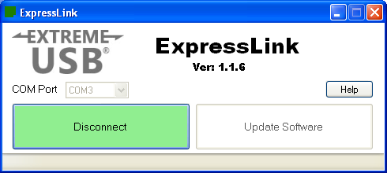

Select the newly added COM port from the drop down box and then click Connect. The button will turn green and the text will read “Disconnect” once it is successfully connected to the device.

When connecting the programming cable to the unit, one thing to note is the location of the black wire. If the unit has a little dot to indicate PIN1, then that is where the black wire should go, as shown in the picture below.

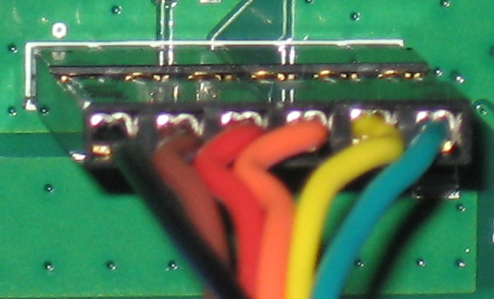

The user will need to power cycle the device after connecting the programming cable to it. When the connection is established, ExpressLink will be waiting for the boot loader string from the device. Once ExpressLink detects that the device is in boot loader mode, the Update Software button will become available and the version of the boot loader detected will be displayed on the status bar on the bottom.

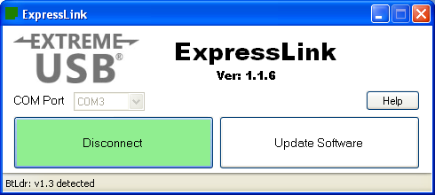

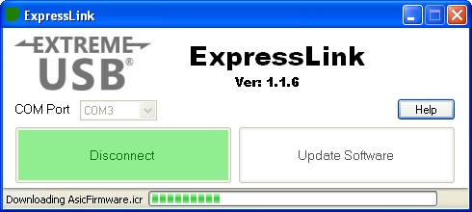

The “Download Complete” displayed at the bottom of the window indicates the download was a success. If an error has occurred, it will also display that in a pop up message box.

