**Coursera Capstone**

**IBM Applied Data Science Capstone**

# *Opening a New Restaurant In Mumbai,India*

By: Sumit

September 2019

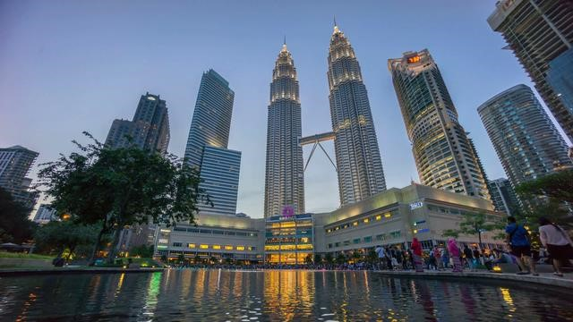

# Introduction

As far back as I can remember, I have always liked going out to eat .

For most of us, visiting restaurants is a great way to relax and enjoy themselves during weekends and holiday. For retailers, the central location. As a result, there are many restaurants in the city of Mumbai and many more are being built. Opening restaurants allows property developers to earn consistent rental income. Now, as with any business decision, opening a new restaurant requires serious consideration and is a lot more complicated than it seems. Particularly, the location of the restaurant is one of the most important decisions that will determine whether the mall will be a success or a failure.

## Business Problem

Goal of this capstone project is to analyse the best locations in the city of Mumbai,India to open a new Restaurant. Using machine learning techniques like clustering,and also the concepts of data science this project aims to provide solutions to answer the business question: In the city of Mumbai,India, if a property developer is looking to open a new restaurant, where would you recommend that they open it?

## Target Audience of this project

This project is particularly useful to property developers and investors looking to open or invest in new restaurants in the Mumbai,India.

# Data

**To solve the problem, we will need the following data:**

* List of neighbourhoods in Mumbai,India. Scope of the project is confined to the city of Mumbai India
* Latitude and longitude coordinates of those neighbourhoods. This is required in order to plot the map and also to get the venue data.
* Venue data, particularly data related to shopping malls. We will use this data to perform clustering on the neighbourhoods.

## Sources of data and methods to extract them

This Wikipedia page =https://en.wikipedia.org/wiki/Category:Suburbs_of_Mumbai[)](https://en.wikipedia.org/wiki/Category:Suburbs_in_Kuala_Lumpur)

Web scrapping using BeautifulSoup.

Foursquare API

Folium