**ANSIBLE**  
Ansible is an opensource IT configuration management, deployment and orchestration tool. It aims to provide large productivity gains to a wide variety of automation challenges.

**Ansible History:**  
➢ Michael Dehaan developed ansible and the ansible project began in February 2012.  
➢ Redhat acquired the ansible tool in 2015.  
➢ Ansible is available for RHEL, Debian, cent OS and oracle Linux.  
➢ We can use this tool whether your servers are in on-premises or in cloud.  
➢ It turns your code into infrastructure i.e. your computing environment has some of the same attributes as your application.

**Advantages:**  
➢ Ansible is free to use by everyone.  
➢ Ansible is very consistent and light weight and no constrains regarding the OS or  
underlying hardware are present.  
➢ It is very secure due to its agentless capabilities and open SSH security features.  
➢ Ansible doesn’t need any special system administrator skills to install and use it.  
➢ It is push mechanism.

**Disadvantages:**  
➢ Insufficient user interface, though ansible tower is GUI, but it is still in development stage.  
➢ Cannot achieve full automation by ansible.  
➢ New to the market, therefore limited support and document is available.

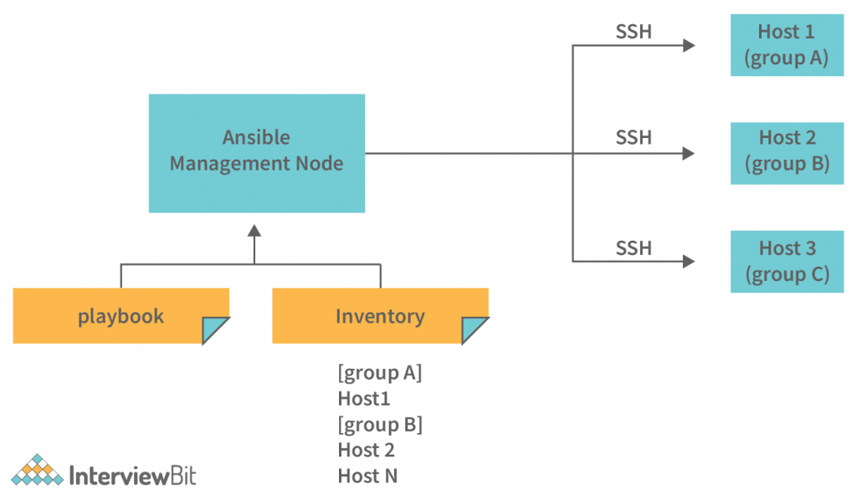

**Terms used in Ansible:**  
a. Ansible Server: the machine where ansible is installed and from which all tasks and Playbooks will be run.  
b. Module: basically, a module is a command or set of similar commands meant to be executed on the client side.  
c. Task: a task is section that consist of a single procedure to be completed.  
d. Role: a way of organizing tasks and related files to be later called playbook.  
e. Fact: information fetched from the client form the global variables with the gather facts operation.  
f. Inventory: file containing data about the ansible client servers.  
g. Play: execution of playbook.  
h. Handler: task which is called only if notifier is present.  
i. Notifier: section attributed to a task which calls a handler if the output is changed.  
j. Playbooks: it consists code in YAML format which describes tasks to be executed.  
k. Host: nodes which are automated by ansible.

Go to AWS account- create 3 EC2 instances in same AZ or 3 Virtual Machines in Azure.

- Take access of all machines via putty.  
- Now go inside ansible server and download ansible package

Refer : <https://adamtheautomator.com/install-ansible/>

- Now go to host file inside ansible server and paste ip of node1 and node2  
# vi /etc/ansible/hosts

- Now this host file is only working after updating ansible.cfg file

# vi /etc/ansible/ansible.cfg

- Now create one user, in all the three instances  
# adduser ansible

- Now switch as ansible user  
# su – ansible

- This ansible user don’t have sudo priviledges right now. If you want to give sudo privilege to ansible user

# visudo

- Now go inside this file  
Root ALL= (ALL) ALL  
(ansible ALL= (ALL) NOPASSWD: ALL)

:wq!  
  
- Now go to ansible server and try to install httpd package as an ansible user.  
# sudo you install httpd -y  
- Now establish connection between server and node, go to ansible server  
$ ssh 172.31.41.240  
o/p- permission denied  
- now we have to do some changes in sshd-config file, go to ansible server  
# vi /etc/ssh/sshd-config  
- Do some changes and saved the file.

Uncomment below:

PermitRootLogin Yes

PasswordAuthentication Yes  
- Do this work in node1 and node2 also.

Service sshd restart

- Now verify in ansible server  
# su -ansible  
# ssh 172.31.41.240  
- Now it asks for passwd, enter the password after that you will be inside node1.  
- Now go to ansible server and create keys.  
- Run this command as ansible user.  
# ssh-keygen  
# ls -a  
o/p- .ssh  
# cd .ssh/  
Ls  
o/p- id_rsa id_rsa_pub  
- now I need to copy public key in both the nodes.  
# ssh-copy-id ansible(username)@172.31.41.240

- Ask for password  
# ssh-copy-id ansible@172.31.41.228  
- Ask for password  
- Now verify, go to ansible server  
# cd ..  
# ssh 172.31.41.240  
Now you will enter into node1.  
- Now go to ansible server and try to install httpd package as an ansible user.  
# sudo you install httpd -y  
- Now establish connection between server and node, go to ansible server  
$ ssh 172.31.41.240  
o/p- permission denied  
- now we have to do some changes in sshd-config file, go to ansible server  
# vi /etc/ssh/sshd-config  
- Do some changes and saved the file.

Uncomment below:

PermitRootLogin Yes

PasswordAuthentication Yes  
- Do this work in node1 and node2 also.

Service sshd restart

- Now verify in ansible server  
# su -ansible  
# ssh 172.31.41.240  
- Now it asks for passwd, enter the password after that you will be inside node1.  
- Now go to ansible server and create keys.  
- Run this command as ansible user.  
# ssh-keygen  
# ls -a  
o/p- .ssh  
# cd .ssh/  
Ls  
o/p- id_rsa id_rsa_pub  
- now I need to copy public key in both the nodes.  
# ssh-copy-id ansible(username)@172.31.41.240

- Ask for password  
# ssh-copy-id ansible@172.31.41.228  
- Ask for password  
- Now verify, go to ansible server  
# cd ..  
# ssh 172.31.41.240  
Now you will enter into node1.  
:wq!  
  
- Now go to ansible server and try to install httpd package as an ansible user.  
# sudo you install httpd -y  
- Now establish connection between server and node, go to ansible server  
$ ssh 172.31.41.240  
o/p- permission denied  
- now we have to do some changes in sshd-config file, go to ansible server  
# vi /etc/ssh/sshd-config  
- Do some changes and saved the file.

Uncomment below:

PermitRootLogin Yes

PasswordAuthentication Yes  
- Do this work in node1 and node2 also.

Service sshd restart

- Now verify in ansible server  
# su -ansible  
# ssh 172.31.41.240  
- Now it asks for passwd, enter the password after that you will be inside node1.  
- Now go to ansible server and create keys.  
- Run this command as ansible user.  
# ssh-keygen  
# ls -a  
o/p- .ssh  
# cd .ssh/  
Ls  
o/p- id_rsa id_rsa_pub  
- now I need to copy public key in both the nodes.  
# ssh-copy-id ansible(username)@172.31.41.240

- Ask for password  
# ssh-copy-id ansible@172.31.41.228  
- Ask for password  
- Now verify, go to ansible server  
# cd ..  
# ssh 172.31.41.240  
Now you will enter into node1.

**Host Patterns:**  
# vi /etc/ansible/hosts  
“all” pattern refers to all the machines in an inventory  
Ansible all –list-host  
Ansible <group name> --list-hosts  
Ansible <groupname>[0] –list-hosts  
victor[0]- picks first machine of the group  
Groupname[1]- picks second machine of the group  
Groupname[-1]- picks last machine of the group  
Groupname[0:1]- picks first two machines of the group  
Groupname[2:5]- picks 3,4,5 and 6 machines of the group  
Group separated by colon (:) can be used to use hosts from multiple groups.  
Groupname1:groupname2

**Ad-hoc Commands:**➢ Ad-hoc commands are commands which can be run individually to perform quick  
functions.  
➢ These ad-hoc commands are not used for configuration management and deployment, because these commands are of one-time usage.

➢ The ansible ad-hoc commands uses the /usr/bin/ansible command line tool to automate a single task.

Go to ansible server  
$ ansible demo -a “ls”  
$ ansible victor[0] -a “touch filez”  
$ ansible all -a “touchfile4”  
$ ansible demo -a “ls-al”  
$ ansible victor -a “sudo yum install httpd -y” or  
$ ansible demo -ba “yum install httpd -y”  
$ ansible demo -ba “yum remove httpd -y”

**Ansible Modules:**  
➢ Ansible ships with a number of modules (called module library) that can be executed directly on remote hosts or through “playbooks”.  
➢ Your library of modules can reside on any machine and there are no servers, daemons or databases required.  
Q. where ansible modules are stored?  
The default location of the inventory file is /etc/ansible/hosts.  
$ ansible demo -b -m yum -a “pkg=httpd state=present”  
$ ansible demo -b -m yum -a “pkg=httpd state=latest”  
$ ansible demo -b -m yum -a “pkg=httpd state=absent”  
$ ansible demo -b -m service -a “name=httpd state=started”  
$ ansible demo -b -m user -a “name=raj”  
$ ansible demo -b -m copy -a “src=file4 dest=/tmp”  
$ ansible demo -m setup  
$ ansible demo -m setup -a “filter= *ipv4* ”

**Playbook:**  
➢ Playbooks in ansible are written in YAML format.  
➢ It is human readable data serialization language and is commonly used for configuration files.  
➢ Playbook is like a file where you write codes consists of variables, tasks, handlers, files,templates and roles.  
➢ Each playbook is composed of one or more ‘modules’ in a list. Module is a collections of configuration files.  
➢ Playbooks are divided into many sections like  
a. Target section: defines the host against which playbooks task must be executed.  
b. Variable: define variables  
c. Task section: list of modules that we need to run in an order.

**YAML (Yet Another Markup Language):**➢ For ansible nearly every YAML files starts with a list.  
➢ Each item in the list is a list of key-value pairs commonly called as a directory.  
➢ All YAML files have to begins with “---”.  
➢ All members of a list lines must begin with same indentation level starting with “-”.  
  
Go to ansible server.

Now create one playbook.  
**# vi victor.yml**

---

- hosts: victor

remote_user: ansible

become: yes

connection: ssh

gather_facts: yes

Esc- :wq!  
$ ansible-playbook target.yml

Now create one playbook.  
**# vi task.yml**

---

- hosts: victor

user: ansible

become: yes

connection: ssh

tasks:

- name: install apache2 on Ubuntu

apt:

name: apache2

state: present

Esc- :wq!  
$ ansible-playbook task.yml

**Variables:**  
➢ Ansible uses variables which are defined previously to enable more flexibility in playbooks and roles. They can be used to loop through a set of given values, access various  
information like the host name of a system and replace certain strings in templates with  
specific values.  
➢ Put variable section above tasks so that we define it first and use it later.  
Now go to ansible server and create one playbook.  
$ vi vars.yml  
---

- hosts: victor

user: ansible

become: yes

connection: ssh

vars:

package_name: apache2

tasks:

- name: install {{ package_name }} on Ubuntu

apt:

name: "{{ package_name }}"

state: present

Esc - :wq!  
Now execute playbook $ ansible-playbook vars.yml

**DRY-RUN:**  
Check whether the playbook is formatted correctly or not.  
ansible-playbook vars.yml --check

**Handlers Section:**  
A handler is exactly the same as a task, but it will run when called by another task.  
Or  
Handlers are just like regular tasks in an ansible playbook, but are only run if the task contains a ‘notify’ directive and also indicates that it changed something.

Go to ansible server  
**$ vi handler.yml**

---

- hosts: victor

user: ansible

become: yes

connection: ssh

vars:

package_name: apache2

tasks:

- name: install {{ package_name }} on Ubuntu task executed by Victor

apt:

name: "{{ package_name }}"

state: present

notify: task executed by ade

handlers:

- name: task executed by ade

service:

name: apache2

state: restarted

Esc- :wq!  
Now execute this playbook  
$ ansible-playbook handlers.yml

**Loops:**  
Sometimes you want to repeat a task multiple time. In computer programming this is called as loops. Common ansible loops include changing ownership on several files and/or directories with the file module, creating multiple users with the user module and repeating a polling step until certain result is reached.  
Now go to ansible server.  
**$ vi loops.yml**  
---

- hosts: victor

user: ansible

become: yes

connection: ssh

vars:

package_names:

- apache2

- nginx

- mysql-server

tasks:

- name: install packages on Ubuntu

apt:

name: "{{ item }}"

state: present

loop: "{{ package_names }}"

Esc- :wq!  
$ansible-playbook loops.yml

**Conditions:**  
Whenever we have different scenarios we put conditions to the scenario.  
We put conditions in ansible by “when” statement.

**$ vi conditions.yml**

---

- hosts: demo

user: ansible

become: yes

connection: ssh

tasks:

- name: install apache on Debian

apt:

name: apache2

state: present

when: ansible_os_family == "Debian"

- name: install apache for Red Hat

yum:

name: httpd

state: present

when: ansible_os_family == "RedHat"

ansible-playbook conditions.yml

**Vault:**  
Ansible allows keeping sensitive data such as passwords or key in encrypted files, rather than a plaintext in your playbooks.

Creating a new encrypted playbook:  
$ ansible-vault create vault.yml

Edit the encrypted playbook:  
$ ansible-vault edit vault.yml

To change the password:  
$ ansible-vault rekey vault.yml

To encrypt on existing playbook:  
$ ansible-vault encrypt target.yml

To decrypt an encrypted playbook:  
$ ansible-vault decrypt target.yml