**MovFlix Movie Library**

The “**MovFlix**” is an online Movie Library.

This application enables the users to view the details of movies based on some search options. It also allows the admin to add new movies.

**Details:**

The application should support two types of users:

1. **User:** can only perform searches to view the details of movies
2. **Admin:** can add or modify new movie details. Modify option though available as a link, is still in progress. Delete option is not supported at present.

As soon as the application is accessed, it should show the Home Screen. There is no login that is required for a “User”.

Home screen enables the users to search for movies, based on any of the 3 criteria i.e., based on a movie id, movie name or based on collection range that the movie has earned.

User clicks on by Movie ID , by Movie Name or by Movie Collection hyperlinks to find details about the movie.

The home page can look like this:

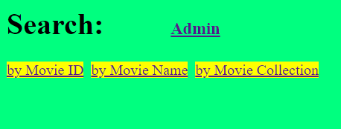

If the user clicks the link “by Movie ID”, it expects the user to enter a movie id like below

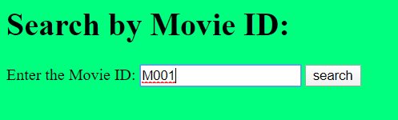

and if the movie id is present, it displays the details of the movie.

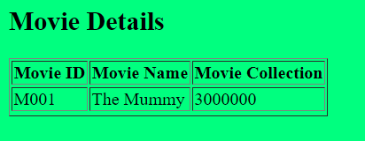

home

If the movie id is not present, it should show an appropriate error message screen. Sample below:

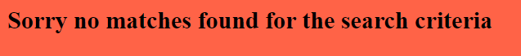

home

If the user clicks the link “by Movie Name”, it expects the user to enter a movie name like below

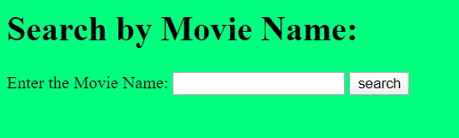

Mummy

and if the movie by that name is present, it displays the details of the movie.

Please note 2 important things for this search:

* It should search based on whether the entered string is present/contained in the name of the movie. Need not be the exact name of the movie. Example 1: if the user enters just “Mummy” then it should show all movie names where the string mummy is present, like it might show 2 movies “The Mummy” and “The Mummy Returns” as both these movie names have the string “Mummy” in them. Example 2: If the user enters “Logan” then it should show only 1 movie detail as there is only one movie with the name which has the string “Logan”.
* It should also work even if the string is entered in upper case or lower case. So, it should be case-insensitive.

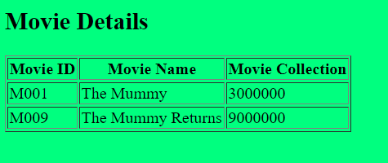

home

If the movie by that name is not present, it should show an appropriate error message screen. Sample below:



home

If the user clicks the link “by Movie Collection”, it expects the user to enter a range of collection like below:

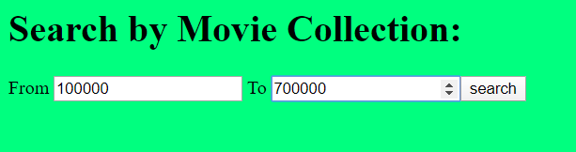

4000000

6000000

and if the movies are present within this collection range, then it displays the details of the movies

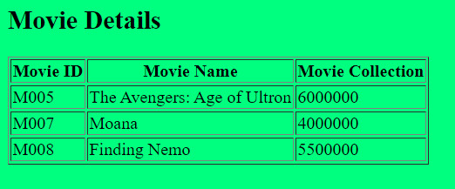

home

If the movies do not qualify for a particular given range, then show an appropriate error message screen. Sample below:



home

**Admin User:**

Admin user can click on the link “Admin” on the home screen to perform admin activities.



At present only 1 admin exists, and her details are:

|  |  |
| --- | --- |
| User id | stella@gmail.com |
| Password | stellar |

So, there is no need to maintain any separate table for user, just use these credentials to check the values entered for user id and password are as per the values given above and use it for validations.

When the “Admin” link is clicked, a login page is shown as below:

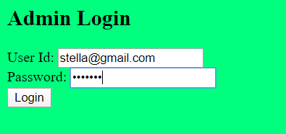

If the credentials entered by the admin are incorrect like either the user id is invalid or the password is incorrect, you can show the below screen and allow the user to navigate back to the login screen.

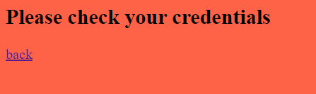

If the credentials are entered correctly, the below Admin Page is shown.

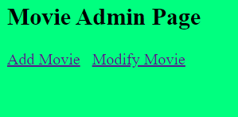

When the user clicks on the “Add Movie” link, the admin should be shown a page to enter new movie details and when submitted, it should get added into the existing movie table and show a confirmation page.

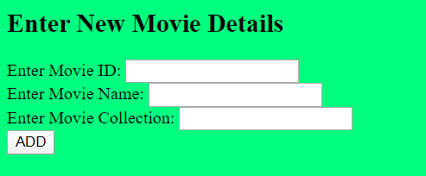



home

When the user clicks on the “Modify Movie” link, it should a page like below as this functionality is still not implemented and is in progress.

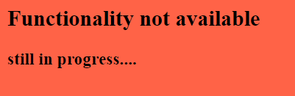

home

**Note: Have “home” link in every result page, so that the user can come back to the home page when they click on it.

**Suggested Database/Table structures:**

**Movie Table**

|  |  |  |
| --- | --- | --- |
| MovieID | MovieName | Collection |
| M001 | The Mummy | 3000000 |
| M002 | The Firm | 2000000 |
| M003 | Mr. Bean | 2500000 |
| M004 | Logan | 2500000 |
| M005 | The Avengers: Age of Ultron | 6000000 |
| M006 | Top Gun | 2000000 |
| M007 | Moana | 4000000 |
| M008 | Finding Nemo | 5500000 |
| M009 | The Mummy Returns | 9000000 |
| M010 | Star Wars | 7000000 |

**General Requirements:**

1. Apply suitable headings/titles as deemed appropriate.
2. Apply suitable validations to the forms wherever applicable (All the fields mandatory etc.,)
3. The screen designs given above are for easy understanding of the flow and functionality. You can design the screens as per your choice.
4. Please use appropriate HTML5 input types and attributes as found suitable.
5. Styling and colors can be used as per your choice

**Technologies mandatorily that needs to be used:**

* **Languages and Frameworks:** Spring Boot, JAX-RS & Spring Data
* **Databases :** Any In-Memory DB or RDBMS of your choice
* **Build Tool:** Use and implement it as a Maven based Spring Boot project