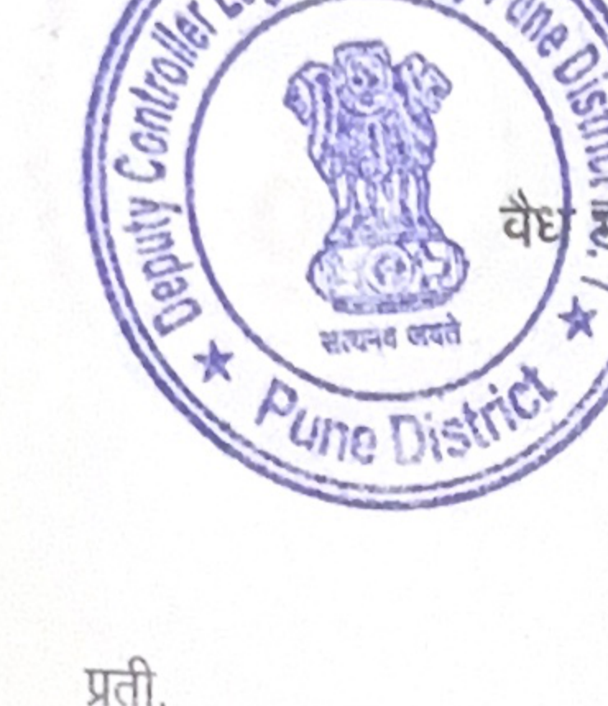 | GOVERNMENT OF MAHARASHTRA  FOOD, CIVIL SUPPLIES AND CONSUMER PROTECTION DEPARTMENT  LEGAL METROLOGY ORGANISATION  Under the Legal Metrology Act, 2009, the Legal Metrology  (Packaged Commodities) Rules, 2011 and the Maharashtra Legal Metrology  (Enforcement) Rules, 2011 | Date: ____ / ____ / 20__  Receipt No.  {{SEIZURE_RECEIPT_NO}}
To,
M/s. ________________________________________________________________________________
________________________________________________________________________________
Business / Establishment: ____________________________________________________________________
In exercise of the powers conferred upon me under the provisions of Section 15 of the Legal Metrology Act, 2009, I have seized and detained the following weight or measure / packaged commodities / articles found in your possession and kept for sale, distribution, storage or use, for the reasons stated below.
Details of the Weight or Measure / Packaged Commodities / Other Articles Seized and Detained | Reasons for Seizure and Detention
Receipt acknowledged. The above particulars are correct.
(Signature)  User of Weight or Measure / Seller of Packaged Commodities /  Wholesale Dealer / Manufacturer / Importer or their Representative  Note: Strike out whichever is not applicable. | Inspector,  Legal Metrology

