SDN-Based DDoS Detection and Mitigation
Project Explanation, Scope, Deliverables, and Evaluation Plan

1. Project Overview
Project idea: Build a Software-Defined Networking (SDN) system that detects abnormal traffic patterns associated with Distributed Denial-of-Service (DDoS) attacks and automatically applies network-level mitigation rules before the protected service becomes unavailable.
In simple terms, instead of configuring every switch manually, the network is controlled by an SDN controller. The controller continuously observes traffic statistics from the switches. If the traffic toward a server suddenly becomes abnormally large or exhibits suspicious patterns, the controller can identify the offending flows and instruct the switches to drop, rate-limit, or redirect them. Legitimate users should continue to reach the server while attack traffic is suppressed.

2. Problem Statement
A DDoS attack attempts to make a service unavailable by overwhelming it with traffic from many sources. Traditional networks can react slowly because mitigation often depends on separate devices, static access-control rules, or manual intervention. The proposed project uses the centralized visibility of SDN to detect suspicious traffic and push mitigation rules dynamically.
- The protected server receives both legitimate and malicious traffic.
- OpenFlow-compatible switches forward traffic and expose flow statistics.
- The SDN controller periodically collects statistics such as packet counts, byte counts, source diversity, destination concentration, and flow rates.
- A detection module classifies traffic as normal or suspicious using threshold-based rules or a lightweight anomaly model.
- When an attack is detected, the controller installs mitigation rules at the switches so malicious traffic is blocked or limited closer to its source.

3. Why SDN is Suitable for DDoS Mitigation
SDN separates the network control plane from the packet-forwarding data plane. The controller therefore has a broader view of the network than an individual switch. This makes it useful for DDoS defense because detection and response logic can be implemented centrally and then enforced across multiple switches.
SDN Capability | How It Helps This Project
Centralized network view | The controller can observe traffic statistics from several switches instead of analyzing only one link.
Programmable control | Detection and mitigation logic can be implemented in software and changed without reconfiguring every switch manually.
Dynamic flow rules | The controller can install temporary drop or rate-limit rules when suspicious traffic is detected.
Fast experimentation | Mininet can emulate hosts, switches, links, and attacks on one computer, making the project practical for a college lab.
Measurable behavior | Traffic before, during, and after mitigation can be compared using throughput, delay, packet loss, and controller response time.

4. Proposed System Architecture
A practical implementation can be built entirely in a controlled virtual lab. A typical stack is Mininet for network emulation, Open vSwitch for programmable switching, a controller such as Ryu or OpenDaylight, and traffic-generation tools for producing legitimate load and controlled attack traffic.
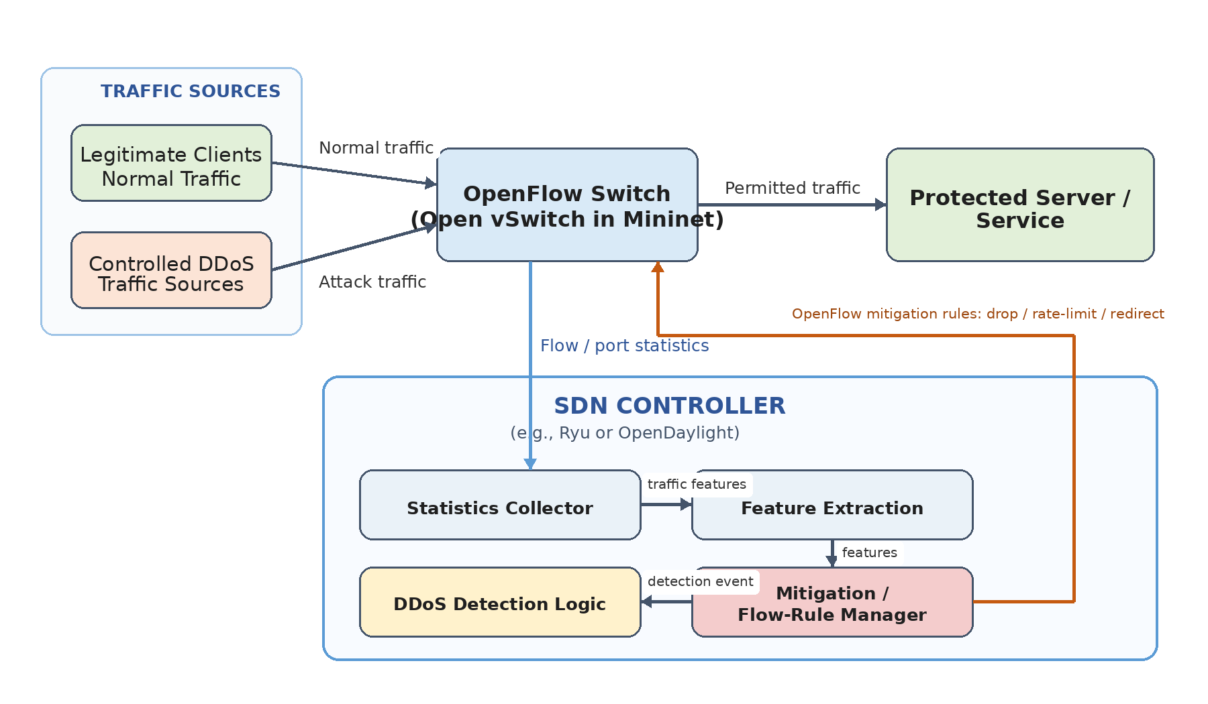
Figure 1. High-level architecture of the proposed SDN-based DDoS detection and mitigation system.

Core Components
Network Emulator: Mininet creates virtual hosts, switches, and links so different traffic loads and attack scenarios can be reproduced safely.
SDN Controller: Ryu, OpenDaylight, or another controller receives switch events and statistics, runs the detection logic, and installs OpenFlow rules.
Monitoring Module: Collects per-flow or per-port statistics at regular intervals and converts them into useful traffic features.
Detection Module: Determines whether a destination or flow is behaving abnormally. The first version should use understandable threshold-based rules; an ML detector can be an optional extension.
Mitigation Module: Installs temporary rules to drop, block, or rate-limit identified attack traffic while preserving legitimate traffic.
Protected Service: A simple HTTP server or similar service that demonstrates whether users can still reach the service during an attack.
Evaluation and Logging: Stores timestamps, traffic measurements, detected attacks, applied rules, and performance metrics for analysis.

5. How the Project Works - Step by Step
1. Normal operation: Legitimate clients send requests to the protected server through SDN-controlled switches. The controller learns the topology and permits ordinary traffic.
2. Traffic monitoring: The controller periodically requests flow/port statistics from the switches.
3. Feature calculation: The system computes indicators such as packets per second, bytes per second, number of new flows, number of unique sources, and traffic concentration on a destination.
4. Attack detection: If the measured behavior exceeds the chosen baseline or threshold for a sustained period, the destination/flow is marked suspicious.
5. Mitigation: The controller installs OpenFlow rules to block or rate-limit the identified traffic. Rules should have timeouts so they do not remain permanently.
6. Recovery: Once traffic returns to normal, mitigation rules expire or are removed, and normal forwarding resumes.
7. Analysis: The system compares network performance with and without mitigation to show whether the controller reduced the impact of the attack.

6. Recommended Course-Project Scope
The project should focus on demonstrating a correct networking concept rather than trying to build a production-grade anti-DDoS platform. A realistic semester version is:
- One Mininet topology with multiple clients, one or more OpenFlow switches, and one protected server.
- One SDN controller application that polls network statistics.
- At least two controlled DDoS-style traffic scenarios, such as high-rate UDP traffic and SYN/connection-flood behavior inside the lab.
- A simple and explainable detection mechanism based on traffic-rate and flow-behavior thresholds.
- Automatic mitigation by installing temporary OpenFlow drop or rate-control rules.
- Comparison of network behavior before attack, during attack without mitigation, and during attack with mitigation.
- A small dashboard or log viewer is optional; it should not take priority over the networking functionality.

7. Project Deliverables
The following deliverables define what the team should be able to submit and demonstrate at the end of the project.
Deliverable | What It Contains | Evidence of Completion | Priority
1. Problem Definition and Literature Review | Short explanation of DDoS, SDN, OpenFlow, existing SDN-based mitigation approaches, and the gap addressed by the project. | Proposal/report section with references and a clear problem statement. | Essential
2. Emulated Network Topology | Mininet topology containing clients, OpenFlow switches, links, and a protected server. | Runnable topology script and topology diagram. | Essential
3. SDN Controller Application | Controller code for topology/flow handling, switch communication, statistics collection, and rule installation. | Controller starts successfully and manages the emulated switches. | Essential
4. Traffic Monitoring Module | Periodic collection of flow or port statistics and calculation of traffic indicators. | Logs/CSV showing traffic values over time. | Essential
5. DDoS Detection Module | Threshold-based or lightweight anomaly logic that raises an alert when attack behavior is observed. | Detection event with timestamp and identified target/source/flow information. | Essential
6. Automatic Mitigation Module | Controller dynamically installs temporary OpenFlow rules to drop or limit suspicious traffic. | Flow-table output showing mitigation rules and reduced malicious traffic. | Essential
7. Attack/Test Scenario Scripts | Repeatable controlled traffic scenarios for normal traffic and DDoS-like conditions. | Scripts/commands plus documented parameters and expected behavior. | Essential
8. Performance Evaluation | Measurement of attack impact and mitigation effectiveness. | Graphs/tables for throughput, delay, packet loss, detection time, and mitigation time. | Essential
9. Logs / Visualization | Readable record of statistics, alerts, and mitigation actions. Optional web/dashboard visualization if time permits. | Controller logs, CSV output, or dashboard screenshots. | Recommended
10. Documentation and Demonstration | README, setup instructions, architecture, algorithm description, limitations, result discussion, and demo flow. | Repository + final report + presentation/demo. | Essential

8. Minimum Functional Requirements
- The controller must connect to the emulated OpenFlow switches.
- The system must collect traffic statistics automatically at fixed intervals.
- The system must distinguish a normal traffic scenario from at least one high-volume attack scenario.
- An attack alert must include enough information to identify the affected destination and suspicious traffic source/flow.
- The mitigation action must be applied automatically through the SDN controller, not by manually editing switch rules during the demonstration.
- The mitigation rule must be temporary or explicitly removable so the network can recover after the experiment.
- Legitimate traffic should remain measurably more available after mitigation than in the unmitigated attack case.
- All tests must run in an isolated lab/emulated environment.

9. Evaluation Metrics
The project becomes stronger when success is measured quantitatively instead of only showing that an alert appears.
Metric | Meaning | Desired Result
Detection time | Time from attack start until the controller raises an alert. | Low and consistent.
Mitigation time | Time from detection until mitigation rules become effective. | Low enough to reduce service disruption.
Server throughput | Useful legitimate traffic reaching the server. | Higher with mitigation than without mitigation.
Packet loss | Fraction of legitimate packets lost during the experiment. | Lower after mitigation.
Latency / RTT | Delay experienced by legitimate clients. | Closer to normal baseline after mitigation.
Attack traffic reduction | Decrease in malicious traffic reaching the server. | Large reduction after mitigation.
False positives | Legitimate flows incorrectly blocked or flagged. | As low as possible.
Controller overhead | CPU, rule count, or statistics-request overhead. | Acceptable for the lab topology.

10. Phase-Wise Implementation Plan
Phase 1 - Foundation: Study SDN architecture, OpenFlow, Mininet, and the selected controller. Build a simple topology and verify host-to-host connectivity.
Phase 2 - Controller and Monitoring: Connect switches to the controller, collect flow/port statistics, and log them at fixed intervals.
Phase 3 - Baseline and Detection: Generate normal traffic, determine reasonable baselines, implement attack-detection rules, and validate that alerts are triggered only under abnormal load.
Phase 4 - Mitigation: Install controller-generated mitigation rules and verify that suspicious traffic is suppressed without unnecessarily blocking legitimate clients.
Phase 5 - Evaluation: Run repeatable normal, attack-without-defense, and attack-with-defense experiments. Record all metrics and create graphs/tables.
Phase 6 - Documentation and Demo: Prepare report, architecture diagram, setup guide, results, limitations, presentation, and a short repeatable live demonstration.

11. Suggested Final Demonstration
1. Start the Mininet topology and SDN controller.
2. Show that legitimate clients can reach the protected server under normal conditions.
3. Show the controller receiving traffic statistics.
4. Start the controlled DDoS traffic inside the emulated lab.
5. Show deterioration in server/network performance.
6. Show the controller detecting the abnormal traffic.
7. Show the mitigation rule being installed automatically.
8. Show reduced malicious traffic and recovery of legitimate service.
9. Present the before/after metrics and explain any false positives or limitations.

12. Optional Extensions
These should only be attempted after the essential deliverables work reliably:
- Machine-learning-based anomaly detection trained on collected flow statistics.
- Adaptive thresholds based on recent traffic rather than fixed constants.
- Source reputation or entropy-based detection for distributed attacks.
- Multiple protected servers and multiple attack targets.
- Automatic rule expiry and recovery-state logic.
- Web dashboard displaying live traffic, alerts, blocked flows, and mitigation history.
- Comparison of two mitigation strategies, such as complete dropping versus rate limiting.

13. Limitations and Responsible Testing
This project is an academic defensive-networking prototype, not a production DDoS protection service. Mininet and a single-machine lab cannot reproduce Internet-scale botnets, ISP-level filtering, or the full behavior of cloud scrubbing centers. Results should therefore be described as controlled experimental results, not proof of Internet-scale protection.
All traffic-generation and attack experiments should be confined to the team's own isolated Mininet/lab environment or other systems for which explicit authorization has been granted. The project does not require targeting external hosts or public services.

14. Definition of Done
The project can be considered successfully completed when the team can demonstrate all of the following:
- A reproducible SDN topology runs successfully.
- The controller monitors traffic automatically.
- Normal and attack traffic produce visibly different monitored behavior.
- The controller detects the selected DDoS scenario without manual intervention.
- The controller installs a mitigation rule automatically.
- The protected service performs significantly better under attack with mitigation than without mitigation.
- Results are supported by quantitative metrics rather than screenshots alone.
- The repository contains setup instructions, source code, experiment scripts, and documented limitations.

15. One-Paragraph Project Summary
The project develops an SDN-based DDoS detection and mitigation system in a controlled Mininet environment. OpenFlow switches forward traffic while an SDN controller continuously gathers network statistics and looks for abnormal traffic behavior directed at a protected server. When the configured detection logic identifies a likely DDoS event, the controller automatically installs temporary mitigation rules to suppress suspicious traffic and preserve legitimate access to the service. The system is evaluated by comparing network performance under normal traffic, an unmitigated attack, and an attack with SDN-based mitigation, using metrics such as detection time, mitigation time, throughput, latency, packet loss, and false positives.

