**Overview**

This is a demonstration of how to migrate static website on AWS (Amazon Web Services) S3 bucket.We are creating a website which contains three informative pages and one error page. On the home page i.e. the first page we are providing links to navigate to other informative pages viz Service page and Contact page. We have also provided links to navigate back and forth through the pages. We have uploaded these all pages in their respective folders on the S3 service which is available on the AWS Console, we have made all these folders public in order to provide public access to our informative website.

Creating Static Website on Premises

Step 1:

This represents the main page for the website.

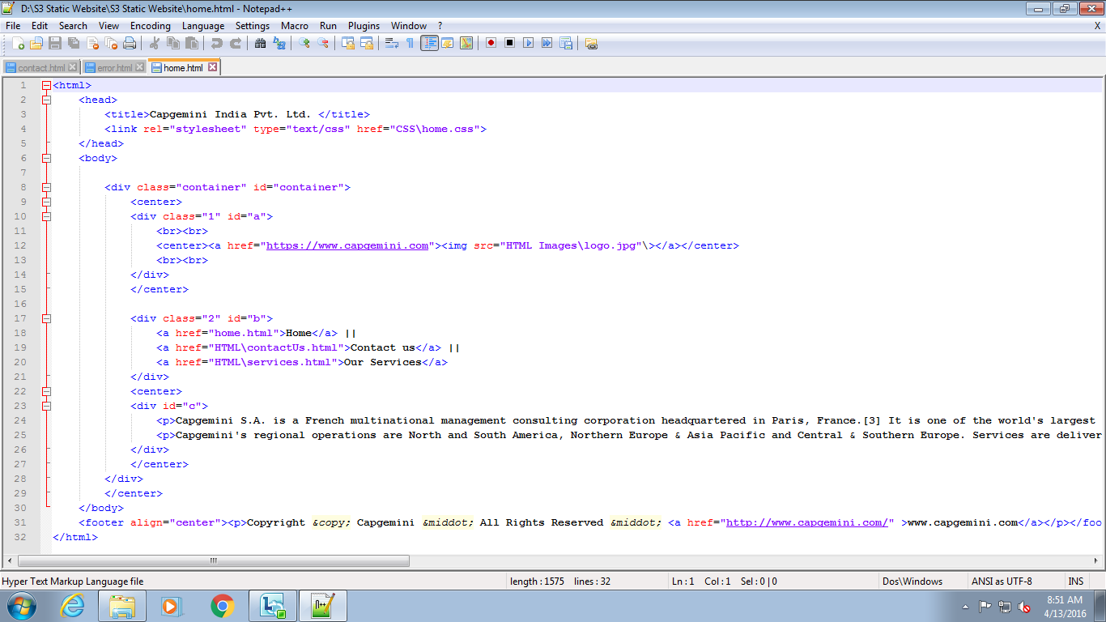

Figure 1: Home page

Step 2: This page contains information about the company.

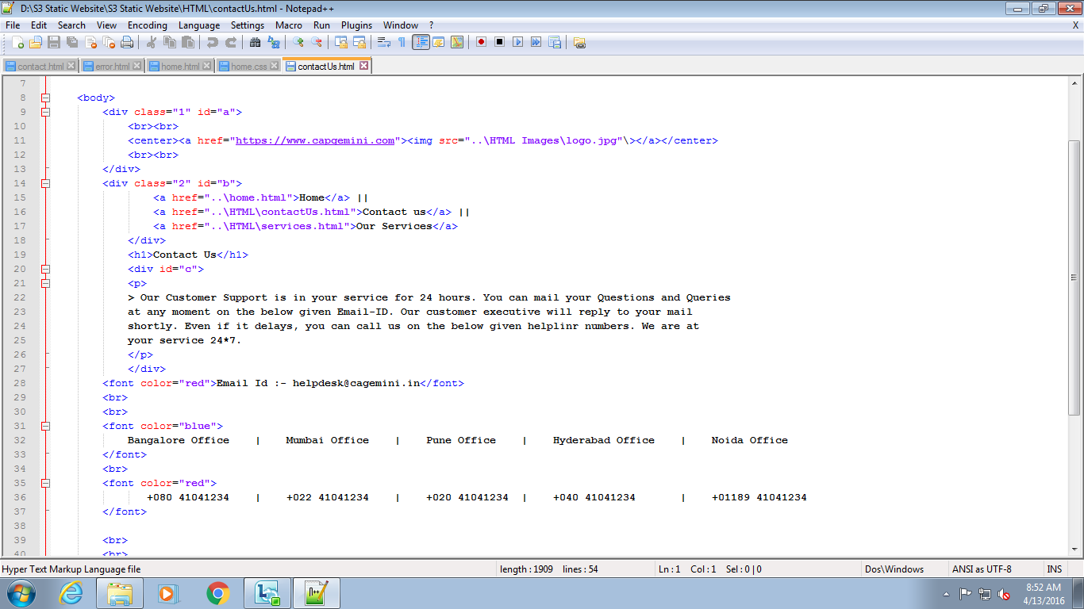

Figure 2:About us page

Step3: This page contains Services provided by the company.

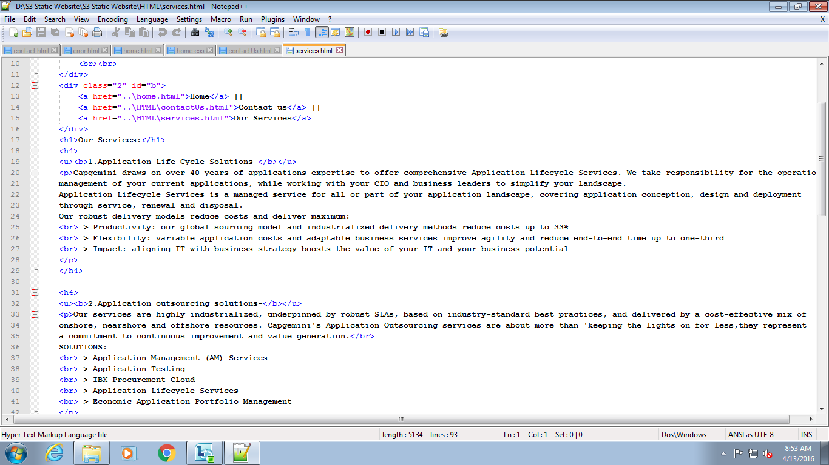

Figure: 3 Service page

Step4: CSS layout.

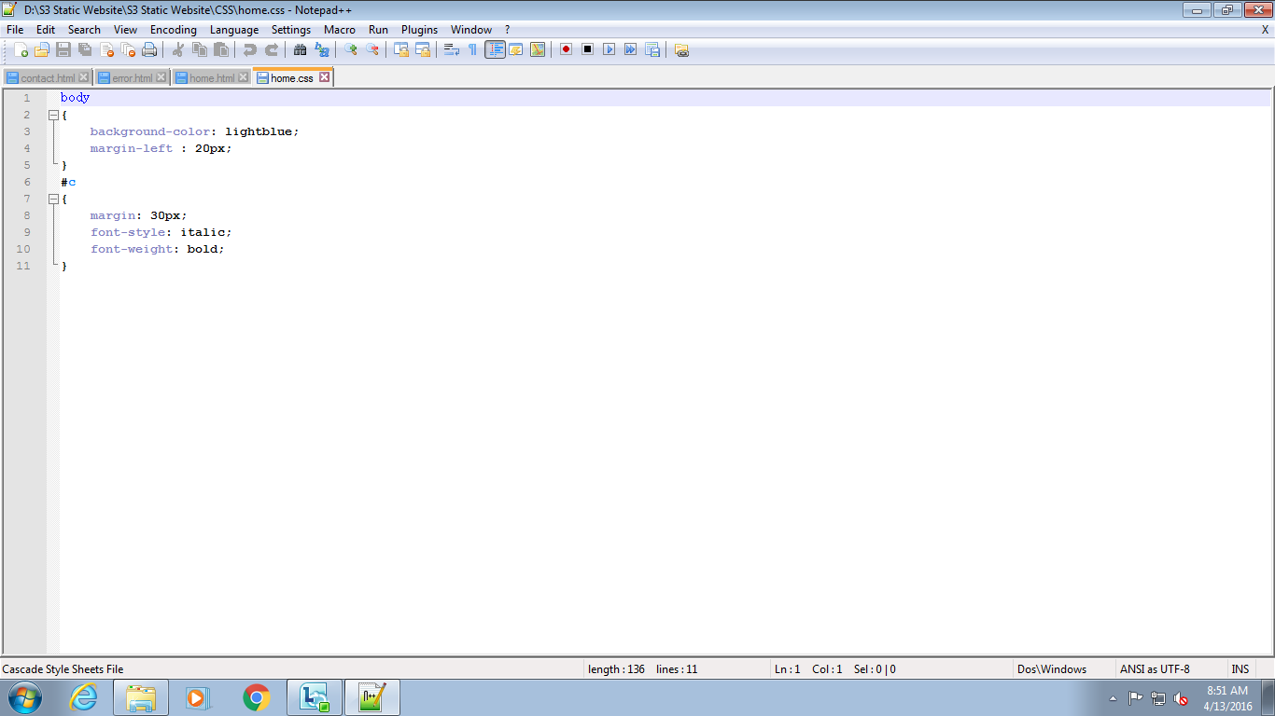

Figure 4: CSS file

Step5: Error page,in case of any error this page will display.

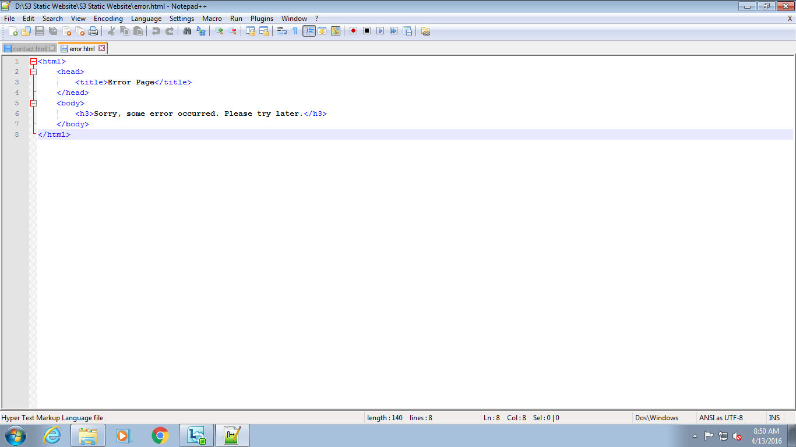

Figure 5:Error page

Step6: create a structure for static website.

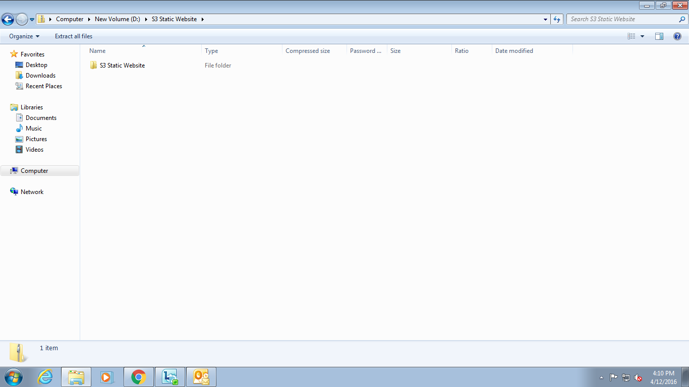

Figure6: S3 static website folder

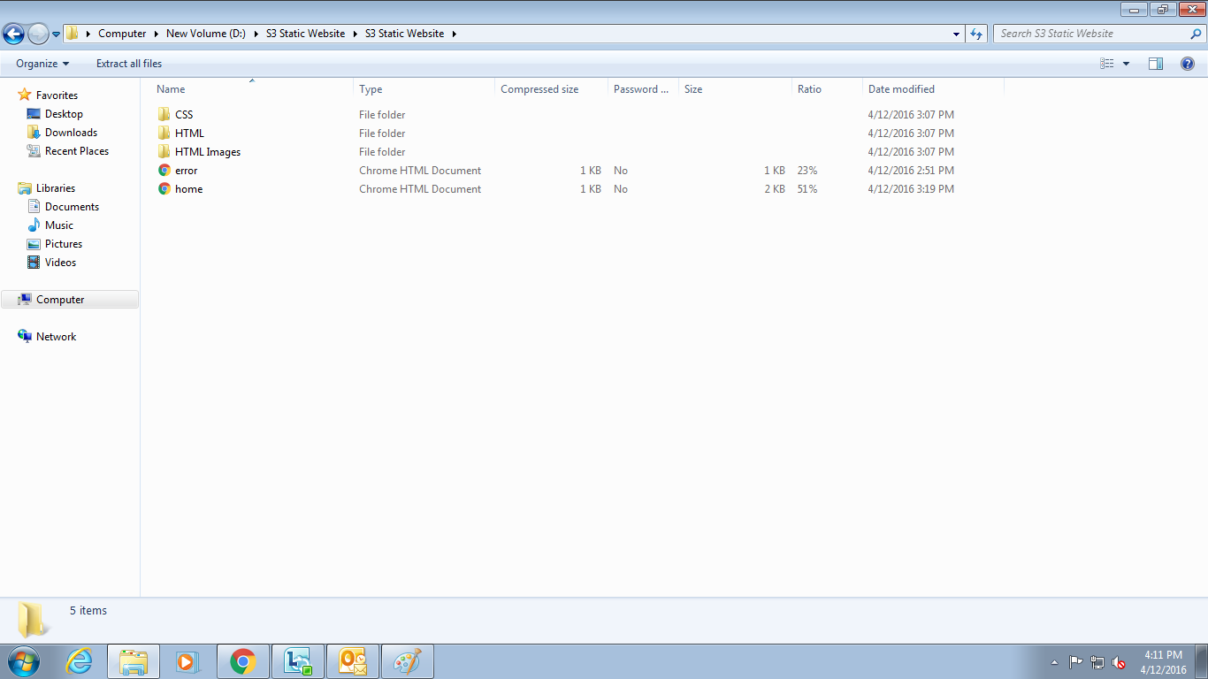

Figure 7: Sub folders contains respective files

Migrating Static Website on Cloud through S3

First step is to create an account on AWS so that we can access services provided by AWS . The access is secure and user friendly.

Step1: Select S3 from Management Console.

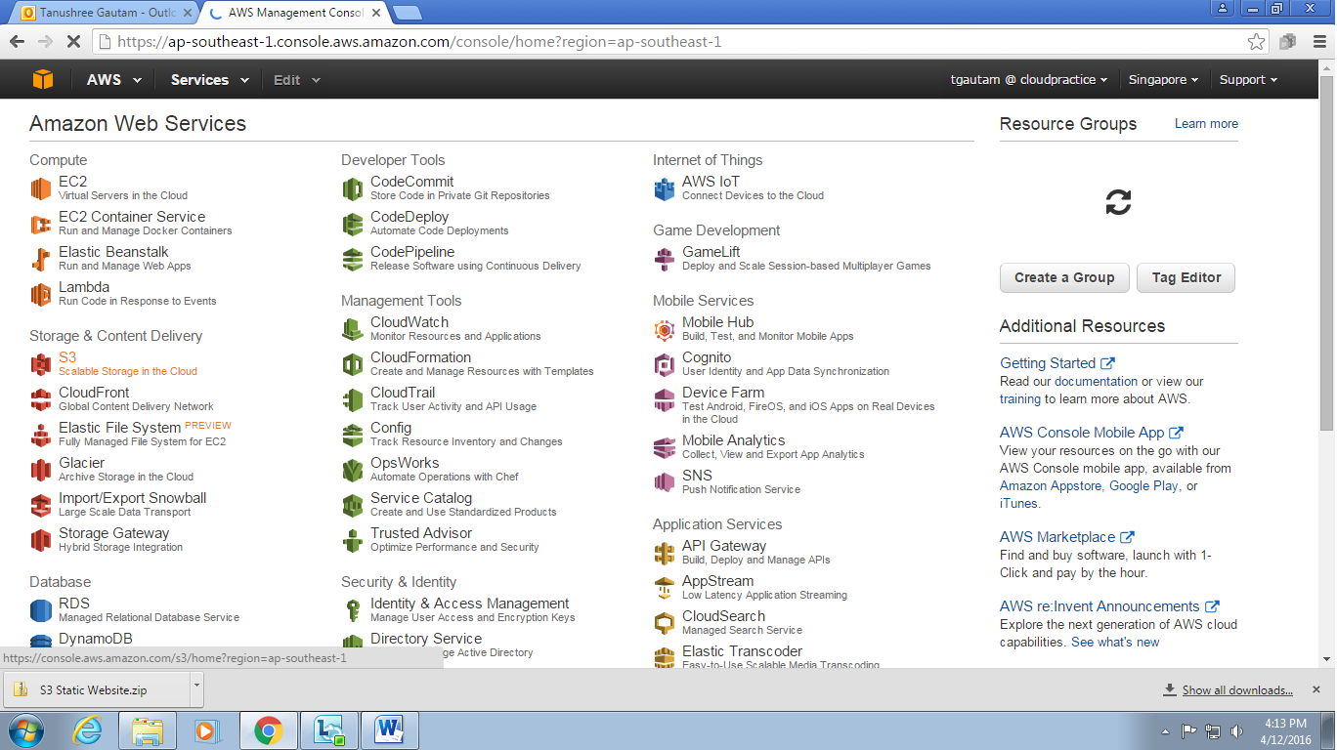

Step2: Create S3 bucket with appropriate name.

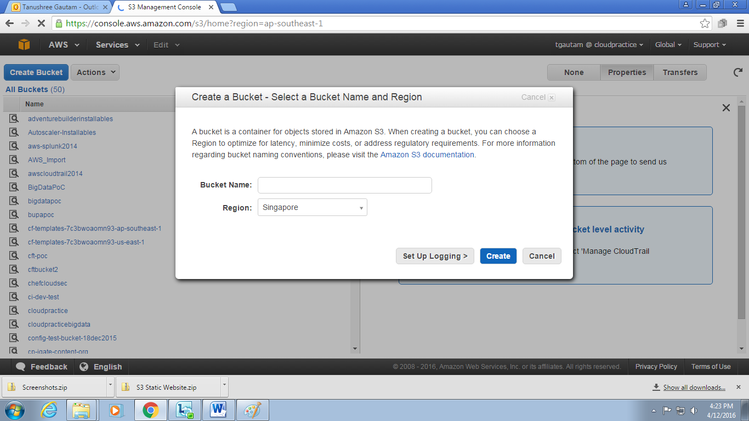

Step3: Upload all folders or files used for static website.

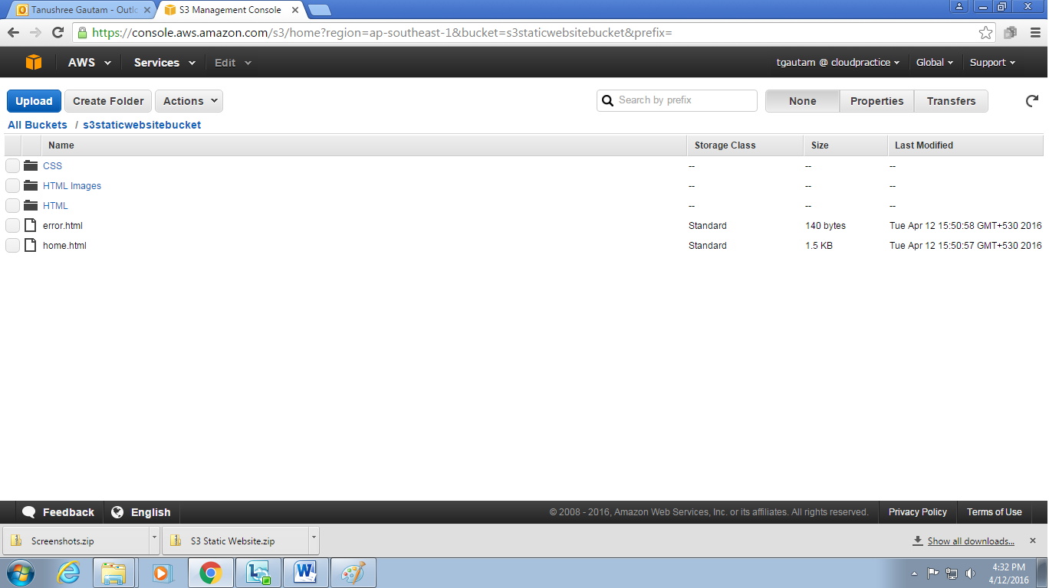

Step4: Make all uploaded folders public.

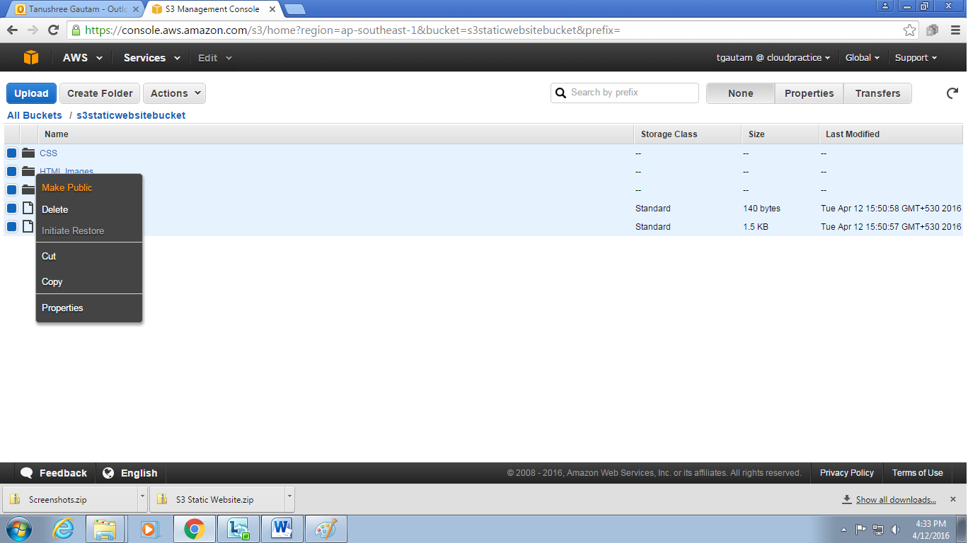

Step5: Enable Website Hosting and add index page and error page of the website.

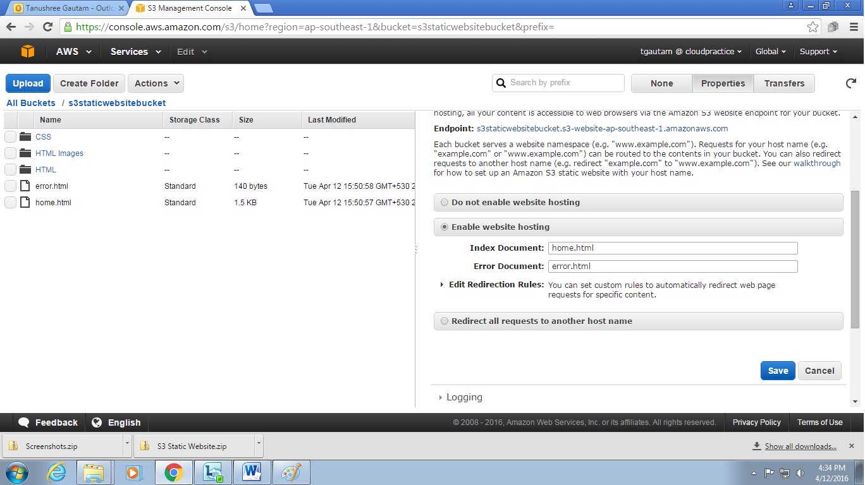

Step6: Open generated URL “http://s3staticwebsitebucket.s3-website-ap-southeast-1.amazonaws.com/ “ into new tab.



Step7: Delete the bucket after completing task.