PeachTrack — Milestone 8
Test Plan Sheet Screenshots (Evidence)
Tester: Sumit Niveriya

1. Test ID: PT-M8-01 — Start Shift (Employee) — Active status + timer
Screenshot 2026-03-06 at 3.35.18 PM.png
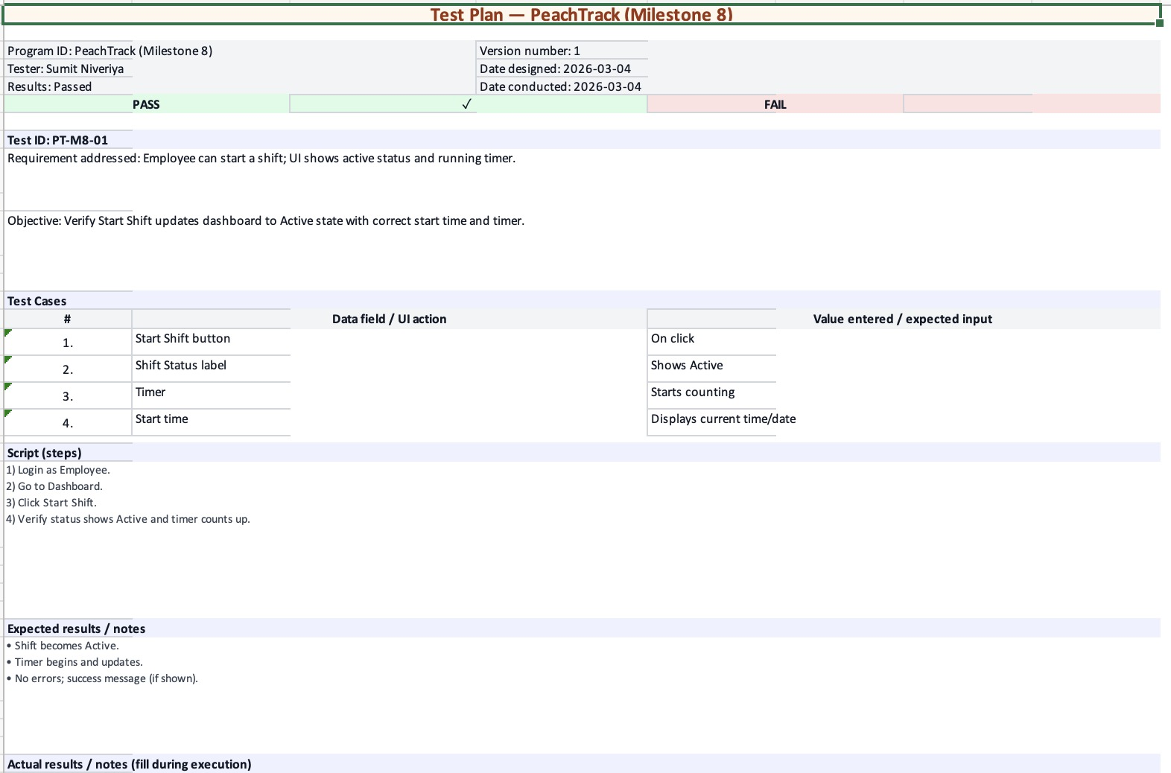

2. Test ID: PT-M8-02 — Log Tip (Cash) — Tip amount + sales amount + success confirmation
Screenshot 2026-03-06 at 3.35.25 PM.png
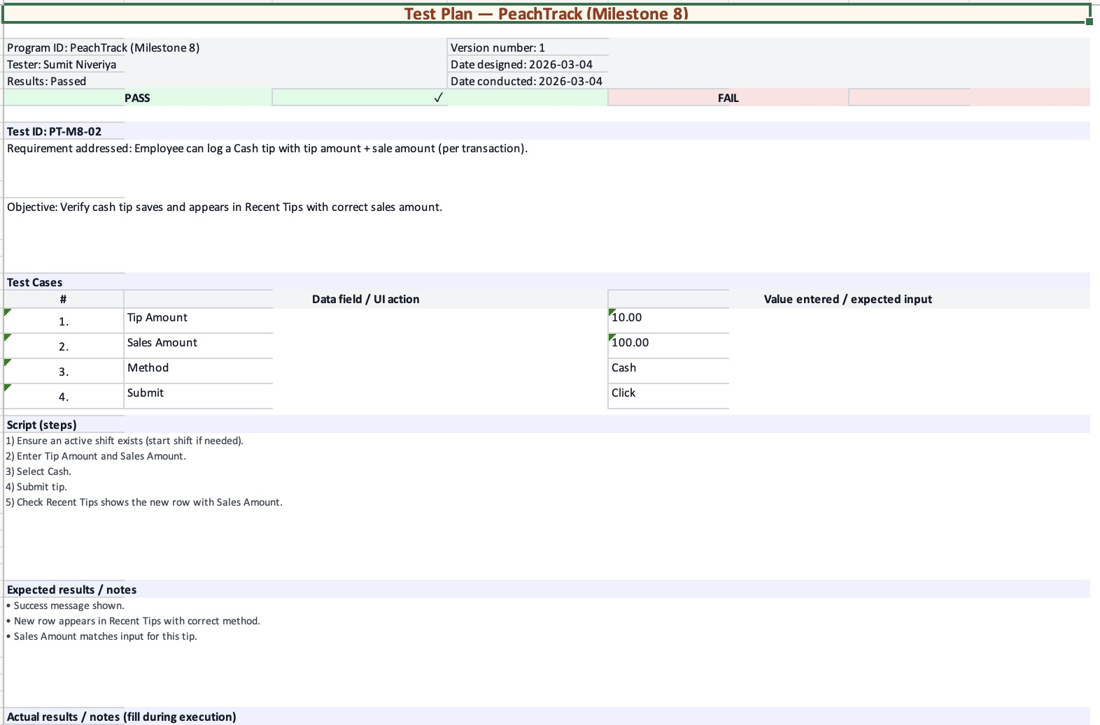

3. Test ID: PT-M8-03 — Log Tip (Electronic) — Tip amount + sales amount + success confirmation
Screenshot 2026-03-06 at 3.35.30 PM.png
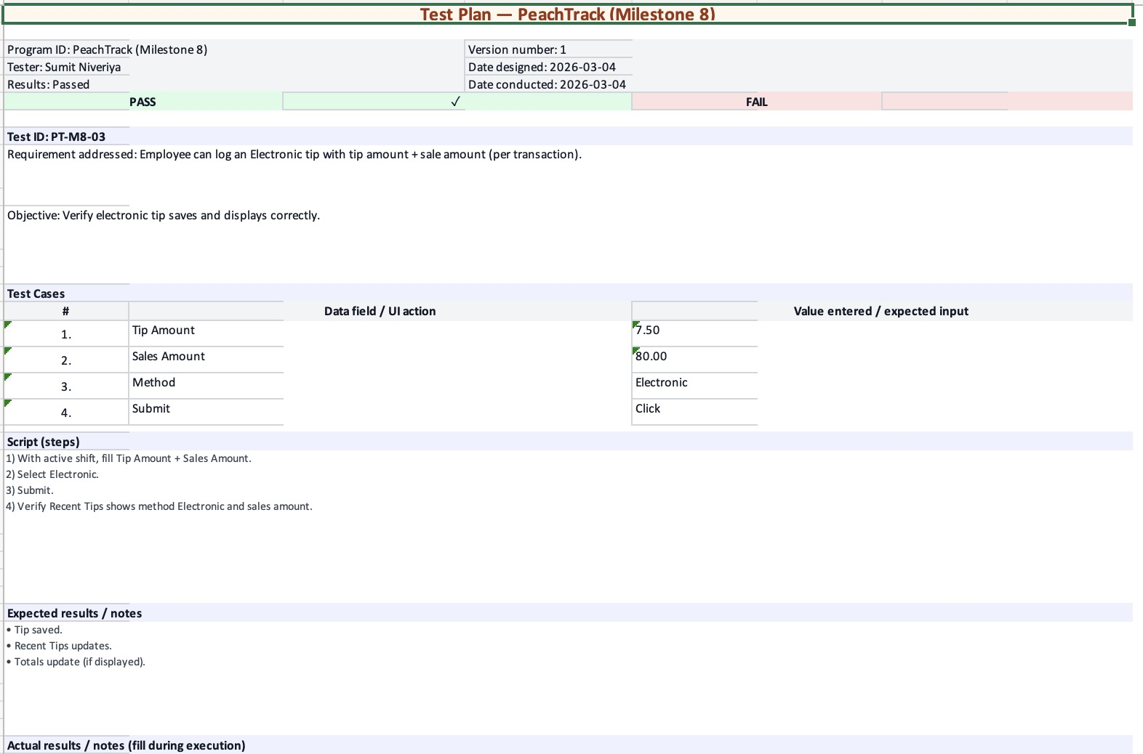

4. Test ID: PT-M8-04 — End Shift — Summary totals shown
Screenshot 2026-03-06 at 3.35.34 PM.png
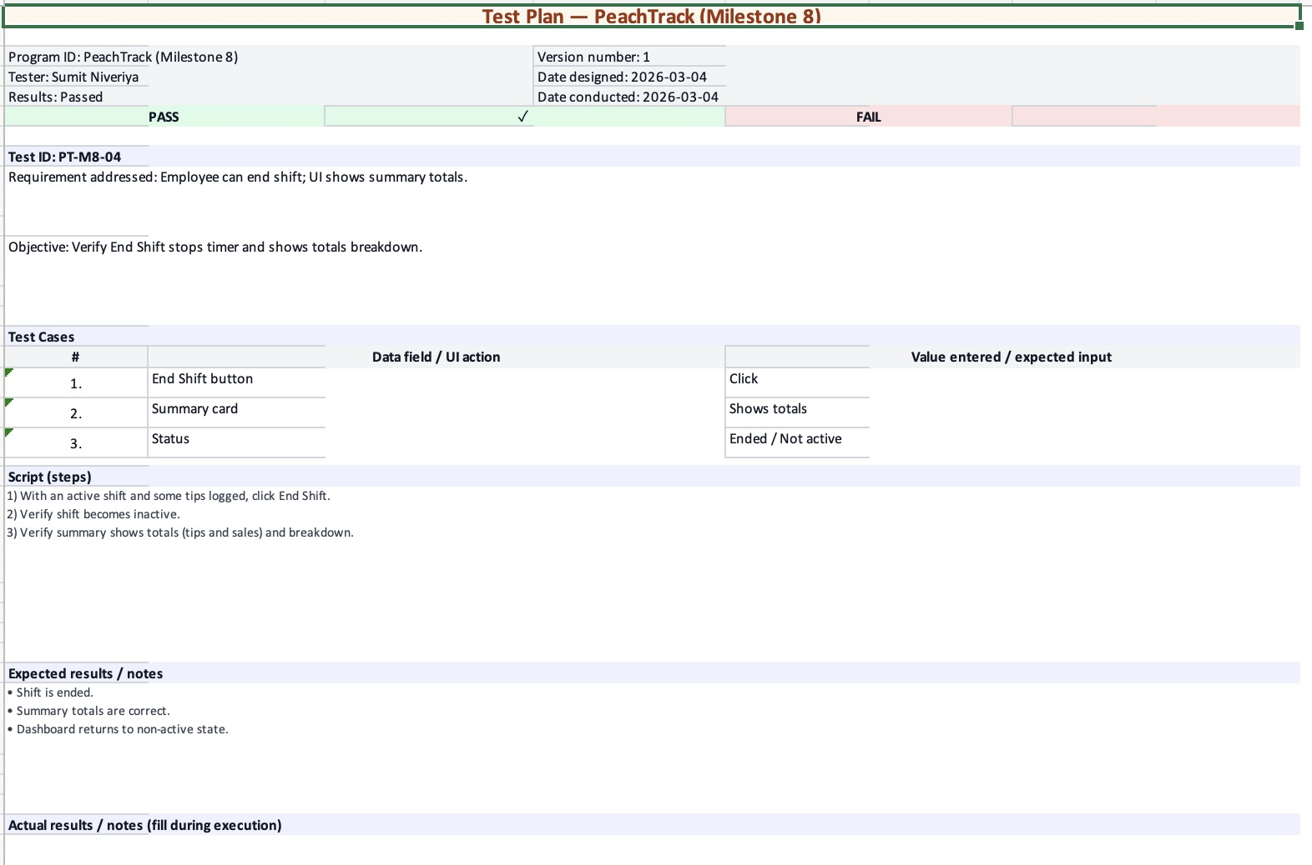

5. Test ID: PT-M8-05 — My Shifts — Shift history table + charts
Screenshot 2026-03-06 at 3.35.38 PM.png
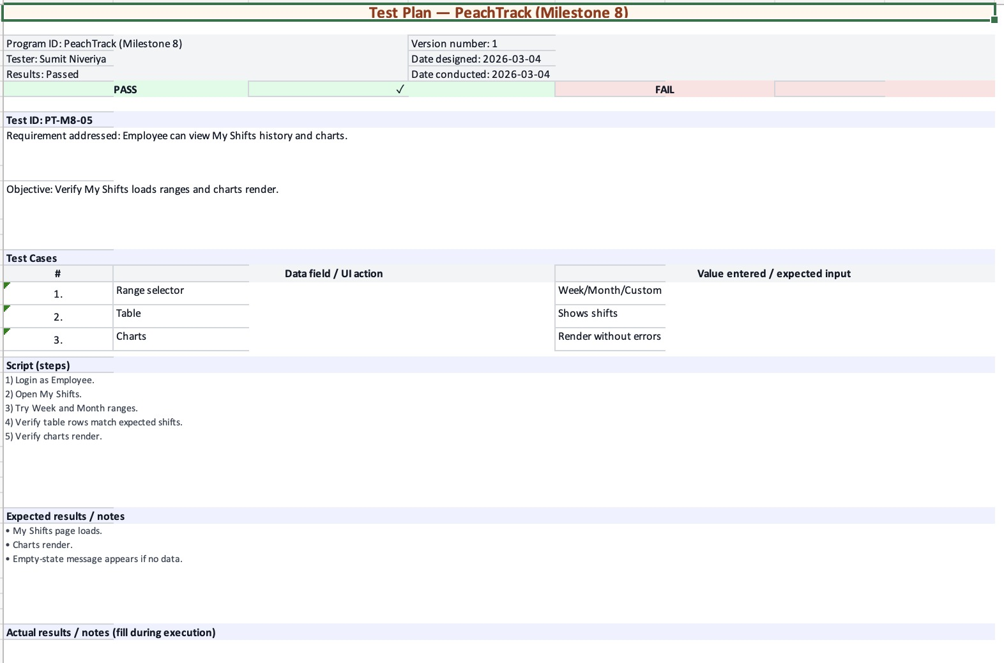

6. Test ID: PT-M8-06 — Reports (Admin) — Date range filters + charts/tables
Screenshot 2026-03-06 at 3.35.41 PM.png
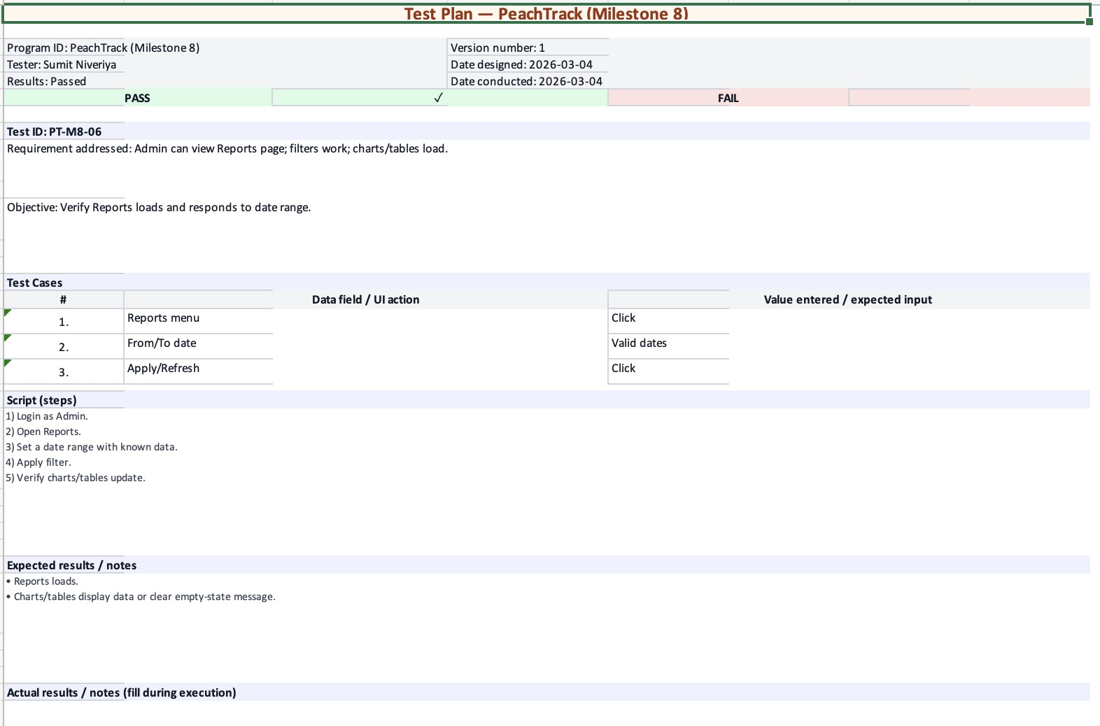

7. Test ID: PT-M8-07 — Payroll (Admin) — Totals + CSV export
Screenshot 2026-03-06 at 3.35.44 PM.png
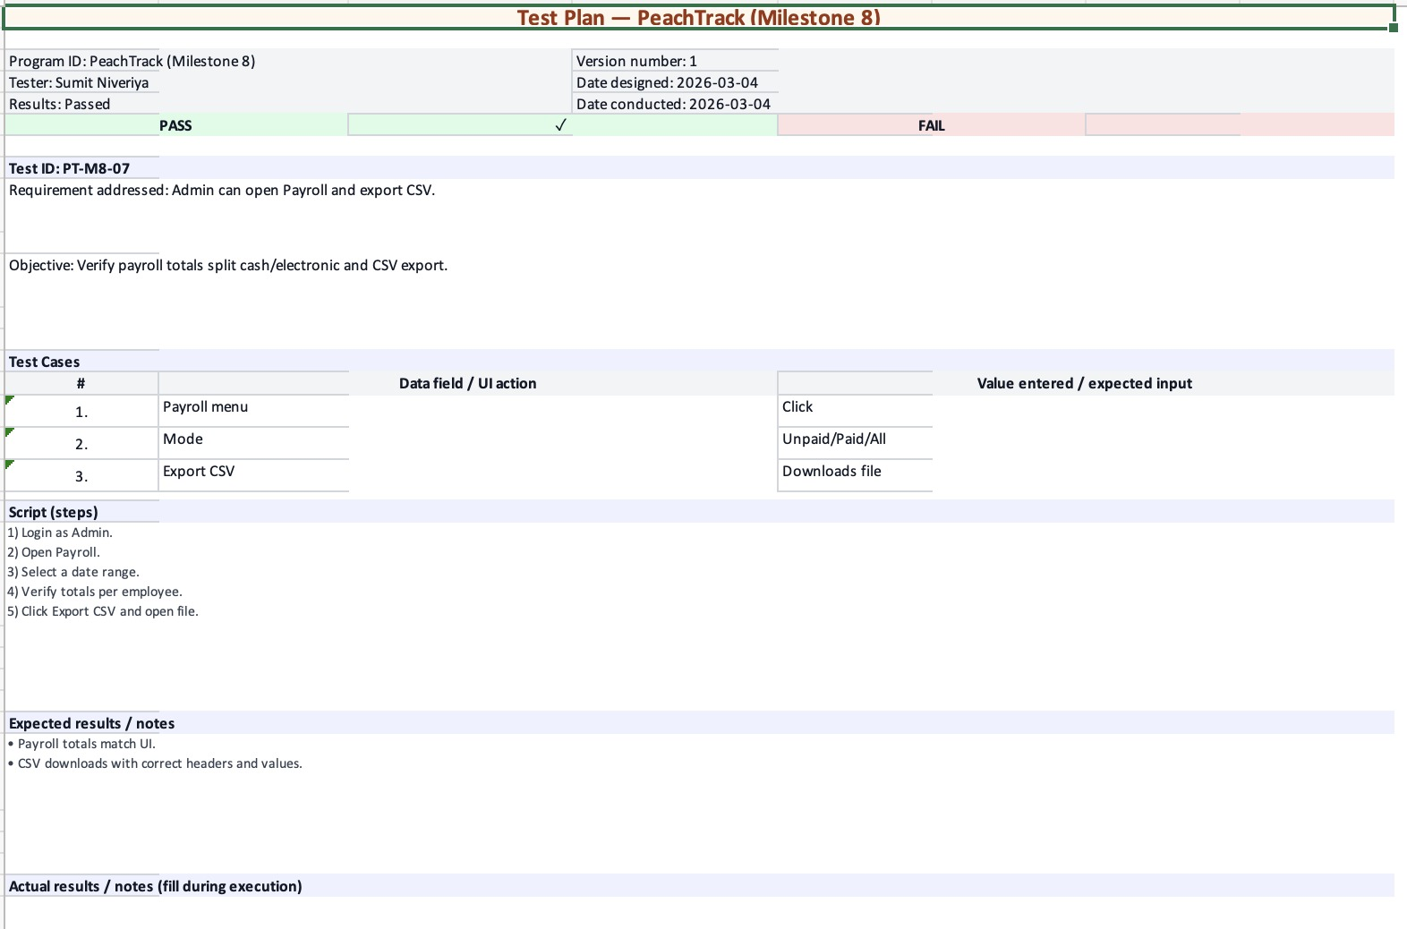

8. Test ID: PT-M8-08 — Payroll — Mark Paid behavior + Paid mode (no Pay button)
Screenshot 2026-03-06 at 3.35.54 PM.png
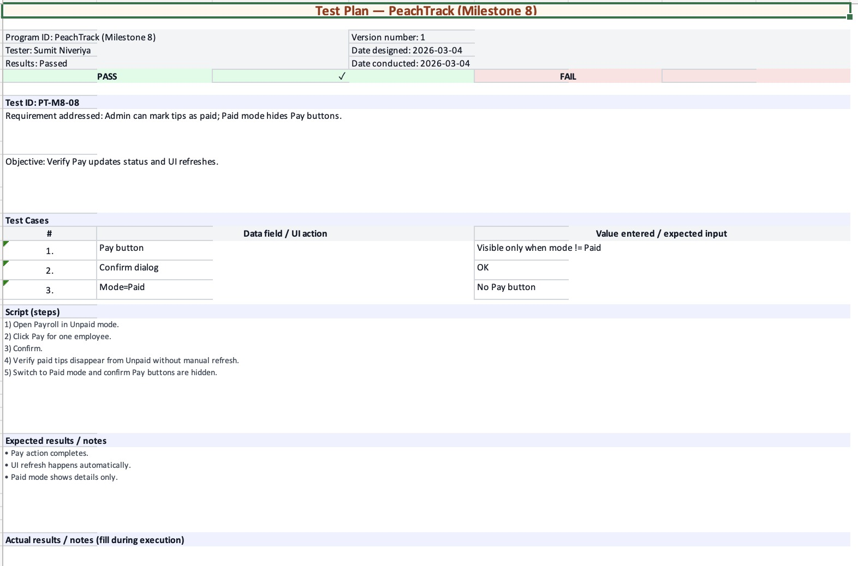

9. Test ID: PT-M8-09 — Manage Shifts (Admin) — Active shifts + Force End
Screenshot 2026-03-06 at 3.36.10 PM.png
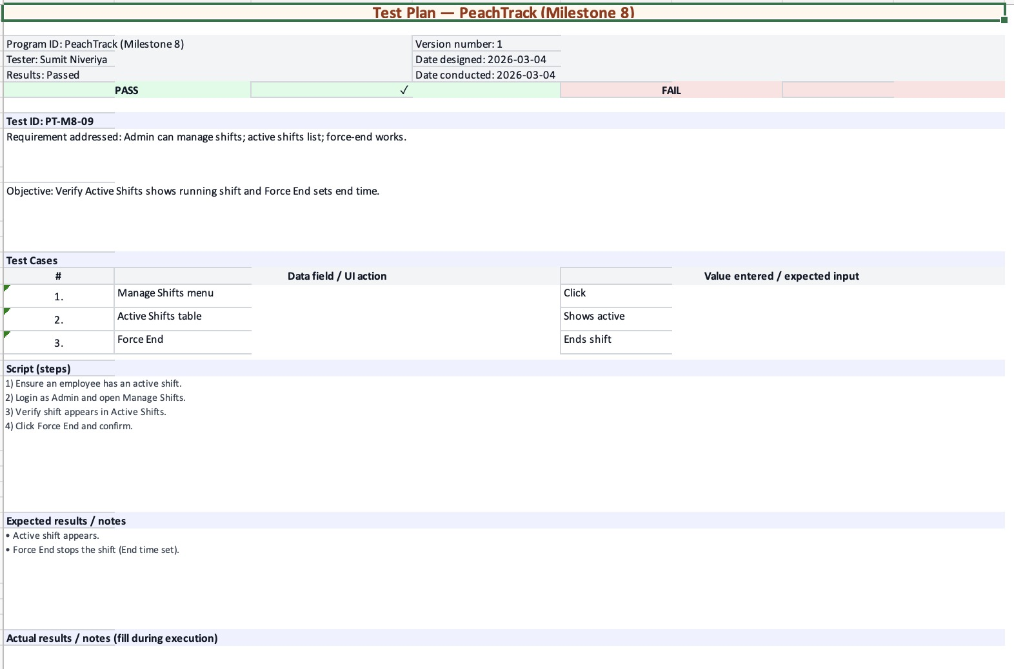

10. Test ID: PT-M8-10 — Edit Shift (Admin) — Edit transaction (tip + sale) + delete tip
Screenshot 2026-03-06 at 3.36.17 PM.png
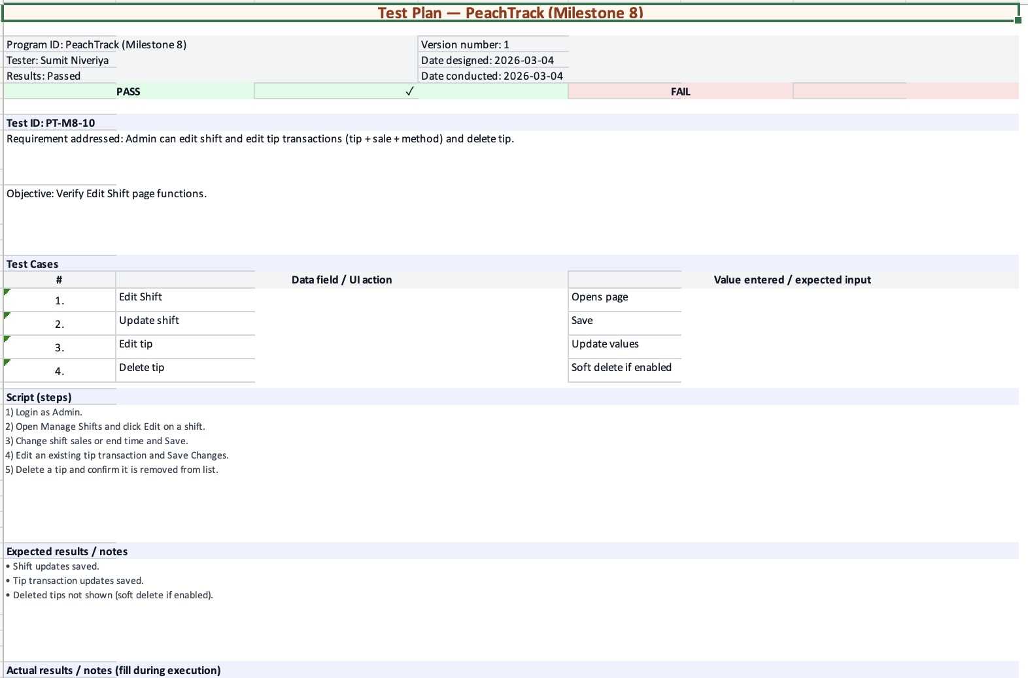

11. Test ID: PT-M8-11 — Employee Mode (Admin) — View as employee while keeping admin name
Screenshot 2026-03-06 at 3.36.29 PM.png
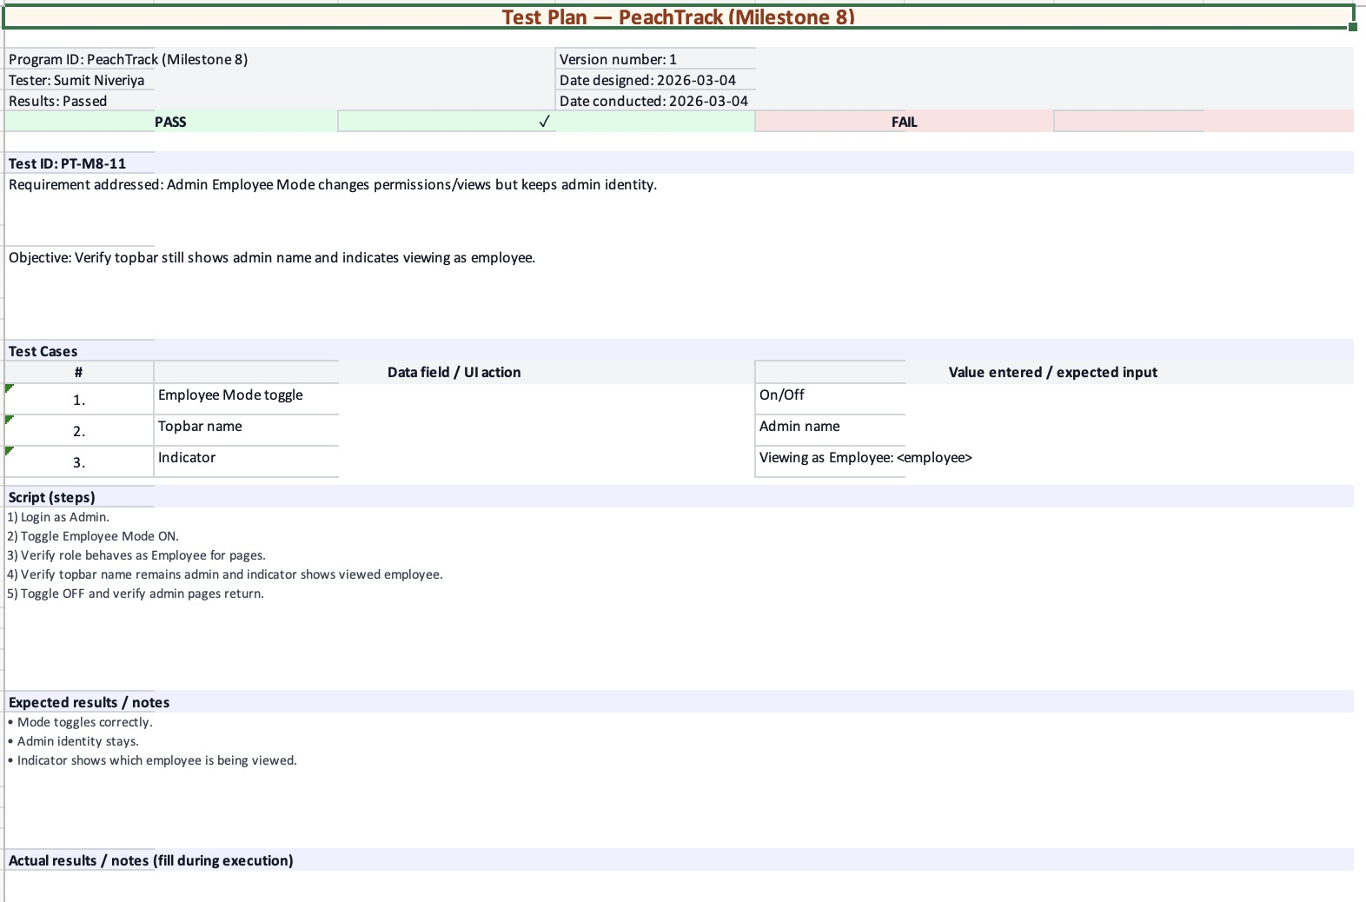

12. Test ID: PT-M8-12 — Audit visibility — Employee can see “Edited” shifts (who/when/note)
Screenshot 2026-03-06 at 3.36.36 PM.png
