PeachTrack — Milestone 8 Testing Screenshots
Tester: Sumit Niveriya

1. Test ID: PT-M8-01 — Admin Dashboard (initial view)
File: 01_admin_dashboard.png
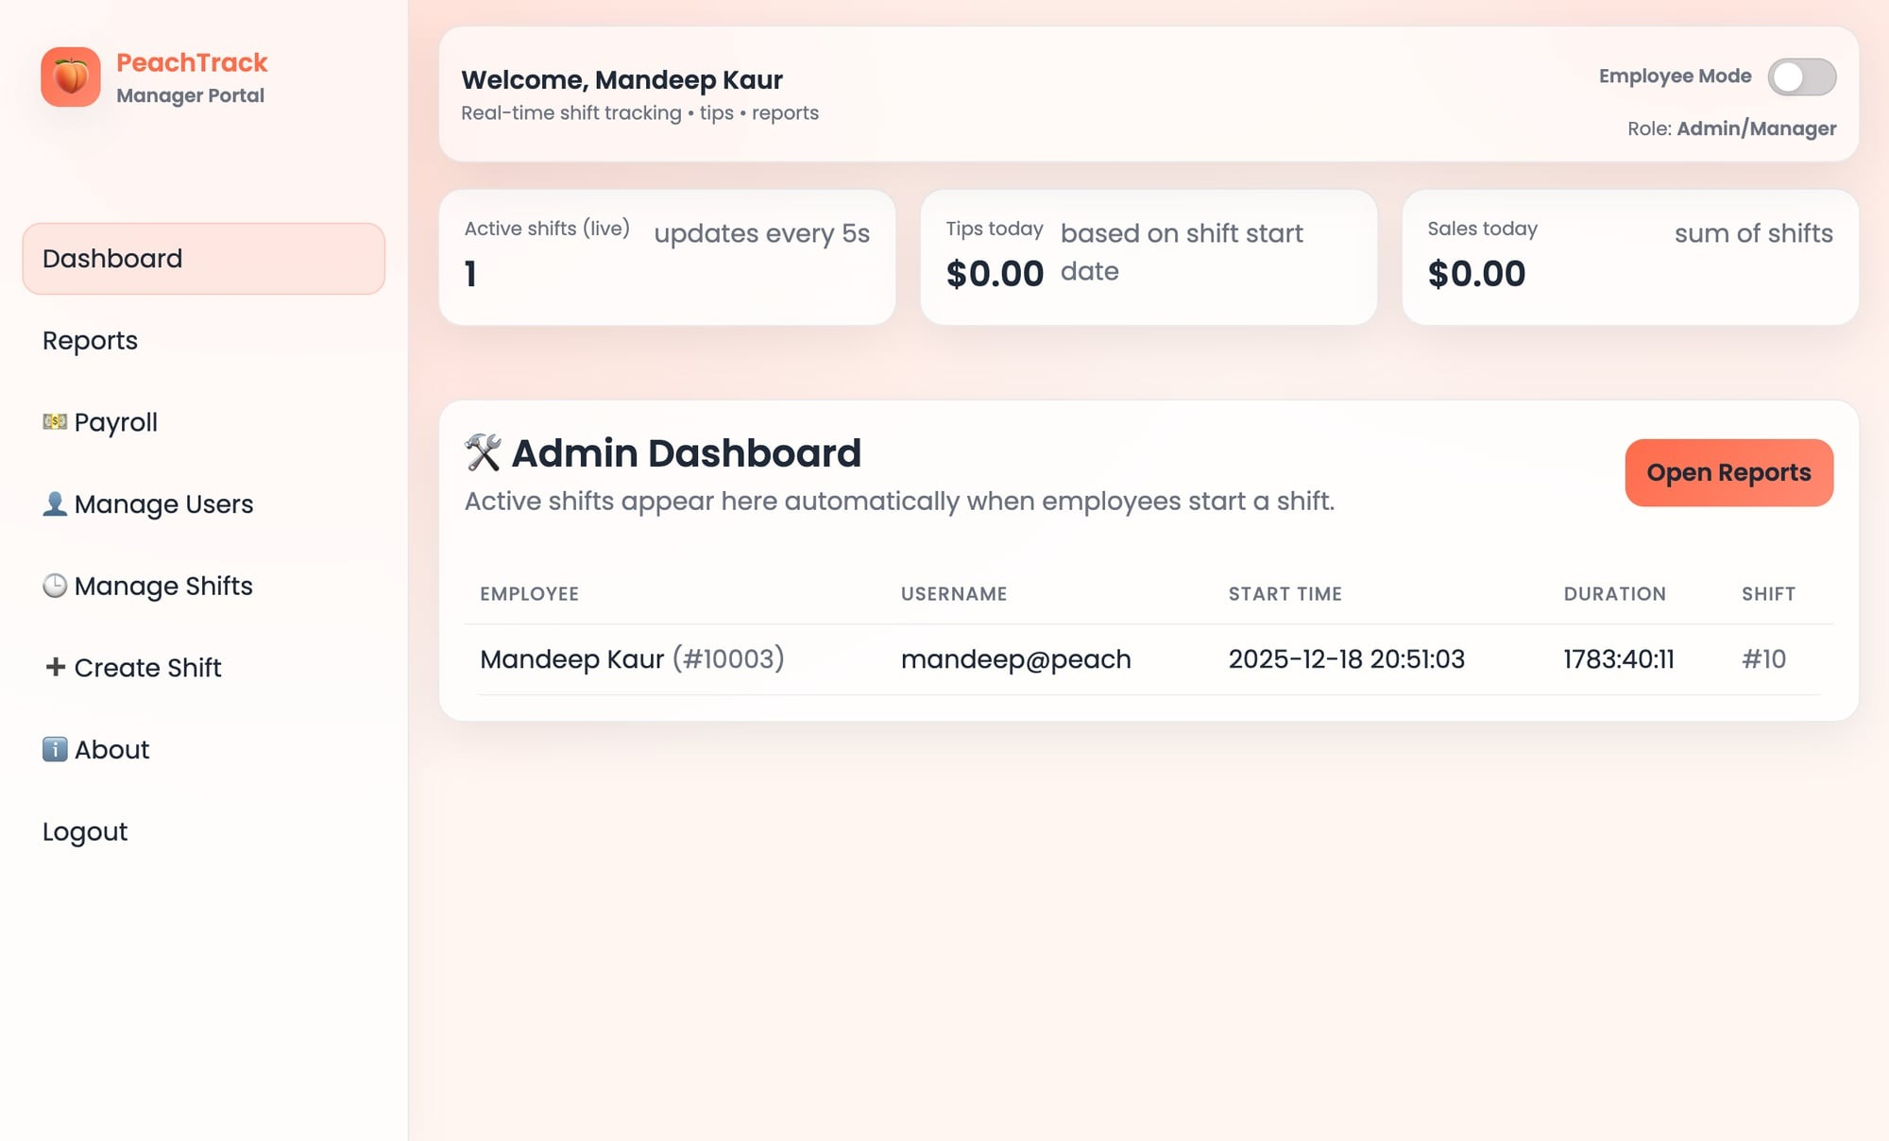

2. Test ID: PT-M8-06 — Reports page layout + charts area / empty-state messaging
File: 02_reports_fullpage.png
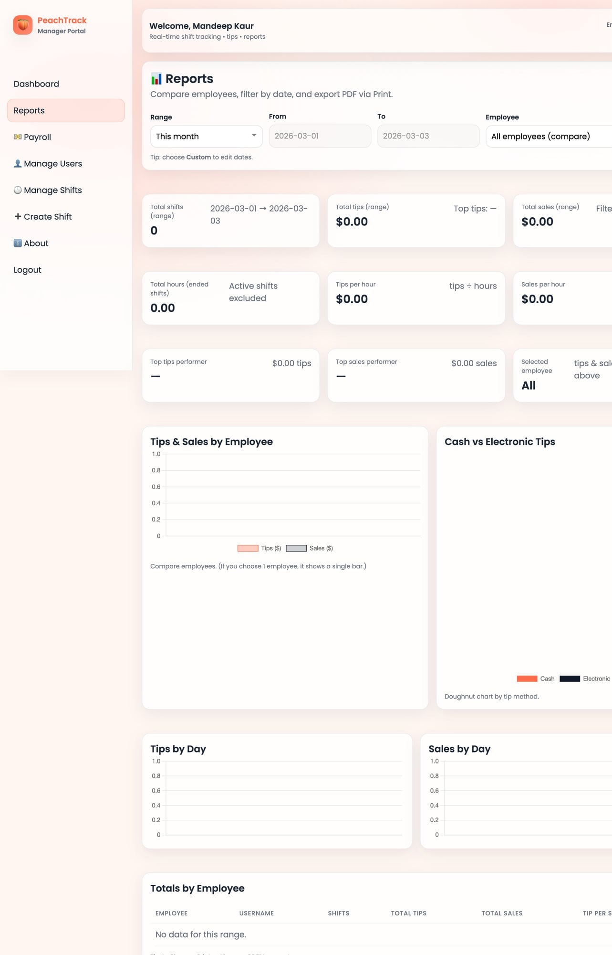

3. Test ID: PT-M8-02 — Employee Dashboard: Log Tip form (labels, inputs)
File: 03_employee_dashboard_log_tip.png
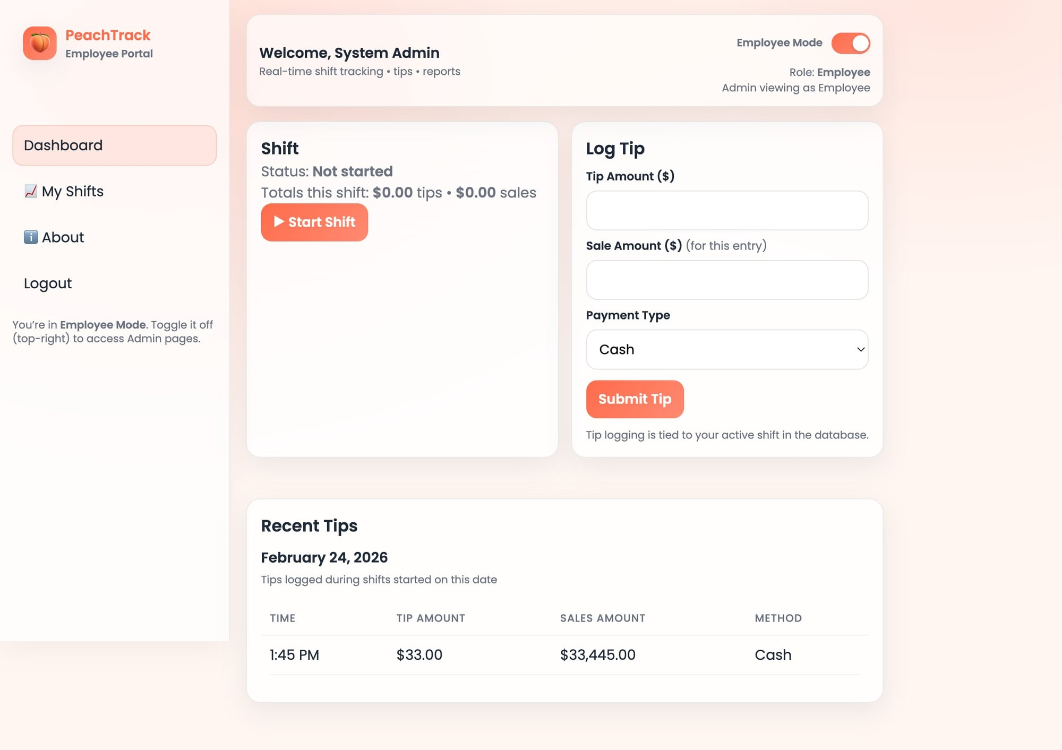

4. Test ID: PT-M8-01 — Employee Shift started: Active status + timer
File: 04_employee_shift_started.png
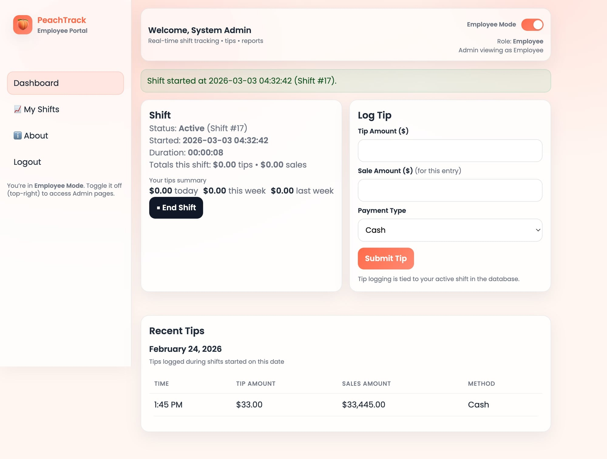

5. Test ID: PT-M8-02 — Tip submitted (Cash): success message + Recent Tips updated
File: 05_employee_tip_submitted_cash.png
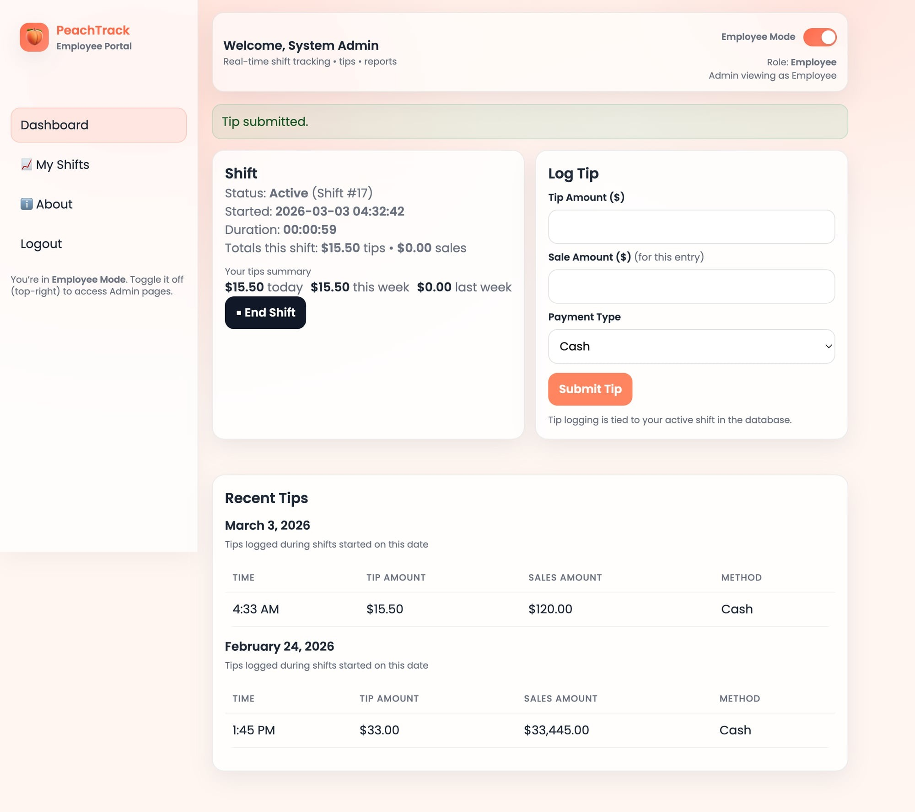

6. Test ID: PT-M8-03 — Tip submitted (Electronic): success message + Recent Tips updated
File: 06_employee_tip_submitted_electronic.png
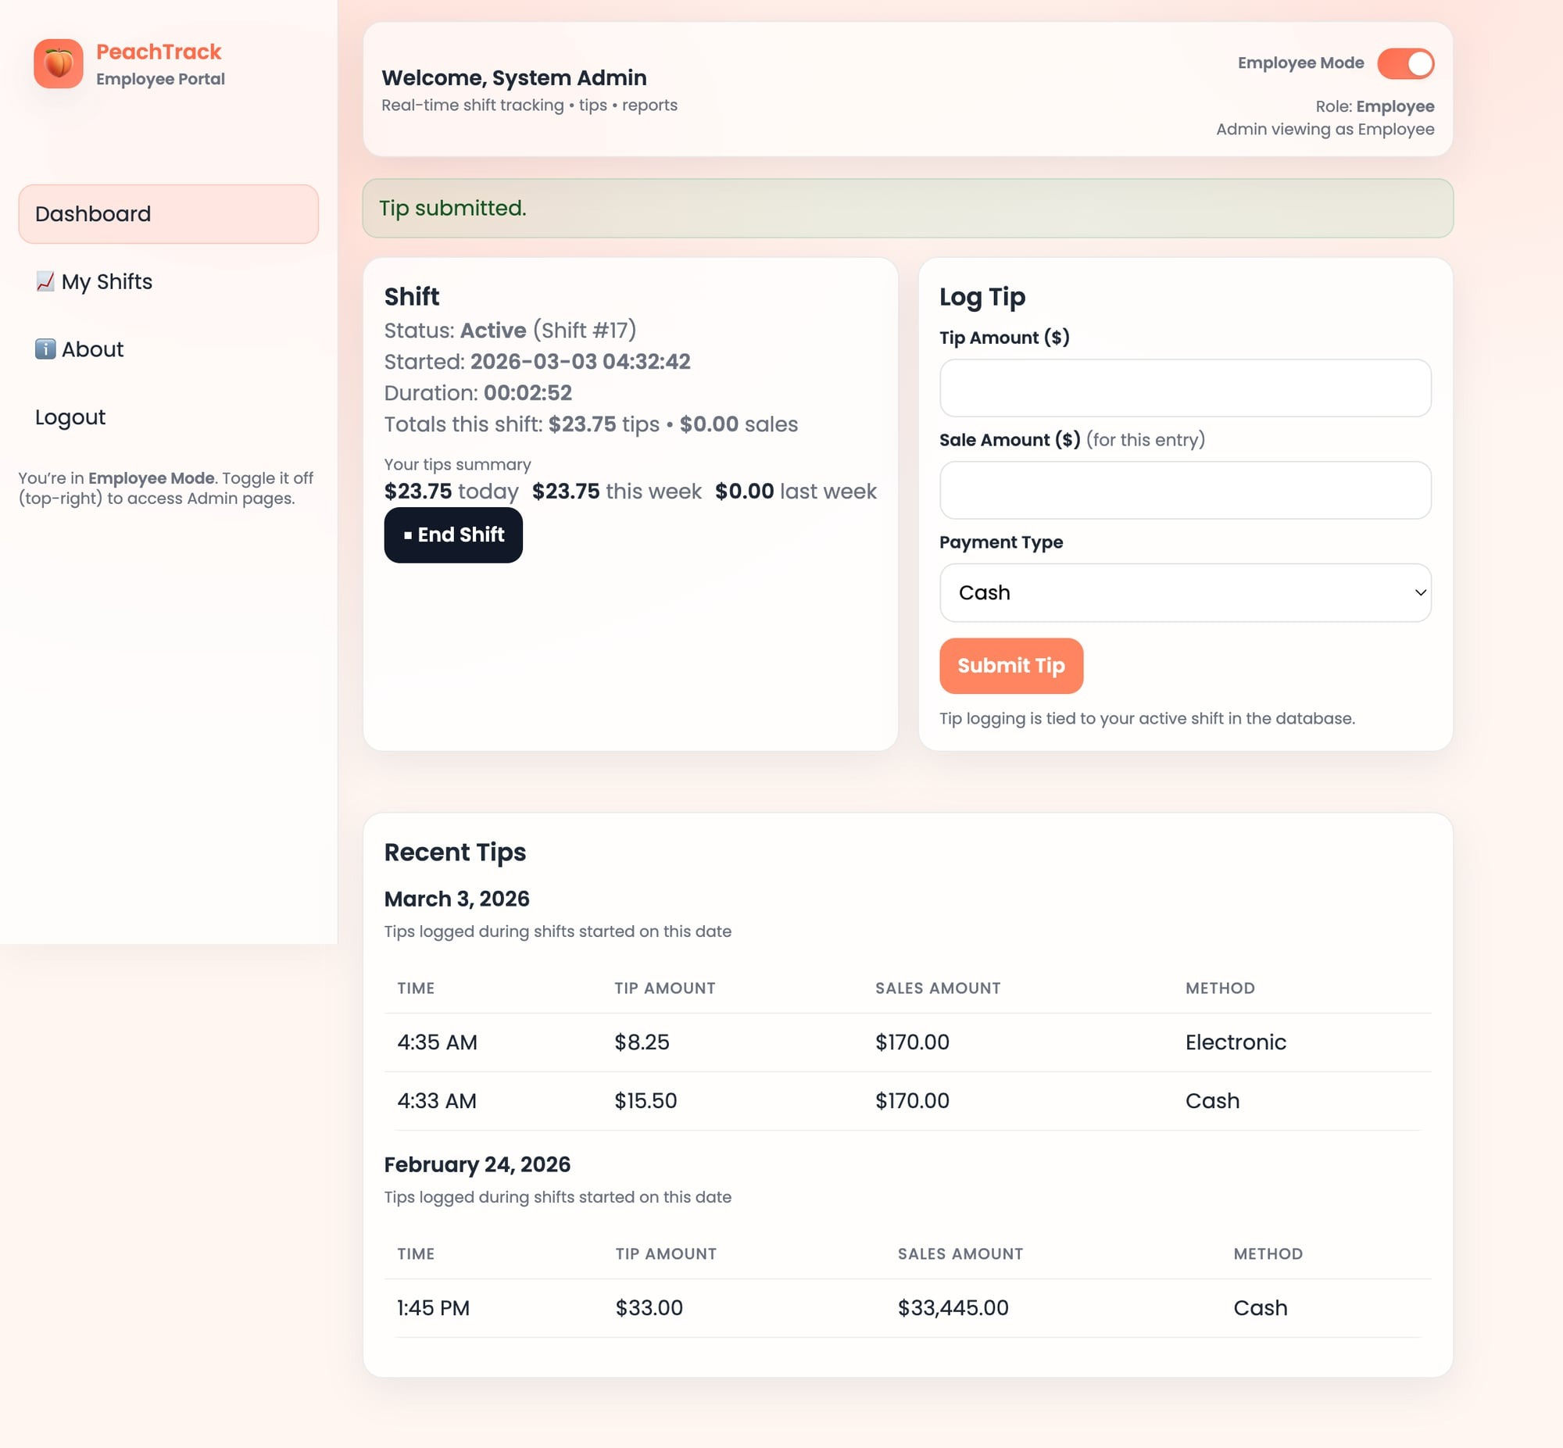

7. Test ID: PT-M8-05 — My Shifts: table + charts rendered
File: 07_employee_my_shifts_with_charts.png
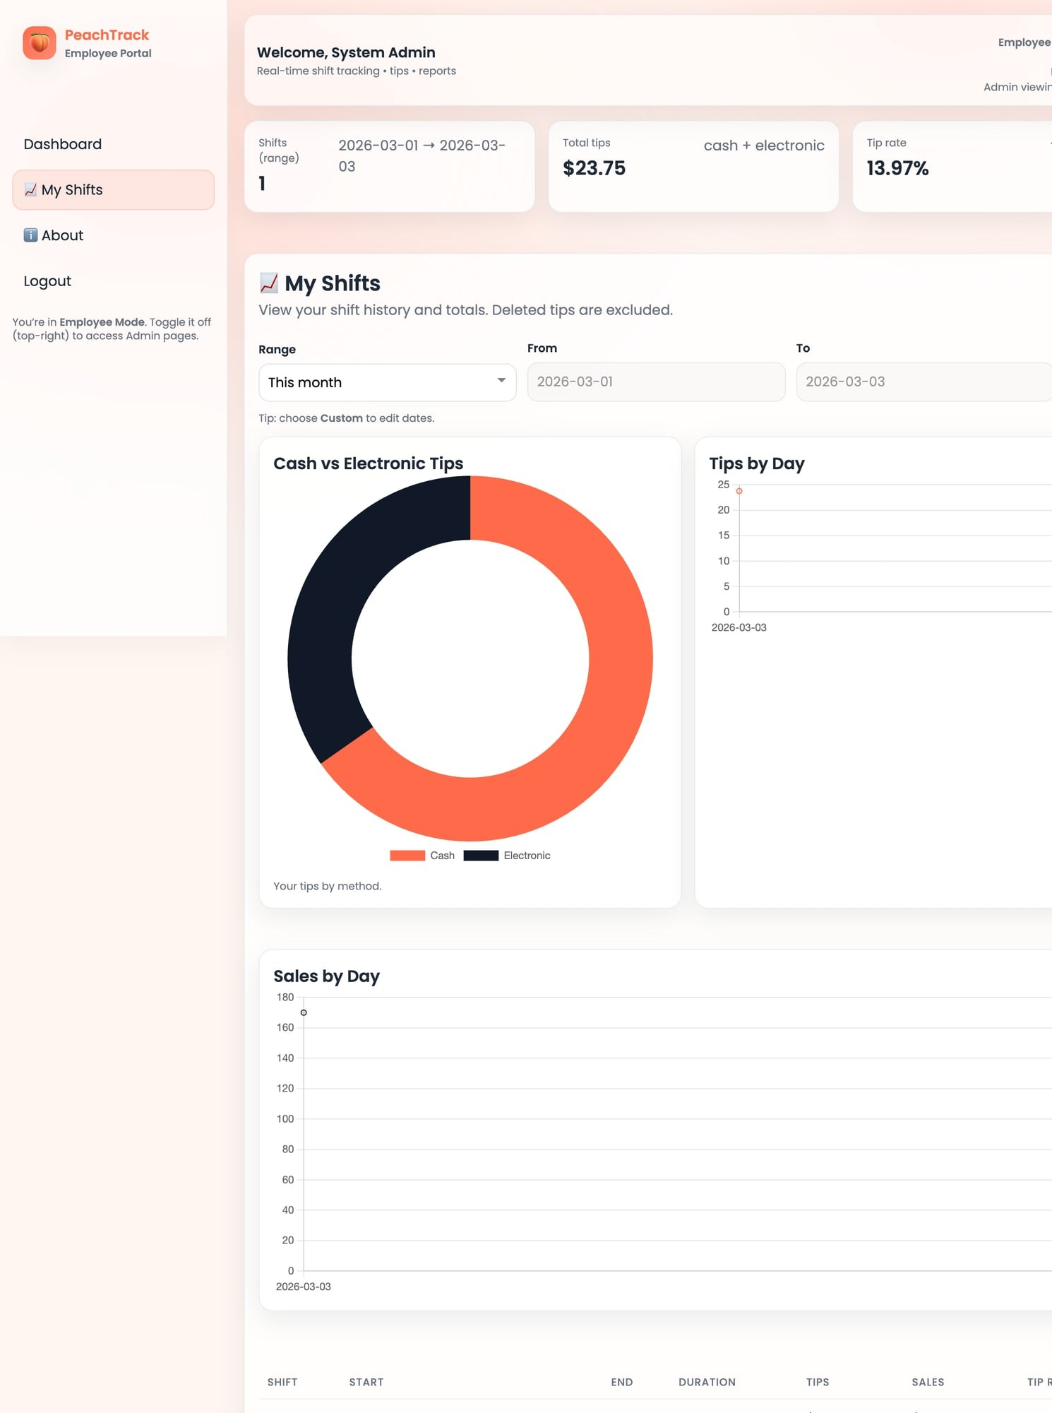

8. Test ID: PT-M8-04 — End Shift: summary/totals shown
File: 08_employee_shift_ended_summary.png
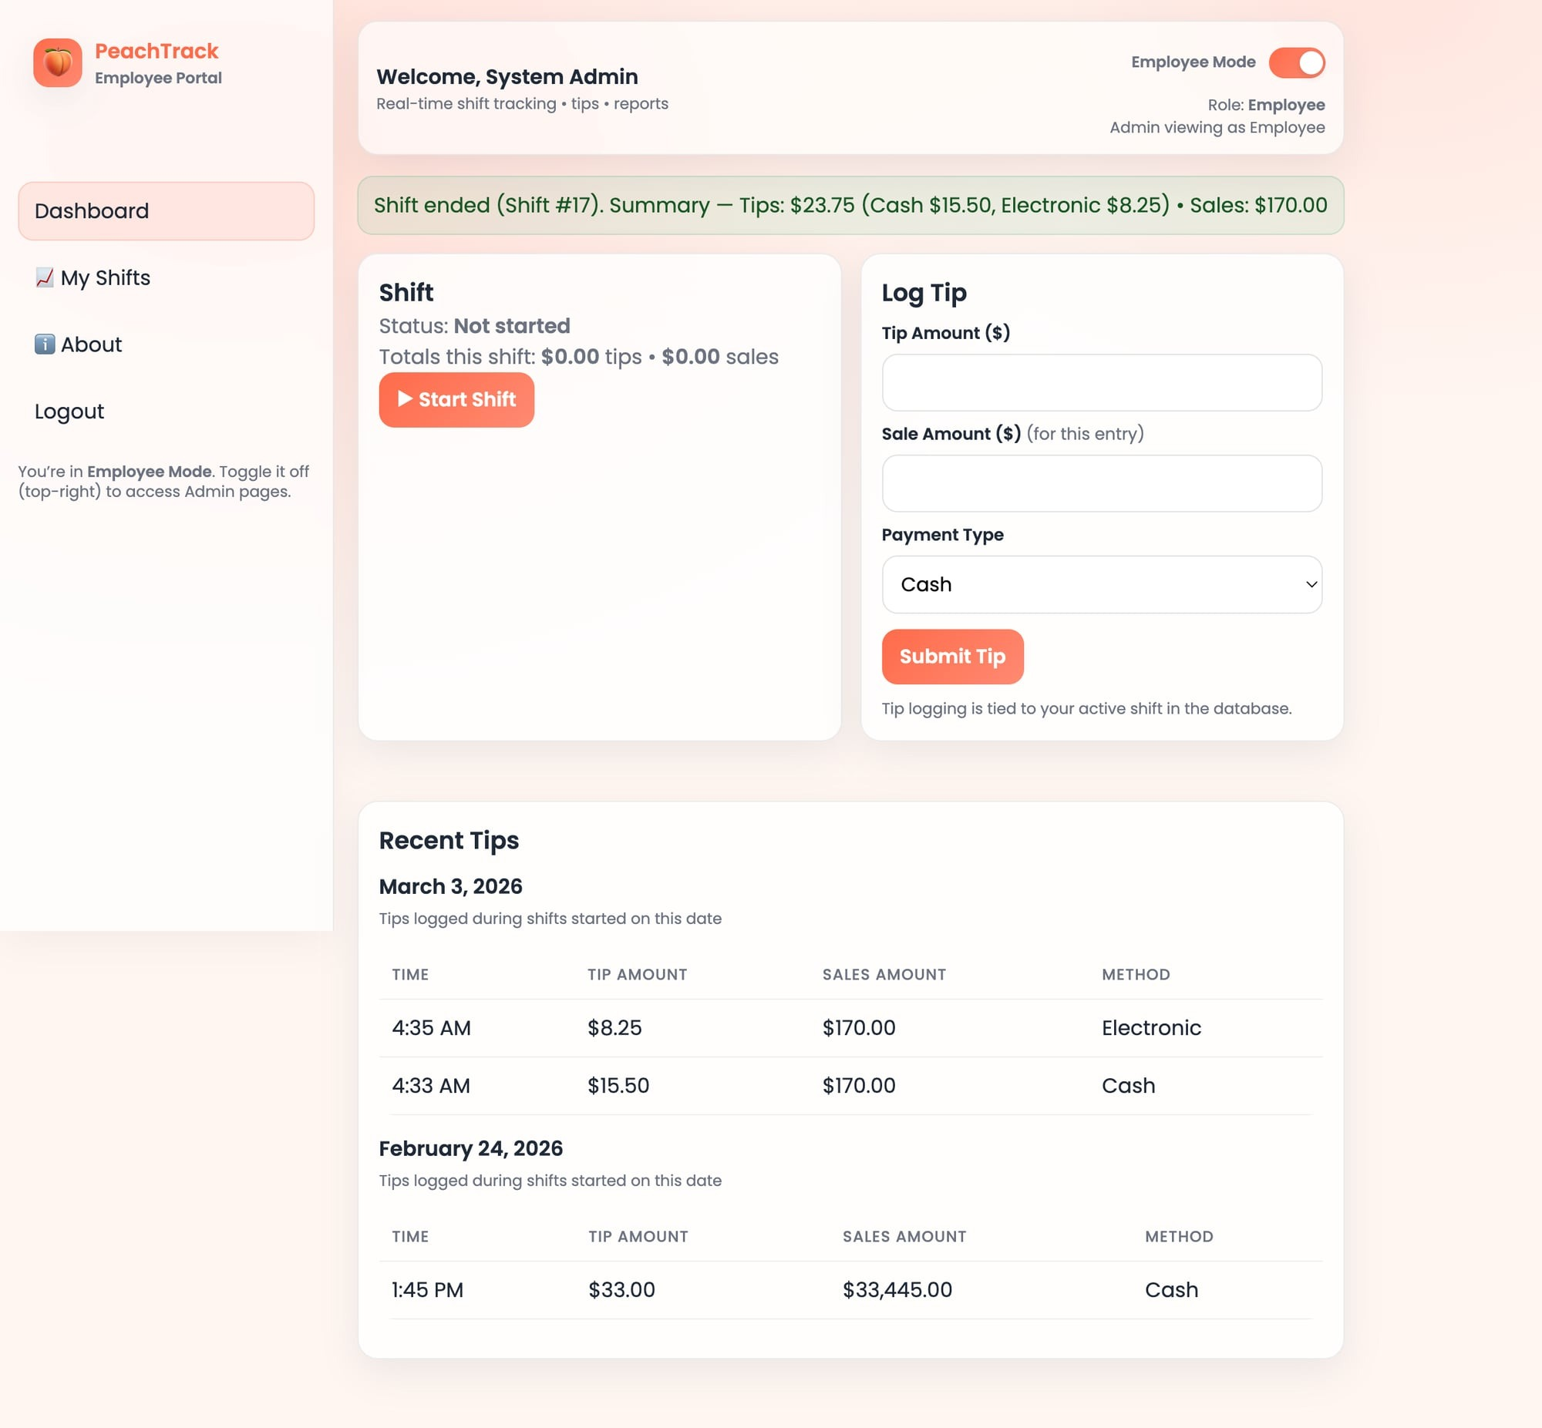

9. Test ID: PT-M8-01/07 — Admin Dashboard totals updated after employee activity
File: 09_admin_dashboard_updated_totals.png
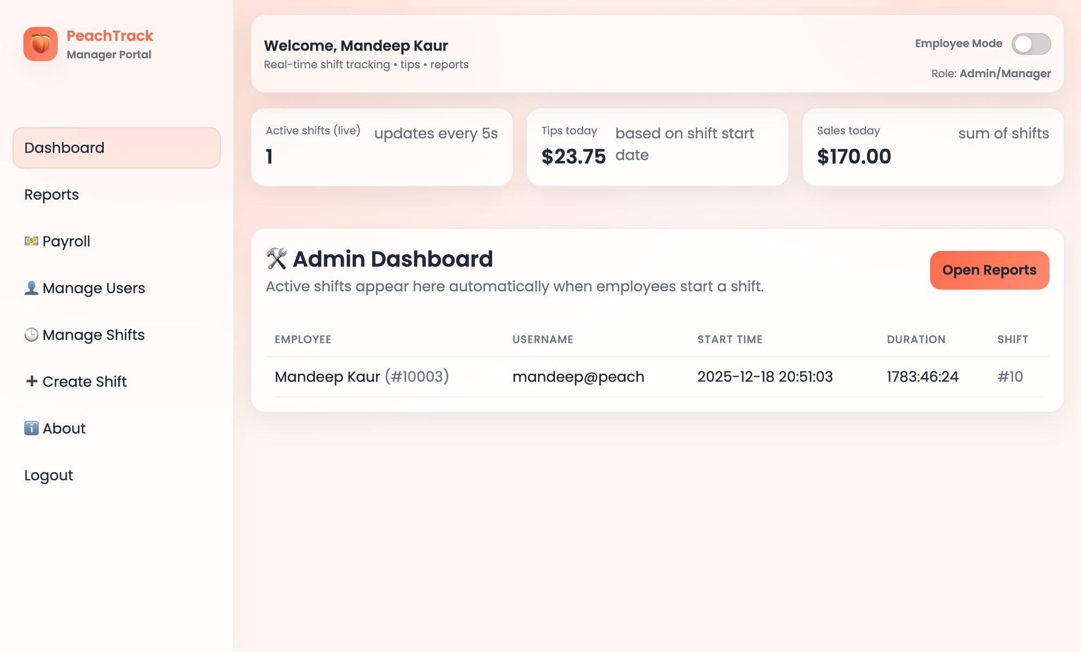

10. Test ID: PT-M8-07 — Payroll totals (Unpaid) + export option
File: 10_admin_payroll_totals_unpaid.png
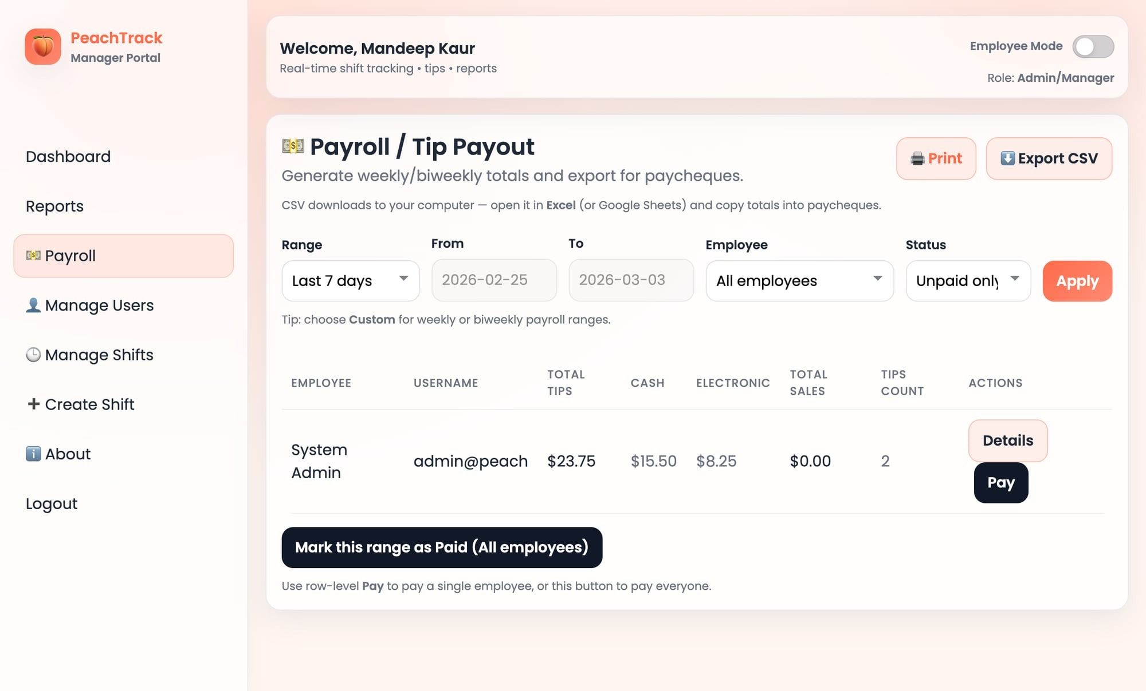

11. Test ID: PT-M8-11 — Manage Users page (admin functions)
File: 11_admin_manage_users.png
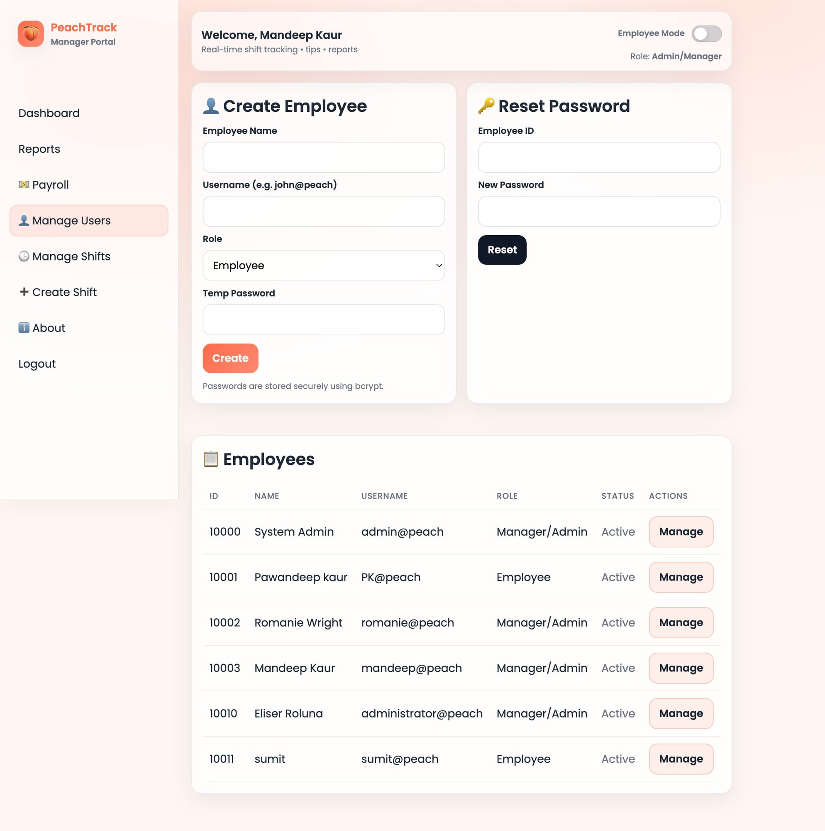

12. Test ID: PT-M8-09/10 — Manage Shifts page (admin functions)
File: 12_admin_manage_shifts.png
