1. PT-M8-01 — Employee Shift Start
Scope
This test verifies that an employee can start a shift successfully and that the dashboard clearly reflects an active shift state (including the running timer and start time).
Screenshot evidence
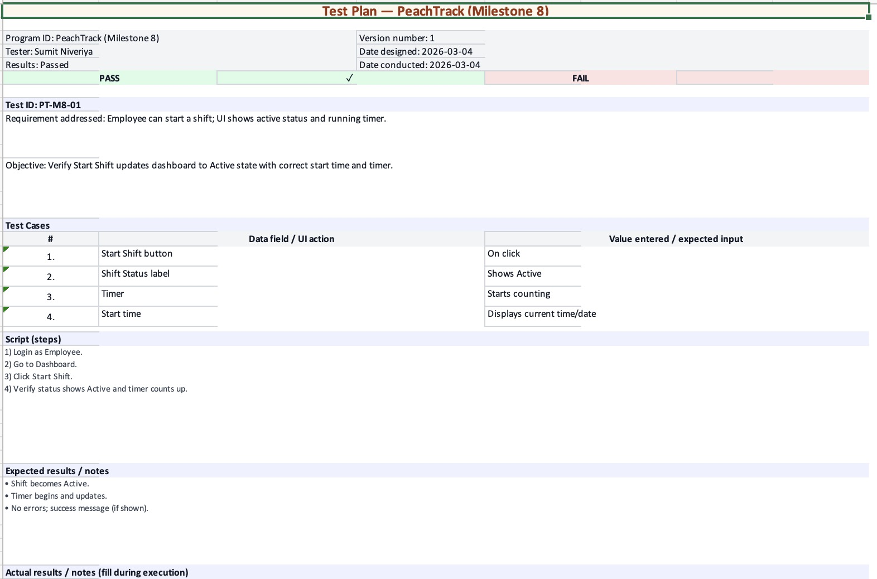
Figure 1. Screenshot evidence for PT-M8-01.

2. PT-M8-02 — Log Tip (Cash)
Scope
This test verifies that an employee can record a cash tip with the required inputs and that the system confirms submission and updates the recent tip history.
Screenshot evidence
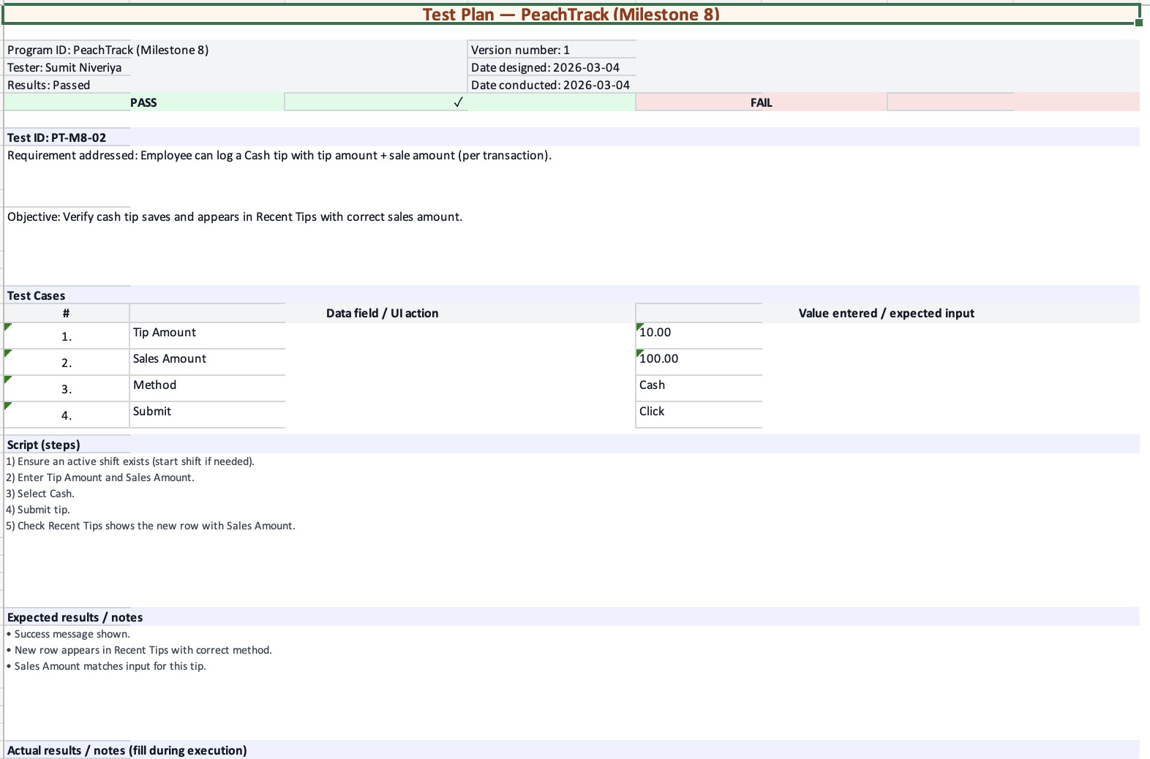
Figure 2. Screenshot evidence for PT-M8-02.

3. PT-M8-03 — Log Tip (Electronic)
Scope
This test verifies that an employee can record an electronic tip with the required inputs and that the system updates the recent tip history appropriately.
Screenshot evidence
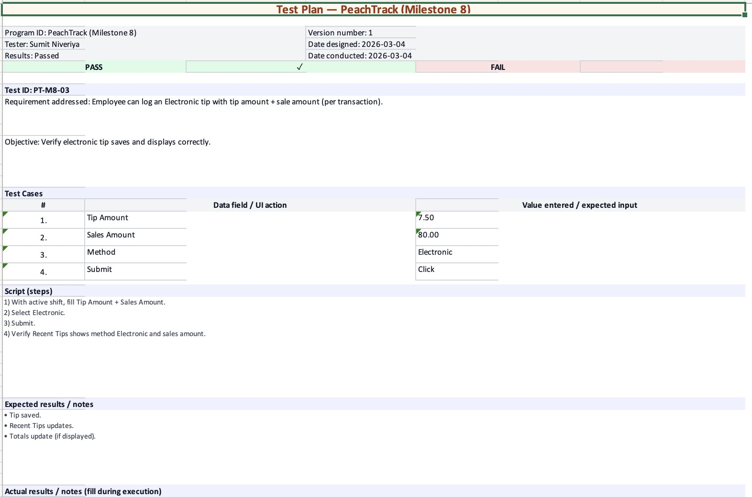
Figure 3. Screenshot evidence for PT-M8-03.

4. PT-M8-04 — End Shift
Scope
This test verifies that an employee can end an active shift and that the system displays a clear end-of-shift summary (tips and totals) while returning the UI to a non-active state.
Screenshot evidence
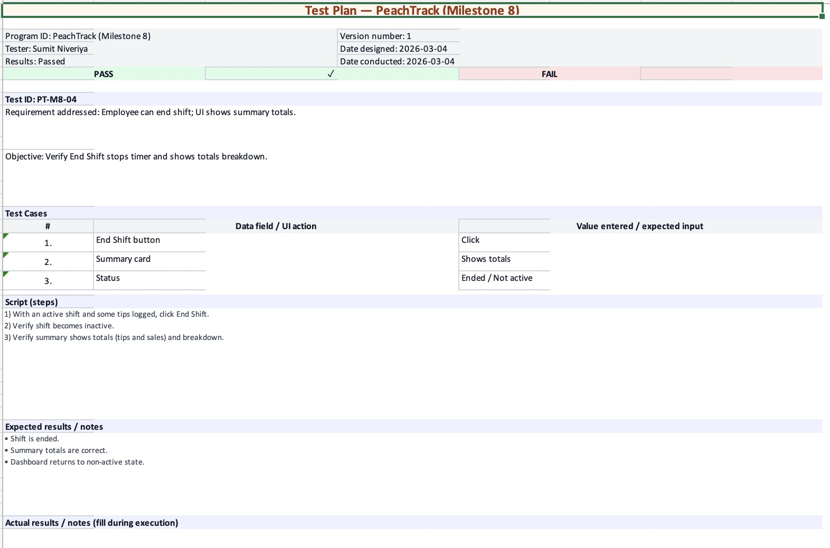
Figure 4. Screenshot evidence for PT-M8-04.

5. PT-M8-05 — My Shifts (Employee View)
Scope
This test verifies that the employee can review shift history for a selected date range and that charts/tables render correctly (or display a clear empty state when no data exists).
Screenshot evidence
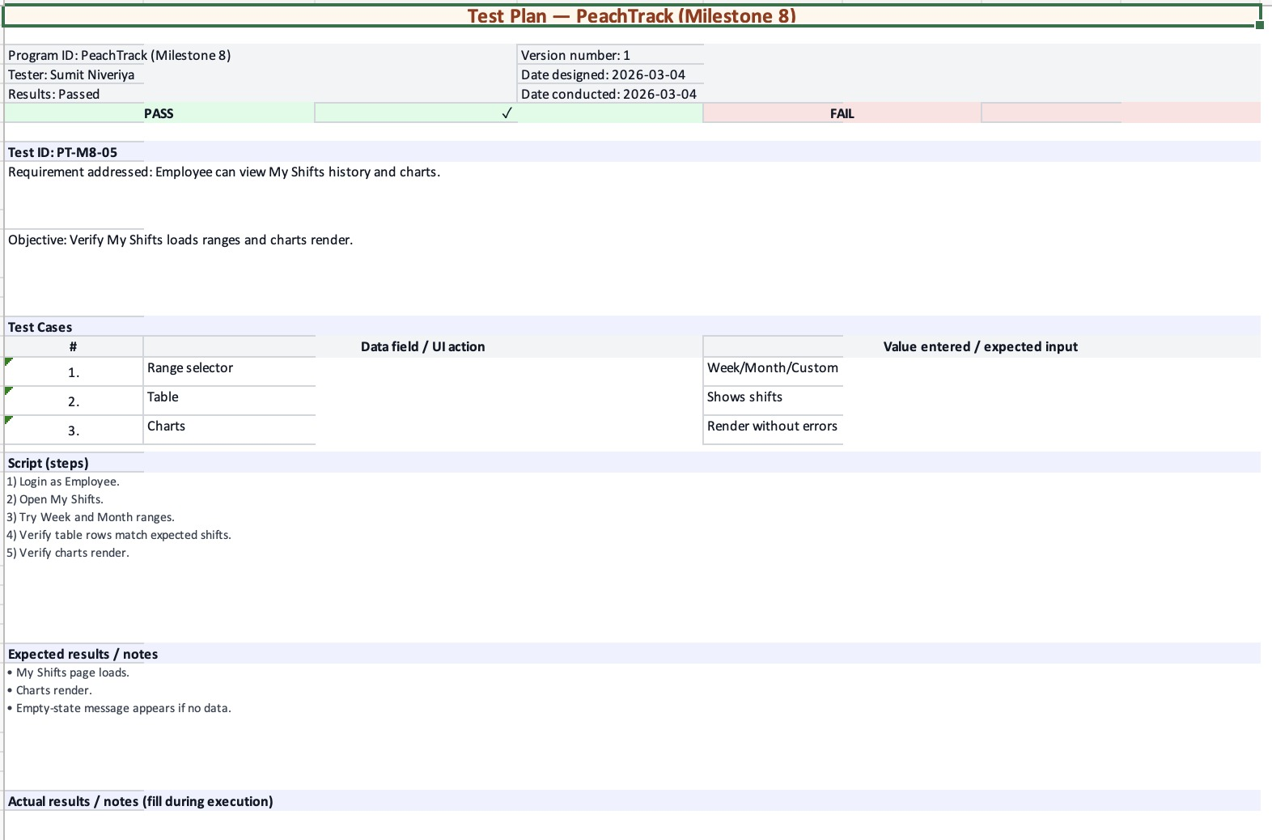
Figure 5. Screenshot evidence for PT-M8-05.

6. PT-M8-06 — Reports (Admin View)
Scope
This test verifies that the Reports page loads for an administrator, accepts date range inputs, and displays the expected charts/tables (or an appropriate no-data message).
Screenshot evidence
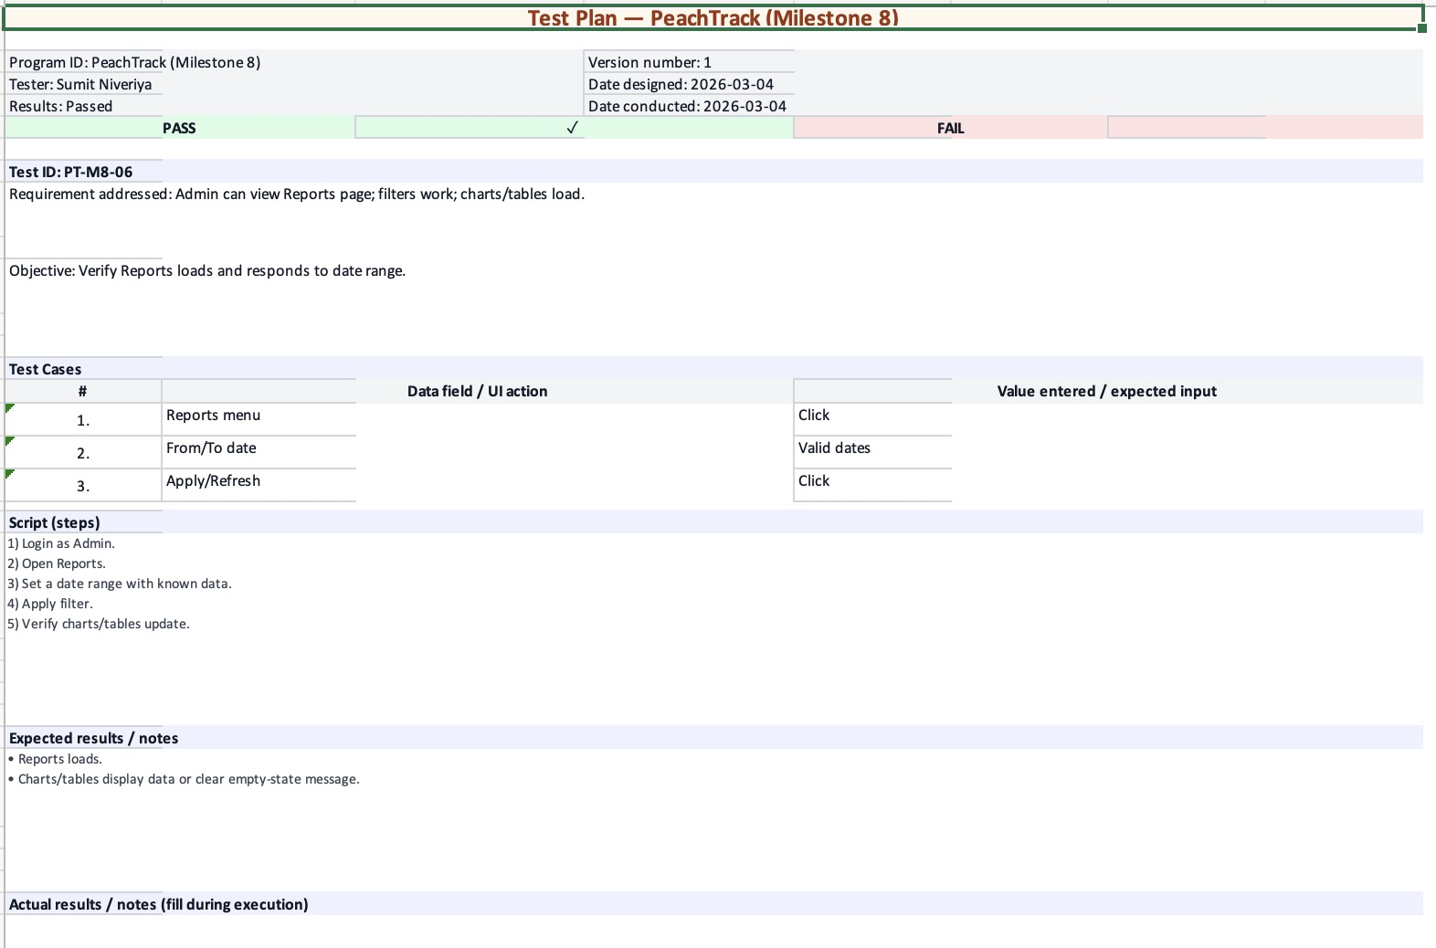
Figure 6. Screenshot evidence for PT-M8-06.

7. PT-M8-07 — Payroll Summary + Export (Admin View)
Scope
This test verifies that payroll totals are calculated and displayed correctly for the selected range and that the CSV export feature produces a usable file.
Screenshot evidence
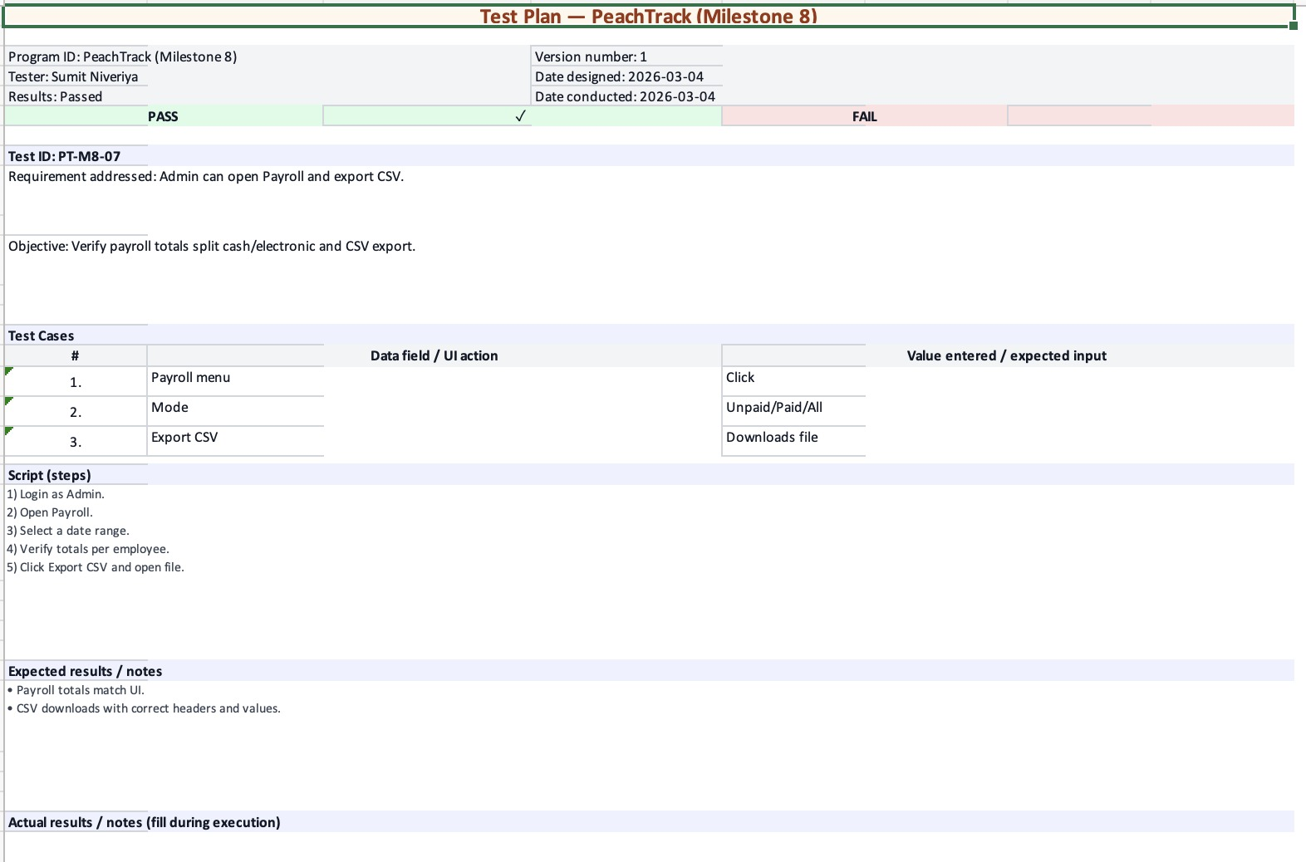
Figure 7. Screenshot evidence for PT-M8-07.

8. PT-M8-08 — Mark Paid Workflow (Admin View)
Scope
This test verifies that an administrator can mark a payroll range (or employee) as paid and that the user interface updates immediately to reflect the payment status.
Screenshot evidence
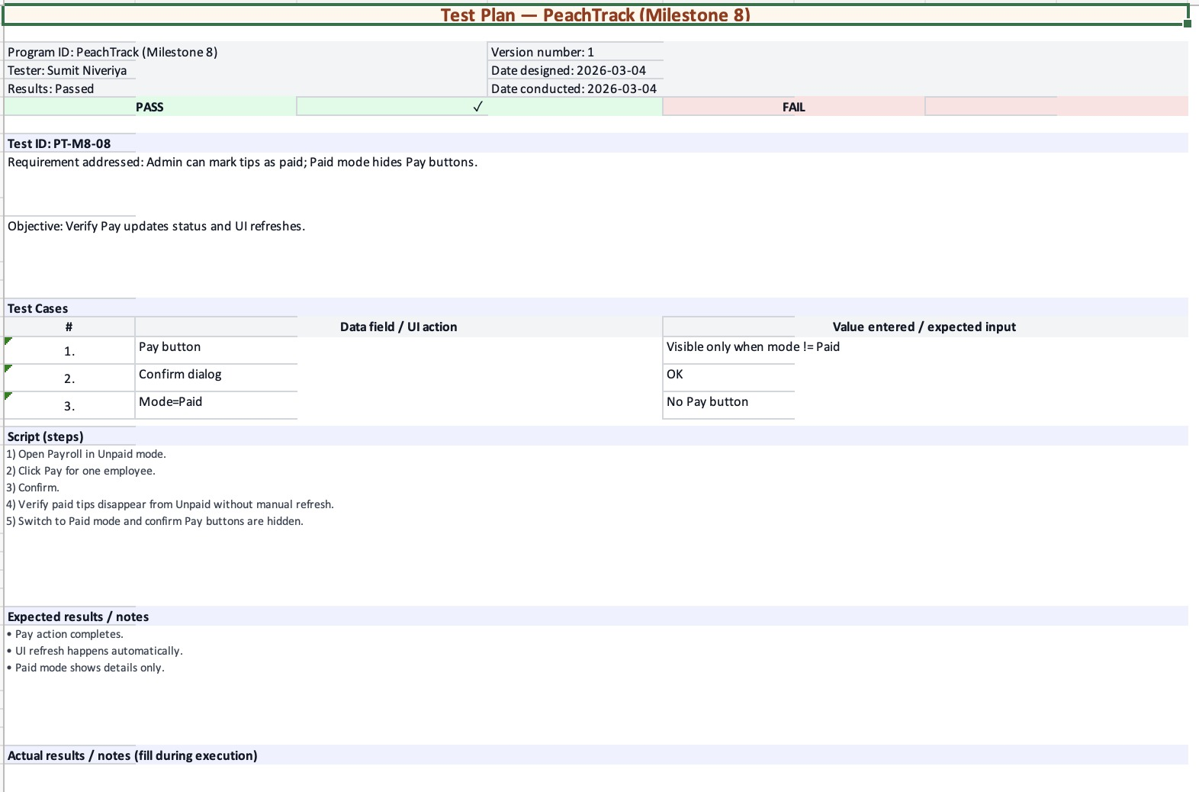
Figure 8. Screenshot evidence for PT-M8-08.

9. PT-M8-09 — Manage Shifts — Active Shifts (Admin View)
Scope
This test verifies that active shifts are visible to an administrator and that the Force End action functions correctly when required.
Screenshot evidence
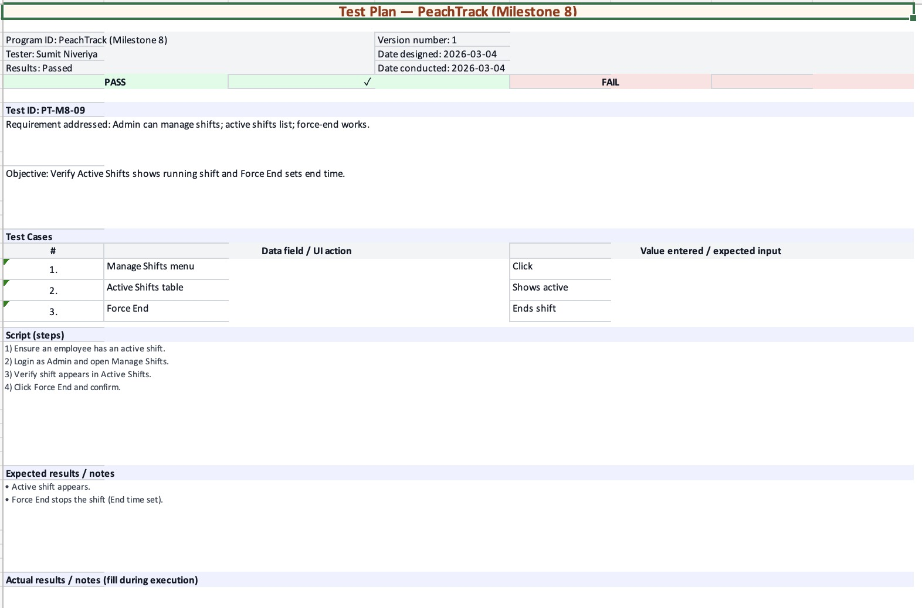
Figure 9. Screenshot evidence for PT-M8-09.

10. PT-M8-10 — Edit Shift + Edit Transaction (Admin View)
Scope
This test verifies that an administrator can edit a shift and update individual tip transactions (including amounts/method) and remove a transaction when necessary.
Screenshot evidence
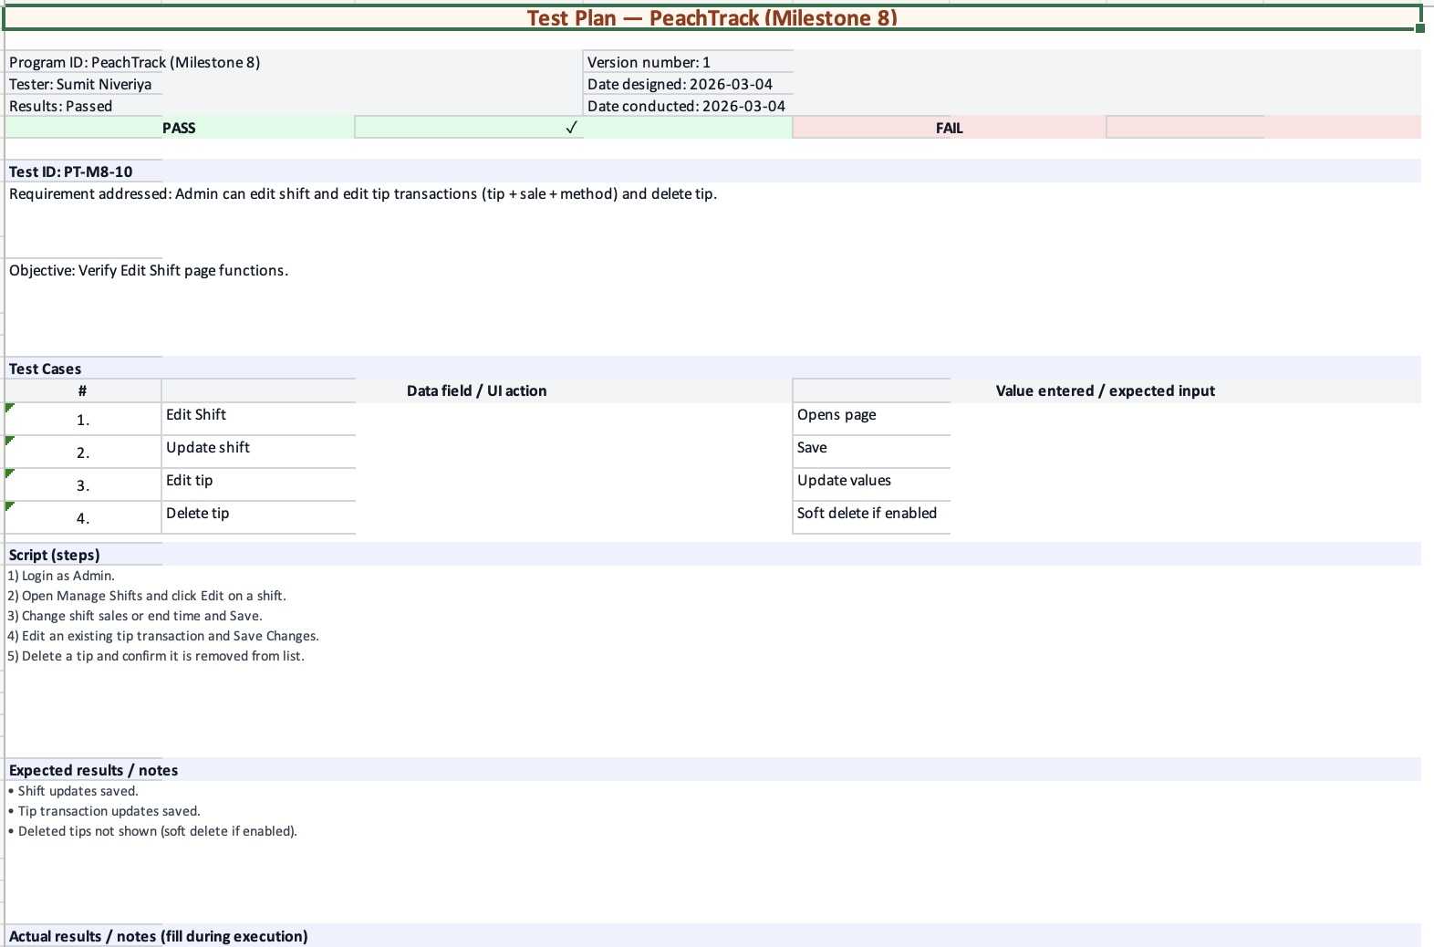
Figure 10. Screenshot evidence for PT-M8-10.

11. PT-M8-11 — Employee Mode (Admin View)
Scope
This test verifies that the administrator can switch into Employee Mode for viewing employee-facing pages while keeping the administrator identity visible for accountability.
Screenshot evidence
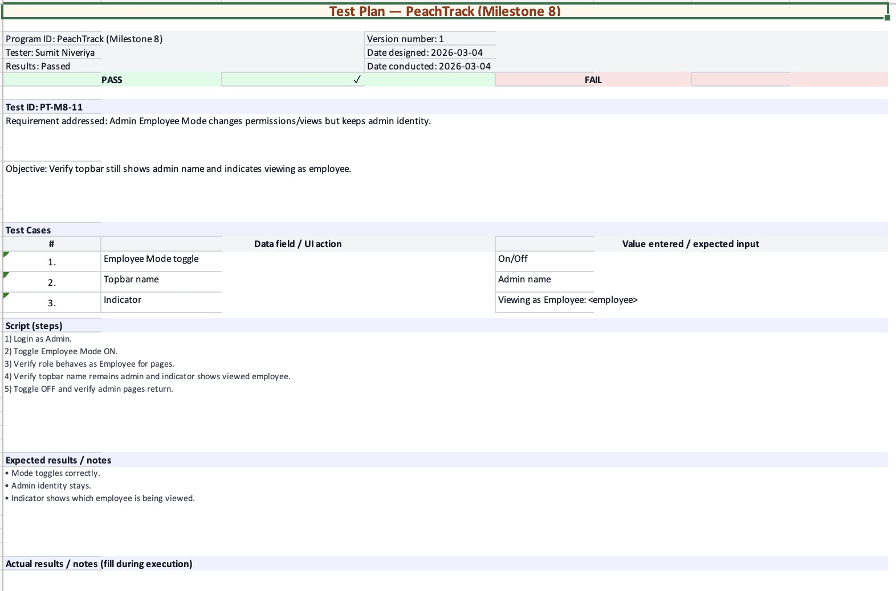
Figure 11. Screenshot evidence for PT-M8-11.

12. PT-M8-12 — Audit Visibility for Edits (Employee View)
Scope
This test verifies that employees can clearly identify when a shift was edited by an administrator (including the editor and edit time/notes, when available).
Screenshot evidence
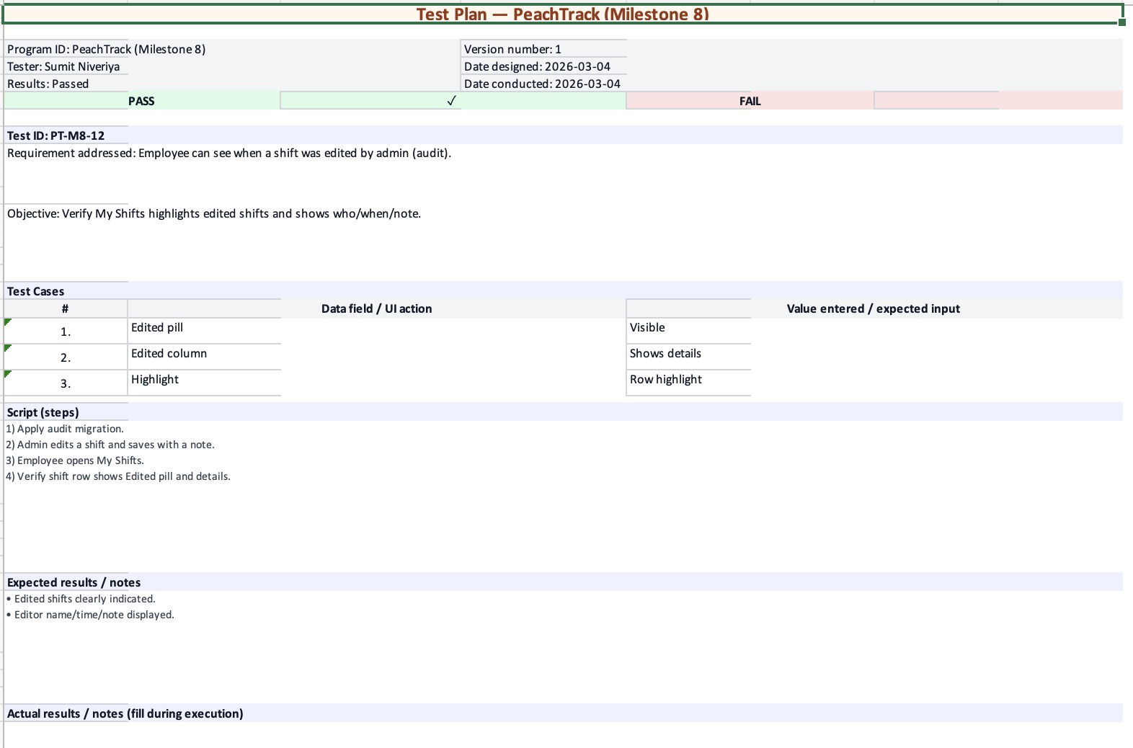
Figure 12. Screenshot evidence for PT-M8-12.

