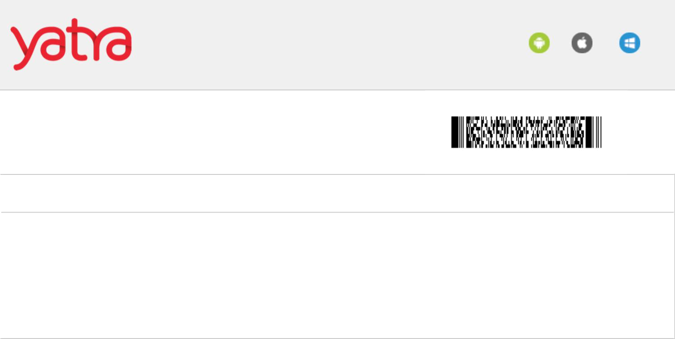
Download Yatra App

Android iOS Windows

 | FLIGHT | E-TICKET | YATRA REF NUMBER |  |  | 181174999898
 | PASSENGERS DETAILS
 | NAME |  |  | DESTINATION |  | MEALS | BAGGAGE | SEAT NO.
 | Mr Sumit Kesarvani (Adult) |  |  | LKO - DEL |  | NA | 15 kgs (Free) | NA
 | Insurance Policy :
 | NA
 |  |  |  | DEL - PNQ |  | NA | 15 kgs (Free) | NA
 |  | Lucknow |  | New Delhi | Tue, Dec 26 2017
 | AIRLINE |  | DEPARTURE |  | ARRIVAL |  | DURATION | PNR
 |  |  | Lucknow |  | New Delhi |  | 01:15 Hrs | EDR2UG
 | Indigo |  | Tue, Dec 26 2017 |  | Tue, Dec 26 2017 |  | Non Stop
 | 6E - 185 |  | 18:25 Hrs |  | 19:40 Hrs |  | Non Stop
 |  |  | Amausi |  | Indira Gandhi, T-1
 |  | New Delhi |  | Pune Tue, Dec 26 2017
 | AIRLINE |  | DEPARTURE |  | ARRIVAL |  | DURATION | PNR
 |  |  | New Delhi |  | Pune |  | 02:10 Hrs | EDR2UG
 | Indigo |  | Tue, Dec 26 2017 |  | Wed, Dec 27 2017 |  | Non Stop
 | 6E - 951 |  | 23:30 Hrs |  | 01:40 Hrs |  | Non Stop
 |  |  | Indira Gandhi, T-1 |  | Lohegaon
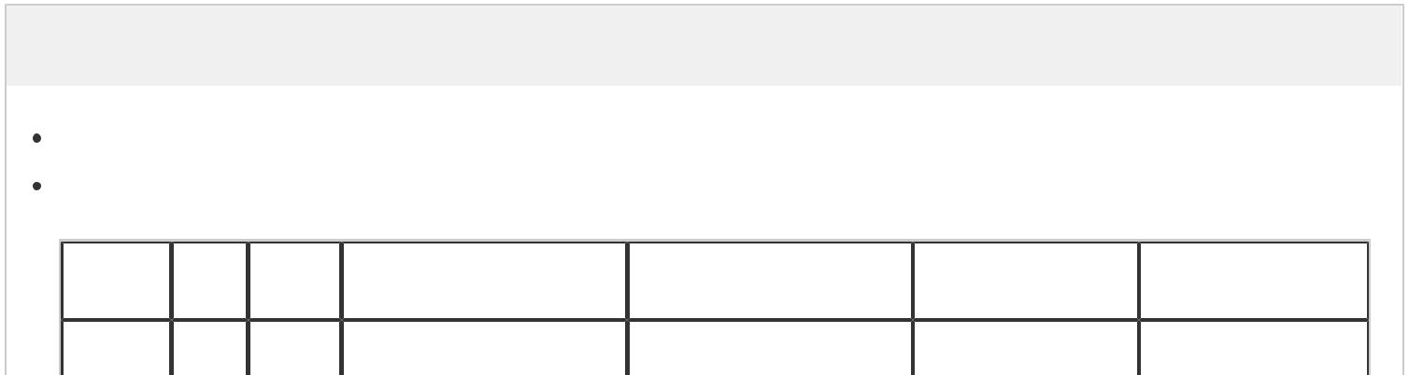
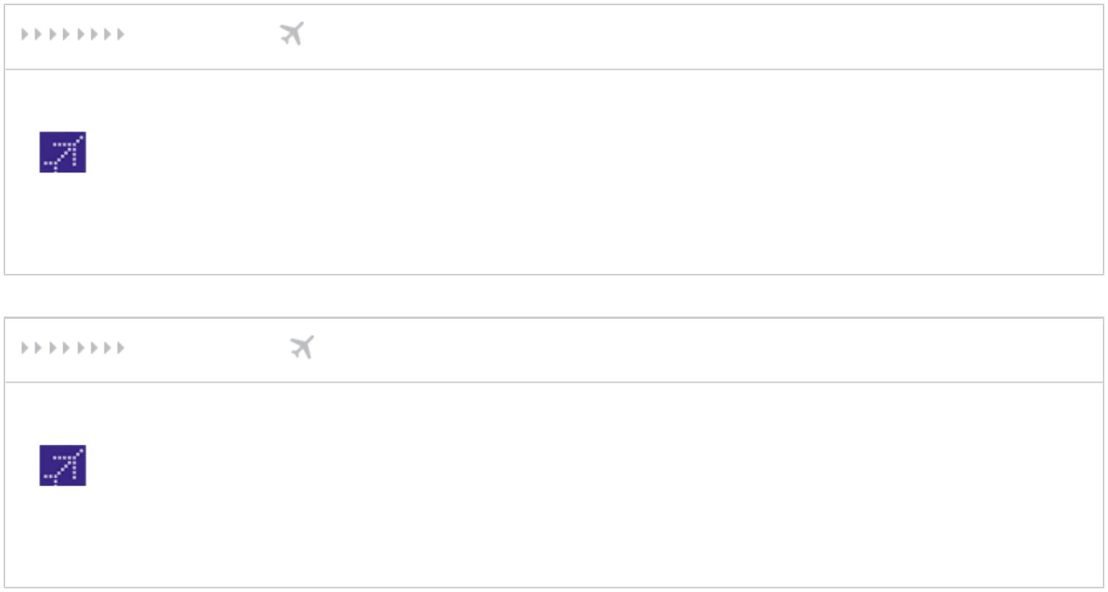

Important Information

All time indicated are the local times (in 24 hrs. format) at the relevant airport.

Cancellation charges:-

Airline Type Sector | Airline Cancellation fee | Airline Change fee | Yatra online | Yatra Offline
Airline Type Sector | Airline Cancellation fee | Airline Change fee | Cancellation Fee | Cancellation Fee
LKO | 2 hrs - 38 days to | 2 hrs - 38 days to


6E ADT -PNQ departure: Rs. 6000 departure: Rs. 6000 Rs. 400 Rs. 1250

Cancellation and date change fees are applicable before departure and per passenger basis. In case of amendment, along with the airline and Yatra fees, you will also have to pay fare difference, if any.

Any change to a confirmed ticket including cancellation, postponement, and change of itinerary must be done at least four hours prior to flight departure. In case a passenger becomes a no show, only the applicable taxes will be refunded to the passenger as per the airlinepolicy.

Please directly contact airline for any cancellation/reschedule within four hours of departure time

Airline Contact Information:

Indigo : +919910383838,+911246613838

Please reference the Airline PNR Number when communicating with the airline regarding this booking.

If ticket is canceled directly from the airlines web site, office or call center, customer needs to inform Yatra.com for the refund to be processed. Yatra will levy Rs. 300 per passenger per segment.

Delhi and Mumbai airports have multiple terminals catering to domestic flights, please check the departure/arrival terminal of your flight with the airlines before reaching airport.

Indian citizens need to carry a printout of the e ticket along with a photo identity proof such as driver's license, voters ID or passport to the airline checkin counter. For infant passengers, it is mandatory to carry the Date of Birth certificate. Foreigners travelling on Indian domestic sectors needs to carry their passport along with e ticket.

Use your Airline PNR for all your communication for this booking with the airline.

We recommend you checkin at least 2 hours prior to departure of your domestic flight and 3 hours prior to your international flight.

When an infant (not entitled to a seat or free baggage allowance) accompanies an adult, a carrycot, or a fully collapsible push chair/stroller is allowed. This may be carried in the cabin if space is available, or else as checked in baggage.

Airlines allows free checked baggage of 15kgs per passenger for all domestic flights.

It is mandatory to carry the Date of Birth certificate for infant passengers.

Hand Baggage(Also applicable for cabin baggage) of maximum 7 kg (which would include Laptop and duty free shopping bags) having maximum overall dimensions of: 115 cms (L+W+H) on Boeing flights and 108 cms (L+W+H) on Bombardier flights, is allowed to be carried per passenger, free of cost. Due to airport security regulations, no cabin baggage is allowed on flights originating from Jammu or Srinagar airports.

To view cancellation charges for this booking click here. To view reschedule charges for this booking click here. Now you can reschedule your domestic bookings online from Yatra My Bookings.


Wishing you a happy and safe journey. Thank you for booking with Yatra.com!

