**ASSIGNMENT – 3**

**Exercise – 2**

**CSCI-6708 Advanced Network Security**

**Sumit Singh**

**B00882103**

[**Sm435410@dal.ca**](mailto:Sm435410@dal.ca)

**Exercise 2:**

**Program one for standard ACL**

**Input one**:

Acl statement:

access-list 3 deny 172.16.4.0 0.0.0.255

access-list 3 permit 172.16.0.0 0.0.255.255

interface EO

ip access-group 3 out

Ip List:

172.16.4.1

172.16.3.5

201.15.3.4

Program output:

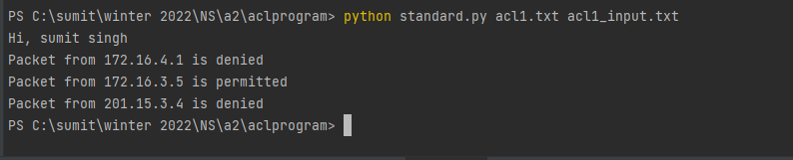

**Input two**:

Acl statement:

access-list 5 deny 170.16.20.0 0.0.0.255

access-list 5 permit 0.0.0.0 255.255.255.255

R3 # interface E1

Ip access group 5 out

Ip List:

170.16.20.230

170.16.80.10

173.3.3.3

Program output:

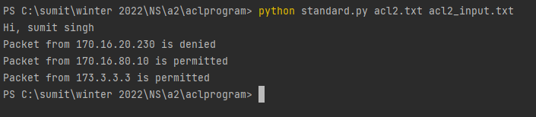

**Input three**:

Acl statement:

access-list 2 deny 170.16.40.0 0.0.0.255

access-list 2 permit 170.16.0.0 0.0.255.255

R2 # interface E0

Ip access group 2 out

Ip List:

170.16.40.0

170.16.23.54

170.11.4.22

Program output:

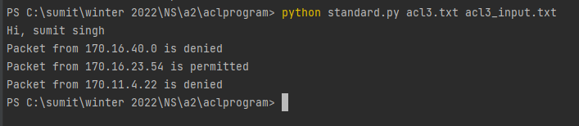

**Program one for extended ACL**

**Input one**:

Acl statement:

access-list 101 deny tcp 172.16.0.0 0.0.255.255 172.16.3.0 0.0.0.255 eq 21

access-list 101 permit ip 172.16.0.0 0.0.255.255 172.16.3.0 0.0.0.255

interface EO

ip access-group 101 out

Ip List:

172.25.3.1 172.16.3.4 22

172.16.4.4 172.16.3.5 22

172.16.4.4 172.16.3.5 21

172.16.5.78 172.16.3.1 21

Program output:

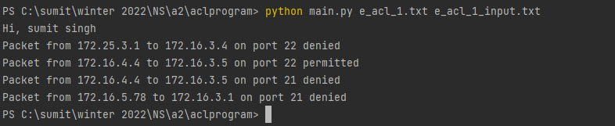

**Input two**:

Acl statement:

access-list 104 permit tcp 170.16.10.5 0.0.0.0 170.16.70.0 0.0.0.255 range 22

access-list 104 deny tcp 170.16.0.0 0.0.255.255 170.16.70.0 0.0.0.255 range 22

access-list 104 permit ip 170.16.0.0 0.0.255.255 0.0.0.0 255.255.255.255

R3 # interface E1

Ip access group 104 out

Ip List:

170.16.10.5 170.16.70.111 22

170.16.10.5 170.16.70.111 80

170.16.5.12 170.16.70.1 22

170.16.6.90 192.45.77.2 59

Program output:

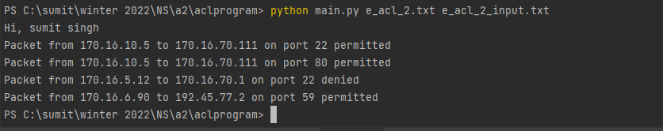

**Input three**:

Acl statement:

access-list 102 deny tcp 170.16.50.75 0.0.0.0 170.16.70.2 0.0.0.0 eq 80

access-list 102 deny tcp 170.16.50.7 0.0.0.0 170.16.70.2 0.0.0.0 eq 80

access-list 102 permit ip 0.0.0.0 255.255.255.255 0.0.0.0 255.255.255.255

R3 # interface E0

Ip access group 102 out

Ip List:

170.16.50.75 170.16.70.2 80

170.16.50.7 170.16.70.2 80

170.16.50.7 170.16.70.2 22

193.43.55.2 190.52.64.22 69

Program output:

