**ASSIGNMENT – 4**

**CSCI-6708 Advanced Network Security**

**Sumit Singh**

**B00882103**

[**Sm435410@dal.ca**](mailto:Sm435410@dal.ca)

**Program 1: Playfair substitution cipher**

**Sample input for method 1:**

**Input sample 1**:

**input key**: PLAYFIRE

**output**: [['P', 'L', 'A', 'Y', 'F'], ['I', 'R', 'E', 'B', 'C'], ['D', 'G', 'H', 'K', 'M'], ['N', 'O', 'Q', 'S', 'T'], ['U', 'V', 'W', 'X', 'Z']]

**Image**:

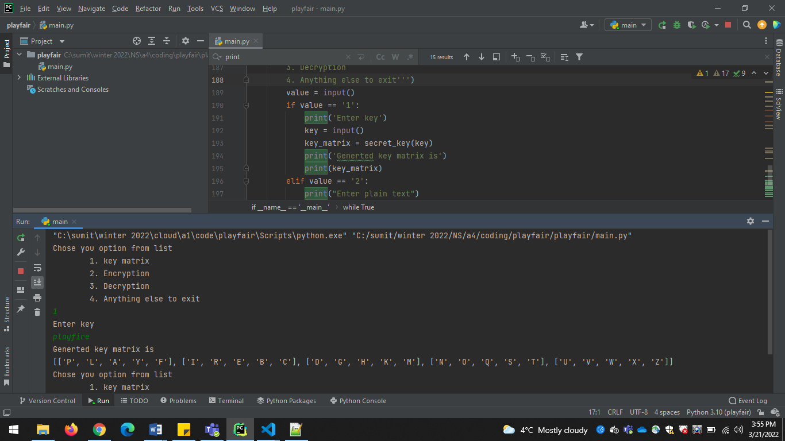

Input sample 2:

**input key**: SECURITY

**output**: [['S', 'E', 'C', 'U', 'R'], ['I', 'T', 'Y', 'A', 'B'], ['D', 'F', 'G', 'H', 'K'], ['L', 'M', 'N', 'O', 'P'], ['Q', 'V', 'W', 'X', 'Z']]

**Image**:

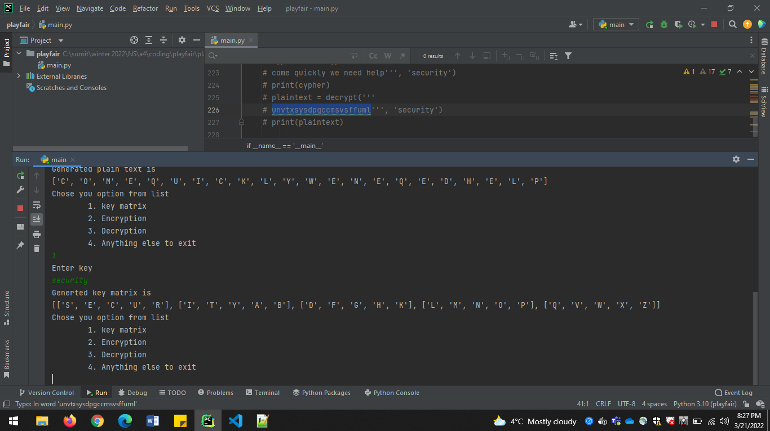

Input sample 3:

**input key**: RAYQUAZA

**output**: [['R', 'A', 'Y', 'Q', 'U'], ['Z', 'B', 'C', 'D', 'E'], ['F', 'G', 'H', 'I', 'K'], ['L', 'M', 'N', 'O', 'P'], ['S', 'T', 'V', 'W', 'X']]

**Image**:

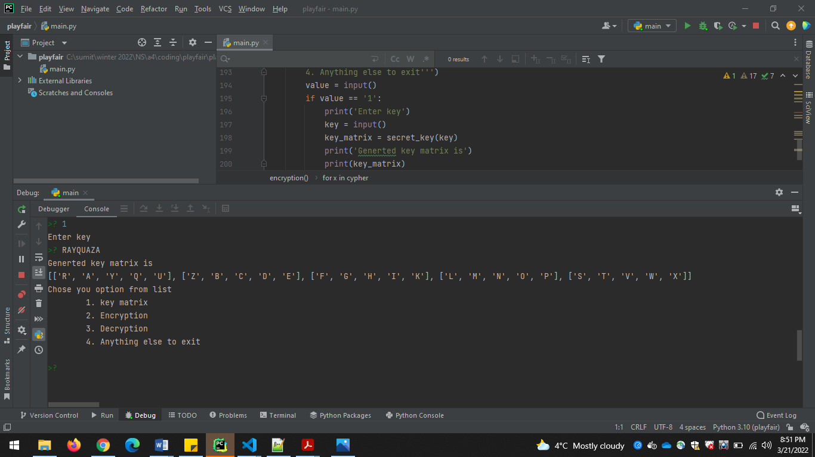

**Sample input for method 2:**

**Input sample 1**:

**Plain Text**: this is cool

**Key used**: playfire

**Cypher**: ['Q', 'M', 'B', 'N', 'B', 'N', 'R', 'T', 'V', 'R']

**Image**:

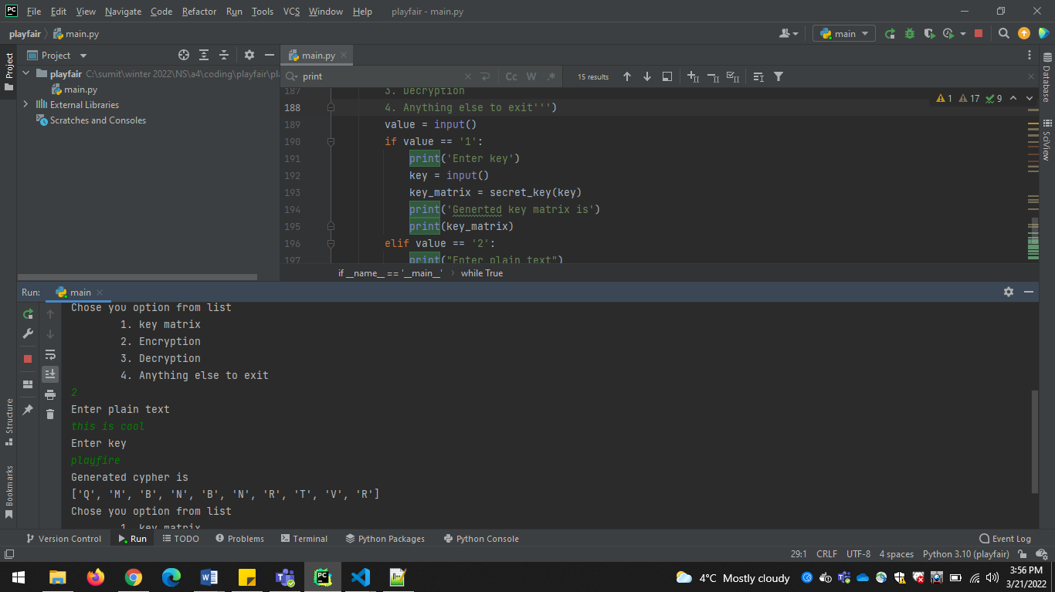

**Input sample 2**:

**Plain Text**: come quickly we need help

**Key used:** security

**Cypher**: ['U', 'N', 'V', 'T', 'X', 'S', 'Y', 'S', 'D', 'P', 'G', 'C', 'C', 'M', 'S', 'V', 'S', 'F', 'F', 'U', 'M', 'L']

**Image**:

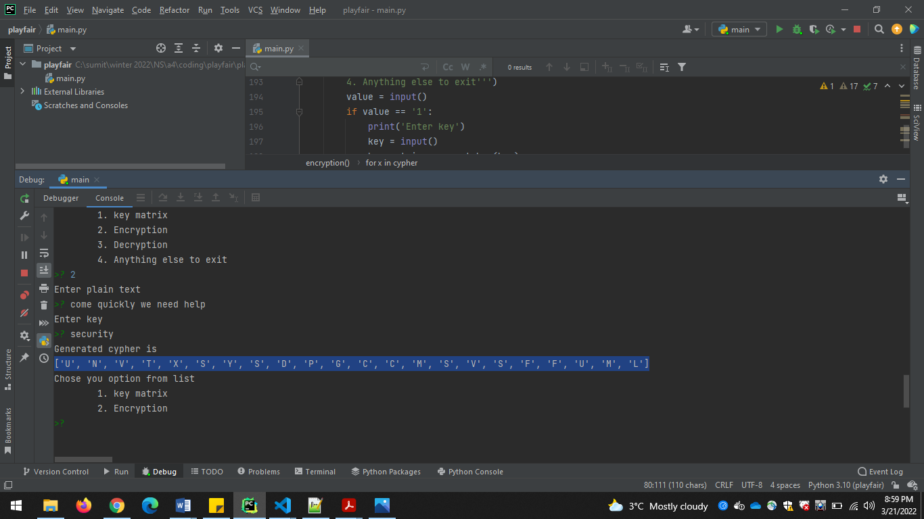

**Input sample 3**: (Asked in assignment to transform)

**Plain Text**: POKEMON TOWER DEFENSE YOUR MISSION IN THIS FUN STRATEGY TOWER DEFENSE GAME IS TO HELP PROFESSOR OAK TO STOP ATTACKS OF WILD RATTATA. SET OUT ON YOUR OWN POKEMON JOURNEY, TO CATCH AND TRAIN ALL POKEMON AND TRY TO SOLVE THE MYSTERY BEHIND THESE ATTACKS. YOU MUST PLACE POKEMON CHARACTERS STRATEGICALLY ON THE BATTLEFIELD SO THAT THEY STOP ALL WAVES OF ENEMY ATTACKER DURING THE BATTLE YOU WILL LEVEL UP AND EVOLVE YOUR POKEMON. YOU CAN ALSO CAPTURE OTHER POKEMON DURING THE BATTLE AND ADD THEM TO YOUR TEAM. USE YOUR MOUSE TO PLAY THE GAME. GOOD LUCKRAYQUAZA

**Key used:** **RAYQUAZA**

**Cypher**: ['L', 'P', 'P', 'K', 'N', 'P', 'M', 'V', 'W', 'Q', 'Z', 'U', 'E', 'Z', 'K', 'Z', 'L', 'V', 'C', 'U', 'P', 'Q', 'A', 'L', 'F', 'W', 'W', 'F', 'P', 'O', 'H', 'O', 'V', 'G', 'F', 'W', 'K', 'R', 'L', 'V', 'S', 'A', 'B', 'A', 'B', 'K', 'A', 'V', 'W', 'Q', 'Z', 'U', 'E', 'Z', 'K', 'Z', 'L', 'V', 'B', 'K', 'B', 'T', 'D', 'K', 'T', 'V', 'N', 'I', 'Z', 'P', 'O', 'U', 'L', 'U', 'L', 'I', 'Z', 'X', 'W', 'L', 'Q', 'L', 'U', 'G', 'W', 'M', 'T', 'V', 'P', 'L', 'B', 'A', 'A', 'B', 'E', 'H', 'W', 'L', 'I', 'S', 'F', 'O', 'Z', 'Q', 'B', 'A', 'A', 'B', 'A', 'B', 'X', 'Z', 'W', 'M', 'A', 'X', 'P', 'O', 'Q', 'N', 'R', 'A', 'W', 'Q', 'O', 'L', 'P', 'I', 'B', 'P', 'P', 'O', 'O', 'W', 'R', 'A', 'P', 'C', 'A', 'V', 'N', 'D', 'B', 'A', 'H', 'N', 'Y', 'M', 'B', 'W', 'A', 'Y', 'H', 'O', 'R', 'M', 'M', 'L', 'P', 'I', 'B', 'P', 'P', 'O', 'Y', 'M', 'B', 'W', 'A', 'Q', 'W', 'M', 'W', 'L', 'N', 'S', 'B', 'X', 'K', 'C', 'N', 'A', 'T', 'V', 'Z', 'U', 'A', 'C', 'C', 'K', 'H', 'O', 'B', 'W', 'K', 'C', 'X', 'Z', 'B', 'A', 'A', 'B', 'E', 'H', 'V', 'R', 'P', 'Q', 'P', 'A', 'T', 'V', 'L', 'M', 'Y', 'B', 'K', 'X', 'P', 'I', 'B', 'P', 'P', 'O', 'H', 'N', 'Y', 'A', 'Y', 'B', 'X', 'B', 'Z', 'R', 'T', 'V', 'A', 'Y', 'X', 'B', 'H', 'K', 'B', 'Y', 'O', 'R', 'N', 'R', 'P', 'O', 'V', 'G', 'Z', 'C', 'B', 'A', 'S', 'M', 'Z', 'K', 'K', 'D', 'O', 'Z', 'W', 'L', 'V', 'G', 'B', 'A', 'V', 'G', 'C', 'U', 'T', 'V', 'P', 'L', 'R', 'M', 'O', 'S', 'Y', 'T', 'Z', 'X', 'L', 'I', 'C', 'P', 'B', 'P', 'Q', 'Y', 'W', 'A', 'A', 'B', 'E', 'H', 'Z', 'U', 'E', 'Q', 'Q', 'F', 'M', 'H', 'V', 'G', 'Z', 'C', 'B', 'A', 'S', 'M', 'C', 'U', 'P', 'Q', 'Q', 'O', 'O', 'R', 'O', 'R', 'P', 'Z', 'X', 'C', 'P', 'R', 'M', 'U', 'O', 'C', 'C', 'X', 'P', 'M', 'X', 'C', 'Q', 'N', 'R', 'A', 'L', 'P', 'P', 'K', 'N', 'P', 'V', 'C', 'P', 'Q', 'B', 'Y', 'M', 'Y', 'S', 'R', 'N', 'D', 'U', 'M', 'X', 'A', 'U', 'Z', 'M', 'W', 'K', 'C', 'U', 'L', 'P', 'I', 'B', 'P', 'P', 'O', 'E', 'Q', 'Q', 'F', 'M', 'H', 'V', 'G', 'Z', 'C', 'B', 'A', 'S', 'M', 'B', 'U', 'O', 'C', 'Q', 'B', 'B', 'W', 'K', 'C', 'T', 'A', 'N', 'Q', 'P', 'Q', 'A', 'S', 'B', 'U', 'P', 'A', 'X', 'Z', 'Q', 'N', 'R', 'A', 'N', 'P', 'R', 'X', 'B', 'X', 'P', 'L', 'M', 'R', 'A', 'V', 'K', 'C', 'M', 'B', 'P', 'B', 'I', 'M', 'W', 'I', 'P', 'R', 'E', 'H']

**Image**:

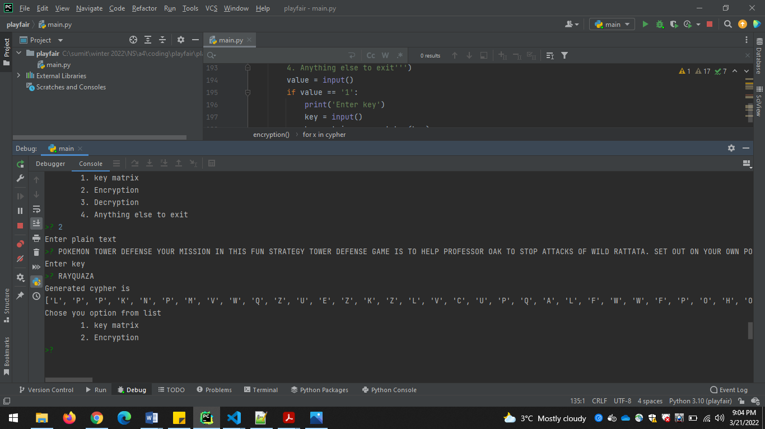

**Sample input for method 3:**

**Input sample 1**:

**Cypher**: qmbnbnrtvr

**Key used:**

**Plain Text**: ['T', 'H', 'I', 'S', 'I', 'S', 'C', 'O', 'O', 'L']

**Image**:

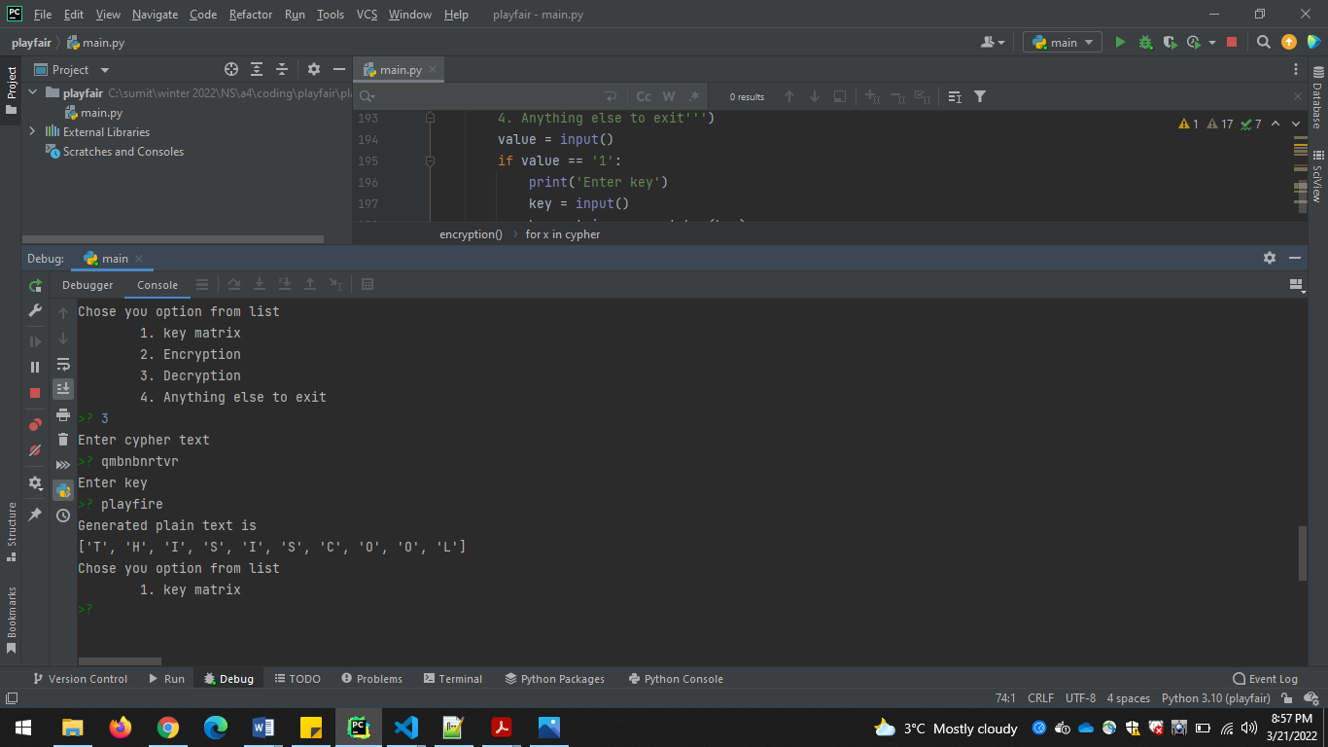

**Input sample 2**:

**Cypher**: UNVTXSYSDPGCCMSVSFFUML

**Key used:** security

**Plain Text**: ['C', 'O', 'M', 'E', 'Q', 'U', 'I', 'C', 'K', 'L', 'Y', 'W', 'E', 'N', 'E', 'Q', 'E', 'D', 'H', 'E', 'L', 'P']

**Image**:

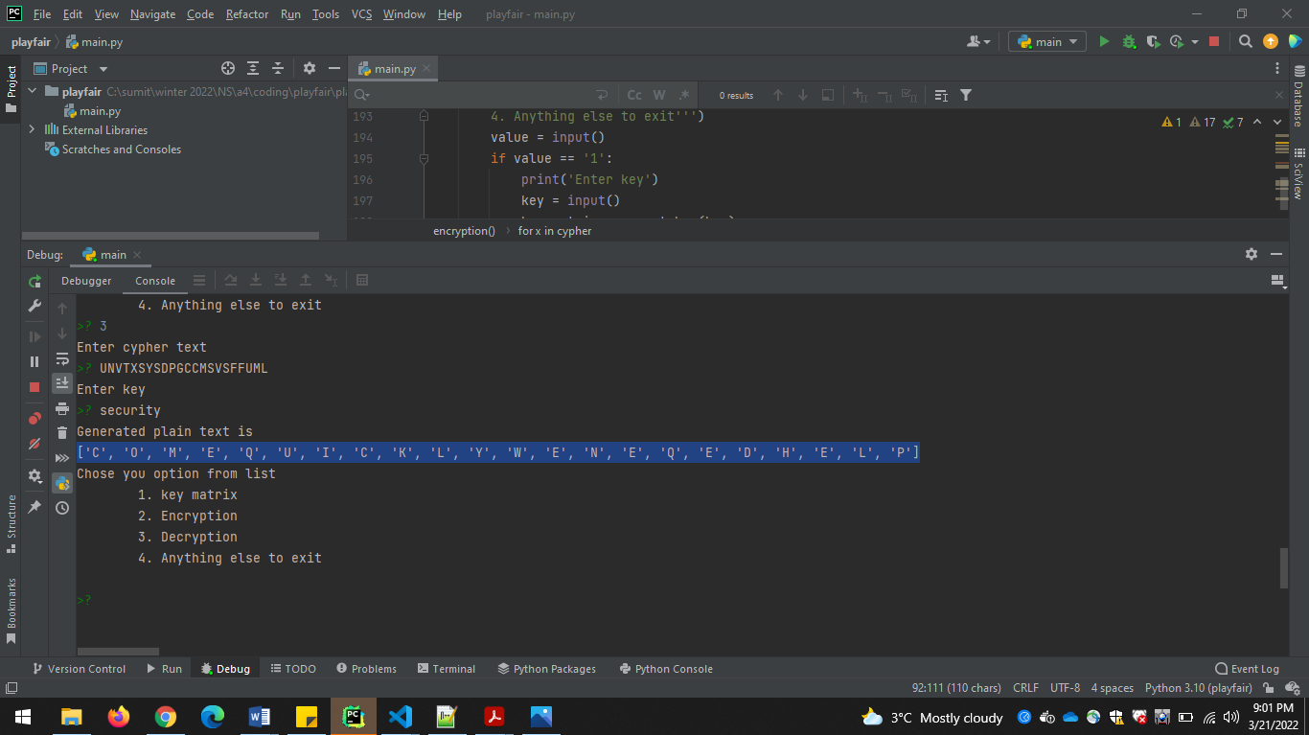

**Program 2: Matrix transposition cipher**

**Sample input for method 1:**

**Input sample 1**:

**Plain text**: this is a good example of

**Key used: [4, 5, 2, 1, 3]**

**Cypher**: ['s', 'a', 'd', 'm', 'o', '%', '%', '%', 'p', 'f', 'h', 's', 'o', 'x', 'e', 't', 'i', 'g', 'e', 'l', 'i', '%', 'o', 'a', '%']

**Image**:

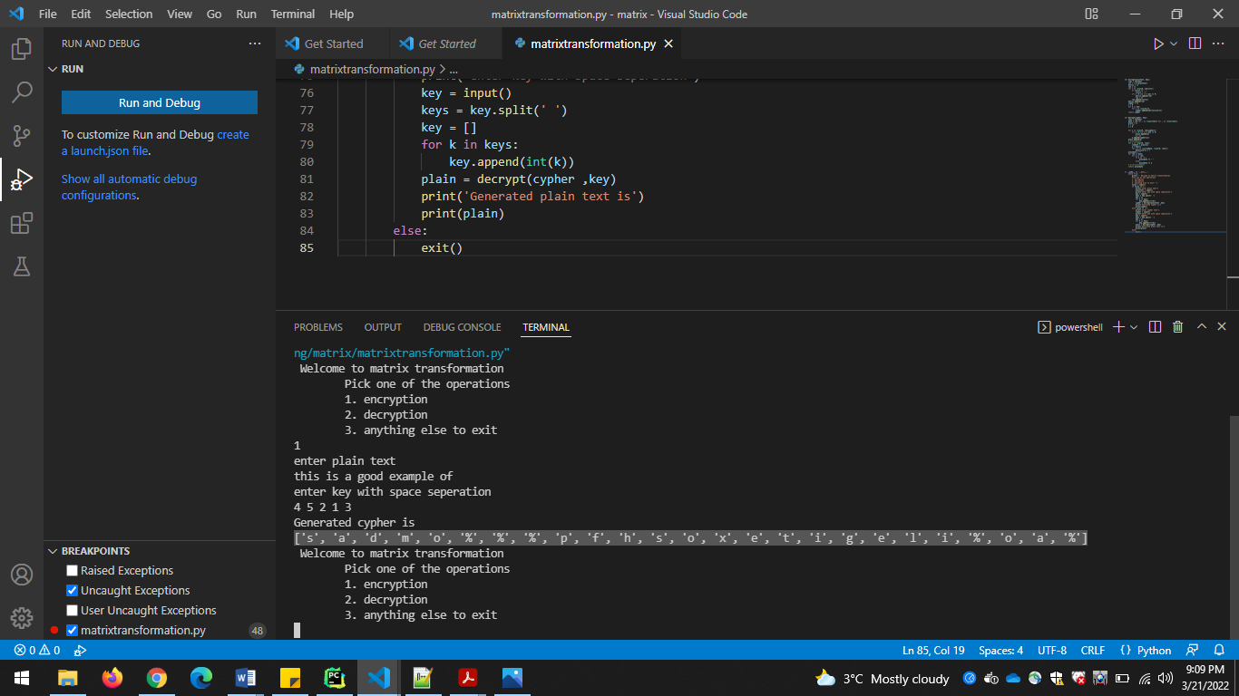

**Input sample 2**:

**Plain text**: meet at military house

**Key used: [5, 4, 1, 3, 2]**

**Cypher**: ['%', 'i', 'r', 'u', '%', 't', 'm', 'a', 'o', '%', 'm', 'a', 'l', 'y', 's', 'e', '%', 't', 'h', '%', 'e', 't', 'i', '%', 'e']

**Image**:

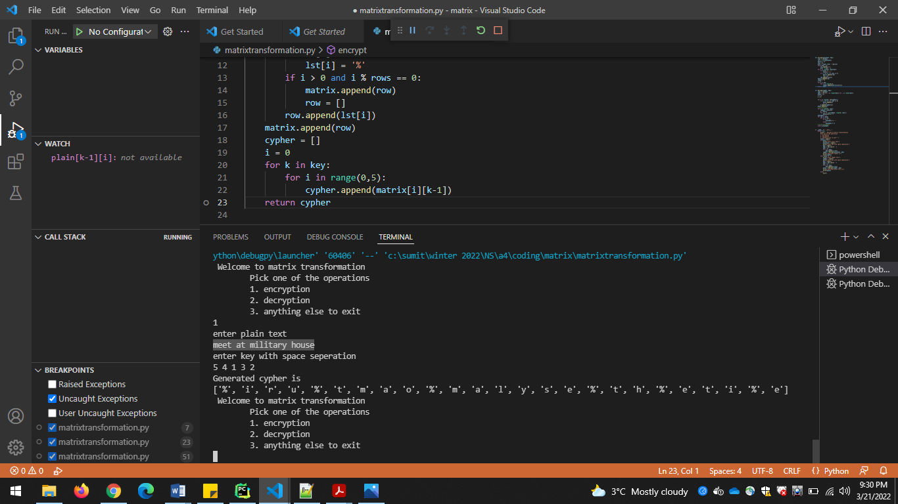

**Sample input for method 2:**

**Input sample 1**:

**Plain text**: sadmo%%%pfhsoxetigeli%oa%

**Key used: [4, 5, 2, 1, 3]**

**Cypher**: this is a good example of

**Image**:

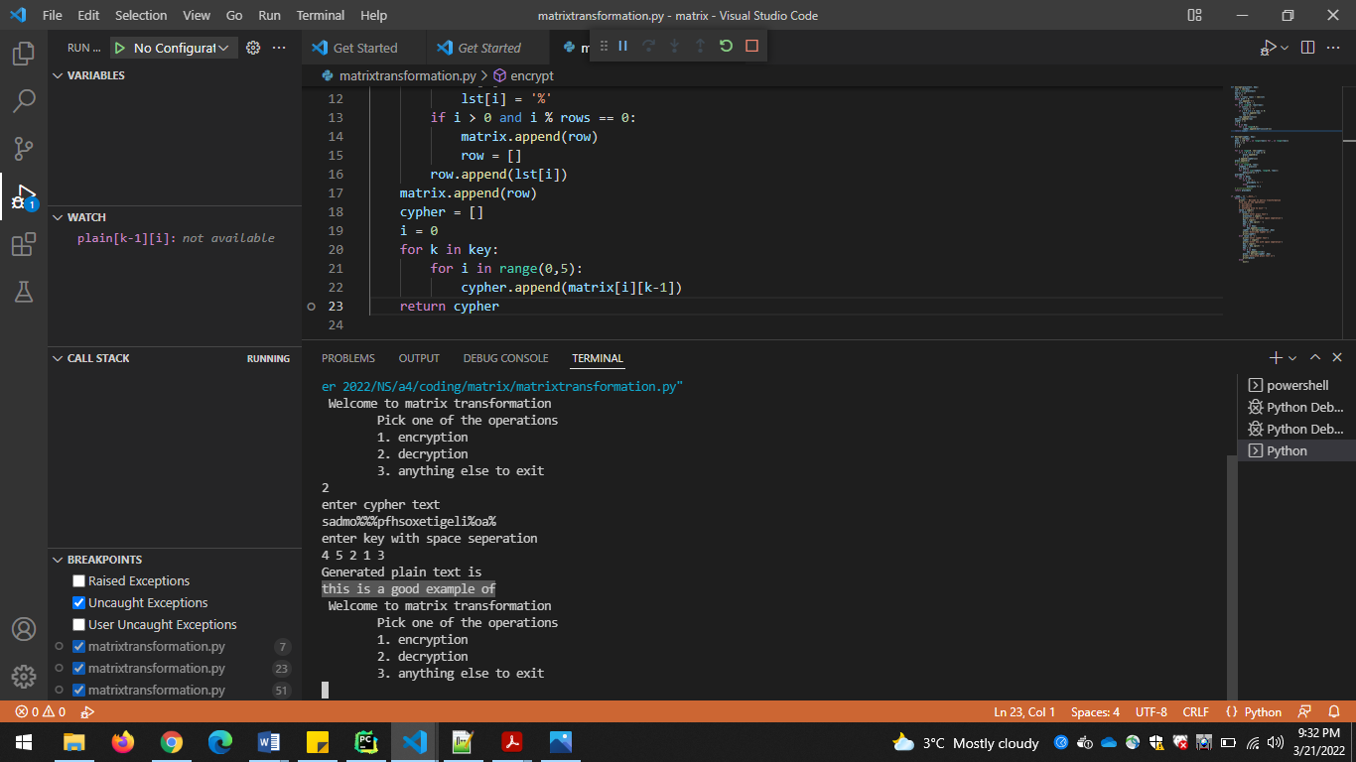

**Input sample 2**:

**Plain text**: %iru%tmao%malyse%th%eti%e

**Key used: [5, 4, 1, 3, 2]**

**Cypher**: meet at military house

**Image**:

