Table of Contents
Reasons to Learn MongoDB 3
Introduction to NoSQL 4
Types of NoSQL Databases 7
MongoDB Introduction 10
Working of MongoDB 11
CRUD Operations 12
Features of the MongoDB database 12
Real-World Applications of MongoDB 13
Language Support by MongoDB 14
Working of MongoDB 14
Difference between RDBMS and MongoDB 18
MongoDB Vs MySQL 22
MongoDB - Database, Collection, and Document 25
MongoDB Cursor 32
Data Types in MongoDB 44
ObjectId in MongoDB 56
MongoDB Query 59
JSON Tutorial 71
Introduction to BSON and Types 76
MongoDB CRUD Operations 81
Creating Database and Collection in MongoDB 90
MongoDB Drop Database 95
MongoDB Drop Database 98
MongoDB – Insert Operations 102
MongoDB – Update Operations 107
MongoDB – Delete Operations 115
MongoDB Query Embedded Documents Using Mongo Shell 117
Aggregation in MongoDB 310
MongoDB Aggregation Pipeline $limit 338
MongoDB Aggregation Commands / Operators 344
MongoDB – Aggregation Tools 369
Transactions in MongoDB 379
Working of ACID Transactions in MongoDB 382
Transactions in Mongoose 386
Creating Relationships in MongoDB 397
Embedded Documents in MongoDB 405
Configuring JSON Schema Validation in MongoDB 408
Scaling in MongoDB 412
Need of Scaling in MongoDB 413
Types of Scaling in MongoDB 413
1. Horizontal Scaling(Scaling Out) 413
Sharding 414
2. Vertical Scaling(Scaling Up) 414
Horizontal Vs Vertical Scaling 415
Replica Sets 416
Sharding Vs Replica Sets 416
MongoDB – Replication and Sharding 418
MongoDB – Security 433



MongoDB Tutorial
MongoDB is an open-source, document-oriented NoSQL database designed to store and manage large volumes of data efficiently using a flexible, JSON-like document model.
- Stores data in BSON format for efficient handling of JSON-like documents.
- Supports dynamic schemas, making it suitable for unstructured or semi-structured data.
- Scalable and easy to learn, widely used in modern web and mobile applications.
- Open-source and freely available on Linux, Windows, and macOS.
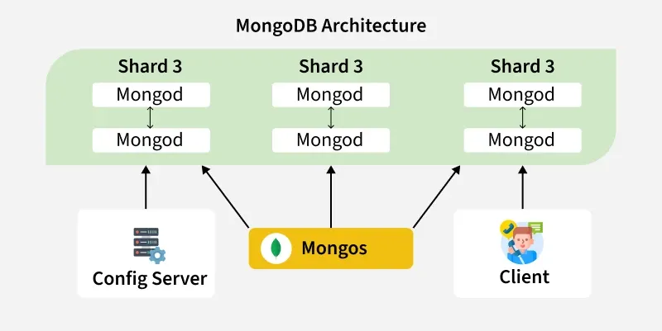

Reasons to Learn MongoDB
Developers use MongoDB because it offers a lot of features for those who like to work with big data. Here are few key reasons of why you should learn MongoDB.
- Popular choice for modern web and real-time applications.
- Provides scalability through sharding and high availability via replication.
- Supports multiple programming languages such as JavaScript, Python, and Java.
- Used by major companies like eBay, Uber, and Adobe for handling large, unstructured data.
- Enables faster development with a flexible, schema-less data model.

Introduction to NoSQL
A NoSQL database is a type of database that stores data using non-relational data models instead of traditional tables.
- Designed to efficiently manage large volumes of structured, semi-structured and unstructured data.
- Work with cloud platforms and distributed systems using tools such as Docker, Kubernetes and Apache Cassandra.
- Optimizes performance by reducing complex JOIN operations.
- Used by high-traffic applications such as social media, e-commerce, gaming and real-time analytics to handle massive volumes of data and concurrent users.
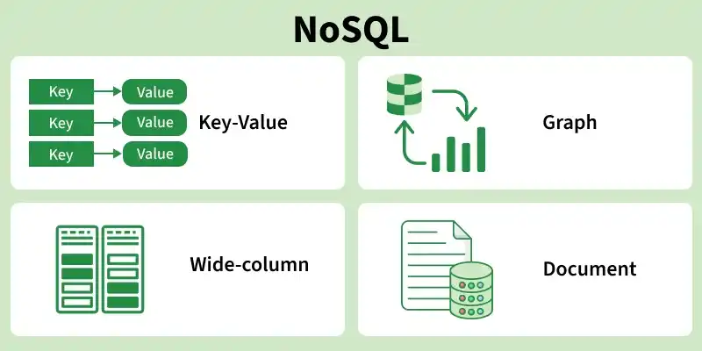
The four main types of NoSQL databases are key-value databases, document databases, column-family databases and graph databases, each designed to support different data storage and access requirements.
Example
An e-commerce application stores product information where different products have different attributes.
Traditional SQL Table
Product_ID | Name | Color | Size | RAM | Storage
101 | T-Shirt | Blue | M | NULL | NULL
102 | Smartphone | NULL | NULL | 8 GB | 128 GB
Many fields remain empty because all products share the same table.
NoSQL Document
{
"ProductID": 101,
"Name": "T-Shirt",
"Color": "Blue",
"Size": "M"
}

{
"ProductID": 102,
"Name": "Smartphone",
"RAM": "8 GB",
"Storage": "128 GB"
}
Each document stores only the required fields, making the database more flexible.
To learn more about the differences between SQL and NoSQL databases, refer to SQL vs NoSQL.

Features
- Horizontal Scalability: Distributes data across multiple nodes, enabling the database to handle increasing workloads by adding more servers.
- Distributed Data Storage: Stores and manages data across a cluster of machines, improving availability and supporting large-scale deployments.
- Multiple Data Models: Supports document, key-value, column-family and graph models, allowing developers to choose the most suitable model for different use cases.
- High Availability: Uses replication and automatic failover mechanisms to ensure continuous access to data even when individual nodes become unavailable.
- Fault Tolerance: Detects node failures and continues serving requests using replicated data and distributed storage.

Popular NoSQL Databases
- MongoDB
- Apache Cassandra
- Redis
- Apache HBase
- Neo4j
- CouchDB
- Couchbase
- Amazon DynamoDB
- Azure Cosmos DB
- Google Cloud Bigtable

Applications
- Content Management Systems (CMS): Efficiently stores and retrieves articles, multimedia files and metadata with varying structures.
- Internet of Things (IoT): Manages high-frequency sensor and device data generated by connected systems.
- Caching and Session Management: Provides low-latency storage for user sessions, authentication tokens and frequently accessed data.
- Big Data Processing: Stores and processes massive datasets generated from distributed applications and analytics platforms.
Refer to this article to learn more about NoSQL applications

Challenges
- Lack of standardization: Different databases use different query languages.
- Limited complex queries: Joins and complex operations are less efficient.
- Management complexity: Distributed systems can be difficult to manage.

Types of NoSQL Databases
NoSQL databases are classified into different types based on the way they store and organize data. Each type is designed to handle specific data structures and application requirements, offering different advantages in terms of scalability, performance and data access.

There are four main types of NoSQL databases:
- Key-Value Database
- Document Database
- Column-Family Database
- Graph Database

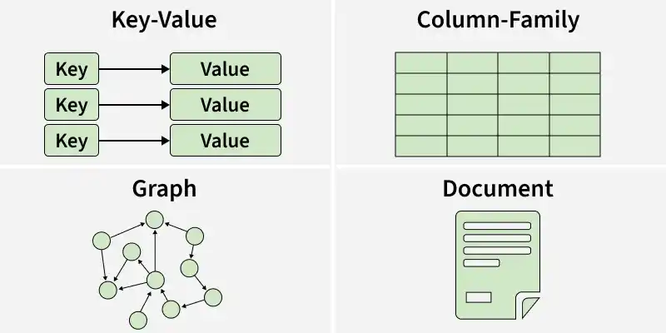
Each type has unique advantages and use cases, making NoSQL a preferred choice for big data applications, real-time analytics, cloud computing and distributed systems.

1. Document-Based Database
A document-based database is a non-relational database that stores data as documents, offering flexible schemas and efficient access aligned with application data models.
- Stores data in documents (JSON, BSON, or XML) instead of tables.
- Closely matches application data objects, reducing data translation.
- Uses collections to group related documents with similar content.
- Allows flexible schemas, so documents in a collection need not be identical.
Popular Document Databases & Use Cases
Database | Use Case
MongoDB | Content management, product catalogs, user profiles
CouchDB | Offline applications, mobile synchronization
Firebase Firestore | Real-time apps, chat application0s

2. Key-Value Stores
A key-value store is a non-relational database that stores data as simple key–value pairs, enabling fast and efficient data access.
- Each key uniquely identifies a value.
- Values can be simple or complex objects.
- Does not support structured schemas, relationships, or SQL-like querying as in relational databases.
Popular Key-Value Databases & Use Cases
Database | Use Case
Redis | Caching, real-time leaderboards, session storage
Memcached | High-speed in-memory caching
Amazon DynamoDB | Cloud-based scalable applications

3. Column Oriented Databases
A column-oriented database is a non-relational database that stores data by columns rather than rows, enabling efficient analytics and fast data retrieval.
- Read only required columns, reducing memory usage.
- Optimized for read-heavy analytical queries and large-scale data processing.
- Suitable for big data and distributed systems.
Popular Column-Oriented Databases & Use Cases
Database | Use Case
Apache Cassandra | Real-time analytics, IoT applications
Google Bigtable | Large-scale machine learning, time-series data
HBase | Hadoop ecosystem, distributed storage

4. Graph-Based Databases
Graph-based databases store data as nodes and relationships, making them ideal for managing and querying complex, interconnected data.
- Used where relationships are important (social networks, fraud detection).
- Supports flexible or optional schema rather than being completely schema-less.
- Efficiently traverses and analyzes connected data using relationships instead of joins.
Popular Graph Databases & Use Cases
Database | Use Case
Neo4j | Fraud detection, social networks
Amazon Neptune | Knowledge graphs, AI recommendations
ArangoDB | Multi-model database, cybersecurity

MongoDB Introduction

MongoDB is a popular document-oriented NoSQL database that stores data in a flexible BSON format, enabling fast and efficient storage and retrieval. It is available under the SSPL, which is not recognized as an open-source license by the Open Source Initiative due to commercial use restrictions.
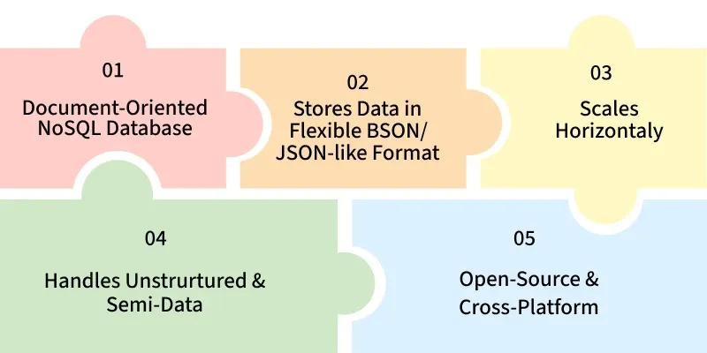

A simple MongoDB document Structure:
{
"_id": 1,
"title": "Geeksforgeeks",
"author": "John Smith",
"url": "https://www.geeksforgeeks.org/",
"tags": ["NoSQL", "Database", "Tutorial"],
"published": true,
"views": 1500
}
- _id: Unique identifier for the document.
- title, author, url: Basic fields storing strings.
- tags: An array of strings.
- published: A Boolean value.
- views: A number representing views or count.

Working of MongoDB
In a MongoDB sharded cluster, the components work together as follows:
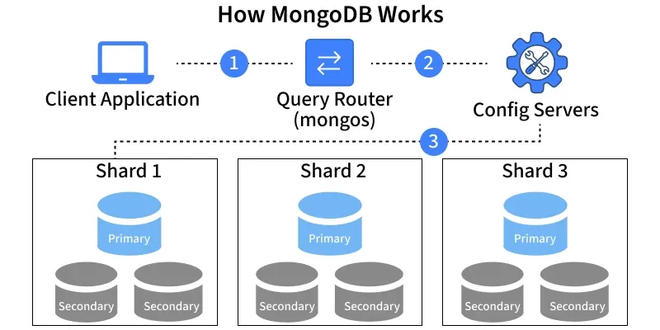
- Client Application: The application sends requests to MongoDB to read or write data.
- Query Router (mongos): The query router receives the client request and determines which shard should handle it.
- Config Servers: Store metadata about the cluster, including which data resides on which shard.
- Shards: Data is horizontally distributed across replica sets, with the primary handling writes and secondaries providing replication and reads.
- Primary Node: Handles all write operations.
- Secondary Nodes: Replicate data from the primary for high availability and read operations.

CRUD Operations
MongoDB provides several basic operations to manage and manipulate data efficiently:
- Create (Insert): Add new documents to a collection.
- Read (Find): Retrieve documents from a collection based on query criteria.
- Update: Modify existing documents in a collection.
- Delete: Remove documents from a collection.

Features of the MongoDB database
MongoDB offers several key features that make it efficient and scalable:
- Document Oriented: Stores all related data together in a single, flexible document rather than multiple tables.
- Indexing: Enables fast queries by avoiding full collection scans, crucial for handling large data efficiently.
- Scalability: Uses sharding to distribute data across multiple servers; easily add new machines to expand.
- Replication and High Availability: Stores multiple data copies on different servers for redundancy and fault tolerance.
- Aggregation: Processes and summarizes data (like SQL GROUP BY) using operations such as sum, avg, min, and max.



Real-World Applications of MongoDB


MongoDB powers a wide range of modern applications:
- Websites & Apps: Platforms like e-commerce sites use MongoDB to store product catalogs, user profiles, and order histories.
- Real-Time Analytics: Companies analyze user activity or sales trends on the fly, such as tracking popular products during a sale.
- Content Management & Personalization: Apps manage dynamic content and personalize recommendations, like suggesting movies based on viewing history.
- Big Data & IoT: MongoDB handles large volumes of unstructured data from sensors, logs, or social media feeds for processing and insights.

Language Support by MongoDB
MongoDB offers official drivers for many popular programming languages, enabling easy integration and database operations.
- C
- C++
- Rust
- C#
- Java
- Node.js
- Perl
- PHP
- Python
- Ruby
- Scala
- Go
- Erlang
Note: Unlike relational databases, MongoDB does not require a fixed schema, making it easier to adapt to changing application needs

Working of MongoDB
MongoDB is a document-oriented NoSQL database that stores data in BSON format with a flexible schema.
- Uses a document-based model instead of traditional tables.
- Supports flexible schema design for dynamic data.
- Efficiently handles large volumes of data with high scalability.

Components of MongoDB
MongoDB consists of core components that work together to store, manage, and retrieve data efficiently in a distributed environment.

1. Drivers
MongoDB drivers are client libraries that enable applications to connect to and interact with MongoDB databases using language-specific APIs.
- Provide interfaces and methods for database communication.
- Support multiple programming languages.
- Enable easy integration with applications.
- Popular drivers include C, C++, C#, .NET, Go, Java, Node.js, PHP, Python, Ruby, Scala, Swift, and Mongoid.

2. MongoDB Shell
MongoDB Shell is an interactive JavaScript-based command-line interface used to interact with MongoDB databases.
- Provides a CLI for working with MongoDB.
- Allows running queries and updating data.
- Supports administrative tasks such as backups and restores.

3. Storage Engine
The storage engine manages how data is stored and retrieved from memory and disk.
- Handles low-level data storage operations.
- Manages reading/writing data efficiently.
- Does not process queries or business logic.
- Default engine: WiredTiger.
MongoDB primarily uses the WiredTiger storage engine, with limited support for specialized engines.
Storage Engine | Description | Use Case
WiredTiger | Default and primary storage engine, it supports document-level concurrency and compression. | Ideal for most applications, including high-performance and write-intensive workloads.
In-Memory Engine | Stores data in RAM for ultra-fast access; data is not persisted after restart. | Suitable for caching and real-time, low-latency applications.

Working of MongoDB
MongoDB works on Application Layer and the Data Layer. The following image shows the working of MongoDB.


1. Application Layer
The Application Layer, also known as the abstraction layer, connects users to MongoDB by handling user interaction and server-side processing.
- Consists of two parts: Frontend and Backend
- Frontend (User Interface): Includes web and mobile applications used by users to interact with the system.
- Backend (Server): Handles server-side logic and communicates with MongoDB using drivers or the MongoDB shell.
- The frontend sends requests to the backend, which processes them and communicates with the MongoDB server in the Data Layer.

2. Data Layer
The Data Layer is responsible for storing and processing data in MongoDB, handling queries and managing data storage through core components.
- MongoDB Server: Receives queries from the application layer and forwards them to the storage engine.
- Storage Engine: Handles actual data read and write operations and manages data storage in memory and on disk.
Note: Reading and writing data from memory is much faster than from disk. MongoDB optimizes performance by using memory for frequently accessed data while relying on disk for long-term storage.

MongoDB Data Flow
This describes the internal flow of data across MongoDB components during operations:
- User Interaction: The user interacts with the application (frontend) and sends a request.
- Backend Processing: The backend server receives the request, processes it, and communicates with MongoDB using drivers or the MongoDB shell.
- MongoDB Server: The MongoDB server receives the request, processes the query, and determines the required data operations.
- Storage Engine: The storage engine performs data read/write operations in memory or on disk as instructed by the MongoDB server.
- Response Return: The result is sent back from MongoDB to the backend, and then to the frontend for the user.

Difference between RDBMS and MongoDB
RDBMS and MongoDB are widely used database systems that differ in their data models and scalability approaches.
- RDBMS follows a relational, table-based structure.
- MongoDB uses a document-based NoSQL model.
- RDBMS emphasizes fixed schemas and relationships.
- MongoDB offers flexible schemas and horizontal scalability.

MongoDB
MongoDB is an open-source, document-oriented NoSQL database designed for scalable and high-volume data storage in modern applications.
- Stores data in BSON (Binary JSON) format.
- Uses a document-based, non-relational data model.
- Supports schema-less and flexible data structures.
- Scales horizontally to handle large data volumes.
- Well-suited for distributed and modern applications.
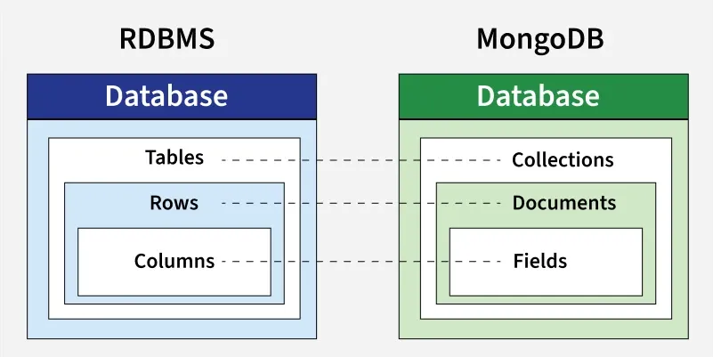

Features of MongoDB
Here are some features of MongoDB listed below:
- Multiple Servers: MongoDB can be configured to run across multiple servers to ensure high availability and fault tolerance.
- Schema-flexible Database: It allows data to be stored without requiring a predefined schema, making it highly flexible.
- Indexing: Any field within a document can be indexed, improving query performance.
- Rich Object Model: MongoDB supports a rich object model with advanced features for handling complex data.
- High Scalability: MongoDB offers horizontal scaling, allowing for seamless growth as data and traffic increase.
- Distributed Database: It can be distributed across multiple machines to handle large datasets and provide data redundancy.

RDBMS
RDBMS (Relational Database Management System) is a traditional database system that stores data in structured tables with fixed schemas, ensuring strong consistency, integrity, and security.
- Stores data in tables with rows and columns.
- Enforces a strict, predefined schema.
- Supports complex relationships between data.
- Provides strong consistency and data integrity.
- Common examples include MySQL, PostgreSQL, and Oracle.
- Ideal for applications with structured data and transactional requirements.

Features of RDBMS
- Data Security: RDBMS provides a high level of data security and integrity.
- Data Integrity: It ensures that data is accurate and consistent through constraints and normalization.
- ACID Compliance: RDBMS systems ensure data integrity through ACID properties—Atomicity, Consistency, Isolation, and Durability.
- Fixed Schema: RDBMS systems require a fixed schema, meaning that the structure of the data must be defined upfront.
- Scalability: Typically, RDBMS is vertically scalable by upgrading server resources, but it may struggle with horizontal scalability.
- Query Language: Uses SQL, a standard and powerful language for querying relational data.

Trade-Off Between RDBMS and MongoDB
- The trade-off between RDBMS and MongoDB lies in their strengths and limitations when it comes to performance and functionality.
- RDBMS excels in handling structured data with complex relationships, ensuring data integrity and supporting powerful SQL queries.
- MongoDB provides high performance, scalability, and flexibility, making it ideal for modern, data-intensive applications.
The following graph compares both systems on these parameters:
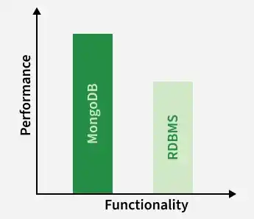

RDBMS Vs MongoDB
Here is a detailed comparison of RDBMS and MongoDB based on various features:
RDBMS | MongoDB
Relational database | Non-relational, document-oriented database
Stores data in tables with rows and columns | Stores data in flexible JSON-like documents (BSON)
Fixed, predefined schema | Schema-less, dynamic schema
Vertically scalable (increase resources like CPU/RAM) | Horizontally scalable (add more servers to handle increased load)
Strong focus on ACID properties | Supports ACID (limited/multi-document in newer versions)
Supports complex joins | Supports joins using $lookup (less powerful than SQL joins)
Row-based data storage | Document-based data storage
Slower for large, distributed datasets | Faster for large-scale, distributed data handling
High level of information security | Provides strong security features
Uses SQL for querying | Uses JSON-like query language
Less flexible for schema changes | Highly flexible for evolving data models
Limited indexing options | Extensive indexing on any field in the document
Suitable for structured data with well-defined relationships | Best for handling unstructured or semi-structured data
Backup and recovery options are manual | Automated backup and recovery options available
Can be deployed on-premises or cloud | Cloud-native and supports multi-cloud deployment
Ideal for transactional applications | Ideal for high scalability and big data applications

MongoDB Vs MySQL
MongoDB and MySQL are widely used database management systems, each built for different application needs. MongoDB focuses on flexibility and scalability, while MySQL emphasizes structured data and relational integrity.
- NoSQL, schema-flexible, highly scalable for unstructured or semi-structured data.
- Relational, schema-based, ideal for structured data and complex relationships.
- MongoDB and MySQL are both used in modern applications, depending on use case and scalability.

MongoDB
MongoDB is an open-source NoSQL document database that stores flexible, JSON-like BSON format data and is designed for scalable, large-scale applications with dynamic schemas.

Features of MongoDB
Here are some features of MongoDB:
- Flexible Schema: Data structure can evolve without affecting existing data.
- Scalability: Supports horizontal scaling using sharding.
- High Availability: Uses replica sets for fault tolerance.
- Document-Oriented: Stores data as BSON documents.
- Indexing: Supports compound, text, geospatial, and hashed indexes.
- Aggregation: Provides powerful data processing and transformation tools.
- ACID Transactions: Supports multi-document ACID transactions (in modern versions).

Use Cases of MongoDB
- Real-time analytics
- Big Data applications
- Content management systems
- IoT applications
- Mobile applications that require rapid scaling

MySQL
MySQL is an open-source relational database (RDBMS) that uses SQL to manage structured data stored in tables with predefined schemas.

Features of MySQL
Here are some features of MySQL:
- Structured Data: Data is stored in tables with rows and columns, adhering to a predefined schema.
- ACID Compliance: MySQL guarantees ACID (Atomicity, Consistency, Isolation, Durability) properties for transactions, ensuring data integrity.
- Joins: Supports complex queries with joins to combine multiple tables, making it ideal for complex data relationships.
- Replication: Supports source-replica replication for high availability.
- Indexing: Supports indexing to speed up query execution, including primary, secondary, and full-text indexes.
- SQL Queries: Uses SQL for querying, making it easier for developers familiar with relational databases.

Use Cases of MySQL
- E-commerce platforms
- Banking and financial applications
- Customer relationship management (CRM) systems
- Enterprise resource planning (ERP) systems.

Difference Between MongoDB and MySQL
Here is a detailed comparison of MongoDB and MySQL based on various features:
MongoDB | MySQL
NoSQL, document-oriented database | SQL, relational database
Flexible schema with collections and documents | Structured data with tables and rows
Uses MongoDB Query Language (MQL) | Uses Structured Query Language (SQL)
Horizontally scalable using sharding | Primarily Vertically scalable
High performance with large data sets | Excellent for complex queries and joins
Eventual consistency (ACID compliance) | Strong consistency with ACID compliance
Schema-less, dynamic schema design | Fixed schema with predefined tables
MongoDB supports multi-document ACID transactions | Full ACID support for multi-row transactions
Ideal for Big Data and Real-time Analytics | Ideal for enterprise and transactional systems
Supports various types of indexes (hashed, compound) | Supports various indexes (primary, unique, full-text)
Best suited for unstructured or semi-structured data | Best suited for structured data

MongoDB - Database, Collection, and Document
MongoDB is a NoSQL database that stores data in a flexible structure. A database is like a container for data, a collection is a group of related records, and a document is a single record stored in JSON-like format.
- MongoDB can have many databases on one server, each separate from the others.
- It creates three default databases: admin, local, and config (used internally).
- A new database is made automatically when you insert data into it or switch using use <dbname>.
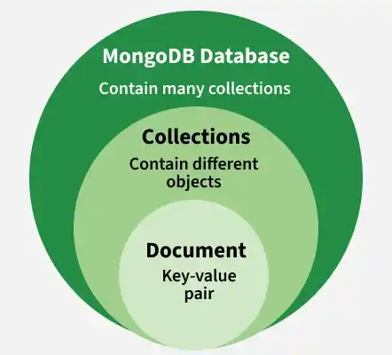

View Database
To see how many databases are present in your MongoDB server, write the following statement in the mongo shell:
show dbs
Here, we freshly started MongoDB, so we do not have a database except for these three default databases, i.e., admin, config, and local.
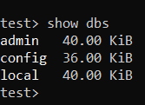
The use GeeksforGeeks command creates and switches to a database, but it does not appear in the database list until at least one document is inserted.
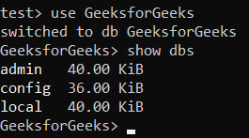

Naming Restriction for Database
Before creating a database we should first learn about the naming restrictions for databases:
- Database names must be case-sensitive.
- The names cannot contain special characters such as /, ., $, *, |, etc.
- MongoDB database names cannot contain null characters(in windows, Unix, and Linux systems).
- MongoDB database names cannot be empty and must contain less than 64 characters.
For windows user, MongoDB database names cannot contain any of these following characters:
/\. "$*:|?
For Unix and Linux users, MongoDB database names cannot contain any of these following characters:
/\. "$
Example:
use LibraryDB # Switch to the LibraryDB database

Collection in MongoDB
A Collection in MongoDB is similar to a table in relational databases. It holds a group of documents and is a part of a database. Collections provide structure to data, but like the rest of MongoDB, they are schema-flexible.
- Schema-flexible: MongoDB collections can store documents with different structures, and documents in the same collection don’t need to follow a uniform schema.
- Multiple Collections: A database can have multiple collections, each holding different types of documents.
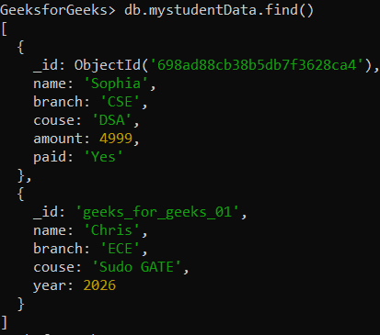

Naming Restrictions for Collection
Before creating a collection we should first learn about the naming restrictions for collections:
- Collection name must start with an underscore(`_`) or a letter (a-z or A-Z)
- Collection names must not start with a number, contain $, null characters, or begin with the reserved system. prefix.
- The maximum length of the collection name is 120 bytes(including the database name, dot separator, and the collection name).
Example:
db.books.insertOne({ title: "Learn MongoDB", author: "Jane Doe", year: 2023 })

Creating collection
After creating database now we create a collection to store documents. The collection is created using the following syntax:
db.collection_name.insertOne({..})
Here, insertOne() function is used to store single data in the specified collection. And in the curly braces {} we store our data or in other words, it is a document.
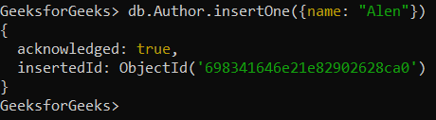
- Creates the Author collection.
- Inserts a document using insertOne().
- { name: "Alen" } is a document with name as the field.
- MongoDB confirms insertion with acknowledged: true.
- A unique _id is automatically generated (custom IDs are allowed).

Document in MongoDB
MongoDB stores data as BSON documents, a binary form of JSON that supports additional data types.
- Data is stored as BSON (Binary JSON) documents.
- BSON supports more data types than JSON.
- Documents use field–value (key–value) pairs.
- Field values can be of any BSON-supported type.
Syntax:
{
field1: value1
field2: value2
....
fieldN: valueN
}

Document Structure
A document in MongoDB is a flexible data structure made up of field-value pairs. For instance:
{
title: "MongoDB Basics",
author: "John Doe",
year: 2025
}

Naming restriction for Document Fields
Before moving further first you should learn about the naming restrictions for fields:
- Fields in documents must be named with strings
- The _id field is a reserved primary key that must be unique, immutable, and cannot be an array.
- The field name cannot contain null characters.
- The top-level field names should not start with a dollar sign($).

Document Size
- Maximum BSON document size: 16MB, preventing excessive RAM or bandwidth usage.
- For larger data, MongoDB provides GridFS.
- Documents can contain duplicate fields.
- Field order in MongoDB documents is preserved as inserted. The _id field is not required to be the first field. Renaming fields may affect their order.

_id Field in MongoDB
Every document must have a unique _id field, acting like a primary key.
- Automatic ObjectId: If _id is not provided, MongoDB generates a unique ObjectId.
- Custom _id: Users can assign a custom unique value for _id.
Example with ObjectId
The name, branch, course, and paid fields are strings, the amount field is an integer, and the _id field is system-generated.
Example with Custom _id
- The _id field is explicitly created by the user.
- Always paste the data inside the function before closing the parenthesis.
- Closing the parenthesis early results in a syntax error.

Differences Between Databases, Collections, and Documents
MongoDB organizes data hierarchically into databases, collections, and documents, each serving a distinct purpose.
- Database: A container for collections, providing structure and logical isolation for data.
- Collection: A group of documents within a database, similar to a table in relational databases.
- Document: A single data record within a collection, stored as a BSON object.
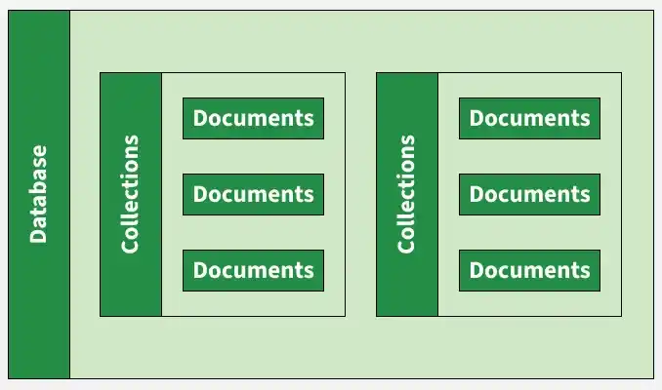

Creating a Database, Collection, and Document
Here’s how you can create a database, collection, and document in MongoDB step by step:
1. Create or Switch to a Database
use LibraryDB
2. Create a Collection and Insert a Document
db.books.insertOne({
title: "MongoDB for Beginners",
author: "Alice Johnson",
year: 2023
})
3. Verify the Insertion
db.books.find()
This will display the document stored in the books collection within the LibraryDB database.
Note: MongoDB automatically creates a unique index on the _id field for every collection. This index helps MongoDB quickly find documents based on their unique identifier.

MongoDB Cursor
In MongoDB, a cursor is an object that represents the result set of a query and allows efficient access to documents returned by methods like find().
- Automatically created when a query like find() is executed.
- Allows iteration over query results, either automatically or manually.
- Retrieves documents efficiently without loading all data into memory.
- Suitable for handling large datasets.
- Provides methods to access, manipulate, and optimize query results.
- Cursors expire after 10 minutes of inactivity, so proper management is required.
Suppose we have the following setup
- Database: gfg
- Collection: student
- Documents: Three documents contain the details of the students
Here, we use the following query to display all the documents present in the student collection
db.student.find().pretty()
This find() method returns a cursor containing all documents present in the student collection.
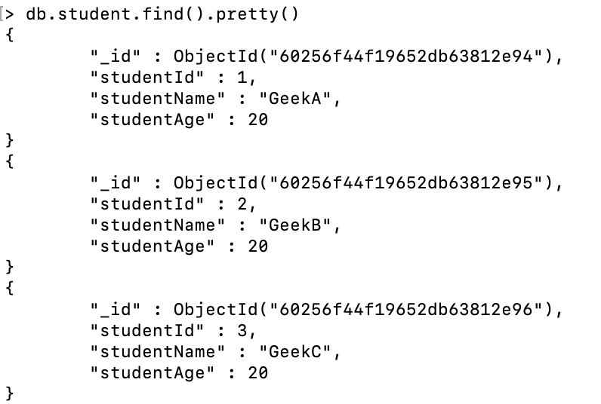

Manually Iterating a Cursor in MongoDB
While MongoDB automatically iterates over the cursor to fetch documents, you can manually iterate it using various techniques. Here are the most common ways to iterate a cursor:

1. Assigning Cursor to a Var Keyword
In MongoDB, the find() method returns the cursor, now to access the document we need to iterate the cursor. To iterate a cursor manually, simply assign the cursor return by the find() method to the var keyword Or JavaScript variable.
Note: In the Mongo shell, cursors not assigned to a variable auto-display up to 20 documents, and inactive cursors are automatically closed after 10 minutes.
Syntax:
var name = db.collection_name.find()
name
Example :
var mycursor = db.student.find({studentId:3}).pretty()
mycursor
We iterate the cursor manually to find the document whose studentId is 3. So, we assigned the cursor returned by the find() method to the JavaScript variable(i.e. mycursor).
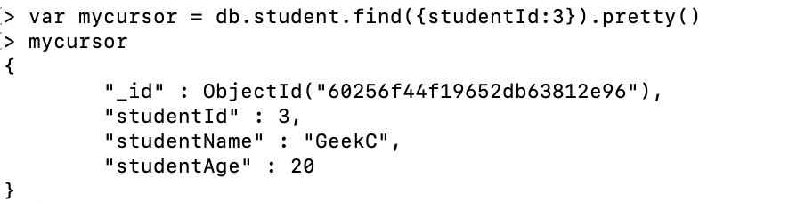

2. Using the next() Method
We can also use the next() cursor method to access the next document. We can use this method to manually iterate through the documents one by one.
Example:
var mycursor = db.student.find({studentId:{$gt:1}});
> while(mycursor.hasNext()){
... print(tojson(mycursor.next()));
... }
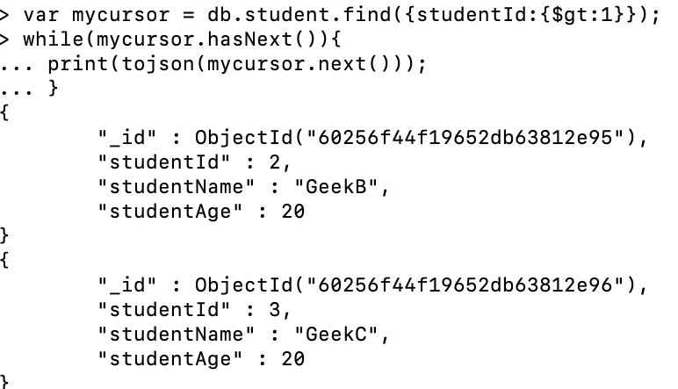
- Only documents with studentId > 1 are retrieved.
- The first document is skipped, so studentId 2 and 3 are displayed.
- The cursor starts from the filtered result set.
- print(tojson()) is used to display the output.
- printjson() can also be used to display the result.

3. Using the forEach() Method
The forEach() method allows us to apply a JavaScript function to each document in the cursor. This is an easy way to process each document without explicitly using a loop.
Syntax:
db.collection.find().forEach(<function>)
Example:
var mycursor = db.student.find({studentId:3}).pretty()
mycursor.forEach(printjson)
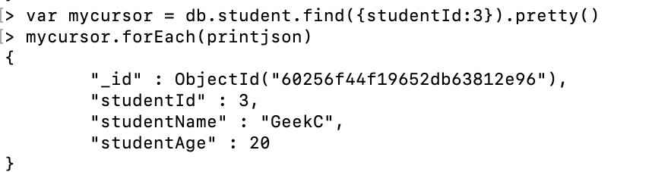
- The cursor returned by find({ studentId: 3 }) is stored in the mycursor variable.
- forEach() is used to iterate over the cursor.
- printjson() is used to display the resulting document.

4. Using the toArray() Method
In Mongo shell, we are allowed to iterate the cursor and display the resultant document in the array using the toArray() method.
Syntax:
cursor.toArray()
Example:
var mycursor = db.student.find()
var docs = mycursor.toArray()
var resultdoc = docs[0]
resultdoc
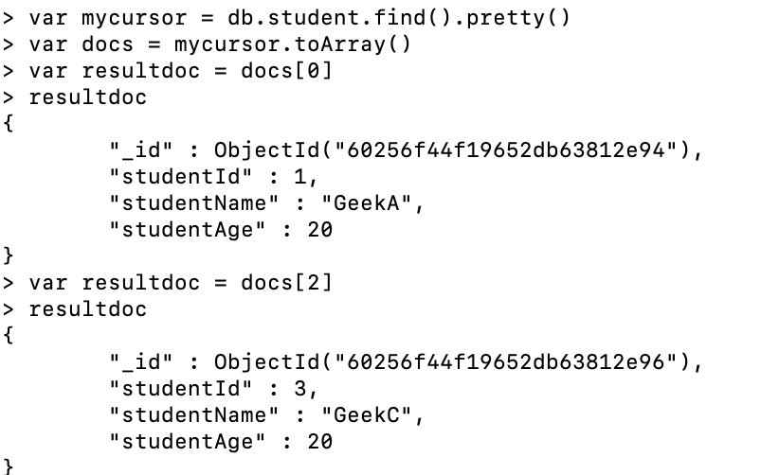
- The cursor returned by the query is stored in mycursor.
- The cursor is converted into an array using toArray() and stored in docs.
- Documents are accessed using array indexes.
- docs[0] retrieves the first document in the result set.

5. Alternate Method: Accessing Documents Using Index
We can also this method to access a document using index on the cursor.
Example:
var mycursor = db.student.find().pretty()
var docs = mycursor.toArray()
var resultdoc = docs[0]
resultdoc
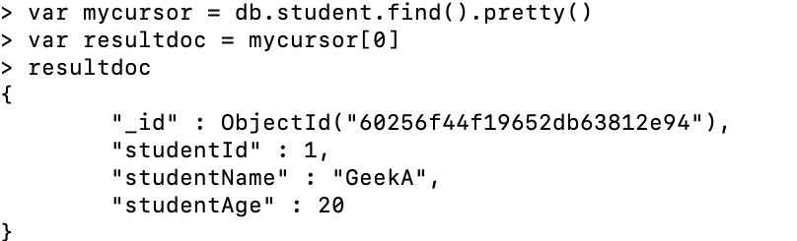

Commonly Used MongoDB Cursor Methods
MongoDB offers various cursor methods to enhance query functionality. Here are some of the most commonly used cursor methods:

1. count() Method
In order to get the correct documents, we need to know how many documents are present for that collection. To get that we can use the count() method which returns the total number of documents present in the given collection.
Syntax:
db.collection_name.countDocuments()
Example:
db.students.find().countDocuments()
Here, we find the total number of documents present in the student collection using the count() method.
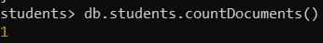

2. limit() Method
The limit() method helps to fetch limited records from a collection. Suppose we have multiple documents, but we want to have the topmost or only 2 documents, then by using the limit() method, we can achieve that.
Syntax:
db.collection_name.find().limit(<number>)
Example:
db.student.find().limit(2).pretty()
Here, we only display the first two documents from the student collection.
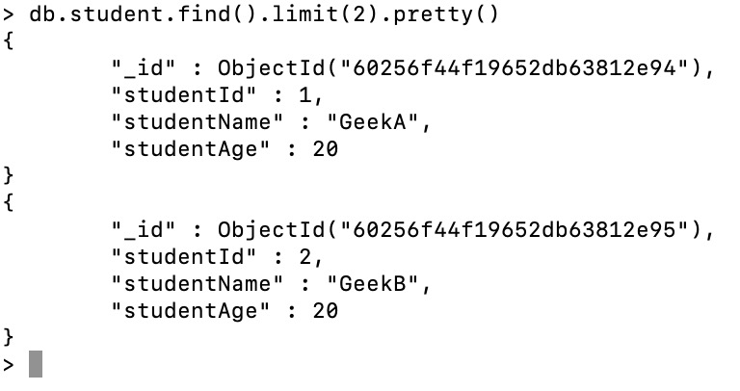

3. sort() Method
When verifying documents in a database, sorted output makes analysis easier. The sort() method is used to arrange documents in ascending order by setting the field value to 1 or in descending order by setting it to -1.
Syntax:
db.collection_name.find().sort(<sort>)
Example:
db.student.find().sort({studentId:-1}).pretty()
We sort all the documents present in the student collection in descending order.
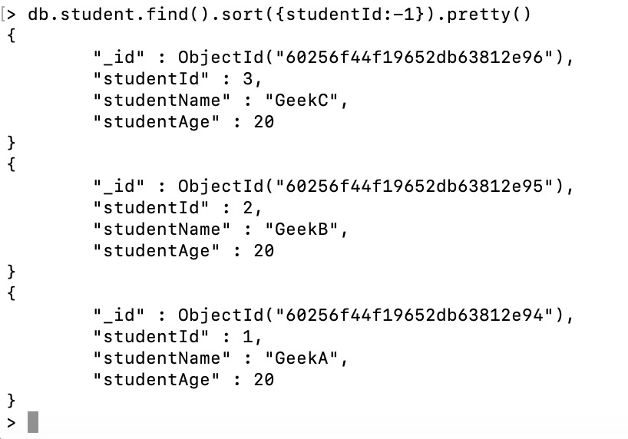

4. toArray() Method
The toArray() method converts the cursor into an array of documents, making it easy to access documents by index.
Syntax:
db.collection_name.find().toArray()
Example:
db.student.find().toArray()
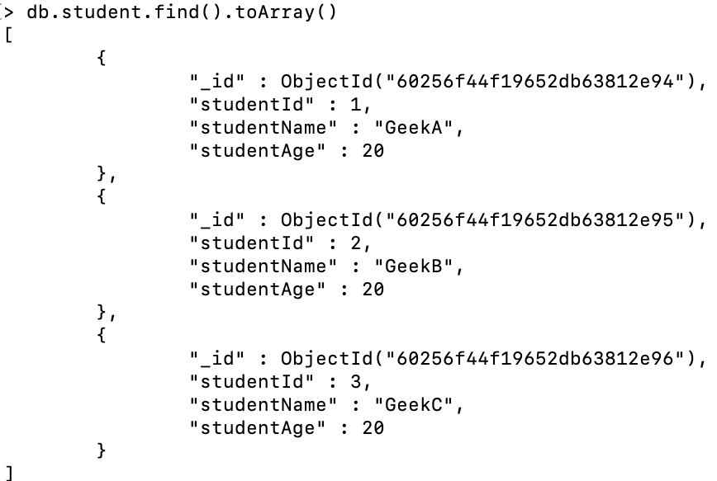

5. next() Method
The next() method returns the next document from a cursor in MongoDB.
Syntax:
db.collection_name.find().next()
Example:
db.student.find().next()
Here, the next() method returns the first document from the collection.
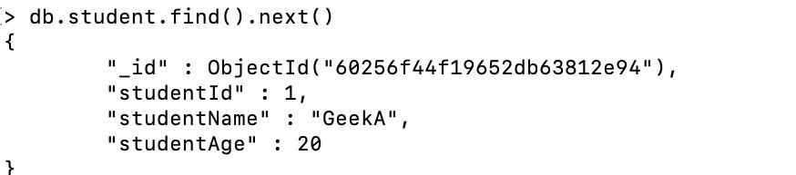

Additional Cursor Methods in MongoDB
MongoDB provides additional advanced cursor methods for more specialized functionality:
Method Name | Description
cursor.addOption() | This method is used to add special wire protocol flags and modify the behavior of the query.
cursor.allowDiskUse() | This method allows MongoDB to use temporary files on disk to store data exceeding the 100-megabyte system memory limit while processing a blocking sort operation.
cursor.allowPartialResults() | This method allows find() operation against a collection to return partial results, rather than an error if one or more queried shards are unavailable.
cursor.batchSize() | This method is used to control the number of documents MongoDB will return to the client in a single network message.
cursor.close() | This method is used to close a cursor and free associated server resources.
cursor.isClosed() | This method is used to return true if the cursor is closed.
cursor.collation() | This method is used to specify the collation for the cursor that is returned by the find() method.
cursor.comment() | This method is used to attacha exhausts a comment to the query to allow for traceability in the logs and the system.profile collection.
cursor.explain() | This method is used to report on the query execution plan for a cursor.
cursor.forEach() | This function is used to apply a JavaScript function for every document present in the cursor.
cursor.hasNext() | This method returns true if the cursor has more documents and can be iterated.
cursor.hint() | This method forces MongoDB to use a specific index for a query.
cursor.isExhausted() | When the cursor is closed and there are no objects remaining in the batch, this method returns true
cursor.itcount() | cursor.count() and itcount() are both similar only. In itcount(), execution on an existing iterator, exhausting its contents in the process.
cursor.map() | Output is available in an array by applying a function to each document in a cursor.
cursor.max() | This method is used to specify an exclusive upper index bound for the cursor.
cursor.maxTimeMS() | This method sets the maximum execution time in milliseconds for operations on a cursor.
cursor.min() | This method is used to specify inclusive lower index bound for a cursor.
cursor.next() | This method is used to retrieve the next document in a cursor.
cursor.noCursorTimeout() | This method instructs the server to avoid closing a cursor automatically after a period of inactivity.
cursor.objsLeftInBatch() | This method is used to find the number of documents left in the current cursor batch.
cursor.pretty() | This method is used to display the results in an easy-to-read manner.
cursor.readConcern() | A read concern is specified for a find() operation.
cursor.readPref() | This method specified a read preference to a cursor to control how the client directs queries to a replica set.
cursor.returnKey() | The returnKey() method modifies the cursor to return only index keys instead of full documents.
cursor.showRecordId() | This method adds an internal storage engine ID field which is returned by the cursor.
cursor.skip() | During the display of documents, we may be required to skip few documents due to various reasons. During that time, skip() helps to display results after skipping a number of documents.
cursor.tailable() | The method is marked as tailable with the cursors of capped collections.

Data Types in MongoDB
In MongoDB, data types specify the kind of values a field can store, such as strings, numbers, or dates. Selecting appropriate data types ensures efficient storage, accurate queries, and better performance.
- Define how data is stored and processed in the database.
- Impact query performance and indexing behavior.
- Help maintain data consistency and efficient data modeling.
Below are the most commonly used MongoDB data types.

1. Integer
In MongoDB, the integer data type is used to store an integer value. We can store integer data type in two forms 32-bit signed integer and 64-bit signed integer. These are used to store whole numbers, such as ages, counts, or any other numerical data that doesn't require decimal points.
Example: We are storing the age of the student in the student collection:
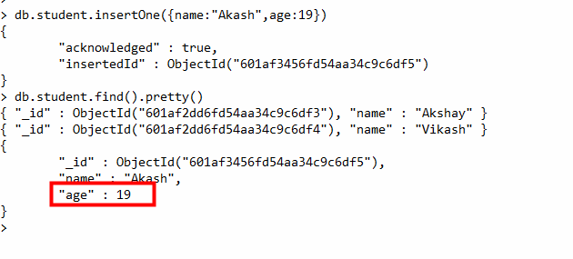
- age is stored as an integer.
- It can be represented as either a 32-bit or 64-bit signed integer.
- It is Suitable for storing whole numbers.

2. Double
The double data type is used for storing floating-point numbers (decimal values). It's commonly used for storing data that requires decimal precision, such as prices, percentages, or scores.
Example: We are storing the marks of the student in the student collection:
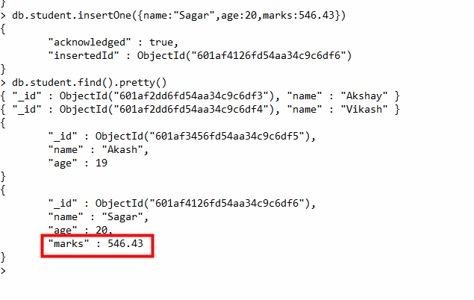
- marks is stored as a double to store the decimal value.
- It is used to store floating-point numbers.
- It is Ideal for data requiring decimal precision.

3. Boolean
The boolean data type stores one of two values: true or false. It's used for representing binary states, such as "active/inactive" or "pass/fail."
Example: We are storing the final result of the student as pass or fail in boolean values.
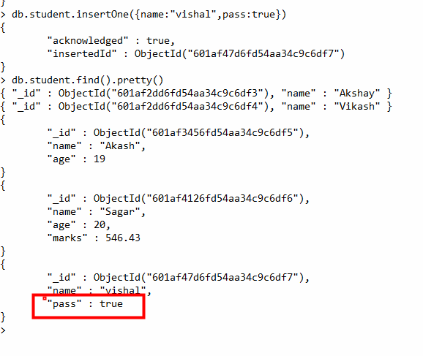
- the passed field is a boolean value indicating whether the student passed or failed.
- It Stores true or false values.
- It is Commonly used for binary states.

4. Null
The null data type stores a null value. This is useful when you want to represent the absence of data, such as an optional field that may not be set.
Example: The student does not have a mobile number so the number field contains the value null.
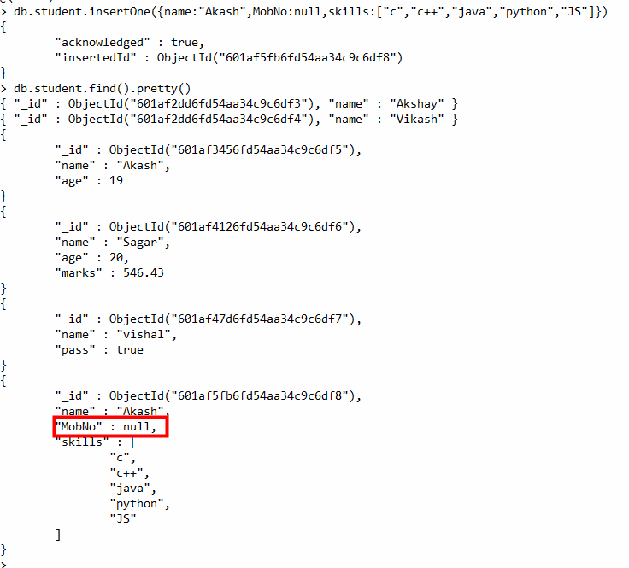
- Here, phone_number is set to null, indicating that the student has not provided a phone number.
- It Represents the absence of data.
- It is used for missing or undefined values.

5. Array
The array data type allows us to store multiple values in a single field.MongoDB arrays can contain values of the same or different data types, providing flexibility in how you store collections of related data. In MongoDB, the array is created using square brackets([]).
Example: We are storing the technical skills of the student as an array.
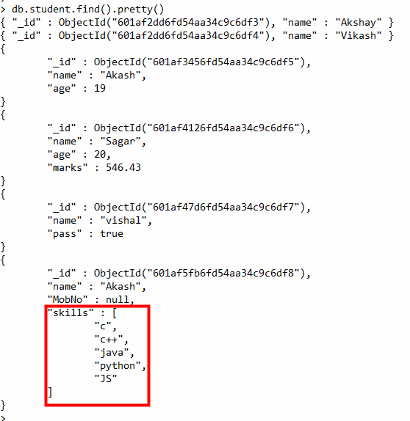
- the skills field stores an array of strings representing the student's technical skills.
- It is used to Store multiple values in a single field.
- It can hold values of different data types.

6. Object (Embedded Document)
Object data type stores embedded documents. Embedded documents are also known as nested documents. Embedded document or nested documents are those types of documents which contain a document inside another document. Embedded documents allow us to structure our data hierarchically, which is useful for representing more complex data models.
Example: We are storing all the information about a book in an embedded document.
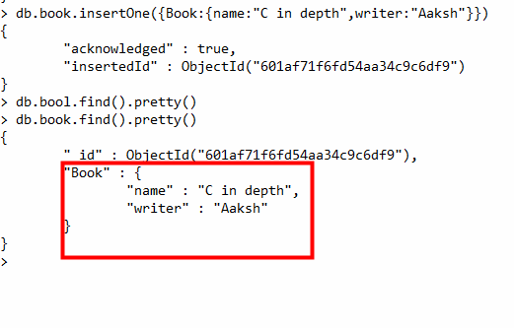
- Here, the book field stores an embedded document with properties like title, author, and published.
- It is used to Store nested documents.
- It is useful for hierarchical data structures.

7. ObjectId
Whenever we create a new document in the collection MongoDB automatically creates a unique objectId for that document(if the document does not have it). There is an _id field in MongoDB for each document. The data which is stored in Id is of hexadecimal format and the length of the id is 12 bytes which consist:
- 4-bytes for Timestamp value.
- 5-bytes for Random values. i.e., 3-bytes for machine Id and 2-bytes for process Id.
- 3- bytes for Counter
We can also create your own id field, but make sure that the value of that id field must be unique.
Example: When we insert a new document it creates a new unique objectId for it.

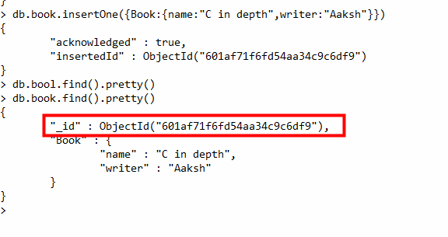
- MongoDB automatically generates a unique _id for each document.
- Unique identifier for each document.
- Automatically generated by MongoDB.

8. Undefined
The undefined data type represents a value that is not defined. It is rarely used in modern MongoDB applications, as it has been replaced by the null value for most practical purposes.
Example: The type of the duration of the project is undefined.
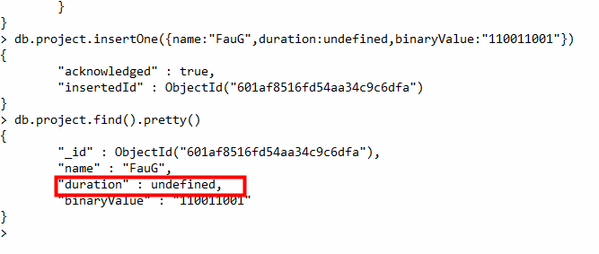
- the duration field is set to undefined.
- It is used to represents an undefined value.
- It is typically replaced by null value.

9. Binary Data
The binary data type stores binary information such as images, files, or encrypted data. Binary data is often used when working with non-textual data.
Example: The value stored in the binaryValue field is of binary type.
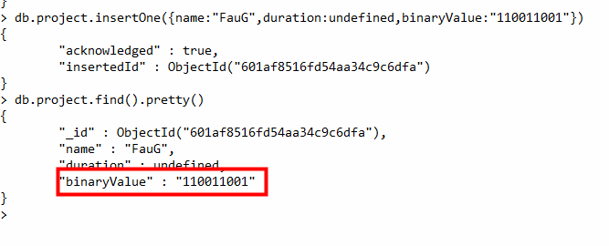
- Here, the image field stores binary data.
- It is used for storing non-textual data (e.g., images, files).
- It is stored as binary data.

10. Date
Date data type stores date. It is a 64-bit integer which represents the number of milliseconds. BSON data type generally supports UTC datetime and it is signed. If the value of the date data type is negative then it represents the dates before 1970. There are various methods to return date, it can be returned either as a string or as a date object. Some method for the date handling:
- Date(): It returns the current date in string format.
- new Date(): It returns a date object. It uses the ISODate() wrapper.
- new ISODate(): It also returns a date object. It uses the ISODate() wrapper.
Example: We are using all the above method of the date:
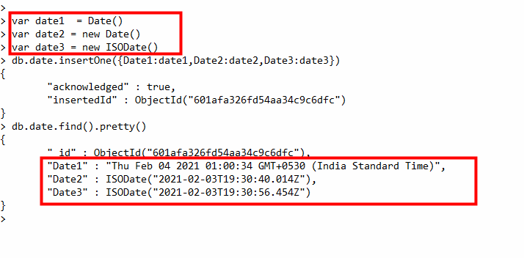
- the created_at field stores the current date and time.
- It is used to store dates and times as 64-bit integers.
- It is commonly used for timestamps.

11. Min & Max key
The MinKey and MaxKey data types are used for internal comparisons. MinKey represents the lowest BSON element, while MaxKey represents the highest.
Example:
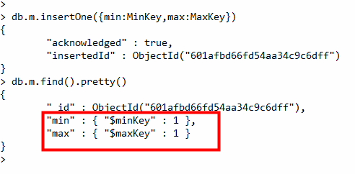
- It is used for internal comparisons in queries.
- It is used to represent the lowest and highest BSON elements.

12. Regular Expression
The regular expression data type is used to store regex patterns. MongoDB supports regex queries for performing pattern matching on string fields.
Example: We are storing the regular expression gfg:
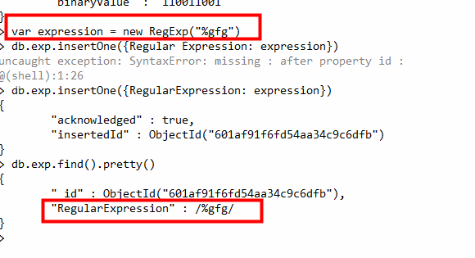
- The name field stores a regular expression to match names that contain "John" case-insensitively.
- It is used for pattern matching with regular expressions.
- It is useful for querying string data.

13. JavaScript
MongoDB allows us to store JavaScript code within documents using the JavaScript data type. This can be useful for storing code or expressions.
Example: We are using the JavaScript syntax in the shell:

- It is used to store JavaScript code.
- It is useful for embedded code or expressions.

14. JavaScript with Scope
The JavaScript with Scope data type in MongoDB was used to store JavaScript code along with its scope (variables and functions). This feature has been deprecated in MongoDB 4.4 and is no longer recommended for use.
Example: In this example, we are using the JavaScript syntax in the shell:

- It is used for storing JavaScript code with scope.
- it is deprecated in MongoDB 4.4.
- It Uses alternatives like aggregation pipelines or external languages for dynamic code execution.

15. Timestamp
In MongoDB, this data type is used to store a timestamp. It is useful when we modify our data to keep a record and the value of this data type is 64-bit. The value of the timestamp data type is always unique.
Example:
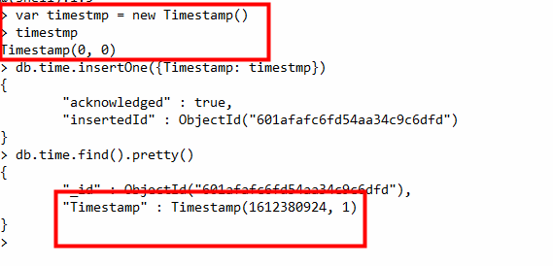
- The updated_at field stores a timestamp value.
- It is used for time tracking.
- It is used to store a 64-bit value

16. Decimal
This MongoDB data type stores 128-bit decimal-based floating-point value. This data type was introduced in MongoDB version 3.4
Example:
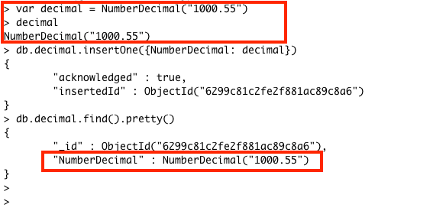
Decimal data type

ObjectId in MongoDB
The _id field uniquely identifies each MongoDB document, using ObjectId by default to ensure uniqueness and efficient data management.
- Every document contains a unique _id field.
- Acts as the primary key for documents in a collection.
- Default _id type is ObjectId.
- ObjectId is a 12-byte BSON data type.
- Provides a very high probability of uniqueness.
- Embeds metadata such as the creation timestamp.

ObjectId Structure
The ObjectId is composed of 12 bytes, broken down as follows:
- The ObjectId is 12 bytes in total.
- The first 4 bytes store the Unix timestamp.
- The next 5 bytes store a random value (used for uniqueness in modern MongoDB implementations).
- The last 3 bytes are used as a counter for uniqueness.
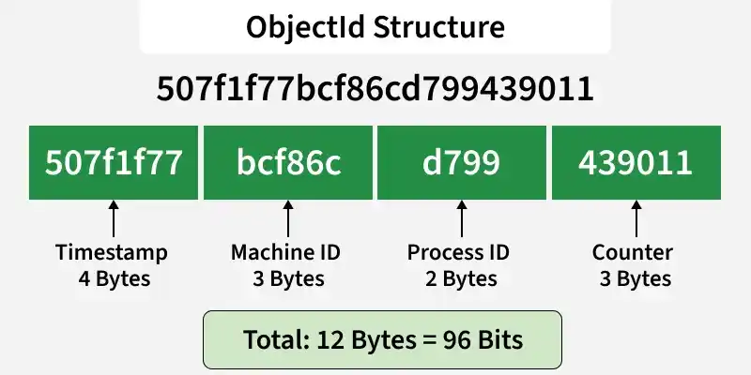
The ObjectId is represented as a hexadecimal string, and its default format is:
ObjectId(<hexadecimal>)
ObjectId is a 12-byte unique identifier represented as a 24-character hexadecimal string, automatically generated by MongoDB but can be custom-defined if unique.
db.collection.insertOne({ _id: ObjectId("64f1a2b3c4d5e6f789012345") })
Example of ObjectId in MongoDB
When we insert a document into a collection, MongoDB automatically assigns a unique_id using the ObjectId format.
- Database : gfg
- Collection: student_gfg
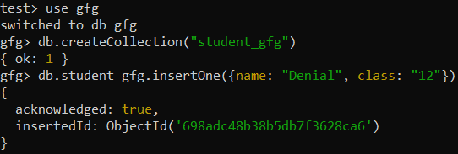
- MongoDB automatically generates a unique _id for the document.
- The document is inserted into the student_gfg collection.
- The _id field is assigned an ObjectId value by default.

Methods of MongoDB ObjectId
MongoDB provides several useful methods to interact with the ObjectId. These methods allow you to access the timestamp, convert the ObjectId to a string, and more.
- toString(): Returns the ObjectId as a 24-character hexadecimal string.
- getTimestamp(): Returns the timestamp portion of the ObjectId as a Date.
- valueOf(): Returns the ObjectId value (generally same as its string representation).

1. Creating an ObjectId
We can generate a new ObjectId using the ObjectId() constructor.
newObjectId = ObjectId()
Output:
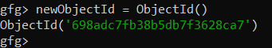

2. Getting the Timestamp from ObjectId
We can retrieve the creation timestamp of the ObjectId using the getTimestamp() method. This method returns the timestamp as a Date object.
var id =new ObjectId();
id.getTimestamp()
Output:
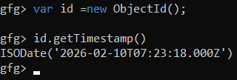

3. Converting ObjectId to String
We can convert an ObjectId into its string format using the str property.
new ObjectId().toString()
Output:
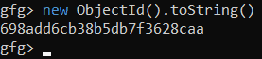

4. Getting the Hexadecimal Representation
You can also use the valueOf() method to get the hexadecimal representation of the ObjectId.
new ObjectId().valueOf()
Output:
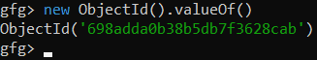

Using ObjectId for Querying
Since ObjectId is used as the default unique identifier for MongoDB documents, we can use it to efficiently query for documents by their _id.
db.student_gfg.findOne({ _id: ObjectId("5f92cbf10cf217478ba93561") })
In this query, the ObjectId is used to retrieve a document with a specific _id. Since ObjectId is indexed, these queries are very efficient.

Usage of ObjectId Vs Custom _id
- Use ObjectId: When you need an automatically generated unique identifier with a timestamp and efficient indexing.
- Use Custom _id: When you need to control the identifier format or when you already have a unique identifier (e.g., a UUID or an existing system-generated ID).

MongoDB Query
A MongoDB query is used to retrieve documents from a collection based on specified conditions, using a JavaScript-like syntax.
- Queries request specific data from the database.
- Use JavaScript-like syntax instead of SQL.
- find() is the most commonly used query method.
- Supports simple and advanced query conditions.
- Useful for both basic data retrieval and complex querying.

Working with MongoDB Queries
MongoDB queries are executed using db.collection.find(), where conditions and operators like $eq, $gte, $lte, $in, $or, and $and are used to filter documents.
db.collection_name.find({ field: value })
This query will retrieve all documents from the articles collection where the author field is equal to "Alen".
db.articles.find({ author: "Alen" })

MongoDB Query Return Value
A MongoDB query returns a cursor pointing to matching documents, which can be iterated over and formatted using .pretty(), or empty if no matches are found.

Setting Up the Environment
Before we dive into various MongoDB query examples, let’s set up a collection named articles to practice different query operations. Below is a sample of the documents in the articles collection:
Query:
[
{
"_id": ObjectId("6009585d35cce6b7b8f087f1"),
"title": "Math",
"author": "Alen",
"level": "basic",
"length": 230,
"example": 11
},
{
"_id": ObjectId("60095b8a3fc110f90873ce29"),
"title": "Array",
"author": "Alen",
"level": "basic",
"length": 200,
"example": 5
},
{
"_id": ObjectId("60095b8a3fc110f90873ce2a"),
"title": "Stack",
"author": "Rim",
"level": "easy",
"length": 400,
"example": 10
},
{
"_id": ObjectId("60095b8a3fc110f90873ce2b"),
"title": "Queue",
"author": "Rim",
"level": "medium",
"length": 350,
"example": 2
},
{
"_id": ObjectId("60095b8a3fc110f90873ce2c"),
"title": "Tree",
"author": "devil",
"level": "high",
"length": 1000,
"example": 10
},
{
"_id": ObjectId("60095b8a3fc110f90873ce2d"),
"title": "Graph",
"author": "Alen",
"level": "high",
"length": 1500,
"example": 15
},
{
"_id": ObjectId("60095b8d3fc110f90873ce2e"),
"title": "Segment Tree",
"author": "devil",
"level": "very high",
"length": 500,
"example": 20
},
{
"_id": ObjectId("60095fd4e5a7731b2a55a922"),
"title": "Trie",
"author": "Rim",
"length": 500,
"example": 20,
"time": 50
}
]

Basic Query Operations
Basic query operations in MongoDB allow you to retrieve data from collections using simple conditions. These operations include retrieving all documents, filtering by specific field values, and limiting the number of results returned.

1. Select Single Documents in a Collection
findOne() retrieves the first document that matches the given filter criteria, or returns null if no matching document is found.
Syntax:
db.collection_name.findOne ()
Example:
db.article.findOne()
Output:
test> db.article.findOne()
{
_id: ObjectId('6009585d35cce6b7b8f087f1'),
title: 'Math',
author: 'Alen',
level: 'basic',
length: 230,
example: 11
}
Here, we are going to display the first document of the article collection where the author is "Alen".

2. Select All Documents in a Collection
find() retrieves all documents from a collection and returns a cursor, with optional conditions for filtering and .pretty() for readable output.
Example:
db.article.find().pretty()
Output:
[
{
_id: ObjectId('6009585d35cce6b7b8f087f1'),
title: 'Math',
author: 'Alen',
level: 'basic',
length: 230,
example: 11
},
{
_id: ObjectId('60095b8a3fc110f90873ce29'),
title: 'Array',
author: 'Alen',
level: 'basic',
length: 200,
example: 5
},
{
_id: ObjectId('60095b8a3fc110f90873ce2a'),
title: 'Stack',
author: 'Rim',
level: 'easy',
length: 400,
example: 10
},
{
_id: ObjectId('60095b8a3fc110f90873ce2b'),
title: 'Queue',
author: 'Rim',
level: 'medium',
length: 350,
example: 2
},
{
_id: ObjectId('60095b8a3fc110f90873ce2c'),
title: 'Tree',
author: 'devil',
level: 'high',
length: 1000,
example: 10
},
{
_id: ObjectId('60095b8a3fc110f90873ce2d'),
title: 'Graph',
author: 'Alen',
level: 'high',
length: 1500,
example: 15
},
{
_id: ObjectId('60095b8d3fc110f90873ce2e'),
title: 'Segment Tree',
author: 'devil',
level: 'very high',
length: 500,
example: 20
},
{
_id: ObjectId('60095fd4e5a7731b2a55a922'),
title: 'Trie',
author: 'Rim',
length: 500,
example: 20,
time: 50
}
]
In the above Query, We have to display the documents of the article collection in a well-formatted way using pretty() method.

3. Filter Documents with Equality Condition
The equality operator($eq) is used to match the documents where the value of the field is equal to the specified value. In other words, the $eq operator is used to specify the equality condition.
Example:
Retrieve and display all documents from the 'article' collection where the author is "devil".
db.article.find({author:{$eq:"devil"}}).pretty()
Output:
[
{
_id: ObjectId('60095b8a3fc110f90873ce2c'),
title: 'Tree',
author: 'devil',
level: 'high',
length: 1000,
example: 10
},
{
_id: ObjectId('60095b8d3fc110f90873ce2e'),
title: 'Segment Tree',
author: 'devil',
level: 'very high',
length: 500,
example: 20
}
]
We have display the documents that matches the filter query(i.e., {author : {$eq : "devil"}}) from the article collection.

4. Filter Documents with Greater Than or Less Than Condition
Use $gte and $lte in find() to filter documents by numeric ranges (greater/less than or equal).
Syntax:
db.collection_name.find({< key > : {$gte : < value >}})
or
db.collection_name.find({< key > : {$lte : < value >}})
Example:
Retrieve and display all documents from the 'article' collection where the length is greater than or equal to 510.
db.article.find({length:{$gte:510}}).pretty()
Output:
[
{
_id: ObjectId('60095b8a3fc110f90873ce2c'),
title: 'Tree',
author: 'devil',
level: 'high',
length: 1000,
example: 10
},
{
_id: ObjectId('60095b8a3fc110f90873ce2d'),
title: 'Graph',
author: 'Alen',
level: 'high',
length: 1500,
example: 15
}
]
We have documented data which has the length attribute value greater than 510. So, we pass a filter query that is {length : {$gte : 510}} in the find() method.

5. Check the Existence of a Field
The $exists operator in MongoDB is used to check whether a specific field exists in the documents of a collection. This operator helps filter documents that either have or do not have a particular field, providing more flexibility in queries.
Example:
db.article.find({ time: { $exists: true } }).pretty()
Output:
[
{
_id: ObjectId('60095fd4e5a7731b2a55a922'),
title: 'Trie',
author: 'Rim,
length: 500,
example: 20,
time: 50
}
]
We have documents which has the attribute named as time by passing a filter query that is {time : {$exists : "true"}} in the find() method.

Advanced MongoDB Query Techniques

1. Specify AND Conditions
The $and operator comes under the type of MongoDB logical operator which perform logical AND operation on the array of one or more expressions and select or retrieve only those documents that match all the given expression in the array.
Example:
db.articles.find({
$and: [
{ author: "Alen" },
{ level: "basic" }
]
}).pretty()
Output:
[
{
"_id": ObjectId("6009585d35cce6b7b8f087f1"),
"title": "Math",
"author": "Alen",
"level": "basic",
"length": 230,
"example": 11
},
{
"_id": ObjectId("60095b8a3fc110f90873ce29"),
"title": "Array",
"author": "Alen",
"level": "basic",
"length": 200,
"example": 5
}
]
- Both documents have author equal to "Alen" and level equal to "basic".
- Other documents are excluded because they don’t satisfy both conditions.
- Notice documents with author: "Alen" but level: "high" (like "Graph") are excluded.
- Documents with level: "basic" but different authors are also excluded.

2. Specify AND as well as OR Conditions
In MongoDB, the $and and $or operators are used to combine multiple conditions in a query, allowing more complex filtering.
- $and: Combines multiple conditions, and documents must satisfy all conditions to be returned.
- $or: Combines multiple conditions, and documents must satisfy at least one condition to be returned.
Example:
db.article.find({
$or: [
{ level: "basic", author: "Alen" },
{ $and: [
{ level: "medium" },
{ author: "Rim" }
]
}
]
}).pretty()
Output:
[
{
_id: ObjectId('6009585d35cce6b7b8f087f1'),
title: 'Math',
author: 'Alen',
level: 'basic',
length: 230,
example: 11
},
{
_id: ObjectId('60095b8a3fc110f90873ce29'),
title: 'Array',
author: 'Alen',
level: 'basic',
length: 200,
example: 5
},
{
_id: ObjectId('60095b8a3fc110f90873ce2b'),
title: 'Queue',
author: 'Rim',
level: 'medium',
length: 350,
example: 2
}
]
Retrieve articles that are either authored by "Alen" and have a level of "basic", or authored by "Rim" with a level of "medium".

3. Use OR Conditions
The $or operator in MongoDB is used to retrieve documents that match any of the specified conditions. It is helpful when you need to match multiple conditions and retrieve documents that meet at least one of them.
Example:
db.articles.find({
$or: [
{ author: "Rim" },
{ level: "high" }
]
}).pretty()
Output
[
{
_id: ObjectId('60095b8a3fc110f90873ce2c'),
title: 'Tree',
author: 'devil',
level: 'high',
length: 1000,
example: 10
},
{
_id: ObjectId('60095b8a3fc110f90873ce2d'),
title: 'Graph',
author: 'Alen',
level: 'high',
length: 1500,
example: 15
}
]
This query retrieves documents where the author is "Rim" or the level is "high".

4. Limit the Number of Results
The limit() method in MongoDB allows you to specify the maximum number of documents that should be returned in a query result. This is useful when you want to restrict the number of documents processed or displayed.
Example:
db. article. find({author : "devil" }). limit(2) . pretty()
Output:
[
{
_id: ObjectId('60095b8a3fc110f90873ce2c'),
title: 'Tree',
author: 'devil',
level: 'high',
length: 1000,
example: 10
},
{
_id: ObjectId('60095b8d3fc110f90873ce2e'),
title: 'Segment Tree',
author: 'devil',
level: 'very high',
length: 500,
example: 20
}
]
- This query method is simply the extension of the find method only provide a result at a maximum limited number(here is 2)
- Query to find record having given attribute: find({author : "devil" })
- Query to limit result: limit(2).

MongoDB Query Operators
MongoDB provides various operators that can be used to refine your queries:
- $eq: Equal to
- $gt: Greater than
- $gte: Greater than or equal to
- $lt: Less than
- $lte: Less than or equal to
- $ne: Not equal to
- $in: Matches any value in an array
- $nin: Matches none of the values in an array
- $exists: Checks for the existence of a field
- $or: Performs a logical OR operation

JSON Tutorial
JSON (JavaScript Object Notation) is a widely-used, lightweight data format for representing structured data.
- Used Extensively : Used in APIs, configuration files, and data exchange between servers and clients.
- Text-based: JSON is a simple text format, making it lightweight and easy to transmit.
- Human-readable: It uses key-value pairs, making the structure easy to understand.
- Language-independent: While it is derived from JavaScript, JSON is supported by many programming languages including Python, Java, PHP, and more.
- Supported Data structures: Represents data as objects, arrays, strings, numbers, booleans, and null.
JSON Data Flow: From Server to Client
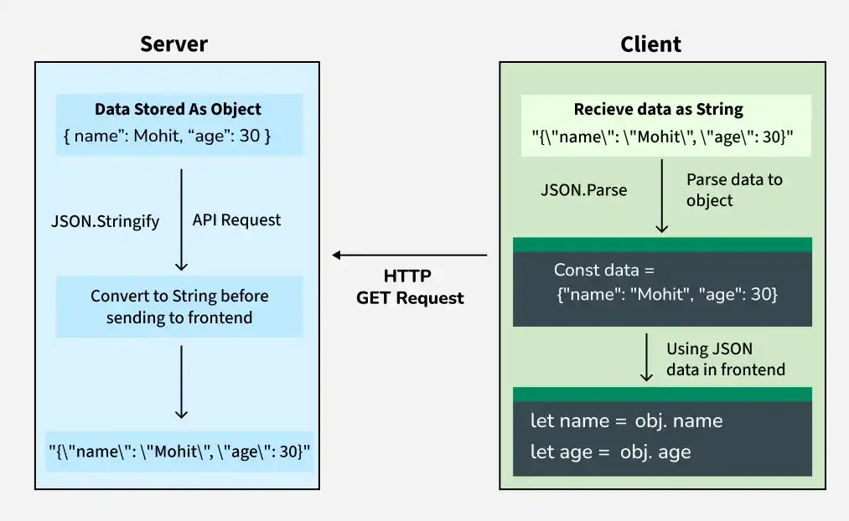
JSON Data Flow: From Server to Client - JSON Tutorial

JSON vs XML
When it comes to data formats, JSON and XML are the two most common choices. JSON is generally preferred for web applications due to its smaller size, ease of use, and better performance. Here's a quick comparison:
Feature | JSON | XML
Readability | Human-readable | Human-readable but more verbose
Data Size | Smaller and more compact | Larger due to extra markup
Parsing | Easier to parse in most languages | More complex parsing
Support | Broad support across languages | Initially JavaScript, but now widely supported
Use Cases | Web APIs, configuration files, data transfer | Data storage, document formatting

How JSON Data Flow Works in Web Applications
In a typical web application, JSON (JavaScript Object Notation) is used to transfer data between the server and the client (frontend). JSON is language-independent, which makes it ideal for communication between different technologies.

Server Side
- Data is stored as an object (for example, a dictionary or class instance).
- Before sending the data over the network, it is converted into a JSON string.
- This JSON string is sent to the client through an API response (such as an HTTP GET request).

Client Side
- The client receives the data as a JSON string.
- The JSON string is parsed back into a native object depending on the programming language used.
- Once parsed, individual values can be accessed and used in the application.
Example JSON String Received from Server
{"name":"Mohit", "age":30}
This JSON data contains:
- name: "Mohit"
- age: 30
Parsing JSON in Different Programming Languages
Although the JSON data is the same, each language uses its own method or library to parse it.
const json_s = '{"name": "Mohit", "age": 30}';
const obj = JSON.parse(json_s);
const name = obj.name;
const age = obj.age;
console.log(`Name: ${name}, Age: ${age}`);

JSON Structure
The basic structure of JSON consists of two primary components:
- Objects: These are enclosed in curly braces {} and contain key-value pairs.
- Arrays: Arrays are ordered lists enclosed in square brackets [].

Objects in JSON
A JSON object is a collection of key-value pairs enclosed in curly braces {}. The key is always a string, and the value can be a variety of data types, including strings, numbers,arrays and even other objects.
Example:
{ "name": "Mohit Kumar",
"age": 30,
"isStudent": false }
In this example, name, age, and isStudent are keys, and "John Doe", 30, and false are their respective values.

Arrays in JSON
A JSON array is an ordered collection of values enclosed in square brackets []. These values can be of any type, including objects, arrays, or primitive data types.
Example:
{ "fruits": ["apple", "banana", "cherry"] }
Here, fruits is a key, and the value is an array containing the elements "apple", "banana", and "cherry".

Key JSON Data Types
JSON supports the following data types:
- String: A sequence of characters, e.g., "hello".
- Number: Integer or floating-point numbers, e.g., 10, 3.14.
- Boolean: A value representing true or false.
- Array: An ordered list of values.
- Object: A collection of key-value pairs.
- Null: A null value indicating the absence of any value.

Working with JSON in JavaScript
In JavaScript, we can easily parse JSON data into a JavaScript object and vice versa using built-in methods like JSON.parse() and JSON.stringify().

Parse JSON to Object
To parse a JSON string into a JavaScript object, use JSON.parse().
let jsonS = '{"name": "Mohit", "age": 30}';
let jsonObj = JSON.parse(jsonS);
​
console.log(jsonObj.name);

Convert Object to JSON
To convert a Javascript object into a JSON string, use JSON.stringify()
let obj = {name: "Mohit", age: 30};
let jsonS= JSON.stringify(obj);
console.log(jsonS);

Working with JSON in Python
Python provides a built-in json module to work with JSON data. We can use the json.loads() method to convert a JSON string to a dictionary and json.dumps() to convert a dictionary to a JSON string.

Parse JSON to Dictionary
In Python, a JSON string can be converted into a dictionary using the built-in json module using json.loads().
import json
​
json_str = '{"name": "Mohit", "age": 30}'
data = json.loads(json_str)
​
print(data["name"])

Convert Dictionary to JSON
In Python, a dictionary can be converted into a JSON string using the json.dumps() method.
import json
​
data = {"name": "Mohit", "age": 30}
json_str = json.dumps(data)
​
print(json_str)

Applications of JSON
- APIs: JSON is the most commonly used format for API responses due to its lightweight nature.
- Configuration Files: Many software systems use JSON files for storing configuration data.
- Databases: Some NoSQL databases, like MongoDB, store data in JSON-like formats.
- Data Transfer: JSON is widely used for transferring data between servers and clients, especially in web development.

Introduction to BSON and Types
BSON (Binary JSON) is a binary-encoded data format derived from JSON, designed for efficient data storage and fast processing, especially in databases like MongoDB.
- Binary-encoded version of JSON.
- Stores and transfers data efficiently.
- Supports more precise data types than JSON.
- Faster data traversal and better performance.
- Less human-readable compared to JSON.
- Commonly used in high-performance databases (e.g., MongoDB).

Need of BSON
BSON is used to overcome JSON’s limitations by providing better data type support and improved performance for machine processing.
- Addresses limitations of JSON.
- Supports advanced data types (ObjectId, Date, Binary).
- Encodes data more precisely.
- Enables efficient storage and fast query performance.
- Used by MongoDB as its primary data format.
- Suitable for applications requiring a robust and efficient data format.

BSON Specification and Structure
BSON is a document-based data format that defines binary encoding rules and supports richer data types than JSON for efficient storage and processing.
A BSON document consists of:
- Document Size: The first 4 bytes represent the total size of the document in bytes.
- Elements: Each element contains a field name, a type identifier, and the corresponding value. Each element is encoded with its type, length, and data.
- End of Object (EOO): BSON documents are terminated by a special marker, ensuring that the parser knows when a document ends.
Here’s an example of a document and its corresponding BSON encoding:
JSON
{
"hello": "world"
}
BSON
\x16\x00\x00\x00 // total document size
\x02 // 0x02 = type String
hello\x00 // field name
\x06\x00\x00\x00world\x00 // field value (size of value, value, null terminator)
\x00 // 0x00 = type EOO ('end of object')

BSON Data Types
BSON extends JSON by adding support for advanced data types, making it suitable for complex use cases such as timestamps and high-precision decimal values.
Data Type | Description | Size | Usage
Double | 64-bit IEEE 754 floating-point value | 8 bytes | Used for storing floating-point numbers.
String | UTF-8 encoded string | Variable (length-prefixed) | Used to store textual data.
Object | Embedded document (similar to a JSON object) | Variable (length-prefixed) | Stores nested documents.
Array | List of values (can be other BSON types) | Variable (length-prefixed) | Stores ordered collections of values.
Binary Data | Arbitrary binary data (used for storing files, images, etc.) | Variable (length-prefixed) | Used to store binary objects (e.g., images).
Undefined | Used in earlier versions of BSON, now deprecated | 1 byte | Deprecated in modern BSON.
ObjectId | 12-byte identifier that uniquely identifies a document in MongoDB | 12 bytes | Used as a unique identifier for documents.
Boolean | Boolean value (true or false) | 1 byte | Used for logical values.
Date | 64-bit integer representing a Unix timestamp in milliseconds | 8 bytes | Used for storing date/time values.
Null | Null value | 1 byte | Used to represent a missing or empty value.
Regular Expression | Regular expression pattern | Variable (length-prefixed) | Used for storing regular expressions.
DBPointer | Pointer to a document in another collection (deprecated in favor of DBRefs) | Variable (length-prefixed) | Deprecated. Previously used for cross-collection references.
JavaScript | JavaScript code (with scope) | Variable (length-prefixed) | Stores JavaScript code.
Symbol | Deprecated data type for storing symbols | Variable (length-prefixed) | Deprecated, previously used for symbols.
Decimal128 | 128-bit decimal representation for high precision (used in financial data) | 16 bytes | Used for storing high-precision decimal values.
MinKey | Special value used for comparison; less than all other values | 1 byte | Used in queries to represent the lowest possible value.
MaxKey | Special value used for comparison; greater than all other values | 1 byte | Used in queries to represent the highest possible value.

Advantages of BSON
BSON offers several benefits over JSON, particularly in terms of storage, performance, and flexibility:
- Lightweight and Efficient: BSON enables efficient parsing and traversal, improving performance while supporting additional data types.
- Supports Rich Data Types: BSON supports complex data types like dates, binary data, and high-precision decimals, making it suitable for modern applications such as financial systems and large-scale data processing.
- Fast Data Parsing: BSON’s binary format enables fast parsing, making it ideal for real-time systems and high-performance databases like MongoDB.
- Schema Flexibility: BSON is schema-less and flexible, allowing data structures to evolve without major database migrations, supporting agile development.

Using BSON in MongoDB
BSON is the native data format used by MongoDB database for storing, processing, and exporting data efficiently.
- MongoDB stores documents internally in BSON
- BSON enables efficient data storage, retrieval, and communication
- Encoding and decoding are handled by the MongoDB engine
- BSON is used during MongoDB data export
- bsondump is used to convert BSON data into JSON
bsondump --outFile=output.json input.bson

Converting JSON to BSON and Vice Versa
To convert JSON data to BSON, we can use various tools and online converters. MongoDB provides a command-line tool called mongoexport and mongoimport are primarily used for JSON/CSV data, while bsondump and mongorestore are used for BSON data.
To import a BSON file into MongoDB:
mongorestore -d mydatabase /path/to/file.bson

Use Cases for BSON
BSON is widely used in MongoDB and other applications that require efficient, high-performance storage. Some key use cases include:
- Database Storage: MongoDB uses BSON for efficient document storage and fast querying, supporting complex data types like ObjectId and Date.
- Network Transfer: BSON’s compact binary format reduces data size and improves transmission efficiency.
- Real-Time Applications: High speed and low overhead make BSON suitable for performance-critical systems like gaming, social media, and analytics.

BSON Vs JSON
While BSON and JSON share many similarities, they are distinct in several ways:
JSON | BSON
Text-based and human-readable | Binary-based and machine-optimized
Limited support for data types | Supports rich data types like ObjectId, Date, and Binary
Slower parsing and traversal | Faster parsing and data access
Less efficient for database storage | Efficient storage and querying in databases like MongoDB
Larger size for network transfer | Compact format, efficient network transfer
Better for simple data exchange | Ideal for high-performance and real-time applications

MongoDB CRUD Operations
CRUD operations are fundamental database actions in MongoDB that enable users to insert, read, update, and delete documents within collections.
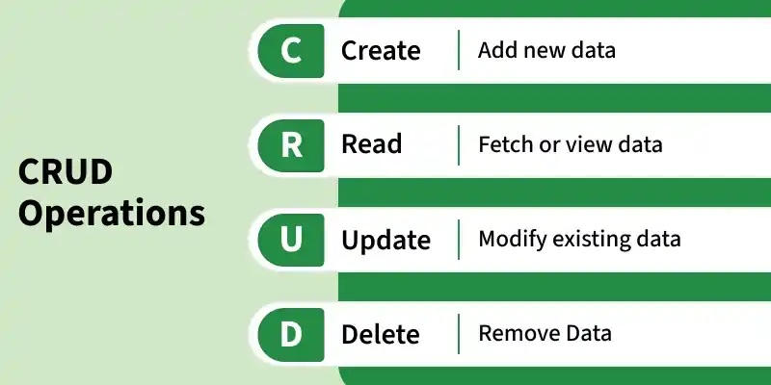
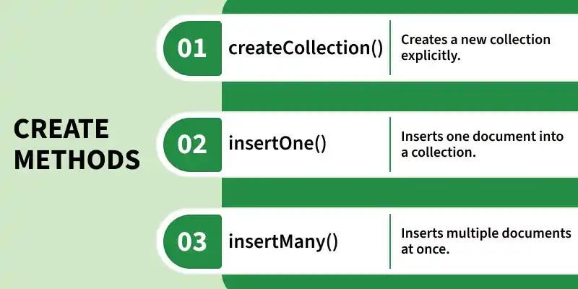

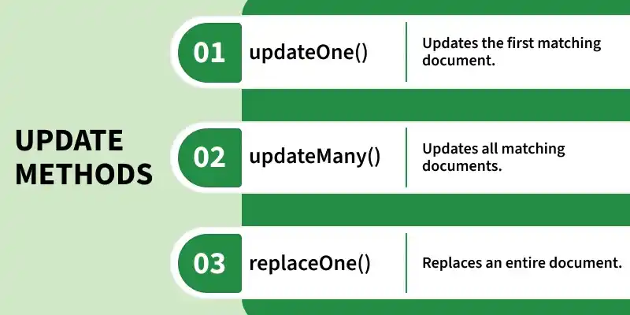


1. Create Operations
Create (insert) operations are used to add new documents to a collection, creating the collection automatically if it does not already exist.
- Adds new documents to a collection.
- Automatically creates the collection if missing.
- Generates a unique _id if not provided.
- Supports inserting single or multiple documents.
Example 1: We are creating a student collection in the database using the db.createCollection() method.
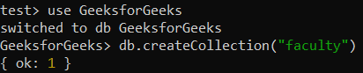
Example 2: We are inserting details of a single student in the form of document in the student collection using db.collection.insertOne() method.
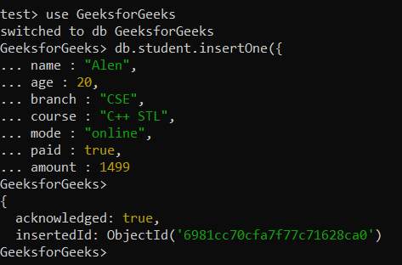
Example 3: We are inserting details of the multiple students in the form of documents in the student collection using db.collection.insertMany() method.
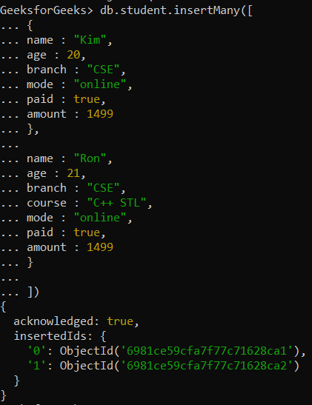

2. Read Operations
Read operations are used to retrieve or query documents from a MongoDB collection.
- Fetch documents from a collection.
- Support filtering, projection, sorting, and limiting results.
- Used to read and analyze stored data.
Examples 1: We are retrieving the details of students from the student collection using db.collection.find() method.
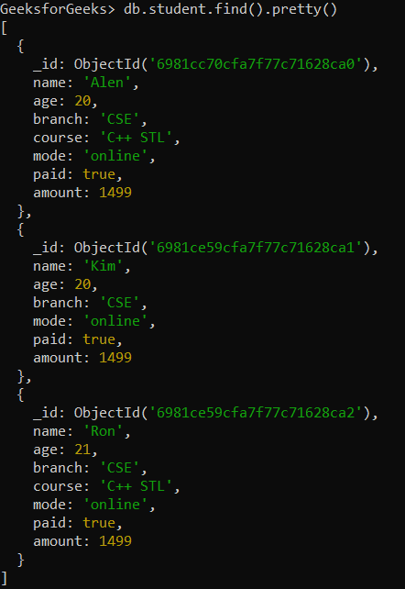

Note: pretty() method is used to decorate the result such that it is easy to read.
Example 2: We are retrieving the details of a single student from the student collection using the db.collection.findOne() method.
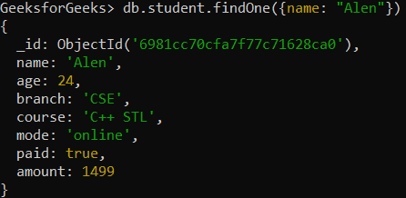

3. Update Operations
Update operations are used to modify existing documents in a MongoDB collection based on specified query conditions.
- Update single or multiple matching documents.
- Use update operators like $set, $inc, and $unset.
- Can replace entire documents if required.
Example 1: We are updating the age of Alen in the student collection using db.collection.updateOne() method.
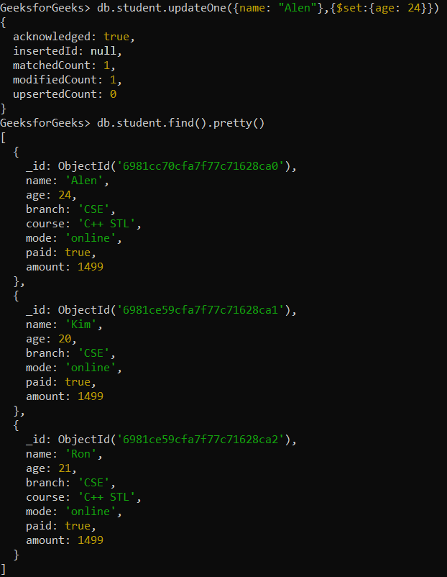
Example 2: We are updating the year of course in all the documents in the student collection using db.collection.updateMany() method.
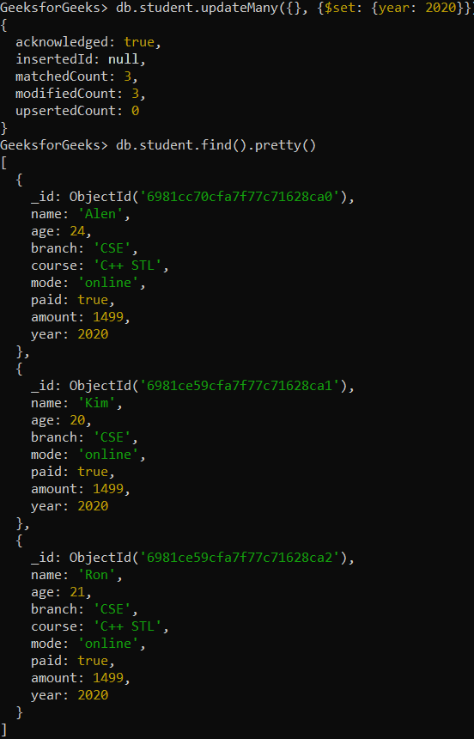
Example 3: We are replacing the complete details of a single student document in the student collection using the db.student.replaceOne() method.
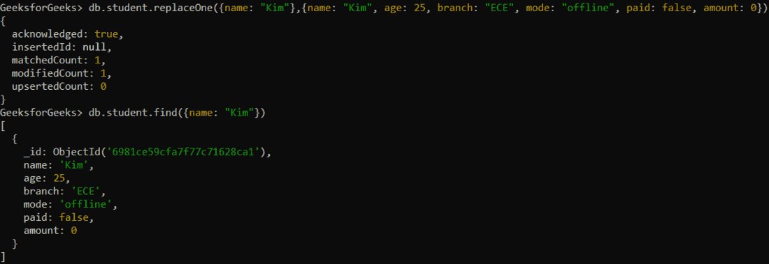

4. Delete Operations
Delete operations are used to remove documents from a MongoDB collection.
- Delete documents based on specific conditions.
- Can remove a single document or multiple documents
- Supports deleting all documents in a collection
Example 1: We are deleting a document from the student collection using db.collection.deleteOne() method.
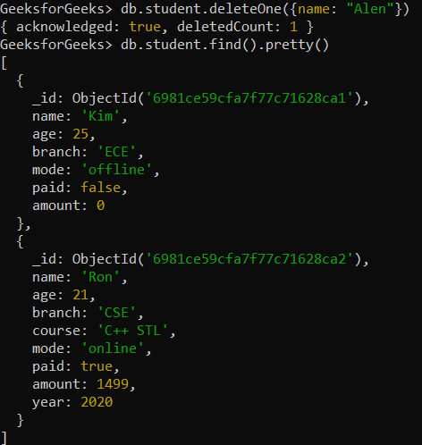
Example 2: We are deleting multiple documents from the student collection using db.collection.deleteMany() method (all documents are deleted only if an empty filter {} is used).
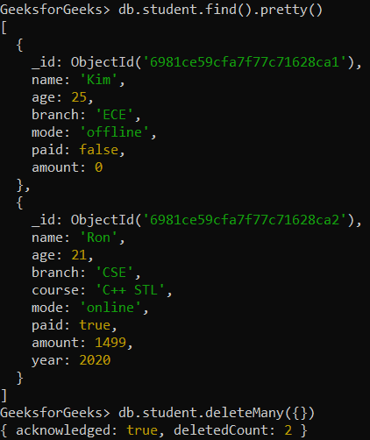

Creating Database and Collection in MongoDB
MongoDB is a NoSQL database that stores data in flexible, JSON-like documents, enabling scalable, high-performance data management for modern applications.
- Designed for flexibility, scalability, and performance.
- Stores data as documents instead of tables and rows.
- Uses databases, collections, and documents.
- Schema-flexible structure supports dynamic data models.
- Enables horizontal scaling and high availability.
- Suitable for both small applications and large-scale data systems.

MongoDB Database and Collection Setup
Follow these steps to create databases and collections in MongoDB.

Step 1: Create a Database In MongoDB
In MongoDB, a database is created only when data is inserted. The use command switches to a database and creates it automatically when data is added if it does not already exist.
Syntax:
use database_name
Example: To create or switch to a database called gfgDB, you would use the following command:
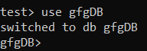
- If the gfgDB database doesn’t exist, MongoDB will create it automatically once you insert data into it.
- If the database already exists, the use command simply switches the context to that database.
- Note that MongoDB doesn’t actually create the database until you store some data.
Check Existing Databases:
To see all the databases that already exist in your MongoDB instance, use the show dbs command:
show dbs
Output:
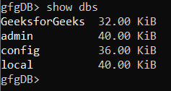
This command lists all the databases in your MongoDB instance (except empty database), including their respective sizes. To check the current database in use, we can use the db command:
db
This will return the name of the currently selected database, e.g., gfgDB

Step 2: Create a Collection in MongoDB
A collection in MongoDB is a group of schema-flexible documents, similar to a table in a relational databases, created explicitly or automatically on insertion.
Syntax:
db.createCollection(' collection_name' );
Example: To create a collection called Student, you would use the following command:
db.createCollection('Student');
- createCollection() explicitly creates an empty collection in MongoDB.
- Inserting a document automatically creates the collection if it doesn’t exist.
For example, running the following command will automatically create the Student collection if it doesn't exist:
db.Student.insertOne({Name: "Noah", age: 23})
Output:
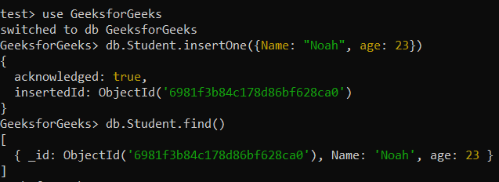
Note:
- Collections are created automatically when the first document is inserted, so using createCollection() is optional.
- MongoDB allows for collections to contain documents with different fields and data types, which provides flexibility when structuring your data.

Step 3: Insert Documents into a Collection in MongoDB
Once a collection exists, add JSON-like documents using insert methods.

1. insertOne() Method
The insertOne() method in MongoDB is used to insert a single document into a collection.
Syntax:
db.collection_name.insertOne({ field1: value1, field2: value2, ... });
Example: Inserts a single document into a new collection.
db.myNewCollection1.insertOne( { name:"geeksforgeeks" } )
Output:
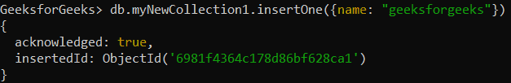
- insertOne() inserts a single document into a collection.
- If the collection does not exist, MongoDB automatically creates it.
- A collection named myNewCollection1 is created with one document containing the field name.

2. insertMany() method
insertMany() method inserts multiple documents in one operation, improving performance over single inserts.
Syntax:
db.collection_name.insertMany([{ field1: value1, field2: value2, ... }, { field1: value1, field2: value2, ... }, ... ])
Example: To create myNewCollection2, insert two documents.
db.myNewCollection2.insertMany([{name:"gfg", country:"India"}, {name:"Lucas", age:20}])
Output:
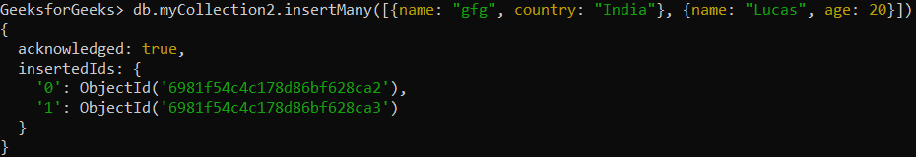
- The insertMany() method accepts an array of documents.
- Two documents are inserted, one for a student named "gfg" and another for a student named "Lucas".

Step 4: View Existing Collections
After inserting data, list all collections using the show collections command.
Syntax:
show collections
Example: If you're working in the gfgDB database and you want to see all the collections, simply run:
show collections
Output:
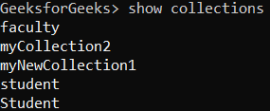
This shows that the Student collection exists within the gfgDB database.
Best Practices for Managing Databases and Collections
Here are some best practices:
- Naming Conventions: Always use meaningful, lowercase names for databases and collections, separating words with underscores (e.g., student_data).
- Indexes: MongoDB automatically indexes the _id field, and adding indexes on frequently queried fields improves performance.
- Schema Design: MongoDB is schema-flexible, but it is still recommended to design your collections in a way that ensures data consistency.
- Data Validation: Although MongoDB is schema-flexible, schema validation can be applied to enforce data integrity.

MongoDB Drop Database
Dropping a database in MongoDB permanently deletes the database along with all its collections and documents, helping maintain a clean database environment.
- Completely removes the database and all associated data.
- Action is permanent and cannot be undone.
- Useful for cleaning up unused or test databases.
- Should be performed with caution due to data loss.

Understanding MongoDB Databases
MongoDB is a document-oriented NoSQL database that stores data in flexible, JSON-like BSON documents, making it scalable and well-suited for modern applications.
- Schema-flexible design: Collections do not require a fixed schema.
- Scalability: Supports horizontal scaling for large datasets.
- High performance: Optimized for fast queries and data retrieval.

Reasons for Dropping a Database in MongoDB
Dropping a database in MongoDB permanently deletes all its data and is commonly done for cleanup, testing, security, and storage management purposes.

1. Data cleanup & Performance Optimization
Over time, databases accumulate redundant or outdated data that can impact performance. Dropping a database helps:
- Eliminate clutter that slows down database operations.
- Optimize storage usage by removing unused or obsolete data.
- Removes unused or obsolete data, which may indirectly improve performance depending on the workload.

2. Development and testing
During software development lifecycle, databases often need to be reset for testing or debugging, and dropping the database provides a quick and efficient way to do so by:
- Resetting the environment for fresh testing scenarios.
- Removing unwanted temporary test data that accumulates over multiple test runs.
- Ensuring a clean database setup without previous configurations affecting new tests.

3. Security and Compliance
In data-sensitive industries, securely deleting databases is essential to meet legal and security compliance requirements.
- Ensures permanent removal of sensitive data.
- Helps comply with regulations such as GDPR, HIPAA, and CCPA.
- Prevents unauthorized access to obsolete or confidential information.

4. Storage Management
Large-scale applications often create multiple databases, some of which become obsolete or unused over time. Keeping them can:
- Consume valuable disk space, leading to increased storage costs.
- Create unnecessary maintenance overhead for database administrators.
- Slow down backup and recovery processes due to excessive data volume.
By dropping unused databases, organizations can optimize storage resources and maintain an efficient database environment.

Steps to Drop a Database in MongoDB
Dropping a database in MongoDB permanently removes all its collections and documents using the db.dropDatabase() method.

Step 1: List Available Databases
Before dropping a database, it's essential to check which databases exist in MongoDB. To list all available databases, run the following command in the MongoDB shell:
show dbs
Output:
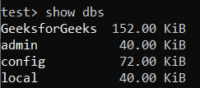
This output displays all the databases on the MongoDB server along with their sizes. Databases without data (empty databases) are not shown.

Step 2: Select the Database to Drop
Switch to the database that we want to drop.
use sampleDB
Output:
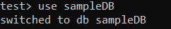
After executing this command, MongoDB sets sampleDB as the active database.

Step 3: Drop the Selected Database
Once the database is selected, we can execute the db.dropDatabase() command to delete it.
db.dropDatabase()
Output:
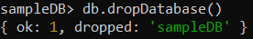
- This command will permanently delete the current database sampleDB and return a confirmation message.
- The "dropped" field confirms that sampleDB has been deleted.
- The "ok": 1 indicates that the operation was successful.
Note: This action is permanent. All collections and documents inside the database will be removed.

Step 4: Verify that the Database has been dropped
To ensure the database has been dropped successfully, we can list the databases again:
show dbs
Output:
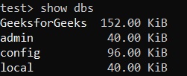
Notice that sampleDB is no longer listed, meaning it has been successfully deleted.
Precautions before Dropping a Database
- Backup Your Data: If you might need the data in the future, create a backup using MongoDB’s mongodump command.
- Verify the Database Name: Ensure you are working with the correct database before executing db.dropDatabase().
- Check User Permissions: Make sure your MongoDB user has admin privileges to drop databases.

MongoDB – Insert Operations
Insert operations are used in MongoDB to add new documents to a collection. MongoDB provides different methods for inserting a single document or multiple documents into a collection.
The important insert methods are:
- insert()
- insertOne()
- insertMany()

1. insert()
The insert() method is used to add one or more documents to a MongoDB collection. It can insert either a single document or multiple documents.
Important: insert() is an older method and is deprecated in modern MongoDB. insertOne() and insertMany() are preferred.
Syntax
db.collection.insert(document)
Example – Insert One Document
db.students.insert({
name: "John",
age: 20,
city: "Delhi"
})
A new document is added to the students collection.
Example – Insert Multiple Documents
db.students.insert([
{
name: "John",
age: 20
},
{
name: "Mike",
age: 21
}
])
Both documents are inserted.
Easy Memory Trick
insert() → Old/general insert method

2. insertOne()
The insertOne() method is used to insert one document into a MongoDB collection. It is the preferred modern method when we need to add a single document.
Syntax
db.collection.insertOne(document)
Example
db.students.insertOne({
name: "John",
age: 20,
city: "Delhi"
})
MongoDB adds this document to the students collection.
Example Result
{
acknowledged: true,
insertedId: ObjectId("...")
}
insertedId shows the _id of the newly inserted document.
Important Point
If you want to insert only one document, use:
insertOne()
Easy Memory Trick
insertOne = Insert ONE document

3. insertMany()
The insertMany() method is used to insert multiple documents into a MongoDB collection in a single operation. It is useful when we need to add many documents at the same time.
Syntax
db.collection.insertMany([
document1,
document2,
document3
])
Example
db.students.insertMany([
{
name: "John",
age: 20,
city: "Delhi"
},
{
name: "Mike",
age: 21,
city: "Mumbai"
},
{
name: "Sara",
age: 19,
city: "Chandigarh"
}
])
Three documents are inserted into the students collection.
Result
MongoDB returns the IDs of the inserted documents.
{
acknowledged: true,
insertedIds: {
"0": ObjectId("..."),
"1": ObjectId("..."),
"2": ObjectId("...")
}
}

Easy Memory Trick
insertMany = Insert MANY documents

insertOne() vs insertMany()
Method | Purpose | Number of Documents
insert() | Older/general insert method | One or more
insertOne() | Insert a single document | 1
insertMany() | Insert multiple documents | Many

Insert vs Update
This is also important to understand.

Insert
Adds a new document:
db.students.insertOne({
name: "John",
age: 20
})
Collection
↓
New Document → Added ✓

Update
Changes an existing document:
db.students.updateOne(
{ name: "John" },
{ $set: { age: 21 } }
)
Existing Document
↓
Changed ✓
So:
Insert = Add new data
Update = Modify existing data

Super Easy Revision
INSERT OPERATIONS
↓
┌───────────────┐
│ │
insert() Modern Methods
│ │
Old method ┌──┴──────────┐
↓ ↓
insertOne() insertMany()
↓ ↓
ONE MANY

Remember this line:
insertOne() → one document
insertMany() → many documents
insert() → older method that can insert one or more documents

MongoDB – Update Operations
Update operations are used in MongoDB to modify existing documents in a collection. They allow us to change field values, add new fields, remove fields, or replace an entire document.
MongoDB provides different methods depending on how many documents we want to modify and whether we want to update specific fields or replace the complete document.
The important update operations are:
- update()
- updateOne()
- updateMany()
- replaceOne()

1. update():
The update() method is used to modify documents that match a given condition. It can update one or multiple documents depending on the options used.
Important: update() is an older/deprecated method in modern MongoDB. In current MongoDB applications, updateOne() and updateMany() are preferred.
Syntax
db.collection.update(
filter,
update,
options
)
Example
Suppose we have:
{
name: "John",
age: 20,
city: "Delhi"
}
We want to change the age:
db.students.update(
{ name: "John" },
{ $set: { age: 21 } }
)
Now the document becomes:
{
name: "John",
age: 21,
city: "Delhi"
}
Easy Memory Trick
update() → Old/general update method

2. updateOne()
The updateOne() method is used to update only one document that matches the specified condition. If multiple documents match the condition, MongoDB updates only the first matching document.
Syntax
db.collection.updateOne(
filter,
update
)
Example
Collection:
{
name: "John",
age: 20
}
Update:
db.students.updateOne(
{ name: "John" },
{ $set: { age: 21 } }
)
Using $inc
db.students.updateOne(
{ name: "John" },
{ $inc: { age: 1 } }
)
This increases John's age by 1.
Important Point
If 5 documents match:
5 matching documents
↓
updateOne()
↓
Only 1 document updated
Easy Memory Trick
updateOne = Update ONE document

3. updateMany()
The updateMany() method is used to update all documents that match a specified condition. It is useful when the same change needs to be applied to multiple documents.
Syntax
db.collection.updateMany(
filter,
update
)
Example
Suppose we have:
{
name: "John",
city: "Delhi"
}
{
name: "Mike",
city: "Delhi"
}
{
name: "Sara",
city: "Mumbai"
}
We want to change the city of all students from Delhi to Chandigarh:
db.students.updateMany(
{ city: "Delhi" },
{ $set: { city: "Chandigarh" } }
)
Result:
John → Chandigarh
Mike → Chandigarh
Sara → Mumbai
Easy Memory Trick
updateMany = Update MANY documents

4. replaceOne()
The replaceOne() method is used to replace one complete document that matches a specified condition with a new document.
The important difference is that replaceOne() does not just change selected fields. It replaces the existing document with the replacement document, while MongoDB preserves the document's _id unless the replacement specifies a different _id.
Syntax
db.collection.replaceOne(
filter,
replacement
)
Example
Original document:
{
_id: 1,
name: "John",
age: 20,
city: "Delhi"
}
Replace it:
db.students.replaceOne(
{ _id: 1 },
{
name: "John",
age: 21,
city: "Mumbai"
}
)
The document is now:
{
_id: 1,
name: "John",
age: 21,
city: "Mumbai"
}
Important Difference
If you use:
$set
you change selected fields.
But with:
replaceOne()
you provide the new complete document.
Easy Memory Trick
replaceOne = Replace ONE complete document

Update vs Replace
This is very important for exams.
Using $set
db.students.updateOne(
{ name: "John" },
{ $set: { age: 21 } }
)
Only age changes.
Other fields remain:
name ✓
age → changed
city ✓
Using replaceOne()
db.students.replaceOne(
{ name: "John" },
{
name: "John",
age: 21
}
)
The old document is replaced by the new document.
So if the old document had:
city
course
phone
and these are not included in the replacement document, they are removed.

Quick Comparison
Method | What it does | Number of documents
update() | Older/general update method | One or more, depending on options
updateOne() | Updates matching document | 1
updateMany() | Updates all matching documents | Many
replaceOne() | Replaces complete document | 1

Super Easy Revision
UPDATE OPERATIONS
↓
┌───────────────┐
│ │
Update Replace
│ │
├─ update() └─ replaceOne()
│
├─ updateOne() → ONE
│
└─ updateMany() → MANY

Remember:
updateOne() → Change one document
updateMany() → Change many documents
replaceOne() → Replace one complete document
update() → Older update method

MongoDB – Delete Operations

1. deleteOne()
The deleteOne() method is used to delete one document from a MongoDB collection that matches a given filter. If multiple documents match the condition, only the first matching document is deleted.
Syntax
db.collection.deleteOne({ condition })
Example
db.student.deleteOne({ age: 22 })
This deletes the first student whose age is 22.
Important Points
- Deletes only one document.
- Uses a filter to find the document.
- If no document matches, nothing is deleted.
- It can also be used with query operators such as $lt, $gt, etc.
Example with Operator
db.student.deleteOne({ age: { $lt: 19 } })
This deletes the first document where age is less than 19.

2. deleteMany()
The deleteMany() method is used to delete all documents that match a specified filter. It is useful when multiple documents need to be removed at the same time.
Syntax
db.collection.deleteMany({ condition })
Example
db.student.deleteMany({ age: 22 })
This deletes all students whose age is 22.
Important Points
- Deletes multiple matching documents.
- Returns the number of deleted documents.
- deleteMany({}) deletes all documents from the collection.
- It supports query operators, write concern, and collation.
Delete All Documents
db.student.deleteMany({})
This removes all documents but keeps the collection and its indexes.

3. Delete Database – dropDatabase()
The dropDatabase() method is used to permanently delete the currently selected database, including all its collections and documents.
Syntax
db.dropDatabase()
Example
use userDB
db.dropDatabase()
This deletes the userDB database.
Important Points
- Deletes the complete selected database.
- Deletes all collections and documents inside it.
- The operation is permanent and cannot be undone.
- You should have the required permissions before deleting a database.

Difference
Method | Purpose
deleteOne() | Deletes one matching document
deleteMany() | Deletes all matching documents
dropDatabase() | Deletes the complete database

Easy Revision
deleteOne() → ONE document
deleteMany() → MANY documents
dropDatabase() → COMPLETE database

MongoDB Query Embedded Documents Using Mongo Shell
MongoDB stores related data as embedded documents within a single record, unlike a relational database that relies on joins.
- Groups related fields in one document.
- Avoids complex joins across collections.
- Can improve read performance in certain use cases, depending on data size and access patterns.
- Supports direct queries on nested fields.
Syntax
db.collection.find(filter, projection)
- filter (optional): Query criteria, omit or use {} to fetch all documents.
- projection (optional): Fields to return, omit to return all fields.
- Returns: Returns a cursor pointing to the matched documents.
Example of an Embedded Document
Embed course details inside each student document instead of using separate collections.
- Database: GeeksforGeeks
- Collection: Courses
- Documents: Three documents that contain the details of the students in the form of field-value pairs.
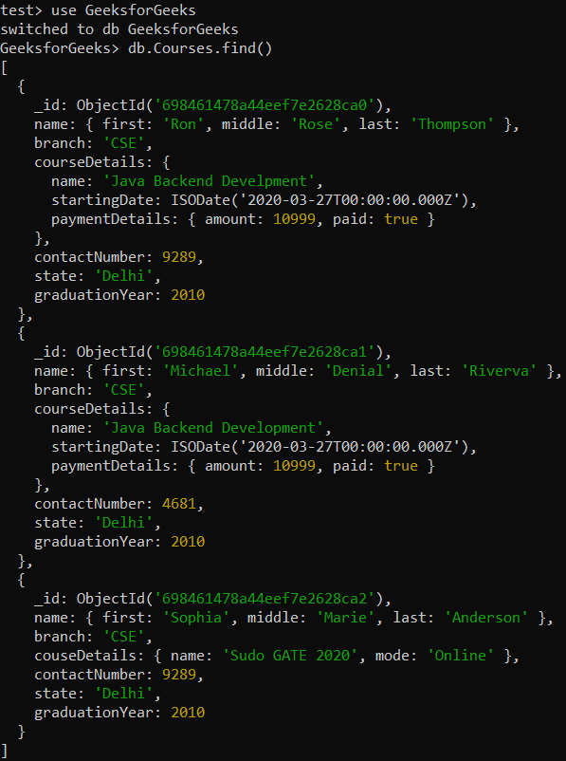
Example 1: Querying Entire Embedded Documents
Retrieving the documents that exactly match the given embedded document.
Query:
db.Courses.find({name: { first: "Ron", middle: "Rose", last: "Thompson"}})
Output:
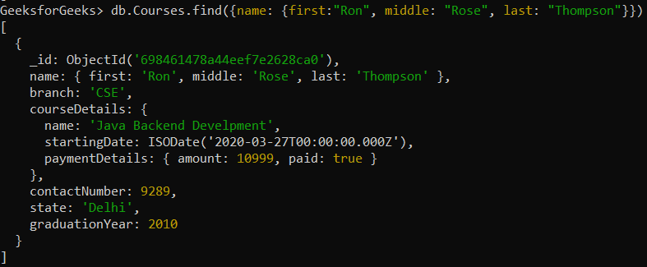
- The field order must exactly match the stored document.
- If the middle name is omitted in the query, the document won't be retrieved.
Example 2: Querying Embedded Documents Using Dot Notation
Query students who are enrolled in Java Backend Development.
Query:
db.Courses.find({"courseDetails.name": "Java Backend Development"})
Output:
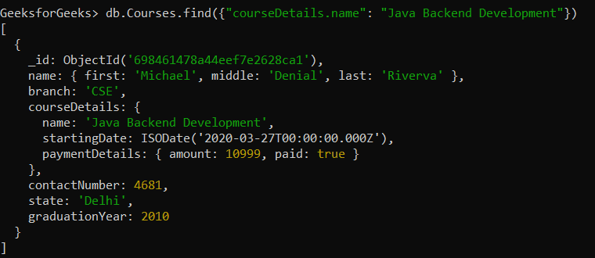
- "courseDetails.name" refers to the nested field inside courseDetails.
- MongoDB retrieves all students where the course name is "Java Backend Development".
Example 3: Using Query Operators for Advanced Filtering
MongoDB query operators enable advanced filtering for precise and efficient document retrieval.
1. $in Operator: Match Multiple Values
This operator is used to match any of the values specified in the given array. Find students whose first name is either "Ron" or "Michael".
Query:
db.Courses.find({"name.first": {$in: ["Ron" , "Michael"]}})
Output:
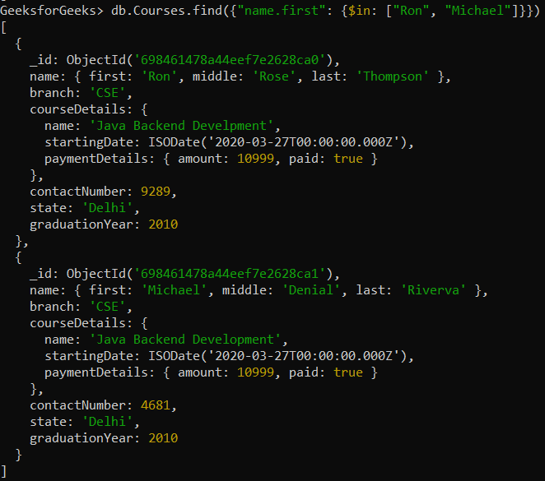
2. $and Operator: Match Multiple Conditions
Find documents matching nested fields where both conditions are true using $and.
Query:
db.Courses.find({ $and: [{ "courseDetails.name": "Sudo GATE 2020" }, { "name.first": "Sophia" }] })
Output:
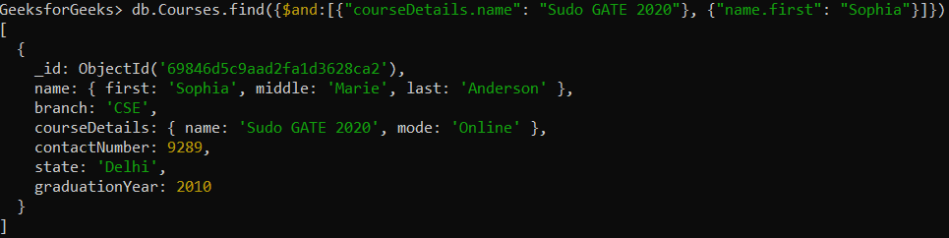
Example 4: Selecting Specific Fields with Projections
By default MongoDB returns full documents, use projection to fetch only required fields like first and last names from nested documents.
Query:
db.Courses.find({branch: "CSE"}, {"name.first": 1, "name.last": 1})
Output:
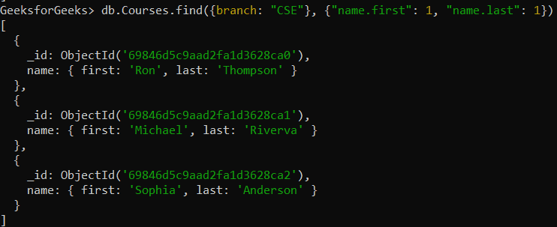
Best Practices
Here are some best practices discussed below:
- Use indexing for faster queries: Index frequently queried fields.
- Use projections to reduce data transfer: Fetch only required fields.
- Avoid deep nesting: Flatten data where possible for better performance.
- Use $exists for missing fields: Check field presence before querying.

MongoDB Query an Array
Efficient querying of array elements in MongoDB helps developers extract relevant data from flexible, document-based collections.
- MongoDB stores data in collections of documents.
- Documents support strings, numbers, objects, and arrays.
- Arrays store ordered, related values within a document.
- Array queries enable precise and efficient data retrieval.

Prerequisites
Before proceeding, ensure you are familiar with the following concepts:
- JSON and BSON
- CRUD operations in MongoDB
- MongoDB Compass or Mongo Shell

Methods to Query Array Elements in MongoDB
MongoDB provides various techniques to query and manipulate arrays. The key methods are discussed below:
Below are the data or records inserted into the blogPosts collection. The collection contains fields such as _id, title, and comments. The comments field is an array of objects, each containing user details.
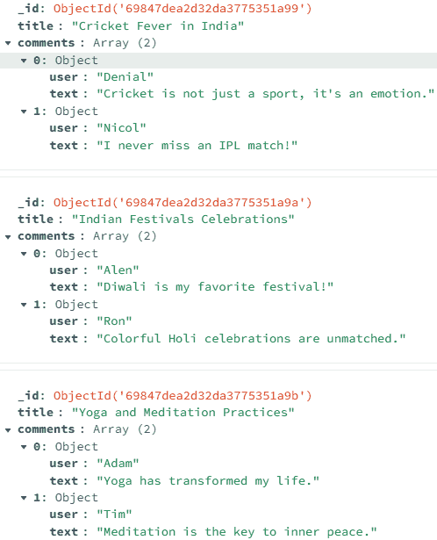

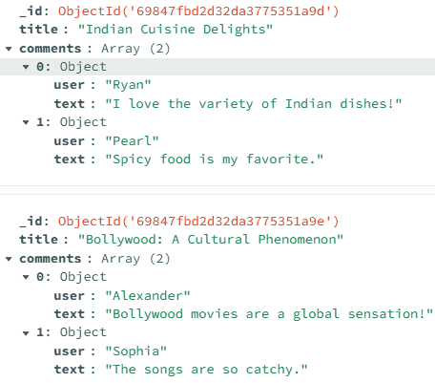

1. Dot Notation
Dot notation accesses fields inside nested objects or arrays in MongoDB queries.
- Used to query fields inside embedded documents.
- Works with array elements (e.g., comments.user).
- Helps filter data without reshaping documents.
Example : Query the Array Elements Using the Dot Notation.
Query Using the Mongo Shell:
db.blogPosts.find({ "comments.user": "Adam" })
Output:
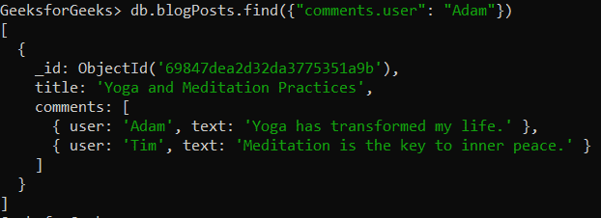
- Searches the blogPosts collection.
- Matches documents with at least one comment where user is "Adam".
- Uses the find() method to retrieve matching documents.
Query Using the MongoDB Compass:
{ "comments.user": "Adam" }
Output:
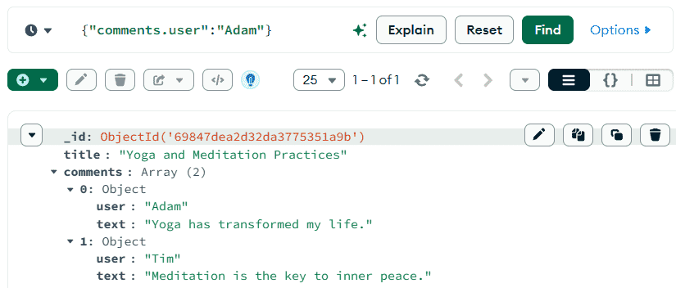

2. $elemMatch
$elemMatch matches documents where at least one array element satisfies multiple conditions.
- Applies multiple criteria to a single array element.
- Prevents matching conditions across different elements.
Example : Query Array Elements Using $elemMatch Operator.
Query Using the Mongo Shell:
db.blogPosts.find({ comments: { $elemMatch: { user: "Alen" } } })
Output:
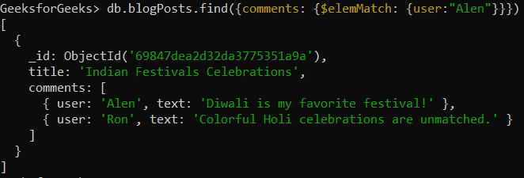
- Searches the blogPosts collection for documents with at least one comment where user is "Alen".
- Uses find() to retrieve matching documents.
- { comments: { $elemMatch: { user: "Alen" } } } is the query condition.
- $elemMatch matches documents where at least one element in the comments array meets the condition.
Query Using the MongoDB Compass:
{ comments: { $elemMatch: { user: "Alen" } } }
Output:
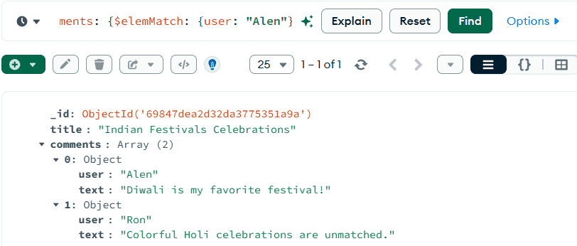

3. $slice
$slice limits the number of array elements returned in query results.
- Returns only selected items from an array field.
- Useful for previewing large arrays.
Example : Query Array Element using $slice Operator.
Query Using the Mongo Shell:
db.blogPosts.find({}, { title: 1, comments: { $slice: 1 } })
Output:
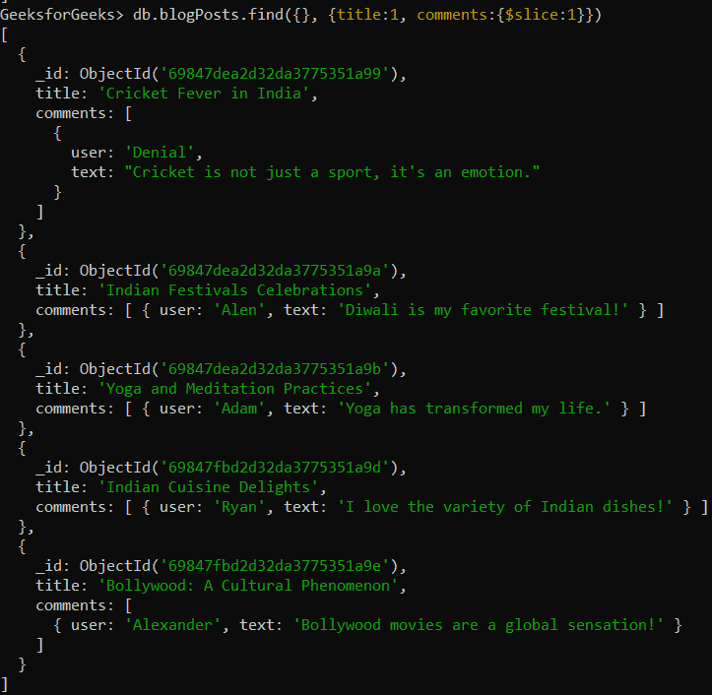
- Retrieves documents from the blogPosts collection.
- Uses find() to fetch matching documents.
- Projects only the title field and the first element of comments.
- { title: 1, comments: { $slice: 1 } } limits the comments array to one item in the result.
Query Using the MongoDB Compass:
{}, { title: 1, comments: { $slice: 2 } }
Output:
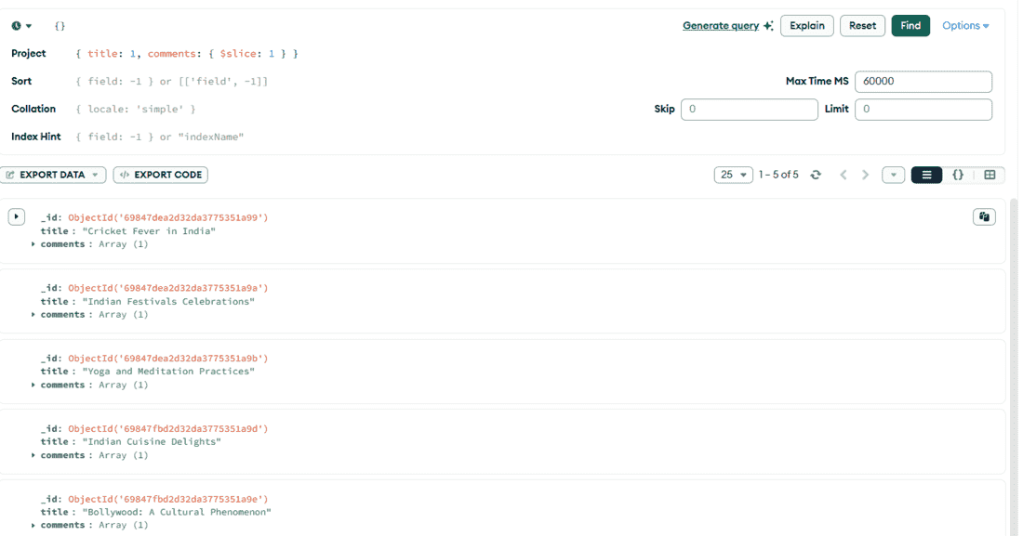

4. $all
$all matches documents where an array contains all specified elements.
- Ensures all given conditions exist in the array.
- Can be combined with $elemMatch for complex matches.
- Useful for matching multiple required values.
Example : Query Array Elements Using $all Operator.
Query Using the Mongo Shell:
db.blogPosts.find({
comments: {
$all: [
{ $elemMatch: { user: "Alexander" } },
{ $elemMatch: { user: "Sophia" } }
]
}
})
Output:
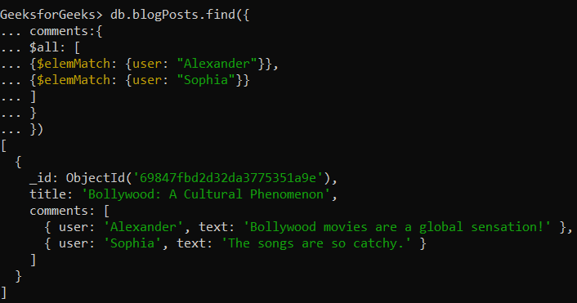
- Uses find() to retrieve documents based on conditions.
- { comments: { $all: [ { $elemMatch: { user: "Alexander" } }, { $elemMatch: { user: "Sophia" } } ] } } is the query condition.
- $all ensures the comments array contains elements matching both users.
Query Using the MongoDB Compass:
{
comments: {
$all: [
{ $elemMatch: { user: "Alexander" } },
{ $elemMatch: { user: "Sophia" } }
]
}
}
Output:
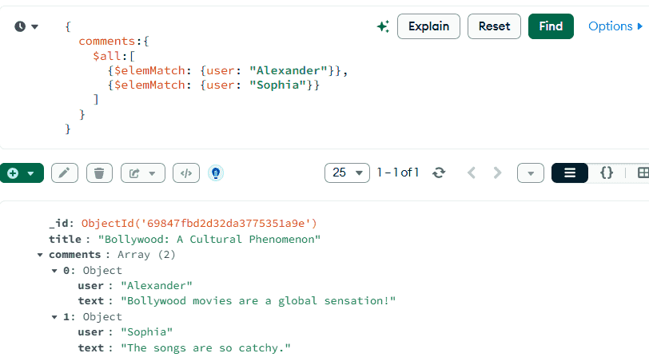

5. $in
$in matches documents where a field equals any value from a given list.
- Checks for multiple possible values in one query.
- Works with array and non-array fields.
- Simplifies OR-like conditions in filters.
Example : Query Array Element Using $in Operator.
Query Using the Mongo Shell:
db.blogPosts.find({ comments: { $elemMatch: { user: { $in: ["Denial", "Tim"] } } } })
Output:
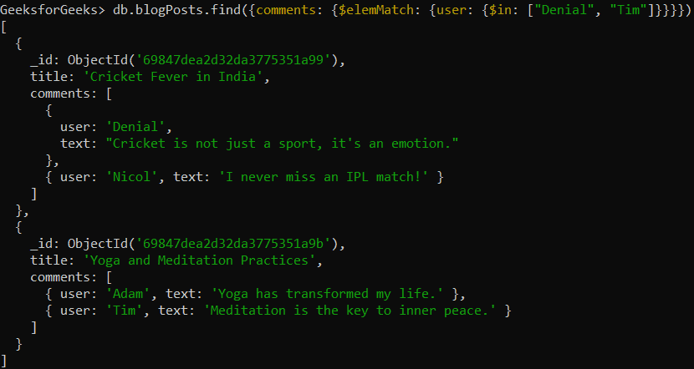
- { comments: { $elemMatch: { user: { $in: ["Denial", "Tim"] } } } } is the query condition.
- $in matches documents where at least one comment’s user is "Denial" or "Tim".
Query Using the MongoDB Compass:
{ comments: { $elemMatch: { user: { $in: ["Denial", "Tim"] } } } }
Output:
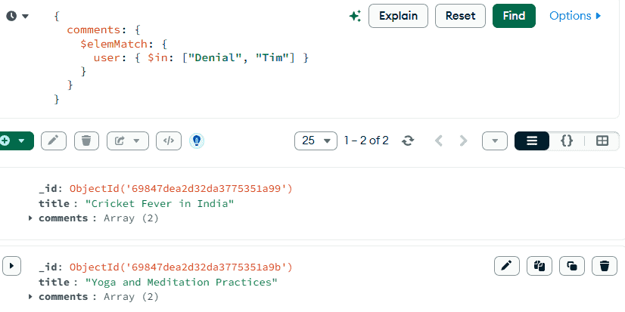

6. $unwind
$unwind breaks an array into multiple documents in the aggregation pipeline.
- Creates one document per array element.
- Repeats parent fields for each element.
- Used for filtering and grouping array data.
Example : Query Array Element Using $unwind Operator.
Query Using the Mongo Shell:
db.blogPosts.aggregate([{ $unwind: "$comments" }])
Output:
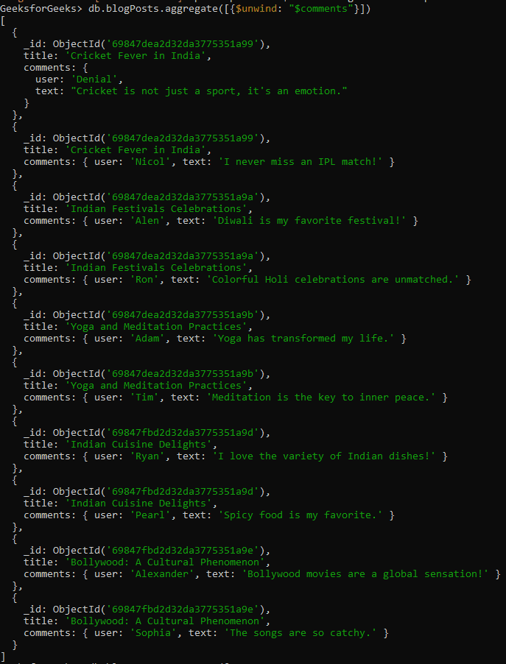
- Each element in the array is returned as a separate document.
- The parent document’s fields are repeated for each array item.
- Helps view and process individual array elements in aggregation results.
Query Using the MongoDB Compass:
"$comments"
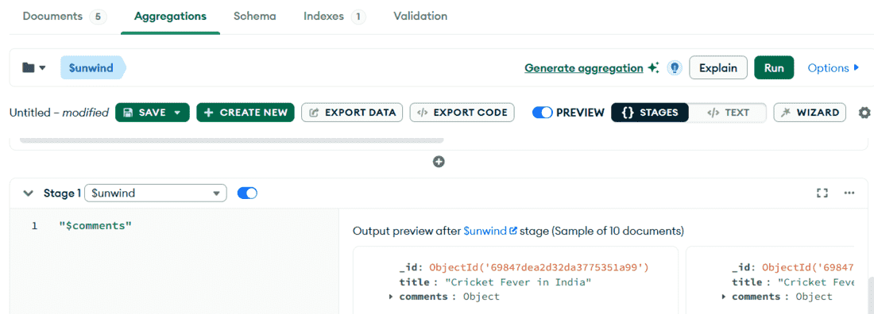
Scroll or expand the preview to see all unwound results.

Query for Null or Missing Fields In MongoDB
Querying null and missing fields in MongoDB (including MongoDB Atlas) helps handle incomplete data accurately using operators like $eq, $exists, $ne, and $or.
- Null field: exists but has a null value.
- Missing field: does not exist in the document.
- Use $exists to check presence and $eq/$ne to match values.
- Example collection (e.g., students with name, email, phone) demonstrate these queries.
{ "_id": 1, "name": "Alen", "email": "alen@example.com", "phone": "123-456-7890" }
{ "_id": 2, "name": "Ben", "email": null, "phone": "458-654-3210" }
{ "_id": 3, "name": "Clevin", "email": "clevin@example.com", "phone": null }
{ "_id": 4, "name": "Denial", "email": null, "phone": null }

Null Values in MongoDB
To query for documents where a specific field is null, MongoDB provides the $eq operator. This operator matches documents where the specified field is equal to the specified value, including null.
Example: Find Students with a null Email
We have a collection named students with documents representing user profiles. We want to find users who have not provided their email addresses.
Query:
db.students.find({ email: { $eq: null } })
Output:
{ _id: 2, name: 'Ben', email: null, phone: 545 }
{ _id: 4, name: 'Denial', email: null, phone: null }
This query returns documents where the email field is null or missing.
Missing Fields in MongoDB
Use the $exists operator with false to return documents where a field is missing.
Example: Find Students Where description Field is Missing
To find students that do not have a description field.
Query:
db.students.find({ description: { $exists: false } })
Output:
{ _id: 1, name: 'Alen', email: "alen@example.com", phone: "123-456-7890" }
{ _id: 2, name: 'Ben', email: null, phone: 458-654-3210 }
{ _id: 3, name: 'Clevin', email: "clevin@example.com", phone: null }
{ _id: 4, name: 'Denial', email: null, phone: null }
- The description field is missing in all documents.
- $exists: false matches documents where the field is missing.
- So the query returns all documents.
Null or Missing Fields in MongoDB
In some cases, we may need to combine conditions to query for documents with null or missing fields based on multiple criteria. MongoDB allows us to use logical operators like $and, $or, and $not for this purpose.
Example: Find Students Without Email or Phone
We want to find students who have not provided their email addresses or phone numbers:
Query:
db.students.find({
$or: [
{ email: { $exists: false } },
{ email: null },
{ phone: { $exists: false } },
{ phone: null }
]
})
Output:
{ _id: 2, name: 'Ben', email: null, phone: '458-654-3210'}
{_id: 3, name: 'Clevin', email: 'c@gmail.com', phone: null}
{_id: 4, name: 'Denial ', email: null, phone: null }
This query uses $or to match documents where email or phone is missing or explicitly null.

MongoDB - find() Method
Last Updated :5 May, 2026

The find() method retrieves documents from a MongoDB collection, supporting query filters, field projection, and query options to customize results while leveraging available indexes for efficient performance.
- Query Operators: Supports comparison, logical, and element operators for complex queries.
- Field Selection: Includes or excludes fields to reduce data transfer.
- Index Usage: May use existing indexes (such as the default _id index) depending on the query planner.
Syntax
db.collection_name.find(selection_criteria, projection,options)
- db.collection_name.find(): Specifies the collection to retrieve documents from (the current database is implied by db).
- selection_criteria (document): Filters documents by conditions. {} returns all documents.
- projection (document): Includes or excludes specific fields in the result.
- options (document): Supports additional parameters like sort, limit, and skip.
Examples of find() Method
Consider a collection called student of gfg database which contains the following documents:
- Database: gfg
- Collections: students
- Document: Three documents contain the details of the students.
Example 1: Find All Documents in a Collection
Find all student records from the "students" collection.
db.students.find()
Output:
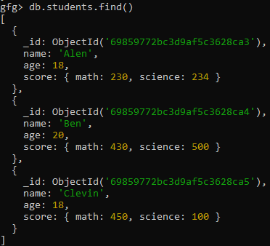
Example 2: Find Documents with a Specific Condition
Find all the students whose age is exactly 18.
db.students.find({age:18})
Output:
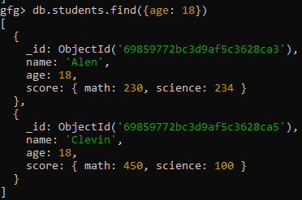
Example 3: Using Nested Documents in Queries
Find student records from the "students" collection where the student's math score is 230 and science score is 234.
db.students.find({score:{math: 230, science: 234}})
Output:
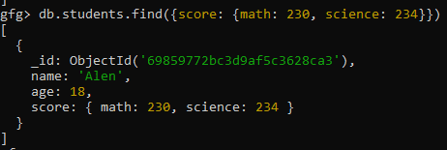
Example 4: Using Projection
Retrieve the names of all students while excluding the score field.
db.students.find({}, {score: 0 })
Output:
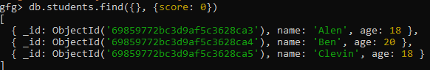
Example 5: Sorting Results
Retrieve all student records sorted by age in ascending order.
db.students.find().sort({ age: 1 })
Output:
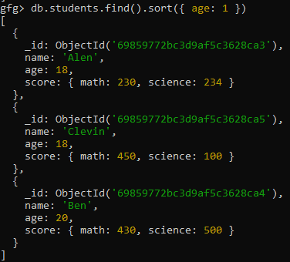
Example 6: Limiting Results
The limit method restricts the number of documents returned to the specified value.
db.students.find().limit(2)
Output:
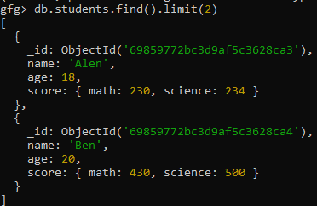

MongoDB - findOne() Method
Last Updated :5 May, 2026

The findOne() method fetches a single matching document from a MongoDB collection, making it ideal when only one specific result is needed.
- Returns one matching document; the order is undefined unless a sort is specified.
- Returns null when no document matches the criteria.
- Supports projection to include or exclude specific fields.
- Reduces overhead when only one document is required.
Syntax
db.collection.findOne(query, projection)
- db.collection: Refers to the collection from which you want to retrieve the document.
- findOne(): The method used to retrieve a single document.
- query: A document that specifies the criteria to match the desired document.
- projection (optional): A document that specifies the fields to include or exclude in the returned document.
Examples of MongoDB findOne()
Here are a few practical examples using the student collection:
[
{ "_id": ObjectId("6011c71f781ba1a1c1ffc5b1"), "name": "Nicol", "language": "C++" },
{ "_id": ObjectId("6011c71f781ba1a1c1ffc5b2"), "name": "Alen", "language": "python" },
{ "_id": ObjectId("6011c71f781ba1a1c1ffc5b3"), "name": "Tim", "language": "python" }
]
Example 1: Empty Query
Retrieve a single document from the student collection.
Query:
db.student.findOne({})
Output:
{ "_id": ObjectId("6011c71f781ba1a1c1ffc5b1"), "name": "Nicol", "language": "C++" }
Example 2: Query Specification
Retrieve a document where the name is "Alen".
Query:
db.student.findOne({ name: "Alen" })
Output:
{ "_id": ObjectId("6011c71f781ba1a1c1ffc5b2"), "name": "Alen", "language": "python" }
Example 3: Include Specific Fields
Retrieve a document where the name is Tim and return only the name and language fields.
Query:
db.student.findOne({ name: "Tim" }, { _id: 0, name: 1, language: 1 })
Output:
{ "name": "Tim", "language": "python" }
Example 4: Exclude a Field
Retrieve a document where the name is "Nicol" and return all fields except the _id field.
Query:
db.student.findOne({ name: "Nicol" }, { _id: 0 })
Output:
{ "name": "Nicol", "language": "C++" }
Example 5: Matching Documents
Retrieve a document where the language is "python". If no document matches the criteria, findOne() returns null.
Query:
var result = db.student.findOne({ language: "python" });
print(result);
Output:
{ "_id": ObjectId("6011c71f781ba1a1c1ffc5b2"), "name": "Alen", "language": "python" }

MongoDB findAndModify() Method
Last Updated :5 May, 2026

findAndModify() is an atomic MongoDB operation that updates, removes, or upserts a single matching document and returns it, ensuring safe read-modify-write behavior in concurrent environments.
- Performs update, remove, or upsert on one document.
- Executes atomically to prevent race conditions.
- Returns the original document by default.
- Use new: true to return the modified document.
- Supports query filters and field projection.
- Useful for counters, queues, and state transitions.
Syntax
db.Collection_name.findAndModify(
{
query:<document>,
sort: <document>,
remove: <boolean>,
update: <document>,
new: <boolean>,
projection: <document>,
upsert: <boolean>,
bypassDocumentValidation: <boolean>,
writeConcern: <document>,
collation: <document>,
arrayFilters: [ <filterdocument1>, ... ]
})
- remove: Removes the matched document when set to true (required if update is not provided).
- update: Updates the matched document using update operators or field–value pairs (required if remove is not provided).
- query: Filters documents to match. Only one matching document is modified.
- sort(optional): Chooses which document to modify when multiple documents match.
- new(optional): Returns the updated document when true (ignored for remove, default is false).
- projection(optional): Returns only selected fields (projection), e.g., { field1: 1, field2: 1 }.
- upsert(optional): Inserts a new document if no match is found (default is false).
- writeConcern(optional): Overrides the default write concern.
- collation(optional): Applies locale-specific string comparison rules.
- arrayFilters(optional): Specifies which array elements to update in array fields.
Return Value of findAndModify()
- Returns the original document by default.
- Use new: true to return the updated document.
- If upsert inserts a document and new is false, it returns null.
- If upsert inserts a document with sort specified and new is false, it returns {}.
Examples of MongoDB findAndModify Method
In the following examples, we are working with:
- Database: gfg
- Collection: student
- Document: Three documents contain name, language they use in coding and the score they got by solving problem on gfg.
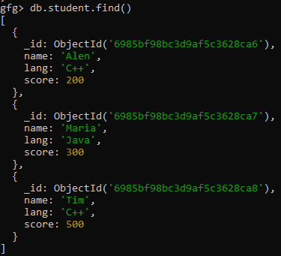
Example 1: Update a Document
To increase the score of a student named Maria by 4.
Query:
db.student.findAndModify({
query: { name: "Maria" },
update: { $inc: { score: 4 } }
})
Output:
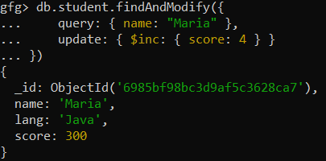
Example 2: Return the Modified Document
Find and modify the document for the student with the name Maria in the student collection by incrementing the score field by 4. Return the modified document.
Query:
db.student.findAndModify({
query:{name:"Maria"},
update:{$inc:{score:4}},
new:true
})
Output:
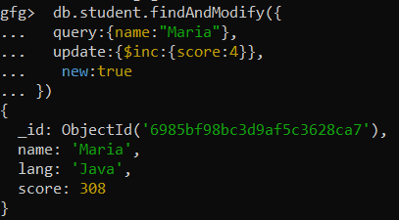
Example 3: Update and Return the Updated Document (Using findOneAndUpdate())
Update Maria’s score to 220 and return the modified document.
Query:
db.student.findOneAndUpdate(
{ name: "Maria" },
{ $set: { score: 220 } },
{ returnDocument: "after" }
)
Output:
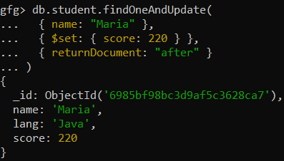
Note: findOneAndUpdate() is the modern, recommended alternative to findAndModify() for update operations and provides a cleaner API to return the updated document.
Example 4: Upsert Operation (Using updateOne())
Updates the document for the student with the name "Jenny" in the students collection. If no document matches the query, insert a new document with the name "Jenny", setting the language to "C#" and the score to 195.
Query:
db.student.updateOne(
{ name: "Jenny" },
{ $set: { lang: "C#", score: 195 } },
{ upsert: true }
)
Output:
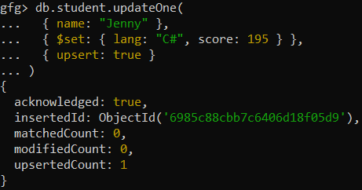
- matchedCount is 0, meaning no document with the name Jenny was found.
- upsertedCount is 1, indicating that one new document was inserted for Jenny.
Note: updateOne() with upsert: true is the recommended way to insert a document when no match is found, instead of using findAndModify() for upserts.
Best Practices for Using findAndModify()
To get the most out of MongoDB's findAndModify() method, consider the following best practices:
- Atomicity: Use findAndModify() for safe, atomic updates.
- Use the new Option for Updated Data: Set new as true to return the updated document.
- Upsert for Missing Documents: Use upsert to insert a document when no match is found.
- Query Efficiency: Use indexed fields to speed up matching and updates.

MongoDB findOneAndDelete() Method
findOneAndDelete() removes a single document that matches a filter and returns the deleted document, making it useful when you need the removed data for logging or auditing.
- Deletes one matching document; the selection order is undefined unless sort is specified.
- Returns the deleted document or null if no match is found.
- Supports options like projection, sort, and write concern.
- Useful for audit logs and follow-up processing after deletion.
Syntax
db.Collection_name.findOneAndDelete(
Selection_criteria,
{
projection: <document>,
sort: <document>,
maxTimeMS: <number>,
collation: <document>
})
- selection_criteria: Filters documents to match; deletes the first matching document.
- projection: Specifies which fields to return from the deleted document.
- sort: Determines which document to delete when multiple documents match.
- maxTimeMS: Sets a time limit for the operation.
- collation: Applies locale-specific string comparison rules (case, accents).
Return Value of findOneAndDelete()
- If a document matches the given filter query then this method returns the deleted document.
- If no document matches the given filter query then this method returns null.
Examples of MongoDB findOneAndDelete()
In the following examples, we are working with:
- Database: gfg
- Collection: student
- Document: Four documents contain name and age of the students
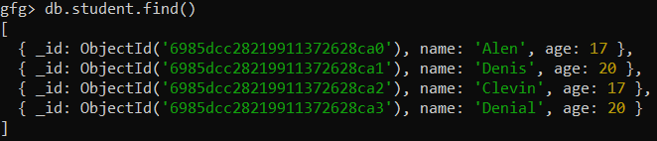
Example 1: Delete A Document by Name
Delete the first document where the name is "Denis" from the student collection.
Query:
db.student.findOneAndDelete({name:"Denis"})
Output:
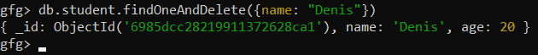
Example 2: Find and Delete the document according to the selection criteria
Delete the first document where age is 17, but sort the matching documents by age in descending order.
Query:
db.student.findOneAndDelete({age:17},{sort:{age:-1}})
Output:
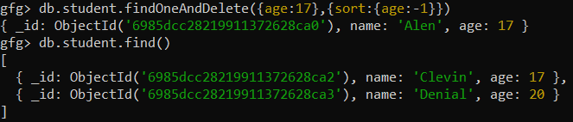
Example 3: When no document matches the filter query.
Delete a document where the name is "Jenny", but no such document exists in the collection.
Query:
db.student.findOneAndDelete({name: "Jenny"})
Output:
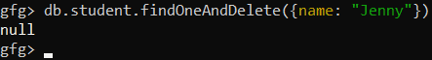
Example 4: Delete A Document Using Write Concern
Delete a document based on its _id, specifying a write concern for acknowledgment from the majority of the replica set.
Query:
db.student.findOneAndDelete(
{ "_id": ObjectId("6985dcc28219911372628ca2") },
{ writeConcern: { w: "majority", wtimeout: 5000 } }
)
Output:
Note: deleteOne() is a related delete method. Use it when you only need acknowledgment and not the deleted document. Use findOneAndDelete() when you need the deleted document back.
Example 5: Sort And Delete A Document
Sort the documents by name and delete the first document found.
Query:
db.student.findOneAndDelete({}, { sort: { name: 1 } })
Output:
Best Practices for Using MongoDB findOneAndDelete()
Here are some best practices to be followed for better results:
- Projections: Return only needed fields to reduce data load.
- Sorting: Define order when multiple documents match.
- Null Handling: Handle cases where no document is deleted.
- Indexing: Index frequently queried fields for faster deletes.
- Write Concern: Use write concerns for critical operations.

Mongoose findOneAndUpdate() Method
Mongoose findOneAndUpdate() is used to safely update a single document in MongoDB using an atomic operation. It helps maintain data consistency in multi-user environments by preventing race conditions and conflicting updates.
- Atomic operation: Find and update happen as one indivisible step.
- Concurrency-safe: Ensures atomic updates at the document level, but race conditions can still arise at the application level.
- Single-document update: Modifies only one matching document.
- Returns updated document: Use { new: true } to get the modified data.
- Supports upsert: Creates a document if no match is found.

Atomic Operations in Mongoose
Mongoose supports atomic updates by executing MongoDB’s single-document atomic operations through its model methods (such as findOneAndUpdate()), ensuring safe updates in concurrent environments.
- Single-document atomicity: Each update on one document is atomic.
- No partial updates: Updates are atomic per document, but only specified fields are modified (not full document replacement unless explicitly done).
- Concurrency-safe: Provides atomic updates at the document level; application-level race conditions may still occur.”
- Filter-based updates: Updates only the document matching the criteria.
- Document-level isolation: Other operations see either old or new data, never an inconsistent state.
Syntax
Model.findOneAndUpdate(filter, update, options)
- filter: Condition to match the document to update.
- update: Update operation to apply (e.g., $set, $inc).
- options (optional): Extra settings like new: true (return updated doc) and upsert: true (insert if no match).
- Return value: Returns updated document with new: true; otherwise returns original (default).
Examples of findOneAndUpdate() Method
The findOneAndUpdate() method is versatile and can be used in various scenarios.
Example 1: Basic Usage
Consider a scenario where we have a collection of users and we want to update the email address of a user named "Alen". Using findOneAndUpdate we can perform this operation atomically as defined below:
const mongoose = require('mongoose');
// Database connection
mongoose.connect('mongodb://127.0.0.1:27017/GeeksforGeeks');
// User model
const User = mongoose.model('User', {
name: String,
email: String,
});
// Update email address for user "Alen"
User.findOneAndUpdate(
{ name: 'Alen' },
{ $set: { email: 'alen@example.com' } },
{ new: true },
(err, user) => {
if (err) return console.error(err);
console.log(user);
}
);
- findOneAndUpdate() finds the user named "Alen" and updates her email.
- $set updates only the email field.
- { new: true } returns the updated document.
Example 2: Upsert with findOneAndUpdate()
In Mongoose, upsert updates a document if it exists or inserts a new one if no matching document is found. The findOneAndUpdate() method supports this using the upsert: true option.
Suppose we want to update the price of a book by title. If the book doesn’t exist, insert it.
const mongoose = require('mongoose');
// Database connection
mongoose.connect('mongodb://127.0.0.1:27017/GeeksforGeeks');
// Book model
const Book = mongoose.model('Book', {
title: String,
price: Number,
});
// Update or insert a book with title
//"The Great Gatsby"
Book.findOneAndUpdate(
{ title: 'The Great Gatsby' },
{ $set: { price: 19.99 } },
{ upsert: true, new: true },
(err, book) => {
if (err) return console.error(err);
console.log(book);
}
);
- If the book exists, its price is updated to 19.99.
- If it doesn’t exist, a new document is inserted.
- { upsert: true } inserts when no match is found.
- { new: true } returns the updated/inserted document.
Example 3: Updating Discriminator Keys
In Mongoose, discriminators let multiple document types exist in one collection. You can change a document’s type by updating its discriminator key using findOneAndUpdate().
const mongoose = require('mongoose');
// Database connection
mongoose.connect('mongodb://127.0.0.1:27017/GeeksforGeeks');
// Base schema with discriminator key
const animalSchema = new mongoose.Schema(
{ name: String },
{ discriminatorKey: '__t' }
);
const Animal = mongoose.model('Animal', animalSchema);
// Update discriminator key to change animal type
Animal.findOneAndUpdate(
{ name: 'Fido', __t: 'Dog' },
{ $set: { __t: 'Cat' } },
{ new: true },
(err, animal) => {
if (err) return console.error(err);
console.log(animal);
}
);
- __t is the discriminator key used to identify the document type.
- The query finds "Fido" with type "Dog".
- $set updates the type to "Cat".
- { new: true } returns the updated document.

Steps to Install Mongoose Module
Follow these steps to set up Mongoose in your project.

Step 1: Install Mongoose
You can visit the link to Install mongoose module. You can install this package by using this command.
npm install mongoose
This will add Mongoose to your project's dependencies.

Step 2: Verify Mongoose Installation
After installing mongoose module, you can check your mongoose version in command prompt using the command.
npm version mongoose

Step 3: Create and Set Up the Project
1. Create a new folder for your project (if you don’t already have one):
mkdir your-project-name
cd your-project-name
2. Create a new file, for example index.js, and add the following code to connect to MongoDB and use the findOneAndUpdate() method in Mongoose
Filename: app.js
const mongoose = require('mongoose');

async function run() {
await mongoose.connect('mongodb://127.0.0.1:27017/GeeksforGeeks');

const userSchema = new mongoose.Schema({
name: String,
age: Number
}, { collection: 'student' });

const User = mongoose.model('User', userSchema);

const doc = await User.findOneAndUpdate(
{ age: { $gte: 5 } },
{ $set: { name: "Denial" } },
{ returnDocument: 'before' }
);

console.log("Original Doc:", doc);

await mongoose.disconnect();
}

run().catch(console.error);
The project structure will look like this:
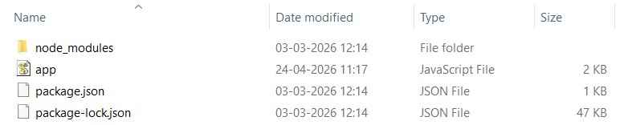
Below is the sample data in the database before the function is executed, you can use any GUI tool or terminal to see the database, like we have used MongoDB Compass tool as shown below:
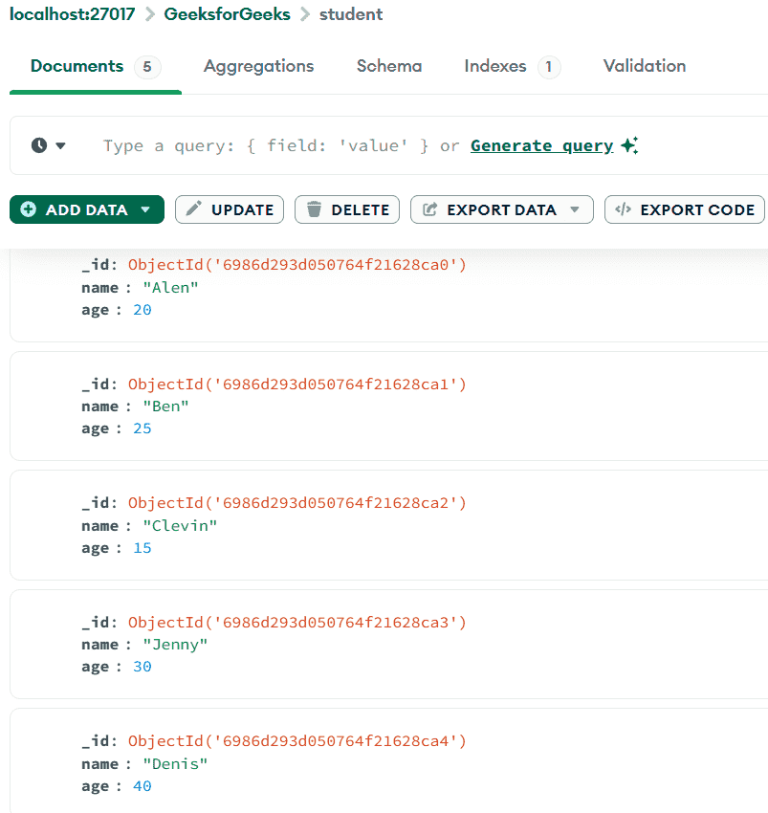

Step 4: Running the Application
After creating the file and adding the code, run the application using the following command:
Run:
node app.js
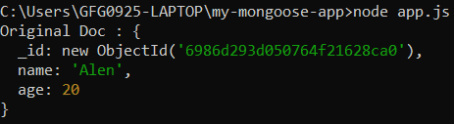

Step 5: Verify the Changes
You can verify the changes in your MongoDB database by using a GUI tool like Robo3T or MongoDB Compass to check if the document has been updated.
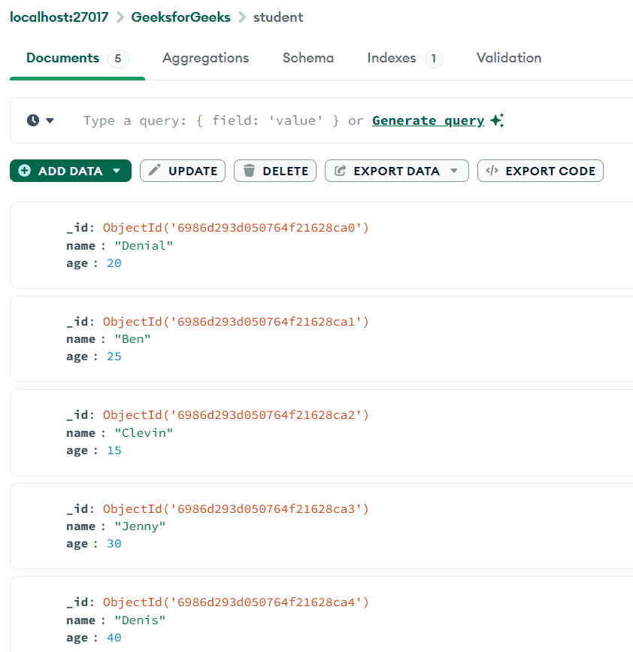

MongoDB findOneAndReplace() Method
In MongoDB, findOneAndReplace() replaces the first matching document (including embedded documents) and returns the original document by default, or the new one using options.
- Single-document replace: Replaces the first matching document.
- Returns original by default: Can return the new document with options.
- Filter-based: Uses a filter to find the document.
- Full replacement: Replaces the entire document (except _id).
- Supports embedded documents: Can replace nested content as part of the document.
- Transaction-safe: Can be used within multi-document transactions.
- Options supported: Control return behavior and other settings.
Syntax
db.collection.findOneAndReplace(filter, replacement, options)
- filter: Criteria to find the document to replace.
- replacement: New document that replaces the matched document.
- options (optional): Additional settings for the operation.
- projection: Selects returned fields (1/true include, 0/false exclude).
- sort: Chooses which document to replace if multiple match.
- maxTimeMS: Sets a time limit (in ms) for the operation.
- upsert: Inserts a new document if no match is found when true.
- returnNewDocument: Returns the replaced document when true; otherwise returns the original (default).
- collation: Applies language-specific string comparison rules (case and accents).
Return Value of findOneAndReplace()
- Returns the original document by default.
- Returns the replaced document when returnDocument: 'after' is set.
Examples of MongoDB findOneAndReplace() Method
In the following examples, we are working with:
- Database: gfg
- Collection: student
- Document: Four documents contain name and the age of the students
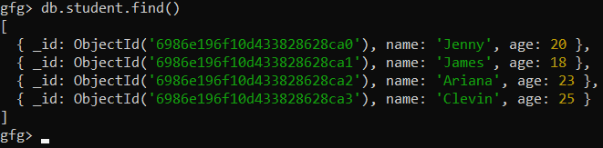
Example 1: Replace first matching document and returns replaced document
Finds the first document where age is 18 and replaces it with a new document. It returns the original document before replacement.
Query:
db.student.findOneAndReplace({age:18},{name:"Maria", age:17})
Before replacement:
After replacement:
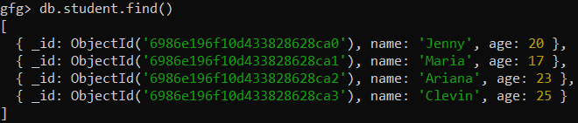
Example 2: Replace the first matched document and returns a new document
Replaces a document where age is 25 and ensures that the updated document is returned instead of the original.
Query:
db.student.findOneAndReplace({age:25}, {name:"Sophia", age:45}, {returnDocument: "after"})
Output:
Important Points
Here are some important points to remember:
- findOneAndReplace() finds and replaces the first document that matches the filter.
- Returns the original document by default; can return the updated document using returnDocument: 'after'.
- Supports options like projection, sort, maxTimeMS, upsert, returnDocument, and collation.
- Can be used for atomic single-document operations and within transactions.

MongoDB Query and Projection Operators
In MongoDB, query operators filter documents based on conditions, while projection operators control which fields are returned in the query result. Together, they help retrieve only the required data efficiently.
- Query operators: Filter documents using conditions (e.g., $eq, $gt, $in).
- Projection operators: Select specific fields to include or exclude in results.
- Improves performance: Fetches only needed fields, reducing data transfer.
- Supports nested fields: Can query and project fields inside embedded documents.
- Works with relational database concepts: Similar to WHERE (filtering) and SELECT columns (projection) in a relational database.

MongoDB Query Operators
MongoDB query operators are used to filter documents based on specific conditions by comparing values, matching patterns, and working with arrays or geospatial data.
- Condition-based filtering: Selects documents that match given criteria.
- Value comparison: Supports operators like $eq, $gt, $lt, $in.
- Pattern matching: Enables text and regex-based searches.
- Array handling: Queries elements within arrays.
- Geospatial support: Filters data using location-based queries.
- Logical comparison: Combines multiple conditions across fields.

Setting Up an Environment
We have created a collection called count_no with the help of the db.createCollection( ) function. After containing some data, the count_no collections look like this:
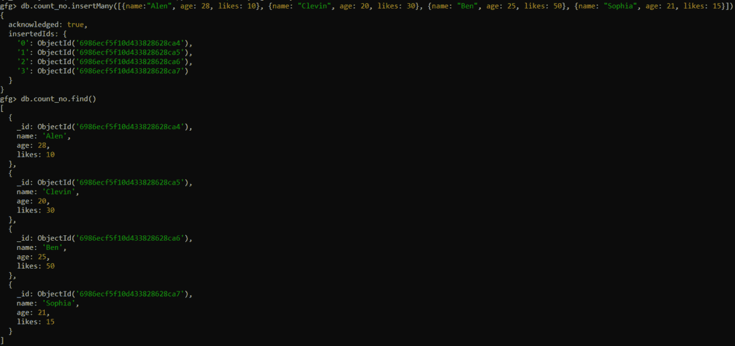

Types of Query Operators in MongoDB
The Query operators in MongoDB can be further classified into 8 types:

1. Comparison Operators
The Comparison Operators in MongoDB are used to perform value-based comparisons in queries. The comparison operators in the MongoDB are shown below:
Example 1: Using $gte Operator
Find all those records in which the age of the person is equal to or greater than 25.
Query:
db.count_no.find( { "age": {$gte:25} }, {"_id":0} )
Output:
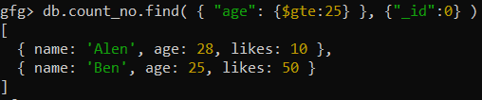
- Filters documents where age ≥ 25.
- Excludes the _id field using projection (_id: 0).
Example 2: Using $gt Operator
Find out those people whose age is greater than 15.
Query:
db.count_no.find( { "age": {$gt:15} }, {"_id":0} )
Output:
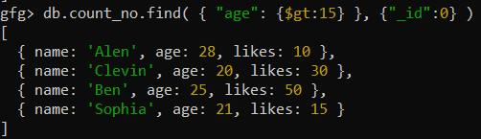
Example 3: Using $eq Operator
Let's find out if the person named Alen is present in our Collections or not.
Query:
db.count_no.find( { "name": {$eq:"Alen"} }, {"_id":0} )
Output:
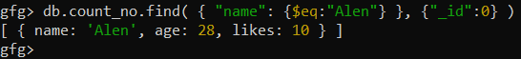

2. Logical Operators
The Logical Operators in MongoDB are used to filter data based on expressions that evaluate to true or false.
Example 1: Using $and Operator
Find out the name of the Person whose likes are 5and whose age is 25.
Query:
db.count_no.find({$and : [ {"likes":50} , {"age":25} ] } )
Output:
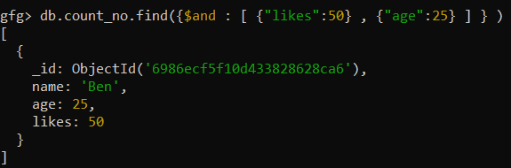
- The $and operator are used and it will return the documents whose likes are 50 and the age is 25.
- If the condition is not satisfied it will not return anything.
Example 2: Using $or Operator
Find out the Person whose ageis either 21 or 40.
Query:
db.count_no.find({$or: [ {"age":21}, {"age":40} ] } )
Output:
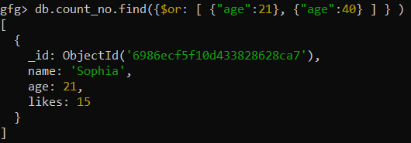
- It returns the documents whose age is 21 or age is 40.
- It returns the documents if either of any conditions is satisfied.

3. Array Operators
The Array Operators in the MongoDB return the result based on the Multiple conditions specified in the array using the array operators. The Array Operators in the MongoDB are:
Example 1: Using $all Operator
Find out the Person whose age is 25.
Query:
db.count_no.find( {"age" :{$all : [25] } }, {_id:0} )
Output:
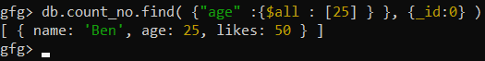
Example 2: Using $elemMatch Operator
First make some updates in our demo collection. Here we will Insert some data into the count_no database
Query:
db.count_no.insertOne( {"name" : "Harry", "age": 24,"likes" : 2,"colors":["Red","Green","Blue"] } )
Output:
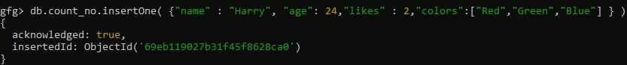
Now, using the $elemMatch operator in MongoDB let's match the Red colors from a set of Colors.
Query:
db.count_no.countDocuments({colors: { $elemMatch: { $eq: "Red" }}})
Output:
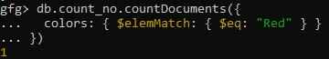
- $elemMatch is applied on the colors array field.
- It checks if any element in the array is "Red".
- countDocuments() returns the number of matching documents.
- Result is a count, not the documents themselves.

4. Evaluation Operators
The Evaluation Operators in the MongoDB are used to return the documents based on the result of the given expression. Some of the evaluation operators present in the MongoDB are:

1. $mod Operator:
The $mod operator in MongoDB performs a modulo operation on the value of a field and selects documents where the modulo equals a specified value. It only works with numerical fields.
Syntax:
{ field: { $mod: [ divisor, remainder ] } }

2. $expr Operator:
The $expr operator in MongoDB allows aggregation expressions to be used as query conditions. It returns documents that satisfy the conditions of the query.
Syntax:
{ $expr: { <aggregation expression> } }

3. $where Operator:
The $where operator in MongoDB uses JavaScript expression or function to perform queries. It evaluates the function for every document in the database and returns the documents that match the condition.
Syntax:
{ $where: <JavaScript expression> }

5. Element Operators
The Element Operators in the MongoDB return the documents in the collection which returns true if the keys match the fields and datatypes. There are mainly two Element operators in MongoDB:

1. $exists Operator:
Filters documents based on whether a specified field is present or missing, helping handle optional fields and validate schema-less data in MongoDB.
Syntax:
{ field: { $exists: <boolean> } }

2. $type Operator:
Filters documents by matching the BSON data type of a field’s value (e.g., string, number, array), useful for validating schema-less data in MongoDB.
Syntax:
{ field: { $type: <BSON type> } }
Example: Find out how many documents are in the count_no whose type is 16.
Query:
db.count_no.find({"age":{$type:16}},{_id:0 } )
Output:
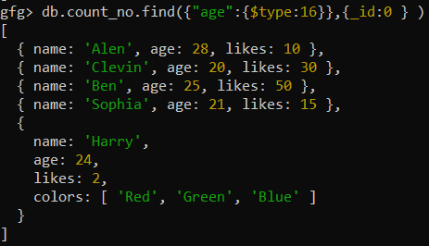
- It checks if the age is of type Int and returns True if it is of Integer data type.
- It uses BSON code to return the document. The BSON code for integers is 16.
- The type operator generally takes the BSON which is nothing but the number that is given to the datatype.

6. Bitwise Operators
The Bitwise Operators in the MongoDB return the documents in the MongoDB mainly on the fields that have numeric values based on their bits similar to other programming languages.
1. $bitsAllClear Operator:
Returns documents where all specified bit positions in a numeric or binary field are set to 0, useful for filtering records based on bitmask or flag values in MongoDB.
Syntax:
{ field: { $bitsAllClear: <bitmask> } }
2. $bitsAnySet Operator:
Returns documents where at least one of the specified bit positions in a numeric or binary field is set to 1, useful for checking if any flag is enabled in MongoDB.
Syntax:
{ field: { $bitsAnySet: <bitmask> } }
3. $bitsAnyClear Operator:
Returns documents where at least one of the specified bit positions in a numeric or binary field is 0, useful for checking if any flag is disabled in MongoDB.
Syntax:
{ field: { $bitsAnyClear: <bitmask> } }
4. $bitsAllSet Operator:
Returns documents where all specified bit positions in a numeric or binary field are set to 1, useful for querying bitmask/flag-based data in MongoDB.
Example: Find the Person whose age has bit 1 from position 0 to 4.
Query:
db.count_no.find({"age":{$bitsAllSet: [0,4] } },{_id:0 } )
Output:
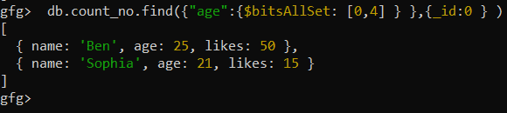
- In the above query, we have used $bitsAllSet and it returns documents whose bits position from 0 to 4 are only ones.
- It works only with the numeric values.
- The numeric values will be converted into the bits and the bits numbering takes place from the right.

7. Geospatial Operators
The Geospatial Operators in the MongoDB are used mainly with the terms that relate to the data which mainly focuses on the directions such as latitude or longitudes. The Geospatial operators in the MongoDB are:
1. $near Operator:
The $near operator finds geospatial objects near a specified point and requires a geospatial index.
Syntax:
{ $near: { geometry: <point_geometry>, maxDistance: <distance> (optional) } }
2. $center Operator:
The $center operator (used with $geoWithin for planar geometry) specifies a circular area around a center point.
Syntax:
{ $geoWithin: { $center: [<longitude>, <latitude>], radius: <distance> } }
3. $maxDistance Operator:
The $maxDistance operator limits the results of $near and $nearSphere queries to a maximum distance from the given point.
Syntax:
{ $near: { geometry: <point_geometry>, maxDistance: <distance> } }
4. $minDistance Operator:
The $minDistance operator limits the results of $near and $nearSphere queries to a minimum distance from the given point.
Syntax:
{ $near: { geometry: <point_geometry>, minDistance: <distance> } }

8. Comment Operators
The Comment Operator in MongoDB is used to write the comments along with the query in the MongoDB which is used to easily understand the data.
Example: Apply some comments in the queries using the $comment Operator.
Query:
db.count_no.find(filter).comment("your comment here")
Output:
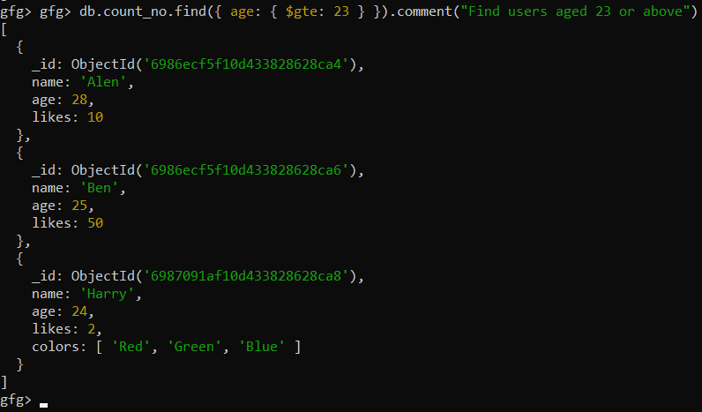
- We used the $comment operator to mention the comment.
- We have used "Find users aged 23 or above" with $comment to specify the comment.
- The comment operator in the MongoDB is used to represent the comment and it increases the understandability of the code.

MongoDB Projection Operators
The Projection Operator in MongoDB controls which fields are included or excluded in query results. By returning only required fields, it improves query performance and reduces data transfer.
- Selective fields: Choose exactly which fields to return.
- Efficient queries: Minimizes unnecessary data retrieval.
- Faster responses: Smaller result sets improve response time.
- Works with nested fields: Can project fields inside embedded documents.
Syntax
db.collection_name.find({},{<field> : <value>})

Projection Operators
1. Include fields: Returns only specified fields.
{ field1: 1, field2: 1 }
2. Exclude fields: Excludes specific fields from the results.
{ field: 0 }
3. $elemMatch: Projects only the first array element that matches a condition.
{ grades: { $elemMatch: { score: { $gt: 80 } } } }
4. $slice: Limits the number of array elements returned.
{ comments: { $slice: 3 } }
5.$meta: Projects document metadata (e.g., text score).
{ score: { $meta: "textScore" } }
Example: Using Projection Operators
Query: Retrieve only the name and age fields
db.count.find({}, {name: 1, age: 1, _id: 0})
Output:
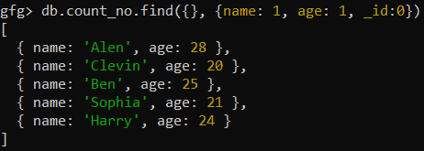
- Selects all documents ({} as filter).
- Returns only name and age.
- Excludes _id.

MongoDB Comparison Query Operators
MongoDB comparison query operators filter documents by matching exact values or selecting value ranges across numeric, string, and date fields, helping retrieve relevant results efficiently.
- Exact match: Use $eq, $ne to match or exclude values.
- Multiple values: Use $in, $nin to match or exclude from a list of values.
- Range queries: Use $gt, $gte, $lt, $lte to filter ranges.
- Type support: Works with numbers, strings, and dates.
- Better filtering: Narrows results for faster, accurate queries.

MongoDB Comparison Operators
Examples using a sample "Students" collection in a database named "GeeksforGeeks".
- Database: GeeksforGeeks
- Collection: Students
- Document: Three documents that contain the details of the Students in the form of field-value pairs.
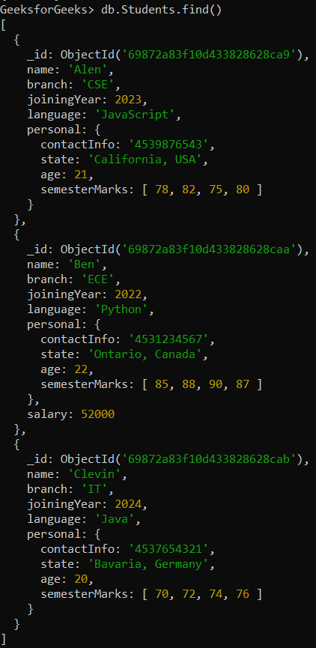

1. $nin operator
$nin matches none of the values specified in an array.
Example: Retrieving only those Student's documents whose name is not "Alen" or "Clevin".
db.Students.find({name: {$nin: ["Alen", "Clevin"]}})
Output:
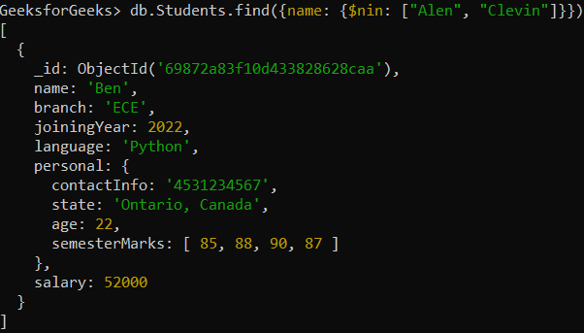

2. $in operator
$in matches any of the values specified in an array.
Example: Retrieving only those students documents whose name is either "Alen" or "Clevin".
db.Students.find({name: {$in: ["Alen", "Clevin"]}})
Output:
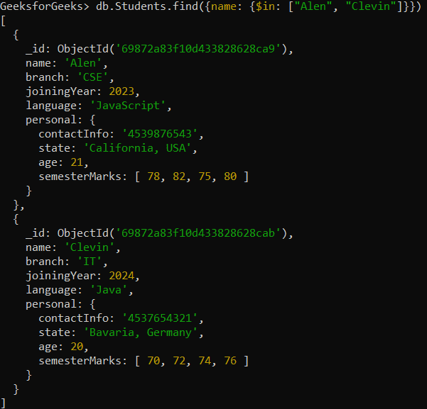

3. $lt operator
$lt matches values of the fields that are less than a specified value.
Example: Retrieving those documents where the value of the salary field is less than 55000.
db.Students.find({salary: {$lt: 55000}})
Output:
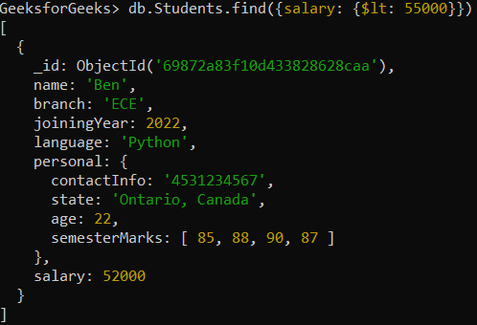

4. $eq operator
$eq matches the values of the fields that are equal to a specified value.
Example: Retrieving those documents where the value of the branch field is equal to "CSE".
db.Students.find({branch: {$eq: "CSE"}})
Output:
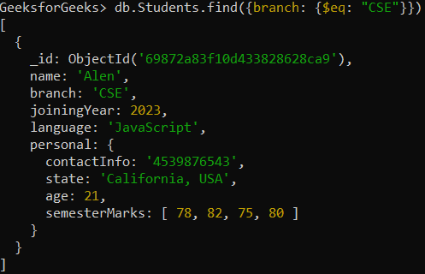

5. $ne operator
$ne matches all values of the field that are not equal to a specified value.
Example: Retrieving those documents where the value of the branch field is not equal to CSE.
db.Students.find({branch: {$ne: "CSE"}})
Output:
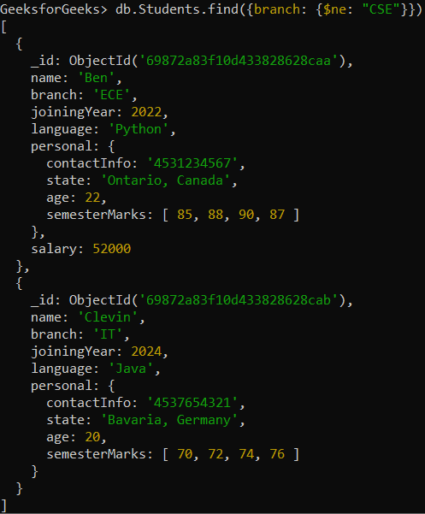

6. $gt operator
$gt matches values of the fields that are greater than a specified value.
Example: Retrieving those documents where the value of the salary field is greater than 5000.
db.Students.find({salary: {$gt: 5000}})
Output:
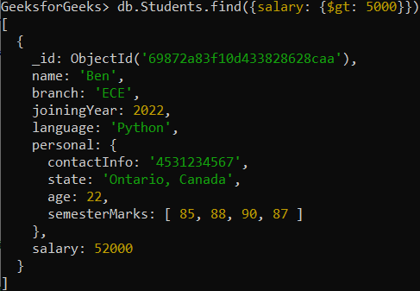

7. $gte operator
$gte matches values of the fields that are greater than or equal to the specified value.
Example: Retrieving those documents where the value of the joiningYear field is greater than equals to 2023.
db.Students.find({joiningYear: {$gte: 2023}})
Output:
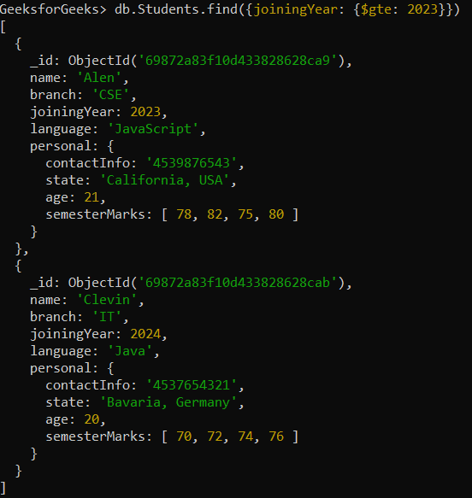

8. $lte operator
$lte matches values of the fields that are less than or equal to the specified value.
Example: Retrieving those documents where the value of the joiningYear field is less than or equal to 2023.
db.Students.find({joiningYear: {$lte: 2023}})
Output:
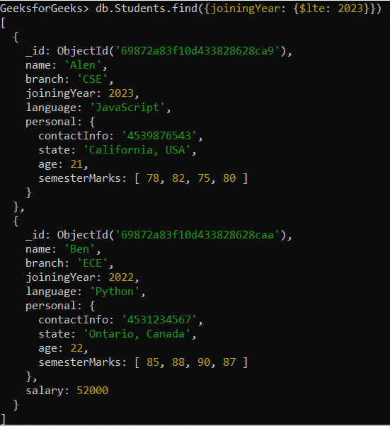

MongoDB $cmp Operator
The MongoDB $cmp operator compares two values and returns their order. It is used in aggregation pipelines for sorting and conditional logic, and follows BSON type ordering for different data types.
- Compares two expressions and returns their relative order.
- Outputs 0, 1, or -1 based on the comparison result.
- Useful for building comparison-based expressions within aggregation pipelines.
- Helps implement conditional logic in pipelines.
- Works across different data types using BSON ordering.
Syntax
{ $cmp: [ <expression1>, <expression2> ] }
- <expression1>: The first value or field to compare.
- <expression2>: The second value or field to compare.

Features of the MongoDB $cmp Operator
Here are some features discussed:
- Returns -1 if the first value is smaller, 1 if greater, and 0 if equal.
- Supports comparisons on nested (embedded) fields.
- Considers both value and data type during comparison.
- Follows BSON type ordering when comparing different data types.
- Used within aggregation pipeline stages like $project, $sort, and conditional expressions.

MongoDB $cmp Operator Examples
Examples of the $cmp operator in MongoDB. In the following examples, we are working with:
- Database: GeeksforGeeks
- Collection: example
- Document: Two documents that contain the details of the shapes in the form of field-value pairs.
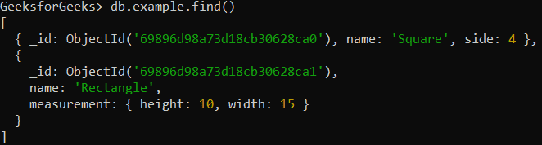
Example 1: Using $cmp to Compare a Field with a Static Value
The $cmp operator compares the value of the side field with 4 and returns 0, which indicates that both values are equal.
Query:
db.example.aggregate([{$match: {name: "Square"}}, {$project: {result: {$cmp:["$side", 4]}}}])
Output:
Example 2: Using $cmp Operator in the embedded Document
Comparing the value of the measurement.height field with the value of the measurement.width field and $cmp operator return -1 which means both values of measurement.height field is less than the value of the measurement.width field.
Query:
db.example.aggregate([{$match: {name: "Rectangle"}}, {$project: {result: {$cmp:["$measurement.height", "$measurement.width"]}}}])
Output:

MongoDB $gt Operator
The $gt operator in MongoDB matches documents where a field’s value is greater than a specified value. It is commonly used with find(), update(), and aggregation pipelines for filtering, analysis, and range-based queries.
- Filters documents where a field value is greater than a given value.
- Works with data types such as numbers, strings, and dates; array comparisons use lexicographical ordering and are less commonly used.
- Can be combined with other query operators for complex filtering.
- Useful for range queries, threshold checks, and data analysis.
Syntax
{field: {$gt: value}}
- field: Specifies the name of the field to evaluate.
- $gt: Indicates the greater-than condition.
- value: The threshold value to compare against.

Features of $gt Operator
The $gt operator is flexible and efficient for filtering documents greater than a given value across different query methods.
- Versatile types: Works with numbers, strings, dates, and arrays.
- Operator chaining: Combines with $lt, $gte, $and, and $or for complex filters.
- Nested queries: Supports dot notation for embedded fields.
- Method support: Works with find(), update(), delete(), and aggregation pipelines.
- Performance-friendly: Uses indexes (if available) to speed up queries.
Examples of MongoDB $gt Operator
Consider the following sample data. We will use a database named GeeksforGeeks and a collection called employee, which contains the following documents:
- Database: GeeksforGeeks
- Collection: employee
- Document: Four documents that contain the details of the employees in the form of field-value pairs.
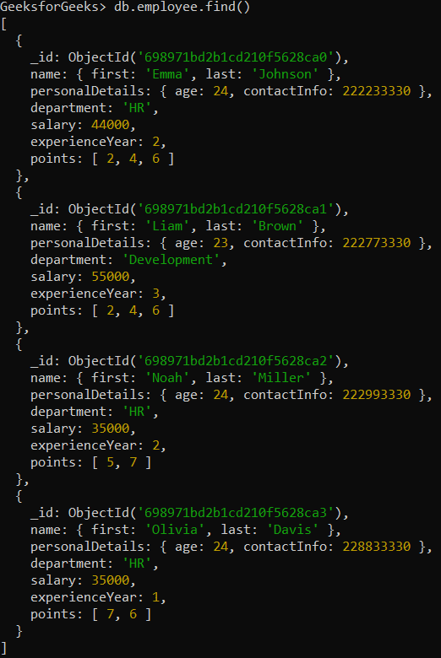
Example 1: Find Employees with a Salary Greater Than 35,000
Retrieving those documents where the value of the salary field is greater than 35000.
Query:
db.employee.find({salary: {$gt: 35000}})
Output:
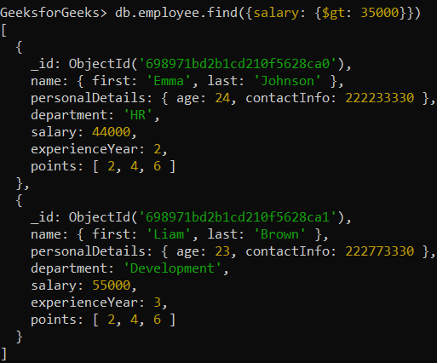
Example 2: Find Employees with Age Greater Than 23
Retrieving only those documents where the age of the employee is greater than 23.
Query:
db.employee.find({"personalDetails.age": {$gt:23}})
Output:
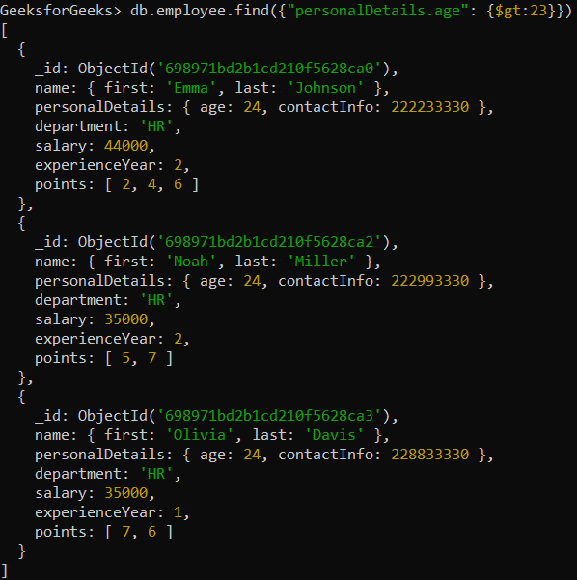
The query uses dot notation to access the nested age field inside the personalDetails document and applies the $gt operator.
Example 3: Using $gt operator with arrays
Retrieving only those documents where the points array is greater than the specified array.
Query:
db.employee.find({points: {$gt: [4,5]}})
Output:
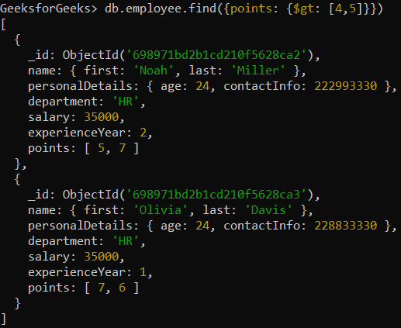
The query compares the points array with [4, 5] using lexicographical ordering, where elements are compared sequentially from left to right.
Use Cases of $gt Operator
The $gt operator is used to filter documents where a field value is greater than a specified threshold.
- Threshold analysis: Find records exceeding a specific value (e.g., salaries above a limit).
- Date filtering: Retrieve documents after a certain date, often combined with $lt for ranges.
- Ranking and scores: Identify entries with scores or ranks above a given level.
- Data validation: Check whether fields meet minimum required values.

MongoDB $lt Operator
The $lt operator in MongoDB filters documents where a field’s value is strictly less than a specified value and is commonly used in find(), update(), and aggregation pipelines.
- Filters documents with values less than a given threshold.
- Works with numbers and dates; array comparisons use lexicographical ordering and are less commonly used.
- Useful for range-based queries and filtering before sorting.
- May use indexes to improve performance depending on the query planner.
- Compares values of compatible data types only (e.g., number with number).
Syntax
{field: {$lt: value}}
- field: The field name to compare.
- $lt: Specifies the less than condition.
- value: The threshold value to compare against.

Important Points About $lt in MongoDB
Here are features discussed:
- Filters documents where a field value is strictly less than a given value.
- Works with numbers and dates; array comparisons use lexicographical ordering and are less commonly used.
- Usable in find(), updateMany(), and aggregation stages like $match.
- Performs faster when relevant fields are indexed.
- Compares compatible data types to ensure accurate results.
Examples of MongoDB $lt Operator
For these examples, we assume the following setup
- Database: GeeksforGeeks
- Collection: employee
- Document: Four documents that contain the details of the employees in the form of field-value pairs.
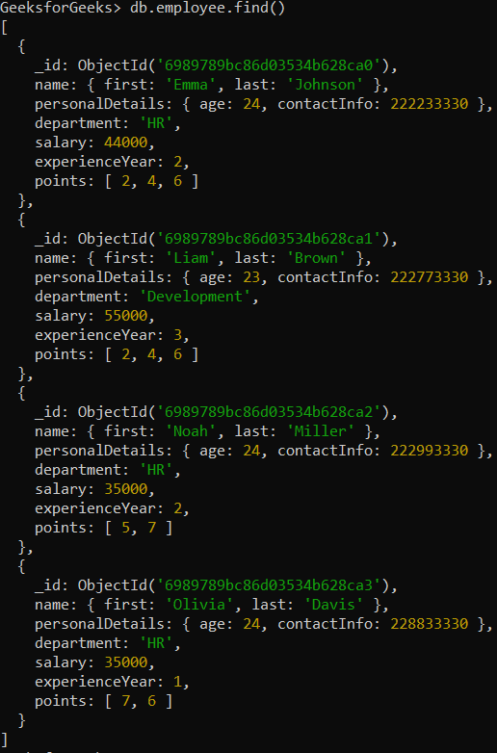
Example 1: Find Employees with Salary Less Than 55000
Retrieving those documents where the value of the salary field is less than 55000.
Query:
db.employee.find({salary: {$lt:55000}})
Output:
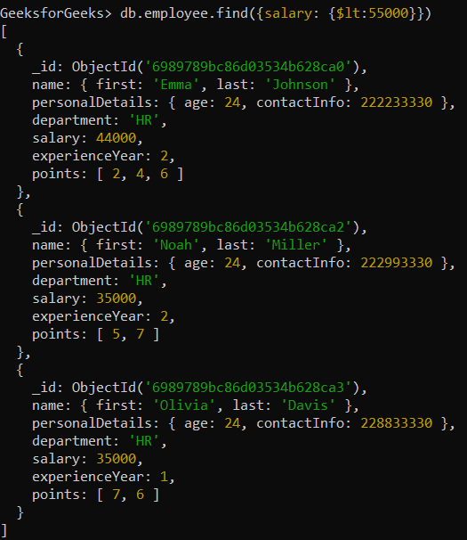
Example 2: Find Employees Younger Than 24 Years
Retrieving only those documents where the age of the employee is less than 24.
Query:
db.employee.find({"personalDetails.age": { $lt: 24 }})
Output:
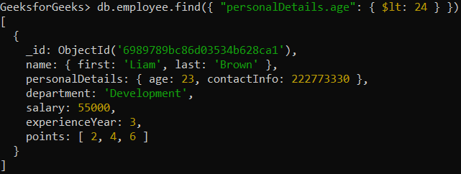
Example 3: Comparing Arrays with $lt Operator
Retrieving only those documents where the points array is lexicographically less than the specified array. MongoDB compares arrays element by element from left to right (similar to string sorting).
Query:
db.employee.find({ points: { $lt: [50, 70, 90] } })
Output:
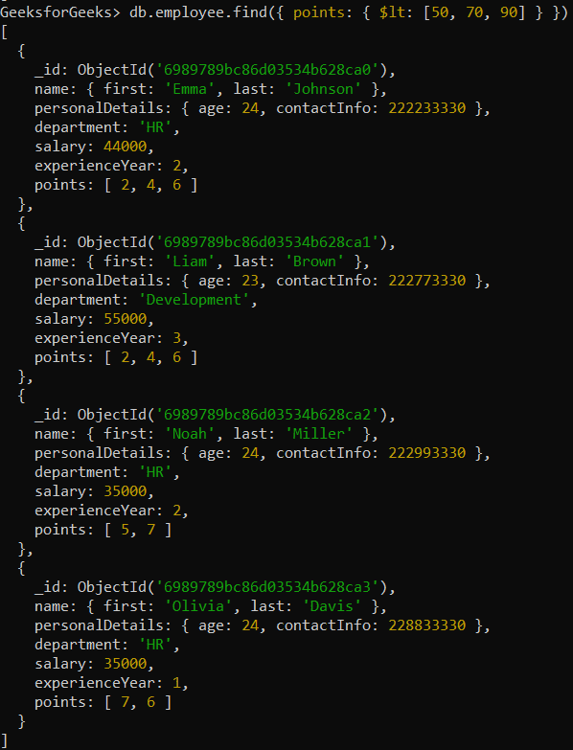
Example 4: Update Salaries for Employees with Less Than 2 Years of Experience
Updating the salary of those employees whose experience year is less than 2 years.
Query:
db.employee.updateMany({ experienceYear: { $lt: 2 } }, { $set: { salary: 40000 } })
Output:
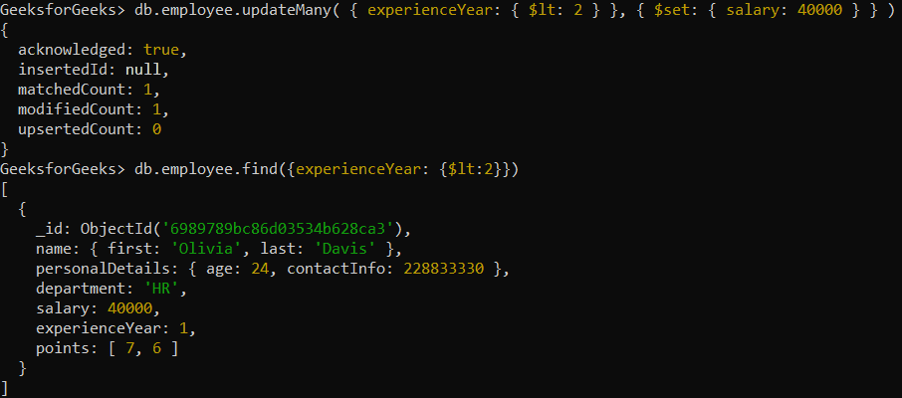
Performance Optimization Tips for Using $lt
To improve query performance when using the $lt operator, follow these best practices:
1. Use Indexing for Faster Queries
Create indexes on frequently filtered fields so $lt queries run efficiently.
db.employee.createIndex({ salary: 1 })
2. Avoid Large Collection Scans
Without indexes, $lt queries may scan the entire collection, slowing performance.
3. Use Projection to Limit Retrieved Fields
Return only required fields to reduce data transfer and processing time.
db.employee.find({ salary: { $lt: 35000 } }, { name: 1, salary: 1 })
4. Ensure Proper Data Type Comparisons
Compare compatible data types (e.g., numbers with numbers) to avoid incorrect results and slow queries.

MongoDB $eq Operator
The MongoDB $eq operator matches documents where a field value exactly equals a specified value, and is commonly used for precise filtering in queries, updates, and aggregation pipelines.
- Matches field values exactly.
- Works with numbers, strings, dates, arrays, and embedded documents.
- Supports dot notation for querying nested fields.
- Can be used implicitly ({ field: value } is the same as { field: { $eq: value } }).
- May use indexes to improve query performance depending on index availability and the query planner.
Syntax
MongoDB allows two ways to use the $eq operator:
1. Explicit Syntax
{field: {$eq: value}}
2. Implicit Syntax
{field: value}
- field: The field name to compare.
- $eq: Specifies the equal to condition.
- value: The exact value to match.

Features of $eq Operator
Here are some features discussed:
- The $eq operator matches documents where a field’s value exactly equals a specified value.
- Can be implicitly written as { field: value }, making queries more concise.
- Works with numbers, strings, dates, arrays, and embedded documents.
- Supports dot notation for filtering inside nested documents.
- Indexing improves query performance, reducing execution time.

MongoDB $eq Operator Examples
Examples demonstrate how to filter documents based on exact matches using $eq. We will be working with:
- Database: GeeksforGeeks
- Collection: employee
- Document: Five documents that contain the details of the employees in the form of field-value pairs.
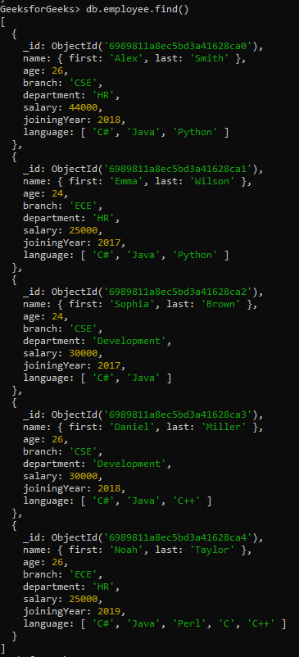
Example 1: Find Employees with Salary Equal to 30,000
Retrieving those documents where the value of the salary field is equal to 30000.
Query:
db.employee.find({salary: {$eq: 30000}})
or using implicit syntax:
db.employee.find({salary: 30000})
Output:
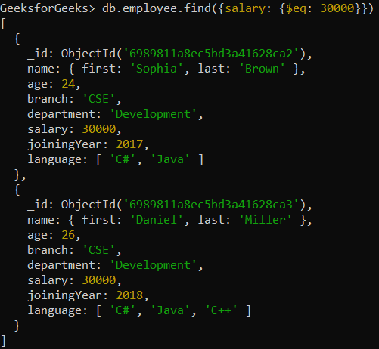
Example 2: Find Employees with First Name “Daniel” in an Embedded Document
Retrieving those documents where the first name of the employee is equal to Daniel. We are specifying conditions on the field in the embedded document using dot notation in this example.
Query:
db.employee.find({"name.first": {$eq: "Daniel"}})
Or using implicit syntax:
db.employee.find({"name.first": "Daniel"})
Output:
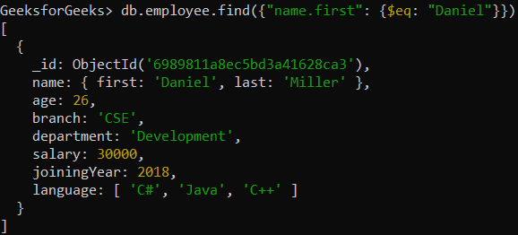
Example 3: Find Employees who contain “C++” as language
Retrieving those documents where the language field matches the value "C++" (for arrays, this matches if the array contains the value).
Query:
db.employee.find({language: {$eq: "C++"}})
Or using implicit syntax:
db.employee.find({language: "C++"})
Output:
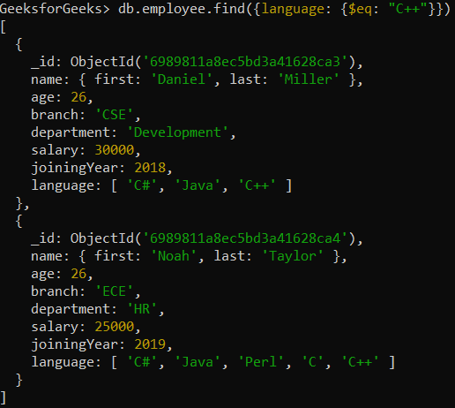
Example 4: Find Employees Where the language Array Matches a Specific Array
Retrieving those documents where the language array is equal to the specified array.
Query:
db.employee.find({ language: { $eq: ["C#", "Java"] } })
Or using implicit syntax:
db.employee.find({ language: ["C#", "Java"] })
Output:
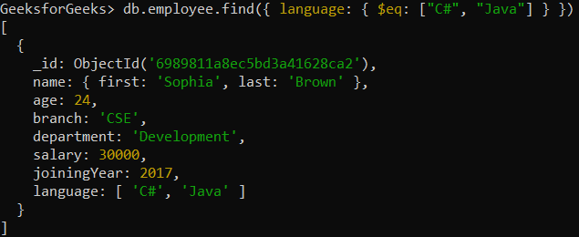

MongoDB Logical Query Operators
MongoDB logical query operators combine multiple conditions in a single query to enable flexible, precise filtering for advanced searches and data analysis.
- Combine multiple query conditions in one filter.
- Enable complex and conditional searches.
- Improve precision in data retrieval.
- Commonly used in advanced filtering and analysis scenarios.

MongoDB Logical Operators
Let’s understand how each operator works with examples from a sample MongoDB collection. In the following examples, we are working with:
- Database: GeeksforGeeks
- Collection: contributor
- Document: three documents that contain the details of the contributors in the form of field-value pairs.
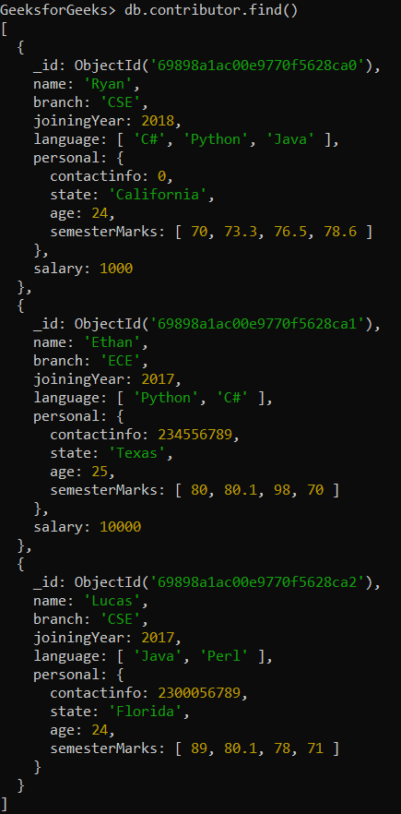

1. $and operator
It Joins query clauses with a logical AND. Returns documents that match all the conditions.
Syntax
{ $and: [ { <expression1> }, { <expression2> }, ... ] }
Example: Retrieving only those employees' documents whose branch is CSE and joiningYear is 2018.
db.contributor.find({$and: [{branch: "CSE"}, {joiningYear: 2018}]})
Output:
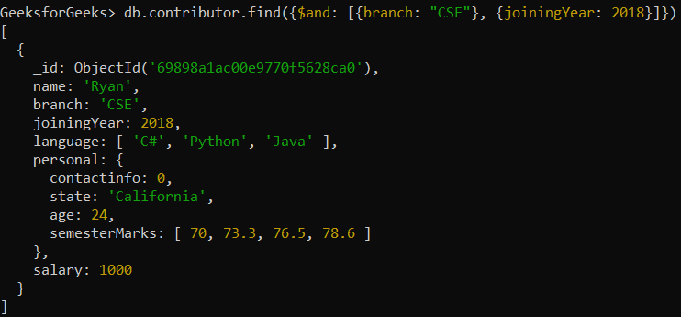

2. $nor operator
It Joins query clauses with a logical NOR. Returns documents that fail to match all the specified conditions (i.e., none of the conditions are true).
Syntax
{ $nor: [ { <expression1> }, { <expression2> }, ... ] }
Example: Retrieving only those employees' documents whose salary and branch is not 3000 and ECE respectively.
db.contributor.find({$nor: [{salary: 3000}, {branch: "ECE"}]})
Output:
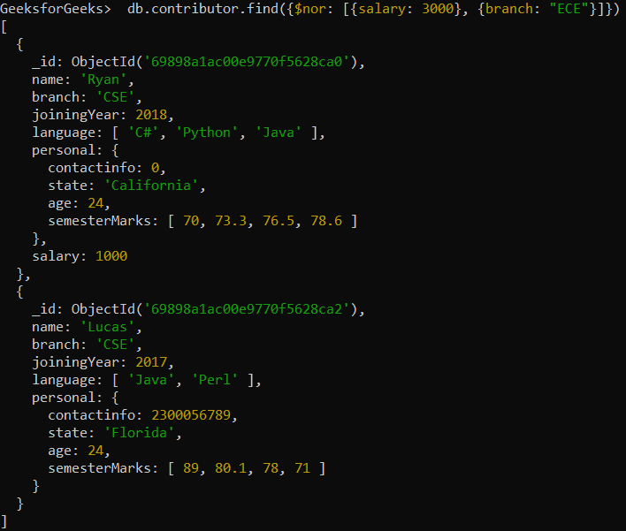

3. $or operator
The $or operator combines multiple conditions, where at least one of the conditions must be true.
Syntax
{ $or: [ { <expression1> }, { <expression2> }, ... ] }
Example: Retrieving only those employees' documents whose branch is ECE or joiningYear is 2017.
db.contributor.find({$or: [{branch: "ECE"}, {joiningYear: 2017}]})
Output:
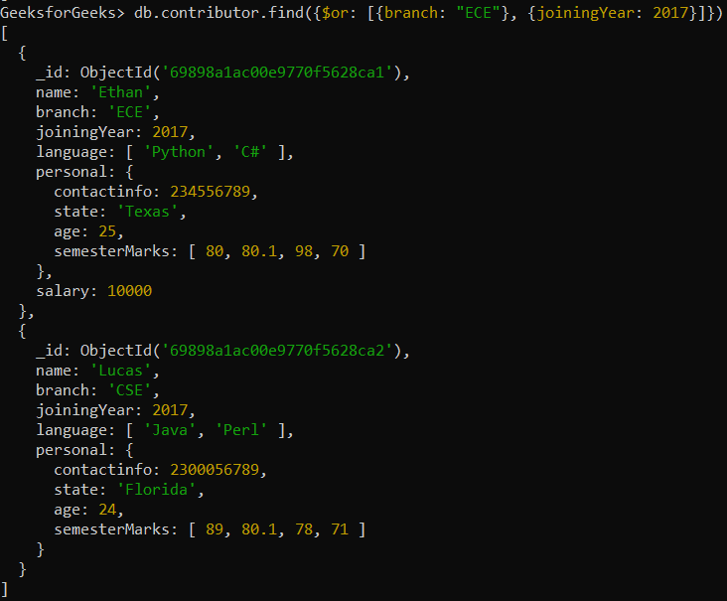

4. $not operator
It negates a condition at the field level and must be used with another operator (e.g., $gt, $eq). Returns documents that do not match the query expression.
Syntax
{ <field>: { $not: { <operator-expression> } } }
Example: Retrieving only those employee’s documents whose salary is not greater than 2000.
Query:
db.contributor.find({salary: {$not: {$gt: 2000}}}).pretty()
Output:
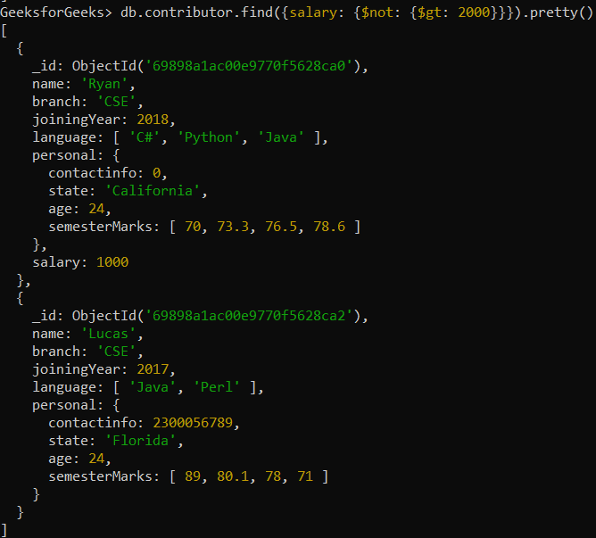

MongoDB AND operator ( $and )
The MongoDB $and operator combines multiple conditions in a single query and returns documents that satisfy all specified criteria, enabling precise and flexible filtering for complex queries.
- Returns documents that match every condition in the query.
- Useful for building complex and precise filters.
- Evaluates multiple conditions together; performance depends on query planning and index usage.
- Can be used explicitly with $and or implicitly by listing conditions.
- Required when applying multiple conditions to the same field or operator.
Syntax:
{ $and: [ { Expression1 }, { Expression2 }, ..., { ExpressionN } ] }
or
{ Expression1, Expression2, ..., ExpressionN }
Usage of $and Operator
Use the $and operator to filter documents that must satisfy multiple conditions at the same time.
- When filtering documents based on multiple criteria.
- When building complex queries where all conditions must be true.
- When combining conditions on the same field or with different operators.
Examples of MongoDB AND Operator
Some practical use cases and MongoDB queries that utilize the $and operator. In the following examples, we are working with:
- Database: GeeksforGeeks
- Collection: contributor
- Document: three documents that contain the details of the contributors in the form of field-value pairs.
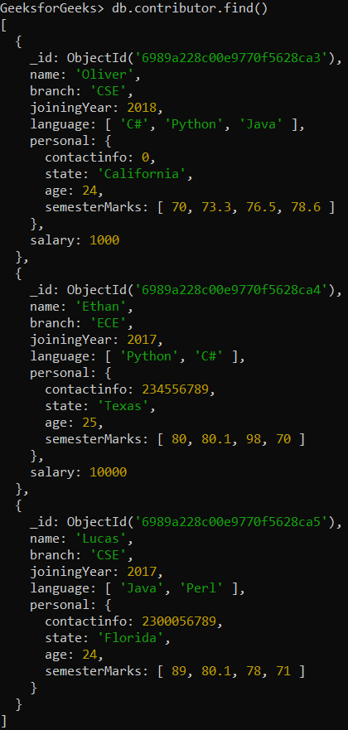
Example 1: Matching values using $and operator
Retrieving only those employees' documents whose branch is CSE and joiningYear is 2018.
db.contributor.find({$and: [{branch: "CSE"}, {joiningYear: 2018}]})
Output:
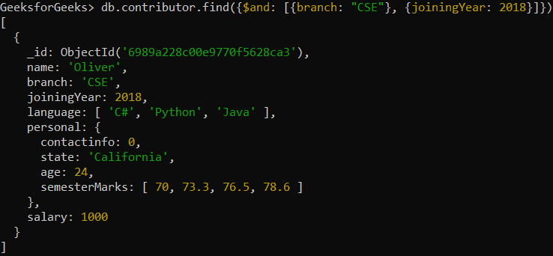
Example 2: With multiple expressions specifying the same field
Retrieving only those employees' documents whose branch is CSE.
db.contributor.find({$and: [{branch: {$eq: "CSE"}}, {branch: {$exists: true}}]})
or
db.contributor.find({branch: {$eq: "CSE", $exists: true}})
Output:
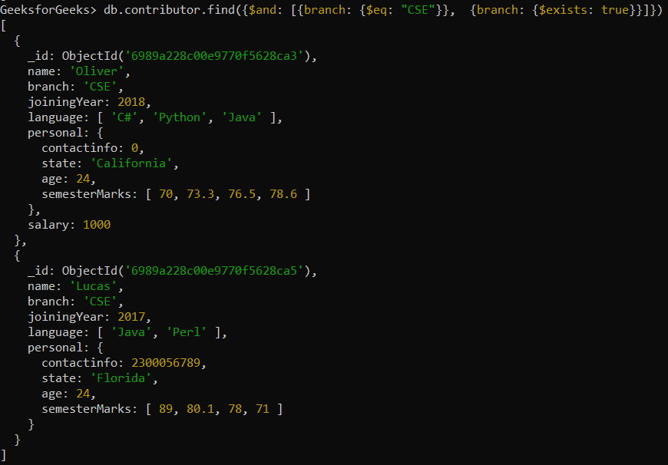
Example 3: With multiple expressions specifying the same operator
Retrieve documents where either the branch is ECE or the joining year is 2017, and either the personal.state is "Texas" or the personal.age is 25.
db.contributor.find({$and: [{ $or: [{ branch: "ECE" }, { joiningYear: 2017 }] }, { $or: [{ "personal.state": "Texas" }, { "personal.age": 25 }] }]})
Output:
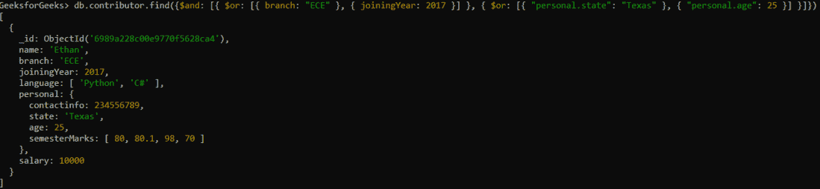
Advantages of Using the $and Operator
Some advantages are discussed below:
- Precise filtering: Ensures documents meet all specified conditions.
- Better performance: Combines conditions efficiently to narrow results early.
- Supports complex logic: Works with $or, $gt, $lt, $in, and other operators for advanced queries.

MongoDB OR operator ( $or )
The MongoDB $or operator matches documents that satisfy at least one of multiple conditions, making it ideal for flexible filtering in searches and data retrieval.
- Returns documents that match any one of the specified conditions.
- Accepts multiple conditions as an array.
- Works with find(), update(), and aggregation pipelines.
- Each condition is evaluated independently.
- Can be nested with other logical operators for complex queries.
- May use indexes (if available) depending on the query planner.
Syntax
{ $or: [ { Expression1 }, { Expression2 }, ..., { ExpressionN } ] }
Examples of Using $or in Queries
Let's first set up MongoDB and insert sample data for demonstration. We will be working with:
- Database: GeeksforGeeks
- Collection: contributor
- Document: Three documents that contain the details of the contributors in the form of field-value pairs.
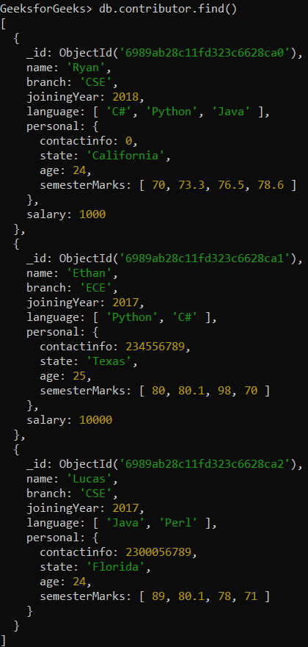
Example: Retrieve all contributor documents where the branch is ECE or the joining year is 2017
db.contributor.find({$or: [{ branch: "ECE" }, { joiningYear: 2017 }]})
Output:
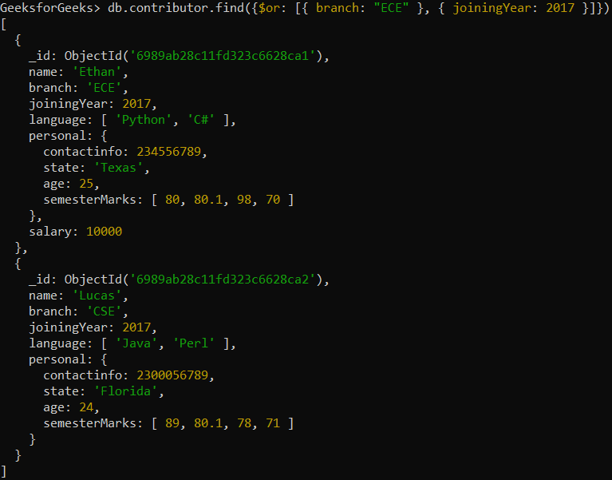
Matching Values in Nested/Embedded Documents
The $or operator can query nested fields, letting you filter documents using multiple conditions within embedded objects.
Example: Retrieve contributor's where either age is 24 or State is Texas
db.contributor.find({$or: [{"personal.age": 24}, {"personal.state": "Texas"}]})
Output:
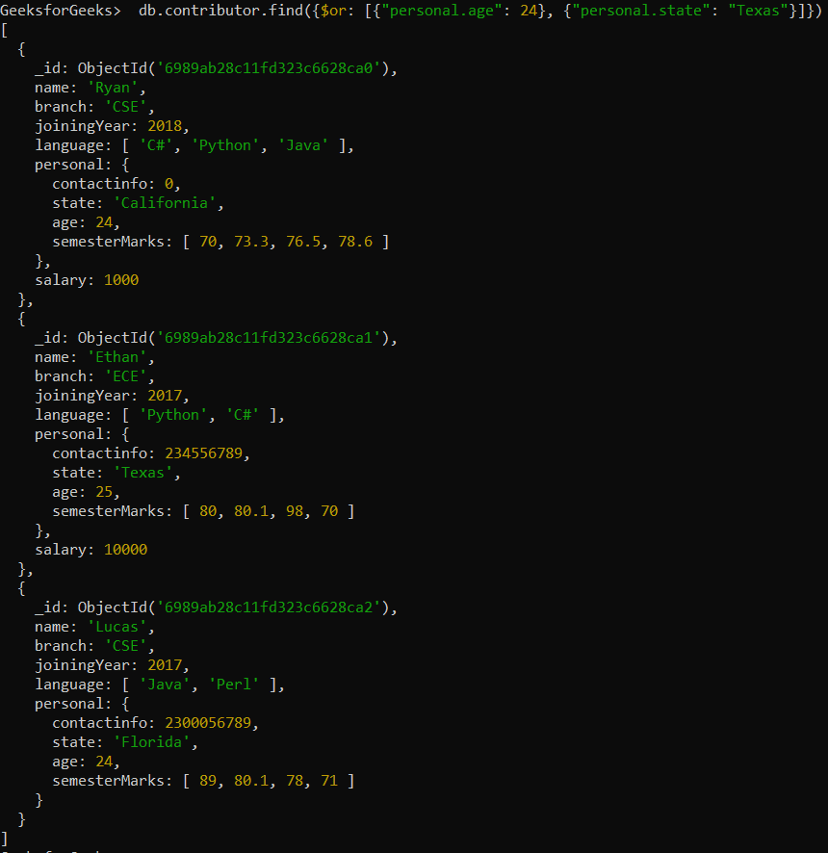
Matching Values in an Array using $or Operator
The $or operator can match values in arrays, returning documents where at least one array element meets a condition.
Example: Retrieve contributors who know either "Java" or "C"
db.contributor.find({$or: [{ language: { $in: ["Java"] } }, { language: { $in: ["C"] } }]})
Output:
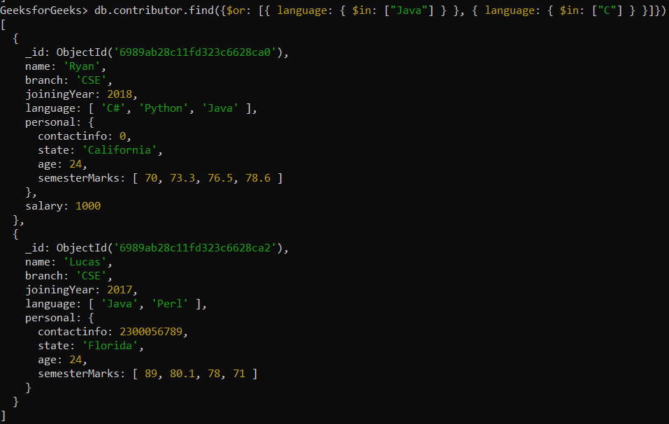
Combining $or with Other Logical Operators
MongoDB lets you combine $or with $and, $nor, and $not to build flexible, complex queries.
Example: Retrieve contributors whose branch is ECE or personal state is Finance Department and are at least 25 years old
db.contributor.find({$and: [{ $or: [{ branch: "ECE" }, { joiningYear: 2017 }] }, { $or: [{ "personal.state": "Texas" }, { "personal.age": 25 }]}]})
Output:
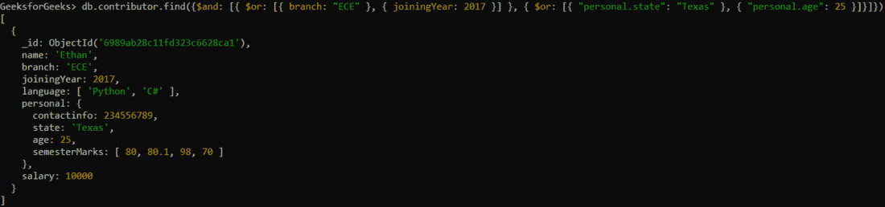
Performance Considerations for $or Queries
Optimizing $or queries with proper indexing helps MongoDB avoid full collection scans and improves query performance.
- Indexing: Use indexes on fields in each $or condition to enable index scans.
- Execution strategy: MongoDB selects the best plan per condition when indexes exist.
- Compound indexes: Create compound indexes when $or queries frequently target the same fields.
Usage of $or in MongoDB
Use the $or operator when documents can match any one of multiple conditions.
- When results may satisfy one of several criteria.
- When querying nested or embedded fields.
- When matching documents with different possible values in an array field.

MongoDB NOT operator ( $not )
The MongoDB $not operator negates a query condition and returns documents that do not match the specified expression, helping exclude unwanted results in complex filters.
- Reverses the logic of another query condition.
- Commonly used with $gt, $eq, $in, $ne, and similar operators.
- Returns documents where the condition is not satisfied, including those where the field is missing.
- Can be used with regular expressions to exclude pattern matches.
Syntax
{ field: { $not: { <operator-expression>} } }
- field: The field to apply the condition on.
- operator-expression: The condition to negate (e.g., $gt, $eq, $in, $regex).
Examples of Using $not Operator in MongoDB
In the following examples, we are working with:
- Database: GeeksforGeeks
- Collection: contributor
- Document: Three documents that contain the details of the contributors in the form of field-value pairs.
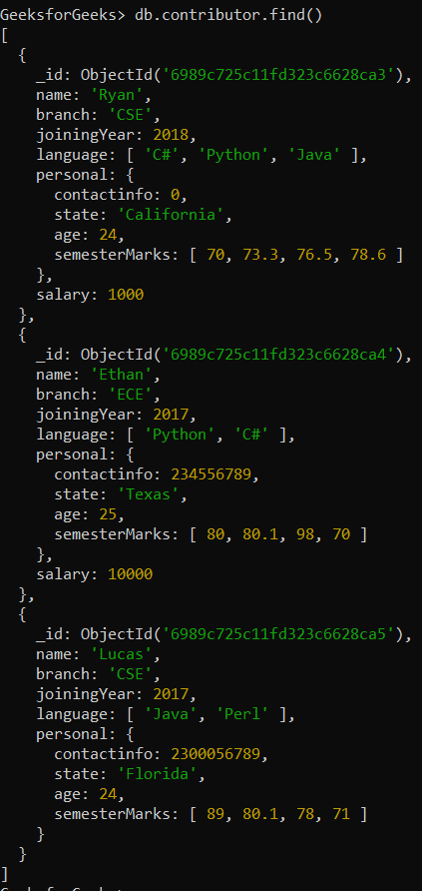
Example 1: Matching values using $not operator
Retrieving only those contributor’s documents whose salary is not greater than 2000.
Query:
db.contributor.find({salary: {$not: {$gt: 2000}}})
Output:
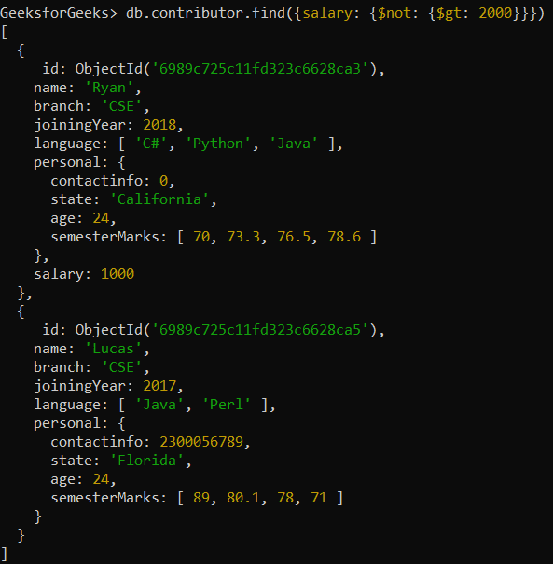
Example 2: Matching values in nested/embedded documents using $not operator
Retrieving only those contributor’s documents whose age is not equal to 24.
Query:
db.contributor.find({"personal.age": {$not: {$eq: 24}}})
Output:
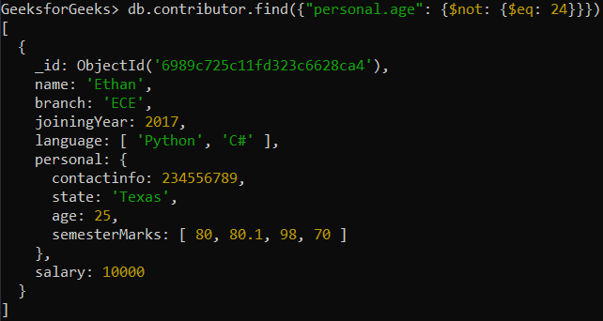
Example 3: Matching values in an array using $not operator
Retrieving only those contributor’s documents where the language is not Java or Perl.
Query:
db.contributor.find({ language: {$not: {$in: ["Java", "Perl"]}}})
Output:
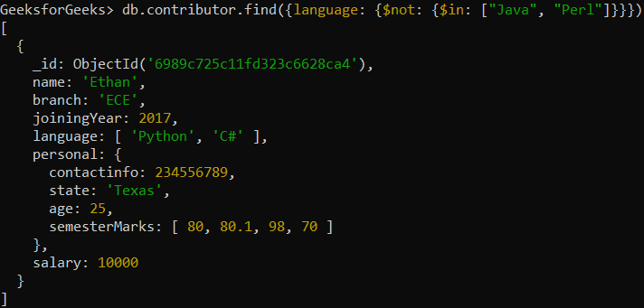
Behavior of $not with Different Data Types
The MongoDB $not operator works across different data types, but its behavior can vary with arrays and missing fields, sometimes producing unexpected results.
- Arrays: Negates the condition for each element in the array.
- Null or missing fields: Matches documents where the field is absent or does not satisfy the condition.
Best Practices for Using the $not Operator
Use $not carefully with clear conditions to avoid performance issues and unexpected results.
- Use with other operators: Combine $not with $gt, $lt, $eq, $in, etc., to define what to negate.
- Optimize for performance: Test queries, especially when using $not with regex or complex filters.
- Keep queries simple: Avoid deeply nested $not conditions to reduce confusion and unexpected behavior.

MongoDB NOR Operator ( $nor )
The $nor operator returns documents where none of the given conditions match, it's the logical inverse of $or, useful for excluding multiple criteria in one query.
- Logical NOR: Matches documents that fail all given conditions.
- Inverse of $or: Excludes any document that matches any condition.
- Takes an array of expressions: { $nor: [ {cond1}, {cond2}, ... ] }.
- Useful for exclusion filters: Cleanly filter out multiple unwanted cases.
- Works with operators: Can combine $gt, $lt, $in, $regex, etc.
- Missing fields: Documents with missing fields may match if the specified conditions do not evaluate to true for those fields.
- Index usage: Performance depends on the indexed fields in conditions.
Syntax
{ $nor: [ { Expression1 }, { Expression2 }, ... { ExpressionN } ] }
- Expression1, Expression2, ..., ExpressionN: These are conditions or queries that documents must not match. The operator returns documents where none of these conditions are true.
Examples of using MongoDB Operations
In the following examples, we are working with:
- Database: GeeksforGeeks
- Collection: contributor
- Document: Three documents that contain the details of the contributors in the form of field-value pairs.
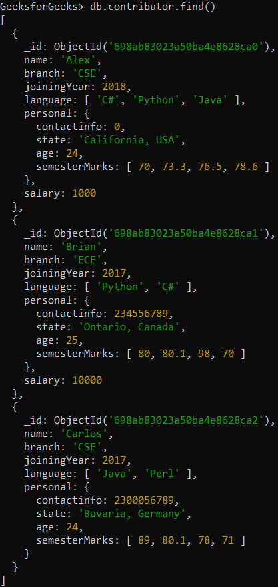
Example 1: Matching Values using $nor Operator
Retrieve documents that do not match any of the specified conditions, meaning documents where the salary is not 3000 and the branch is not "ECE".
Query:
db.contributor.find({$nor: [{salary: 3000}, {branch: "ECE"}]})
Output:
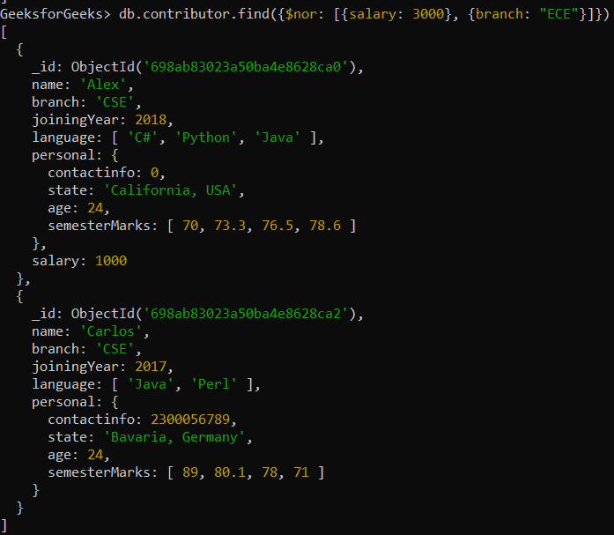
Example 2: Matching Values in Nested/Embedded Documents using $nor Operator
Retrieve contributor documents where the age is not 24 and the state is not "California, USA" in the personal subdocument.
Query:
db.contributor.find({$nor: [{ "personal.age": 24 }, { "personal.state": "California, USA" }]})
Output:
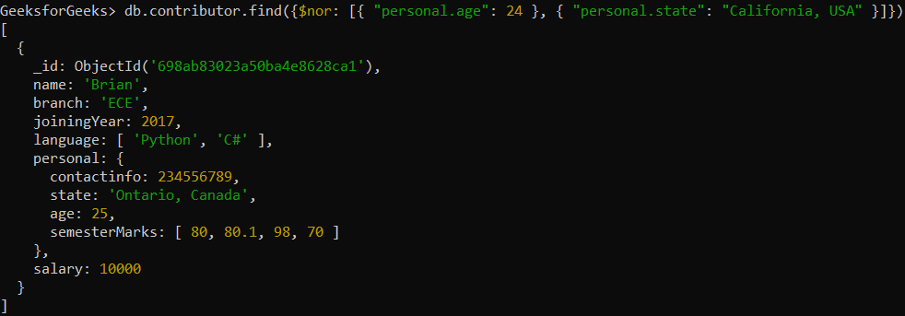
Example 3: Matching Values in an Array using $nor Operator
Retrieve documents where the language field does not contain either "Java" or "C++".
Query:
db.contributor.find({$nor: [{language: {$in: ["Java", "C++"]}}]})
Output:
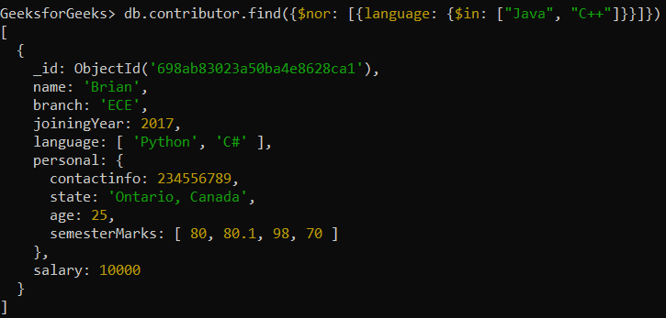
Usage of $nor Operator in MongoDB
The $nor operator in MongoDB helps exclude documents by ensuring none of multiple conditions match. It’s ideal for applying a logical NOT across combined criteria in complex filters.
- Excludes documents matching any given condition.
- Applies logical NOT to combined expressions.
- Filters records that fail all specified criteria.
- Useful for excluding categories or statuses.
- Helps ignore specific flags/values across fields.
- Supports complex exclusion logic in queries.
Advantages of Using $nor in MongoDB
The $nor operator enables flexible exclusion in MongoDB queries by returning documents where none of multiple conditions match.
- Flexible Filtering: $nor enables powerful filtering in MongoDB queries for complex negative conditions, offering more flexibility than simple negation.
- Exclusion Logic: Useful for excluding documents that match any condition in an array of expressions.
- Complex Queries: Combines with $eq, $gt, $lt, $in, etc., to build complex exclusion logic in MongoDB queries.

MongoDB $add Operator
Last Updated :15 Apr, 2026

The $add operator in MongoDB is an aggregation arithmetic operator used to add numeric values and combine numbers with dates, helping transform and compute fields in MongoDB queries.
- Performs addition on numeric values.
- Combines numbers with dates in the aggregation pipeline.
- Works with integers, decimals, and dates.
- Operands must be compatible; $add supports number + number or date + number (milliseconds).
- Useful for field calculations and data transformation.
Syntax
{ $add: [ <Expression1>, <Expression2>, ... <ExpressionN>] }
- $add: MongoDB aggregation operator for addition.
- [ ... ]: Array of values to be added.
- <Expression1>, <Expression2>, ...: Fields, constants, or expressions.
- Type compatibility: All expressions must be compatible (numbers or dates).
Examples of $add Operator
In the following examples, we are working with:
- Database: GeeksforGeeks
- Collection: Employee
- Document: Four documents that contain the details of the employees in the form of field-value pairs.
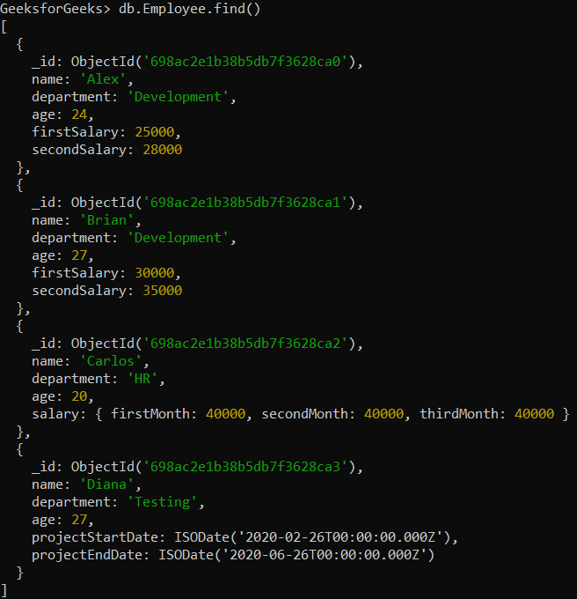
Example 1: Add Numbers Together
Calculate the total salary of every employee in the development department by adding their firstSalary and secondSalary fields.
db.Employee.aggregate([
{ $match: { department: "Development" } },
{
$project: {
name: 1,
tSalary: { $add: ["$firstSalary", "$secondSalary"] }
}
}
])
Output:
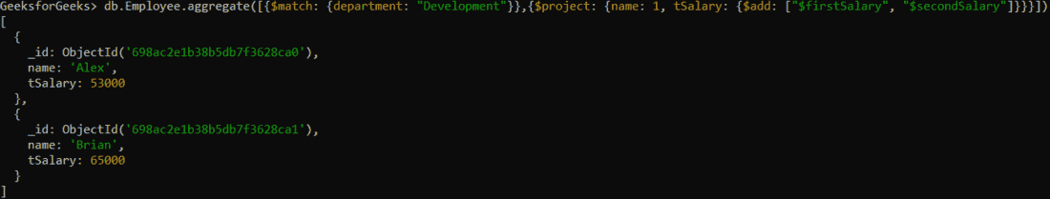
Example 2: Adding numbers in the embedded document
Find a total of three months' salary of the employee in the HR department by adding three months' worth of salary, which is stored in an embedded document.
db.Employee.aggregate([
{ $match: { department: "HR" } },
{ $project: { name: 1, tSalary: { $add: ["$salary.firstMonth", "$salary.secondMonth", "$salary.thirdMonth"] } } }
])
Output:
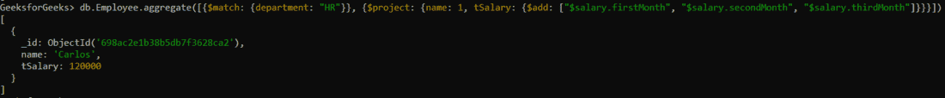
Example 3: Adding to a Date Field
Extend the project end date for the Testing department by adding 5 days (in milliseconds) to projectEndDate.
db.Employee.aggregate([
{ $match: { department: "Testing" } },
{ $project: { extendProjectDate: { $add: ["$projectEndDate", 5 * 24 * 60 * 60 * 1000] } } }
])
Output:
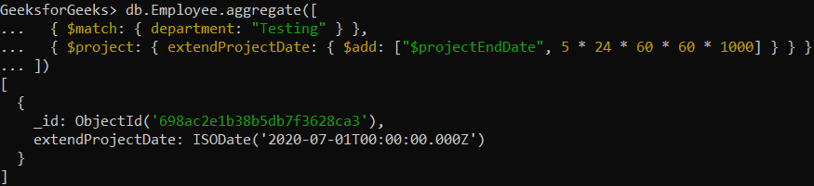

MongoDB $subtract Operator
Last Updated :15 Apr, 2026

The $subtract operator in MongoDB is an aggregation arithmetic operator used to subtract numbers and perform date/time calculations, helping transform fields in MongoDB queries.
- Subtracts two numbers and returns the difference.
- Subtracts two dates and returns the difference in milliseconds.
- Subtracts milliseconds from a date and returns a new date.
- Takes exactly two expressions: { $subtract: [expr1, expr2] }.
- Second value is subtracted from the first.
- Supports number–number, date–date (returns milliseconds), and date–number (subtracts milliseconds from date).
Syntax
{ $subtract: [ <expression1>, <expression2> ] }
- $subtract: MongoDB aggregation operator for subtraction.
- [ ... ]: Array containing exactly two values.
- <expression1>: The base value (number or date).
- <expression2>: The value to subtract from the first.
- Type compatibility: Expressions must be compatible (numbers or dates).
Examples of MongoDB $subtract Operator
In the following examples, we are working with:
- Database: GeeksforGeeks
- Collection: Employee
- Document: four documents that contain the details of the employees in the form of field-value pairs.
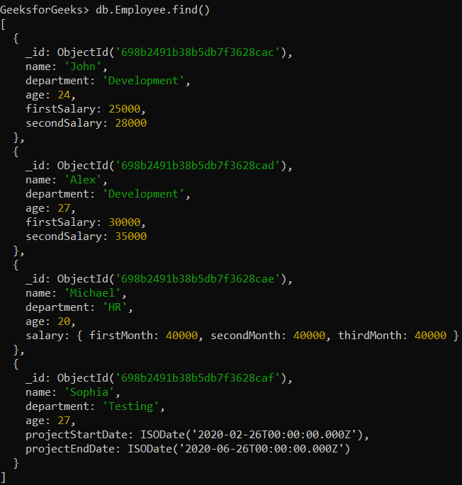
Example 1: Subtract Numbers
Subtract the value of firstSalary field from the value of secondSalary field using $subtract operator.
Query:
db.Employee.aggregate([
{ $match: { department: "Development" } },
{
$project: {
result: { $subtract: ["$secondSalary", "$firstSalary"] }
}
}
])
Output:
Example 2: Subtract Two Dates
Subtract two dates, i.e, the value of projectStartDate field from the value of projectEndDate field using a $subtract operator.
Query:
db.Employee.aggregate([
{ $match: { department: "Testing" } },
{
$project: {
diffResult: { $subtract: ["$projectEndDate", "$projectStartDate"] }
}
}
])
Output:
Example 3: Subtract Milliseconds from a Date
Subtract 5*24*60*60000 milliseconds (i.e., 5 days) from the value of projectEndDate field using a $subtract operator.
Query:
db.Employee.aggregate([
{ $match: { department: "Testing" } },
{ $project: {
newprojectEndDate: {
$subtract: ["$projectEndDate", 5 * 24 * 60 * 60000]
}
}
}
])
Output:
Use Cases of MongoDB $subtract Operator
The $subtract operator is useful for various scenarios, including:
- Age calculation: Find age using the difference between the current date and birth date.
- Time-based calculations: Measure the duration between two events.
- Date manipulation: Add or subtract days, months, or years from a date.
- Financial calculations: Compute differences between amounts (e.g., salary, balance).

MongoDB $multiply Operator
Last Updated :5 May, 2026

The $multiply operator multiplies two or more numeric values or expressions within MongoDB aggregation pipelines to compute results directly in the database.
- Multiplies two or more numeric expressions and returns a single result.
- Used inside aggregation stages like $project, $addFields, $group.
- Helpful for calculations (totals, discounts, conversions, scores).
- Works with fields, constants, and computed expressions.
- May return null if any argument evaluates to null or is missing, depending on expression evaluation.
- Improves performance by doing math inside the database.
Syntax
{ $multiply: [ <expression1>, <expression2>, ... <expressionN> ] }
- Takes two or more numeric expressions inside an array: { $multiply: [ <exp1>, <exp2>, ... ] }.
- Each expression can be a field, constant value, or computed expression.
- Returns the product of all values. May result in an error or null, depending on the context, if non-numeric values are used.
Examples of MongoDB $multiply Operator
In the following examples, we are working with:
- Database: GeeksforGeeks
- Collection: employee
- Document: Three documents that contain the details of the employees in the form of field-value pairs.
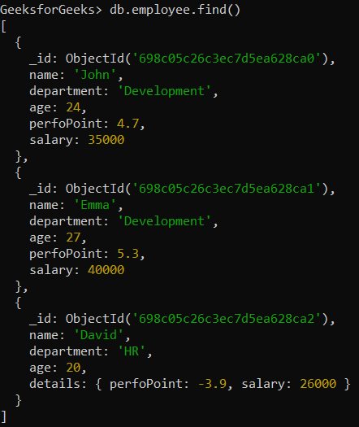
Example 1: Using $multiply Operator
Multiply the salary of the development department's employees by 2.
db.employee.aggregate([
{ $match: { department: "Development" } },
{
$project: {
name: 1,
newSalary: { $multiply: ["$salary", 2] }
}
}
])
Output:
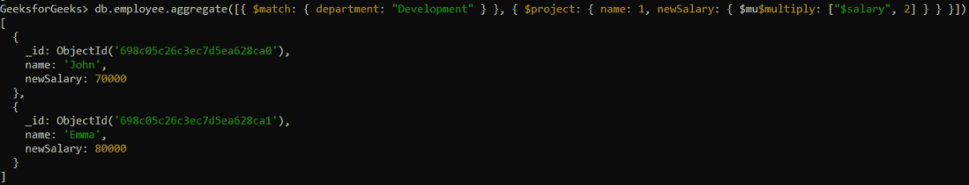
Example 2: Multiply Using $multiply Operator in the Embedded Document
Multiplies the salary of employees in the "HR" department, where the salary is stored inside an embedded document.
db.employee.aggregate([
{ $match: { department: "HR" } },
{
$project: {
name: 1,
newSalary: { $multiply: ["$details.salary", 3] }
}
}
])
Output:
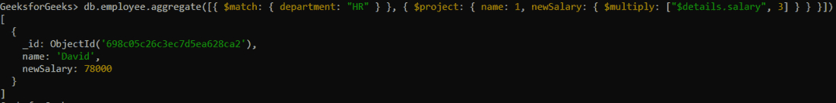
Combine $multiply with Other Operators
$multiply can be combined with other arithmetic operators in aggregation pipelines to build complex calculations like bonuses or adjusted totals directly in MongoDB.
- Enables multi-step formulas in a single pipeline stage.
- Supports nesting with $add, $subtract, and $divide.
- Works with both field values and constants.
- Helps derive new computed fields on the fly.
Example combining $multiply with $add
Given below is the sample data:
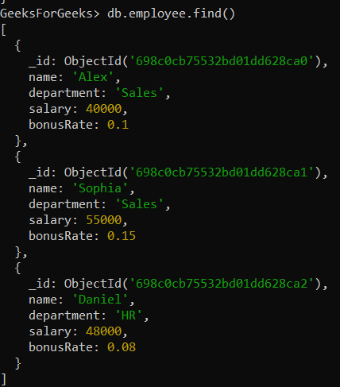
Query:
db.employee.aggregate([
{
$project: {
name: 1,
totalPay: {
$add: [
"$salary",
{ $multiply: ["$salary", "$bonusRate"] },
1000
]
}
}
}
])
Output:
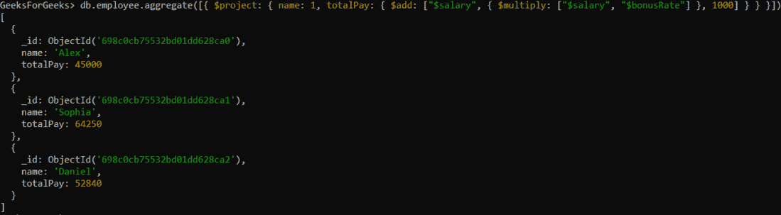
Benefits of Using the $multiply Operator in MongoDB
Here are some benefits:
1. Perform Complex Calculations
The $multiply operator allows you to perform arithmetic operations in MongoDB aggregation pipelines, saving time by eliminating the need for complex post-processing in your application.
2. Flexible Arithmetic Operations
You can multiply numeric fields, constants, or values from embedded documents, offering great flexibility in manipulating your data directly within MongoDB.
3. Efficient Data Transformations
The $multiply operator is ideal for transforming data in real-time, whether adjusting salaries, calculating totals, or making adjustments to other numerical values.

MongoDB $divide Operator
Last Updated :15 Apr, 2026

The $divide operator in MongoDB performs division between two numeric values or expressions within aggregation pipelines, enabling precise, in-database calculations for analytics and data transformation.
- Divides one value (dividend) by another (divisor).
- Arguments are passed as an array: [dividend, divisor].
- Works with fields, constants, and computed expressions.
- Used in stages like $project, $addFields, and $group.
- Returns a numeric result for further processing.
- Errors if arguments don’t resolve to numbers or if division by zero occurs.
Syntax
{ $divide: [ <expression1>, <expression2> ] }
- Expression1: The dividend (the number to be divided).
- Expression2: The divisor (the number by which the dividend will be divided).
Both expressions must resolve to valid numeric values (integers or floats). The operator returns the result of dividing Expression1 by Expression2
Features of the MongoDB $divide Operator
Here are some key features of $divide operator:
- Arithmetic Precision: Performs accurate division directly in the database.
- Flexible Inputs: Supports fields, constants, and computed expressions.
- Aggregation Support: Integrates with aggregation pipelines for calculations.
- Server-Side Processing: Handles large datasets efficiently on the server.
Examples of MongoDB $divide Operator
In the following examples, we are working with:
- Database: GeeksforGeeks
- Collection: employee
- Document: Three documents that contain the details of the employees in the form of field-value pairs.
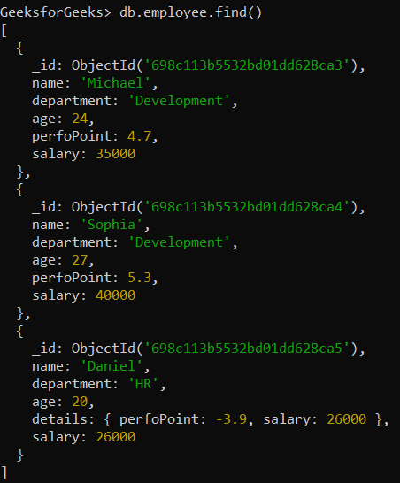
Example 1: Divide using $divide operator
Use the $divide operator to divide the salary of employees in the "Development" department by 2. This could be used, for example, to calculate a bonus or a tax deduction.
db.employee.aggregate([
{ $match: { department: "Development" } },
{
$project: {
name: 1,
halfSalary: { $divide: ["$salary", 2] }
}
}
])
Output:
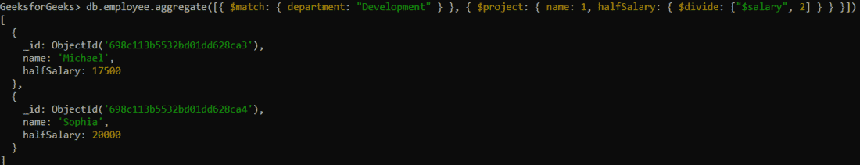
Example 2: Perform Divide in the Embedded Document
Divide the salary of the HR department's employees into half, where the salary is part of an embedded document.
db.employee.aggregate([
{ $match: { department: "HR" } },
{ $project: { name: 1, halfsalary: { $divide: ["$details.salary", 2] } } }
])
Output:
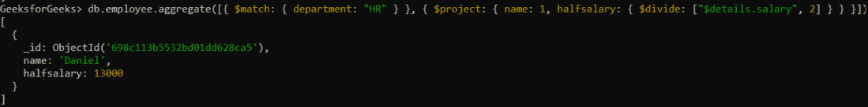

MongoDB $abs operator
Last Updated :15 Apr, 2026

The $abs operator returns the absolute value of a number in MongoDB aggregation pipeline, converting negative values to positive for clean and consistent calculations.
- Used within aggregation pipeline stages (e.g., $project, $addFields, $group).
- Accepts numeric values or numeric fields.
- Helps standardize values for comparisons and reports.
- Commonly used in financial and time-difference calculations.
- Can be combined with other aggregation expressions (e.g., $add, $subtract) within pipeline stages.
Syntax
{ $abs: <number> }
- <number> can be a numeric field or expression.
- Returns the absolute (non-negative) value.
- Used inside $project, $addFields, $group, etc.
- Supports computed values (not just constants).
Features of the MongoDB $abs Operator
- Absolute values: Always returns non-negative numbers.
- Operator chaining: Works with $add, $subtract, $multiply, and $divide .
- Data cleaning: Normalizes negative values to positive.
- Aggregation use: Used within aggregation pipelines for data processing.
Examples of MongoDB $abs operator
In the following examples, we will work with the GeeksforGeeks database and the Employee collection.
- Database: GeeksforGeeks
- Collection: Employee
- Document: Three documents that contain the details of the employees in the form of field-value pairs.
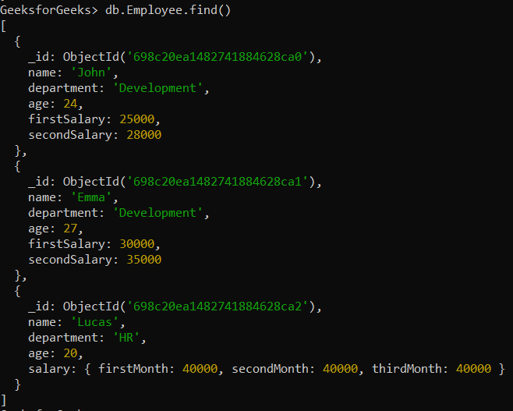
Example 1: Using $abs to Ensure Non-Negative Salary Values
Total salary of every employee in the development department, ensuring that we only use positive values (by taking the absolute value).
db.Employee.aggregate([
{ $match: { department: "Development" } },
{
$project: {
name: 1,
tSalary: {
$abs: {
$add: ["$firstSalary", "$secondSalary"]
}
}
}
}
])
Output:
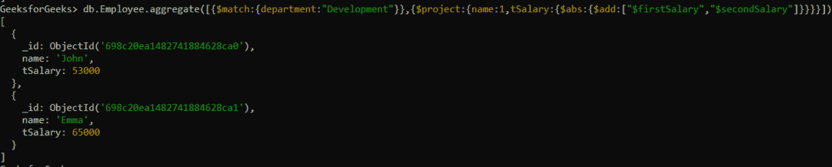
Example 2: Using $abs operator in embedded documents
Total of three months' salary of the employee in the HR department, where the salary is stored in an embedded document, and ensure that the result is non-negative.
db.Employee.aggregate([
{ $match: { department: "HR" } },
{
$project: {
name: 1,
tSalary: {
$abs: {
$add: [
"$salary.firstMonth",
"$salary.secondMonth",
"$salary.thirdMonth"
]
}
}
}
}
])
Output:
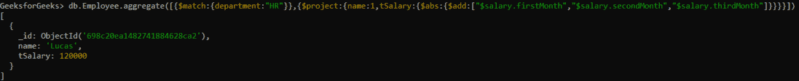

MongoDB $floor Operator
Last Updated :11 Feb, 2026

The $floor operator in MongoDB rounds a number down to the nearest integer within aggregation pipelines, making numeric values suitable for reporting and analysis.
- Rounds values down to the nearest whole number.
- Used inside aggregation pipeline stages like $project and $addFields.
- Accepts fields, constants, or numeric expressions.
- Useful for reporting, formatting, and analytics.
Syntax
{ $floor: <number> }
- <number> can be a numeric field, constant, or expression.
- Returns the largest integer ≤ the input value.
- Used within $project, $addFields, $group, etc.
- Supports computed values (not only fixed numbers).
Use Cases of the $floor Operator
Here are some use cases:
- Data normalization: Round values down to standardize numeric data (e.g., financial figures).
- Data formatting: Prepare clean integers for reports and dashboards.
- Data transformation: Combine with $add, $subtract, $multiply for calculations.
- Data consistency: Ensures uniform numeric values during aggregation.
- In-database processing: Simplifies transformations directly in MongoDB, improving performance.
Examples of MongoDB $floor
In the following examples, we are working with:
- Database: GeeksforGeeks
- Collection: employee
- Document: Three documents that contain the details of the employees in the form of field-value pairs.
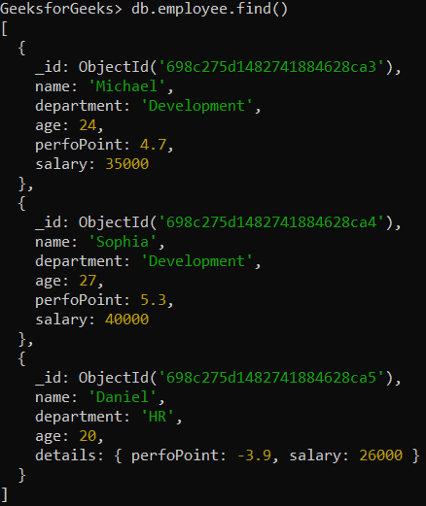
Example 1: Using $floor operator
Find the largest integer less than or equal to the value of the perfoPoint field in the development department.
db.employee.aggregate([
{ $match: { department: "Development" } },
{
$project: {
perfoPoint: 1,
floorPoint: { $floor: "$perfoPoint" }
}
}
])
Output:
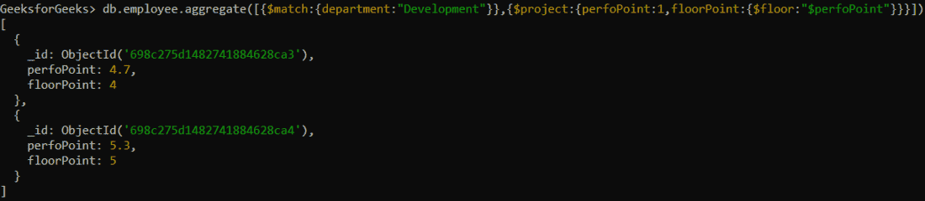
Example 2: Using $floor operator in the embedded document
Find the largest integer less than or equal to the value of the details.perfoPoint field in the HR department. Here, the field is inside an embedded document.
db.employee.aggregate([
{ $match: { department: "HR" } },
{
$project: {
"details.perfoPoint": 1,
floorPoint: { $floor: "$details.perfoPoint" }
}
}
])
Output:
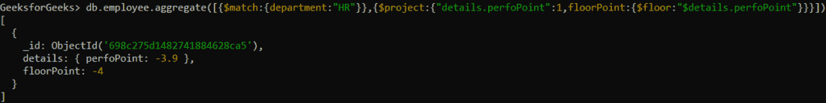

MongoDB Field Update Operators
Field update operators are used to modify existing fields or their values in MongoDB documents without replacing the entire document. They are commonly used with methods such as updateOne(), updateMany(), and findOneAndUpdate() to perform specific changes efficiently.

1. Field Update Operators
Field update operators in MongoDB provide a way to modify, add, remove, rename, or transform individual fields of existing documents without having to replace the complete document. They make it possible to perform targeted updates such as increasing a value, setting minimum or maximum limits, multiplying numbers, or changing field names.
- Modify specific fields without replacing the entire document.
- Used mainly with updateOne(), updateMany(), and findOneAndUpdate().
- Can update one document or multiple documents.
- Help perform database updates efficiently and safely.
- Common field update operators include $inc, $mul, $max, $min, and $rename.
Basic Syntax
db.collection.updateOne(
{ <filter> },
{
<updateOperator>: {
<field>: <value>
}
}
)
Example
Suppose we have:
{
name: "Rahul",
age: 20,
marks: 75
}
We can update only the marks field:
db.students.updateOne(
{ name: "Rahul" },
{
$inc: { marks: 5 }
}
)
Result:
{
name: "Rahul",
age: 20,
marks: 80
}
The other fields remain unchanged.

2. $max — Maximum Operator
The $max operator updates a field only when the new value provided is greater than the current value stored in that field. If the new value is smaller than or equal to the existing value, MongoDB does not modify the field. It is particularly useful for maintaining highest scores, maximum temperatures, peak values, or record values without manually checking the existing value first.
- Updates the field only when the new value is greater.
- Keeps the existing value if the new value is smaller.
- If the field does not exist, MongoDB creates it with the specified value.
- Commonly used for highest scores, maximum values, and records.
- Works with numeric and other comparable values.
Syntax
db.collection.updateOne(
{ <filter> },
{
$max: {
<field>: <value>
}
}
)
Example
Suppose the document is:
{
name: "Rahul",
highestScore: 85
}
Now we try to update the highest score to 90:
db.students.updateOne(
{ name: "Rahul" },
{
$max: { highestScore: 90 }
}
)
Result:
{
name: "Rahul",
highestScore: 90
}
Because 90 is greater than 85.
If we try:
db.students.updateOne(
{ name: "Rahul" },
{
$max: { highestScore: 80 }
}
)
The document remains:
{
name: "Rahul",
highestScore: 90
}
Because 80 is not greater than 90.
Easy way to remember
$max = Update only if the new value is bigger.

3. $min — Minimum Operator
The $min operator updates a field only when the new value provided is smaller than the current value stored in that field. If the new value is greater than or equal to the existing value, MongoDB leaves the field unchanged. It is useful for maintaining lowest scores, minimum prices, shortest times, minimum temperatures, or other record-low values.
- Updates the field only when the new value is smaller.
- Keeps the existing value when the new value is larger.
- Creates the field if it does not already exist.
- Useful for maintaining minimum or lowest values.
- Commonly used for prices, times, scores, and measurements.
Syntax
db.collection.updateOne(
{ <filter> },
{
$min: {
<field>: <value>
}
}
)
Example
Suppose:
{
name: "Rahul",
lowestPrice: 500
}
Now:
db.products.updateOne(
{ name: "Rahul" },
{
$min: { lowestPrice: 400 }
}
)
Result:
{
name: "Rahul",
lowestPrice: 400
}
Because 400 is smaller than 500.
If we try:
db.products.updateOne(
{ name: "Rahul" },
{
$min: { lowestPrice: 600 }
}
)
The document remains:
{
name: "Rahul",
lowestPrice: 400
}
Because 600 is not smaller than 400.
Easy way to remember
$min = Update only if the new value is smaller.

4. $inc — Increment Operator
The $inc operator increases or decreases the value of a numeric field by a specified amount. It is one of the most commonly used MongoDB update operators because it allows values such as counters, quantities, scores, balances, and ages to be changed without first reading the current value. A positive number increases the field, while a negative number decreases it.
- Increases a numeric value when given a positive number.
- Decreases a numeric value when given a negative number.
- If the field does not exist, MongoDB creates it with the increment value.
- Commonly used for counters, stock quantities, scores, and views.
- Performs the operation directly in the database.
Syntax
db.collection.updateOne(
{ <filter> },
{
$inc: {
<field>: <amount>
}
}
)
Example 1 — Increase a value
Suppose:
{
name: "Rahul",
age: 20
}
Run:
db.students.updateOne(
{ name: "Rahul" },
{
$inc: { age: 1 }
}
)
Result:
{
name: "Rahul",
age: 21
}
Example 2 — Increase views
{
title: "MongoDB Tutorial",
views: 100
}
db.blogs.updateOne(
{ title: "MongoDB Tutorial" },
{
$inc: { views: 1 }
}
)
Result:
{
title: "MongoDB Tutorial",
views: 101
}
Example 3 — Decrease a value
{
product: "Laptop",
stock: 10
}
db.products.updateOne(
{ product: "Laptop" },
{
$inc: { stock: -1 }
}
)
Result:
{
product: "Laptop",
stock: 9
}
Easy way to remember
$inc = Increase or decrease a number.

5. $mul — Multiply Operator
The $mul operator multiplies the existing value of a numeric field by a specified number. Instead of retrieving the current value, multiplying it in application code, and saving it again, MongoDB performs the multiplication directly during the update operation. It is useful when values need to be scaled, adjusted, increased by a percentage factor, or converted using a multiplication factor.
- Multiplies an existing numeric value by a specified number.
- Performs the calculation directly in MongoDB.
- Can multiply by numbers such as 2, 1.5, 0.5, etc.
- If the field does not exist, MongoDB creates it with value 0.
- Useful for prices, quantities, measurements, and scaling values.
Syntax
db.collection.updateOne(
{ <filter> },
{
$mul: {
<field>: <multiplier>
}
}
)
Example 1 — Double a value
Suppose:
{
product: "Laptop",
price: 50000
}
Run:
db.products.updateOne(
{ product: "Laptop" },
{
$mul: { price: 2 }
}
)
Result:
{
product: "Laptop",
price: 100000
}
Because:
50000 × 2 = 100000
Example 2 — Increase by 10%
{
product: "Laptop",
price: 50000
}
db.products.updateOne(
{ product: "Laptop" },
{
$mul: { price: 1.10 }
}
)
Result:
{
product: "Laptop",
price: 55000
}
Because:
50000 × 1.10 = 55000
Example 3 — Reduce to half
db.products.updateOne(
{ product: "Laptop" },
{
$mul: { price: 0.5 }
}
)
If the price was 50000:
50000 × 0.5 = 25000
Easy way to remember
$mul = Multiply the existing value.

6. $rename — Rename Operator
The $rename operator changes the name of an existing field in a MongoDB document while keeping its stored value unchanged. It is useful when a field name needs to be corrected, made more descriptive, or changed to follow a new naming convention. MongoDB moves the value from the old field name to the new field name and removes the old field.
- Changes the name of an existing field.
- Keeps the value of the field unchanged.
- Removes the old field name after renaming.
- Useful for correcting field names and changing database structure.
- Can rename multiple fields in a single update operation.
Syntax
db.collection.updateOne(
{ <filter> },
{
$rename: {
"<oldFieldName>": "<newFieldName>"
}
}
)
Example 1 — Rename one field
Suppose:
{
name: "Rahul",
mob: "9876543210"
}
We want to change mob to mobileNumber.
db.students.updateOne(
{ name: "Rahul" },
{
$rename: {
"mob": "mobileNumber"
}
}
)
Result:
{
name: "Rahul",
mobileNumber: "9876543210"
}
Notice that:
mob → mobileNumber
The value remains the same.
Example 2 — Rename multiple fields
Suppose:
{
fname: "Rahul",
lname: "Kumar",
mob: "9876543210"
}
We can rename all three:
db.students.updateOne(
{ fname: "Rahul" },
{
$rename: {
"fname": "firstName",
"lname": "lastName",
"mob": "mobileNumber"
}
}
)
Result:
{
firstName: "Rahul",
lastName: "Kumar",
mobileNumber: "9876543210"
}
Easy way to remember
$rename = Change the field's name, not its value.

Quick Comparison
Operator | What it does | Example
$max | Updates only if new value is greater | 85 → 90
$min | Updates only if new value is smaller | 500 → 400
$inc | Adds/subtracts a number | 100 + 10 = 110
$mul | Multiplies a number | 100 × 2 = 200
$rename | Changes the field name | mob → mobile

MongoDB Array Expression Operators
Array expression operators in MongoDB are used to inspect, access, combine, and transform array values within aggregation expressions. They are especially useful when working with documents that contain arrays such as students' subjects, product lists, tags, orders, or user skills.
- Work with array fields inside MongoDB documents.
- Used mainly inside aggregation pipeline stages such as $project, $addFields, and $set.
- Can check whether a value is an array.
- Can find the number of elements in an array.
- Can access a particular element from an array.
- Can combine multiple arrays.
- Can reverse the order of array elements.

1. $isArray — Check Whether a Value Is an Array
The $isArray operator checks whether a specified expression evaluates to an array in MongoDB. It returns true when the expression contains an array and false when it contains another data type such as a string, number, object, or null. This operator is useful when the structure of data may vary and you need to safely determine whether a value can be processed as an array.
- Returns true if the value is an array.
- Returns false if the value is not an array.
- Can check both fields and expressions.
- Useful when documents may contain different data types.
- Commonly used before performing other array operations.
Syntax
{
$isArray: <expression>
}
Example
Suppose we have:
{
name: "Rahul",
skills: ["JavaScript", "MongoDB", "Node.js"]
}
We can check whether skills is an array:
db.students.aggregate([
{
$project: {
name: 1,
isSkillsArray: {
$isArray: "$skills"
}
}
}
])
Result:
{
name: "Rahul",
isSkillsArray: true
}
Because skills contains an array.
Another Example
Suppose:
{
name: "Aman",
skills: "JavaScript"
}
Then:
{
$isArray: "$skills"
}
returns:
false
because "JavaScript" is a string, not an array.
Easy way to remember
$isArray = Is this value an array?

2. $size — Find the Number of Elements
The $size operator returns the number of elements present in an array. It does not return the amount of memory used by the array or the size of individual elements; instead, it simply counts how many values the array contains. It is useful for finding the number of skills, subjects, products, tags, orders, or other items stored in an array.
- Returns the number of elements in an array.
- Works with arrays containing numbers, strings, objects, or other values.
- Does not modify the original array.
- Commonly used with $project and $addFields.
- The expression must resolve to an array.
Syntax
{
$size: <array>
}
Example
Suppose:
{
name: "Rahul",
skills: [
"JavaScript",
"MongoDB",
"Node.js",
"React"
]
}
We can count the skills:
db.students.aggregate([
{
$project: {
name: 1,
totalSkills: {
$size: "$skills"
}
}
}
])
Result:
{
name: "Rahul",
totalSkills: 4
}
Because there are four elements in the skills array.
Another Example
{
name: "Aman",
subjects: ["Math", "Physics", "Chemistry"]
}
Expression:
{
$size: "$subjects"
}
Result:
3
Important
$size counts elements, not the number of characters.
For example:
["JavaScript", "MongoDB"]
has a size of:
2
not the total number of characters.
Easy way to remember
$size = How many elements are inside the array?

3. $arrayElemAt — Access an Array Element
The $arrayElemAt operator returns the element located at a specified index position inside an array. MongoDB arrays use zero-based indexing, meaning the first element is at index 0, the second at index 1, and so on. It is useful when you need to retrieve a specific value from an array without processing the entire array.
- Returns an element from a specified array position.
- Uses zero-based indexing.
- Index 0 represents the first element.
- Supports negative indexes to access elements from the end.
- Useful for retrieving first, second, last, or specific array elements.
Syntax
{
$arrayElemAt: [
<array>,
<index>
]
}
Example
Suppose:
{
name: "Rahul",
skills: [
"JavaScript",
"MongoDB",
"Node.js",
"React"
]
}
To get the first skill:
db.students.aggregate([
{
$project: {
name: 1,
firstSkill: {
$arrayElemAt: ["$skills", 0]
}
}
}
])
Result:
{
name: "Rahul",
firstSkill: "JavaScript"
}
Understanding the Index
The array:
[
"JavaScript",
"MongoDB",
"Node.js",
"React"
]
has indexes:
Index: 0 1 2 3
↓ ↓ ↓ ↓
Value: JavaScript MongoDB Node.js React
Therefore:
{ $arrayElemAt: ["$skills", 0] }
returns:
JavaScript
and:
{ $arrayElemAt: ["$skills", 2] }
returns:
Node.js
Negative Index
You can also use a negative index.
{
$arrayElemAt: ["$skills", -1]
}
This returns the last element:
React
Similarly:
{
$arrayElemAt: ["$skills", -2]
}
returns:
Node.js
Easy way to remember
$arrayElemAt = Give me the element at this index.

4. $concatArrays — Combine Arrays
The $concatArrays operator combines two or more arrays into a single array, preserving the order of the elements from each input array. It is useful when information is stored in separate arrays but needs to be combined into one list, such as combining old and new skills, multiple product lists, tags, subjects, or categories.
- Combines two or more arrays.
- Maintains the original order of elements.
- Does not automatically remove duplicate values.
- Returns a new combined array.
- Useful for joining related lists together.
Syntax
{
$concatArrays: [
<array1>,
<array2>,
...
]
}
Example
Suppose:
{
name: "Rahul",
programming: [
"JavaScript",
"Python"
],
databases: [
"MongoDB",
"MySQL"
]
}
We can combine both arrays:
db.students.aggregate([
{
$project: {
name: 1,
allSkills: {
$concatArrays: [
"$programming",
"$databases"
]
}
}
}
])
Result:
{
name: "Rahul",
allSkills: [
"JavaScript",
"Python",
"MongoDB",
"MySQL"
]
}
Combining Three Arrays
You can combine more than two arrays:
{
$concatArrays: [
"$programming",
"$databases",
"$tools"
]
}
For example:
programming → ["JavaScript", "Python"]
databases → ["MongoDB", "MySQL"]
tools → ["Git", "Docker"]
Result:
[
"JavaScript",
"Python",
"MongoDB",
"MySQL",
"Git",
"Docker"
]
Important
$concatArrays does not remove duplicates.
For example:
["JavaScript", "Python"]
+
["Python", "MongoDB"]
produces:
[
"JavaScript",
"Python",
"Python",
"MongoDB"
]
Easy way to remember
$concatArrays = Join multiple arrays together.

5. $reverseArray — Reverse an Array
The $reverseArray operator reverses the order of the elements in an array and returns a new array with the elements arranged from last to first. It does not sort the array or change the values themselves; it simply changes their order. This can be useful when you need to display information in the opposite order, such as showing the latest item first instead of the oldest item first.
- Reverses the order of array elements.
- Does not sort the values.
- Does not change the values themselves.
- Returns a new array in reverse order.
- Useful for reversing lists, histories, sequences, and ordered data.
Syntax
{
$reverseArray: <array>
}
Example
Suppose:
{
name: "Rahul",
skills: [
"JavaScript",
"MongoDB",
"Node.js",
"React"
]
}
We can reverse the array:
db.students.aggregate([
{
$project: {
name: 1,
reversedSkills: {
$reverseArray: "$skills"
}
}
}
])
Result:
{
name: "Rahul",
reversedSkills: [
"React",
"Node.js",
"MongoDB",
"JavaScript"
]
}
Understanding
Original:
JavaScript → MongoDB → Node.js → React
After $reverseArray:
React → Node.js → MongoDB → JavaScript
The values are exactly the same; only their order changes.
Important Difference
$reverseArray does not sort values.
For example:
["Zebra", "Apple", "Mango"]
becomes:
["Mango", "Apple", "Zebra"]
It does not become:
["Apple", "Mango", "Zebra"]
because reversing and sorting are two different operations.
Easy way to remember
$reverseArray = Put the array elements in reverse order.

Quick Comparison
Operator | Main Purpose | Example Result
$isArray | Checks whether a value is an array | true / false
$size | Counts array elements | ["A","B","C"] → 3
$arrayElemAt | Gets an element at an index | index 1 → "B"
$concatArrays | Combines arrays | [A,B] + [C,D] → [A,B,C,D]
$reverseArray | Reverses array order | [A,B,C] → [C,B,A]
Simple Memory Trick
$isArray → Is it an array?
$size → How many?
$arrayElemAt → Which element?
$concatArrays → Combine arrays
$reverseArray → Reverse the order
One Important Point
These are Array Expression Operators, so they are generally used as expressions inside aggregation stages such as:
$project
$addFields
$set
For example:
db.students.aggregate([
{
$project: {
name: 1,
totalSkills: { $size: "$skills" },
firstSkill: { $arrayElemAt: ["$skills", 0] },
reversedSkills: { $reverseArray: "$skills" }
}
}
])
Here, MongoDB is not directly updating the stored document. It is creating a result containing calculated fields.

MongoDB Array Update Operators
Array update operators in MongoDB are used to modify array fields inside existing documents without replacing the entire array or document. They allow you to add new elements, remove specific elements, remove elements from the beginning or end, update matching elements, or update all elements that satisfy a condition.
- Used to add, remove, or modify array elements.
- Commonly used with updateOne(), updateMany(), and findOneAndUpdate().
- Can work with arrays of strings, numbers, objects, or other values.
- Help perform array modifications directly inside MongoDB.
- Particularly useful for fields such as skills, tags, subjects, products, comments, and orders.
For the examples below, imagine this document:
{
name: "Rahul",
skills: ["JavaScript", "MongoDB", "Node.js", "React"]
}

1. $pull — Remove Matching Elements
The $pull operator removes all elements from an array that match a specified condition or value. It is useful when you want to remove particular values from an array without knowing their exact position. MongoDB checks each element of the array and removes every element that satisfies the given condition.
- Removes elements that match a specified value or condition.
- Removes all matching elements, not just the first one.
- The position of the element does not matter.
- Can work with simple values as well as objects and conditions.
- Useful for removing unwanted skills, tags, products, or records.
Syntax
db.collection.updateOne(
{ <filter> },
{
$pull: {
<arrayField>: <condition>
}
}
)
Example 1 — Remove a specific value
Suppose:
{
name: "Rahul",
skills: ["JavaScript", "MongoDB", "Node.js", "React"]
}
We want to remove "MongoDB":
db.students.updateOne(
{ name: "Rahul" },
{
$pull: {
skills: "MongoDB"
}
}
)
Result:
{
name: "Rahul",
skills: ["JavaScript", "Node.js", "React"]
}
Example 2 — Remove numbers based on a condition
Suppose:
{
name: "Rahul",
marks: [35, 80, 45, 20, 90]
}
Remove all marks less than 40:
db.students.updateOne(
{ name: "Rahul" },
{
$pull: {
marks: { $lt: 40 }
}
}
)
Result:
{
name: "Rahul",
marks: [80, 45, 90]
}
MongoDB checks every element:
35 → remove
80 → keep
45 → keep
20 → remove
90 → keep
Example 3 — Remove objects matching a condition
Suppose:
{
name: "Rahul",
subjects: [
{ name: "Math", marks: 80 },
{ name: "Physics", marks: 35 },
{ name: "Chemistry", marks: 70 }
]
}
Remove subjects where marks are less than 40:
db.students.updateOne(
{ name: "Rahul" },
{
$pull: {
subjects: {
marks: { $lt: 40 }
}
}
}
)
Result:
{
name: "Rahul",
subjects: [
{ name: "Math", marks: 80 },
{ name: "Chemistry", marks: 70 }
]
}
Easy way to remember
$pull = Remove array elements that match a condition.

2. $pop — Remove First or Last Element
The $pop operator removes one element from either the beginning or the end of an array. Unlike $pull, it does not search for a particular value or condition. Instead, it works based on the element's position: using -1 removes the first element, while 1 removes the last element.
- Removes exactly one element.
- 1 removes the last element.
- -1 removes the first element.
- Does not require you to specify the actual value.
- Useful for queues, stacks, histories, and ordered lists.
Syntax
db.collection.updateOne(
{ <filter> },
{
$pop: {
<arrayField>: 1
}
}
)
Or:
db.collection.updateOne(
{ <filter> },
{
$pop: {
<arrayField>: -1
}
}
)
Example 1 — Remove the last element
Suppose:
{
name: "Rahul",
skills: ["JavaScript", "MongoDB", "Node.js", "React"]
}
Run:
db.students.updateOne(
{ name: "Rahul" },
{
$pop: {
skills: 1
}
}
)
Result:
{
name: "Rahul",
skills: ["JavaScript", "MongoDB", "Node.js"]
}
React was the last element, so it was removed.
Example 2 — Remove the first element
db.students.updateOne(
{ name: "Rahul" },
{
$pop: {
skills: -1
}
}
)
Result:
{
name: "Rahul",
skills: ["MongoDB", "Node.js", "React"]
}
JavaScript was the first element, so it was removed.
Remember
$pop: 1 → Remove LAST element
$pop: -1 → Remove FIRST element
Easy way to remember
$pop = Remove one element from the beginning or end.

3. $pullAll — Remove Multiple Specific Values
The $pullAll operator removes all occurrences of the specified values from an array. Unlike $pull, which can use a condition, $pullAll is designed for removing a list of exact values from an array. It is useful when several known elements need to be removed in a single update operation.
- Removes multiple specified values from an array.
- Removes every occurrence of those values.
- Uses an array containing the values that should be removed.
- Does not require separate update operations for each value.
- Best suited for removing known exact values.
Syntax
db.collection.updateOne(
{ <filter> },
{
$pullAll: {
<arrayField>: [
<value1>,
<value2>,
...
]
}
}
)
Example
Suppose:
{
name: "Rahul",
skills: [
"JavaScript",
"MongoDB",
"Node.js",
"React",
"Python"
]
}
We want to remove:
MongoDB
Python
Use:
db.students.updateOne(
{ name: "Rahul" },
{
$pullAll: {
skills: ["MongoDB", "Python"]
}
}
)
Result:
{
name: "Rahul",
skills: [
"JavaScript",
"Node.js",
"React"
]
}
$pull vs $pullAll
$pull:
{
$pull: {
marks: { $lt: 40 }
}
}
Here, MongoDB removes elements based on a condition.
$pullAll:
{
$pullAll: {
skills: ["MongoDB", "Python"]
}
}
Here, MongoDB removes specific values.
Easy way to remember
$pullAll = Pull out multiple specified values.

4. $push — Add an Element to an Array
The $push operator adds a new element to the end of an array. It is one of the most commonly used array update operators because it allows applications to add new values such as skills, tags, comments, products, or other items to an existing array without replacing the entire array.
- Adds a new element to an array.
- By default, the new element is added to the end.
- Can add strings, numbers, objects, or other values.
- Can be combined with modifiers such as $each, $position, $slice, and $sort.
- Useful for maintaining lists and collections inside documents.
Syntax
db.collection.updateOne(
{ <filter> },
{
$push: {
<arrayField>: <value>
}
}
)
Example 1 — Add one element
Suppose:
{
name: "Rahul",
skills: ["JavaScript", "MongoDB"]
}
Run:
db.students.updateOne(
{ name: "Rahul" },
{
$push: {
skills: "Node.js"
}
}
)
Result:
{
name: "Rahul",
skills: ["JavaScript", "MongoDB", "Node.js"]
}
The new element is added to the end.
Example 2 — Add multiple elements using $each
Suppose:
{
name: "Rahul",
skills: ["JavaScript"]
}
We want to add multiple skills:
db.students.updateOne(
{ name: "Rahul" },
{
$push: {
skills: {
$each: ["MongoDB", "Node.js", "React"]
}
}
}
)
Result:
{
name: "Rahul",
skills: [
"JavaScript",
"MongoDB",
"Node.js",
"React"
]
}
Example 3 — Insert at a specific position
Using $position, we can specify where new elements should be inserted.
db.students.updateOne(
{ name: "Rahul" },
{
$push: {
skills: {
$each: ["Python"],
$position: 1
}
}
}
)
If the original array was:
["JavaScript", "MongoDB", "Node.js"]
The result becomes:
["JavaScript", "Python", "MongoDB", "Node.js"]
Important Difference
$push allows duplicate values.
For example:
{
$push: {
skills: "JavaScript"
}
}
If "JavaScript" already exists, another "JavaScript" will be added.
If you want to prevent duplicates, $addToSet is generally more appropriate.
Easy way to remember
$push = Add an element to an array.

5. Positional $ — Update the First Matching Array Element
The positional $ operator is used to update the first array element that matches the query condition. Instead of specifying the numeric index of an element, $ acts as a placeholder for the position of the first matching array element found by the query. This is particularly useful when arrays contain objects and you want to update a specific object based on one of its fields.
- Updates the first matching element in an array.
- $ represents the position of the matching element.
- The array field generally needs to be referenced in the query condition.
- Useful for arrays containing objects.
- Updates only one matching array element.
Syntax
db.collection.updateOne(
{
<arrayField>: {
<condition>
}
},
{
$set: {
"<arrayField>.$.<field>": <newValue>
}
}
)
Example
Suppose we have:
{
name: "Rahul",
subjects: [
{ subject: "Math", marks: 70 },
{ subject: "Physics", marks: 65 },
{ subject: "Chemistry", marks: 80 }
]
}
We want to change the marks of Physics from 65 to 75.
db.students.updateOne(
{
name: "Rahul",
"subjects.subject": "Physics"
},
{
$set: {
"subjects.$.marks": 75
}
}
)
Result:
{
name: "Rahul",
subjects: [
{ subject: "Math", marks: 70 },
{ subject: "Physics", marks: 75 },
{ subject: "Chemistry", marks: 80 }
]
}
How $ works
The query:
"subjects.subject": "Physics"
finds the matching array element:
{ subject: "Physics", marks: 65 }
Then:
"subjects.$.marks": 75
means:
subjects
↓
matching element ($)
↓
marks = 75
Important
The positional $ operator updates the first matching element, not every matching element.
Easy way to remember
$ = Update the first array element that matches the query.

6. All Positional $[] — Update Every Array Element
The all positional $[] operator is used when you want to update every element of an array. Instead of identifying one particular matching element, $[] acts as a placeholder for every position in the array. This makes it useful when the same modification needs to be applied to all array elements, especially when arrays contain objects with a common field that needs to be changed.
- Updates every element of an array.
- $[] represents all array positions.
- Can be used with $set, $inc, $mul, and other update operators.
- Useful when the same change must be applied to every array element.
- Different from $, which updates only the first matching element.
Syntax
db.collection.updateOne(
{ <filter> },
{
$set: {
"<arrayField>.$[].<field>": <newValue>
}
}
)
Example
Suppose:
{
name: "Rahul",
subjects: [
{ subject: "Math", marks: 70 },
{ subject: "Physics", marks: 65 },
{ subject: "Chemistry", marks: 80 }
]
}
We want to add 5 marks to every subject.
We can use $inc with $[]:
db.students.updateOne(
{ name: "Rahul" },
{
$inc: {
"subjects.$[].marks": 5
}
}
)
Result:
{
name: "Rahul",
subjects: [
{ subject: "Math", marks: 75 },
{ subject: "Physics", marks: 70 },
{ subject: "Chemistry", marks: 85 }
]
}
MongoDB applies:
Math → 70 + 5 = 75
Physics → 65 + 5 = 70
Chemistry → 80 + 5 = 85
$ vs $[]
This is extremely important:
$ → First matching array element
$[] → Every array element
For example:
"subjects.$.marks"
means:
Update the first matching subject.
Whereas:
"subjects.$[].marks"
means:
Update the marks of every subject.
Easy way to remember
$[] = Update ALL elements in the array.

Quick Comparison
Operator | Purpose | What happens?
$pull | Remove matching elements | Removes all elements matching a condition
$pop | Remove from beginning/end | Removes one element
$pullAll | Remove specified values | Removes multiple exact values
$push | Add elements | Adds element to array
$ | Update first matching element | Updates only the first match
$[] | Update all elements | Updates every element
Simple Memory Trick
$pull → Remove matching elements
$pop → Remove first/last element
$pullAll → Remove multiple exact values
$push → Add element
$ → Update FIRST matching element
$[] → Update ALL elements
The Most Important Difference
Think of these three operators together:
$push
↓
ADD something to an array

$pull
↓
REMOVE matching things from an array

$pop
↓
REMOVE first or last thing from an array
And for updating array elements:
$
↓
First matching element

$[]
↓
Every element
So, for example:
// Add
{ $push: { skills: "Python" } }

// Remove matching
{ $pull: { skills: "Python" } }

// Remove last
{ $pop: { skills: 1 } }

// Update first matching object
{ $set: { "subjects.$.marks": 90 } }

// Update every object
{ $inc: { "subjects.$[].marks": 5 } }

MongoDB String Expression Operators
String expression operators in MongoDB are used to create, compare, convert, and manipulate string values inside aggregation expressions. They are especially useful when you need to format text, combine multiple strings, change letter case, compare strings, or extract a portion of a string.
- Work with string values inside MongoDB documents.
- Commonly used in aggregation stages such as $project, $addFields, and $set.
- Can combine multiple strings into one value.
- Can convert strings between uppercase and lowercase.
- Can compare two strings.
- Can extract a specific portion of a string.
For the examples below, suppose we have:
{
firstName: "Rahul",
lastName: "Kumar",
city: "Delhi",
message: "Hello MongoDB"
}

1. $concat — Combine Strings
The $concat operator combines two or more strings into a single string. It is useful when information is stored in separate fields but needs to be displayed or processed as one value, such as combining a first name and last name, creating full addresses, or constructing formatted messages.
- Combines two or more strings.
- Returns a single combined string.
- Can combine field values with constant strings.
- Useful for creating full names, addresses, labels, and messages.
- Does not automatically add spaces or other separators between strings.
Syntax
{
$concat: [
<string1>,
<string2>,
...
]
}
Example 1 — Combine first and last name
Suppose:
{
firstName: "Rahul",
lastName: "Kumar"
}
We can create a full name:
db.students.aggregate([
{
$project: {
fullName: {
$concat: [
"$firstName",
" ",
"$lastName"
]
}
}
}
])
Result:
{
fullName: "Rahul Kumar"
}
Notice that " " is manually added because $concat does not automatically insert spaces.
Example 2 — Combine multiple strings
{
$concat: [
"Hello ",
"$firstName",
", welcome to MongoDB!"
]
}
If firstName is "Rahul", the result is:
Hello Rahul, welcome to MongoDB!
Important
If any argument evaluates to null or is missing, $concat returns null.
Easy way to remember
$concat = Join multiple strings together.

2. $strcasecmp — Compare Two Strings
The $strcasecmp operator compares two strings and returns an integer indicating whether the first string is less than, equal to, or greater than the second string. The comparison is case-insensitive, meaning uppercase and lowercase differences are ignored. It is useful when you need to compare text values without treating "MongoDB" and "mongodb" as different because of their letter casing.
- Compares two strings.
- Performs a case-insensitive comparison.
- Returns 0 when the strings are equal.
- Returns a negative value when the first string is smaller.
- Returns a positive value when the first string is greater.
- Useful when comparing text values without considering capitalization.
Syntax
{
$strcasecmp: [
<string1>,
<string2>
]
}
Example 1 — Equal strings
{
$strcasecmp: [
"MongoDB",
"mongodb"
]
}
Result:
0
Why?
"MongoDB"
"mongodb"
↓
Same text when case is ignored
Therefore, the result is 0.
Example 2 — Different strings
{
$strcasecmp: [
"Apple",
"Banana"
]
}
The result is a negative number because "Apple" comes before "Banana" in the comparison.
Similarly:
{
$strcasecmp: [
"Banana",
"Apple"
]
}
returns a positive number.
Understanding the result
$result < 0
↓
First string < Second string

$result = 0
↓
Both strings are equal

$result > 0
↓
First string > Second string
Easy way to remember
$strcasecmp = Compare two strings while ignoring case.

3. $toUpper — Convert to Uppercase
The $toUpper operator converts all alphabetic characters in a string to uppercase letters. It is useful when text needs to be standardized or displayed consistently, such as converting names, city names, categories, labels, or codes into uppercase format.
- Converts a string to uppercase.
- Changes lowercase alphabetic characters to uppercase.
- Does not modify the original stored field when used in aggregation.
- Useful for standardizing and formatting text.
- Can accept a field or a string expression.
Syntax
{
$toUpper: <expression>
}
Example
Suppose:
{
name: "rahul kumar"
}
Use:
db.students.aggregate([
{
$project: {
upperName: {
$toUpper: "$name"
}
}
}
])
Result:
{
upperName: "RAHUL KUMAR"
}
Another Example
{
$toUpper: "hello mongodb"
}
Result:
HELLO MONGODB
Easy way to remember
$toUpper = Convert text to UPPERCASE.

4. $toLower — Convert to Lowercase
The $toLower operator converts all alphabetic characters in a string to lowercase letters. It is commonly used to normalize text so that values stored or displayed with different capitalization can be handled consistently, such as usernames, email addresses, categories, city names, or search-related data.
- Converts a string to lowercase.
- Changes uppercase alphabetic characters to lowercase.
- Useful for text normalization and formatting.
- Can work with fields or string expressions.
- Does not modify the original document when used in an aggregation expression.
Syntax
{
$toLower: <expression>
}
Example
Suppose:
{
name: "RAHUL KUMAR"
}
Use:
db.students.aggregate([
{
$project: {
lowerName: {
$toLower: "$name"
}
}
}
])
Result:
{
lowerName: "rahul kumar"
}
Another Example
{
$toLower: "HELLO MONGODB"
}
Result:
hello mongodb
Easy way to remember
$toLower = Convert text to lowercase.

5. $substrCP — Extract Part of a String
The $substrCP operator extracts a portion of a string based on Unicode code points, allowing MongoDB to correctly handle strings containing characters that may use multiple bytes. It takes a string, a starting position, and the number of code points to extract. It is useful when you need to create shortened text, extract names or prefixes, or display only a specific portion of a string.
Note: In current MongoDB documentation, $substrCP is still the operator used for extracting a substring by Unicode code-point positions.
- Extracts a portion of a string.
- Uses Unicode code points rather than bytes.
- Takes three values: the string, starting position, and length.
- The starting position is zero-based.
- Useful when working with text containing Unicode characters.
- Particularly useful for safely extracting portions of multilingual strings.
Syntax
{
$substrCP: [
<string>,
<start>,
<length>
]
}
Where:
<string> → String from which characters are extracted
<start> → Starting position
<length> → Number of code points to extract
Example 1 — Extract part of a string
Suppose:
{
name: "Rahul Kumar"
}
We want to extract "Rahul".
db.students.aggregate([
{
$project: {
firstPart: {
$substrCP: [
"$name",
0,
5
]
}
}
}
])
Result:
{
firstPart: "Rahul"
}
Understanding the positions
For:
Rahul Kumar
the positions start from 0:
R a h u l K u m a r
↑ ↑ ↑ ↑ ↑
0 1 2 3 4
Starting from 0 and taking 5 code points:
0 → R
1 → a
2 → h
3 → u
4 → l
Result:
Rahul
Example 2 — Extract from the middle
{
$substrCP: [
"Hello MongoDB",
6,
7
]
}
Result:
MongoDB
Because:
Hello_ MongoDB
↑
position 6
and "MongoDB" contains 7 characters.
Why CP?
CP means Code Point.
This matters when working with Unicode characters. String characters are not always represented by one byte, so code-point-based operations are safer for multilingual text than simply counting bytes.
Easy way to remember
$substrCP = Extract a specific number of Unicode characters from a string.

Quick Comparison
Operator | Main Purpose | Example
$concat | Combines strings | "Hello " + "Rahul" → "Hello Rahul"
$strcasecmp | Compares strings ignoring case | "MongoDB" vs "mongodb" → 0
$toUpper | Converts to uppercase | "hello" → "HELLO"
$toLower | Converts to lowercase | "HELLO" → "hello"
$substrCP | Extracts part of a string | "MongoDB" → "Mongo"
Simple Memory Trick
$concat → JOIN strings
$strcasecmp → COMPARE strings
$toUpper → UPPERCASE
$toLower → lowercase
$substrCP → EXTRACT substring
One Combined Example
Suppose:
{
firstName: "rahul",
lastName: "kumar",
city: "DELHI",
username: "Rahul123"
}
You can use several string operators together:
db.students.aggregate([
{
$project: {
fullName: {
$concat: [
"$firstName",
" ",
"$lastName"
]
},

upperCity: {
$toUpper: "$city"
},

lowerUsername: {
$toLower: "$username"
},

shortUsername: {
$substrCP: [
"$username",
0,
5
]
}
}
}
])
Result:
{
fullName: "rahul kumar",
upperCity: "DELHI",
lowerUsername: "rahul123",
shortUsername: "Rahul"
}
This shows an important point: string expression operators generally calculate a new value in an aggregation pipeline; they do not automatically change the original stored document.

Aggregation in MongoDB
MongoDB Aggregation processes documents through a pipeline of stages to transform, analyze, and compute results directly in the database.
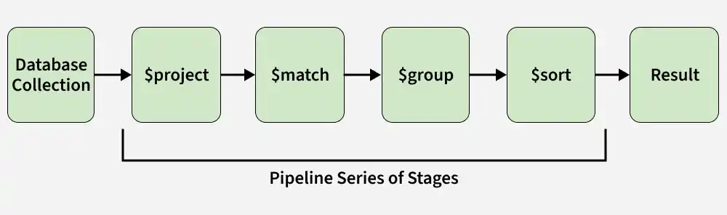
- Processes data step by step through pipeline stages.
- Performs computations on the server to reduce client load.
- Transforms and reshapes documents for analytics.
Aggregation Approaches
MongoDB provides multiple approaches for performing aggregation -depending on the complexity and type of data analysis you need to perform.
1. Single Purpose Aggregation
Single-purpose aggregation methods are used for quick, simple analytics like counting documents or fetching distinct field values, without using the aggregation pipeline.
- count(): Returns the number of documents in a collection.
- distinct(): Retrieves unique values for a specified field.
- estimatedDocumentCount(): Provides an estimated count of documents.
Example: Counting Users in Each City
Consider a single-purpose aggregation example where we find the total number of users in each city from the users collection.
db.users.aggregate([
{ $group: { _id: "$city", totalUsers: { $sum: 1 } } }
])
Output:
[
{ _id: 'Los Angeles', totalUsers: 1 },
{ _id: 'New York', totalUsers: 1 },
{ _id: 'Chicago', totalUsers: 1 }
]
- This example uses the aggregation pipeline (not single-purpose aggregation) because it involves the $group stage.
Note: countDocuments() is the recommended method for accurate document counts, supports query filters, and replaces the deprecated count() method for reliable results.
2. MongoDB Aggregation Pipeline
The MongoDB aggregation pipeline is a multi-stage process where each stage transforms documents. The output of one stage becomes the input for the next, with each stage filtering, modifying, or computing on documents until the final result is produced.
- Filters that will operate like queries.
- The document transformation that modifies the resultant document.
- Provide pipeline tools for grouping and sorting documents.
- Aggregation pipelines can run on sharded collections, where processing is distributed across shards and results are merged efficiently.
The aggregation pipeline consists of stages, which can use expressions and accumulators to process and transform data.
db.collection.aggregate([
{
$group: {
_id: "$groupField",
totalCount: { $sum: 1 }
}
}
])
- Stages: Define each step in the aggregation pipeline to filter, group, sort, or reshape documents.
- Expressions: Compute values and transform fields within pipeline stages.
- Accumulators: Perform calculations (sum, average, count) while grouping documents.
Aggregation Pipeline Method
To understand Aggregation Pipeline Method let's imagine a collection named users with some documents for our examples.
{
"_id": ObjectId("60a3c7e96e06f64fb5ac0700"),
"name": "Alex",
"age": 30,
"email": "alex@example.com",
"city": "New York"
}
{
"_id": ObjectId("60a3c7e96e06f64fb5ac0701"),
"name": "Ben",
"age": 35,
"email": "ben@example.com",
"city": "Los Angeles"
}
{
"_id": ObjectId("60a3c7e96e06f64fb5ac0702"),
"name": "Clevin",
"age": 25,
"email": "clevin@example.com",
"city": "Chicago"
}
1. $group: It Groups documents by the city field and calculates the average age using the $avg accumulator.
db.users.aggregate([
{ $group: { _id: "$city", averageAge: { $avg: "$age" } } }
])
Output:
[
{ _id: 'New York', averageAge: 30 },
{ _id: 'Chicago', averageAge: 25 },
{ _id: 'Los Angeles', averageAge: 35 }
]
2. $project: Include or exclude fields from the output documents.
db.users.aggregate([
{ $project: { name: 1, city: 1, _id: 0 } }
])
Output:
[
{ name: 'Alex', city: 'New York' },
{ name: 'Ben', city: 'Los Angeles' },
{ name: 'Clevin', city: 'Chicago' }
]
3. $match: Filter documents to pass only those that match the specified condition(s).
db.users.aggregate([
{ $match: { age: { $gt: 30 } } }
])
Output:
[
{
_id: ObjectId('60a3c7e96e06f64fb5ac0701'),
name: 'Ben',
age: 35,
email: 'ben@example.com',
city: 'Los Angeles'
}
]
4. $sort: It Sorts documents based on field values.
db.users.aggregate([
{ $sort: { age: 1 } }
])
Output:
[
{
_id: ObjectId('60a3c7e96e06f64fb5ac0702'),
name: 'Clevin',
age: 25,
email: 'clevin@example.com',
city: 'Chicago'
},
{
_id: ObjectId('60a3c7e96e06f64fb5ac0700'),
name: 'Alex',
age: 30,
email: 'alex@example.com',
city: 'New York'
},
{
_id: ObjectId('60a3c7e96e06f64fb5ac0701'),
name: 'Ben',
age: 35,
email: 'ben@example.com',
city: 'Los Angeles'
}
]
5. $limit: Limit the number of documents passed to the next stage.
db.users.aggregate([
{ $limit: 2 }
])
Output:
[
{
_id: ObjectId('60a3c7e96e06f64fb5ac0700'),
name: 'Alex',
age: 30,
email: 'alex@example.com',
city: 'New York'
},
{
_id: ObjectId('60a3c7e96e06f64fb5ac0701'),
name: 'Ben',
age: 35,
email: 'ben@example.com',
city: 'Los Angeles'
}
]
Using MongoDB Aggregation
To use MongoDB for aggregating data, follow below steps:
1. Connect to MongoDB: Ensure you are connected to your MongoDB instance.
2. Choose the Collection: Select the collection you want to perform aggregation on, such as students.
3. Define the Aggregation Pipeline: Create an array of stages, like $group to group documents and perform operations (e.g., calculate the average grade).
4. Run the Aggregation Query: Use the aggregate method on the collection with your defined pipeline.
Example: Calculates the average grade of all students in the students collection.
db.students.aggregate([
{
$group: {
_id: null,
averageGrade: { $avg: "$grade" }
}
}
])
Output:
[
{ "_id": null, "averageGrade": 85 }
]
Factors affecting Aggregation performance in MongoDB
Aggregation speed depends on pipeline complexity, data size, server hardware, and index efficiency.
- MongoDB’s aggregation framework is designed to handle large data sets and complex operations efficiently.
- Proper query optimization and use of indexes improve performance.
- Server configuration plays a key role in ensuring fast and scalable aggregation.
- Performance can vary by use case and setup, so monitoring and tuning are important.

Update with Aggregation Pipeline
The aggregation pipeline is a framework for processing data through a sequence of stages. Each stage performs a specific operation on the documents in the database.
- Stages apply operations like filtering, grouping, sorting, and transforming.
- Output of one stage becomes input for the next stage.
- Enables complex data processing inside MongoDB.
Using Aggregation Pipeline in Updates
MongoDB introduced update operations using aggregation pipelines (since version 4.2), allowing advanced transformations during updates
- Supports in-place transformations of documents during update operations using pipeline stages.
- Uses a limited subset of aggregation pipeline stages (such as $set, $addFields, $project, $unset, $replaceRoot) in update operations; stages like $group, $sort, and $lookup are not supported.
- Improves flexibility and efficiency of updates
- Reduces application-side processing logic
Syntax:
The basic syntax for using aggregation pipeline in update operations is as follows:
db.collection.updateMany(
<filter>,
[
{
$set: {
<field>: <expression>
}
},
// Additional pipeline stages
]
)
- <filter>: Specifies the selection criteria for documents to update.
- $set: Indicates the update operation to perform.
- <field>: Specifies the field to update.
- <expression>: Represents the aggregation expression to compute the new value for the field.
Example of Update with Aggregation Pipeline
To understand Update with Aggregation Pipeline here is a collection and some documents on which we will perform various operations and queries.
[
{
"name": "John Doe",
"salary": 60000,
"department": "Engineering",
"status": "Senior"
},
{
"name": "Jane Smith",
"salary": 45000,
"department": "HR",
"status": "Junior"
},
{
"name": "Alice Johnson",
"salary": 75000,
"department": "Finance",
"status": "Senior"
},
...
]
Example: Update the salary field for all employees by adding a 10% bonus. We can achieve this using the aggregation pipeline in the update operation
db.employees.updateMany(
{},
[
{
$set: {
salary: { $multiply: ["$salary", 1.1] }
}
}
]
)
Output:
[
{
"name": "John Doe",
"salary": 66000,
"department": "Engineering",
"status": "Senior"
},
{
"name": "Jane Smith",
"salary": 49500,
"department": "HR",
"status": "Junior"
},
{
"name": "Alice Johnson",
"salary": 82500,
"department": "Finance",
"status": "Senior"
}
]
- {} matches all documents in the employees collection.
- $set updates the salary field.
- $multiply computes the new salary with a 10% bonus.
Using Aggregation Operators in Updates
MongoDB provides a wide range of aggregation operators that can be used within the aggregation pipeline for update operations. These operators enable users to perform various transformations and computations on the data before updating documents.
Example Using $cond Operator
If the salary is greater than $50,000, set the status to "Senior", otherwise, set it to "Junior". We can achieve this using the $cond operator within the update pipeline.
db.employees.updateMany(
{},
[
{
$set: {
status: {
$cond: {
if: { $gte: ["$salary", 50000] },
then: "Senior",
else: "Junior"
}
}
}
}
]
)
Output:
[
{
"name": "John Doe",
"salary": 60000,
"department": "Engineering",
"status": "Senior"
},
{
"name": "Jane Smith",
"salary": 45000,
"department": "HR",
"status": "Junior"
},
{
"name": "Alice Johnson",
"salary": 75000,
"department": "Finance",
"status": "Senior"
}
...
]
The $cond operator evaluates the condition $gte (greater than or equal) to determine the value of the status field based on the salary.
Combining Multiple Stages
One of the key advantages of using the aggregation pipeline for updates is the ability to combine multiple stages to perform complex transformations in a single operation.
Example of Updating Multiple Fields
Update both the salary and department fields for all employees simultaneously. We can achieve this by adding multiple $set stages to the update pipeline
db.employees.updateMany(
{},
[
{
$set: {
salary: { $multiply: ["$salary", 1.1] }
}
},
{
$set: {
department: "Engineering"
}
}
]
)
Output:
[
{
"name": "John Doe",
"salary": 66000,
"department": "Engineering",
"status": "Senior"
},
{
"name": "Jane Smith",
"salary": 49500,
"department": "Engineering",
"status": "Junior"
},
{
"name": "Alice Johnson",
"salary": 82500,
"department": "Engineering",
"status": "Senior"
},
...
]
Two $set stages are used to update the salary and department fields independently.

Aggregation Pipeline Stages in MongoDB
Last Updated :5 May, 2026

MongoDB’s aggregation pipeline is a framework that processes data in a sequence of stages, where each stage performs a specific operation and passes the transformed result to the next stage.
- Data flows through multiple stages in a defined order.
- Each stage performs a specific operation such as filtering, grouping, sorting, or transforming data.
- The output of one stage becomes the input for the next stage.
- It allows complex data processing and analysis in a step-by-step manner.
- Common stages include $match, $group, $sort, $project, and $limit.
Syntax:
db.<collection_name>.aggregate(pipeline, options)
or
db.<collection_name>.aggregate( [ { <stage1> }, {<stage2>},... ] )
- db.<collection_name>: Refers to the collection to work on.
- .aggregate(): Starts the aggregation process.
- pipeline: A list of stages (steps) that process the data. Each stage is written inside {}.
- options: Extra settings (optional) to control the aggregation.
- [ { <stage1> }, { <stage2> }, ... ]: Stages run in order, one after another.
Aggregation Stages
Aggregation stages are individual steps that work on data to filter, group, or sort it.
1. $addFields Stage
$addFields stage is used to add new fields to the existing documents. It returns documents that contain all the existing fields and newly added fields.
Syntax :
db.<collection_name>.aggregate([
{
$addFields: {
<newField1>: <expression>,
<newField2>: <expression>
// ...
}
}
])
Example: Add a new field isActive with the value true to every document in the employee_details collection using the MongoDB aggregation pipeline.
db.employee_details.aggregate([
{
$addFields: {"isActive" : true }
}
])
Output:
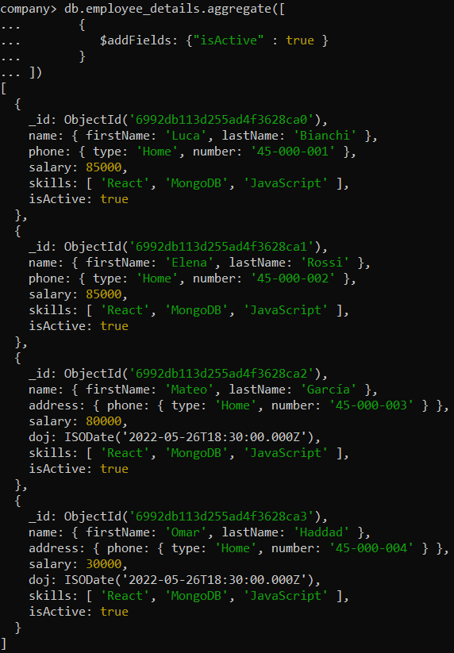
2. $set Stage
$set can overwrite existing fields; however, modifying the _id field is restricted and generally not allowed in most practical scenarios.
Syntax:
db.<collection_name>.aggregate([
{
$set: {
<newField>: <expression>
// ...
}
}
])
Example: Add a new field 'company_name' with the value 'GFG' to every document in the 'employee_details' collection using the MongoDB aggregation pipeline.
db.employee_details.aggregate([
{
$set: {"company_name" : "GFG"}
}
])
Output:
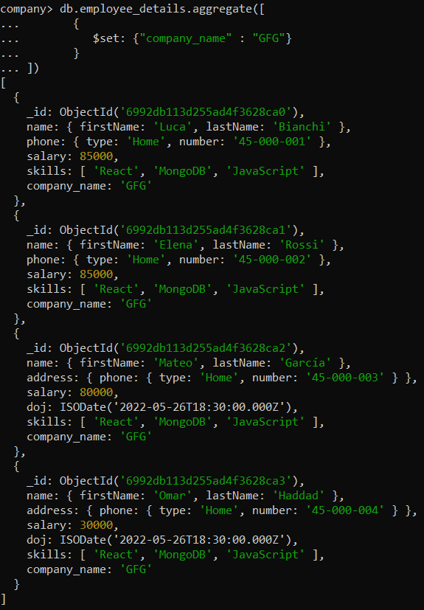
Note: $set stage is new stage in version 4.2.
3. $unset Stage
$unset stage is used to remove/exclude fields from the documents. If you want to remove the field or fields from the embedded document then use the dot notation. $unset stage is new staging in version 4.2.
Syntax:
- To remove a single field, The $unset stage takes a string that specifies the field to remove.
db.<collection_name>.aggregate([
{
$unset: "<field>"
}
])
- To remove multiple fields, The $unset takes an array of fields to remove.
db.<collection_name>.aggregate([
{
$unset: ["<field1>", "<field2>"]
}
])
Example: Remove the nested field 'address.phone.type' from every document in the 'employee_details' collection using the MongoDB aggregation pipeline.
db.employee_details.aggregate([
{
$unset: "address.phone.type"
}
])
Output:
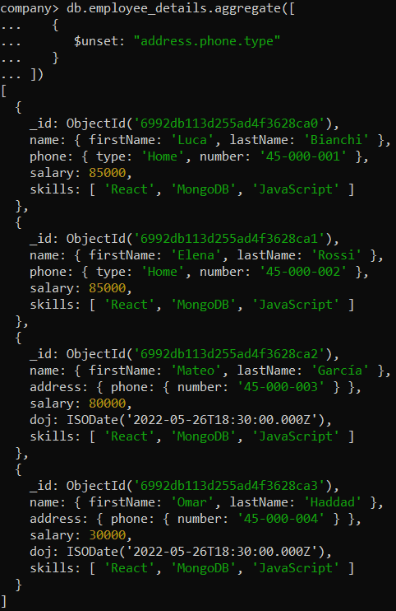
4. $project Stage
$project stage is used to include fields, exclude _id field, add new fields and replace the existing field value in the output document. The following is the table that describes the specification and its description.
Specification | Description
field : <1 or true> | include the field in the output document.
_id : <0 or false> | exclude the _id from the output document.
field : <expression> | add the new field or replace the existing field value.
field : <0 or false> | excluding any field (except _id) in $project prevents using other inclusion/expression specification.
Syntax:
db.<collection_name>.aggregate([
{
$project: {
<specification>
}
}
])
Example: Retrieve only the 'firstName' and 'lastName' fields from the 'name' object and the 'salary' field for every document in the 'employee_details' collection, excluding the '_id field, using the MongoDB aggregation pipeline.
db.employee_details.aggregate(
[
{
$project:{"name.firstName":1, "name.lastName":1, "salary":1, "_id":0}
}
])
Output:
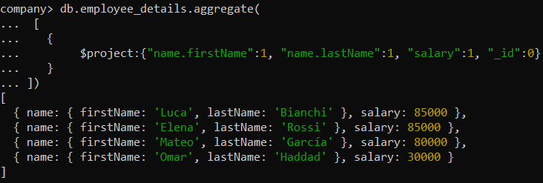
5. $count Stage
$count returns the count of the documents present in the selected collection.
Syntax:
db.<collection_name>.aggregate([
{
$count: "<fieldName>"
}
])
<fieldName> is the name of the output field that stores the count value.
Example: Count the total number of documents in the 'employee_details' collection and return the result as 'employees_count' using the MongoDB aggregation pipeline.
db.employee_details.aggregate(
[
{ $count: "employees_count" }
])
Output:
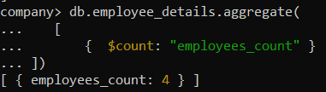
Note: To get the count of documents in a collection, you can also use db.<collection_name>.countDocuments(). It returns only the count value and does not allow specifying an output field.
6. $unwind Stage
$unwind deconstructs an array field into separate documents. If the field isn’t an array but exists (not null/missing/empty), it’s treated as a single-element array, and includeArrayIndex is set to null.
Syntax:
db.<collection_name>.aggregate(
[
{
$unwind:
{
path: <field path>,
includeArrayIndex: <string>,
preserveNullAndEmptyArrays: <boolean>
}
}
])
- path: Field path to unwind (e.g., "$skills").
- includeArrayIndex: Adds the array index to the output; null for non-array values.
- preserveNullAndEmptyArrays: If true, keeps documents where the field is missing, null, or an empty array (default: false).
Example: Skip the first 3 documents and then unwind the 'skills' array field in each remaining document in the 'employee_details' collection using the MongoDB aggregation pipeline.
db.employee_details.aggregate(
[
{$skip : 3},
{ $unwind: "$skills" }
]
)
Output:
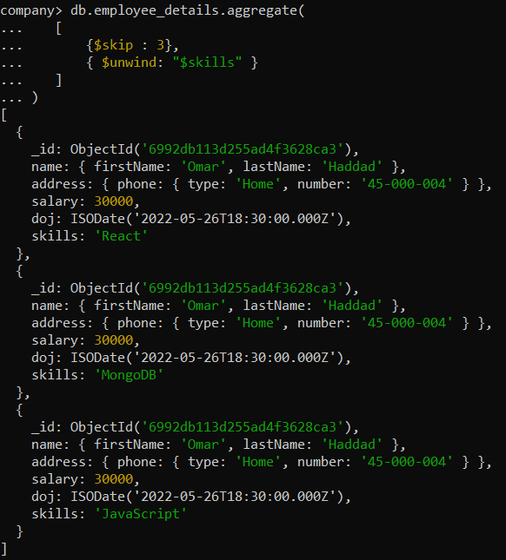
Note: $unwind stage does not include documents whose field is missing, null or empty array until you use preserveNullAndEmptyArrays : true
7. $limit Stage
$limit stage is used to limit the number of documents passed to the next stage in pipeline.
Syntax:
db.<collection_name>.aggregate(
[
{
$limit: <positive 64-bit integer>
}
])
Example: Limit the results to the first 2 documents and then count these documents, returning the result as 'employees_count', using the MongoDB aggregation pipeline.
db.employee_details.aggregate(
[
{$limit : 2},
{$count : "employees_count" }
])
Output:
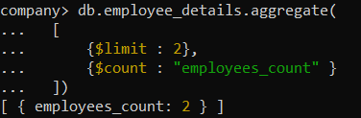
8. $sort Stage
$sort orders documents by one or more fields, applying sort keys left to right (first by <field1>, then by <field2> for ties).
Syntax:
db.<collection_name>.aggregate(
[
{ $sort: { <field1>: <sort order>, <field2>: <sort order> ... } }
])
<field> represents the document field on the basis of which we sort the document either ascending or descending depends on the <sort-order>. <sort order> has the following values :
Value | Order
1 | Ascending
-1 | Descending
Example of $sort in Ascending Order
Sort the documents in the 'employee_details' collection in ascending order based on the 'firstName' field in the 'name' object using the MongoDB aggregation pipeline.
db.employee_details.aggregate(
[
{$sort : {"name.firstName" : 1}}
])
Output:
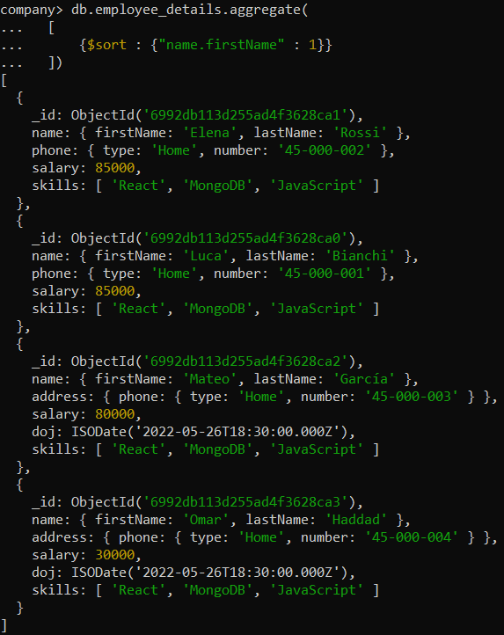
Example of $sort in Descending Order
Sort the documents in the 'employee_details' collection in descending order based on the 'firstName' field in the 'name' object using the MongoDB aggregation pipeline.
db.employee_details.aggregate(
[
{$sort : {"name.firstName" : -1}}
])
Output:
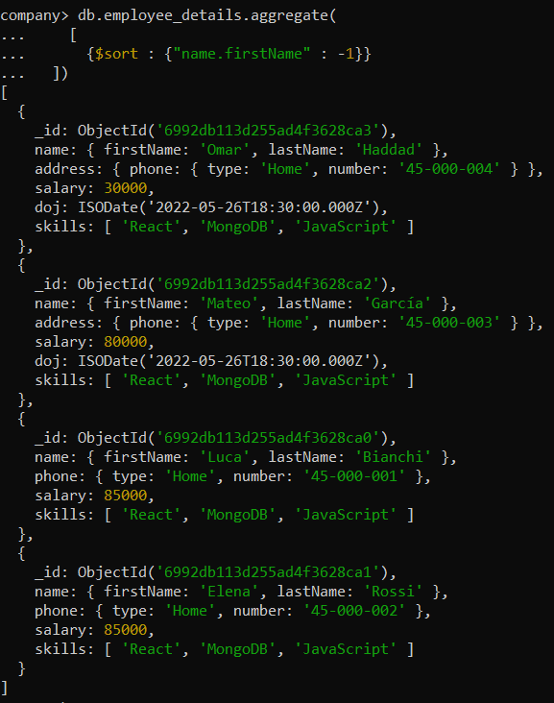
Note: You can sort a maximum of 32 keys.
9. $sortByCount Stage
$sortByCount groups documents by a field, counts each group, and returns the results sorted by count in descending order.
Syntax:
db.<collection_name>.aggregate(
[
{$sortByCount : "<field path>"}
])
Example: Create a MongoDB aggregation pipeline to list and count the occurrences of each skill across all employees in the employee_details collection after unwinding the skills array field.
db.employee_details.aggregate(
[
{$unwind : "$skills"},
{$sortByCount : "$skills"}
])
Output:
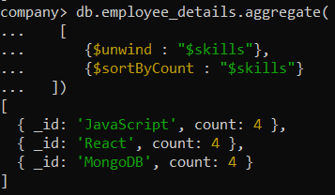
Note: $sortByCount is equivalent to applying $group with { $sum: 1 } followed by $sort in descending order of the count.
10. $skip Stage
$skip stage is used to skip the number of documents and passes the remaining documents to the next stage in the pipeline. It returns the remaining documents.
Syntax:
db.<collection_name>.aggregate(
[
{ $skip: <positive 64-bit integer> }
])
Example: Skip the first 3 documents in the 'employee_details' collection using the MongoDB aggregation pipeline.
db.employee_details.aggregate(
[
{$skip : 3}
])
Output:
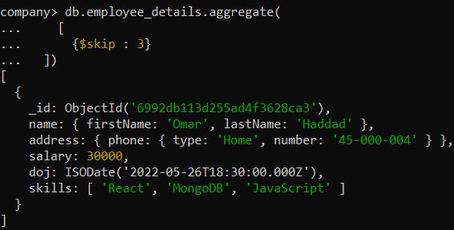

MongoDB Aggregation Pipeline $limit
The $limit stage in MongoDB controls how many documents move through the aggregation pipeline, helping reduce processing overhead and optimize query performance.
- Restricts the number of documents passed to the next stage.
- Reduces data processed, improving performance.
- Commonly used to limit final result sets (pagination/top-N).
- Can be placed at any point in the pipeline.
- Accepts a single numeric argument as the maximum limit.
Syntax:
{ $limit: <positive integer> }
- $limit: The keyword indicating the stage.
- <positive integer>: The maximum number of documents to output from the pipeline.
Common Aggregation Pipeline Stages Used with $limit
These stages are commonly combined with $limit to filter, transform, order, and paginate results efficiently within the aggregation pipeline.
- $match: Match filters documents based on conditions before limiting them.
- $group: Group documents by a specified key and performs aggregation operations.
- $project: Reshapes documents by including, excluding, or renaming fields.
- $sort: Sorts documents based on specified fields.
- $skip: Skips a number of documents before applying $limit (useful for pagination).
Example of using $limit in MongoDB
The $limit stage helps control the number of documents returned in an aggregation query, improving efficiency and reducing processing time. Below are practical examples demonstrating how to apply $limit in different scenarios. Let's consider a sample orders collection:
[
{ "_id": ObjectId("60f9d7ac345b7c9df348a86e"), "customer": "Alex", "total": 150 },
{ "_id": ObjectId("60f9d7ac345b7c9df348a86f"), "customer": "Ben", "total": 200 },
{ "_id": ObjectId("60f9d7ac345b7c9df348a870"), "customer": "Clevin", "total": 100 },
{ "_id": ObjectId("60f9d7ac345b7c9df348a871"), "customer": "David", "total": 75 },
{ "_id": ObjectId("60f9d7ac345b7c9df348a872"), "customer": "Eve", "total": 300 },
{ "_id": ObjectId("60f9d7ac345b7c9df348a873"), "customer": "Frank", "total": 180 },
{ "_id": ObjectId("60f9d7ac345b7c9df348a874"), "customer": "Grace", "total": 220 },
{ "_id": ObjectId("60f9d7ac345b7c9df348a875"), "customer": "Harry", "total": 95 },
{ "_id": ObjectId("60f9d7ac345b7c9df348a876"), "customer": "Ivy", "total": 210 },
{ "_id": ObjectId("60f9d7ac345b7c9df348a877"), "customer": "Jack", "total": 125 }
]
Example 1: Retrieve the First 3 Orders
Suppose We want to retrieve only the first three orders from the collection. Here's how we can use the $limit stage to achieve this
db.orders.aggregate([
{ $limit: 3 }
])
Output:
[
{ "_id": ObjectId("60f9d7ac345b7c9df348a86e"), "customer": "Alex", "total": 150 },
{ "_id": ObjectId("60f9d7ac345b7c9df348a86f"), "customer": "Ben", "total": 200 },
{ "_id": ObjectId("60f9d7ac345b7c9df348a870"), "customer": "Clevin", "total": 100 }
]
- db.orders.aggregate([]) starts the aggregation pipeline.
- $limit passes only the first three documents to the next stage.
- Reduces processing time and network load by returning fewer documents.
Example 2: Retrieve the First 5 Orders
Retrieve only the first five orders from the collection. Here's how we can use the $limit stage to achieve this
db.orders.aggregate([
{ $limit: 5 }
])
Output:
[
{ "_id": ObjectId("60f9d7ac345b7c9df348a86e"), "customer": "Alex", "total": 150 },
{ "_id": ObjectId("60f9d7ac345b7c9df348a86f"), "customer": "Ben", "total": 200 },
{ "_id": ObjectId("60f9d7ac345b7c9df348a870"), "customer": "Clevin", "total": 100 },
{ "_id": ObjectId("60f9d7ac345b7c9df348a871"), "customer": "David", "total": 75 },
{ "_id": ObjectId("60f9d7ac345b7c9df348a872"), "customer": "Eve", "total": 300 }
]
- $limit returns the first N documents based on the current pipeline order; without a preceding $sort, the order is not guaranteed.
- Useful for fetching a small result set (e.g., top five recent records).
- Improves performance by reducing processed data.
Example 3: Implement Pagination using $limit and $skip
Pagination is a common use of $limit, enabling efficient page-wise data retrieval (e.g., fetching a specific set of customer orders per page).
const pageSize = 10;
// First page
const pageNumber = 1;
db.orders.aggregate([
{ $sort: { _id:1} }, // define order first
{ $skip: (pageNumber-1)*pageSize},
{ $limit: pageSize}
])
- Pagination requires a defined order using $sort; without it, results may be inconsistent across pages.
Output:
The output will contain the documents corresponding to the specified page of results.
[
{ "_id": ObjectId("60f9d7ac345b7c9df348a86e"), "customer": "Alex", "total": 150 },
{ "_id": ObjectId("60f9d7ac345b7c9df348a86f"), "customer": "Ben", "total": 200 },
{ "_id": ObjectId("60f9d7ac345b7c9df348a870"), "customer": "Clevin", "total": 100 },
{ "_id": ObjectId("60f9d7ac345b7c9df348a871"), "customer": "David", "total": 75 },
{ "_id": ObjectId("60f9d7ac345b7c9df348a872"), "customer": "Eve", "total": 300 }
]
- Calculates documents to skip using page number and page size.
- Applies $skip to move to the correct page.
- Uses $limit to fetch only the required records.
Benefits of Using $limit in MongoDB
The $limit stage can be used in various scenarios, including:
- Enhances Performance: Reducing the amount of data processed in complex aggregation pipelines to improve query performance.
- Pagination Support: Limiting the number of results returned for paginated queries. It is Essential for building paginated APIs and web applications.
- Efficient Sampling: Retrieves only a subset of documents for analysis or testing.
- Reduces Network Load: Minimizes data transfer between MongoDB and the application.
Optimizing Techniques for $limit in Aggregation Pipelines
To work within the limits of the aggregation pipeline and ensure efficient query execution, developers can employ various optimization techniques:
1. Use Indexes for Faster Query Execution
Creating indexes on frequently queried fields improves the efficiency of $limit queries. Utilizing indexes also reduces the number of documents processed by the pipeline.
db.orders.createIndex({ orderDate: -1 });
db.orders.aggregate([
{ $match: { status: "completed" } },
{ $sort: { orderDate: -1 } },
{ $limit: 5 }
])
2. Projection Optimization
Limit the fields returned in output documents using the $project stage to minimize data transfer and processing overhead. By reducing the number of fields, you improve query performance and lower memory usage.
db.orders.aggregate([
{ $project: { customer: 1, total: 1 } },
{ $limit: 5 }
])
3. Apply $match Before $limit
Filtering early reduces the number of documents processed. Place $match stages early in the pipeline to filter out irrelevant documents and reduce computation costs.
db.orders.aggregate([
{ $match: { total: { $gt: 100 } } },
{ $limit: 3 }
])
4. Optimize $sort Before $limit
Sorting should be applied before limiting to reduce processing time. Apply $limit stages to restrict the number of documents processed by the pipeline and improve query efficiency.
db.orders.aggregate([
{ $sort: { total: -1 } },
{ $limit: 3 }
]);
5. Avoiding In-Memory Operations
Minimize in-memory operations within the pipeline to reduce memory usage and prevent out-of-memory errors. Use indexing, early filtering ($match), and projection ($project) to limit data processing and optimize query performance.

MongoDB Aggregation Commands / Operators
MongoDB aggregation is used to process documents through a pipeline and produce calculated, grouped, filtered, joined, or transformed results. Instead of simply finding documents, aggregation allows you to perform operations such as calculating totals, counting documents, grouping data, combining data from different collections, and saving the final result.

Important: $out, $count, $group, $lookup, and $first are used inside an aggregation pipeline. $first is an aggregation expression/operator, while the others listed here are mainly pipeline stages/operators.

A basic aggregation pipeline looks like:

db.collection.aggregate([
{ <stage1> },
{ <stage2> },
{ <stage3> }
])

For example:
db.students.aggregate([
{ $match: { age: { $gte: 18 } } },
{ $group: { _id: "$city", totalStudents: { $sum: 1 } } }
])
Here, the documents pass through one stage and then the next stage.

1. Aggregation Commands

MongoDB aggregation commands provide a framework for processing documents through multiple stages, where each stage performs a specific operation on the data. Aggregation can be used to filter documents, group them, calculate values, count records, join collections, reshape documents, and store the final result.

Processes documents through an aggregation pipeline.
Each stage receives the output of the previous stage.
Used for analysis, reporting, calculations, and data transformation.
Can work with large amounts of data.
Common stages include $match, $group, $project, $sort, $count, $lookup, and $out.
Basic Syntax
db.collection.aggregate([
{
<stage1>: {
...
}
},
{
<stage2>: {
...
}
}
])
Example

Suppose students contains:

[
{ name: "Rahul", city: "Delhi", marks: 80 },
{ name: "Aman", city: "Delhi", marks: 70 },
{ name: "Priya", city: "Mumbai", marks: 90 }
]

We can find the average marks by city:

db.students.aggregate([
{
$group: {
_id: "$city",
averageMarks: {
$avg: "$marks"
}
}
}
])

Result:

[
{ _id: "Delhi", averageMarks: 75 },
{ _id: "Mumbai", averageMarks: 90 }
]
Easy way to remember

Aggregation = Process documents step-by-step to get useful results.

2. $out — Save Aggregation Results

The $out operator is used to write the final results of an aggregation pipeline into a MongoDB collection. Instead of only displaying the aggregation result, $out stores that result as documents in the specified collection. If the destination collection already exists, MongoDB replaces its contents with the pipeline results.

Writes aggregation results into a collection.
Must generally be used as the last stage of the pipeline.
Creates the destination collection if it does not exist.
If the destination collection already exists, its contents are replaced.
Useful for creating reports, summaries, and processed datasets.
$out is different from $merge, which can update or merge results into an existing collection.
Syntax
db.collection.aggregate([
{
<aggregation stages>
},
{
$out: "<collectionName>"
}
])
Example

Suppose students contains:

[
{ name: "Rahul", city: "Delhi", marks: 80 },
{ name: "Aman", city: "Delhi", marks: 70 },
{ name: "Priya", city: "Mumbai", marks: 90 }
]

We want to calculate average marks by city and save the result in cityReports.

db.students.aggregate([
{
$group: {
_id: "$city",
averageMarks: {
$avg: "$marks"
}
}
},
{
$out: "cityReports"
}
])

MongoDB creates:

cityReports

with documents similar to:

[
{
_id: "Delhi",
averageMarks: 75
},
{
_id: "Mumbai",
averageMarks: 90
}
]
Important

Think of the pipeline as:

students
↓
$group
↓
calculate average
↓
$out
↓
cityReports collection
Easy way to remember

$out = Save the final aggregation result into a collection.

3. $count — Count Documents

The $count operator counts the number of documents that reach that stage of the aggregation pipeline and stores the resulting number under a specified field name. It is useful when you want to know how many documents satisfy conditions applied in earlier stages, such as the number of students who passed, products that are available, or users from a particular city.

Counts the number of documents entering the stage.
Produces a document containing the count value.
The output field name is specified by you.
Commonly used after $match.
Useful for reports, statistics, and record counting.
Syntax
db.collection.aggregate([
{
$count: "<outputFieldName>"
}
])
Example 1 — Count all students

Suppose there are 5 documents in students.

db.students.aggregate([
{
$count: "totalStudents"
}
])

Result:

[
{
totalStudents: 5
}
]
Example 2 — Count students who passed

Suppose:

[
{ name: "Rahul", marks: 80 },
{ name: "Aman", marks: 35 },
{ name: "Priya", marks: 90 },
{ name: "Rohit", marks: 25 }
]

We want to count students with marks greater than or equal to 40.

db.students.aggregate([
{
$match: {
marks: { $gte: 40 }
}
},
{
$count: "passedStudents"
}
])

Result:

[
{
passedStudents: 2
}
]
How it works
All students
↓
$match
↓
marks >= 40
↓
$count
↓
2
Easy way to remember

$count = Count how many documents reached this stage.

4. $group — Group Documents

The $group operator groups documents that have the same value for a specified expression and allows you to calculate summary information for each group. It is one of the most important aggregation stages because it can be combined with accumulator operators such as $sum, $avg, $min, $max, and $first to create useful reports and statistics.

Groups documents based on a specified expression.
Uses the _id field to define the group.
Can calculate values such as sum, average, minimum, and maximum.
Commonly used with $sum, $avg, $min, $max, and $first.
Useful for reports, statistics, totals, and data analysis.
Syntax
db.collection.aggregate([
{
$group: {
_id: <groupExpression>,
<field1>: {
<accumulator>: <expression>
}
}
}
])
Example 1 — Group students by city

Suppose:

[
{ name: "Rahul", city: "Delhi", marks: 80 },
{ name: "Aman", city: "Delhi", marks: 70 },
{ name: "Priya", city: "Mumbai", marks: 90 }
]

Query:

db.students.aggregate([
{
$group: {
_id: "$city"
}
}
])

Result:

[
{ _id: "Delhi" },
{ _id: "Mumbai" }
]

MongoDB creates one group for each unique city.

Example 2 — Count students in each city
db.students.aggregate([
{
$group: {
_id: "$city",
totalStudents: {
$sum: 1
}
}
}
])

Result:

[
{
_id: "Delhi",
totalStudents: 2
},
{
_id: "Mumbai",
totalStudents: 1
}
]

Here:

$sum: 1

means:

Add 1 for every document in the group.

Example 3 — Calculate average marks by city
db.students.aggregate([
{
$group: {
_id: "$city",
averageMarks: {
$avg: "$marks"
}
}
}
])

Result:

[
{
_id: "Delhi",
averageMarks: 75
},
{
_id: "Mumbai",
averageMarks: 90
}
]
Easy way to remember

$group = Put similar documents together and calculate something for each group.

5. $lookup — Join Two Collections

The $lookup operator performs a left outer join between two MongoDB collections, allowing documents from one collection to be combined with matching documents from another collection. It is especially useful when related information is stored in separate collections, such as students and courses, customers and orders, or products and categories.

Combines data from two collections.
Works similar to a JOIN in SQL.
Performs a left outer join.
Matching documents from the second collection are returned in an array.
Useful when related data is stored in separate collections.
Does not permanently merge the collections; it only combines their data in the aggregation result.
Syntax
db.collection.aggregate([
{
$lookup: {
from: "<otherCollection>",
localField: "<fieldInCurrentCollection>",
foreignField: "<fieldInOtherCollection>",
as: "<resultArray>"
}
}
])
Meaning of the fields
from
↓
Which collection should MongoDB search?

localField
↓
Field from the current collection

foreignField
↓
Field from the other collection

as
↓
Name of the new array containing matching documents
Example

Suppose we have two collections.

students
[
{
_id: 1,
name: "Rahul",
courseId: 101
},
{
_id: 2,
name: "Aman",
courseId: 102
}
]
courses
[
{
_id: 101,
courseName: "MongoDB"
},
{
_id: 102,
courseName: "JavaScript"
}
]

We want to get the course information along with each student.

db.students.aggregate([
{
$lookup: {
from: "courses",
localField: "courseId",
foreignField: "_id",
as: "courseDetails"
}
}
])

Result:

[
{
_id: 1,
name: "Rahul",
courseId: 101,
courseDetails: [
{
_id: 101,
courseName: "MongoDB"
}
]
},
{
_id: 2,
name: "Aman",
courseId: 102,
courseDetails: [
{
_id: 102,
courseName: "JavaScript"
}
]
}
]
How $lookup works
students
|
| courseId
↓
courses
|
| _id
↓
Matching course
|
↓
courseDetails array
Important

$lookup returns matching documents inside an array, even when only one matching document exists.

If you want to convert that one-element array into an object, $unwind is often used afterward.

Easy way to remember

$lookup = Find matching data in another collection and bring it into the result.

6. $first — Get the First Value

The $first operator returns the value of an expression from the first document in a group or the first element in an array, depending on how it is used. In $group, it is commonly used to retain the value from the first document encountered in each group. The order of documents matters, so $sort is often placed before $group when you need a specific document to be considered first.

Returns the value from the first document in a group.
Commonly used with $group.
The order of documents matters.
Often used after $sort to control which document becomes first.
Useful for finding the first name, first date, first transaction, or another representative value.
Can also be used with arrays in expression contexts.
Syntax with $group
db.collection.aggregate([
{
$group: {
_id: <groupExpression>,
<fieldName>: {
$first: <expression>
}
}
}
])
Example

Suppose:

[
{
name: "Rahul",
city: "Delhi",
marks: 80
},
{
name: "Aman",
city: "Delhi",
marks: 70
},
{
name: "Priya",
city: "Mumbai",
marks: 90
}
]

We want the first student from each city.

db.students.aggregate([
{
$group: {
_id: "$city",
firstStudent: {
$first: "$name"
}
}
}
])

Possible result:

[
{
_id: "Delhi",
firstStudent: "Rahul"
},
{
_id: "Mumbai",
firstStudent: "Priya"
}
]

Here, for Delhi, "Rahul" was encountered first.

$first with $sort

If you want the highest-scoring student from each city, first sort by marks in descending order and then use $first.

db.students.aggregate([
{
$sort: {
marks: -1
}
},
{
$group: {
_id: "$city",
topStudent: {
$first: "$name"
},
highestMarks: {
$first: "$marks"
}
}
}
])

If the data is:

[
{ name: "Rahul", city: "Delhi", marks: 80 },
{ name: "Aman", city: "Delhi", marks: 70 },
{ name: "Priya", city: "Mumbai", marks: 90 }
]

Result:

[
{
_id: "Mumbai",
topStudent: "Priya",
highestMarks: 90
},
{
_id: "Delhi",
topStudent: "Rahul",
highestMarks: 80
}
]
Why $sort is important

Without $sort, "first" means the first document encountered by the pipeline, which may not represent the highest, lowest, earliest, or latest value you want.

Think:

$sort
↓
Decide the order
↓
$group
↓
$first
↓
Take the first document/value

Easy way to remember
$first = Give me the first value/document in the current order.

⭐ Quick Comparison
Operator Main Purpose Simple Meaning
$out Save aggregation results Save result
$count Count documents How many?
$group Group similar documents Make groups
$lookup Combine collections Join data
$first Get first value First one
🧠 Super-Easy Memory Trick
$out → OUTPUT / SAVE
$count → COUNT
$group → GROUP
$lookup → JOIN
$first → FIRST
One complete example

These operators become much easier when you see how they can work together:
db.students.aggregate([
{
$sort: {
marks: -1
}
},
{
$group: {
_id: "$city",
totalStudents: {
$sum: 1
},
topStudent: {
$first: "$name"
},
highestMarks: {
$first: "$marks"
}
}
},
{
$out: "cityReports"
}
])

The pipeline does:
students
↓
$sort
↓
Highest marks first
↓
$group
↓
Create one group per city
↓
$count-like counting using $sum
↓
$first gets top student
↓
$out
↓
Save results in cityReports

So the core idea of aggregation is:
Take documents → process them through stages → produce a useful final result.

MongoDB – Aggregation Tools
1. Map-Reduce
Definition
Map-Reduce is a data processing method used in MongoDB to process a large number of documents. It works in two main steps: Map and Reduce. The Map function processes each document and produces key-value pairs, while the Reduce function combines the values of the same key to produce a final result.
Main Points
- It is used to process large amounts of data.
- It works in two steps:
  - Map – reads documents and creates key-value pairs.
  - Reduce – combines values having the same key.
- It can be used for grouping and calculating data.
- It is useful for complex data processing.
- For most modern MongoDB aggregation tasks, the Aggregation Pipeline is preferred over Map-Reduce.
Basic Syntax
db.collection.mapReduce(
mapFunction,
reduceFunction,
{
out: "outputCollection"
}
)
Example
Suppose we have:
{
name: "John",
department: "IT",
salary: 50000
}
Map function:
function() {
emit(this.department, this.salary);
}
Reduce function:
function(key, values) {
return Array.sum(values);
}
This can calculate the total salary for each department.
Easy Memory Trick
Map = Make key-value pairs
Reduce = Combine the values

MongoDB – Indexing
What is Indexing?
Definition
Indexing is a technique used in MongoDB to make data searching and retrieval faster. An index is a special data structure that stores information about selected fields of documents. MongoDB can use the index to find required documents without checking every document in the collection.
Why do we use Indexes?
Without an index:
Collection
↓
Check Document 1
↓
Check Document 2
↓
Check Document 3
↓
Check Document 4
↓
Find required document
With an index:
Query
↓
Index
↓
Find matching document quickly
Advantages
- Makes queries faster.
- Improves data retrieval performance.
- Helps MongoDB find documents efficiently.
- Useful for frequently searched fields.
Disadvantages
- Indexes require extra storage.
- Too many indexes can slow down insert, update, and delete operations.
- Indexes should be created carefully.

1. Create an Index
Definition
The createIndex() method is used to create an index on one or more fields of a MongoDB collection. It helps MongoDB find documents faster when those fields are used in queries.
Syntax
db.collection.createIndex({ field: 1 })
Here:
- 1 = Ascending order
- -1 = Descending order
Example
db.students.createIndex({ age: 1 })
This creates an ascending index on the age field.
Another example:
db.students.createIndex({ name: 1 })
Now searches using the name field can be faster.

2. Get an Index
Definition
The getIndexes() method is used to display all the indexes created on a MongoDB collection. It helps us check which indexes are available for that collection.
Syntax
db.collection.getIndexes()
Example
db.students.getIndexes()
This displays all indexes of the students collection.
Usually, MongoDB automatically has an index on:
_id

3. Drop an Index
Definition
The dropIndex() method is used to remove an existing index from a MongoDB collection. It is useful when an index is no longer required or when we want to reduce unnecessary indexes.
Syntax
db.collection.dropIndex("index_name")
Example
db.students.dropIndex("age_1")
This removes the index created on the age field.
To remove all removable indexes
db.students.dropIndexes()
The default _id index cannot be removed.
Easy Memory Trick
Create → Make index
Get → See index
Drop → Remove index

4. Types of Indexes
MongoDB provides different types of indexes for different types of data and queries.
Important Types
- Single Field Index
- Compound Index
- Multikey Index
- Text Index
- Geospatial Index
- Hashed Index
- Unique Index
- Wildcard Index
For your syllabus, the important ones are:
Single Field
↓
Compound
↓
Multikey
↓
Text

5. Single Field Index
Definition
A Single Field Index is an index created on only one field of a document. It is useful when queries frequently search or sort data using one particular field.
Syntax
db.collection.createIndex({ field: 1 })
Example
db.students.createIndex({ age: 1 })
Here, the index is created only on:
age
Example Query
db.students.find({ age: 20 })
MongoDB can use the index on age to find matching documents more efficiently.
Example Structure
Student Document

{
name: "John",
age: 20,
city: "Delhi"
}
Index:
age → Index
Memory Trick
Single Field = One field

6. Compound Index
Definition
A Compound Index is an index created on two or more fields of a document. It is useful when queries frequently use multiple fields together.
Syntax
db.collection.createIndex({
field1: 1,
field2: 1
})
Example
db.students.createIndex({
age: 1,
city: 1
})
This creates one index using:
age + city
Example Query
db.students.find({
age: 20,
city: "Delhi"
})
The compound index can help this type of query.
Important Point
The order of fields in a compound index matters.
For example:
{ age: 1, city: 1 }
is different from:
{ city: 1, age: 1 }
Memory Trick
Compound = Combination of multiple fields

7. Multikey Index
Definition
A Multikey Index is an index used for fields that contain arrays. MongoDB automatically creates a multikey index when an index is created on a field containing an array.
Example Document
{
name: "John",
skills: ["JavaScript", "MongoDB", "React"]
}
Create index:
db.students.createIndex({
skills: 1
})
MongoDB creates a multikey index for the skills array.
Example Query
db.students.find({
skills: "MongoDB"
})
MongoDB can use the multikey index to find students whose skills contain "MongoDB".
Memory Trick
Multi-key = Multiple values inside an array

8. Text Index
Definition
A Text Index is an index used to search for words or text inside string fields. It is useful when we want to perform text-based searches instead of searching for an exact value.
Example Document
{
title: "MongoDB Tutorial",
description: "Learn MongoDB database"
}
Create a text index:
db.articles.createIndex({
description: "text"
})
Search Text
db.articles.find({
$text: {
$search: "MongoDB"
}
})
This searches for documents containing the word:
MongoDB
Memory Trick
Text Index = Search words in text

Quick Comparison
Topic | Meaning | Example
Create Index | Creates an index | createIndex()
Get Index | Shows indexes | getIndexes()
Drop Index | Removes an index | dropIndex()
Single Field | Index on one field | {age: 1}
Compound | Index on multiple fields | {age: 1, city: 1}
Multikey | Index for array fields | {skills: 1}
Text | Index for text searching | {description: "text"}
Map-Reduce | Processes data using Map and Reduce | mapReduce()
One-Line Revision
Map-Reduce → Process data
Indexing → Make searching faster
Create → Create index
Get → See indexes
Drop → Remove index
Single → One field
Compound → Multiple fields
Multikey → Array field
Text → Text search

Transactions in MongoDB
MongoDB 4.0 introduced multi-document ACID transactions, enabling developers to maintain data integrity across multiple operations, collections, and documents in a NoSQL database.
- Supports multi-document transactions across collections and databases.
- Ensures ACID Properties for reliable data consistency.
- Simplifies handling of complex multi-step operations.
- Improves data integrity in distributed applications.
ACID Transactions in MongoDB
MongoDB supports multi-document ACID transactions to ensure data integrity and consistency across multiple operations, making it suitable for systems that require guaranteed correctness, such as banking and order processing.
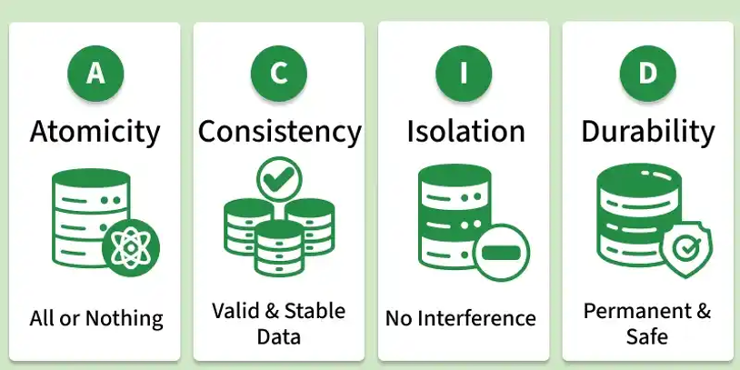
- Groups multiple operations into a single atomic transaction.
- All changes are rolled back if the transaction is explicitly aborted or if an error occurs before a successful commit. Suitable for enterprise applications such as banking, supply chain, shipping, and e-commerce systems.
- Supports multi-document and distributed transactions.
- Useful for critical workflows like orders and payments.
Features of Transactions in MongoDB
Here are some features of transactions in MongoDB:
- Atomic Unit: Groups multiple operations into a single transaction that commits or rolls back together.
- Data Consistency: Maintains consistency across multiple documents, collections, and databases.
- Use Cases: Suitable for System of Record and Line of Business apps (banking, supply chain, shipping, e-commerce).
- Transaction APIs: Core API (manual control) and Callback API (withTransaction).
- Core API Behavior: Requires explicit start and commit calls.
- Callback API Behavior: Automatically commits or aborts on error.
- Session-Based: Transactions execute within a client session.
- Timeout Handling: Transactions exceeding 60 seconds are automatically aborted.
Implementation of MongoDB Transactions
MongoDB transactions are implemented using start_session(), start_transaction(), and commit_transaction().
1. Set up MongoDB Client:
from pymongo import MongoClient
client = MongoClient("mongodb://localhost:27017")
database = client["your_database"]
- Connects to the MongoDB server.
- Selects the target database.
2. Start a Transaction Session:
with client.start_session() as session:
session.start_transaction()
- Starts a new session.
- Begins a transaction within the session.
3. Perform Operations within the Transaction:
try:
# Perform operations within the transaction
database.collection1.insert_one({"key": "value"}, session=session)
database.collection2.update_one(
{"key": "old_value"},
{"$set": {"key": "new_value"}},
session=session
)
# Commit the transaction
session.commit_transaction()
except Exception as e:
# Abort the transaction in case of an error
print("An error occurred:", e)
session.abort_transaction()
- Executes multiple operations in a single transaction.
- Commits all changes if successful.
- Aborts and rolls back if any operation fails.
Advantages of Transactions in MongoDB
MongoDB transactions provide ACID guarantees that ensure data validity and reliability despite failures and concurrent operations.
- Atomicity: Atomicity ensures that a transaction is executed as a single indivisible unit, where either all operations are committed or the entire transaction is rolled back, preventing partial or inconsistent state changes in the database.
- Consistency: Consistency ensures that each transaction transitions the database from one valid state to another, enforcing all constraints and rules. If a transaction violates consistency constraints, it is rolled back, leaving the database unchanged.
- Isolation: Isolation ensures that concurrent transactions execute as if they were serialized, preventing other transactions from observing intermediate or uncommitted states.
- Durability: Durability guarantees that once a transaction is committed, its changes are persisted to stable storage and survive system crashes or failures.
Disadvantages of MongoDB Transactions
While MongoDB transactions offer significant advantages, there are also some challenges associated with their use:
- Performance Overhead: Transactions introduce performance overhead, especially in write-intensive workloads. The need for coordination between operations and locking mechanisms can slow down the overall performance of the database.
- Complexity in Implementation: Implementing transactions, especially for multi-document transactions, requires additional code and logic. For complex systems with many operations across different collections, managing these transactions can become difficult.
- Not Ideal for All Use Cases: MongoDB transactions are not necessary for every application. For example, if your application performs only simple operations where atomicity is not a critical concern, transactions may add unnecessary overhead.

Working of ACID Transactions in MongoDB
MongoDB ACID transactions allow multiple operations to run as one atomic unit, ensuring reliable and consistent data changes.
- Ensures all-or-nothing execution of operations.
- Maintains consistency and isolation across documents/collections.
- Guarantees durability of committed changes.
ACID Transaction Workflow
A MongoDB transaction moves through several states:
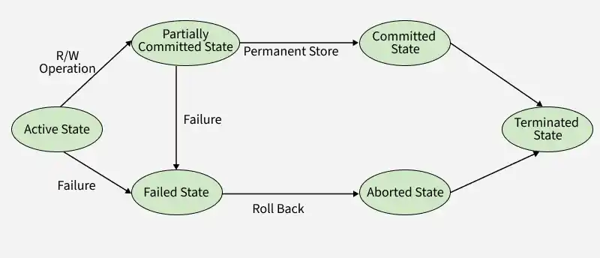
Working
- Active State: Transaction starts and performs read/write operations.
- Partially Committed State: Operations are done but not yet permanently stored.
- Committed State: Changes are successfully saved to the database.
- Terminated State: Transaction completes successfully.
- Failed State: If a failure occurs during the transaction, it enters this state.
- Aborted State: The transaction is rolled back to undo changes after a failure.
ACID Properties in MongoDB
The term ACID stands for Atomicity, Consistency, Isolation, and Durability. Let's understand each of these ACID transaction properties with their examples.
1. Atomicity
Atomicity ensures that a transaction is executed as a single unit—either fully completed or fully rolled back.
- All operations succeed or none are applied.
- Partial execution is not allowed.
- Changes are rolled back if the transaction is explicitly aborted or fails before a successful commit.
- Prevents inconsistent database states.
Example (Bank Transfer): If money is debited from one account but crediting the other fails due to a crash, the entire transaction is rolled back. Both accounts remain unchanged.
2. Consistency
Consistency ensures the database moves from one valid state to another, preserving all rules and constraints.
- Maintains integrity constraints.
- Database remains valid before and after a transaction.
- Invalid updates are rejected.
- Prevents rule violations.
Example (Grade Validation): When updating a student’s grade, only valid values (A, B, C, D, F) are allowed. If an invalid grade is assigned, the transaction is aborted.
3. Isolation
Isolation ensures that concurrent transactions do not interfere with each other.
- Transactions run independently.
- Uncommitted changes are not visible to others.
- Prevents dirty reads and intermediate states.
- Ensures predictable results.
Example (Concurrent Transactions): If Transaction A is transferring money to Account Y and Transaction B reads Account Y’s balance, Transaction B will see either the old balance or the final committed balance- not an intermediate value.
4. Durability
Durability ensures that once a transaction is successfully committed, its changes are permanently stored and will survive system failures.
- Committed data is persisted permanently.
- Survives crashes, restarts, and power failures.
- Ensures data recovery after failures.
- Restores the database to the last consistent state on restart.
Example (Transaction Persistence & Recovery): After a successful fund transfer in a banking system, the changes are saved permanently. Even if the system crashes immediately afterward, the committed transaction is recovered when the system restarts, and the database is restored to its last consistent state.
Working of multi-document transactions
MongoDB multi-document transactions enable atomic and consistent operations across multiple documents and collections within a single session.
- Start Transaction: Open a session and begin the transaction.
- Define Operations: Perform inserts, updates, deletes, and reads using the same session.
- Execute Operations: Run all steps while the transaction is active.
- Isolation: Uncommitted changes remain hidden from other sessions.
- Consistency: Rules and constraints are enforced to keep data valid.
- Atomicity: Any failure triggers a rollback of all changes.
- Commit: Permanently save changes when all steps succeed.
- Rollback: Abort the transaction if errors or business rules fail.
- Durability: Committed data persists even after restarts or crashes.
ACID Vs BASE
Here is the detailed comparison between ACID Vs BASE .
ACID | BASE
Provides strong consistency so data remains valid and reliable | Provides eventual consistency, where data may be temporarily inconsistent
Supports complex, multi-step transactions with rollback | Transactions are minimal or not guaranteed
May sacrifice availability to maintain consistency | Prioritizes high availability, even if data is temporarily inconsistent
Changes are permanent once committed | Durability in BASE systems is eventual; data is persisted but consistency is achieved over time.
Banking, financial systems, critical applications | Large-scale distributed systems, web applications, caching systems.

Transactions in Mongoose
Transactions in Mongoose let you use MongoDB’s ACID transactions easily within Node.js applications using Mongoose models.
- Built on MongoDB transactions, providing ACID guarantees depending on deployment configuration (e.g., replica set or sharded cluster) and settings like writeConcern and readConcern.
- Uses sessions to manage transactions.
- Supports multi-document/multi-collection operations.
- Ensures all-or-nothing commit or rollback.
Mongoose Transactions Setup
Here are the steps to set up transactions in Mongoose:
Step 1: Setting Up Mongoose in Your Node.js Application
Before implementing transactions, ensure Mongoose is installed and properly connected to your MongoDB instance in your Node.js application.
import mongoose from 'mongoose';
Step 2: Creating a Session for Transactions
Transactions in Mongoose are handled using sessions, which can be created from the default Mongoose connection or a custom connection.
const session = await mongoose.startSession();
Step 3: Performing Operations within a Transaction
Transactions can be executed using withTransaction() or Connection#transaction() with automatic commit and rollback handling.
await session.withTransaction(async () => {
await Customer.create([{ name: 'Test' }], { session });
});
await session.endSession();
Transactions with Mongoose Documents
When a document is retrieved using a session in Mongoose, subsequent save() operations automatically use that session. The associated session for a document can be accessed or assigned using doc.$session().
Now let's understand this with the help of example:
const UserModel = db.model('User', new Schema({ name: String }));

let userSession = null;

return UserModel.createCollection()
.then(() => db.startSession())
.then(session => {
userSession = session;
userSession.startTransaction();

return UserModel.create(
[{ name: 'john' }],
{ session: userSession }
);
})
.then(() => {
return UserModel.findOne({ name: 'john' }).session(userSession);
})
.then(user => {
assert.ok(user.$session());
user.name = 'smith';
return user.save({ session: userSession });
})
.then(() => {
return userSession.commitTransaction();
})
.then(() => {
userSession.endSession();
return UserModel.findOne({ name: 'smith' });
})
.then(result => {
assert.ok(result);
})
.catch(err => {
if (userSession) {
return userSession.abortTransaction().finally(() => {
userSession.endSession();
});
}
throw err;
});
- Initialize the User model, start a session, and create a user (john) within a transaction.
- Query using the same session, update the name to smith, and save.
- Commit the transaction and terminate the session.
Transactions with the Aggregation Framework
Mongoose allows aggregation pipelines to run inside transactions by binding them to a session using the session() helper, which is useful for complex transactional analytics.
Now let's understand this with the help of example:
const EventModel = db.model('Event',
new Schema({ createdAt: Date }), 'Event');

let eventSession = null;
let insertManyResult = null;
let aggregationResult = null;

return EventModel.createCollection()
.then(() => db.startSession())
.then(session => {
eventSession = session;
eventSession.startTransaction();

const documentsToInsert = [
{ createdAt: new Date('2018-06-01') },
{ createdAt: new Date('2018-06-02') },
// ... other documents ...
];

return EventModel.insertMany(documentsToInsert, { session: eventSession });
})
.then(result => {
insertManyResult = result;
return EventModel.aggregate([
// your aggregation pipeline here
]).session(eventSession);
})
.then(result => {
aggregationResult = result;
return eventSession.commitTransaction();
})
.then(() => {
eventSession.endSession();
return aggregationResult;
})
.catch(err => {
if (eventSession) {
return eventSession.abortTransaction()
.finally(() => eventSession.endSession());
}
throw err;
});
- Initialize the Event model, start a session, and begin a transaction.
- Perform insertMany() within the transaction using the same session.
- Execute Event.aggregate().session(session) as part of the transaction.
- Commit the transaction and end the session.
Manual Control & Rollbacks
Transactions in Mongoose can manage them manually for full control or use helper functions that handle rollbacks automatically.
1. Manual Transaction Control
For advanced users requiring fine-grained control, you can start a transaction manually using session.startTransaction(). This allows you to commit or abort the transaction explicitly.
Now let's understand this with the help of example:
const session = await mongoose.startSession();
session.startTransaction();

try {
await Customer.create([{ name: 'Test' }], { session });

// Perform additional operations...
// Commit manually
await session.commitTransaction();
} catch (error) {
// Rollback on error
await session.abortTransaction();
console.error('Transaction failed:', error);
} finally {
session.endSession();
}
- Starts a Mongoose session and begins a manual transaction.
- Creates a Customer document within the transaction.
- Commits the transaction if all operations succeed.
- Rolls back the transaction on error using abortTransaction().
- Ends the session in the finally block.
2. Automatic Rollbacks with withTransaction()
For simpler usage, session.withTransaction() automatically commits if all operations succeed or rolls back on error. When using withTransaction(), manual abortTransaction() is generally unnecessary and not recommended, as the transaction is automatically aborted when an error is thrown.
const session = await mongoose.startSession();

try {
await session.withTransaction(async () => {
await Order.create([{ item: 'Book' }], { session });

if (someConditionFails) {
await session.abortTransaction(); // Manual rollback
throw new Error('Transaction aborted due to failed condition');
}
});
} catch (error) {
console.error('Transaction failed:', error);
} finally {
session.endSession();
}
- Starts a Mongoose session and executes a transaction via withTransaction().
- Creates an Order document within the transactional session.
- Automatically rolls back on thrown errors (manual abort is optional/redundant).
- Ensures resource cleanup by ending the session in finally.

Data Modelling in MongoDB
Last Updated :5 May, 2026

MongoDB data modeling focuses on structuring documents and collections in a way that matches application access patterns, improves query performance, and supports future scalability using MongoDB’s flexible schema.
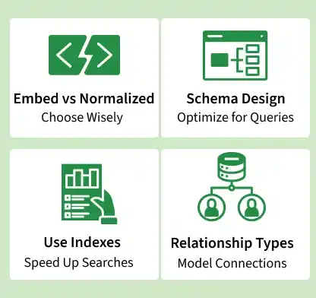
Data Modeling
- Designs document and collection structures for efficient storage and queries.
- Leverages flexible schema for dynamic and evolving data.
- Optimizes for application access patterns (reads/writes).
- Improves database performance via efficient storage and indexing.
- Plans for future scalability and changing requirements.
MongoDB Data Model Designs
For modeling data in MongoDB, two strategies are available. These strategies are different and it is recommended to analyze scenario for a better flow. The two methods for data model design in MongoDB are:
1. Embedded Data Model
The Embedded Data Model stores related data within a single MongoDB document, improving read performance by keeping frequently accessed information together and reducing the need for joins.
- Stores related data as sub-documents in one document.
- Reduces the need for cross-collection joins.
- Improves read performance for related data.
- Supports atomic updates on a single document.
Embedded Data Model example
If we obtain student information in three different documents, Personal_details, Contact, and Address, we can embed all three in a single one, as shown below.
{
_id: ObjectId(),
Std_ID: "987STD001",
Personal_details: {
First_Name: "Ron",
Last_Name: "Smith",
Date_Of_Birth: "1999-08-26"
},
Contact: {
email: "ron_smith.123@gmail.com",
phone: "9987645673"
},
Address: {
city: "Karnataka",
Area: "BTM2ndStage",
State: "Bengaluru"
}
}
Advantages of the Embedded Model:
- Faster reads: All related data is fetched together, reducing the need for multiple queries.
- Atomic operations: Data is stored in a single document, ensuring atomic write operations (a single document is updated at once).
Disadvantages:
- Data redundancy: Data may be duplicated, increasing storage usage.
- Limited by document size: MongoDB documents have a size limit of 16MB.
2. Normalized Data Model
The Normalized Data Model stores related data in separate collections and links them using references, reducing duplication and supporting complex relationships across collections.
- Links related data across collections using references (IDs).
- Reduces duplication and supports complex relationships.
- Suitable for large, shared, hierarchical datasets.
Normalized Data Model Example
Created multiple collections for storing students data which are linked with _id.
Student:
{
_id: <StudentId101>,
Std_ID: "10025AE336"
}
Personal_Details:
{
_id: <StudentId102>,
stdDocID: "StudentId101",
First_Name: "Ron",
Last_Name: "Smith",
Date_Of_Birth: "1999-08-26"
}
Contact:
{
_id: <StudentId103>,
stdDocID: " StudentId101",
e-mail: "ron_smith.123@gmail.com",
phone: "9987645673"
}
Address:
{
_id: <StudentId104>,
stdDocID: " StudentId101",
city: "Karnataka",
Area: "BTM2ndStage",
State: "Bengaluru"
}
Advantages of the Normalized Model:
- Reduces data redundancy: Common data (e.g., personal details) is stored once and referenced where necessary.
- Efficient for many-to-many relationships: Works well for complex relationships between data.
Disadvantages:
- Slower reads: Requires multiple queries or joins to retrieve related data, which can impact performance.
- More complex to manage: Managing relationships between collections can be more difficult.
Advantages Of Data Modeling in MongoDB
Data modeling in MongoDB helps design efficient schemas that improve performance, simplify development, and support long-term scalability and maintenance.
- Boosts application performance with optimized schema design.
- Speeds up development cycles through easier object mapping.
- Improves data understanding, standards, and validation.
- Supports future scalability and maintainability of applications.
Best Practices
Some important points to consider while creating a data model for MongoDB database are:
- Design Based on Application Needs: Model the data according to how it will be accessed (e.g., frequent queries, updates, etc.).
- Separate Collections for Different Entities: Store unrelated data in separate collections to reduce complexity.
- Embed Frequently Accessed Data: For better performance, embed related data that will be accessed together in a single document.
- Avoid Complex Joins: Perform joins during writes, not reads, to optimize query performance.
- Use Aggregation: Leverage MongoDB's aggregation framework to perform complex queries and transformations.

Creating Relationships in MongoDB
MongoDB models relationships between data using embedded documents, references (normalized model), and the $lookupaggregation stage, allowing you to balance performance, structure, and query flexibility based on application needs.
- Embedded documents: Store related data within a single document for faster reads and data locality when accessed together.
- References (normalized model): Link related documents across collections using IDs for large or independently accessed data and reduced duplication.
- $lookup (aggregation): Perform joins between collections for complex relationships (e.g., many-to-many) when embedding isn’t suitable.
These techniques provide flexibility in handling various data relationships, optimizing both storage and access patterns.
Embedded Document Model
In the Embedded Document Model, related data is stored within a single MongoDB document, allowing associated information (e.g., student and address) to be retrieved in one query for faster access.
- Stores related data as sub-documents in one document.
- Enables single-query retrieval of related information.
- Improves read performance by keeping data together.
- Best for data that is frequently accessed together.
1. One-to-One Relationships with Embedded Documents
Using embedded documents, a one-to-one relationship can be modeled by storing related data (e.g., a student’s address) inside the parent document. This reduces the number of read operations and enables single-query retrieval.
Before Embedding (Separate Documents)
/// Student document
{
"StudentName": "GeeksA",
"StudentId": "g_f_g_1209",
"Branch": "CSE"
}
// Address document
{
"StudentName": "GeeksA",
"PermanentAddress": "XXXXXXX",
"City": "Delhi",
"PinCode": 202333
}
Problem with Separate Documents
When address data is frequently accessed, querying separate collections using the same key (e.g., StudentName) requires multiple queries, increasing complexity and read overhead.
After Embedding (Single Document)
{
"StudentName": "GeeksA",
"StudentId": "g_f_g_1209",
"Branch": "CSE",
"Address": {
"PermanentAddress": "XXXXXXX",
"City": "Delhi",
"PinCode": 202333
}
}
Advantages
- Single-query retrieval of related data.
- Improved read performance.
- Better data locality.
- Atomic updates within one document.
Limitations
- Document size can grow as more data (e.g., academics, athletics) is embedded.
- Large documents may slow down reads.
Subset Pattern (When Documents Grow Large)
If only a subset of fields is frequently accessed, move large or infrequently used data into separate collections (subset pattern) to keep the main document lightweight.
Trade-off of Subset Pattern
- Improves read performance for common queries.
- Increases maintenance complexity and makes data tracking harder due to data being split across collections.
Example: Display the address of the student
Here, we are working with:
Database: gfg
Collection: student
Documents: One document that contains the details of a student
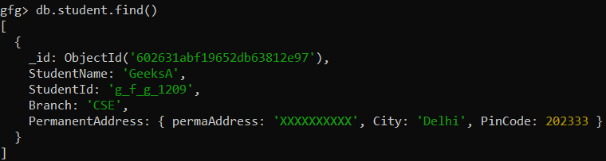
Query:
db.student.find({StudentName:"GeeksA"},{"PermanentAddress.permaAddress":1})
Output:
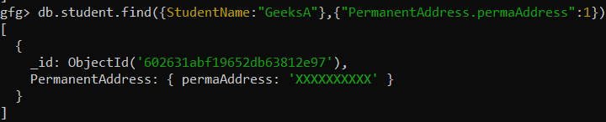
2. One-to-Many Relationships with Embedded Documents
A one-to-many relationship can be modeled using embedded documents when multiple related items (e.g., multiple addresses) belong to a single parent document. This enables efficient single-query retrieval and reduces read operations.
Before Embedding (Separate Documents)
// Student document
{
"StudentName": "GeeksA",
"StudentId": "g_f_g_1209",
"Branch": "CSE"
}
// Permanent Address document
{
"StudentName": "GeeksA",
"AddressType": "Permanent",
"Address": "XXXXXXX",
"City": "Delhi",
"PinCode": 202333
}
// Current Address document
{
"StudentName": "GeeksA",
"AddressType": "Current",
"Address": "XXXXXXX",
"City": "Mumbai",
"PinCode": 334509
}
After Embedding (Single Document with Array of Addresses)
{
"StudentName": "GeeksA",
"StudentId": "g_f_g_1209",
"Branch": "CSE",
"Addresses": [
{
"Type": "Permanent",
"Address": "XXXXXXX",
"City": "Delhi",
"PinCode": 202333
},
{
"Type": "Current",
"Address": "XXXXXXX",
"City": "Mumbai",
"PinCode": 334509
}
]
}
Advantages
- Retrieves all related data in a single query.
- Reduces read operations and query complexity.
- Supports one-to-many relationships using arrays.
- Preserves data locality within one document.
Example: Display all the addresses of the student
Here, we are working with:
Database: gfg
Collection: student
Documents: One document that contains the details of a student
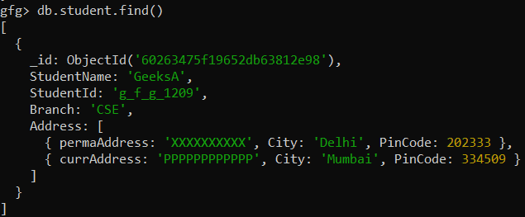
Query:
db.student.find({StudentName:"GeeksA"},
{"Address.permaAddress":1,
"Address.currAddress":1})
Output:
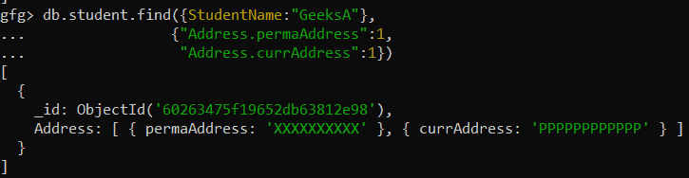
Note:
- Store multiple related items as a bounded array within the parent document.
- Use embedding when related data is frequently accessed together.
Reference Model
In the Normalized (Reference) Data Model, related data is stored in separate collections and linked using references (IDs), enabling normalized relationships and independent access to each entity.
- Stores related data in separate documents/collections.
- Uses reference IDs to link related entities.
- Supports independent queries and updates of related data.
- Suitable for normalized relationships and larger, shared datasets.
1. One-to-Many relationships with the document reference
In the reference model, related data is stored in separate collections, and the parent document maintains references (IDs) to multiple child documents. This is suitable for one-to-many relationships where related entities (e.g., classes) are accessed independently or can grow over time.
Before Referencing (Separate Documents)
// Teacher document
{
"name": "Sam",
"TeacherId": "g_f_g_1209"
}
// Class 1 document
{
"TeacherId": "g_f_g_1209",
"ClassId": "C_123",
"ClassName": "GeeksA",
"StudentCount": 23,
"Subject": "Science"
}
// Class 2 document
{
"TeacherId": "g_f_g_1209",
"ClassId": "C_234",
"ClassName": "GeeksB",
"StudentCount": 33,
"Subject": "Maths"
}
Problem
Retrieving all classes taught by a teacher requires multiple queries across collections, increasing query complexity.
After Referencing (Using IDs in Parent Document)
// Teacher document
{
"name": "Sam",
"TeacherId": "g_f_g_1209",
"ClassIds": ["C_123", "C_234"]
}
Now using these classIds field teacher can easily retrieve the data of class 1 and 2.
Example: Display the values of classId field
Here, we are working with:
Database: gfg
Collection: teacher
Documents: Three document that contains the details of the classes
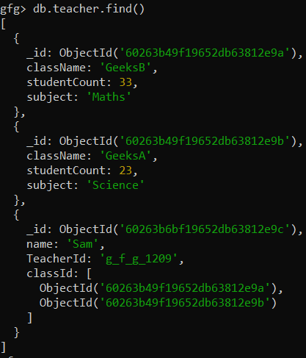
Query:
db.teacher.findOne({name:"Sam"}, {classId:1})
Output:
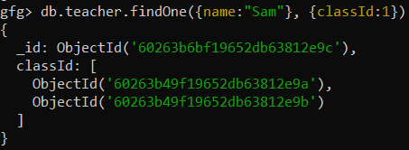

Embedded Documents in MongoDB
MongoDB’s Embedded (Nested) Documents allow you to store documents inside other documents, enabling hierarchical data structures and provides faster access to related data, especially in read-heavy workloads where related data is frequently accessed together within a single query.
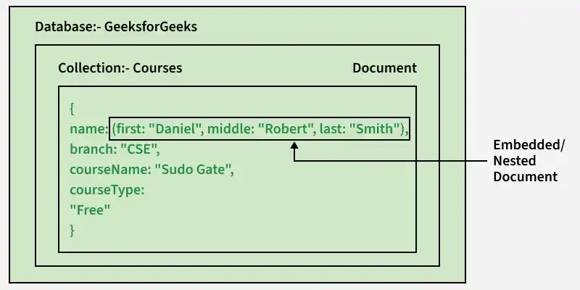
- Stores documents within documents (nested structure).
- Represents hierarchical relationships naturally.
- Enables single-query retrieval of related data.
- Reduces the need for cross-collection joins.
Notes - In MongoDB, you can only nest documents up to 100 levels. The overall document size must not exceed 16 MB.
Creating Embedded Documents
Creating embedded documents involves structuring related data as sub-documents within a parent document using nested fields.
- Uses nested curly braces {} to embed documents within documents.
- Stores related data as sub-documents under a parent field.
- Supports multi-level nesting for hierarchical structures.
- Enables single-query access to related data.
Syntax:
db.collection.insertOne({
field1: value1,
field2: value2,
embeddedField: {
subField1: value1,
subField2: value2,
nestedField: {
innerField1: value1
}
}
})
Example 1: In the GeeksforGeeks database, the Courses collection stores a document where the name field is an embedded document containing first, middle, and last fields.
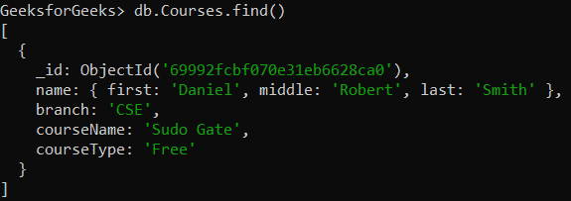
Example 2: In the GeeksforGeeks database, we add another document to the Courses collection where courseDetails is an embedded document containing course info and a nested paymentDetails sub-document.
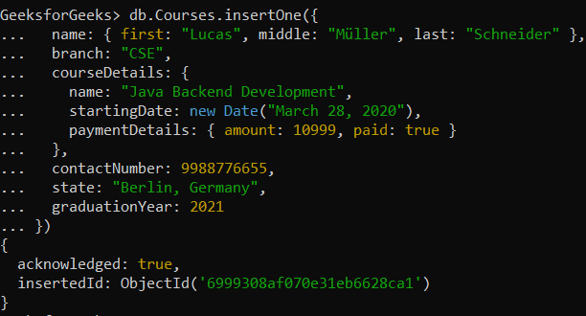
So, overall the Courses collection contains two documents and these documents contain nested documents.
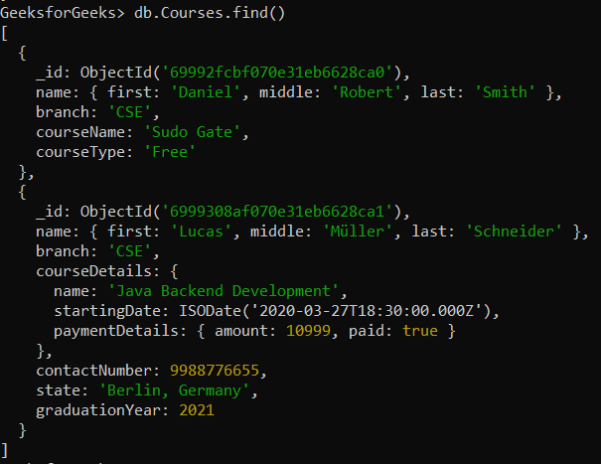

Configuring JSON Schema Validation in MongoDB
MongoDB’s JSON Schema Validation enforces structured rules on documents at the collection level, ensuring only valid and consistent data is stored while keeping NoSQL flexibility.
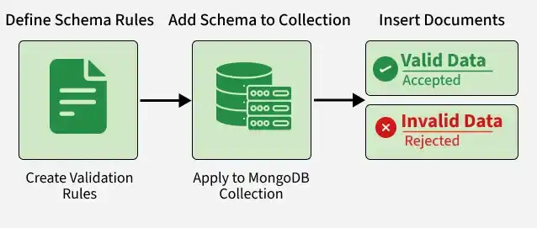
- Defines field types and required fields using $jsonSchema.
- Supports constraints like patterns (regex), ranges, and enums.
- Validates documents on insert and update operations.
- Improves data integrity by introducing structured validation while still maintaining MongoDB’s flexible schema model.
Implementation Steps for JSON Schema Validation
A step-by-step process to define, apply, and test schema rules for ensuring valid data in MongoDB collections.
Step 1: Creating a JSON Schema
Create a $jsonSchema object to define validation rules for the collection. The schema enforces required fields (first_name, last_name, email) and validates data types, with a regex constraint to ensure email follows a valid format.
The JSON that we will use for the Schema Validation:
{
$jsonSchema: {
bsonType: "object",
required: ["first_name", "last_name", "age", "email"],
properties: {
first_name: {
bsonType: "string",
description: "must be a string"
},
last_name: {
bsonType: "string",
description: "must be a string"
},
age: {
bsonType: "int",
description: "must be an integer"
},
email: {
bsonType: "string",
pattern: "^[a-zA-Z0-9._%+-]+@[a-zA-Z0-9.-]+\\.[a-zA-Z]{2,}$",
description: "must be a valid email address"
}
}
}
}
Step 2: Adding the JSON Schema Validation to the Collection
Pass the $jsonSchema validator to db.createCollection() to create the Users collection with enforced validation rules for first_name, last_name, age, and email.
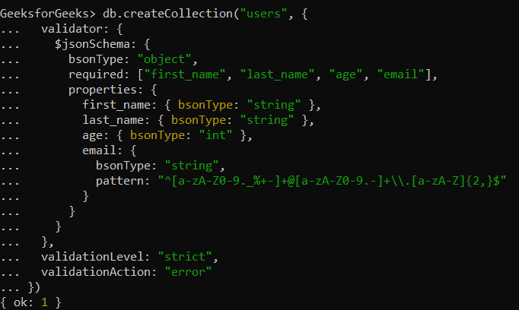
- Applies $jsonSchema validation to the users collection using the validator option.
- Enforces schema rules on insert and update, rejecting invalid documents.
Step 3: Adding Documents to the Collection
After defining the validator, insert operations are checked against the schema, documents that match the rules are accepted, while invalid documents are rejected with a validation error.
Part A: Adding a Document with Invalid Data
Insert operations are validated against the schema: documents that satisfy all $jsonSchema constraints are accepted, while documents violating rules (e.g., invalid email format) are rejected with a MongoDB validation error.
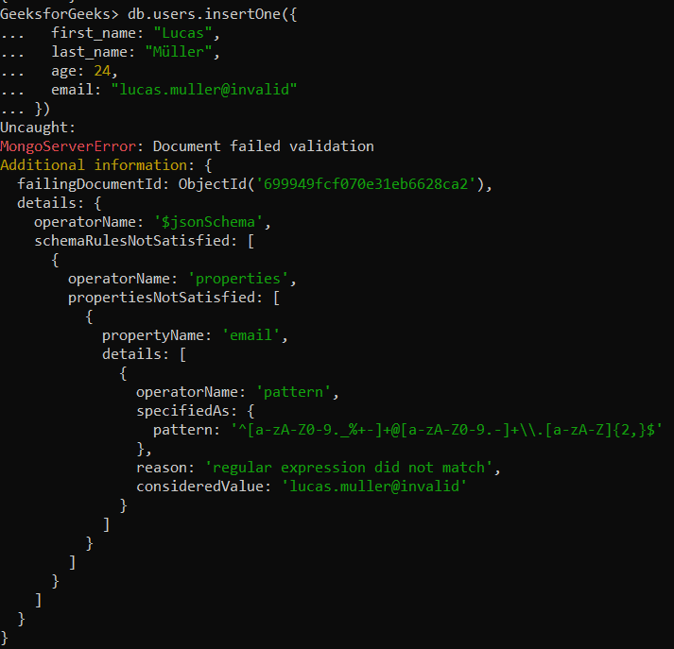
- The insert operation is rejected due to $jsonSchema validation failure.
- The email field does not match the required regex pattern.
- MongoDB blocks the write to prevent invalid data storage.
Part B: Adding a Document with Valid Data
Insert operations that satisfy all $jsonSchema constraints are accepted, documents meeting required fields and pattern validations (e.g., valid email format) are successfully written to the users collection.
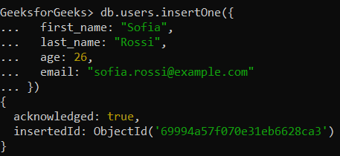
- The document is inserted successfully as it passes all $jsonSchema validation rules.
- Required fields are present and the email format is valid.
Benefits of JSON Schema Validation
Here are the benefits of JSON Schema Validation:
- Data Integrity: Schema validation enforces strict rules on document structure, ensuring only valid data is stored and reducing application-level errors.
- Consistency: By enforcing data types and rules, the MongoDB database ensures consistent document structure for format-dependent applications.
- Prevents Invalid Data: JSON Schema Validation blocks invalid or incomplete data, ensuring strict data accuracy.

Scaling in MongoDB
Last Updated :5 May, 2026

MongoDB Scaling is the process of increasing a database’s capacity and performance to handle growing data volumes, user traffic, and processing demands while maintaining optimal performance and resource utilization.
- Adapts database capacity to growing data and workload requirements.
- Helps maintain performance as application usage increases.
- Supports efficient resource utilization at scale.
- Provides built-in mechanisms to manage growth and traffic.

Need of Scaling in MongoDB
Scaling in MongoDB is essential for supporting growing applications by handling increasing data volumes, user traffic, and workload complexity while maintaining performance, reliability, and efficient resource utilization.
- Increased Data Volume: Distributes growing data across nodes to avoid query and operation slowdowns.
- Rising User Traffic: Handles higher concurrent read/write requests while maintaining responsiveness.
- Diverse Workloads: Adapts to changing query patterns and processing needs.
- Improved Fault Tolerance: Sharding spreads data across servers to ensure high availability during failures.
- Cost-Efficiency: Enables incremental horizontal scaling to optimize infrastructure costs.

Types of Scaling in MongoDB
In MongoDB, scaling can be achieved through different approaches, each addressing specific aspects of resource allocation and accommodating different requirements. The primary types of scaling in MongoDB include:

1. Horizontal Scaling(Scaling Out)
Horizontal scaling in MongoDB distributes data across multiple servers using sharding, allowing the database to handle large data volumes and high workloads by partitioning data into manageable shards within a sharded cluster.

- Distributes data across multiple servers or nodes (shards).
- Uses sharding to partition the database into smaller, manageable pieces.
- Each shard stores a portion of the overall dataset.
- Shards run on separate servers or replica sets.
- All shards together form a sharded cluster for scalability and availability.

Sharding
Sharding in MongoDB is a horizontal scaling technique that distributes data across multiple servers to improve performance, scalability, and write throughput for large datasets.
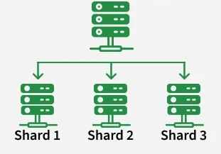
- Splits and distributes large datasets across shards to balance load and improve performance.
- Enables horizontal scaling to handle larger data volumes and higher write throughput.
- Uses a shard key to partition data; each shard (server/replica set) stores a subset within a sharded cluster.

2. Vertical Scaling(Scaling Up)
Vertical scaling in MongoDB increases the capacity of a single server by upgrading hardware resources (CPU, RAM, storage) to improve performance and handle higher workloads.

- Upgrading Hardware: Involves moving to a more powerful server by increasing CPU cores, RAM, or using faster storage.
- Increased Capacity: Improves the ability of a single server to handle more concurrent connections and higher workloads.
- Downtime Risk: Hardware upgrades may require service interruption, especially when replacing critical components.

Horizontal Vs Vertical Scaling
Here are some differences:
Horizontal Scaling | Vertical Scaling
Distributes workload across multiple servers (nodes). | Increases the capacity of a single server.
Adds more machines or nodes to the system. | Upgrades existing server hardware (CPU, RAM, storage).
Highly scalable, handles significant growth efficiently. | Limited scalability, becomes costly at higher levels.
High availability through replication, minimal downtime when scaling. | Availability depends on backups, upgrades may cause downtime.
Suitable for unpredictable or rapidly growing workloads. | Suitable for modest or predictable growth.
Example: During IPL, streaming platforms add servers to handle traffic spikes. | Example: Streaming platforms upgrade servers (CPU/RAM) to support 4K streaming.

Replica Sets
A MongoDB replica set is a distributed architecture that provides high availability and fault tolerance by maintaining multiple synchronized copies of data across nodes, ensuring continuous database availability during failures or maintenance.
- Primary Node: Handles all write operations and serves reads by default; only one primary exists at a time.
- Secondary Nodes: Replicate data from the primary and provide redundancy; can be used for read scaling with eventual consistency.
- Data Replication: Uses asynchronous replication to keep secondary nodes eventually consistent with the primary.
- High Availability: Ensures database access continues even if one or more nodes go offline.

Sharding Vs Replica Sets
Here are the differences:
Sharding | Replica Sets
Distributes data across multiple servers to handle large datasets and high write loads. | Provides high availability and data redundancy by maintaining multiple copies of data.
Suitable when data volume or write throughput exceeds a single server’s capacity. | Suitable for fault tolerance and high availability during failures or maintenance.
Splits data into chunks (shards) using a shard key; each shard stores a subset of data. | Stores identical copies of the entire dataset on multiple nodes (no shard key).
Enables parallel writes across shards for better write scalability. | Writes go to the primary node, secondaries can serve reads (eventual consistency).
Reads can be distributed across shards through the mongos query router, depending on shard key targeting and query routing. | Reads can be load-balanced across replica set members.
Fault tolerance via data distribution; other shards continue serving if one shard fails. | Fault tolerance via replicas, a new primary is elected on failure.
Eventual consistency across shards. | Strong consistency on primary, secondaries may be eventually consistent.
Sharding alone doesn’t provide failover, replica sets are used per shard for failover. | Supports automatic failover by electing a new primary.
Uses config servers to store sharding metadata. | Does not use config servers, config is stored in replica set metadata.
More complex to set up and manage (config servers + shard key selection). | Simpler to set up and manage for high availability.

MongoDB – Replication and Sharding
These are important MongoDB topics. I’ll explain them in simple English, with definitions, examples, and exam-friendly points.

1. Replication and Sharding
MongoDB uses Replication and Sharding for different purposes.
Replication
Replication means keeping copies of the same data on multiple MongoDB servers.
Main purpose:
- High availability
- Data safety
- Failover
- Better read availability
Primary
↓
┌───────┴───────┐
↓ ↓
Secondary Secondary
(Copy) (Copy)
If the Primary server fails, another eligible member can become Primary.
Sharding
Sharding means dividing and distributing data across multiple servers called shards.
Main purpose:
- Handle very large amounts of data
- Distribute workload
- Improve scalability
Data
↓
┌───────┼───────┐
↓ ↓ ↓
Shard 1 Shard 2 Shard 3
Replication vs Sharding
Replication | Sharding
Creates copies of data | Divides data
Improves availability | Improves scalability
Same data exists on multiple servers | Different data is distributed
Uses Replica Sets | Uses Sharded Clusters
Easy Memory Trick
Replication = Copy data
Sharding = Split data

2. Change Streams
Definition
Change Streams allow applications to listen for changes happening in MongoDB in real time. They can detect operations such as insert, update, and delete without continuously checking the database.
Example
Suppose an application is watching the students collection.
When a new student is inserted:
{
name: "John",
age: 20
}
The Change Stream can detect this change.
Syntax
const changeStream = db.students.watch();

changeStream.on("change", change => {
console.log(change);
});
Uses
Change Streams are useful for:
- Real-time notifications
- Updating applications when data changes
- Event-driven applications
- Synchronizing data
- Monitoring database changes
Easy Memory Trick
Change Stream = Listen to database changes

3. Replica Set Members
Definition
A Replica Set is a group of MongoDB servers that maintain the same data set. The members of the replica set work together to provide data redundancy and high availability.
The main types of members are:
- Primary
- Secondary
- Arbiter

A. Primary
The Primary is the main member of the replica set.
It normally:
- Receives write operations.
- Records changes.
- Replicates changes to secondary members.
Application
↓
Primary
↓
┌───┴───┐
↓ ↓
Secondary Secondary

B. Secondary
A Secondary maintains a copy of the Primary's data.
It receives replicated changes from the Primary.
If the Primary fails, an eligible Secondary can be elected as the new Primary.

C. Arbiter
An Arbiter participates in elections but does not store a copy of the data.
Its main purpose is to provide an additional vote when an election is needed.
Easy Memory Trick
Primary → Writes
Secondary → Copies data
Arbiter → Votes

4. Replica Set Deployment
Definition
Replica Set Deployment means setting up multiple MongoDB instances as members of a replica set so that they maintain copies of data and provide high availability.
A basic deployment can contain:
Primary
|
┌────────┴────────┐
↓ ↓
Secondary Secondary
Basic Steps
- Start multiple MongoDB instances.
- Give them the same replica set name.
- Initialize the replica set.
- Add the other members.
- MongoDB starts replicating data.
Example
rs.initiate()
Add a member:
rs.add("mongodb2:27017")
Another member:
rs.add("mongodb3:27017")
Result
Replica Set
↓
┌───┼────────┐
↓ ↓ ↓
P S S
Where:
- P = Primary
- S = Secondary
Main Benefit
If the Primary fails:
Primary fails
↓
Election
↓
Secondary becomes Primary
This provides automatic failover.

5. Sharded Cluster Components
Definition
A Sharded Cluster is a MongoDB system that distributes data across multiple servers called shards. It is used to handle very large datasets and high workloads.
A MongoDB sharded cluster mainly contains:
- Shards
- mongos
- Config Servers

A. Shards
A Shard stores a portion of the data.
Shard 1 → Part of data
Shard 2 → Part of data
Shard 3 → Part of data
A shard is normally deployed as a replica set for high availability.

B. mongos
mongos is the query router.
It receives requests from applications and sends them to the appropriate shards.
Application
↓
mongos
/ | \
↓ ↓ ↓
S1 S2 S3
Think:
mongos = Router

C. Config Servers
Config servers store metadata about the sharded cluster, such as information about:
- Shards
- Data distribution
- Chunk ranges
They help mongos know where data is located.
Easy Memory Trick
Shard → Stores data
mongos → Routes requests
Config Server → Stores cluster metadata

6. Shard Keys
Definition
A Shard Key is a field or combination of fields used by MongoDB to distribute documents across different shards in a sharded cluster.
The shard key is very important because it determines how data is distributed.
Example
Suppose we have:
{
userId: 101,
name: "John",
city: "Delhi"
}
We can choose:
userId
as the shard key.
Example Command
sh.shardCollection(
"school.students",
{ userId: 1 }
)
Here:
userId → Shard Key
Good Shard Key
A good shard key should help distribute data and workload evenly.
Important characteristics include:
- Good distribution
- Suitable for common queries
- Avoids creating a hotspot
- Provides good scalability
Easy Memory Trick
Shard Key = Decides where data goes

7. Hashed Sharding
Definition
Hashed Sharding distributes documents across shards using a hashed value of the shard key. MongoDB calculates a hash of the selected field and uses that value for data distribution.
Example
Suppose:
{
userId: 101,
name: "John"
}
If userId is used as a hashed shard key:
sh.shardCollection(
"school.students",
{ userId: "hashed" }
)
MongoDB hashes the userId values and distributes the data based on the hash values.
Advantages
- Provides relatively even distribution.
- Helps reduce concentration of data on one shard.
- Useful when the original values are not evenly distributed.
Disadvantage
Hashed sharding is generally less useful for range-based queries because nearby original values can have very different hash values.
Easy Memory Trick
Hashed = Hash the key → Distribute data

8. Ranged Sharding
Definition
Ranged Sharding distributes documents according to ranges of shard key values. Data with nearby shard key values can be stored in the same range.
For example, if userId is the shard key:
Shard 1 → 1 – 1000
Shard 2 → 1001 – 2000
Shard 3 → 2001 – 3000
This is a simple conceptual example.
Example
sh.shardCollection(
"school.students",
{ userId: 1 }
)
Advantages
- Good for range queries.
- Related values can be kept together.
- Useful when queries commonly search ranges.
Example:
db.students.find({
userId: {
$gte: 1000,
$lte: 2000
}
})
Disadvantage
If the shard key values or write pattern are poorly distributed, one shard may receive too much work. This is called a hotspot.
Easy Memory Trick
Ranged = Divide data into ranges

9. Replica Set Read and Write Semantics
This topic explains where MongoDB reads data from and how writes are acknowledged in a replica set.

Read Preference
Read Preference controls which replica set members MongoDB uses for read operations.
Common read preferences include:

1. Primary
Reads are sent to the Primary.
Read → Primary
This is the default read preference.

2. Primary Preferred
MongoDB prefers the Primary, but can read from a Secondary if the Primary is unavailable.

3. Secondary
Reads are sent to Secondary members.

4. Secondary Preferred
MongoDB prefers a Secondary but can use the Primary if no suitable Secondary is available.

5. Nearest
MongoDB chooses a suitable member with the lowest network latency.
Easy Memory Trick
Read Preference = Where should I READ from?

Write Concern
Write Concern controls the level of acknowledgement MongoDB requires before considering a write operation successful.
For example:
{
w: "majority"
}
means the write should be acknowledged by a majority of the voting members.
Example
db.students.insertOne(
{
name: "John"
},
{
writeConcern: {
w: "majority"
}
}
)
Important Terms
w → Number or level of acknowledgements required.
j → Requests acknowledgement that the write has been written to the journal.
wtimeout → Maximum time to wait for the required write acknowledgement.
Easy Memory Trick
Write Concern = How safely should I WRITE?

10. Sharding Deployment Architectures
Definition
A Sharding Deployment Architecture describes how the different components of a MongoDB sharded cluster are arranged and connected.
A typical architecture looks like this:
Application
↓
mongos
↓
┌────────────┼────────────┐
↓ ↓ ↓
Shard 1 Shard 2 Shard 3
↓ ↓ ↓
Replica Set Replica Set Replica Set

↑
|
Config Servers
Components
Application
↓
mongos
↓
Shards
↓
Replica Sets
And:
Config Servers
↓
Cluster Metadata
Why use this architecture?
It provides:
- Scalability through sharding
- High availability through replica sets
- Distributed workload
- Fault tolerance
- Support for very large datasets

⭐ Most Important Comparison
Concept | Main Purpose
Replication | Copies data for availability
Sharding | Distributes data for scalability
Change Streams | Listen to database changes
Primary | Main read/write member
Secondary | Maintains data copy
Arbiter | Participates in elections
Shard | Stores part of the data
mongos | Routes queries
Config Server | Stores cluster metadata
Shard Key | Determines data distribution
Hashed Sharding | Distributes using hash values
Ranged Sharding | Distributes using key ranges
Read Preference | Controls where reads go
Write Concern | Controls write acknowledgement
🧠 One-Minute Revision
REPLICATION → COPY

Primary → Main server
Secondary → Copy
Arbiter → Vote

SHARDING → SPLIT

Shard → Stores data
mongos → Routes queries
Config → Stores metadata

Shard Key → Decides distribution

Hashed → Hash-based distribution
Ranged → Range-based distribution

Read Preference → Where to READ
Write Concern → How WRITE is acknowledged

Change Streams → Listen for changes
The easiest way to remember the whole chapter:
Replication = Same data on multiple servers.
Sharding = Different parts of data on multiple servers.

MongoDB – Security
MongoDB Security is used to protect database data from unauthorized access. It helps ensure that only authorized users can access or modify the database.
The main security concepts in your syllabus are:
- Securing MongoDB
- Access Control & Authentication
- Authentication
- Role-Based Access Control (RBAC)

1. Securing MongoDB
MongoDB security is the process of protecting a MongoDB database from unauthorized access, data theft, and unwanted changes. It includes authentication, authorization, encryption, network security, and auditing to keep database information safe.
Main Security Measures
MongoDB security can include:
- Authentication → Check who the user is.
- Authorization → Decide what the user can do.
- Encryption → Protect data from being read by unauthorized people.
- Auditing → Keep records of important database activities.
- Network Security → Protect MongoDB from unwanted network access.
- Access Control → Give users only the permissions they need.
Simple Security Flow
User
↓
Authentication
↓
"Who are you?"
↓
Authorization
↓
"What are you allowed to do?"
↓
Database
Easy Memory Trick
Authentication = Who are you?
Authorization = What can you do?

2. Access Control and Authentication
Authentication is the process of verifying the identity of a user before allowing access to MongoDB. It checks whether the username and password or other authentication credentials are valid.
For example:
Username → John
Password → ********
↓
MongoDB checks credentials
↓
Valid → Access allowed
Invalid → Access denied
Why is Authentication Important?
Without authentication:
Anyone → Database
With authentication:
Authorized User → Database
Unauthorized User → ❌ Access Denied
Example
A user can connect to MongoDB using authentication credentials:
mongosh --username myUser --password --authenticationDatabase admin
MongoDB asks for the password and verifies the user's identity.

3. Access Control
Access control is the process of controlling which users can access MongoDB resources and what actions they are allowed to perform.
For example:
User A → Can read data
User B → Can read + write data
User C → Can manage database
So, access control prevents users from performing actions they are not permitted to perform.
Example
Suppose there are three users:
User | Permission
Student | Read data
Teacher | Read + Write
Admin | Full database management
This is access control.
Easy Memory Trick
Access Control = Control who can access what

4. Enable Authentication
Enabling authentication means configuring MongoDB so that users must provide valid credentials before they can access the database.
A common configuration is:
security:
authorization: enabled
After enabling authorization, users generally need to authenticate before performing operations allowed by their roles.
Basic Process
1. Create user
↓
2. Give user a role
↓
3. Enable authorization
↓
4. User logs in
↓
5. MongoDB checks credentials
↓
6. MongoDB checks permissions
↓
7. Access allowed/denied
Important Point
Authentication and authorization are related but different:
Authentication → Identity
Authorization → Permission

5. Role-Based Access Control (RBAC)
Role-Based Access Control (RBAC) is a security system in which permissions are assigned to roles, and users are assigned those roles. A user's ability to perform database operations depends on the privileges provided by their assigned roles.
Instead of giving every permission separately to every user, we create roles with specific permissions.
Simple Structure
User
↓
Role
↓
Privileges
↓
Allowed Operations
For example:
John
↓
Read Role
↓
Read permission
↓
Can read documents

Example of RBAC
Suppose we have:
User 1
Role → read
Can:
Find documents ✓
Read data ✓
Delete data ✗
User 2
Role → readWrite
Can:
Read ✓
Insert ✓
Update ✓
Delete ✓
User 3
Role → Database Administrator
Can perform many administrative database operations.

Built-in MongoDB Roles
MongoDB provides many built-in roles.
Some important examples are:
Role | Purpose
read | Read data
readWrite | Read and write data
dbAdmin | Database administration
userAdmin | Manage users and roles
dbOwner | Full control over a database
clusterAdmin | Cluster administration
root | Very broad administrative privileges

Easy Memory Trick
read → Read
readWrite → Read + Write
dbAdmin → Database administration
userAdmin → User management
root → Highest/broad privileges

Creating a User with a Role
Example:
use school

db.createUser({
user: "student",
pwd: "password123",
roles: [
{ role: "read", db: "school" }
]
})
Here:
User → student
Password → password123
Role → read
Database → school
The user gets the permissions associated with the read role.

Custom Roles
MongoDB also allows administrators to create custom roles when built-in roles do not provide exactly the required permissions.
Example idea:
Custom Role
↓
Can read students
Can update students
Cannot delete students
This provides more specific control over database operations.

Authentication vs Authorization vs RBAC
Concept | Meaning
Authentication | Checks who the user is
Authorization | Checks what the user can do
Access Control | Controls access to resources and operations
RBAC | Uses roles to assign permissions
Best Example
Imagine a college database:
You enter your username + password
↓
Authentication
"Are you really John?"
↓
YES
↓
Authorization
"What can John do?"
↓
Read only
RBAC decides this through the role:
John
↓
Student Role
↓
Read Permission

Short Answer
What is MongoDB Security?
MongoDB Security is a set of methods used to protect MongoDB data from unauthorized access and unwanted changes. It includes authentication, authorization, access control, encryption, network security, and auditing. These security methods help maintain the confidentiality, integrity, and safety of database information.
What is Authentication?
Authentication is the process of verifying the identity of a user before allowing access to MongoDB. It usually uses credentials such as a username and password. Only users with valid authentication can access the database according to their permissions.
What is Role-Based Access Control?
Role-Based Access Control (RBAC) is a security method in which permissions are assigned to roles and users are assigned those roles. It allows administrators to control what operations each user can perform in the database.

🧠 Super Easy Revision
SECURITY
↓
Protect Database
↓
┌──────────────┬──────────────┬────────────┐
│ │ │ │
Authentication Authorization Encryption Auditing
│ │
Who are you? What can you do?
│
↓
RBAC
│
User → Role → Permission

Remember this one line:
Authentication checks identity, Authorization checks permission, and RBAC gives permissions through roles.

