OPERATING SYSTEM
An Operating System (OS) is a software program that manages the hardware and software resources of a computer. It is like the manager of the computer that tells how other programs and hardware components work together.
Most devices wouldn’t function properly without an operating system. It makes sure tasks are handled efficiently and applications run smoothly.

Types of Operating Systems
There are different types of operating systems. each designed for specific uses.
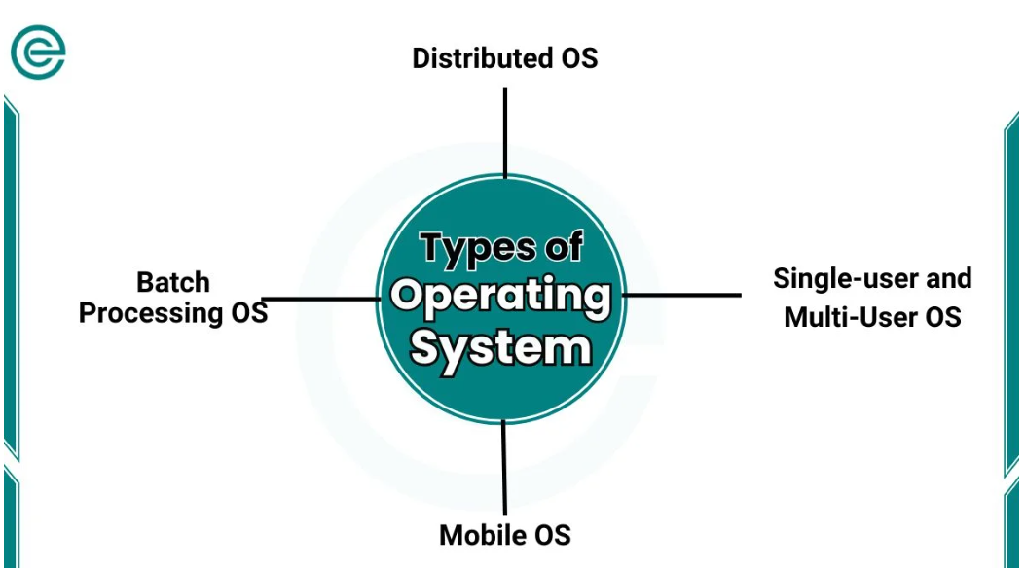

1. Single-user and Multi-User OS
A Single-User OS is designed for one person to use at a time. Examples include most home computers running Windows or macOS.
A Multi-User OS allows multiple people to use the computer at the same time. It is often found on servers and in organizations.

2. Batch Processing OS
In a Batch Processing OS, tasks are grouped and processed all at once. This type of OS was more common in the early days of computing. It’s mostly used today for specific purposes, like in industries where large amounts of data are processed in batches to save time.

3. Real-Time OS
A Real-Time OS is used in situations where timing is crucial, like in medical devices or aeroplanes. It processes data instantly to ensure accurate and quick responses.
For example, in a heart monitor, a real-time OS makes sure the system reacts immediately to changes in the patient’s heartbeat.

4. Distributed OS
A Distributed Operating System connects multiple computers to work together as a single system. This setup is often used in large networks.
For example, universities and tech companies often use distributed OS for research projects where many computers work together to process large amounts of data.

5. Mobile OS
Mobile Operating Systems are specifically designed for smartphones and tablets. They are user-friendly and optimized for touchscreen devices. Mobile OS examples include Android and iOS.

Functions of Operating System
An OS performs different important functions to ensure a device works effectively:
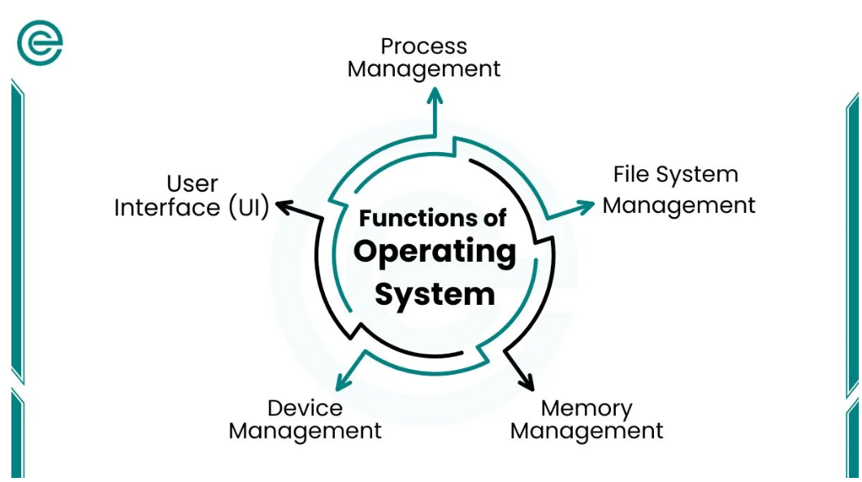

1. Process Management
Process management helps the OS handle multiple applications at the same time. It organizes running programs. It makes sure each one gets the resources it needs without interfering with others. This is why you can browse the web, listen to music, and type a document at the same time.

2. Memory Management
The OS is responsible for memory management. This involves allocating (or assigning) memory to each application and freeing it when the application is closed. Good memory management ensures a device doesn’t slow down or crash.

3. File System Management
The OS manages files and directories. It organizes how files are stored, named, and accessed. This is why you can easily find your saved documents, photos, or videos on your device.

4. Device Management
Device management allows the OS to control various hardware components, like printers, keyboards, and USB drives. It helps the computer communicate with these devices and ensures they work smoothly.

5. User Interface (UI)
The user interface (UI) is the way users interact with the OS. For example, on a computer, the UI includes windows, icons, and menus that let you open applications, save files, and change settings.

Examples of Popular Operating Systems
There are many operating systems in use today. Here are a few examples of operating systems:
- Windows: A widely-used OS developed by Microsoft. It is often found on home and office computers. It is known for its user-friendly interface and compatibility with a variety of software.
- macOS: An OS developed by Apple. It is designed exclusively for computers like the MacBook. macOS is known for its sleek design, security features, and seamless integration with other Apple devices.
- Linux: An open-source OS popular among developers and tech enthusiasts. Linux is highly customizable and is commonly used for servers, programming, and in some cases, personal computers.
- Android and iOS: These are the two main mobile OS. Android, developed by Google. It is used by a range of smartphone brands, while iOS is exclusive to Apple devices like the iPhone and iPad.

Virtual Memory in Operating Systems
Virtual memory is a technique used in computer operating systems (OS). It helps manage memory efficiently. Operating systems use virtual memory to store data temporarily, which may not fit in the primary memory (RAM). Virtual memory ensures programs run smoothly, even with limited RAM.
Table of Contents

Why is Virtual Memory Needed?
Computers have limited RAM. When you run many programs simultaneously, the RAM can fill up quickly. Virtual memory solves this issue by extending available memory.
Virtual memory uses storage like a hard disk. It creates a space called a “swap file” or “paging file.” This space acts like extra RAM.
Example
Imagine you have a small desk for study. You can only keep limited books on it. If more books are needed, you put some on the floor. Virtual memory works like the floor, storing less-used data temporarily.

Components of Virtual Memory
Virtual memory works through several components:
- Page Table: The page table converts virtual addresses into physical addresses. It acts as a translator. It helps the operating system find data quickly.
- Pages and Page Frames: Data is divided into small blocks called pages. These pages are stored in memory slots known as page frames.
- Swap Space: Swap space is part of the hard drive or SSD. It stores data that cannot fit into the RAM temporarily. When needed, this data swaps back into the RAM.

How Does Virtual Memory Work?
Virtual memory creates a space on the storage drive to act like additional RAM. When the RAM is full, the operating system moves less-used data to this space. Later, if the data is needed, it moves back to the RAM.
Feature | Virtual Memory | Physical Memory (RAM)
Location | Hard drive or SSD | RAM chips
Speed | Slower | Faster
Size | Limited by storage space | Fixed by hardware capacity
Purpose | Extends memory capacity | Stores active data
Cost | Relatively inexpensive (uses existing storage) | Expensive (hardware upgrade required)
Dependency | Depends on storage space | Depends on installed RAM
Setup | Configurable via operating system settings | Installed physically on the motherboard
Power Consumption | Uses a disk, consuming less power | Uses more power due to constant activity
Performance Impact | Slows down when heavily relied upon | Boosts system performance significantly
Role in Multitasking | Supports running additional programs | Directly executes processes in real-time
Lifespan Impact | Can reduce SSD lifespan with excessive use | No direct wear due to memory operations
Usage for Small Tasks | Not required for small processes | Handles small tasks effectively
Reliability | May fail if a disk is full or damaged | Stable unless physically damaged
Error Handling | This may lead to errors during heavy use | Handles errors better for active processes
Access Time | Milliseconds | Nanoseconds
Examples of Use | Editing large files, multitasking | Running operating systems, apps, and games

Key components include:
- Virtual Address: The address that a program uses to locate data.
- Physical Address: The actual location of data in the computer’s hardware.
The operating system manages these addresses and ensures programs run as if there is unlimited memory.
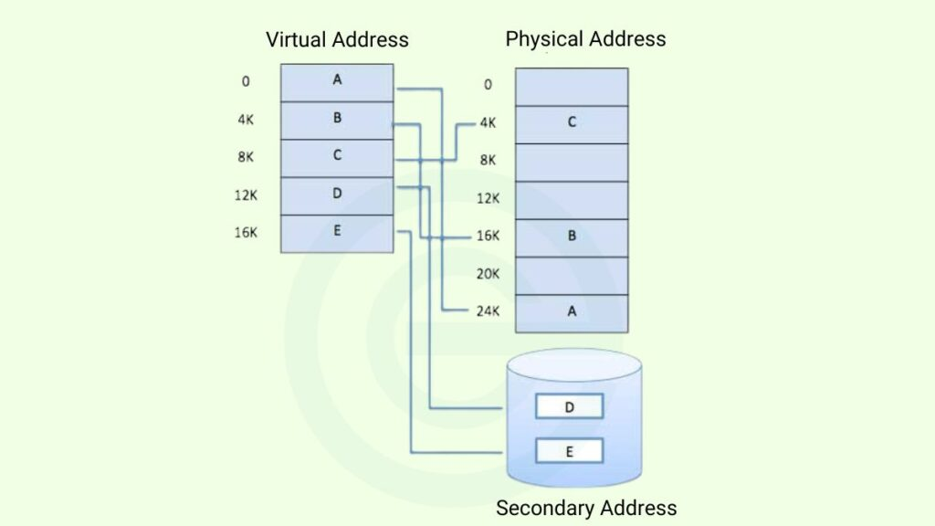

Real-Life Example of Virtual Memory
You open a web browser, a word processor, and a game. Your RAM cannot handle all three at once. The operating system moves the game data to virtual memory. When you switch back to the game, the system retrieves its data.
This process allows you to multitask without closing applications.

Difference between virtual memory and Physical memory
The following table shows the comparison table virtual vs physical memory:

Key Terms Related to Virtual Memory
- Virtual Address: The location of data as seen by a program.
- Physical Address: The actual location of data in RAM or storage.
- Page Table: A map that translates virtual addresses to physical addresses.
- Swap Space: A temporary storage area for data when RAM is full.
- Paging: The process of moving data between RAM and swap space.

Advantages of Virtual Memory
- Improves System Performance:
Programs can run without crashing due to low memory.
- Cost-Effective Solution:
Using virtual memory avoids the need for costly RAM upgrades.
- Enhances Multitasking:
Virtual memory allows smooth switching between programs.
- Handles Larger Workloads:
It supports running memory-intensive applications.

Challenges of Virtual Memory
- Slower Than RAM:
Storage drives are slower than RAM. Virtual memory can cause delays.
- Increased Wear on Drives:
Frequent use of storage for swapping can reduce its lifespan.
- Page Faults Can Slow Down Performance:
Too many page faults may make the system lag.
- Requires Disk Space:
Virtual memory uses storage space, which may fill up quickly.

What Happens Without Virtual Memory?
Without virtual memory, systems may crash. Programs may stop working due to insufficient memory. Multitasking becomes nearly impossible.
For example, imagine writing a report while streaming a video. If your RAM fills up, the video may stop, or your report program might crash. Virtual memory prevents this by handling extra tasks.

