HR WORKFORCE ANALYTICS
Employee Attrition, Workforce Demographics & Compensation Analysis
Excel-Based Project Report

9,964  Total Employees | 8,674  Active Employees | 1,290  Employees Exited | 12.95%  Attrition Rate

Prepared from: HR_Analysis_Workfore.xlsx

1. Executive Summary
This project analyzes a workforce dataset containing 9,964 employee records to understand employee attrition, workforce demographics, tenure, compensation, performance, employment type, job roles, and location-level workforce patterns. The analysis was performed using the supplied Excel workbook, with the raw employee table and the workbook's supporting analysis/pivot outputs.
The overall attrition rate is 12.95%, representing 1,290 employees who have exited and 8,674 employees who remain active. Average employee age is 43.4 years, average annual salary is $81,364, average tenure is 4.8 years, and average training hours are 49.1 hours.
The most important analytical finding is the concentration of attrition among employees with 2–5 years of service. This group has a 19.07% attrition rate, materially above the overall 12.95% rate. Employees with 5–10 years of service have a much lower 8.03% attrition rate.

Key Findings at a Glance
- Overall attrition is 12.95% (1,290 exits).
- IT has the highest department attrition rate at 15.24%.
- Sales and Marketing also show elevated attrition at 14.43% and 14.33%.
- The 2–5 year tenure group has the highest attrition at 19.07%.
- Phoenix has the highest location-level attrition at 16.47%, followed by Mumbai at 16.16%.
- Employees rated 'Needs Improvement' have the highest attrition among performance groups at 14.01%.
- Legal has the highest average department salary at $110,043; Support has the lowest at $54,723.

2. Project Overview
The objective is to transform the supplied HR workforce data into an actionable management view. The analysis focuses on identifying where attrition is concentrated, which workforce segments may require retention attention, and how compensation and performance patterns differ across the organization.

Business Questions
- What is the current workforce size and overall attrition rate?
- Which departments and locations have the highest attrition?
- Which age and tenure groups are most exposed to employee exits?
- Does attrition differ by gender or employment type?
- How does performance rating relate to attrition?
- Which departments have the highest and lowest average salaries?
- Which job titles show elevated attrition?
- Where should HR prioritize retention investigations?

3. Dataset & Workbook Structure
The supplied workbook contains four sheets. The primary analysis table is HR_Data, while the other sheets contain supporting pivot-style analysis and dashboard content.
Workbook Sheet | Purpose
HR_Data | Employee-level workforce data
Attrition Analysis | Attrition by age, location, tenure and performance
Workforce Demographics | Workforce KPIs, salary, department, location, gender and hiring-year summaries
HR Analysis Dashbord | Dashboard worksheet area

The HR_Data sheet contains 9,964 rows and 20 columns. Key fields include employee ID, demographics, department, employment type, job title, hire/exit dates, attrition, tenure, salary, bonus, performance, training hours and location.

Data Quality Observations
- All 9,964 employee IDs are populated.
- The Attrition field and AttritionFlag are complete and consistent for calculating exits.
- Exit_Date is blank for active employees; this is expected rather than a data-quality error.
- Reports_To_Manager_ID is missing for 1,525 records (15.3%). This should be reviewed if manager-level analysis is required.
- The workbook includes age and tenure bucket fields that support segmentation and pivot analysis.
- The analysis in this report uses the raw HR_Data values as the primary source of truth and cross-checks the workbook's summary outputs.

4. Analysis Methodology
The analytical process followed a standard HR analytics workflow:
- Reviewed workbook structure and identified HR_Data as the employee-level source.
- Validated record counts, missing values and categorical fields.
- Used AttritionFlag to calculate employee exit rates consistently.
- Calculated workforce KPIs including headcount, active employees, exits, attrition, salary, age, tenure and training.
- Segmented attrition by department, age, tenure, location, gender, employment type, performance rating and job title.
- Compared average salary across departments to identify compensation differences.
- Converted the results into management-oriented findings and retention recommendations.

5. Workforce KPI Analysis
43.4 yrs  Average Age | $81,364  Average Salary | 4.8 yrs  Average Tenure | 49.1 hrs  Avg. Training

The workforce has a broad age and experience mix. Average tenure is approximately 4.8 years, while the largest tenure segment is 5–10 years. The overall salary average is approximately $81.4K.

6. Attrition Analysis
Overall attrition is 12.95%. Of 9,964 employees, 1,290 are marked as exited and 8,674 are active. The analysis below identifies the segments with the highest observed attrition.
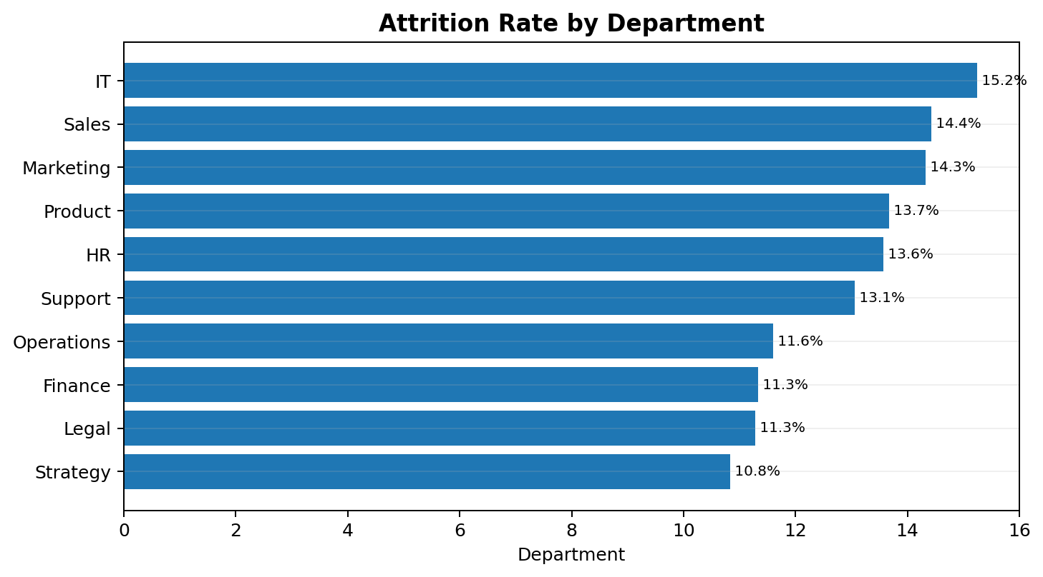
Figure 1. Department-level attrition rate.
Department | Employees | Exited | Attrition Rate | Average Salary
IT | 1,004 | 153 | 15.24% | $91,400
Sales | 1,012 | 146 | 14.43% | $66,971
Marketing | 1,033 | 148 | 14.33% | $72,943
Product | 1,009 | 138 | 13.68% | $97,466
HR | 951 | 129 | 13.56% | $73,419
Support | 996 | 130 | 13.05% | $54,723
Operations | 1,009 | 117 | 11.60% | $64,677
Finance | 1,015 | 115 | 11.33% | $79,082
Legal | 957 | 108 | 11.29% | $110,043
Strategy | 978 | 106 | 10.84% | $104,611

Department Findings
- IT has the highest attrition rate at 15.24% with 153 exits.
- Sales records 14.43% attrition, while Marketing records 14.33%.
- Strategy has the lowest attrition among departments at 10.84%.
- High attrition should be investigated together with role mix, tenure, manager structure, compensation and workload rather than interpreted as a causal effect of department alone.

6.1 Attrition by Tenure
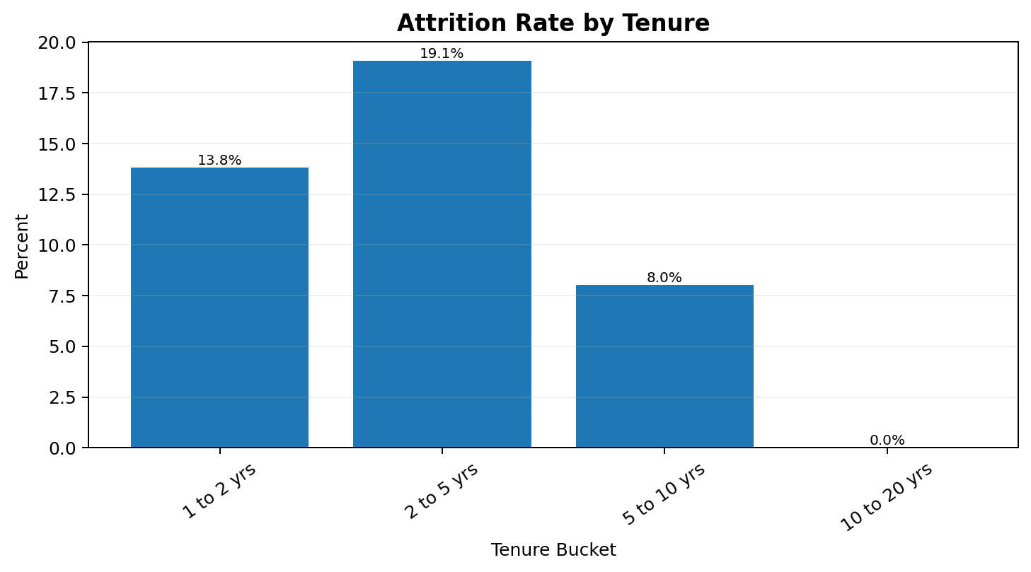
Figure 2. Attrition rate by tenure bucket.
Tenure Bucket | Employees | Exited | Attrition Rate
1 to 2 yrs | 1,881 | 260 | 13.82%
2 to 5 yrs | 3,472 | 662 | 19.07%
5 to 10 yrs | 4,581 | 368 | 8.03%
10 to 20 yrs | 30 | 0 | 0.00%

The 2–5 year group is the most important retention segment: 3,472 employees with a 19.07% attrition rate. The rate falls to 8.03% for employees with 5–10 years of service.

6.2 Attrition by Age
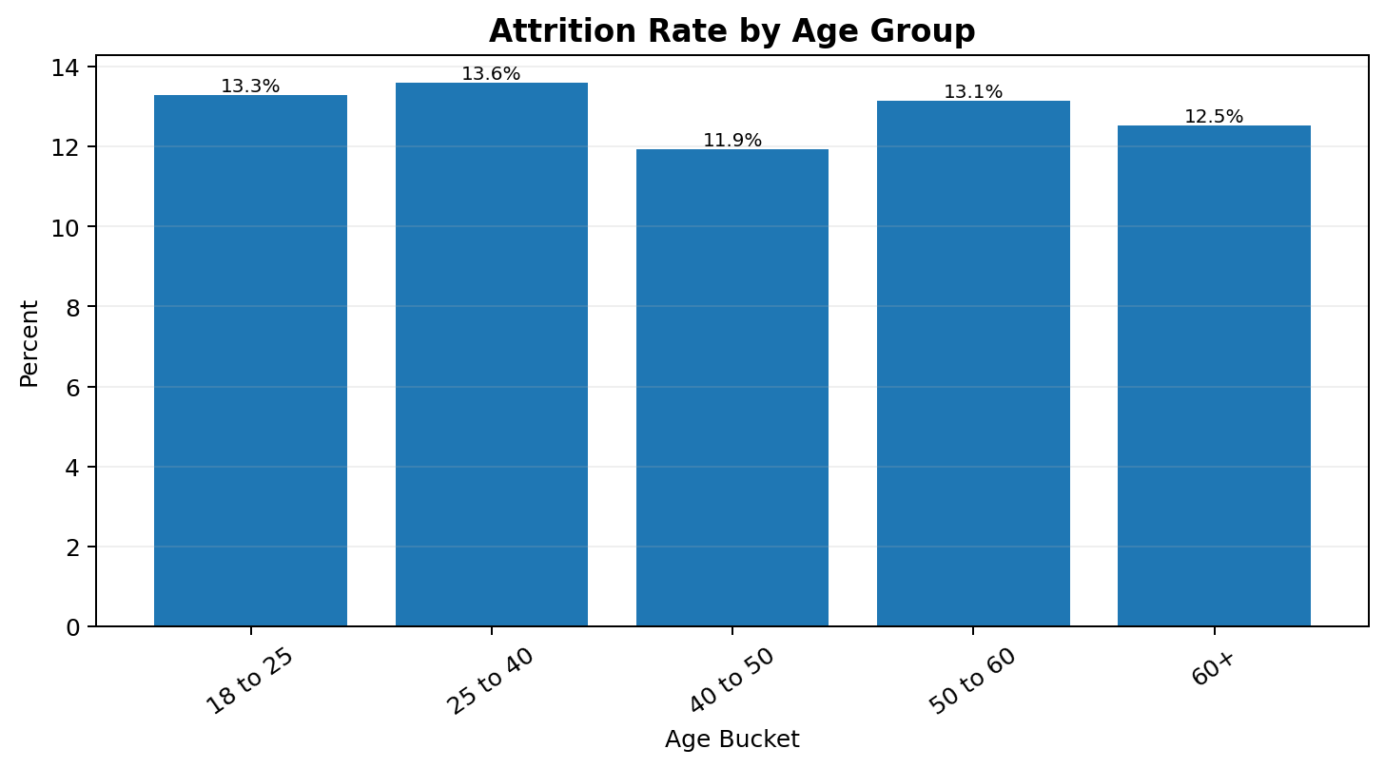
Figure 3. Attrition rate by age bucket.
Age Bucket | Employees | Exited | Attrition Rate
18 to 25 | 670 | 89 | 13.28%
25 to 40 | 3,470 | 472 | 13.60%
40 to 50 | 2,298 | 274 | 11.92%
50 to 60 | 2,176 | 286 | 13.14%
60+ | 1,350 | 169 | 12.52%

The 25–40 age group has the highest attrition rate at 13.60%, followed by the 18–25 and 50–60 groups. The 40–50 group has the lowest observed attrition.

7. Workforce Demographics

7.1 Gender
Gender | Employees | Exited | Attrition Rate
Female | 4,961 | 614 | 12.38%
Male | 5,003 | 676 | 13.51%

Male employees show 13.51% attrition compared with 12.38% for female employees. The difference is relatively small, so gender alone should not be treated as a primary retention driver.

7.2 Employment Type
Employment Type | Employees | Exited | Attrition Rate
Contract | 2,133 | 276 | 12.94%
Full-Time | 5,866 | 760 | 12.96%
Part-Time | 1,965 | 254 | 12.93%

Attrition rates are nearly identical across full-time, contract and part-time employees in this dataset. This suggests employment type is not a strong differentiator in the observed overall attrition pattern.

7.3 Performance Rating
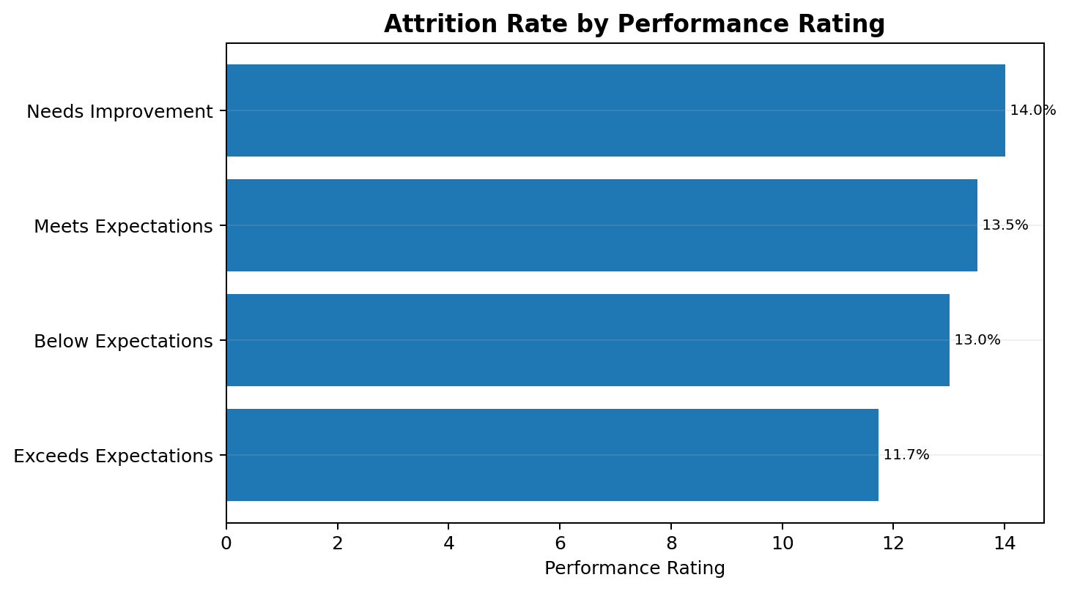
Figure 4. Attrition rate by performance rating.
Performance Rating | Employees | Exited | Attrition Rate
Needs Improvement | 614 | 86 | 14.01%
Meets Expectations | 4,736 | 640 | 13.51%
Below Expectations | 1,776 | 231 | 13.01%
Exceeds Expectations | 2,838 | 333 | 11.73%

Employees rated 'Needs Improvement' have the highest attrition rate at 14.01%, while 'Exceeds Expectations' has the lowest at 11.73%. This pattern can support targeted performance coaching and retention review, but it does not establish causation.

8. Location Analysis
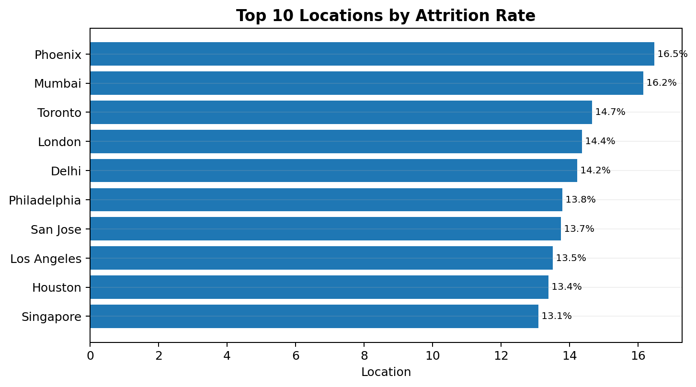
Figure 5. Ten highest observed location-level attrition rates.
Location | Employees | Exited | Attrition Rate
Phoenix | 516 | 85 | 16.47%
Mumbai | 526 | 85 | 16.16%
Toronto | 491 | 72 | 14.66%
London | 557 | 80 | 14.36%
Delhi | 541 | 77 | 14.23%
Philadelphia | 522 | 72 | 13.79%
San Jose | 531 | 73 | 13.75%
Los Angeles | 555 | 75 | 13.51%
Houston | 493 | 66 | 13.39%
Singapore | 542 | 71 | 13.10%

Phoenix has the highest location attrition rate at 16.47%, followed by Mumbai at 16.16% and Toronto at 14.66%. These locations should be prioritized for deeper HR investigation, especially when combined with tenure and department.

9. Compensation Analysis
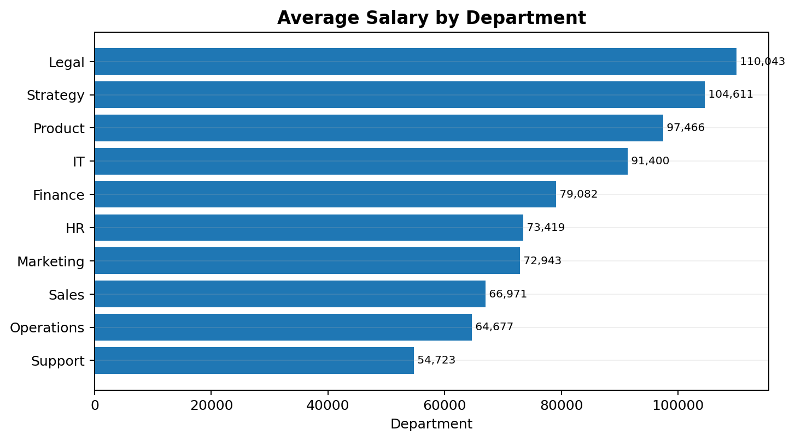
Figure 6. Average annual salary by department.
Department | Employees | Average Salary | Attrition Rate
Legal | 957 | $110,043 | 11.29%
Strategy | 978 | $104,611 | 10.84%
Product | 1,009 | $97,466 | 13.68%
IT | 1,004 | $91,400 | 15.24%
Finance | 1,015 | $79,082 | 11.33%
HR | 951 | $73,419 | 13.56%
Marketing | 1,033 | $72,943 | 14.33%
Sales | 1,012 | $66,971 | 14.43%
Operations | 1,009 | $64,677 | 11.60%
Support | 996 | $54,723 | 13.05%

Legal has the highest average department salary at $110,043, followed by Strategy at $104,611. Support has the lowest average salary at $54,723. The salary differences are substantial, but salary alone should not be used to explain attrition without additional employee-level and role-level analysis.

10. Job Title Risk View
To avoid over-interpreting very small groups, the ranking below considers job titles with at least 100 employees.
Job Title | Employees | Exited | Attrition Rate | Average Salary
Sales Executive | 213 | 41 | 19.25% | $66,467
Digital Marketing Specialist | 209 | 40 | 19.14% | $73,172
Account Executive | 201 | 35 | 17.41% | $67,442
Business Development Manager | 184 | 32 | 17.39% | $66,943
Systems Engineer | 161 | 28 | 17.39% | $92,255
Product Analyst | 199 | 33 | 16.58% | $99,105
Senior Developer | 178 | 29 | 16.29% | $89,928
Compensation Manager | 194 | 31 | 15.98% | $73,787
HR Executive | 198 | 31 | 15.66% | $72,658
Support Engineer | 181 | 28 | 15.47% | $55,710

Among sufficiently large job-title groups, Sales Executive and Digital Marketing Specialist show the highest observed attrition rates. These roles merit further investigation around workload, career progression, incentives, manager support and compensation competitiveness.

11. Research Questions & Key Findings
Business Question | Finding
What is the overall attrition level? | 12.95% overall attrition, with 1,290 exits.
Which department needs the most attention? | IT has the highest department attrition at 15.24%.
Which tenure segment is most vulnerable? | Employees with 2–5 years of service have 19.07% attrition.
Does attrition vary by age? | Yes. The highest age-bucket attrition is 25–40 at 13.60%.
Is employment type a major differentiator? | No clear difference is observed; all three employment types are around 12.9% attrition.
Which performance group has the highest attrition? | 'Needs Improvement' at 14.01%.
Which location has the highest attrition? | Phoenix at 16.47%.
Where are salaries highest? | Legal has the highest average department salary at $110,043.

12. HR Recommendations
Prioritize the 2–5 year tenure segment: Create a focused retention review for employees in the 2–5 year range. Review promotion pathways, compensation progression, manager relationships, learning opportunities and workload.
Investigate IT, Sales and Marketing: Use department-level attrition as a screening signal. Drill down by job title, tenure, location and performance before taking corrective action.
Run location-specific retention reviews: Phoenix and Mumbai show elevated attrition. Compare their role mix, tenure distribution, manager structure and compensation against lower-attrition locations.
Strengthen career development: The lower attrition among longer-tenured employees suggests that career stability and organizational attachment may be important areas to explore.
Combine performance and retention monitoring: Employees with 'Needs Improvement' ratings have the highest attrition. HR can combine coaching plans with retention conversations rather than treating performance and attrition as separate processes.
Build an early-warning HR dashboard: Track attrition rate, exits, tenure bands, department, location, performance, salary band and employment type monthly so HR can identify emerging risk segments.

13. Excel Dashboard & Reporting Design
The workbook contains an HR dashboard sheet and supporting analysis sheets. A portfolio-ready dashboard should present the following elements on one executive view:
- KPI cards: Total Employees, Active Employees, Exited Employees, Attrition Rate, Average Salary and Average Tenure.
- Attrition by Department and Location.
- Attrition by Tenure and Age Bucket.
- Performance Rating vs Attrition.
- Average Salary by Department.
- Interactive slicers for Department, Gender, Employment Type, Location and Performance Rating.
- A detailed employee lookup area for HR investigation.
The analysis sheets in the supplied workbook already provide several pivot-style outputs that can feed these dashboard visuals.

14. Limitations & Next Steps
- The analysis is descriptive and identifies associations; it does not prove that a particular factor causes attrition.
- The workbook does not include employee engagement scores, manager effectiveness, promotion history, satisfaction surveys or exit reasons.
- The 10–20 year tenure bucket contains only 30 employees, so its 0% attrition rate should not be generalized.
- Missing manager IDs limit manager-level analysis.
- Future analysis could add monthly attrition trends, salary bands, promotion history, exit reasons and predictive modeling.

15. Conclusion
This Excel-based HR Workforce Analytics project provides a structured view of a 9,964-employee workforce with an overall attrition rate of 12.95%. The analysis highlights IT, Sales and Marketing as higher-attrition departments, while the 2–5 year tenure segment is the clearest workforce retention priority. Location and performance analysis provides additional dimensions for targeted HR investigation.
The project demonstrates practical Excel analytics skills including data validation, KPI calculation, PivotTable-style segmentation, workforce profiling, attrition analysis, compensation analysis and management-oriented reporting.

