Detailed Specifications

Blofi / Kondor +

Introducing the New Index ESTR in EMEA and Adjusting the feed for EONIA

TABLE OF CONTENT

1 Brief Introduction 4

2 FUNCTIONAL CONTEXT 5

2.1 General Context 5

2.1.1 Desirable features of reference rates and main trade-offs 6

2.1.2 Taxonomy and properties of the new overnight RFRs 6

2.1.3 Context to Implement the ESTR in IT Treasury 8

3 Impacted Application 9

3.1 Request description – PRB 9

4 Objective And CURRENT SITUATION 10

4.1 Objective 10

4.2 Current situation in BLOFI 11

4.3 Current situation in K+ 11

4.3.1 EONIA Rates 11

4.3.2 EUR FundingRate 11

5 TARGET SOLUTION 12

5.1 Functional description 12

5.1.1 Proposed solution 12

6 User Stories 17

6.1 User stories 17

6.2 I.N.V.E.S.T checks 17

6.2.1 US 1 17

6.2.2 US 2 17

6.2.3 US 3 17

6.2.4 US 4 17

7 Requirements Matrices 19

8 Financial Glossary 20

***Audit***

|  |  |  |  |  |
| --- | --- | --- | --- | --- |
| Author | Version | Date | Status | Comment |
| Krishna Kumar Pandey | 1.0 | 03/07/2019 | Creation |  |

***Attached files***

|  |  |  |  |
| --- | --- | --- | --- |
| Author | Object | Language | Document |
|  |  |  |  |

# Brief Introduction

|  |  |
| --- | --- |
| Calitrack ID | 1. [ITT1-3807](https://calitrack.ca.cib/jira/browse/ITT1-3807) |
| Request Origin | The aim of this project is to implement new Index ESTR in EMEA as a part of Global BenchMark project. |
| Severity | Very High |
| Interested users  team | Full EMEA FO & MO Team/ IT Treasury /MAM/DRM/BO IT |
| Impacted users | Front Office Treasury CASA-CACIB Paris/MO & MAM/DRM |
| Involved  IT teams | MDA/CARD/BLOFI/K+/BO IT |
| User vision | As a Front office user I want to have Overnight rate available in BLOFI and K+ in real time for deal booking or coming from upstream system.  As a MAM user, I would want my accrued to be re-calculated for asofdate after the reception of new rate of D-1 on D date |

# FUNCTIONAL CONTEXT

## General Context

There is currently considerable momentum for transitioning away from LIBOR benchmarks.

A major impetus for reform comes from the need to strengthen market integrity following cases of misconduct involving banks’ LIBOR submissions.

To protect them against manipulation, the new (or reformed) benchmark rates would ideally be grounded in actual transactions and liquid markets rather than be derived from a poll of selected banks. But the significant decline in activity in interbank deposit markets, together with structural changes in the money market landscape since the Great Financial Crisis (GFC), has complicated the search for alternatives. The reform process constitutes a major intervention for both industry and regulators, as it is akin to surgery on the pumping heart of the financial system.

In the major currency areas, authorities have already started publishing rates intended to eventually replace (or complement) the IBOR benchmarks. The initial focus has been on introducing credible, transaction-based overnight (O/N) RFRs anchored in sufficiently liquid money markets. Currently, cash and derivatives markets linked to the new RFRs are still in their infancy, but are gradually gaining in liquidity. In addition, a number of jurisdictions in which it was deemed feasible to reform IBORstyle benchmarks have opted for a two-benchmark approach complementing the new ones based on RFRs.

This special feature outlines some key aspects of the new reference rates. First, it sets out a framework and a taxonomy for the main characteristics of existing and new benchmark rates with the aim of highlighting the key trade-offs involved. Second, it reviews the state of financial markets linked to the new RFRs and what this means for the future of term benchmark rates (i.e. those longer than overnight). Third, it takes a closer look at the implications for banks’ asset-liability management. It concludes by touching upon some broader issues surrounding the transition, such as legacy exposures linked to IBORs and cross-currency implications.

So in short: **some key Take away**

* The new risk-free rates (RFRs) provide for robust and credible overnight reference rates, well suited for many purposes and market needs. In the future, cash and derivatives markets are expected to migrate to the RFRs as the main set of benchmarks. The transition will be most challenging for cash markets because of the bespoke nature of contracts and structurally tighter links to interbank offered rates.
* To manage asset-liability risk, financial intermediaries may continue to need a set of benchmarks that provide a close match to their marginal funding costs – a feature that RFRs or term rates linked to them are unlikely to deliver. This may call for RFRs to be complemented with some form of credit-sensitive benchmark, an approach already undertaken in some jurisdictions.
* It is possible that, ultimately, a number of different benchmark formats will coexist, fulfilling a variety of purposes and market needs. The jury is still out on whether any resulting market segmentation would lead to material inefficiencies or could even be optimal under the new normal.

## Desirable features of reference rates and main trade-offs

Devising a new reference rate is no easy task. This is because it may not be feasible to preserve all the desirable characteristics of IBORs while also ensuring that the new rates are grounded in actual transactions in liquid markets. Moreover, for the reform to succeed, a new reference rate must be broadly accepted by market participants that currently rely on IBORs.

**The ideal**

Reference rate – one that could be like a Swiss army knife, serve every conceivable purpose.

1. Provide a robust and accurate representation of interest rates in core money markets that is not susceptible to manipulation. Benchmarks derived from actual transactions in active and liquid markets, and subject to best-practice governance and oversight, represent arguably the best candidates in terms of this criterion;
2. Offer a reference rate for financial contracts that extend beyond the money market. Such a reference rate should be usable for discounting and for pricing cash instruments and interest rate derivatives. For example, overnight index swap (OIS) contracts of different maturities should reference this rate without difficulty, providing an OIS curve for pricing contracts at longer tenors; and
3. Serve as a benchmark for term lending and funding. Given that financial intermediaries are both lenders and borrowers, they require a lending benchmark that behaves not too differently from the rates at which they raise funding.

For instance, banks may fund a long-term fixed rate loan to a client by drawing on short-term (variable rate) funding instruments. To hedge the associated interest rate risk, a bank may enter into an interest rate swap as a fixed rate payer in return for receiving a stream of floating interest rate payments determined by a benchmark that reflects the bank’s funding costs. If the two types of rate diverge, the bank runs a “basis risk” between its asset and liability exposures.

**Need**

Reform efforts have focused on linking the new benchmarks with actual transactions in the most liquid segments of money markets. In practice, this has meant that the new reference rates incorporate some (or all) of the following attributes:

1. shorter tenor, essentially by moving to O/N markets, where volumes are larger than for longer-dated tenors such as three months;
2. moving beyond interbank markets to add bank borrowing from a range of non-bank wholesale counterparties (cash pools/money market funds, other investment funds, insurance companies etc.); and
3. In some jurisdictions, drawing on secured rather than unsecured transactions. The secured transactions could also include banks’ repurchase agreements (repos) with non-bank wholesale counterparties.

## Taxonomy and properties of the new overnight RFRs

Authorities have taken steps to identify and construct alternative RFR benchmarks compliant with standards such as the IOSCO principles. Five of the largest currency areas have all moved to an O/N benchmark as the backbone of the new regime.

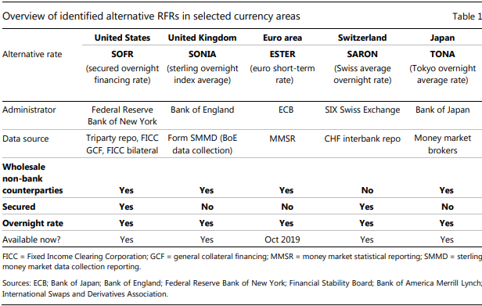

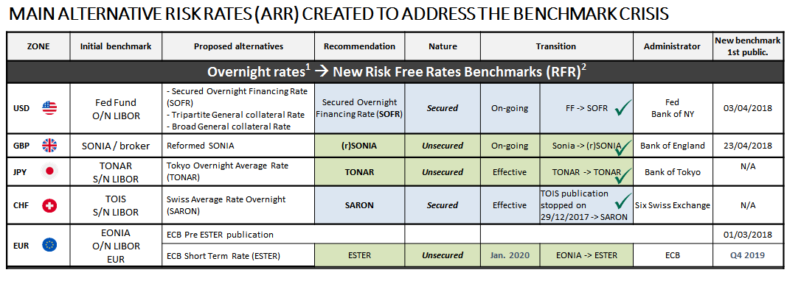

## Context to Implement the ESTR in IT Treasury

As part of the benchmark project, For the Eonia - € STR transition, here are the risks and action plan I have identified for the treasury:

**Scenario 0:**

1. Maintaining an index with a modified methodology: From 02/10/2019,

EONIA recalibrated = € STR + 8.5 bp

1. Based on the recommendations of WG BCE, the administrator of the EONIA index modifies the methodology for calculating the Eonia from 02 Oct 2019 and recalibrates it on the basis of a € STR + a fixed spread until at the end of 2021
2. This spread calculated by the ECB and set at 8.5 bp represents the difference observed between the pre- € STR and the Eonia over the period of 17/04/2018 water 16/04/2019 according to the methodology adopted by EMMI.
3. The EONIA becomes a tracker of the € STER with EONIA = € STER +8.5 bp between 02/10/2019 and 31/12/2021
4. The date of publication of the Eonia is shifted to D + 1, 9:15 am from 02 Oct 2019

**Risks and action plan:**

The change in publication date of the Eonia (D 19h to D + 1 9h15) represents an operational risk

1. Interest calculations will be staggered and payments may be impacted
2. The timing of the IT batches will have to be reviewed
3. No new financial risk for the treasury (neither on stock nor on new operations)
4. The recalibrated Eonia remains the Eonia until the end of 2021
5. Loans / deposit, CD and indexed EONIA stock may be run out before the end of 2021
6. Continuity of quoted indexed EONIA with an EONIA quotation strictly equivalent to € STER + 0.085%

**Scenario 1:**

1. Creating a new € STR index for new production
2. Deployment of an indexed cash products offer € STR
3. No financial risk because perfect indexation continuity indexed € STR with a quotation € STR strictly equivalent to EONIA- 0.085%
4. Quotation of Loans / Deposit, Cd issues on a € STR basis from 02/10/2019 to external clients (mostly AM), intragroup and internal
5. An operational risk related to the confusion on the quotations or the booking: the price given for a L/D indexed € STR can be understood/booked vs. EONIA or conversely
6. A need for coverage of TF operations depending on the depth of the SWAPS market
7. Risk of customers questioning margins

**Actions to implement:**

1. Use internal and external communication to explain the nature of the spread of 8.5 bp
2. Check product NAP to use a new index on all TSY products
3. Prepare cash for a target production on the date of 02/10 (quotation mails etc.)
4. Put in place new curves of reval, curve swap of reference ..., date of review of the TIR
5. Check aptitude of GMD / Market to offer quotation service of indexed swaps € STR, benchmark swap curve

# Impacted Application

The application impacted is as follow:

* BLOFI
* KONDOR+

## Request description – PRB

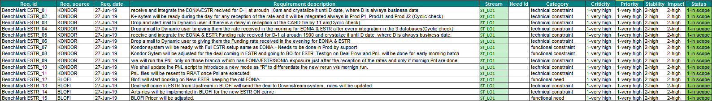

# Objective And CURRENT SITUATION

## Objective

The Objective can broadly divided as below:

* To collect the Overnight Fixing rate from CARD for EUR currency on 2 indexes for D-1 date and crystalize it to D date , where D is always a business date.
* Run the Pnl again for those branches which are having the exposure to EONIA/ESTER and SONIA.
* Import the Funding rate from the evening file and crystalize it for D date, where D is a business date.
* To implement the New Indexes and BLOFI, so that new ESTER booking can be started.
* To implement the smooth deal flow from BLOFI and Upstream system to K+ and to BO.
* To Implement ESTER similar to EONIA in terms of Curves, Fixing and funding rate.
* To Implement the below flow of actions.

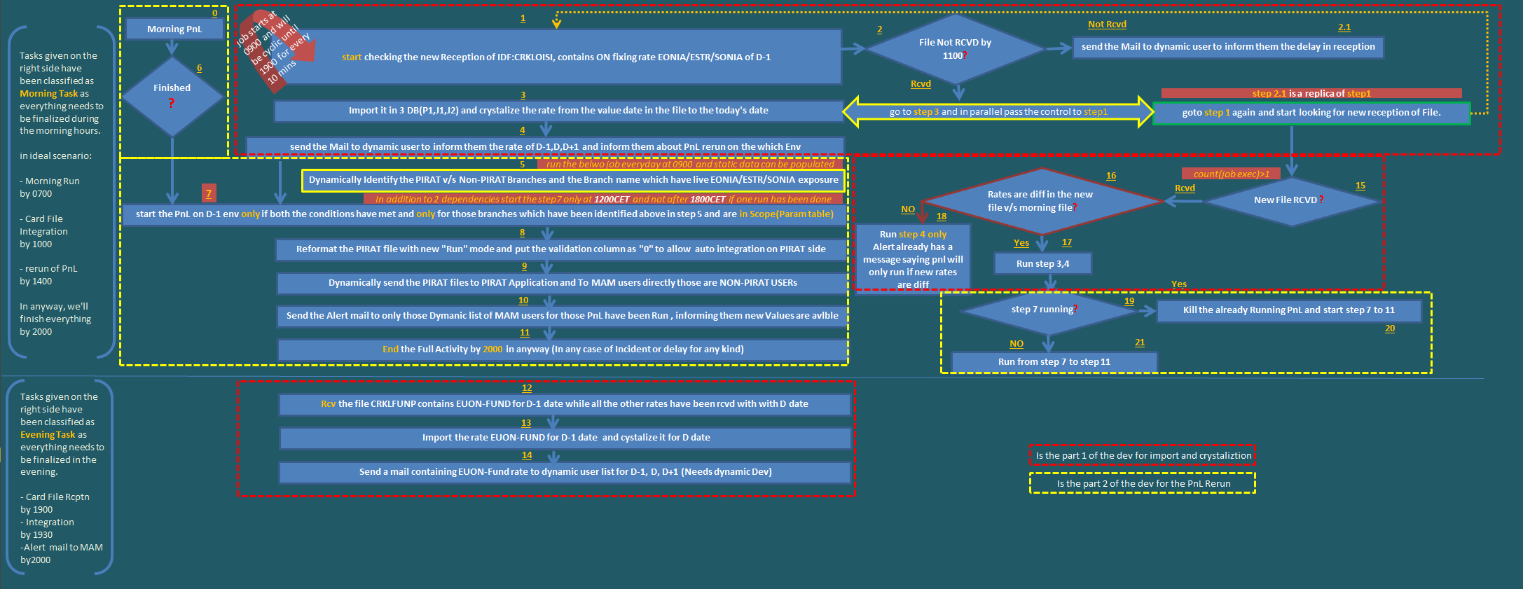

## Current situation in BLOFI

As of now in BLOFI:

We have a dedicated OIS screen to book ON EUR deals on EONIA.

1. The plan is to keep the old screen for EONIA Trading.
2. BLOFI sends Trades to 3 downstream (Kondor/OT/Murex); rules are there on BLOFI side for the deals coming from upstream system to identify that deal has been booked EONIA and similar rule exist for downstream system.
3. BLOFI Pricer has a curve for EONIA market rates.

## Current situation in K+

## EONIA Rates

K+ Receives EONIA rates from CARD in the evening file names CRKLFXLP at around 1900.

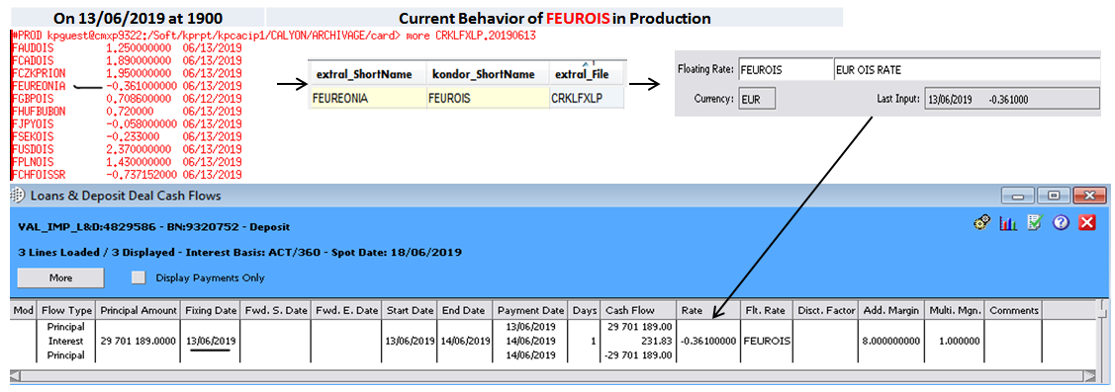

## EUR Funding Rate

K+ Receives EONIA rates from CARD in the evening file names CRKLFUNP at around 1900.

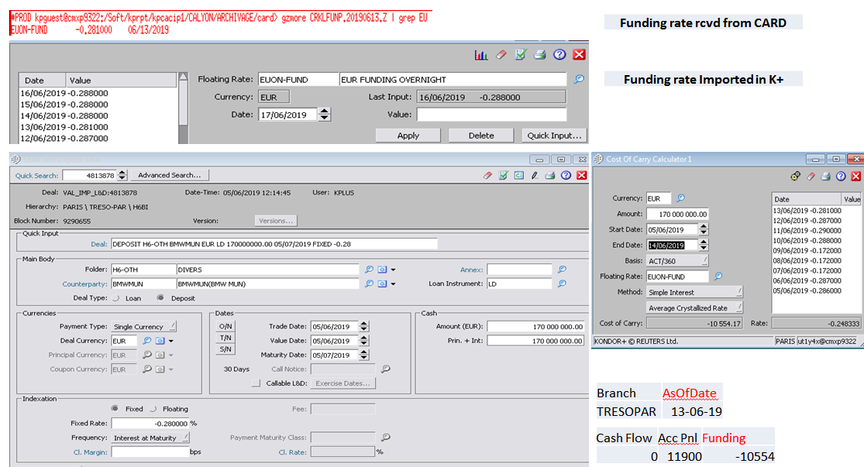

# TARGET SOLUTION

## Functional description

This request aims to below:

1. To import the fixing rates of EONIA and ESTER in 3 DB, this until Oct 2nd used to come in the evening but the publication time will be changed from T to T+1 at around 0900 containing the rate of T.
2. To Import the Funding rates into K+ 3 DB in the evening.
3. Send the automatic alerts for each occurrences
4. Adjust BLOFI /K+ to allow new bookings in ESTR and allow the reception and good xml to downstream system.
5. Rerun the PnL, after the reception of morning fixing rates.

## Proposed solution

For Kondor Items in Blue are the part of First dev. and Black for the second dev. includes PnL Rerun.

And items in Maroon are for studies to do in Test and for support to do in Prod directly.

**In Blofi** To keep the old way of booking the EONIA deals.

**In Blofi** Give a new way of booking for the ESTR deals

**In Blofi** Adjust blofi for the upstream and downstream system for the bookings of EONIA and ESTER.

**In Blofi** Adjust the new pricer for the new EUROIS curve, this is now supposed to be derived from ESTER by keeping the old EONIA curve.

**In Kondor** Toallow the Import of the card file and crystallization the rate from the value date given in the file to the D date in the morning, where D is always business date. (**IDF -CRKLOISI)**

***Scenario1:*** *On Monday, the date and rate will be as of Friday so rate will be imported for Friday, Saturday Sunday and Monday.*

***Scenario2:*** *Rate of Monday will be corrected on the next day (Tuesday) when the file will be having the rate of Monday in it and for Tuesday, our new developed process will crystalize it.*

**

**In Kondor** Toallow the Import of the card file and crystallization the rate from the value date given in the file to the D date in the evening, where D is always business date. **(IDF -CRKLFUNP)**

***Scenario1:*** *On Monday, the date and rate will be as of Friday so rate will be imported for Friday, Saturday Sunday and Monday.*

***Scenario2:*** *Rate of Monday will be corrected on the next day (Tuesday) when the file will be having the rate of Monday in it and for Tuesday, our new developed process will crystalize it.*

Now the rate EUON-Fund on the D date will be received for D-1 date.



**In Kondor** In Kondor we must be able to send the alert messages for the delay in the reception of Morning file. We have to make content of this mail to have floating rate in dynamic.



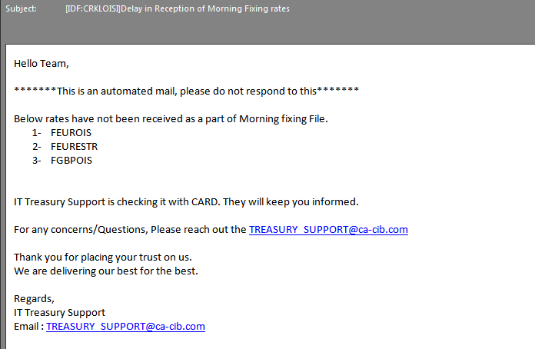

**In Kondor** In Kondor, after the reception we must be able to send the updated rate to Dynamic users. We have to make content of this mail to have floating rate in dynamic.



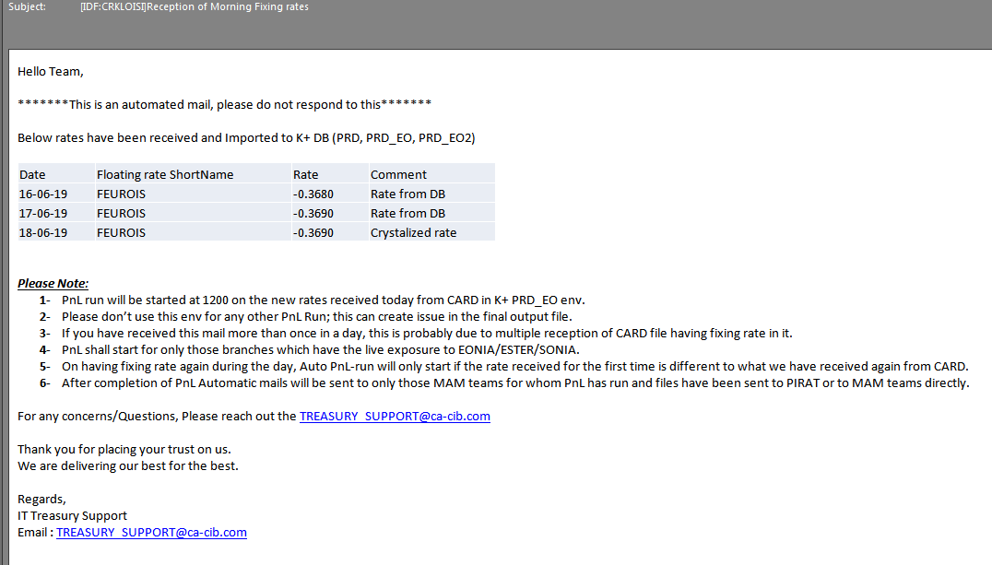

**In Kondor** we must be able to send the mail to Dynamic user on having the EUR- Funding rate imported in the evening file- we have to make content of this mail to have floating rate in dynamic.



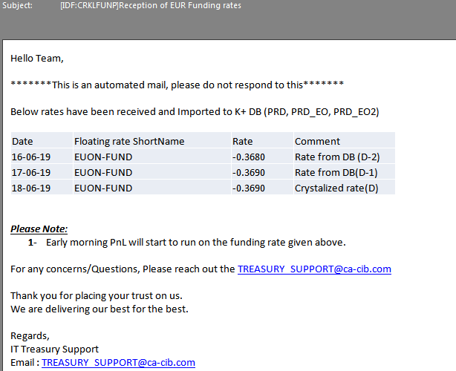

**In Kondor** recipient of these mails will be initially as; we must be able to change it dynamically.

|  |  |  |  |
| --- | --- | --- | --- |
| **id** | **Mail Subject** | **Mail To** | **Mail Cc** |
| 1 | [IDF:CRKLOISI]Delay in Reception of Morning Fixing rates | mam-treso@ca-cib.com | [TREASURY_SUPPORT@ca-cib.com](mailto:TREASURY_SUPPORT@ca-cib.com) |
| 2 | [IDF:CRKLOISI]Reception of Morning Fixing rates | mam-treso@ca-cib.com | [TREASURY_SUPPORT@ca-cib.com](mailto:TREASURY_SUPPORT@ca-cib.com) |
| 3 | [IDF:CRKLFUNP]Reception of EUR Funding rates | mam-treso@ca-cib.com | [TREASURY_SUPPORT@ca-cib.com](mailto:TREASURY_SUPPORT@ca-cib.com) |

**In Kondor** our job shall wait for the correct morning fixing file and one it has arrived, rates will be imported and job will again to start to wait for the next occurrence of the file and if that happens – we will import the rate in K+ only if the morning rates received are different from what we have received again.

**In Kondor** we will be putting start time on check and receives job and dependencies on import and mailing jobs as shown in the table.

|  |  |  |  |  |
| --- | --- | --- | --- | --- |
| **Id** | **Job Name** | **start Time** | **End Time** | **Cyclic** |
| 1 | Rcv Job | 0900 | 2000 | 10 mins |
| 2 | Check Job | 0900 | 2000 | 10 mins |
| 3 | Import job | Dependent upon Rcv job | | |
| 4 | alert mail for Delay | Dependent upon Check job | | |
| 5 | Mail of reception of Fixing rate | Dependent upon import Job | | |

**In Kondor** we will check if the Morning Fixing file has been received and morning Pnl have been finished, and then rerun on the **selected** branch will be started in the new **Run** mode.

**In Kondor** **selected** branches will be identified by a dynamic check of getting which has the live exposure of EONIA/SONIA and ESTER deals for now and there will be static set of branches as well.

**In Kondor** A new “**Run**” has to be created for this rerun which will give the feed value as 0 for the PIRAT files.

**In Kondor** *multiple reruns* in PnL will only be done if the rate during day differs from what we have received in first file and imported in DB.

**In Kondor** a final alert mail will be sent to dynamic users of MAM team belongs to only those branches for whom PnL have been regenerated.



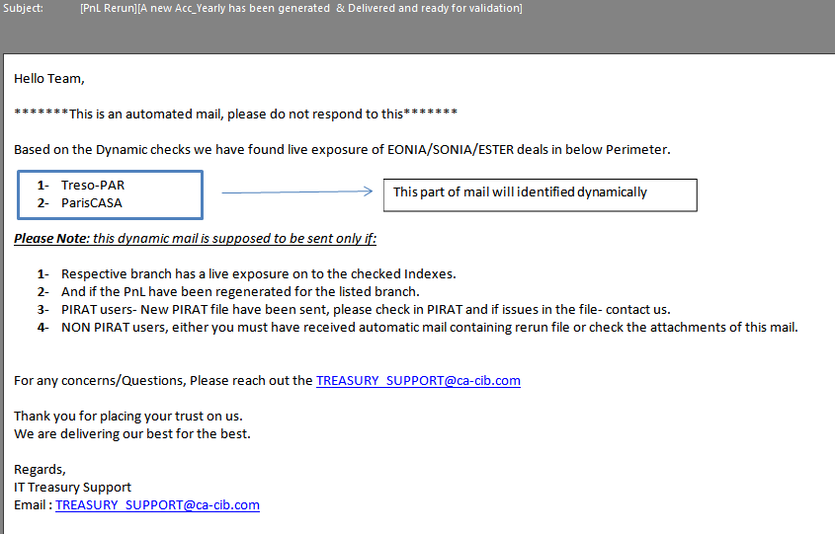

**In Kondor** we have identified the below list as PIRAT and non PIRAT branches with their contact list and the initial static of Rerun Required.

|  |  |  |  |
| --- | --- | --- | --- |
| **Branch** | **PIRAT Branch** | **Rerun Needed** | **MAM Contact** |
| CASALONDON | YES | YES | MAM UK TREAS <[MAMUKTREAS@ca-cib.com](mailto:MAMUKTREAS@ca-cib.com)> |
| DUBAI | YES | YES | [DXB-MarketRisk&MiddleManagement@msx.cib.cal](mailto:DXB-MarketRisk&MiddleManagement@msx.cib.cal) |
| KIEV | YES | YES | Snarova, Kateryna V (CREDIT AGRICOLE UKRAINE) <[kateryna.snarova@credit-agricole.ua](mailto:kateryna.snarova@credit-agricole.ua)>; ODYNAIEV Nazar Oleksandrovych <[Nazar.ODYNAIEV@credit-agricole.ua](mailto:Nazar.ODYNAIEV@credit-agricole.ua)>; Truong, Pascal (CA-CIB) <[pascal.truong@ca-cib.com](mailto:pascal.truong@ca-cib.com)> |
| PARISCASA | YES | YES | MAM-TRESO <[mam-treso@ca-cib.com](mailto:mam-treso@ca-cib.com)> |
| RUSSIA | YES | YES | Bardakhanova, Anna <[anna.bardakhanova@ca-cib.com](mailto:anna.bardakhanova@ca-cib.com)>;Ardikouts, Maxim (CA-CIB) <[maxim.ardikouts@ca-cib.com](mailto:maxim.ardikouts@ca-cib.com)> |
| TRESOPAR | YES | YES | MAM-TRESO <[mam-treso@ca-cib.com](mailto:mam-treso@ca-cib.com)> |
| UK | YES | YES | MAM UK TREAS <[MAMUKTREAS@ca-cib.com](mailto:MAMUKTREAS@ca-cib.com)> |
| DIFC | YES | YES | [DXB-MarketRisk&MiddleManagement@msx.cib.cal](mailto:DXB-MarketRisk&MiddleManagement@msx.cib.cal) |
| CABP | YES | YES | Kazmierski, Lukasz (LUKAS-BANK) <[lukasz.kazmierski@credit-agricole.pl](mailto:lukasz.kazmierski@credit-agricole.pl)> |
| MILAN | YES | YES | MAM UK TREAS <[MAMUKTREAS@ca-cib.com](mailto:MAMUKTREAS@ca-cib.com)> |
| ALMCPM | YES | YES | MAM-TRESO <[mam-treso@ca-cib.com](mailto:mam-treso@ca-cib.com)> |
| ALMPAR | NO | NO | DAMOU, Nour (CA-CIB) <[nour.damou@ca-cib.com](mailto:nour.damou@ca-cib.com)> |
| CAE | NO | To be checked | El-Dahman, Amr (CA-EGYPTE) <[amr.el-dahman@ca-egypt.com](mailto:amr.el-dahman@ca-egypt.com)>;Errafas, Nabil (CA-EGYPTE) <[nabil.errafas@ca-egypt.com](mailto:nabil.errafas@ca-egypt.com)> |
| CRP | NO | To be checked | Franze', Marta (CARIPARMA) <[marta.franze@credit-agricole.it](mailto:marta.franze@credit-agricole.it)> |
| FRA | NO | To be checked | Franze', Marta (CARIPARMA) <[marta.franze@credit-agricole.it](mailto:marta.franze@credit-agricole.it)> |
| CSP | NO | To be checked | Franze', Marta (CARIPARMA) <[marta.franze@credit-agricole.it](mailto:marta.franze@credit-agricole.it)> |
| CASCAS | NO | YES | VIDIC, Jocelyn (CAPBS) <[jocelyn.vidic@ca-indosuez.ch](mailto:jocelyn.vidic@ca-indosuez.ch)>;RIMA MAM/CH/CAI/CAIS (CAIS) <[rima.mam@ca-indosuez.ch](mailto:rima.mam@ca-indosuez.ch)>; Trésorerie CAS/CH/CAI/CAIS (CAIS) <[tresorerie.cas@ca-indosuez.ch](mailto:tresorerie.cas@ca-indosuez.ch)> |

**In Kondor** Create a new Fixing rate for ESTER similar to FEUROIS, create a new curve for ESTER_OIS similar to EUR_OIS; create a default TOI for the FESTROIS rates.

Market rate of the ESTER_OIS will be mapped to EUR_OIS curve at the starting.

**In Kondor** based on the availability of market rates from CARD, we’ll change the mapping directly in Prod, plus any additional changes which has dynamic behavior needs changes in Prod directly by support team.

**In Kondor** you will find detailed excel sheet placed on below which talks more on the subject.

\\cmfrfi002\DOT\DOT IT\FO-BO Systems\Front Office\Tfw\Documents Kondor+\CURRENT PROJECTS\188 - Benchmark project\Studies\02 - Specification Documents

# User Stories

## User stories

The feature can be split in 5 user’s stories:

|  |  |  |
| --- | --- | --- |
| US ID | US description | US Business Value |
| 1 | As a User, I would want the old and new way of booking the deals in BLOFI and K+ on EONIA and ESTER. | 5 |
| 2 | As a User, I don’t want to see any impact on EONIA/ESTER and SONIA time publication changes. | 5 |
| 3 | As a user, I want a new PnL run to be made on my branch after having the fixing rate during the day. | 5 |
| 4 | New curve for ESTER should exist like EONIA and Funding to be calculated correctly. | 5 |

## I.N.V.E.S.T checks

## US 1

|  |  |  |
| --- | --- | --- |
| Independent | Yes |  |
| Negotiable | No |  |
| Valuable | Yes | Added value for User |
| Estimable | Yes |  |
| Small | Yes |  |
| Testable | Yes, by setting up the test env |  |

## US 2

|  |  |  |
| --- | --- | --- |
| Independent | Yes |  |
| Negotiable | No |  |
| Valuable | Yes | Added value for User |
| Estimable | Yes |  |
| Small | Yes |  |
| Testable | Yes, by setting up the test env |  |

## US 3

|  |  |  |
| --- | --- | --- |
| Independent | Yes |  |
| Negotiable | No |  |
| Valuable | Yes |  |
| Estimable | Yes |  |
| Small | Yes |  |
| Testable | Yes with MAM |  |

## US 4

|  |  |  |
| --- | --- | --- |
| Independent | Yes |  |
| Negotiable | No |  |
| Valuable | Yes |  |
| Estimable | Yes |  |
| Small | Yes |  |
| Testable | Yes with IT Treasury and MAM |  |

# Requirements Matrices

|  |  |
| --- | --- |
| **ID** | **Description** |
| [REQ 01] | As a User, I would want the old and new way of booking the deals in BLOFI and K+ on EONIA and ESTER. |
| [REQ 02] | As a User, I don’t want to see any impact on EONIA/ESTER and SONIA time publication changes. |
| [REQ 03] | As a user, I want a new PnL run to be made on my branch after having the fixing rate during the day. |
| [REQ 04] | New curve for ESTER should exist like EONIA and Funding to be calculated correctly. |

# Financial Glossary

|  |  |
| --- | --- |
| **Acronyms/ Notions** | **Description** |
|  |  |
|  |  |