A

Project report on

**PCB Design of Digital clock**

Prepared as a part of the requirement for the subject of B.E- Semester- **VII**

(Electronics and Communication Branch)

Submitted by:

Sumit Adep

190170111002

|  |  |
| --- | --- |
| **Guided by:**  **Prof. Ketan. N. Patel**  **Assistant Professor** | **Prof. Arun. B. Nandurbarkar**  **Head of Department** |

|  |  |  |
| --- | --- | --- |
|  | Department of Electronics and Communication **Vishwakarma Government Engineering College** Affiliated with  **Gujarat Technological University** | C:\Users\pa\Desktop\New folder\vgec_hd.png |

**Academic Year**

2022-23

|  |  |
| --- | --- |
| C:\Users\pa\Desktop\New folder\vgec_hd.png | Vishwakarma Government Engineering College – Chandkheda Department of Electronics and Communication Engineering |

**CERTIFICATE**

This is to certify that the Internship/Mini Project Report entitled “**PCB Design of Digital Clock**” submitted by **Sumit Adep****.**

Towards the partial fulfillment in Internship/Mini Project(Electronics and communication Engineering) of Gujarat Technological University is the record of work carried out by him under our supervision and guidance. The work submitted has in our opinion reached a level required for being accepted for examination. The results embodied in this Project Work to the best of our knowledge have not been submitted to any other University or diploma.

|  |  |
| --- | --- |
| Guided by:  Prof. Ketan. N. Patel Assistant Professor | Prof. Arun. B. Nandurbarkar  Head of Department |

**ABSTRACT**

The main aim of this project is to create PCB design of digital clock which can be used for mass production of the product. A PCB design of a digital clock is designed with the help of Altium Designer which is one of the mostly used hardware design tool in hardware design industry. In this project schematics and footprints of the projects are made from the scratch using Altium footprints wizard and schematic design tool. For 3D visualization 3D designs of the components are placed successfully and 3D designs are collected from the website: 3dcontentcentral.com. Simulation and prototypes are referred for connections and for the parameters of the components. It includes components like LEDs, resistors, seven segments displays, push buttons, breadboard and jumper wires. Proteus software is used for making simulation. At last necessary files are created which are important.

**ACKNOWLEDGEMENT**

With great pleasure, I take this opportunity to express my deep sense of gratitude and indebtedness to my renowned and esteemed guide **Prof. Ketan. N. Patel** Assistant Professor, Department of Electronics and communication Engineering, Vishwakarma Government Engineering College, Chandkheda for his consummate knowledge, due criticism, invaluable guidance and encouragement which has enabled us to give present shape to this work.

I am heavily indebted to **Prof. Arun. B. Nandurbarkar**, Head of the Department, Power Electronics Engineering, Vishwakarma Government Engineering College, Chandkheda, for his everlasting willingness to extend his profound knowledge and experience in the preparation of this report. Any attempt to define this indebtedness would be incomplete. I am immensely thankful to **Dr. N. N. Bhuptani**, Principal, Vishwakarma Government Engineering College, Chandkheda, for her valuable support and inspiration.

Finally, I would like to thank our friends and family for their support and patience throughout the year, especially to our parents who without their encouragement and financial support, this would not have been possible.

Sumit Adep (190170111002)

**CONTENTS**

* 1. [Introduction 5](#_TOC_250020)
     1. [Introduction 5](#_TOC_250019)
     2. Purpose of the Project 5
  2. Components ……6
     1. Microcontroller 6
     2. [Seven segment display 7](#_TOC_250006)
     3. Resistor…………………………………………………….......7
     4. LED………………………………………………………….....8
     5. Transistor…………………………………………….................8
     6. Capacitor……………………………………………………….9
     7. Push button……………………………………………………..9

**3. Simulation……………………………………………………………..**10

**4. Schematic……………………………………………………………...**12

**5. PCB Design……………………………………………………………**13

**6. 3D visualization of PCB…………………………................................**15

**7. Layers stack…………...........................................................................**16

**8. Layers used in project………………………………………………...**19

**9**. **Layers and Drawing………………………………………………......**20

**10. Conclusion……………………………………………………………**28

**LIST OF FIGURES**

Atmega328 schematic, footprint and 3D Model 6

Seven segment display schematic, footprint and 3D Model…………………...…7

Resistor schematic, footprint and 3D Model……………………………………..7

LED schematic, footprint and 3D Model…………………………………………8

Transistor schematic, footprint and 3D Model……………………………………8

Capacitor schematic, footprint and 3D Model……………………………………9

Push Button schematic, footprint and 3D Model…………………………………9

Simulation………………………………………………………………………..10

Schematic design…………………………………………………………….......12

PCB Design………………………………………………………………..…….13

3D visualization of PCB…………………………………………………………15

Stack Layer……………………………………………………………...……….16

Layers and Drawings…………………………………………………………….20

# 1. INTRODUCTION

PCB Designing is one of the essential processes of designing of any product. The Altium Designer is used to design schematics and footprints of digital clock.

With the help of components like seven segment displays, microcontroller, resistors, transistors and LEDs design is prepared. Necessary information of components like voltage-current rating and dimensions are collected from their respective datasheets.

**Purpose of Project**

The project is an implementation of PCB design of digital clock.

To generate necessary files like Gerber file, NC drill file, job file which are necessary for the manufacturer for the production of the product.

To gain the necessary skills in PCB designing like designing of schematics, footprints and placement of 3D models.

It includes routing of tracks and how they going to be connected with each other etc.

How to read datasheets of the components so that information regarding dimensions of the components can be gathered

To process of PCB designing of any electronic product needs to be designed before the manufacturing process.

To know the design process of any electronics product and how to necessary take to complete the design process of it.

**2. COMPONENTS**

* 1. **Microcontroller : atmega328**

**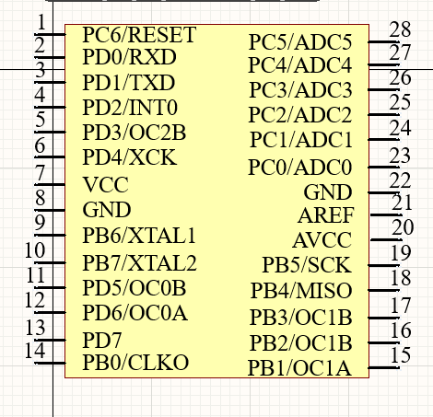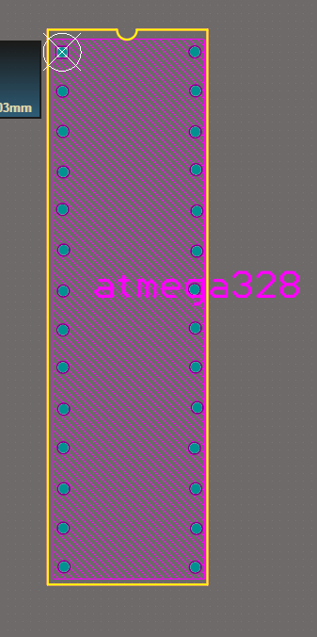**

Figure 2. schematic

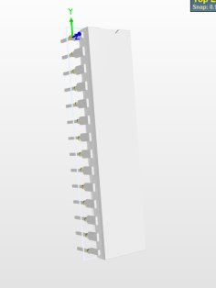

Figure .3 3D Model

Figure .2 footprint

The high-performance Microchip 8-bit AVR RISC-based microcontroller combines 32 KB ISP Flash memory with read-while-write capabilities, 1024B EEPROM, 2 KB SRAM, 23 general purpose I/O lines, 32 general purpose working registers, three flexible timer/counters with compare modes, internal and external interrupts, serial programmable USART, a byte-oriented Two-Wire serial interface, SPI serial port, a 6-channel 10-bit A/D converter (8-channels in TQFP and QFN/MLF packages), programmable watchdog timer with internal oscillator, and five software selectable power saving modes. The device operates between 1.8-5.5 volts.

Atmega328 is one the 8 bit microcontroller from Atmel Corporation.

It includes 28 pins in which 13 pins are GPIO pins.

5V and GND are used to power to the systems depending on the need of it.

It comes in various packages but DIP-Dual Inline Package is used in this project.

IDE used for the programming of this controller is Arduino IDE.

* 1. **Seven Segment Display**

**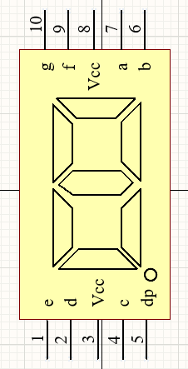**

Figure 2.4 schematic

**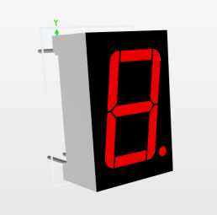**

Figure 2.6 3D Model

**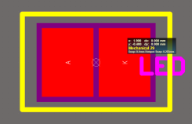**

Figure 2.5 footprint

The 7-segment display, also written as “seven segment display”, consists of seven LEDs (hence its name) arranged in a rectangular fashion as shown. Each of the seven LEDs is called a segment because when illuminated the segment forms part of a numerical digit (both Decimal and Hex) to be displayed.

An additional 8th LED is sometimes used within the same package thus allowing the indication of a decimal point, (DP) when two or more 7-segment displays are connected together to display numbers greater than ten.

It comes in two options common Anode which has every anode terminal of the segment is shorted and common Cathode which has every cathode terminal of the segment is shorted.

**Operating forward voltage**: 1.9-2.2V.

**Operating forward current**: 30mA.

There are total 4 common anode seven segment displays are used and multiplexed with each other.

To limit current resistors are used.

**Resistor**

**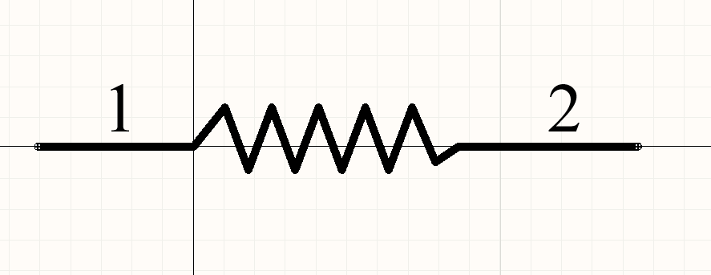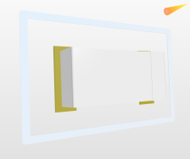**

Figure 2.7 schematic

Figure 2.9 3D model

**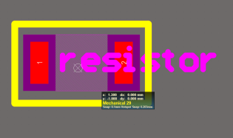**

Figure 2.8 footprint

A resistor is **an electrical component that limits or regulates the flow of electrical current in an electronic circuit**. Resistors can also be used to provide a specific voltage for an active device such as a transistor.

Schematic

Resistor type: SMD (Surface Mount Device)

Resistance : 150 ohm and 2.5k ohm

* 1. **LED**

**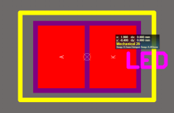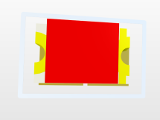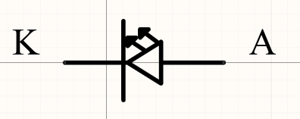**

Figure 2.11 footprint

Figure 2.12 3D Model

Figure 2.10 schematic

A **light-emitting diode** (**LED**) is a semiconductor light source that emits light when current flows through it. Electrons in the semiconductor recombine with electron holes, releasing energy in the form of photons. The color of the light (corresponding to the energy of the photons) is determined by the energy required for electrons to cross the band gap of the semiconductor.

Here LED used is SMD type. Operating forward voltage of the LED is between of 1.8 to 2.4 V according to the datasheet of the LED and operating current is 20mA.

The purpose to use this LED in project to differentiate hour and minute display unit.

Footprint includes dimensions of the LED like length and width which are collected from the datasheet of the component.

Along with that resistor of 150 ohm resistance is it is placed between of hour and minute display unit.

**Transistor**

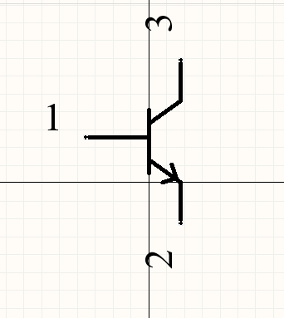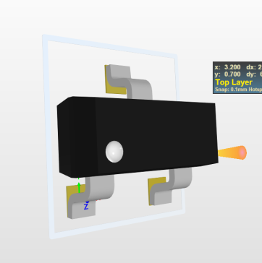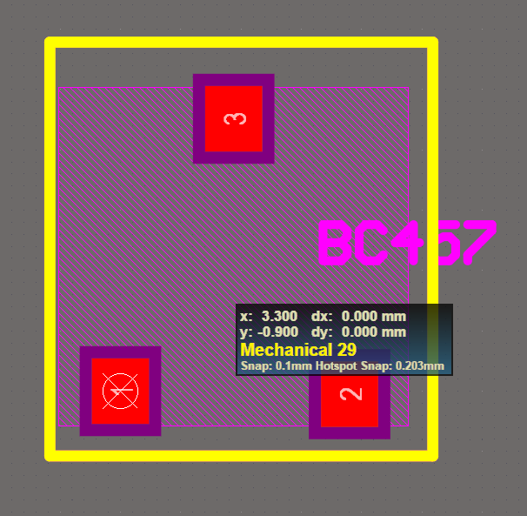

Figure 2.13 schematic

Figure 2.15 3D Model

Figure 2.14 footprint

A transistor is a semiconductor device used to amplify or switch electrical signals and power. The transistor is one of the basic building blocks of modern electronics. It is composed of semiconductor material, usually with at least three terminals for connection to an electronic circuit. A voltage or current applied to one pair of the transistor's terminals controls the current through another pair of terminals. Because the controlled (output) power can be higher than the controlling (input) power, a transistor can amplify a signal. Some transistors are packaged individually, but many more are found embedded in integrated circuits.

**Basic Knowledge of BC547 Transistor Parameters**

Followings are the key knowledge of BC547 that you must understand:

* BC547 is a bipolar junction transistor (BJT).
* It is kind of an NPN transistor.
* It has three terminals: Emitter, Collector and Base.
* The maximum current gain of BC547 is 800A.
* The Collector−Emitter Voltage is 65V.
* The Collector-Base Voltage is 80V.
* The Emitter-Base voltage is 8V.

**Capacitor**

**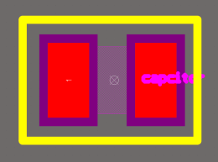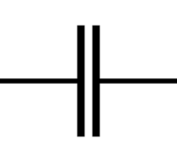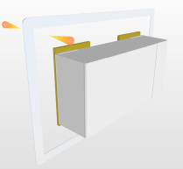**

Figure 2.17 footprint

Figure 2.16 schematic

Figure 2.18 3D Model

**C**apacitor, device for storing electrical energy, consisting of two conductors in close proximity and insulated from each other. A simple example of such a storage device is the parallel-plate capacitor. If positive charges with total charge +Q are deposited on one of the conductors and an equal amount of negative charge −Q is deposited on the second conductor, the capacitor is said to have a charge Q .

12 Pico farad capacitor is recommended to use when microcontroller is operating in range of 4-20 MHz frequency according to datasheet. It

Too little capacitance raises oscillator frequency, and risks a feeble oscillator that refuses to oscillate.  
Too much capacitance runs at a lower oscillator frequency, and risks damaging the crystal with too much power. Such a robust oscillator can also potentially run at spurious crystal resonances other than the fundamental frequency. In this simple simulation, only the fundamental crystal resonance is included.

**Push Button**

**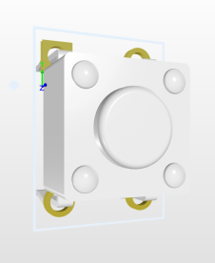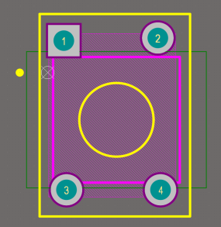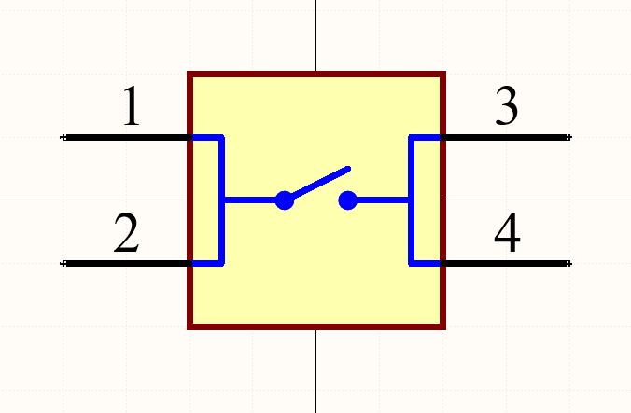**

Figure 2.21 3D Model

Figure 2.20 footprint

Figure 2.19 schematic

It simply used to connect to different connections together.

**3. Simulation**

**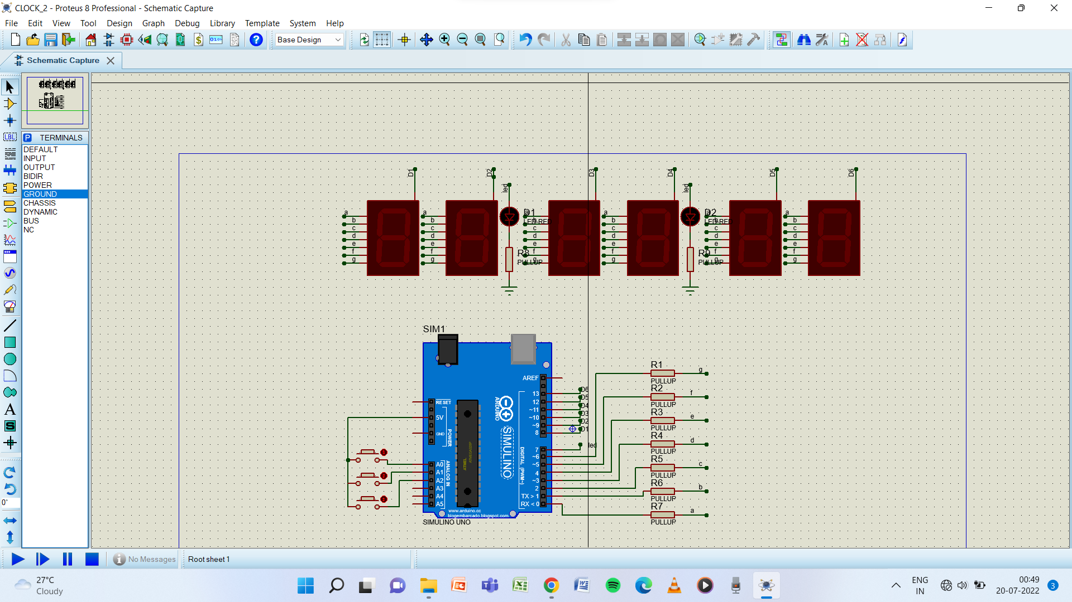**

This is the simulation performed in Proteus which is one of most popular softwares used in electronics industry for the prototyping purpose. A simulation imitates the operation of real world processes or systems with the use of models. The model represents the key behaviors and characteristics of the selected process or system while the simulation represents how the model evolves under different conditions over time. Simulations are usually computer-based, using a software-generated model to provide support for the decisions of managers and engineers as well as for training purposes. Simulation techniques aid understanding and experimentation, as the models are both visual and interactive. Simulation systems include discrete event simulation, process simulation and dynamic simulation. Businesses may use all of these systems across different levels of the organization.

Figure 3.1 simulation

### 4. Schematic

### Screenshot 2022-07-18 003344.png

Figure .1 schematic

### For the schematics design Altium Schematic editor is used.

### A schematic diagram is a logical and visual representation of an electrical circuit. It is the very first step of electronic product design. Earlier, designers used to draw the circuit diagram on paper. Now, they have started to use PCB design tools (M-CAD and E-CAD) which have simplified the design process. It is advised to designers to follow standard schematic guidelines to have a well-structured and error-free design. Today, designers use numerous EDA (electronic design automation) tools such as Altium, Allegro, Pads, Kicad, Tinycad, Express PCB, and so on. These design tools ensure that the schematic circuits are error-free as they continually monitor logical and connection errors. Designers need to follow a standard design rule to make the circuit machine-readable.

### 5. PCB Design

### footprints.png

Figure .1 PCB design

### A printed circuit board or PCB, is a plate or board used for placing the different elements that conform an electrical circuit that contains the electrical interconnections between them.The most simple printed circuit boards are the ones that contains copper tracks or interconnects only on one of its surfaces. These kinds of boards are known as 1 layer printed circuit board or 1 layer PCB. The most common PCB's manufactured today are the ones that contain 2 layers, that is, you can find interconnects in both surfaces of the board. However, depending on the physical complexity of the design ( PCB layout ), the boards can be manufactured of 8 or more layers.

### 6. 3D visualization of the PCB

### board.png

Figure .1 3D PCB

### For the 3D visualization 3D Models are imported from the 3dcontentcentral.com website.PCB 3D design software to help you prepare your circuit board for manufacturing and assembly processes. Designing electronics in the late 1990s or early 2000s was a very different experience than it is today. Older designs often weren’t limited in terms of board space, and mechanical constraints weren’t as difficult to satisfy for most products. As electronic components got smaller, their enclosures became more intricate. Today, it’s essential to investigate the mechanical aspects of a PCB alongside its electrical behavior. Instead of working out the mechanical details of your circuit board with multiple CAD programs and prototypes, you need a design platform that allows 2D and 3D PCB design in a single interface. Altium Designer is the only PCB 3D design software application that includes a complete set of electrical design tools and integrates with popular MCAD applications like Solid Works. You can design more advanced products with sleek enclosures when you use Altium Designer.

### 7. Layer stack

### stack manager.png

Figure .1 Stack manager

### The PCB is designed and formed as a stack of layers. In the early days of printed circuit board (PCB) manufacturing, the board was simply an insulating core layer, clad with a thin layer of copper on one or both sides. Connections are formed in the copper layer(s) as conductive traces by etching away (removing) unwanted copper.

### The Layer Stack Manager

### The definition of the PCB layer stack is a critical element of successful printed circuit board design. No longer just a series of simple copper connections that transfer electrical energy, the routing of many modern PCBs is designed as a series of circuit elements, or transmission lines.

### Achieving a successful, high-speed PCB design is a process of balancing the material selection and layer stack up and assignment, against the routing dimensions and clearances, to achieve suitable single-sided and differential routing impedances. There are also numerous other design considerations that come into play when designing a modern, high-speed PCB, including: layer-pairing, careful via design, possible back drilling requirements, rigid/flex requirements, copper balancing, layer stack symmetry and material compliance.

### The Layer Stack Manager brings together all of these layer-specific design requirements, into a single editor.

## ****The meaning of layers in the PCB****

Signal Layers**:**

Signal layers include Top Layer, Bottom Layer, and Mid Layer 1…30.  
These layers are all layers with electrical connections, that is, the actual copper layers.  
The middle layer refers to the middle board layer used for wiring. The layer is covered with wires.

Top Layer.

The top layer, also called the component layer, is mainly used to place components.  
For double layers and multilayer, it can be used to arrange wires or copper.

Bottom signal layer (Bottom Layer), also known as solder layer, is mainly used for wiring and soldering. For double-layer board and multilayer board, components can be placed.  
Mid-Layers can have up to 30 layers and are used to arrange signal lines in the multilayer board.  
This does not include power lines and ground lines.

Paste Mask:  
The solder paste layer, which includes the top paste layer and the Bottom paste layer,  
refers to the exposed surface mount pads that we can see.  
It is the part that needs to be coated with solder paste before welding.  
Therefore, this layer is also useful when the pad is hot-air leveled and welded stencils are made.

Mechanical Layers:  
Up to 16 mechanical layers can be selected.  
Designing a double panel requires only the default option Mechanical Layer 1.  
The mechanical layer is the definition of the appearance of the entire PCB board,  
it is generally used to place the instructional information on the board and assembly methods,  
such as the PCB’s dimensions, dimensions, data, information, PCB assembly instructions and other information.

Designed as a PCB mechanical shape, the default LAYER1 is the outline layer.  
Other LAYER2/3/4 can be used as mechanical dimensioning or special purpose.  
For example, LAYER2/3/4 can be used when some boards need to make conductive carbon oil,  
but the use of this layer must be clearly marked on the same layer.

Mask Layers Altium Designer provides two types of mask layers, Solder Mask and Paste Mask,  
with two layers, the top layer and the bottom layer.

Keep Out Layer:  
Defines the boundaries of the wiring layer.  
After defining the disabling of the wiring layer, the wiring with the electrical characteristics cannot exceed the boundary of the disabling wiring layer in the subsequent wiring process.  
Many designers also use the mechanical shape of the PCB.

If there are KEEPOUT and MECHANICAL LAYER1 on the PCB, the appearance of the two layers is mainly determined by the appearance of MECHANICAL LAYER1.  
It is recommended to use MECHANICAL LAYER1 as the outline when designing.  
If using KEEPOUT LAYER as the outline, do not use MECHANICAL LAYER1 again to avoid confusion!

Drill Layer:  
Drill guide and Drill drawing are drilling data.  
Drilling layers provide drill hole information during the board manufacturing process (e.g., pads, which require drilling).  
Propel 99 SE provides two drilling layers, Drill grid and Drill drawing.

Multi-layer:  
refers to all layers of the PCB board.  
The pads on the circuit board and through-holes penetrate the entire circuit board and establish electrical connections with different conductive pattern layers.

Therefore, the system specifically sets up an abstract layer—multilayer.  
In general, the pads and vias should be placed on multiple layers. If this layer is closed, the pads and vias cannot be displayed.

Solder mask:  
Solder mask refers to the green oil part of the board; because it is a negative output,  
so actually the actual effect of the solder mask part is not on the green oil, but the tin plating, silvery white!

paste mask, which is used when the device is mounted on a chip. It is the pad corresponding to all the patch components. The size is the same as that of the top layer/bottom layer.  
It is used to open the steel mesh for tin leakage.

### 

### 8. Layers used in project

Top overlay:

The Top Overlay layer is used to label the component's projection profile, the component's label, nominal value or model number, and various comment characters. The Bottom Overlay is the same as the top screen layer.

Top soldier:

Top solder layer is a thin layer of polymer that is put on a circuit board to protect the copper from oxidation and shorts during operation. It also protects the PCB from environmental influences such as dust and several other contaminants that may lead to shorts in the long run.

### L1:

### It is the first signal layer which is used in this design.

### It is used for connecting terminals of the components with each other so that signal can passed.

### Dielectric:

### Dielectric layer is used for separating two different signal layers so that they don’t get shorted.

### L2:

### It is the second signal layer which works same as L1.

### Bottom soldier layer:

### It is the soldier layer which includes soldier paste so that components can be soldiered with each other.

### Bottom overlay:

### It is similar to the top overlay layer, there is only difference is this is bottom layer and used to label the component's projection profile, the component's label, nominal value or model number, and various comment characters. The Bottom Overlay is the same as the top screen layer.

### 9. Layers and drawings in Gerber file

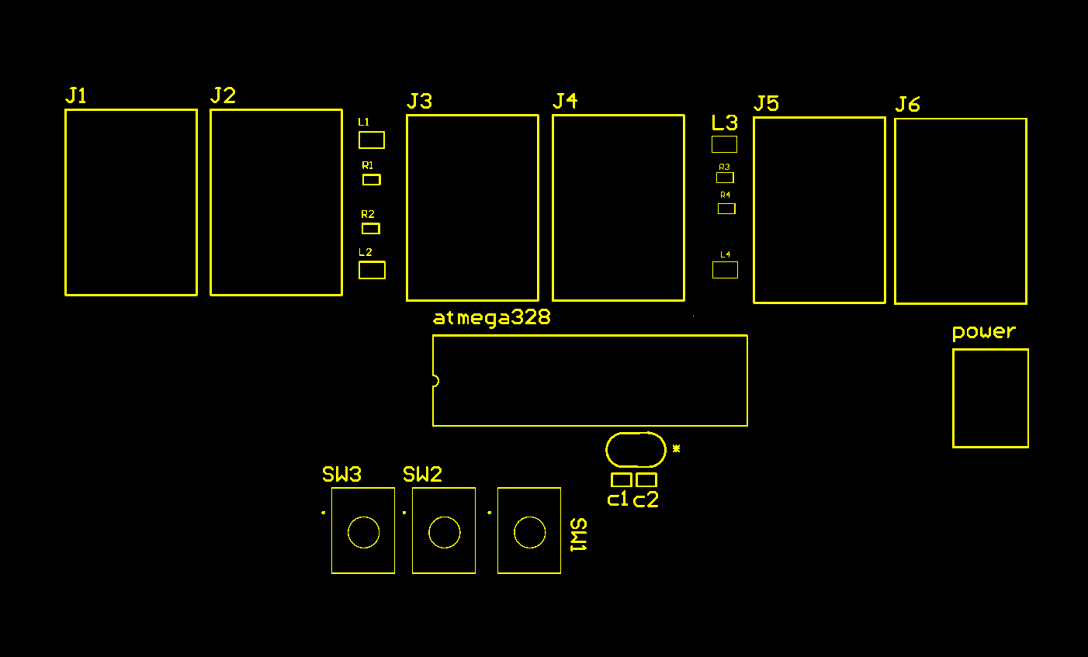9.1 Top overlay layer

Figure 9.1 Top overlay layer

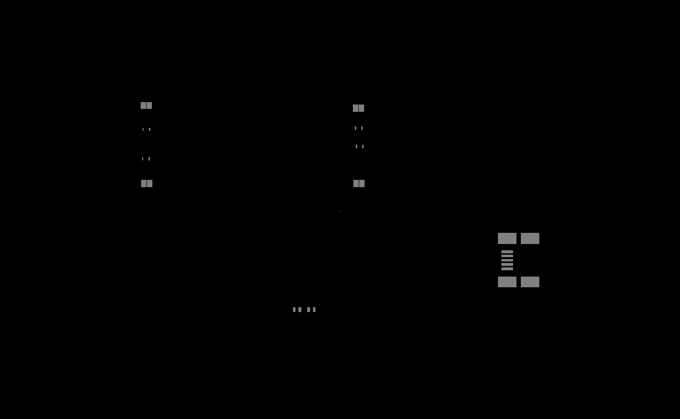9.2 Top soldier mask layer

Figure 9.2 Top soldier mask layer

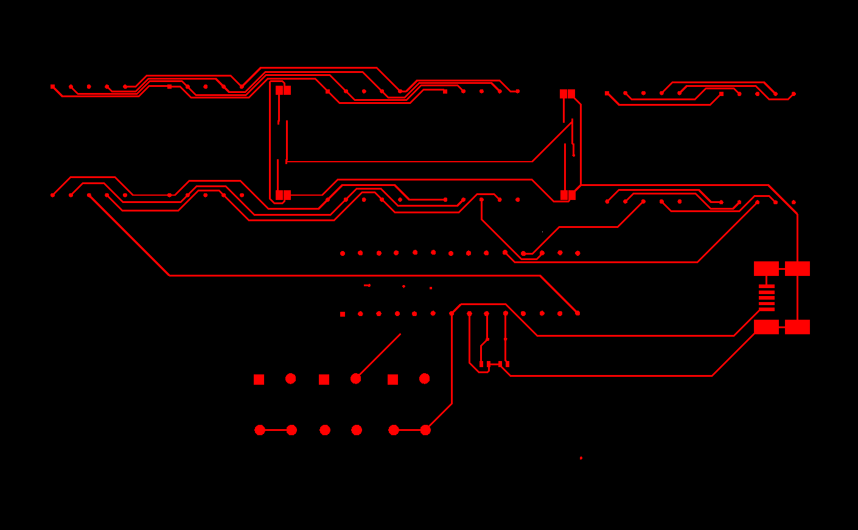9.3 Top signal layer

Figure 9.3 Top signal layer

9.4 Bottom signal layer

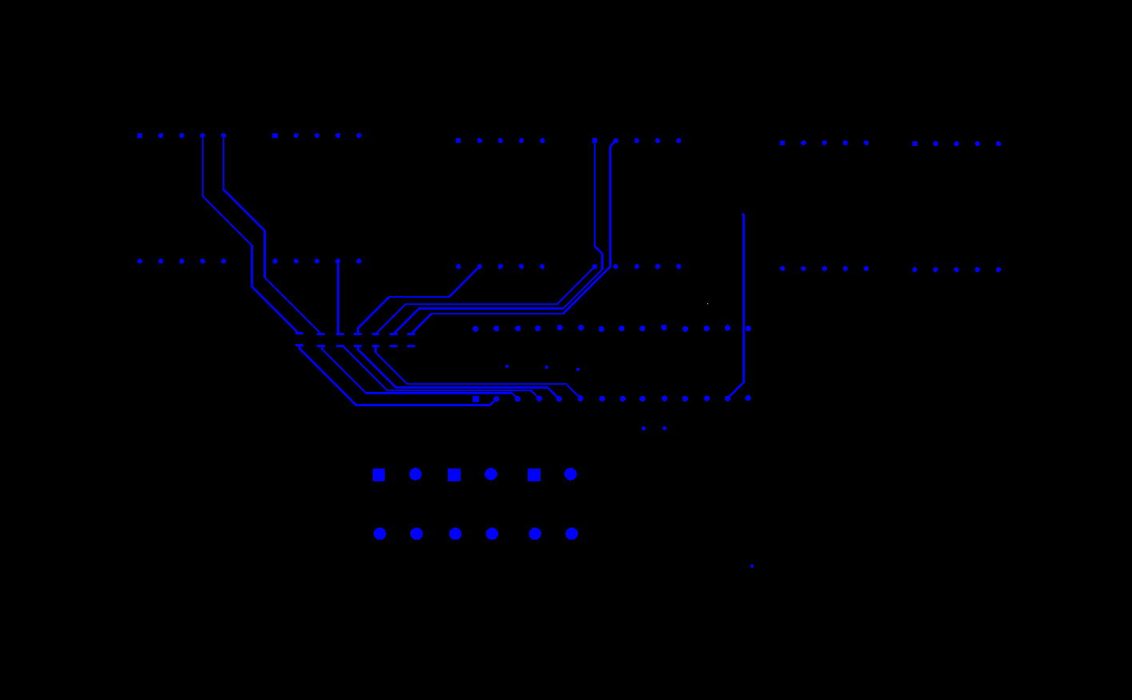

Figure 9.4 Bottom signal layer

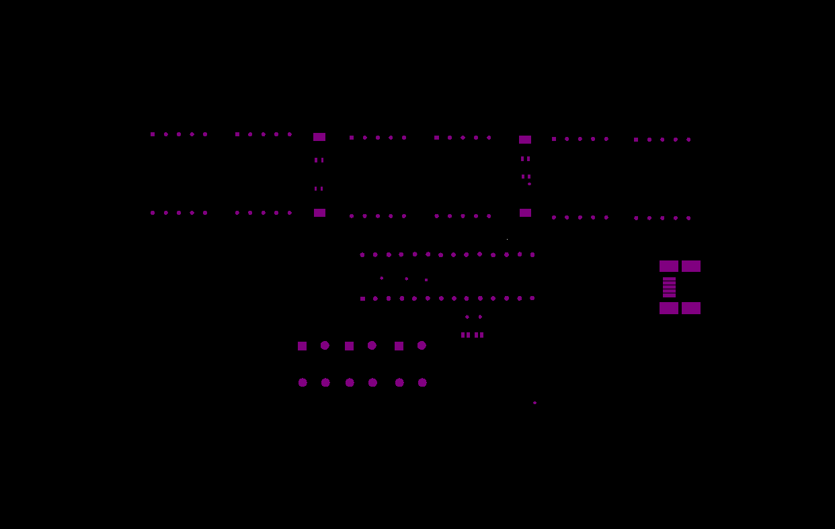9.5 Top view mechanical layer

Figure 9.5 Top view Mechanical layer

### 9.6 Bottom view mechanical layer

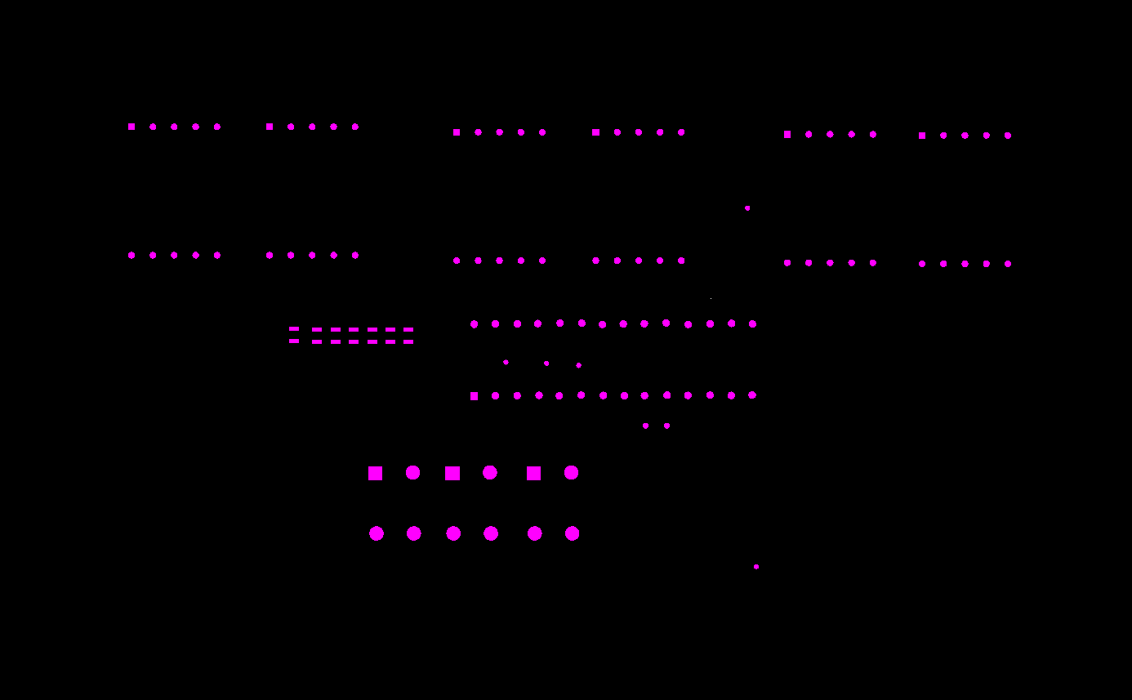

Figure 9.6 Bottom View Mechanical layer

9.7 Assembly drawing top view

### assembly drawing.png

Figure 9.7 Assembly Drawing

### 9.8 Assembly drawing bottom view

Figure 9.8 Assembly drawing

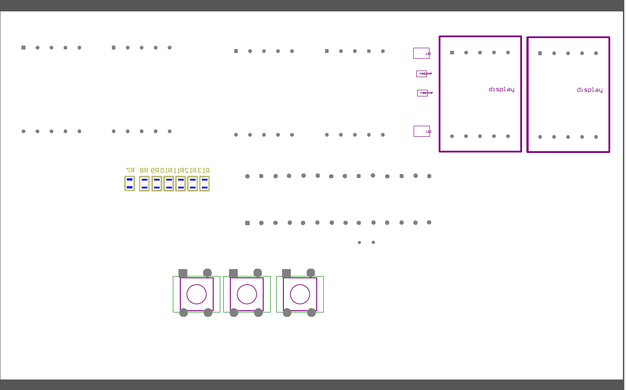

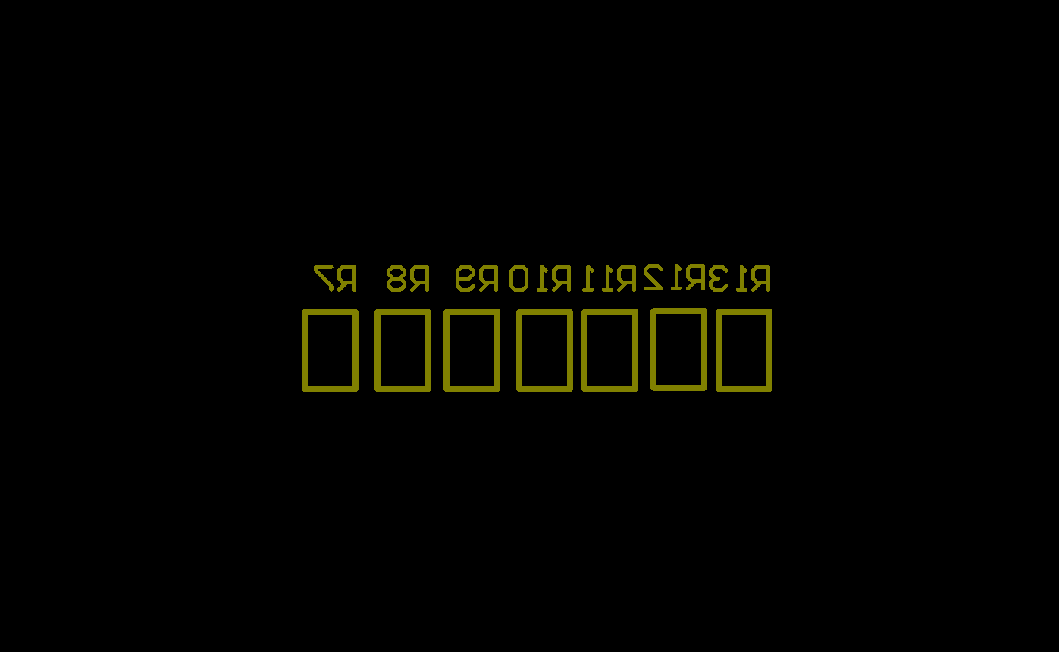9.9 Bottom overlay layer

Figure 9.9 Bottom overlay

### 9.10 Bottom soldier mask layer

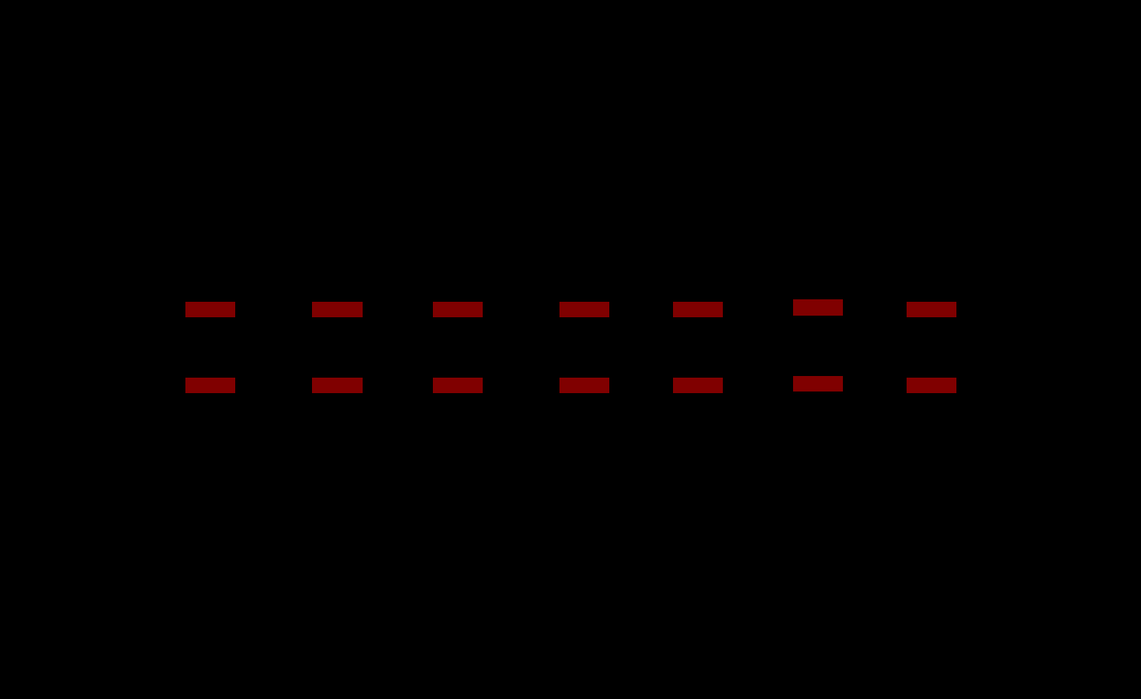

Figure 9.10 Bottom soldier mask layer

### 9. Conclusion

### Conclusion:

### At the end of this project many necessary files which are important for the further manufacturing process like Gerber file, NC drill file, 3D PDF are generated.

### Schematics page, PCB design and 3D Model of the board is created from scratch.

Got to learn many things about datasheets and information like dimensions and parameter of the

Components can be retrieved.