**Web Development with PHP**

#### A PROJECT REPORT

***Submitted by***

## Ahir Chirag Bhupatbhai

#### 180170111001

***In partial fulfillment for the award of the degree of***

## BACHELOR OF ENGINEERING

***In***

#### Electronics and Communication

**Vishwakarma Government Engineering College, Chandkheda**



## Gujarat Technological University, Ahmedabad

May, 2022

 

## Vishwakarma Government Engineering College

Vishwakarma Government Engineering College,

Nr. Visat three roads, Sabarmati-Koba highway, Chandkheda, Ahmedabad, Gujarat, India-382424

# CERTIFICATE

This is to certify that the internship report submitted along with the internship entitled **Web Development with PHP** has been carried out by **Ahir Chirag Bhupatbhai** under my guidance in partial fulfillment for the degree of Bachelor of Engineering in Electronics and Communication, 8th Semester of Gujarat Technological University, Ahmadabad during the academic year 2022-23.

Prof. Jayesh Diwan Prof. Arun Nandurbarkar

Internal Guide Head of the Department



**COMPLETION CERTIFICATE OF INTERNSHIP**

This is to certify that Mr. Chirag B. Ahir final year student of Vishwakarma Government Engineering College, Chandkheda has successfully completed 3 months long internship programme starting from 3rd January 2022 to 28th March 2022 at Agile Infoways Pvt. Ltd.

He has worked as a Web development intern and worked on front-end as well as back-end technologies. During the period of his internship programme with us he was found punctual, hardworking and quick-learner also he gone through real life projects and client side interface.

For being an enthusiastic and keen learner we wish him Good luck and success for his future endeavours.



Authorized Signatory Kailesh K. Sanjava Agile Infoways Pvt Ltd.



 

## Vishwakarma Government Engineering College

Vishwakarma Government Engineering College,

Nr. Visat three roads, Sabarmati-Koba highway, Chandkheda, Ahmedabad, Gujarat, India-382424

# DECLARATION

I hereby declare that the Internship / Project report submitted along with the Internship / Project entitled **Web Development with PHP** submitted in partial fulfillment for the degree of Bachelor of Engineering in Electronics and Communication to Gujarat Technological University, Ahmedabad, is a bonafide record of original project work carried out by me at Agile Infoways Pvt. Ltd. under the supervision of Prof. Jayesh Diwan and that no part of this report has been directly copied from any students’ reports or taken from any other source, without providing due reference.

Name of the student Sign of student

1. Ahir Chirag Bhupatbhai

# ACKNOWLEDGEMENT

I wish to express my sincere gratitude to both of my internal and external mentors Prof. Jayesh Diwan and Mr. Kailesh K. Sanjava from Agile Infoways and all the faculty members for helping us through my internship by giving me the necessary suggestions and advices along with their valuable co-ordination in completing this internship.

I also thank our parents, friends and all the members of the family for their precious support and encouragement which they had provided in completion of my Internship. In addition to that, I would also like to mention the college personals who gave me the permission to use and experience the valuable resources required for the Internship from the college premises.

Thus, In conclusion to the above said, I once again thank the faculties and members of Vishwakarma Government Engineering College for their valuable support in completion of the Internship.

Thank You, Ahir Chirag B.

# ABSTRACT

*As the demand for online education increases after covid pendemic so does the need for omline study resources and materials increases. One of the key components of the online education is the getting best resources from the Internet. It’s hard for the students to find their needs because sometimes they have to pay for resources and sometimes they are not getting related materials for their study hence they are not getting good score in the Examination. Our aim is to provide the best study materials to the students without any cost.*

*The contents of this report are about the basics of a web development. The website has been created using the prior knowledge of frontend technologies coupled with Bootstrap as a framework tool. The layout of website has been created using online plateform Figma where I developed a wireframe. The code is uploaded on the GitHub plateform and Deployment is done through Netlify deployment service.*

*The performance of the website was measured in* [*GTmetrix*](https://gtmetrix.com/reports/ec-master.netlify.app/7E9mSvWO/) *to verify its performance. In most cases, the objectives of the project were met. You can get the detailed performance of this website by* [*click here*](https://gtmetrix.com/reports/ec-master.netlify.app/lwCzf9ds/)*. The future work can be divided into work on the collect more informative materials or resources and understand student’s needs from their feedbacks. Moreover I thanks to my project partners Aman Joshi, Abdul Azim and Harsh Vataliya for their kind support in making this project.*

*To view my project tap on the link provided:* [*https://Bit.ly/ecmaster*](https://bit.ly/ecmaster)

#### List of Figures

Fig 1.1 HTML Logo 2

Fig 1.2 Paragraph tag example 3

Fig 1.3 Paragraph style example 4

Fig 1.4 Class attribute 4

Fig 1.5 HTML Structure 6

Fig 2.1 CSS Logo 8

Fig 2.2 CSS Rules 9

Fig 2.3 CSS Linking 9

Fig 2.4 CSS Box Modal 11

Fig 2.5 CSS FlexBox modal 13

Fig 2.6 CSS FlexBox Architecture 13

Fig 2.7 CSS Grid Architecture 14

Fig 2.8 CSS Media Query Example 16

Fig 2.9 CSS Media Query On Different Screen Sizes 16

Fig 3.1 JavaScript Variables 18

Fig 3.2 JavaScript Embedded Method 19

Fig 3.3 JavaScript Event Attribute 19

Fig 3.4 JavaScript External Method 20

Fig 3.5 JavaScript Reference File Method 20

Fig 3.6 JS Hoisting Function 22

Fig 3.7 JS Arrow Function 23

Fig 3.8 JS Spread Operator 23

Fig 3.9 JS Module Example 24

Fig 3.10 JS Window Events 24

Fig 3.11 JS Mouse Events 25

Fig 3.12 JS Form Events 25

Fig 3.13 JS Mini Project Output 25

Fig 4.1 Bootstrap Logo 26

Fig 4.2 Bootstrap Container 27

Fig 4.3 Bootstrap Container-fluid 28

Fig 4.4 Bootstrap Padding Classes 28

Fig 4.5 Bootstrap Grid System Layout 29

Fig 4.6 Bootstrap Three Column Layout 30

Fig 4.7 Bootstrap Listgroup 31

Fig 4.8 Bootstrap Listgroup active class 31

Fig 4.9 Bootstrap Listgroup with icons 32

Fig 4.10 Bootstrap Images 33

Fig 4.11 Bootstrap Image Alignments 34

Fig 4.12 Bootstrap Buttons 35

Fig 4.13 Bootstrap Primary Buttons 35

Fig 4.14 Bootstrap Dropdowns 36

Fig 4.15 Bootstrap Forms 38

Fig 4.16 Bootstrap Navbar 39

Fig 5.1 GIT and GitHub logo 40

Fig 6.1 Figma Logo 42

Fig 7.1 PHP Logo 43

Fig 7.2 PHP Syntex 45

Fig 7.3 PHP Conditions 46

Fig 7.4 PHP For Loop 47

Fig 7.5 PHP While Loop 47

Fig 7.6 PHP Do While loop 47

Fig 7.8 PHP For each loop 48

Fig 7.9 PHP Post project output 49

Fig 7.10 XAMPP Logo 50

Fig 7.11 XAMPP Control Panel 51

Fig 7.12 PHP MyAdmin dashboard 54

Fig 8.1 Website Prototype 55

Fig 8.2 JS AOS library example 56

**List of Tables**

Table 1.1 Block level elements VS Inline elements 7

Table 5.1 Basic Git Commands 41

Table C1 Project Codes 59

**Table of Contents**

Acknowledgement i

Abstract ii

List of Figures iii

List of Tables v

Table of Contents vi

About company ix

What is Web development 1

Chapter 1 Introduction to HTML 2

* 1. HTML Use cases 2
  2. Main parts of an element 3
  3. Pros and cons of HTML 5
  4. How are HTML CSS JS related 5
  5. Most used HML elements 6
     1. Block level elements 6
     2. Inline elements 7

Chapter 2 Introduction to CSS 8

* 1. Connecting CSS file with HTML page 8
  2. CSS Box Modal 10
  3. CSS Flex Box 12
  4. CSS Grid system 13
     1. Grid Parent properties 14

2.4.1 Grid Child properties 15

* 1. CSS Media queries 15

[Chapter 3 Introduction to JavaScript 17](https://www.instagram.com/gtu_brainheaters)

* 1. Introduction to JS 17
  2. JavaScript variables 17
  3. Features of JavaScript 18
  4. Working of JavaScript 19
  5. Adding JS to HTML page 19
  6. Weakness of JavaScript 20
  7. JS DOM modal 21
  8. JS scope 21
  9. JS closures 22
  10. JS hoisting 22
  11. ES6 latest version of JS 23
  12. JS events 24

Chapter 4 Introduction to Bootstrap Framework 26

* 1. Introduction to Bootstrap 26
  2. Advantages of using Bootstrap 27
  3. Bootstrap containers 27
  4. Bootstrap padding and margins 28
  5. Bootstrap grid system 29
  6. Bootstrap list group 30
  7. Working with images 32
  8. Alignment of images 33
  9. Bootstrap buttons 34
  10. Bootstrap dropdown menus 36
  11. Bootstrap forms 36
      1. Verticle form layout 37
      2. Horizontal form layout 37
      3. Inline form layout 37
  12. Bootstrap navbar 38

Chapter 5 Git and GitHub 40

* 1. Understanding about GIT and GitHub 40
     1. Setting up an online GIT repository 40
  2. Basic GIT commands 40

Chapter 6 Understanding about Figma 42

6.1 Introduction to Figma designing tool 42

Chapter 7 What are PHP and XAMPP? 43

* 1. PHP Installation 44
  2. Features of PHP 44
  3. Basic PHP syntex 44
  4. PHP Variables 45
  5. PHP Conditional statements 45
  6. PHP Loops 46
  7. PHP arrays 48
  8. PHP POST vs GET method 49
  9. What is XAMPP 50
  10. XAMPP control panel 51
  11. About PHPMySQL 52
  12. Creating a database 52
  13. Selecting a database 53
  14. About PHPMyAdmin 54

Chapter 8 Developing final project 55

* 1. JavaScript AOS library 56
  2. Designing of navbar and serchfield 56
  3. Designing Header photo and header text 57
  4. Designing About Us section 57
  5. Designing service section 57
  6. Designing education section 57
  7. Designing of number counter 57
  8. Designing of Testimonial and Featured section 57
  9. Designing of contact us form 57
  10. Designing of footer 58
  11. Designing of sidebar nav 58
  12. Making website responsive 58

Conclusion 59

References 60

# ABOUT COMPANY



**A COMPLETE CREATIVE SOLUTIONS**

**PROVIDER FOR WEB, MOBILE & SOFTWARE**

AGILE Infoways Pvt Ltd is an IT development outsourcing firm based in India. Agile Infoways, which was founded in 2006, is a pioneer in the field of information technology. With a team of 200+ in-house talents, we have a worldwide presence in India, the United States, and Canada. Our passion and belief in becoming the finest has made us the most sought-after organisation on the planet. We believe in putting ourselves in the shoes of our clients in order to improve their product in new and exciting ways. Our professionals have the ability to communicate the most effective solutions. We guarantee that clients will be able to present their distinctive ideas to the market in a more straightforward manner. We value timeliness and consider quality to be the most important aspect of our job.

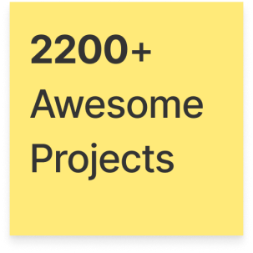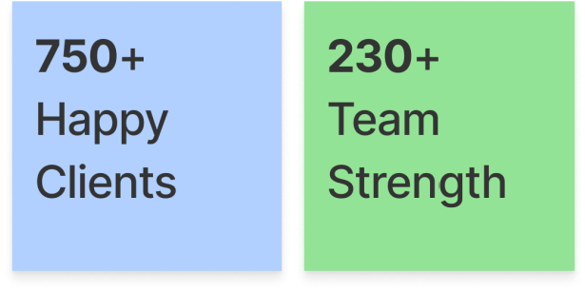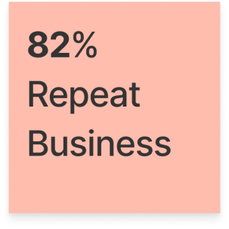

COMPANY WEBSITE: [HTTPS://WWW.AGILEINFOWAYS.COM/](https://www.agileinfoways.com/)

[ ix ]

### WHAT IS WEB DEVELOPMENT?

Web development is the work that goes into making and managing websites; it's the work that goes into making a website look attractive, run swiftly, and give a consistent user experience.

Web developers, sometimes known as "devs," use a variety of computer languages to do this. The languages they use are dictated by the tasks they complete and the platforms they use.

Web development talents are in high demand and well compensated all across the world, making it an excellent career choice. It is one of the most easily accessible higher-paying industries because it does not require a typical university degree.

The area of web development is divided into two parts: front-end development (the user-facing side or client side) and back-end development (the back-end or the server side).

Let's get into the specifics. In India, a web developer's salary for a fresher is approximately a minimum of ₹125,000 while that of an experienced developer's salary is approximately

₹890,000.

#### WHAT IS THE DISTINCTION BETWEEN FRONTEND | BACKEND DEVELOPMENT?

A front-end dev deals with format, plan, and intuitiveness utilizing HTML, CSS and JavaScript. They take a thought from the planning phase and transform it into the real world. What you see and what you use, like the visual part of the site, the drop down menus and the text, are completely united by the front-end dev, who composes a progression of projects to tie and design the components, make them look great and add intuitiveness. These projects are gone through a program.

What happens behind the scenes is handled by the backend developer. This is where the data is kept, and without it, the frontend would be useless. The server that hosts the website, an application to operate it, and a database to store the data make up the backend of the web.

Backend developers use software programs to guarantee that the server, application, and database all work together smoothly. Backend developers use a number of server-side languages, including PHP, Ruby, Python, and Java, to accomplish all of this incredible work.

**CHAPTER 1 INTRODUCTION TO HTML**

HTML (stands for Hypertext Markup Language) is a computer language that makes up most web pages and online applications. A hypertext is a text that is used to reference other pieces of text, while a markup language is a series of markings that tells web servers the style and structure of a document.

HTML, or HyperText Markup Language, allows web users can create and structure sections, paragraphs, and links using elements, tags, and attributes. However, it’s worth nothing that HTML is not considered a programming language as it can’t create dynamic functionality.



Figure 1.1 HTML Logo

#### HTML USE CASES:

* Web development. Developers use HTML code to design how a browser displays web page elements, such as text, hyperlinks, and media files.
* Internet navigation. Users can easily navigate and insert links between related pages and websites as HTML is heavily used to embed hyperlinks.
* Web documentation. HTML makes it possible to organize and format documents, similarly to Microsoft Word.
* It’s also worth noting that HTML is considered an official web standard. The World Wide Web Consortium maintains and develop HTML specifications, along with providing updates.

The average website includes several different HTML pages. For instance, a home page, an about page, and a contact page would all have separate HTML files.

HTML documents are files that end with a .html or .htm extension. A web browser reads the HTML file and renders its content so that internet users can view it.

All HTML pages have a series of HTML elements, consisting of a set of tags and attributes. HTML elements are the building blocks of a web page. A tag tells the web browser where an element begins and ends, whereas an attribute describes the characteristics of an element.

#### THE THREE MAIN PARTS OF AN ELEMENT ARE:

**Opening tag** – used to state where an element starts to take effect. The tag is wrapped with opening and closing angle brackets. For example, use the start tag <p> to create a paragraph.

**Content** – this is the output that other users see.

**Closing tag** – the same as the opening tag, but with a forward slash before the element name. For example, </p> to end a paragraph.

The combination of these three parts will create an HTML element:

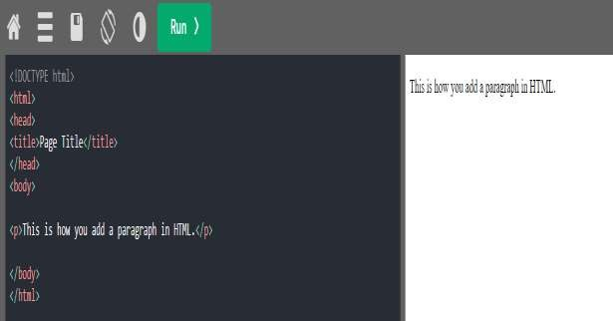

Figure 1.2 Paragraph tag example

Another critical part of an HTML element is its attribute, which has two sections a name and attribute value. The name identifies the additional information that a user wants to add, while the attribute value gives further specifications. For example, a style element adding the color purple and the font-family verdana will look like this:

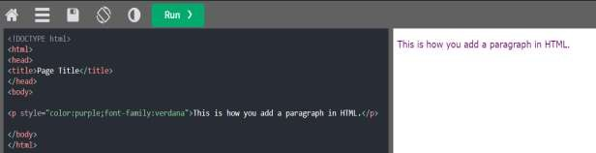

Figure 1.3 Paragraph style example

Another attribute, the HTML class, is most important for development and programming. The class attribute adds style information that can work on different elements with the same class value.

For example, we will use the same style for a heading <h1> and a paragraph <p>. The style includes background color, text color, border, margin, and padding, under the class .important. To achieve the same style between <h1> and <p>, add class=”important” after each start tag:

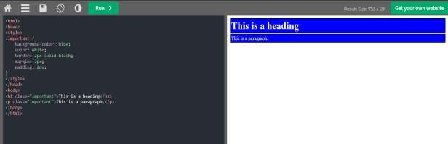

Figure 1.4 Class attribute

Most elements have an opening and a closing tag, but some elements do not need closing tags to work, such as empty elements. These elements do not use an end tag because they do not have content: *<img src="/" alt="Image">*

This image tag has two attributes – an src attribute, the image path, and an alt attribute, the descriptive text. However, it does not have content nor an end tag. Img tag does not requires closing tag.

#### PROS AND CONS OF HTML:

* Pros:
  + 1. Beginner-friendly. HTML has a clean and consistent markup, as well as a shallow learning curve.
    2. Support. The language is widely used, with a lot of resources and a large community behind it.
    3. Accessible. It is open-source and completely free. HTML runs natively in all web browsers.
    4. Flexible. HTML is easily integrable with backend languages such as PHP and Node.js.
* Cons:

1. Static. The language is primarily used for static web pages. For dynamic functionality, you may need to use JavaScript or a back-end language such as PHP.
2. Separate HTML page. Users have to create individual web pages for HTML, even if the elements are the same.
3. Browser compatibility. Some browsers adopt new features slowly. Sometimes older browsers don’t always render newer tags.

HTML is the primary markup language found on the internet. Every HTML page has a series of elements that create the content structure of a web page or application.

HTML is a beginner-friendly language with plenty of support and is mainly used for static website pages. HTML works best together with CSS for the styling and JavaScript for the functionality.

First developed by Tim Berners-Lee in 1990, HTML is short for Hypertext Markup Language. HTML is used to create electronic documents (called pages) that are displayed on the World Wide Web. Each page contains a series of connections to other pages called hyperlinks.

#### HOW ARE HTML, CSS, AND JAVASCRIPT RELATED

HTML is used to add text elements and create the structure of content. However, it is not enough to build a professional and fully responsive website. So, HTML needs the help of Cascading Style Sheets (CSS) and JavaScript to create the vast majority of website content.

CSS is responsible for stylings such as background, colors, layouts, spacing, and animations. On the other hand, JavaScript adds dynamic functionality such as sliders, pop-ups, and photo galleries. These three languages are the fundamentals of front-end development.

HTML is the standard markup language for documents designed to be displayed in a web browser. It can be assisted by technologies such as Cascading Style Sheets and scripting languages such as JavaScript.

#### MOST USED HTML ELEMENTS

Currently, there are 142 HTML tags available that allow for the creation of various elements. Even though modern browsers no longer support some of these tags, learning all the different elements available is still beneficial.

##### Block Level Elements

A block-level element takes up the entire width of a page. It always starts a new line in the document. For example, a heading element will be in a separate line from a paragraph element.

Every HTML page uses these three tags:

<html> tag is the root element that defines the whole HTML document.

<head> tag holds meta information such as the page’s title and charset.

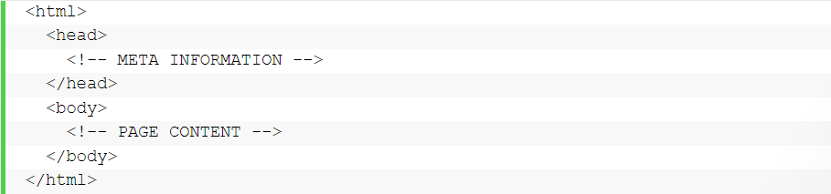<body> tag encloses all the content that appears on the page.

Figure 1.5 HTML Structure Other popular block-level tags include:

Heading tags – these range from <h1> to <h6>, where heading h1 is largest in size, getting smaller as they move up to h6.

Paragraph tags – are all enclosed by using the <p> tag.

List tags – have different variations. Use the <ol> tag for an ordered list, and use <ul> for an unordered list. Then, enclose individual list items using the <li> tag.

##### Inline Elements

An inline element formats the inner content of block-level elements, such as adding links and emphasized strings. Inline elements are most commonly used to format text without breaking the flow of the content.

For example, a <strong> tag would render an element in bold, whereas the <em> tag would show it in italics. Hyperlinks are also inline elements that use an <a> tag and an href attribute to indicate the link’s destination:



The ability to code using HTML is essential for any web professional. Acquiring this skill should be the starting point for anyone who is learning how to create content for the web. Modern website uses HTML for structure CSS for presentation and javascript for behaviour.

Table below shows the list of Block level elements and Inline elements.

Table 1.1 Block level elements VS Inline elements

|  |  |  |  |
| --- | --- | --- | --- |
| **Block level elements** | | **Inline elements** | |
| <address> | <li> | <a> | <br> |
| <dd> | <ol> | <img> | <input> |
| <div> | <table> | <textarea> | <select> |
| <canvas> | <video> | <button> | <object> |
| <main> | <nav> | <span> | <strong> |
| <ul> | <footer> | <sub> | <sup> |

## CHAPTER 2 INTRODUCTION CSS

HTML (HyperText Markup Language) and CSS (Cascading Style Sheet) are the fundamental web development languages. HTML defines a website’s content and structure, while CSS specifies the design and presentation. Together, both languages allow to create a website that is well-structured and functional.



Figure 2.1 CSS Logo

CSS defines style declarations and applies them to HTML documents. There are three different ways to link CSS to HTML based on three different types of CSS styles:

* + - 1. Inline – uses the style attribute inside an HTML element
      2. Internal – written in the <head> section of an HTML file
      3. External – links an HTML document to an external CSS file

#### CONNECTING A CSS STYLE SHEET TO AN HTML FILE:

While there are multiple approaches linking CSS to an HTML file, the most efficient way is to link an external style sheet to an HTML document. It requires a separate document with a .css extension which solely contains all CSS rules without HTML tags.

Unlike internal and inline styles, this method changes many HTML pages by editing one CSS file. It saves time there is no need to change each CSS property on every HTML page.

Start linking style sheets to HTML files by creating an external CSS document using an HTML text editor and adding CSS rules. Here we are making one CSS file using css properties and by giving them values. External stylesheet is best for web development as there are separate files for each HTML page and easy to manage. For instance, here are the style rules of example.css:

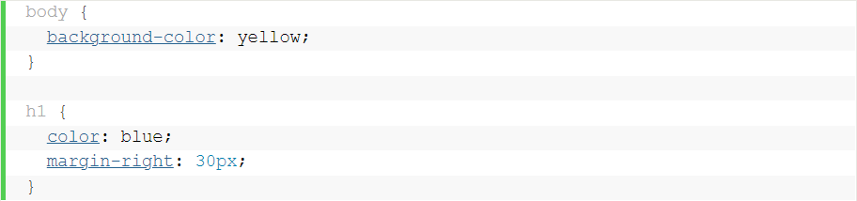

Figure 2.2 CSS Rules

Make sure not to add a space between the property value. For example, instead of margin-right: 30px write margin-right: 30 px.

Then, use the <link> tag in the <head> section of your HTML page to link a CSS file to an HTML document. Next, specify the name of your external CSS file. In this case, it’s example.css so the code will look as follows:



Figure 2.3 CSS linking

For better understanding, here’s a breakdown of the attributes contained within the <link> tag:

* rel – defines the relationship between the linked document and the current one. Use the rel attribute only when the href attribute is present.
* type – determines the content of the linked file or document between the <style> and

</style> tags. It has a text or css as the default value.

* href – specifies the location of the CSS file you want to link to the HTML. If both HTML and CSS files are in the same folder, enter only the file name. Otherwise, include the folder name in which you store the CSS file.
* media – describes the type of media the CSS styles are optimized for. In this example, we put screen as the attribute value to imply its use for computer screens. To apply the CSS rules to printed pages, set the value to print.

Once you’ve included the <link> element in your HTML file, save the changes and enter your website’s URL in your web browser. Styles written in the CSS file should change the look of the website.

Although external CSS helps make the web development process easier, there are a few things to keep in mind that HTML pages might not be rendered properly before the external style sheet is loaded. Furthermore, linking to several CSS documents can increase your website’s loading time.

On that note, if you want to edit a specific HTML element, it might be better to use the inline style method. Meanwhile, the internal or embedded style might be ideal for applying CSS rules to a single page.

CSS is a style sheet language that manages the website’s visual representation. It consists of a list of formatting rules to style elements written in markup languages like HTML. In addition, CSS defines the display of HTML elements on various media types, such as projected presentations or television-type devices.

Whenever a browser finds a style sheet, it’ll convert the HTML file according to the provided style information. Hence, it’s important to link CSS to an HTML file to give your site a more engaging look across devices.

In the end we can say that Embedding CSS rules to HTML elements can be time-consuming and energy-wasting. Luckily, external style sheets make the process more efficient.

#### CSS BOX MODEL:

CSS box modal is a box that wraps around every HTML element. It is used to develop the design and structure of a web page. It can be used as a set of tools to personalize the layout of different components. According to the CSS box model, web browser supplies each element as a square prism. The following diagram illustrates how the CSS properties of width, height, padding, border and margin dictate that how much space an attribute occupy on a HTML web page.

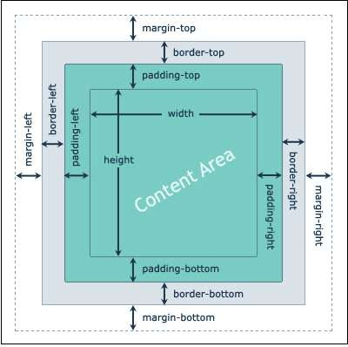

Figure 2.4 CSS Box Modal

The CSS box model contains the different properties in CSS.

* + 1. Border
    2. Margin
    3. Padding
    4. Content

##### Border Field

It is a region between the padding-box and the margin. Its proportions are determined by the width and height of the boundary.

##### Margin Field

This segment consists of the area between the boundary and the edge of the border. The proportion of the margin region is equal to the margin-box width and height. It is better to separate the product from its neighbor nodes.

##### Padding Field

This field requires the padding of the component. In essence, this area is the space around the subject area and inside the border-box. The height and the width of the padding box decide its proportions.

##### Content Field

Material such as text, photographs, or other digital media is included in this area. It is constrained by the information edge, and its proportions are dictated by the width and height of the content enclosure.

Typically, when you assign the width and height of an attribute using the CSS width and height assets, it means you just positioned the height and width of the subject areas of that component.

#### CSS BOX MODAL HAS FOUR AREAS :

Content Area: This area consists of content like text, images, or other media content. It is bounded by the content edge and its dimensions are given by content-box width and height.

Padding Area: It includes the element’s padding. This area is actually the space around the content area and within the border-box. Its dimensions are given by the width of the padding- box and the height of the padding-box.

Border Area: It is the area between the box’s padding and margin. Its dimensions are given by the width and height of the border.

Margin Area: This area consists of space between border and margin. The dimensions of the Margin area are the margin-box width and the margin-box height. It is useful to separate the element from its neighbors.

#### CSS FLEX BOX:

The flexbox or flexible box model in CSS is a one-dimensional layout model that has flexible and efficient layouts with distributed spaces among items to control their alignment structure.

ie., it is a layout model that provides an easy and clean way to arrange items within a container. Flexbox can be useful for creating small-scales layouts & is responsive and mobile-friendly.

There are 2 main components of the Flexbox:

* Flex Container: The parent “div” which contains various divisions is called a flex container.
* Flex Items: The items inside the container “div” are flex items.

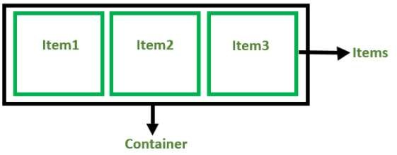

Figure 2.5 CSS FlexBox modal

For creating the flexbox, we need to create a flex container along with setting the display property to flex. While working with Flexbox, we deal with 2 axes: Main Axis and Cross Axis.

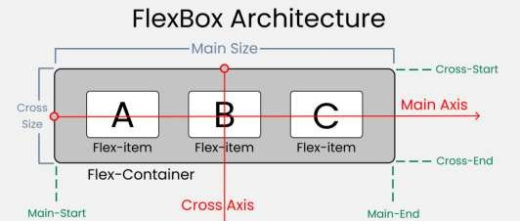

Figure 2.6 CSS FlexBox Architecture

#### CSS GRID SYSTEM :

In Cascading Style Sheets, CSS grid layout or CSS grid creates complex responsive web design grid layouts more easily and consistently across browsers. Historically, there have been other methods for controlling web page layout methods, such as tables, floats, and more recently, CSS Flexible Box Layout. It offers a grid-based layout system, with rows and columns, making it easier to design web pages without having to use floats and positioning.

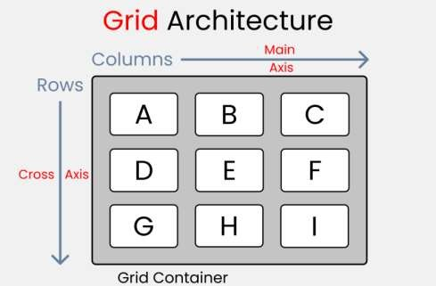

Figure 2.7 CSS Grid Architecture

The whole box which consists of A to I blocks is called Parent and all the box A to I is called their childs.

##### Grid Parent Properties :

1. Grid-template-column: this property is used to define the number and width of columns. You can either individually set the width of each column, or set a uniform width for all columns using the repeat() function.
2. Grid-template-rows: this property is used to define the number and height of rows. You can either individually set the height of each row, or set a uniform height for all rows using the repeat() function.
3. Column-gap: this property use to place a gap between Columns inside the grid.
4. Row-gap: this property use for place a gap between Rows inside the grid.
5. Justify-items: this property use for position grid-items (children) inside grid containers along the X-Axis [Main Axis].
6. Align-items: this property use to position grid-items (children) inside the grid container along the Y-Axis [Cross Axis].
7. Justify-content: this property use to position your grid [Basically everything] inside the grid container along the X-Axis [Main Axis].
8. Align-content: this property use to position our grid [Basically everything] inside the grid container along the Y-Axis [Cross Axis].

##### Grid child properties :

1. Justify-self: this property use to position 1 individual grid-item (child) inside a grid container along the X-Axis [Main Axis].
2. Align-self: this property use to position 1 individual grid-item (child) inside a grid container along the Y-Axis [Cross Axis].

Hence CSS Grid allows us to write better layouts using the in-browser capability of grids. Prior to CSS Grid, we either had to use our own custom grid system or something like Bootstrap.

#### 2.6 CSS MEDIA QUERIES:

Media queries in CSS3 extended the CSS2 media types idea: Instead of looking for a type of device, they look at the capability of the device.

Media queries can be used to check many things, such as:

1. width and height of the viewport
2. width and height of the device
3. Orientation (is the tablet/phone in landscape or portrait mode?)
4. Resolution

Using media queries are a popular technique for delivering a tailored style sheet to desktops, laptops, tablets, and mobile phones. A media query consists of a media type and can contain one or more expressions, which resolve to either true or false.

The result of the query is true if the specified media type matches the type of device the document is being displayed on and all expressions in the media query are true. When a media query is true, the corresponding style sheet or style rules are applied,

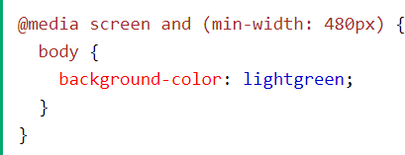

Figure 2.8 CSS Media Query Example

The following example changes the background-color to lightgreen if the viewport is 480 pixels wide or wider (if the viewport is less than 480 pixels, the background-color will be pink): Here's a simple example of the media query for standard devices.

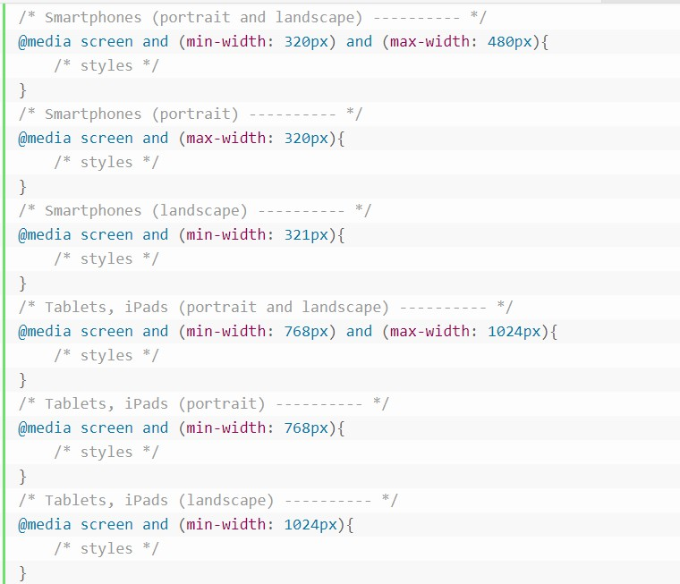

Figure 2.9 CSS Media Query On Different Screen Sizes

## CHAPTER 3 INTRODUCTION TO JAVASCRIPT

#### INTRODUCTION TO JS

JavaScript is a cross-platform, object-oriented scripting language used to make webpages interactive (e.g., having complex animations, clickable buttons, popup menus, etc.). There are also more advanced server side versions of JavaScript such as Node.js, which allow you to add more functionality to a website than downloading files (such as realtime collaboration between multiple computers). Inside a host environment (for example, a web browser), JavaScript can be connected to the objects of its environment to provide programmatic control over them.

JavaScript contains a standard library of objects, such as Array, Date, and Math, and a core set of language elements such as operators, control structures, and statements. Core JavaScript can be extended for a variety of purposes by supplementing it with additional objects; for example:

* Client-side JavaScript extends the core language by supplying objects to control a browser and its Document Object Model (DOM). For example, client-side extensions allow an application to place elements on an HTML form and respond to user events such as mouse clicks, form input, and page navigation.
* Server-side JavaScript extends the core language by supplying objects relevant to running JavaScript on a server. For example, server-side extensions allow an application to communicate with a database, provide continuity of information from one invocation to another of the application, or perform file manipulations on a server.

This means that in the browser, JavaScript can change the way the webpage (DOM) looks. And, likewise, Node.js JavaScript on the server can respond to custom requests from code written in the browser.

#### JAVASCRIPT VARIABLES :

Variables are what make up most of JavaScript. These variables make up things from numbers to objects, which are all over JavaScript to make one's life much easier.

var myvariable = “This is Variable”;

This is an example of defining variables. This variable is called a "string" because it has ASCII characters (A-Z, 0-9,!@#$, etc.)

There are different types of variables which we are using in Javascript

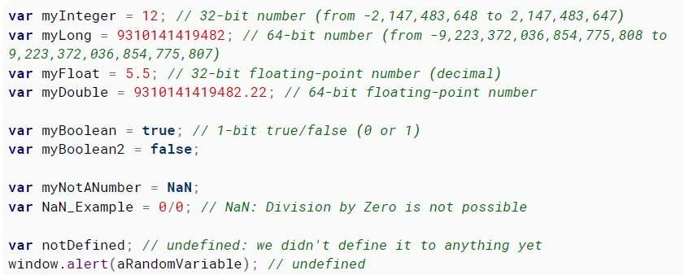

Figure 3.1 JavaScript Variables

#### FEATURES OF JAVASCRIPT:

JavaScript has a number of advantages that make it a better choice than its competitors. The following are several benefits of using JavaScript:

Simplicity ‒ having a simple structure makes JavaScript easier to learn and implement, and it also runs faster than some other languages. Errors are also easy to spot and correct.

Speed ‒ JavaScript executes scripts directly within the web browser without connecting to a server first or needing a compiler. Additionally, most major browsers allow JavaScript to compile code during program execution.

Versatility ‒ JavaScript is compatible with other languages like PHP, Perl, and Java. It also makes data science and machine learning accessible to developers.

Popularity ‒ plenty of resources and forums are available to help beginners with limited technical skills and knowledge of JavaScript.

Server load ‒ another perk of operating on the client-side is that JavaScript reduces the requests sent to the server.

#### WORKING OF JAVASCRIPT :

JavaScript is either embedded directly into a web page or referenced via a separate .js file. When a user visits that web page, their browser will run the script along with the HTML and CSS code ‒ creating a functional page displayed via the browser tab.

The script is downloaded to the visitors’ machines and processed there. This differs from a server-side language, in which the server processes the script before sending it to the browser.

When encountering a block of JavaScript code, a web browser will process it from top to bottom. Since it’s order-sensitive, make sure to reference the objects or variables within the block first before modifying them. Having variables with no values will result in an undefined error.

#### HOW TO ADD JAVASCRIPT CODE TO A WEBSITE?

There are two ways of adding JavaScript code to an HTML web page ‒ internally and externally. Internal JavaScript uses the <script> tag within the body of the HTML script to encapsulate all the JavaScript code. Here’s an example of internal JavaScript with the <script> tag:

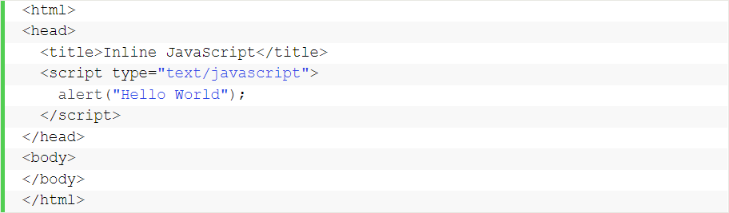

Figure 3.2 JavaScript Embedded Method

You can also embed its script on HTML event attributes, prompting the browser to execute it when an event is triggered ‒ this script type is called inline JavaScript:



Figure 3.3 JavaScript Event Attribute

On the other hand, external JavaScript involves storing the code in a separate .js file and then recalling it within the HTML page. Developers often use this method when working on large projects, as doing so keeps the script organized. Plus, it lets you reuse the script in multiple HTML pages, which is something that many developers value greatly.

For example, adding the following script to an HTML page lets you recall an external JavaScript file named script.js:

External JavaScript method is best for Web Development as we easily change and modify our codes in external files for each separate HTML files.

Figure 3.4 JavaScript External Method Here’s an example of how to reference an external JavaScript file:

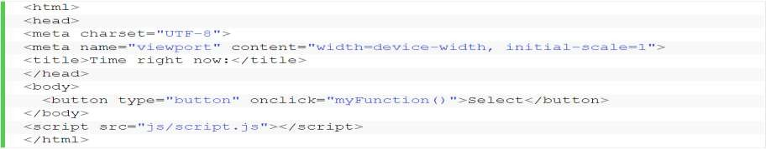

Figure 3.5 JavaScript Reference File Method

#### WEAKNESS OF JAVASCRIPT :

Browser compatibility ‒ different web browsers interpret JavaScript code differently, causing inconsistency. Therefore, you should test your JavaScript script in all popular web browsers, including their older versions, to avoid harming the user experience.

Security ‒ JavaScript code that runs on the client-side is vulnerable to exploitation by irresponsible users.

Debugging ‒ while some HTML editors support debugging, they’re less efficient than other editors. Since browsers don’t show any warning for errors, finding the issue may be challenging.

#### JAVASCRIPT DOM MODEL:

The Document Object Model (DOM) is a programming interface for HTML and XML documents. It is an API that allows developers to make changes in HTML by using JavaScript. This concept is the key to building dynamic websites and helps in linking HTML and JavaScript on the frontend.

DOM is essentially a tree-like structure and elements in our DOM are arranged in a hierarchy which is used to help organize our HTML elements, Figureure out what CSS style rules apply, and what ones must be applied to which things.

JavaScript is all about enhancing the user experience by dynamically changing the page according to the user's requirements. Working with DOM modal and manipulating DOM modal is essential skills needed in web development.

#### JS SCOPE:

Scope is a function of JavaScript and is basically referred to as the current context of code, which determines the visibility and accessibility of variables.

The scope is an important concept in JavaScript to understand since it determines the lifespan, access, and visibility of variables, functions, and objects throughout your code.

One of the main advantages of scope is that it provides a level of security to your code by putting certain restrictions.

In the JavaScript language there are two types of scopes:

##### Global Scope

A variable that is declared outside of any function is considered global and can be accessed and modified from any function.

##### Local Scope

A local variable is a variable that is declared within a function and can only be accessed within that function.

#### JS CLOSURES:

A closure is a function that has access to the variable from another function’s scope which is accomplished by creating a function inside a function. As defined on MDN:

*“Closures are functions that refer to independent (free) variables. In other words, the function defined in the closure ‘remembers’ the environment in which it was created.”*

In JavaScript, closures are created every time a function is created, at function creation time. Most JavaScript developers use closure consciously or unconsciously — but knowing closure provides better control over the code when using them.

#### JS HOISTING:

In JavaScript, hoisting is a behavior in which a function or a variable can be used before declaration.

Basically, it gives us an advantage that no matter where a variable and a function are declared, they are moved to the top of their scope regardless of whether their scope is local or global.

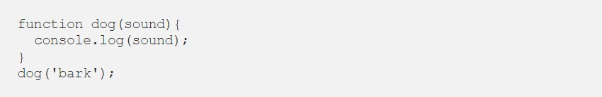Example 1: Invoking function after its declaration

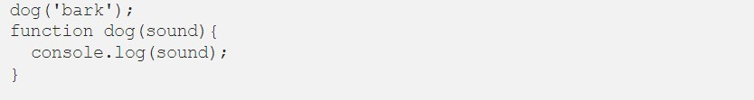Example 2: Invoking function before its declaration (with hoisting)

Figure 3.6 JS Hoisting Function

Both the above examples will get you the same output barkin your console no matter if you invoke a function before or after declaration and this is what is called hoisting in JavaScript.

#### ES6 JAVASCRIPT :

JavaScript ES6 is the more current variant of JavaScript that was presented in 2015. ECMAScript is the standard that JavaScript programming language uses. ECMAScript gives the particular on how JavaScript programming language should function. Below are the new introduced features of ES6.

1. JavaScript let : JavaScript let is used to declare variables. Previously, variables were declared using the var keyword. The variables declared using let are block-scoped. This means they are only accessible within a particular block.
2. JavaScript Const : The const statement is used to declare constants in JavaScript. Once declared, you cannot change the value of a const variable.
3. 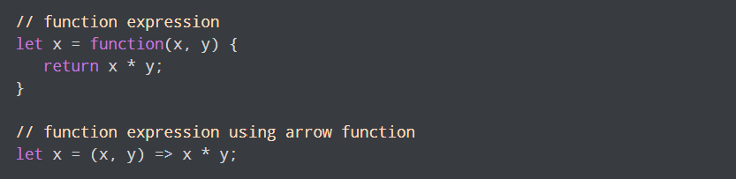JavaScript Arrow function : In the ES6 version, you can use arrow functions to create function expressions. Arrow functions are a great addition to the JavaScript language. They make for short and concise code. For example,

Figure 3.7 JS Arrow Function

1. The template literal has made it easier to include variables inside a string. Using template literal we can write multiline string without /n
2. 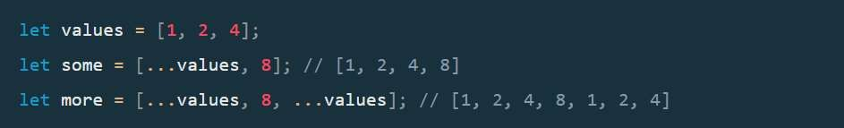Spread operator : The spread operator (...) is a very convenient syntax to expand elements of an array in specific places, such as arguments in function calls. Ex.

Figure 3.8 JS Spread Operator

1. Modules : Modules are certainly a welcome addition to the JavaScript language Any serious JavaScript project today uses some sort of module system However, browsers don’t feature any kind of module system. You always need a build step or a loader for your AMD or CommonJS modules. The ES6 specification includes both a new syntax and a loader mechanism for modules. on to the ES6 module syntax. Modules are designed around the export and import keywords.

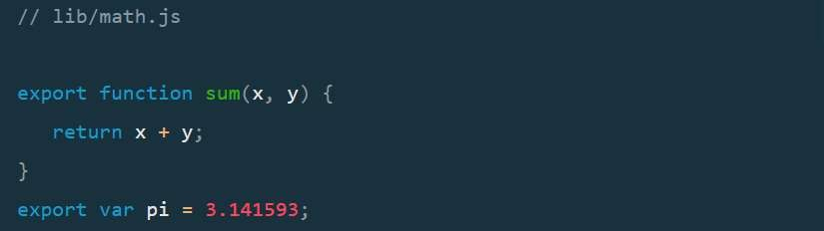

Figure 3.9 JS Module Example

#### JAVASCRIPT EVENTS:

The change in the state of an object is known as an Event. In html, there are various events which represents that some activity is performed by the user or by the browser. When javascript code is included in HTML, js react over these events and allow the execution. This process of reacting over the events is called Event Handling. Thus, js handles the HTML events via Event Handlers. For example, when a user clicks over the browser, add js code, which will execute the task to be performed on the event. Some of the HTML events and their event handlers are:

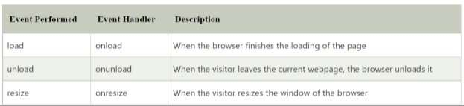

Figure 3.10 JS Window Events

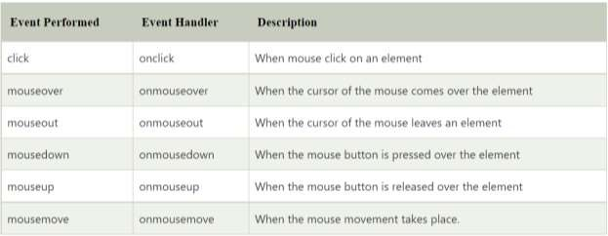

Figure 3.11 JS Mouse Events

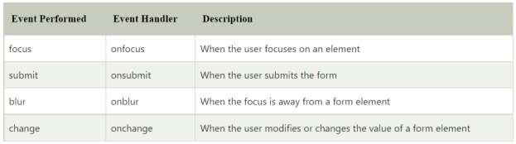

Figure 3.12 JS Form Events

we had gone through JS project which validates user information before it is submitted into the main database. Link of the project: <https://chirag-ahir.github.io/JS-Validation-form/>

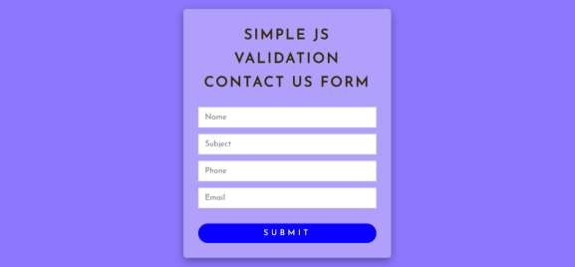

Figure 3.13 JS Mini Project Output

**CHAPTER 4 INTRODUCTION TO BOOTSTRAP FRAMEWORK**

#### INTRODUCTION TO BOOTSTRAP

Bootstrap is a potent front-end framework used to create modern websites and web apps. It's open-source and free to use, yet features numerous HTML and CSS templates for UI interface elements such as buttons and forms. Bootstrap also supports JavaScript extensions.



Figure 4.1 Bootstrap Logo

First and foremost, Bootstrap is easy to learn. Due to its popularity, plenty of tutorials and online forums are available to help you get started.

One of the reasons why Bootstrap is so popular among web developers and web designers is that it has a simple file structure. Its files are compiled for easy access, and it only requires basic knowledge of HTML, CSS, and JS to modify them.

You can also use themes for popular content management systems as learning tools. For example, most WordPress themes were developed using Bootstrap, which any beginner web developer can access.

To increase the site’s page load time, Bootstrap minifies the CSS and JavaScript files. Additionally, Bootstrap maintains consistency across the syntax between websites and developers, which is ideal for team-based projects.

Bootstrap is free to use you can install the latest version of bootstrap from it’s official website and use it in your HTML page.

#### ADVANTAGES OF USING BOOTSTRAP:

* Save lots of time — You can save lots of time and efforts using the Bootstrap predefined design templates and classes and concentrate on other development work.
* Responsive features — Using Bootstrap you can easily create responsive websites that appear more appropriately on different devices and screen resolutions without any change in markup.
* Consistent design — All Bootstrap components share the same design templates and styles through a central library, so the design and layout of your web pages will be consistent.
* Easy to use — Bootstrap is very easy to use. Anybody with the basic working knowledge of HTML, CSS and JavaScript can start development with Bootstrap.

#### BOOTSTRAP CONTAINERS :

Containers are the most basic layout element in Bootstrap and are required when using the grid system. Containers are basically used to wrap content with some padding. They are also used to align the content horizontally center on the page in case of fixed width layout.

Bootstrap provides three different types containers:

.**container,** which has a max-width at each responsive breakpoint.

**.container-fluid,** which has 100% width at all breakpoints.

**.container-{breakpoint},** which has 100% width until the specified breakpoint.

You can simply use the *.container* class to create a responsive, fixed-width container. The width of the container will change at different breakpoints or screen sizes.

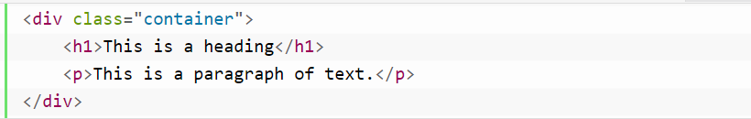

Figure 4.2 Bootstrap Container

You can use the *.container-fluid* class to create a full width container. The width of the fluid container will always be 100% irrespective of the devices or screen sizes.

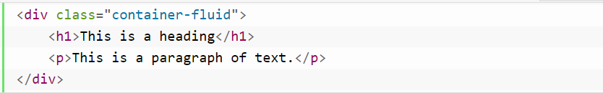

Figure 4.3 Bootstrap Container-fluid

#### BOOTSTRAP PADDINGS AND MARGINS:

By default, containers have padding of 12px on the left and right sides, and no padding on the top and bottom sides. To apply extra padding and margins you can use the spacing utility classes.

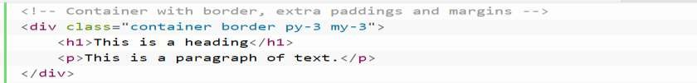

You can use the spacing utility classes to quickly adjust the margin and padding of an element. The # character in the classes .mt-#, .pt-#, etc. represents the size of the margin or padding. The value of the size can be an integer from 0 to 5, or auto

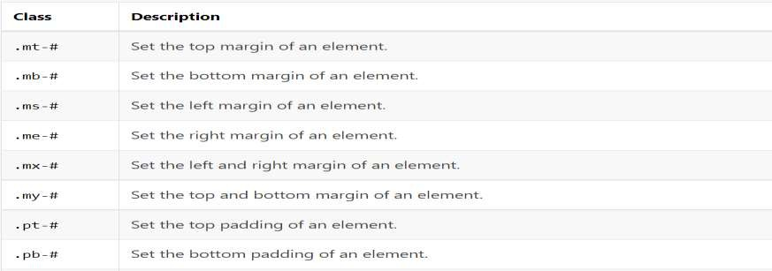

Figure 4.4 Bootstrap Padding Classes

#### BOOTSTRAP GRID SYSTEM:

Bootstrap grid system provides an easy and powerful way to create responsive layouts of all shapes and sizes. It is built with flexbox with mobile-first approach.

You can use the Bootstrap's predefined grid classes for quickly making the layouts for different types of devices like mobile phones, tablets, laptops, desktops, and so on. For example, you can use the .*col-\** classes to create grid columns for extra small devices like mobile phones in portrait mode, and the *.col-sm-\** classes for mobile phones in landscape mode.

Similarly, you can use the *.col-md-\** classes to create grid columns for medium screen devices like tablets, the *.col-lg-\** classes for devices like small laptops, the .*col-xl-\** classes for laptops and desktops, and the *.col-xxl-\** classes for large desktop screens. First we are creating a 2 column layout. The following example will show you how to create two column layouts for medium, large and extra large devices like tables, laptops and desktops etc.

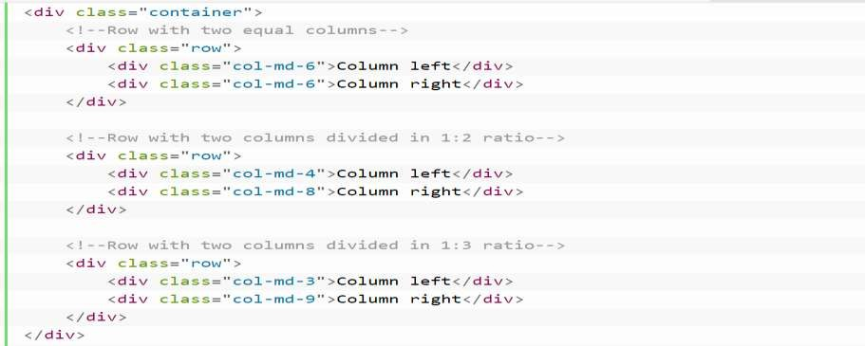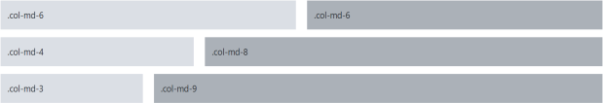

Figure 4.5 Bootstrap Grid System Layout

Similarly, you can create other layouts based on the above principle. For instance, the following example will typically create three column layouts for laptops and desktops screens. It also works in tablets in landscape mode if screen resolution is more than or equal to 992 .

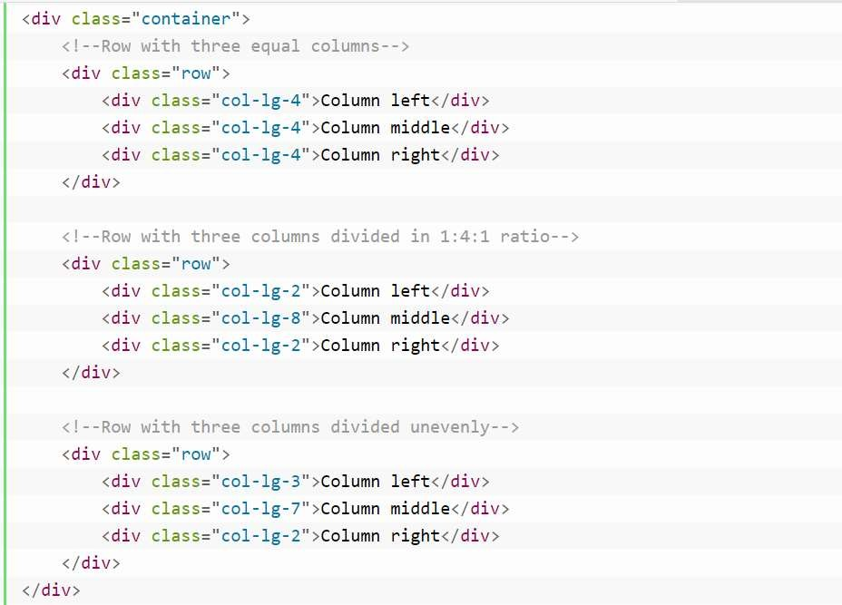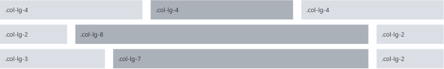

Figure 4.6 Bootstrap Three Column Layout

#### BOOTSTRAP LIST GROUP:

The list groups are very useful and flexible component for displaying lists of elements in a beautiful manner. In most basic form a list group is simply an unordered list with the class .list- group whereas, the list items having the class .list-group-item.

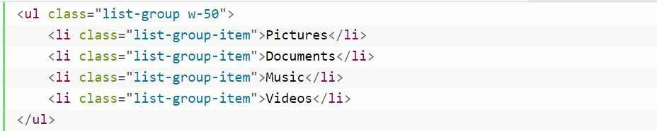

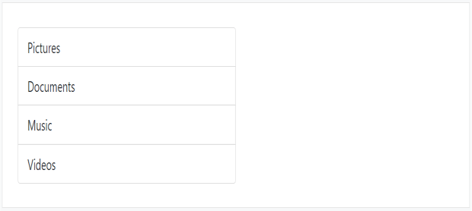

Figure 4.7 Bootstrap Listgroup

You can simply add the class *.active* to a *.list-group-item* to indicate the current active selection. Similarly, you can add *.disabled* to a *.list-group-item* to make it look like disabled.

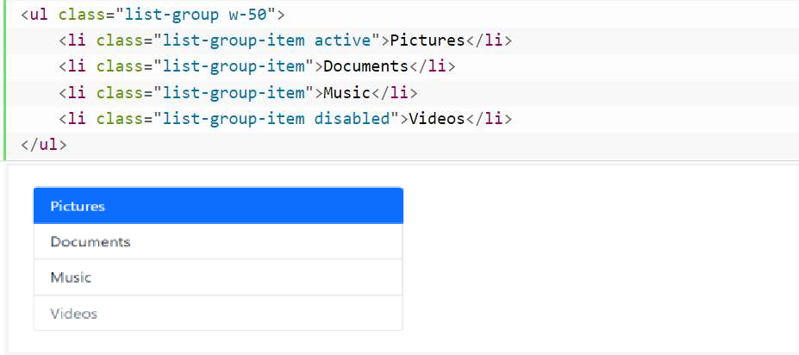

Figure. 4.8 Bootstrap listgroup active class

You can also link list group items with the little change in HTML markup. Just replace the <li> with <a> tag and use <div> element as a parent instead of <ul>. You can also add icons and badges to this list group to make it more elegant. Here's an example:

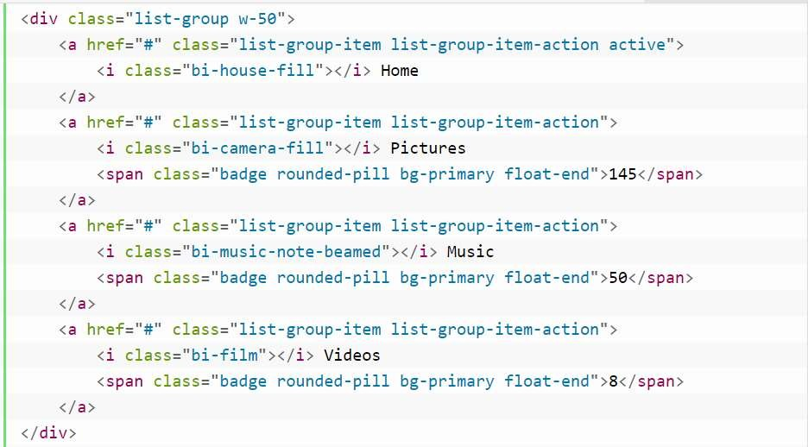

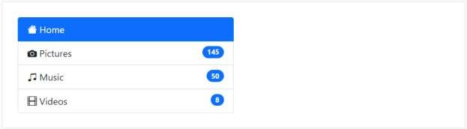

Figure 4.9 Bootstrap Listgroup with icons

#### WORKING WITH IMAGES:

Images are very common in modern web design. So styling images and placing it properly on the web pages is very important for improving the user experience.

Using the Bootstrap built-in classes you can easily style images such as making the round cornered or circular images, or give them effect like thumbnails. Following is the code for this.

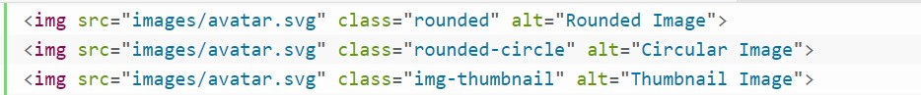



Figure 4.10 Bootstrap Images

With Bootstrap you can make the images responsive too. Just add the class .img-fluid to the

<img> tag. This class mainly applies the styles max-width: 100%; and height: auto; to the image so that it scales nicely to fit the containing element in case if the width of the image is larger than the containing element itself.

#### ALIGNMENT OF IMAGES:

You can use the text alignment classes such as *.text-center*, and .*text-end* on the parent container to align the inline images horizontally center and right. You can also align images to the left and right within a larger box using the classes *.float-start* and *.float-end*. However, to center align the block-level images you need to use the *.mx-auto* margin utility class.

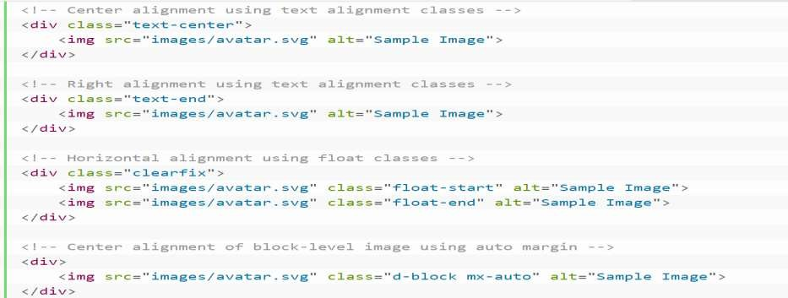

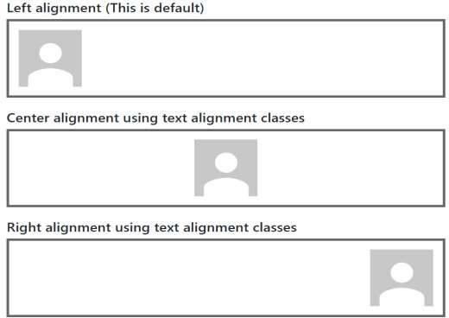

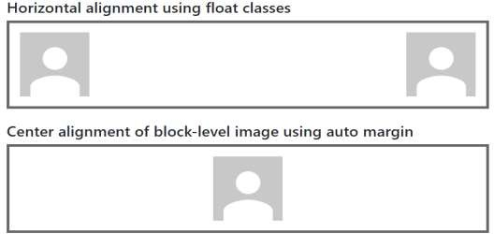

Figure 4.11 Bootstrap Image Alignments

#### BOOTSTRAP BUTTONS:

Buttons are the integral part of a website and application. They are used for various purposes like, submit or reset an HTML form, performing interactive actions such as showing or hiding something on a web page on click of the button, redirecting user to another page, and so on. Bootstrap provides a quick and easy way to create and customize the buttons. Different classes are available in Bootstrap for styling the buttons as well as to indicate the different states or

semantic. Button styles can be applied to any element. However, it is applied normally to the

<a>, <input>, and <button> elements for the best rendering. The following example will show you how to create different styles of buttons in Bootstrap:

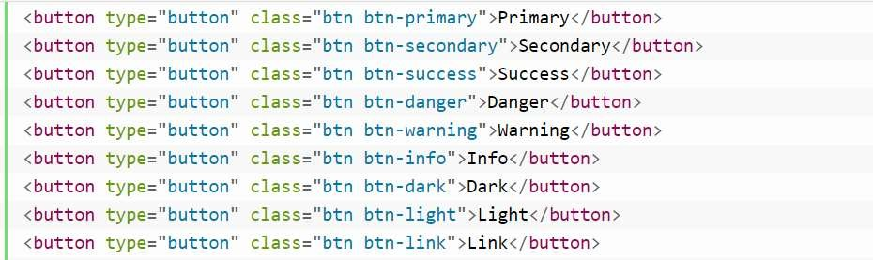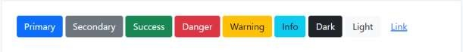

Figure 4.12 Bootstrap Buttons

Moreover, you can also apply the class .active to force the buttons look like active Usually we don't need to add this class to the buttons, as their active state is automatically styled by the Bootstrap using CSS :active pseudo-class.

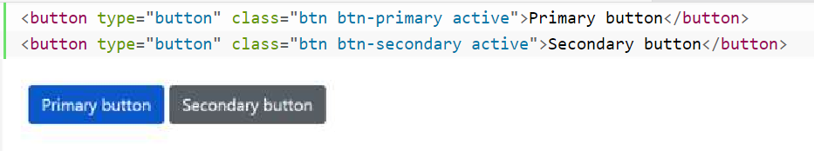

Figure 4.13 Bootstrap Primary Buttons

Sometimes we need to disable a button for certain reasons, for example, a user in case is not eligible to perform this particular action, or we want to ensure that user should performed all other required actions before proceed to this particular action. Buttons created through

<button> or <input> tag can be disabled by adding the *disabled* attribute.

#### BOOTSTRAP DROPDOWN MENUS:

The dropdown menu is typically used inside the navigation header to display a list of related links when a user mouse hover or click on the trigger element. we can use the Bootstrap dropdown plugin to add toggleable dropdown menus to almost anything such as links, buttons or button groups, navbar, tabs and pills nav etc.

Bootstrap provides an easy and elegant mechanism for adding the dropdown menu to an element via data attributes. The following example will show you the minimum markup required for adding a dropdown menu to the hyperlink via data attributes.

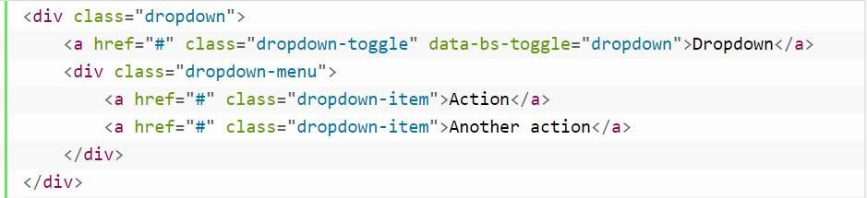

Figure 4.14 Bootstrap Dropdowns

The Bootstrap dropdown has basically two components — the dropdown trigger element which can be a hyperlink or button, and the dropdown menu itself.

* The *.dropdown* class specifies a dropdown menu.
* The *.dropdown-toggle* class defines the trigger element, which is a hyperlink in our case, whereas the attribute data-bs-toggle="dropdown" is required on the trigger element to toggle the dropdown menu.

#### BOOTSTRAP FORMS:

HTML forms are an integral part of the web pages and applications, but creating the form layouts or styling the form controls manually one by one using CSS are often boring and tedious. Bootstrap greatly simplifies the process of styling and alignment of form controls like labels, input fields, selectboxes, textareas, buttons, etc. through predefined set of classes.

Bootstrap provides three different types of form layouts:

##### Verticle Form Layout:

To create vertical form layouts simply use the predefined margin utility classes for grouping the labels, form controls, optional form text, and form validation messages. Here's an example of vertically stacked form.

##### Horizontal Form Layout:

You can also create horizontal form layouts where labels and form controls are aligned side- by-side using the Bootstrap grid classes. To create a horizontal form layout add the class .row on form groups and use the *.col-*-\** grid classes to specify the width of your labels and controls. Also, be sure to apply the class .col-form-label on the <label> elements, so that they're vertically centered with their associated form controls.

##### Inline Form Layout:

Sometimes you may want to display a series of form controls, and buttons in a single horizontal row to compact the layout. You can do this easily by using the Bootstrap's grid classes.

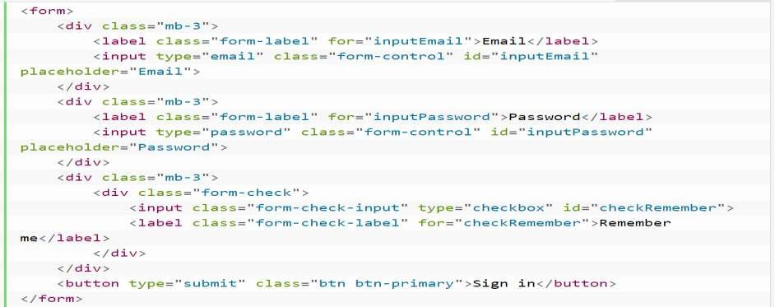

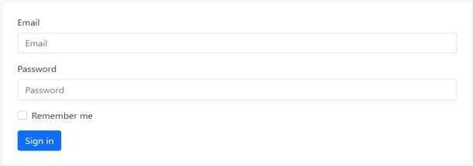

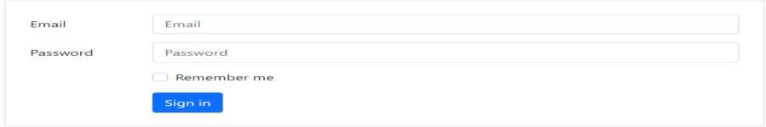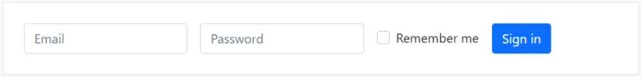

Figure 4.15 Bootstrap Forms

#### BOOTSTRAP NAVABAR:

We can use the Bootstrap navbar component to create responsive navigation header for your website or application. These responsive navbar will be collapsed on devices having small viewports like mobile phones but expand when user click the toggle button. However, it will be horizontal as normal on the medium and large devices such as laptop or desktop.

We can also create different variations of the navbar such as navbars with dropdown menus and search boxes as well as fixed positioned navbar with much less effort. There are different colours for navbar too so that we can easily find good matching navbar for our website.

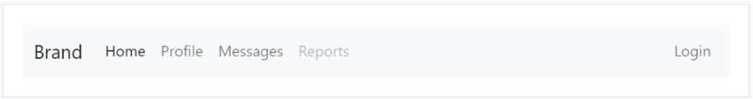

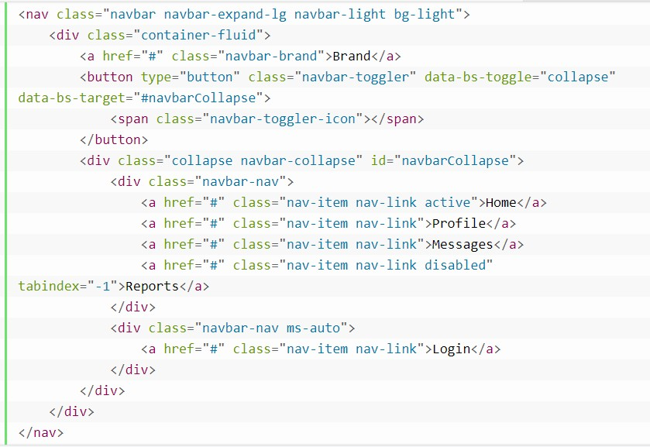

Figure 4.16 Bootstrap Navbar

At the end of this chapter I can say that Bootstrap is a free front-end framework that is popular among developers today, particularly those who work in the web design world. It’s easy to use and saves developers a lot of time from having to write HTML, CSS, and JavaScript code manually.

Bootstrap’s best feature is the design templates that make web pages work optimally on all screen sizes. It was Originally created by a designer and a developer at Twitter, Bootstrap has become one of the popular front-end frameworks and open source projects in the world.

In addition that I uploaded all my codes on GitHub plateform. you can refer it by tap on this [Link](https://chirag-ahir.github.io/Bootstrap-all-basic/)

We also gone through one project of Bootstrap (Project Bootcamp Website) where I applied my all knowledge of Bootstrap components.

I uploaded my project on GitHub you can refer this project by tap on this link

<https://virtualbootcamp.netlify.app/>

## CHAPTER 5 GIT AND GITHUB

#### UNDERSTANDING GIT AND GITHUB

Git is a DevOps tool used for source code management. It is a free and open-source version control system used to handle small to very large projects efficiently. Git is used to tracking changes in the source code, enabling multiple developers to work together on non-linear development.



Figureure 5.1 GIT and GitHub logo

In simple words Git is a version control system used for tracking changes in computer files. This tool was created in 2005 by developers working on the Linux operating system. It is generally used for source code management in software development. Git makes it possible for several people involved in the project to work together and track each other's progress over time. In software development, the tool helps in Source Code Management.

GitHub is a company founded in 2008 that makes tools which integrate with git. You do not need GitHub to use git, but you cannot use GitHub without using git. GitHub is a for-profit company that offers a cloud-based Git repository hosting service. Essentially, it makes it a lot easier for individuals and teams to use Git for version control and collaboration. GitHub’s interface is user-friendly enough so even novice coders can take advantage of Git.

GitHub is so user-friendly, though, that some people even use GitHub to manage other types of projects – like writing books. Additionally, anyone can sign up and host a public code repository for free, which makes GitHub especially popular with open-source projects.

#### SETTING UP AN ONLINE GIT REPOSITORY

Sign up for an account either at Bitbucket (https://bitbucket.org) or GitHub ([https://github.com](https://github.com/)). Then set up an online Git repository named git-test. Note the URL of your online Git repository which can be useful in future process.

#### GIT COMMANDS

Git supports many command-line tools and graphical user interfaces. The Git command line is the only place where you can run all the Git commands. GIT commands used for push our project on our repository and than we can host our project using GitHub free service. Here are some commands which we use in general.

Table 5.1 Basic Git Commands

|  |  |
| --- | --- |
| **Commands** | **Description** |
| Git Init | Git init will create a new local GIT repository on GitHub. |
| Git add | This will add all your files to the staging area |
| Git commit | This will commit all your changes with message. |
| Git branch –m main | This will create a folder with name main in your GitHub repository. |
| Git remote add origin | This will add your remote origin to your local repository so that you can connect to your local and remote repository. |
| Git push –u origin main | This will push your local project to your remote repository into your main branch. |
| Git Branch | This command lists all the branches available in the repository. |
| Git clone repo - URL | This will download a local copy of a repository from GitHub in your local system. |
| Git merge BranchName | This command is used to merge the specified branch?s history into the current branch |

Apart from this in this week I made some projects based on what I learnt in previous sessions and hosted those projects on the GitHub plateform. The projects which I made are listed belows.

* JS Counter app: <https://chirag-ahir.github.io/JS-Counter-app/>
* JS Color changer: <https://chirag-ahir.github.io/JS-Colour-changer/>

**CHAPTER 6 GETTING STARTED WITH DESIGN TOOL FIGMA**

#### 6.1 Introduction to Figma tool

Figma is a web-based graphics editor and UI design tool. You can use it to accomplish everything from wireframing websites to developing mobile app interfaces, prototyping designs, and creating social media posts.



.

Figure 6.1 Figma Logo

Figma is different from other graphics editing tools. Mainly because it works directly on your browser. This means you get to access your projects and start designing from any computer or platform without having to buy multiple licenses or install software. Another reason why designers love this app is that Figma offers a generous free plan where you can create and store 3 active projects at a time.

Figma provides very good features like Grid system, margin layout suggestions and many more which helps developeres to done their work fast. Figma is a browser-based interface design tool that is taking the design world by storm. Unlike sketch it runs in a standalone macOS app.

In Figma instead of exporting static images we can share a link to the Figma file to our clients to access in their browser. This in itself saves significantly time and inconvenience in designer work flow but, more importantly this means both client and Colleagues can interact in a greater depth with their projects and review the latest file.

Apart from this I clear my basics of Figma by designing SunnySide website prototype using Figma. Tap on this link to view this design: [https://www.Figma.com/file/29ZFjVAJcfKN6eW1ZZAvds/sunnyside-website-prototype](https://www.figma.com/file/29ZFjVAJcfKN6eW1ZZAvds/sunnyside-website-prototype).

## CHAPTER 7 WHAT ARE PHP AND XAMPP?

The abbreviation PHP initially stood for Personal Homepage. But now it is a recursive acronym for Hypertext Preprocessor. The first version of PHP was launched 26 years ago. Now it's on version 8, released in November 2020, but version 7 remains the most widely used.



Figure 7.1 PHP Logo

PHP runs on the Zend engine, which is the most popular implementation. There are some other implementations as well, like parrot, HPVM (Hip Hop Virtual Machine), and Hip Hop, created by Facebook.

PHP is mostly used for making web servers. It runs on the browser and is also capable of running in the command line. So, if you don't feel like showing your code output in the browser, you can show it in the terminal.

Instead of lots of commands to output HTML (as seen in C or Perl), PHP pages contain HTML with embedded code that does "something" (in this case, output "Hi, I'm a PHP script!"). The PHP code is enclosed in special start and end processing instructions <?php and ?> that allow you to jump into and out of "PHP mode."

What distinguishes PHP from something like client-side JavaScript is that the code is executed on the server, generating HTML which is then sent to the client. The client would receive the results of running that script, but would not know what the underlying code was. You can even conFigureure your web server to process all your HTML files with PHP, and then there's really no way that users can tell what you have up your sleeve.

The best part about using PHP is that it is extremely simple for a newcomer, but offers many advanced features for a professional programmer. PHP also provides security of your code no one can easily get your detailed code if you developed your website in PHP.

#### PHP INSTALLATION

To start using PHP, you can:

* + 1. Find a web host with PHP and MySQL support
    2. Install a web server on your own PC, and then install PHP and MySQL

Use a Web Host with PHP Support If your server has activated support for PHP you do not need to do anything. Just create some .php files, place them in your web directory, and the server will automatically parse them for you.

#### FEATURES OF PHP

It is one of the widely used open-source general-purpose scripting language that is used for backend Development.

* Free of Cost: Since it is an open-source language, therefore developers are allowed to use its components and all methods for free.
* Flexible: Since It is a dynamically typed language, therefore there are no hard rules on how to build features using it.
* Supports nearly all databases: It supports all the widely used databases, including MySQL, ODBC, SQLite etc.
* Secured: It has multiple security levels provides us a secure platform for developing websites as it has multiple security levels.
* Huge Community Support: It is loved and used by a huge number of developers. The developers share their knowledge with other people of the community that want to know about it.

#### BASIC PHP SYNTAX

All the php code in a php script should be enclosed within <?php and ?>, else it will not be considered as php code. Adding php code inside the PHP tags is known as Escaping to php. Every expression in PHP ends with a semicolon ; Basic PHP syntax is shown in below example.

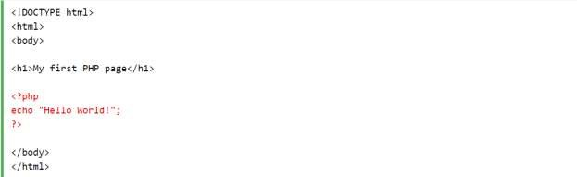

Figure 7.2 PHP Syntex

#### PHP VARIABLES:

In PHP, a variable is declared using a $ sign followed by the variable name. Here, some important points to know about variables:

As PHP is a loosely typed language, so we do not need to declare the data types of the variables. It automatically analyzes the values and makes conversions to its correct datatype. After declaring a variable, it can be reused throughout the code. Assignment Operator (=) is used to assign the value to a variable.

Syntax of declaring a variable in PHP is given below:

$variablename = value;

Rules for declaring PHP variable:

* A variable must start with a dollar ($) sign, followed by the variable name.
* It can only contain alpha-numeric character and underscore (A-z, 0-9, _).
* A variable name must start with a letter or underscore (_) character.
* A PHP variable name cannot contain spaces.
* Variable name cannot start with a number or special symbols.

#### PHP CONDITIONAL STATEMENTS:

In PHP we have the following conditional statements:

* if statement - executes some code if one condition is true
* if...else statement - executes some code if a condition is true and another code if that condition is false
* if...elseif...else statement: executes different codes for more than two conditions
* switch statement - selects one of many blocks of code to be executed

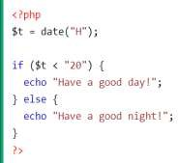

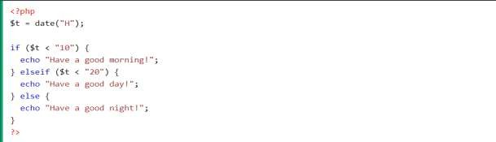

Figure 7.3 PHP Conditions

#### PHP LOOPS:

Like any other language, loop in PHP is used to execute a statement or a block of statements, multiple times until and unless a specific condition is met. This helps the user to save both time and effort of writing the same code multiple times.

PHP supports four types of looping techniques;

* + 1. for loop: This type of loops is used when the user knows in advance, how many times the block needs to execute. That is, the number of iterations is known beforehand. These type of loops are also known as entry-controlled loops. There are three main parameters to the code, namely the initialization, the test condition and the counter.

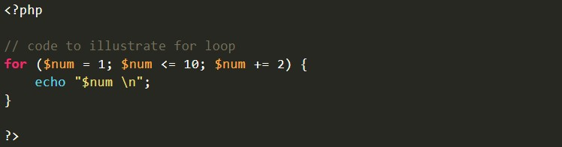

Figure 7.4 PHP For Loop

* + 1. While loop: The while loop is also an entry control loop like for loops i.e., it first checks the condition at the start of the loop and if its true then it enters the loop and executes the block of statements, and goes on executing it as long as the condition holds true.

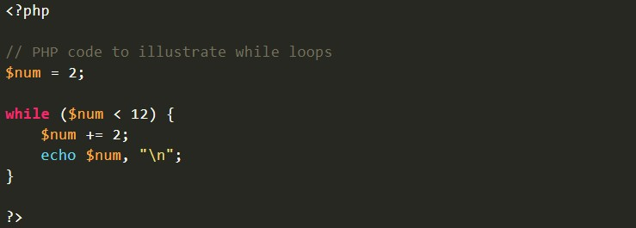

Figure 7.5 PHP While Loop

* + 1. Do while loop: This is an exit control loop which means that it first enters the loop, executes the statements, and then checks the condition. Therefore, a statement is executed at least once on using the do…while loop. After executing once, the program is executed as long as the condition holds true.

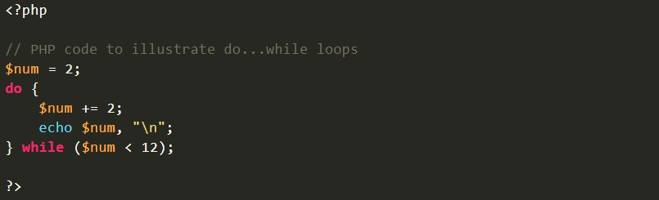

Figure 7.6 PHP Do While loop

* + 1. For each loop: This loop is used to iterate over arrays. For every counter of loop, an array element is assigned and the next counter is shifted to the next element.

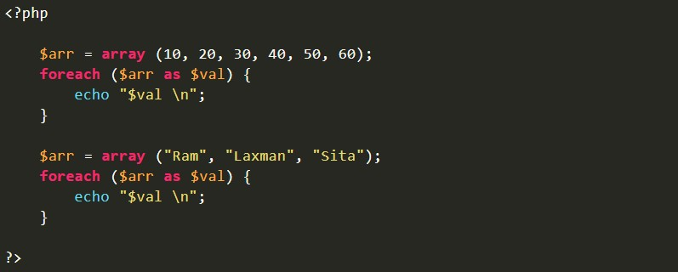

Figure 7.8 PHP For each loop

#### PHP ARRAYS:

Arrays are a form of data structure in PHP that allows us to store several pieces of the same data type in a single variable, saving us the time and effort of having to create a new variable for each data type. The arrays are useful for creating a list of similar-type components that can be retrieved by their index or key. Let's say we wish to save five names and print them out. The usage of five separate string variables makes this simple. However, if the number of variables increases from five to a hundred, the user or developer will find it quite difficult to construct that many different variables. Here array comes into play and helps us to store every element within a single variable and also allows easy access using an index or a key. array is created using an array() function in PHP. In PHP, there are three types of arrays:

* Indexed arrays - Arrays with a numeric index
* Associative arrays - Arrays with named keys
* Multidimensional arrays - Arrays containing one or more arrays

The index can be assigned automatically (index always starts at 0), like this:

$cars = array("Volvo", "BMW", "Toyota");

Associative arrays are arrays that use named keys that you assign to them.

$age = array("Peter"=>"35", "Ben"=>"37", "Joe"=>"43");

Multidimensional arrrays consists more than one array.

$cars = array (array("Volvo",22,18,45,28), array("Saab",5,2,5,63,5,8),

array("Land Rover",17,15));

#### PHP POST VS GET METHOD:

* The GET method passes our array variables through the URL parameters
* Should be used only for sending non-sensitive data
* Never send passwords through the GET method.
* All variables are displayed openly in the URL.
* The POST method passes variables using the HTTP Post method.
* The POST method is much more secure because variables are not displayed in the URL
* Information is invisible to others because it is embedded within the body of the HTTP request.
* It has no limits as to the amount of information we can send.
* This method is preferred by developers.

To understand the concept of POST and GET method we gone through PHP mini project in which when user submit their data than data will be displayed on that page itself. I uploaded my PHP code on GitHub.

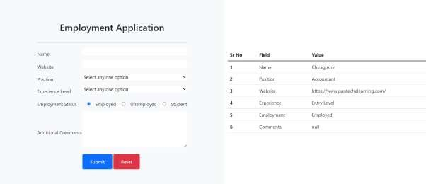

Figure 7.9 PHP Post project output

#### WHAT IS XAMPP?

XAMPP is an open-source, cross-platform web server that consists of a web server, MySQL database engine, and PHP and Perl programming packages. It is compiled and maintained by Apache. It allows users to create WordPress websites online using a local web server on their computer. It supports Windows, Linux, and Mac. It is compiled and maintained by apache.



Figure 7.10 XAMPP Logo

XAMPP has the ability to serve web pages on the World Wide Web. A special tool is provided to password-protect the most important parts of the package. XAMPP also provides support for

creating and manipulating databases in MariaDB and SQLite among others. The acronym XAMPP stands for;

X – [cross platform operating systems] meaning it can run on any OS Mac OX , Windows , etc. A – Apache - this is the web server software.

M – MySQL - Database. P – PHP

P – Perl – scripting language

#### WHY USE XAMPP?

XAMPP provides an easy-to-use control panel to manage Apache, MySQL, and other programs without using commands. To use PHP, we need to install Apache and MySQL. It’s not easy to install Apache and conFigureure it as it needs to be set up and integrated with PHP and Perl, among other things. XAMPP deals with all the complexity to set up and integrate Apache with PHP.

#### XAMPP CONTROL PANEL:

XAMPP Control Panel is a management tool that offers to supervise the actions of individual components of XAMPP. It controls each component of the text server. The user can initiate or halt discrete modules by operating upon the buttons below the "Actions" column. Control panels efficiently manage all the components of the XAMPP package.

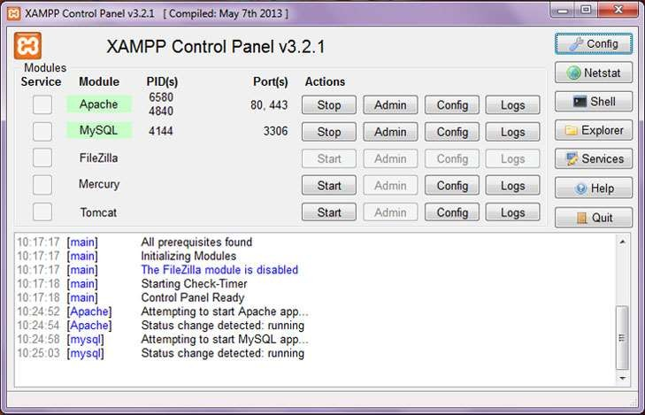

Figure 7.11 XAMPP Control Panel

One can use the Control Panel to determine whether Apache, MySQL, Mercury, etc. are currently in function or not. The development environment can only be used when Apache and MySQL are in running state. The XAMPP Control Panel icon exists in the system tray. It is an orange-colored icon that is visible when Panel is in running state.

The functionality of different control buttons.

* Start – Use this button to Start and Stop the respective module/service.
* Admin – Use this button to open the admin or application console for the respective module.
* Config – User this button to open conFigureuration files like httpd.conf, my.ini, mercuri.ini
* Logs – Using this button to open log file like access.log, error.log

To turn on the XAMPP server go to Start and search for XAMPP and select the XAMPP Control panel to start it in Windows.

Now, click the start button for the respective module/service to start the service. As soon as you click Start Button, the module background turns green, and Ports, PIDs get populated. This means service is started successfully. The caption of the button changes to Stop. Use the same button to stop service.

#### ABOUT PHP-MYSQL:

PHP is a fast and feature-rich open source scripting language used to develop Web Applications or Internet / Intranet Applications.

MySQL is a powerful open source database server built based on a relational database management system (RDBMS) and is capable of handling a large concurrent database connection. When combined together, talented PHP and MySQL developers can build very powerful and scalable Web Applications.

PHP and MySQL are Open Source, meaning that they are free development tools, and there is a large community of dedicated volunteer programmers who contribute to make improvements and are continuously adding features to it.

#### CREATING A DATABASE:

To create and delete a database you should have admin privilege. It’s very easy to create a new MySQL database. PHP uses mysql_query function to create a MySQL database. This function takes two parameters and returns TRUE on success or FALSE on failure. The basic syntex written below.

bool mysql_query( sql, connection );

The following example demonstrates how we can create a database in MySQL

<?php

$dbhost = 'localhost:3036';

$dbuser = 'root';

$dbpass = 'rootpassword';

$conn = mysql_connect($dbhost, $dbuser, $dbpass); if(! $conn ) {

die('Could not connect: ' . mysql_error());

}

echo 'Connected successfully';

$sql = 'CREATE Database test_db';

$retval = mysql_query( $sql, $conn );

if(! $retval ) {

die('Could not create database: ' . mysql_error());

}

echo "Database test_db created successfully\n"; mysql_close($conn);

?>

#### SELECTING A DATABASE:

Once you establish a connection with a database server then it is required to select a particular database where your all the tables are associated. This is required because there may be multiple databases residing on a single server and you can do work with a single database at a time.

PHP provides function *mysql_select_db* to select a database.It returns TRUE on success or FALSE on failure. The basic syntex written below.

bool mysql_select_db( db_name, connection );

The following example demonstrates how we can select a database in MySQL.

<?php

$dbhost = 'localhost:3036';

$dbuser = 'guest';

$dbpass = 'guest123';

$conn = mysql_connect($dbhost, $dbuser, $dbpass);

if(! $conn ) {

die('Could not connect: ' . mysql_error());

}

echo 'Connected successfully'; mysql_select_db( 'test_db' ); mysql_close($conn);

?>

#### ABOUT PHPMYADMIN:

phpMyAdmin is a free software tool written in PHP, intended to handle the administration of MySQL over the Web. phpMyAdmin supports a wide range of operations on MySQL. It is a web application wich let you manage (with a visual interface) MySQL Databases. Frequently used operations (managing databases, tables, columns, relations, indexes, users, permissions, etc) can be performed via the user interface, while you still have the ability to directly execute any SQL statement. phpMyAdmin provides GUI based interface which makes our life easy.

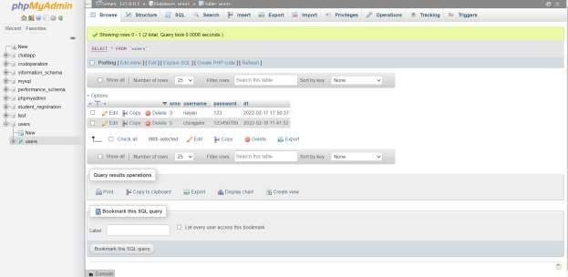

Figure 7.12 PHP MyAdmin dashboard

## CHAPTER 8 DEVELOPING FINAL PROJECT

We first started with the wireframing part of our website. Wireframing is the essential part before starting of making any website. It will define the layout of your website like how your website will look in different different display devices. It is a process where designers draw overviews of interactive products to establish the structure and flow of possible design solutions. These outlines reflect user and business needs. Paper or software-rendered wireframes help teams and stakeholders ideate toward optimal, user-focused prototypes and products.

A wireframe is a schematic, a blueprint, useful to help you and your programmers and designers think and communicate about the structure of the software or website you're building.

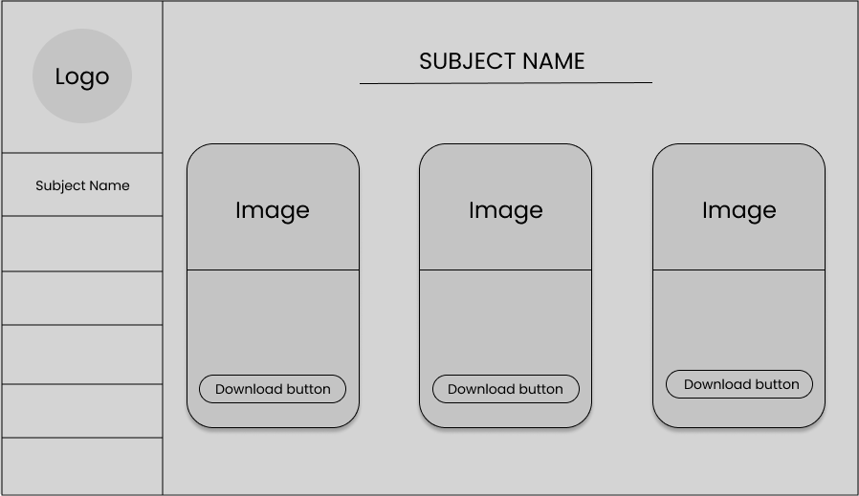

Figure 8.1 Website Prototype

The same screen can be built in a lot of different ways, but only a few of them will get your message across correctly and result in an easy-to-use software or website. Nailing down a good interface structure is possibly the most important part of designing software. We used a Figurema tool for developing our Website wireframe design. Figurema is a powerful design tool that helps you to create anything: websites, applications, logos, and much more. In this week we created our website mockup and wireframe using this Figurema tool.

#### JAVASCRIPT AOS LIBRARY

As front-end developer, a popular request you might get from your clients is to implement stunning animation effects on page scroll.

There are many libraries to make this task easier for us. AOS, also called Animate on Scroll, is one such library and it does exactly what its name suggests: it lets you apply different kinds of animations to elements as they scroll into view.

This library was created by Michal Sajnóg and he also created this website that demonstrates all of the various sorts of animations you’ll provide to your HTML elements. You can use aos library by simply adding CDN links to your HTML file.

After initializing the library all you have to do is add some specific attributes. To use basic animations you just need to add data-aos="animation_name" to your HTML elements.

There are several types of animation you can choose from. For example, you can add fade animations like “fade”, “fade-up” and “fade-down-left”. Similarly, you can also add flip and slide animations like “flip-up”, “flip-left”, “slide-down”, and “slide-right”. Figure below shows the example of aos library

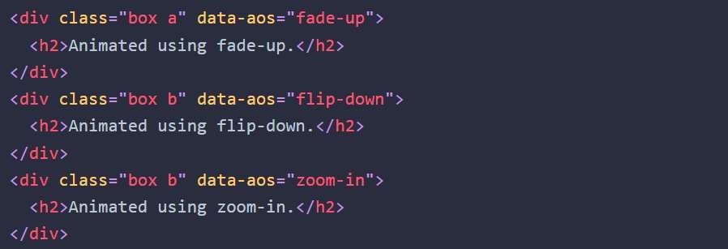

Figure 8.2 JS Aos library example

#### DESIGNING OF NAVBAR AND SERCH FIELD

I developed navbar and serchbar using Bootstrap navbar classes where I put different links which connect to different sections of website. I used CSS gradient.io website for giving background color to navbar. Using serch bar user can easily find his/her subject by writing subject name.

#### DESIGNING HEADER PHOTO AND HEADER TEXT

I used Javascript for creating typing effect in header text where I used different keyframes of different time duration to display different words at different time.

#### DESIGNING ABOUT US SECTION

I used h2 and P tag in about us section for writing about us sentence. I used font awesome for making Quote Icons. You can refer fontawesome website for more details by tap on this link <https://fontawesome.com/>

#### DESIGNING SERVICE SECTION

I made a cards using div class of HTML and used grid system to make it mobile responsive I gave effects to cards using AOS library of JavaScript. I set the background colour from gradient.io.

#### DESIGNING EDUCATION SECTION

I used list group class of bootstrap to make a a subject cards of different semesters and I put a external links of each semester which redirect user to their respective semester subjects.

#### DESIGNING OF NUMBER COUNTER

Increment counter designed based on JavaScript where I used counter which stop at given condition.

#### DESIGNING OF TESTIMONIAL AND FEATURED SECTION

Testimonial section designed based on Bootstrap Grid system. Each testimonial contains 3% width out of the 12%. I used rounded-circle class of bootstrap for making images in rounded shape. The same concept is used in Featured partner section. I used external images in both of these sections.

#### DESIGNING OF CONTACT US FORM

I used bootstrap form class to create contact form and used a google form API as a backend to store user’s feedbacks. All the data of users will be store in excel file which is located in Google drive.

#### DESIGNING OF FOOTER

In footer I used CSS grid style to make division of equal parts where I set external links through user can easily access useful links.

#### DESIGNING OF SIDEBAR NAV

In today’s time mobile-first design is first priority for a web designer so Sidebar Nav is key feature of websites just like a normal websites has menu links and a hamburger in ease-out from. In this I first created parent div using class s-layout, s denotes sidebar then we create multiple divs, ul for ordering the nav menu next we create li and anchor <a> tags then create main element its not usable but gives a better look in end after it I styled it with CSS and made it usable.

#### MAKING WEBSITE RESPONSIVE

After completing all the design part we gone through how our website looks on different display devices than according to that we writedown media queries for different screen sizes.

I uploaded my project source codes on GitHub Repository you can refer this project by tap on this link [*https://github.com/Chirag-ahir/project-ecmaster*](https://github.com/Chirag-ahir/project-ecmaster)

**CONCLUSION**

After finishing three months of internship, I acquired valuable knowledge in the field of web development. I learned about crucial CSS subjects like the Grid system, FlexBox, and the Box model, as well as JS topics like DOM manipulation, API data fetching. During the internship I was involved in real-world initiatives and worked with client side interface. In addition, I learned about the CSS popular framework Bootstrap, which simplifies our programme and speeds up developeres work. Along with this I have used the Figurema tool to create a real-life website prototype design, and as a result I have a decent understanding of this design tool. I've worked out how to use the GitHub hosting platform to deploy and host our project without purchasing domain. Moreover I gain the enough knowledge of how server side sidescripting language works and how it is useful for creating validation in dynamic page. Also I learned how MySQL dataset works and how user’s data getting enter in dataset in real life scenario.

After these all I can confidently say that now I am able to design any website prototype and able to connect it in real life scenario. I sincerely thanks to both of my Internal and External guides for their honest support to complete this three month internship at Agile Infoways software Development Company. I provided my source codes of my internship in below table.

Table C1 Project Codes

|  |  |
| --- | --- |
| **Project Name** | **Source Code** |
| JS Validation form | <https://github.com/Chirag-ahir/JS-Validation-form> |
| JS Counter app | <https://github.com/Chirag-ahir/JS-Counter-app> |
| JS Colour changer | <https://github.com/Chirag-ahir/JS-Colour-changer> |
| Bootcamp website | <https://github.com/Chirag-ahir/Frontend-Bootcamp-website> |
| PHP Login system | <https://github.com/Chirag-ahir/PHP-Login-Logout> |
| PHP POST project | <https://github.com/Chirag-ahir/PHP-Post-project> |
| EC Master project | <https://github.com/Chirag-ahir/project-ecmaster> |
| Bootstrap Basics | https://github.com/Chirag-ahir/Bootstrap-all-basic |

**REFERENCES**

* + 1. AOS library: <https://github.com/michalsnik/aos>
    2. Bhaumik Shroff (2008) ‘Introduction to Internet and HTML Scripting third edition’
    3. Bootstrap Documents: <https://getbootstrap.com/docs/5.0/getting-started/introduction/>
    4. GitHub Docs: <https://docs.github.com/en>
    5. MDN web docs: <https://developer.mozilla.org/en-US/>
    6. PHP Tutorials: <https://www.tutorialspoint.com/php/index.htm>
    7. TutorialRepublic: <https://www.tutorialrepublic.com/>
    8. W3school: <https://www.w3schools.com/>