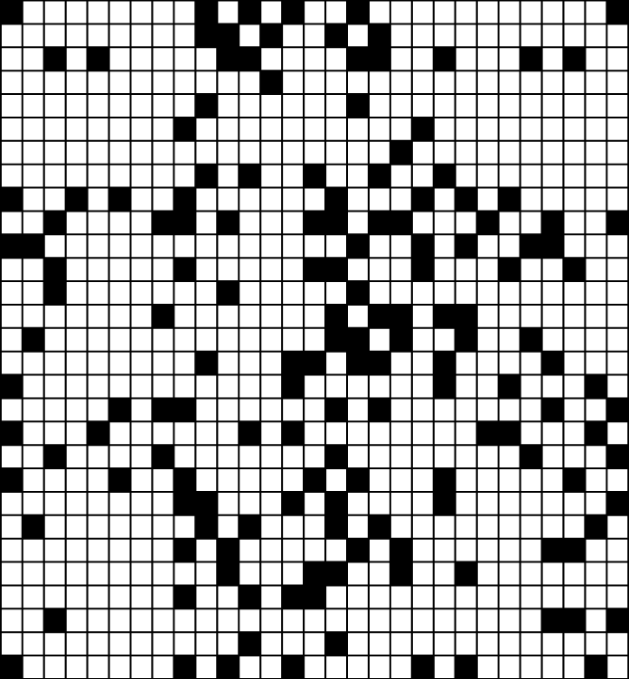

1

5

1

1

2

1

1

2

1

7

1

2

1

1

5

1

4

2

2

4

2

1

4

2

2

1

2

2

10

1

1

5

2

1

1

1

3

1

2

1

2

1

2

1

3

1

2

5

1

2

1

3

1

1

3

1

1

2

1

1

1

3

1

1

1

2

1

2

2

1

2

2

1

1

1

1

1

1

1

3

3

1

1

2

3

4

7 1 1 1 3 7

1 1 2 4 2 1 1

1 3 1 2 1 2 1 1 3 1

7

1

3

1

1

1

7

1

1

1

1

1

1

7 3 1 3 1

7 1 1 1 1 1 1 1 7

7 3 3 2 1 1 1 1

7

1

1

1

1

1

1

1

7

7

1

1

1

2

1

1

2

7

1

1

1

3

1

2

1 3 1 5 4 1 3 1

1 3 1 1 4 3 1 3 1

1 1 7 1 1 1

1

3

1

5

1

1

1

3

1

1

1

1

2

1

1

1

1

1

1

1

1

2

3

1

2

1

3

1

1

1

8

1

3

1

2

1

2

1

1

2

1

1

3

3

2

4

2

1 1 3 1 1 1 1 4

1 3 1 1 2 1 5 1

1 3 1 1 1 4 2 5 1

1 3 1 1 2 3 1

1 1 2 1 1 2 1

1 2 1 2 1

1 1 2 1 1 1 2 1 1

2 2 1 1 2 4 1 1 1

2 6 1 1 1 4

1 4 1 2 1 1 2

1 6 2 2 2 2 1 2

2 1 1 1 2 2

12 2 1 1 5

2 2 2 2 3 1 1

1 6 5 2 1 1

1 1 2 1 1 1 3 1 1

1 1 2 2 1 2 2

2 1 3 7 1 2

1 4 5 1 1 5 1

2 1 4 1 1 3

2

4

1

2

2

1

1

1

2

2

1

1

3

4

1

2

2

2

7

1

3

2

1

4

1

1

1

1

1

3

1

3

6

2

2

3

1

2

5

1

1

2

3

1

2

Solve this puzzle to reveal a secret message.