EXPERIMENT – 3
Title: TCP Server Client

Objective:
- To study TCP based client–server communication.
- To implement a TCP server and a TCP client using Python.
- To understand reliable data transfer using sockets

Software / Tools Required
- Operating System: Linux
- Programming Language: Python 3
- Custom Module: netpack
Theory
TCP (Transmission Control Protocol) is a reliable and connection-oriented protocol used for data communication over a network. Before any data transfer takes place, a connection is established between the client and the server. TCP ensures that data is delivered correctly and in order.
In a client–server model, the server waits for incoming client requests on a fixed IP address and port number. The client initiates the connection and receives data from the server. Acknowledgments are exchanged to confirm successful data reception. The connection continues until either the client or server requests termination.
In this experiment, the TCP server sends random data to the client. The client receives the data and sends an acknowledgment back to the server. This process continues until the client closes the connection.
Diagram (TCP Communication):
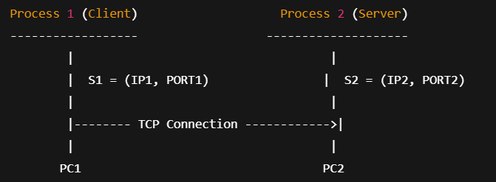

Procedure / Algorithm

Create a TCP socket for the server using the netpack module.

Bind the server socket to a local IP address and port number.

Start the server and wait for a client connection.

Create a TCP socket on the client side.

Connect the client socket to the server’s IP address and port.

After connection, the server sends random data to the client.

The client receives the data and displays it on the terminal.

The client sends an acknowledgment message to the server.

Steps 6 to 8 repeat until the client chooses to close the connection.

Close the client and server sockets properly.

Program Code
TCP Server Program:
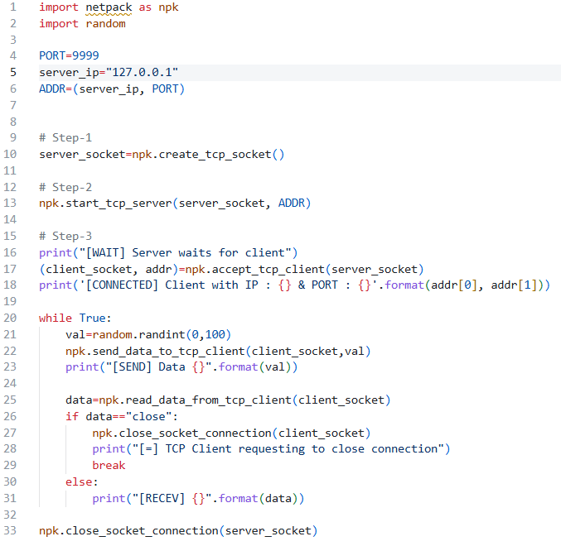
TCP Client Program:
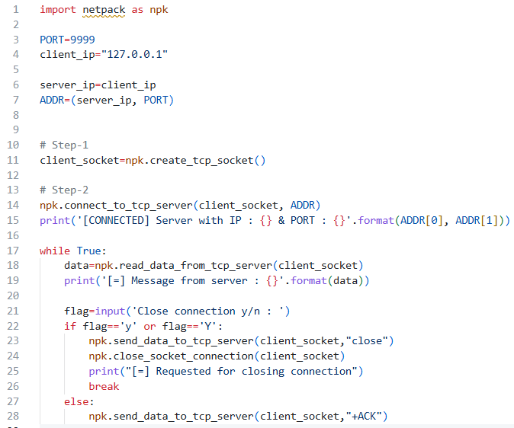
Output:
Client Side: Server Side:
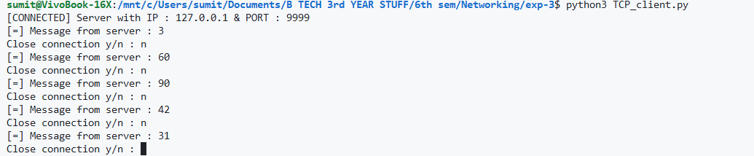 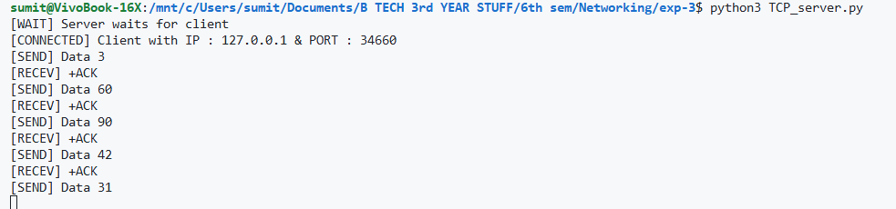
Result
The TCP client and server successfully communicated with each other. The client correctly received all data sent by the server and acknowledgments were exchanged without any error.

Conclusion
This experiment demonstrated TCP based client–server communication using Python. It showed how a reliable connection is established using sockets, how data is exchanged between the server and client, and how acknowledgments ensure successful communication. The experiment helped in understanding basic socket programming concepts used in computer networks.

