EXPERIMENT – 5
Title: Broadcast Socket Programming

Objective:
To implement broadcast socket programming for sending a message to all computers in a network.
Software / Tools Required
- Operating System: Linux
- Programming Language: Python 3
- Custom Module: netpack
Theory
Broadcast communication in computer networks means sending a message from one device to all devices present in the same network at the same time. This is done using a special broadcast IP address so that every host connected to the network can receive the message.
One common broadcast address is 255.255.255.255, which is called limited broadcast. It sends the message to all hosts within the same local network and routers normally do not forward this message to other networks.
Another type is directed broadcast, where the address contains the network ID and all 1’s in the host part. For example, for the network 20.0.0.0/8, the broadcast address becomes 20.255.255.255, which sends the message to all hosts in that particular network.
In this experiment, a UDP broadcast socket is used where the server sends broadcast messages and multiple clients in the network receive the same message simultaneously.
Limited Broadcast
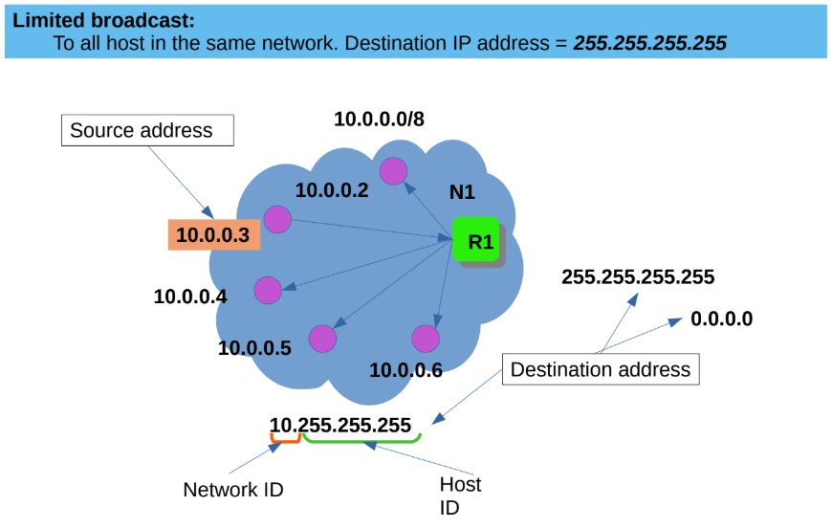
Directed Broadcast
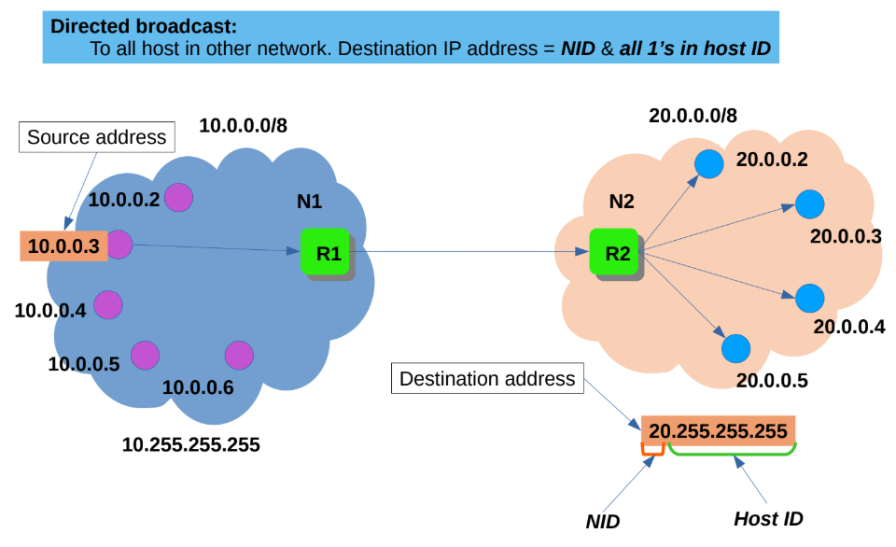

Procedure / Algorithm
Server Side

Import required modules.

Create UDP broadcast server socket.

Define broadcast IP address 255.255.255.255 and client port.

Generate random number to send as broadcast message.

Send the message to broadcast address.

Wait for a few seconds and repeat broadcasting.

If user interrupts the program, send "close" message and terminate connection.

Client Side

Import required modules.

Create UDP broadcast client socket.

Bind the socket to the specified port.

Wait for broadcast message from server.

Receive message from server and display it.

If the received message is "close", close the connection and terminate the program.

Program Code
Server Program:
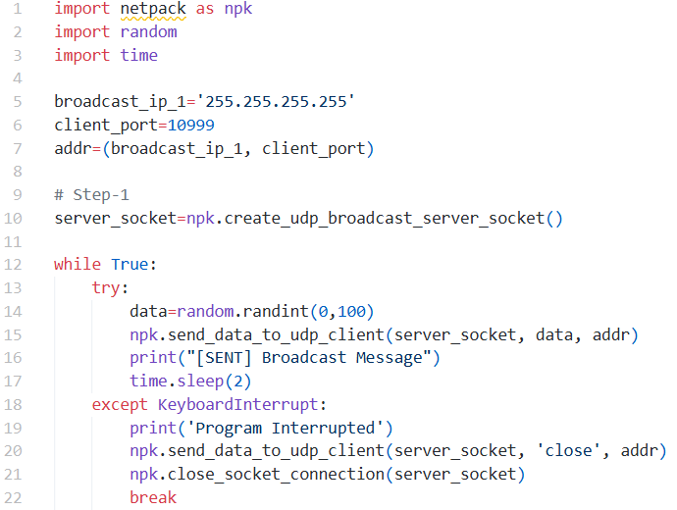
Client Program:
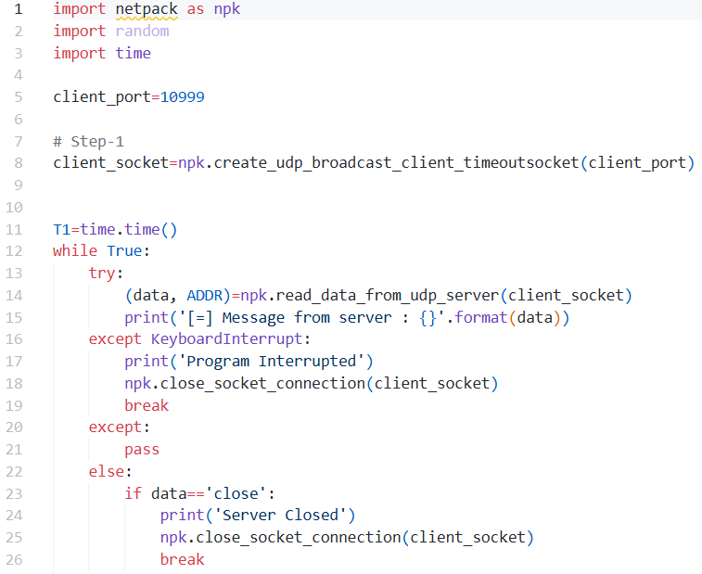
Output:
Server Side: 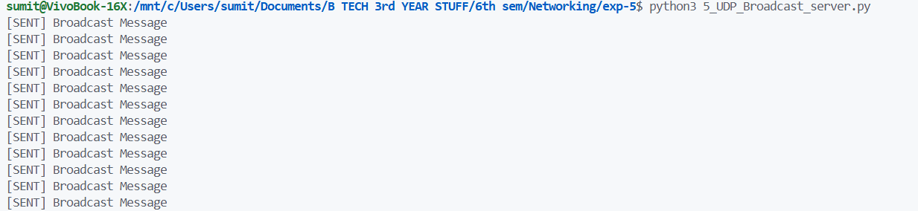
Client Side:
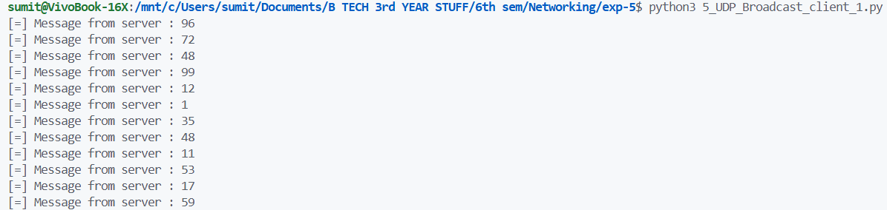
Result
The broadcast socket program was executed successfully and the server message was received by multiple clients in the network.

Conclusion
From this experiment we learned how broadcast communication works using UDP sockets and how a single server can send the same message to multiple clients in a network.

