EXPERIMENT – 6
Title: Prototype Multithreaded Server

Objective:
To implement a multithreaded server that can handle multiple client connections at the same time.

Software / Tools Required
- Operating System: Linux
- Programming Language: Python 3
- Custom Module: netpack
Theory
A thread is a small unit of execution inside a program that can run independently. A single process can have multiple threads, and each thread performs its own task.
In networking, using threads helps a server to handle multiple clients at the same time. Instead of serving one client and then moving to another, the server creates a separate thread for each client connection.
There are two types of execution: synchronous and asynchronous. In synchronous execution, tasks are performed one after another, while in asynchronous execution, multiple tasks appear to run at the same time.
In this experiment, a multithreaded TCP server is created where each client is handled by a separate thread. The server sends data to multiple clients and receives responses from them independently.

Concept of Thread
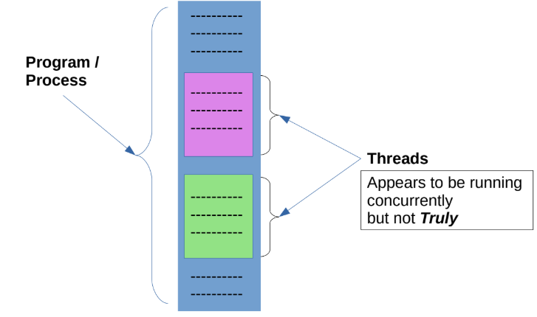
Synchronous & Asynchronous Thread
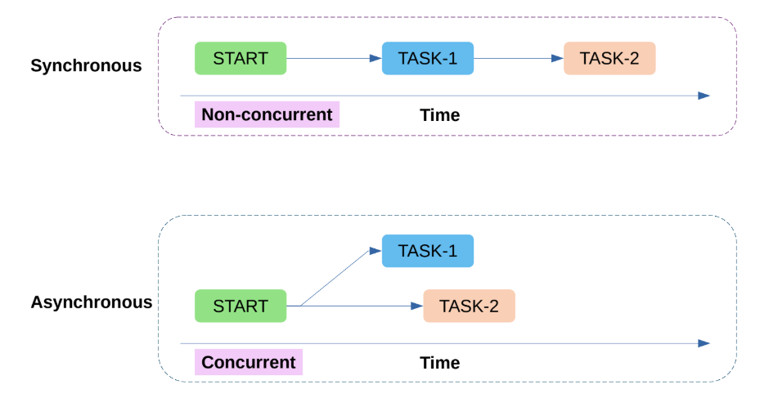

Procedure / Algorithm
Server Side
- Import required modules.
- Create TCP server socket and start server.
- Wait for client connection and accept it.
- Create a new thread for each client.
- Send data to client and receive response.
- If client sends "close", terminate that thread

Client Side

Import required modules.

Create TCP client socket.

Connect to server.

Receive and display message.

Send acknowledgment to server.

If user exits, send "close" and terminate connection.

Program Code
Server Program:
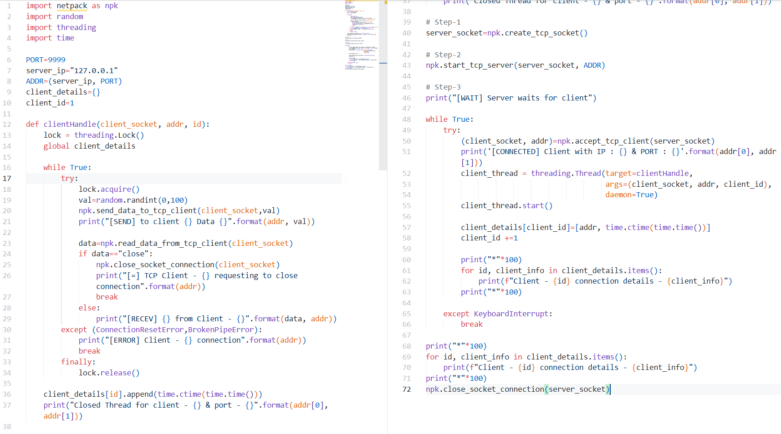

Client Program:
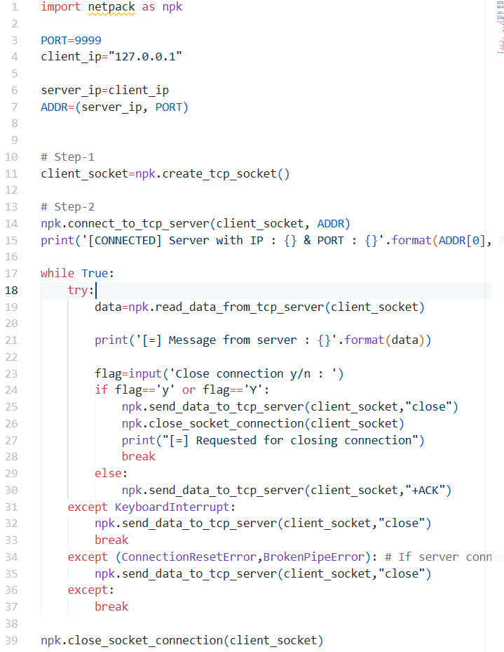

Output:
Server Side: 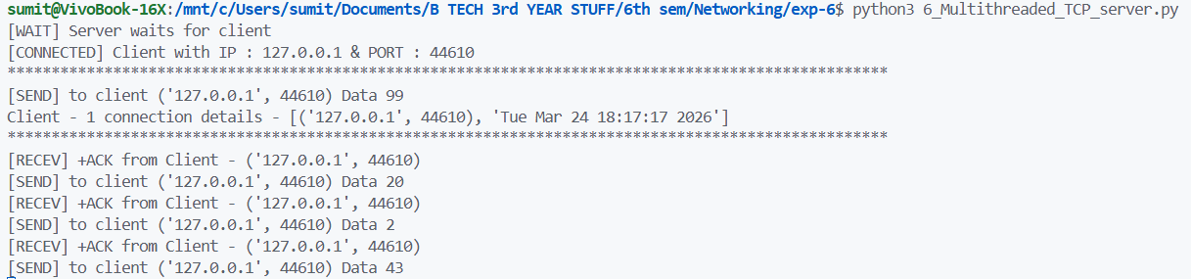
Client Side:
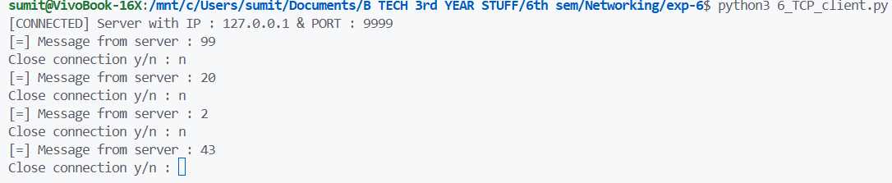

Result
The multithreaded server program was executed successfully and multiple clients were handled simultaneously.
Conclusion
The multithreaded server program was executed successfully and multiple clients were handled simultaneously.

