EXPERIMENT – 4
Title: UDP Socket Programming

Objective:
Communicating between two computers located at different places and connected via network.

Software / Tools Required
- Operating System: Linux
- Programming Language: Python 3
- Custom Module: netpack
Theory
UDP (User Datagram Protocol) is a connectionless protocol. It does not establish a proper connection like TCP. Data is sent in the form of datagrams. It is faster but less reliable because there is no guarantee of delivery.
In this experiment, we created a UDP server and UDP client using Python. The server generates random numbers and sends them to the client. The client receives the data and sends acknowledgement back. If client sends “close”, the server closes the connection.

UDP Socket Flow:
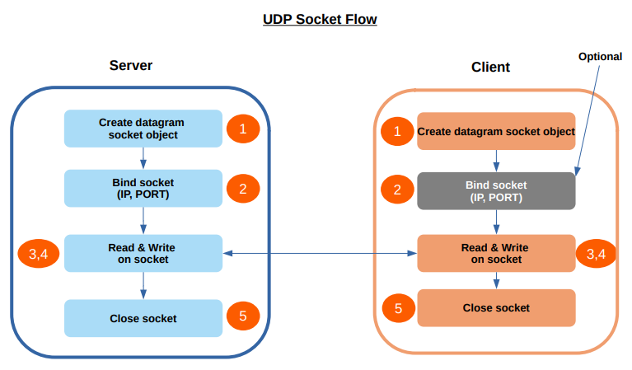

Procedure / Algorithm

Server Side

Import required modules.

Create UDP socket.

Bind the socket with IP and Port.

Wait for client request.

Generate random number and send to client.

Receive acknowledgement from client.

If client sends “close”, terminate connection.

Client Side

Import required modules.

Create UDP socket.

Send initial message to server.

Receive data from server.

Send “+ACK” after receiving data.

If user enters ‘y’, send “close” and terminate.

Program Code
Server Program:
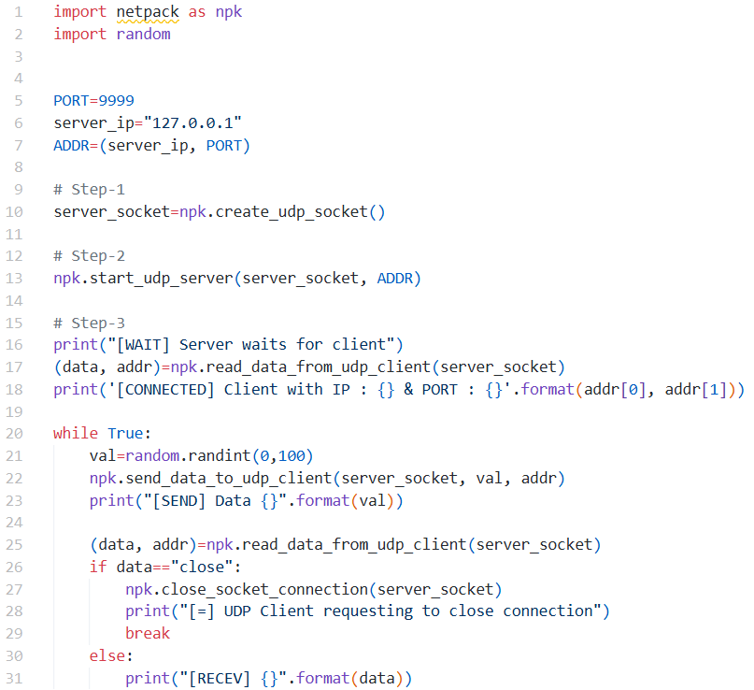
Client Program:
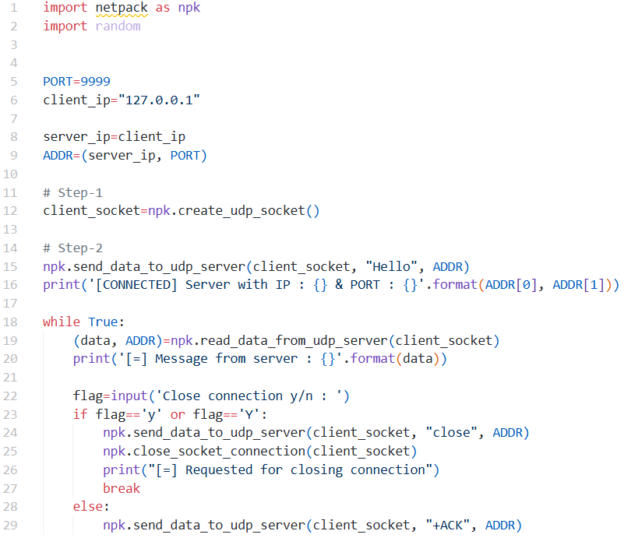
Output:
Server Side: 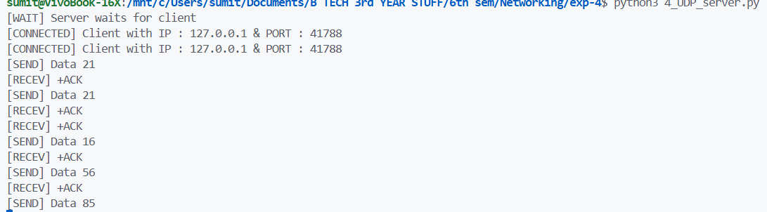
Client Side:
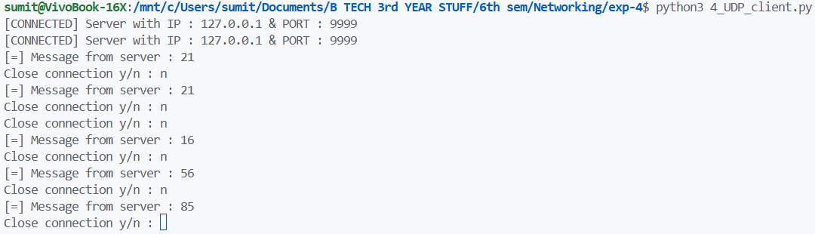
Result
UDP client and server communication was successfully implemented and data was exchanged properly.

Conclusion
From this experiment, I understood how UDP works without connection setup. Data can be sent and received using socket programming, but reliability depends on application logic.

