EXPERIMENT – 8
Title: Implementation of Selective Repeat Mechanism
Objective:
To understand data link layer flow control mechanism under noisy channel.Software / Tools Required
- Operating System: Linux
- Programming Language: Python 3
- Custom Module: netpack
Theory
Selective Repeat ARQ is a flow control and error control protocol used in the Data Link Layer for reliable data transmission over noisy channels. It is a type of sliding window protocol where multiple frames can be sent before receiving acknowledgements.
In this mechanism, the sender transmits several frames continuously within a fixed window size. Each frame contains a sequence number so that the receiver can identify them correctly. The receiver checks every incoming frame and sends ACK for correctly received frames and NACK for lost or damaged frames.
Unlike Go-Back-N ARQ, Selective Repeat retransmits only the specific lost or corrupted frame instead of retransmitting all frames after it. This improves bandwidth efficiency and reduces unnecessary retransmission.
Both sender and receiver maintain separate windows. The sender stores transmitted frames temporarily until ACK is received. If an ACK is not received within the timeout period, the sender retransmits that particular frame.
Selective Repeat ARQ is mainly used in noisy communication channels where frame loss or ACK loss may occur. It provides better performance and efficient communication compared to Stop-and-Wait and Go-Back-N protocols.
Protocol Concept:
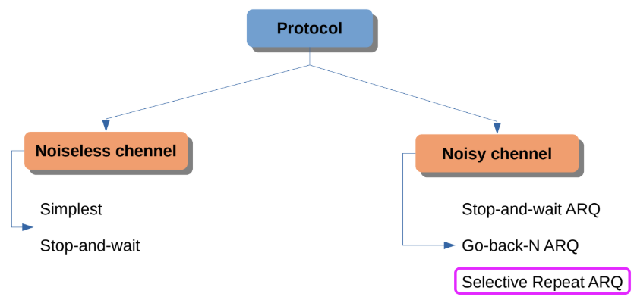
Selective Repeat Flow (ACK Lost):
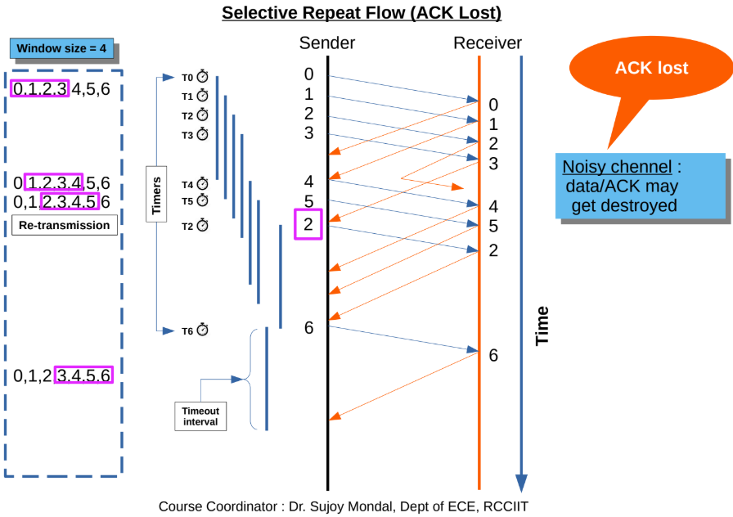

Selective Repeat Flow (Frame lost):
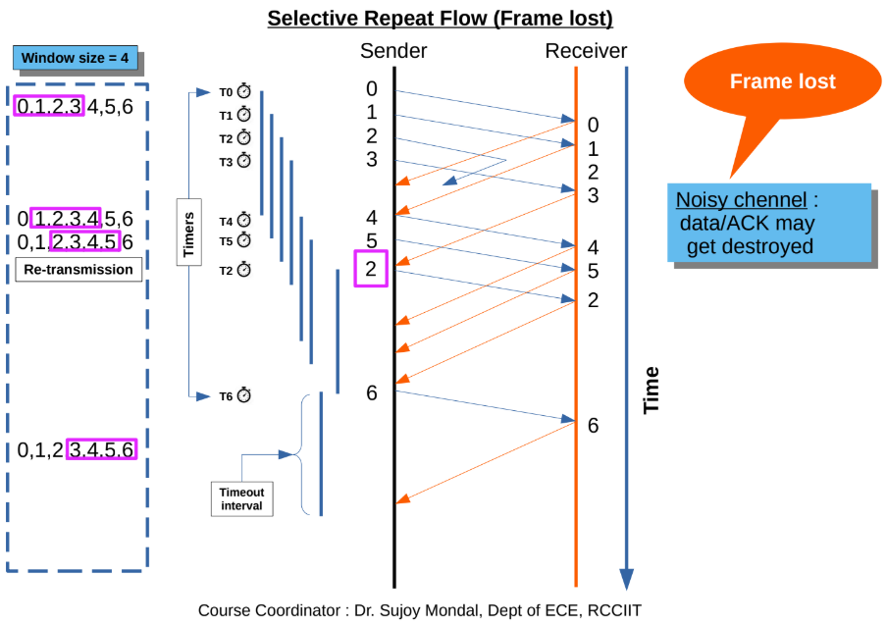
Procedure / Algorithm
Sender Side
- Create UDP server socket.
- Define sender window size.
- Send frames one by one.
- Start timer for each frame.
- Wait for ACK/NACK.
- Retransmit frame if timeout occurs.
- Stop after all frames are acknowledged.
Receiver Side
- Create UDP client socket.
- Receive frames from sender.
- Check frame condition.
- Send ACK if frame received correctly.
- Send NACK if frame lost.
- Store received data in buffer.
- Display final received message.

Program Code
Sender Program:
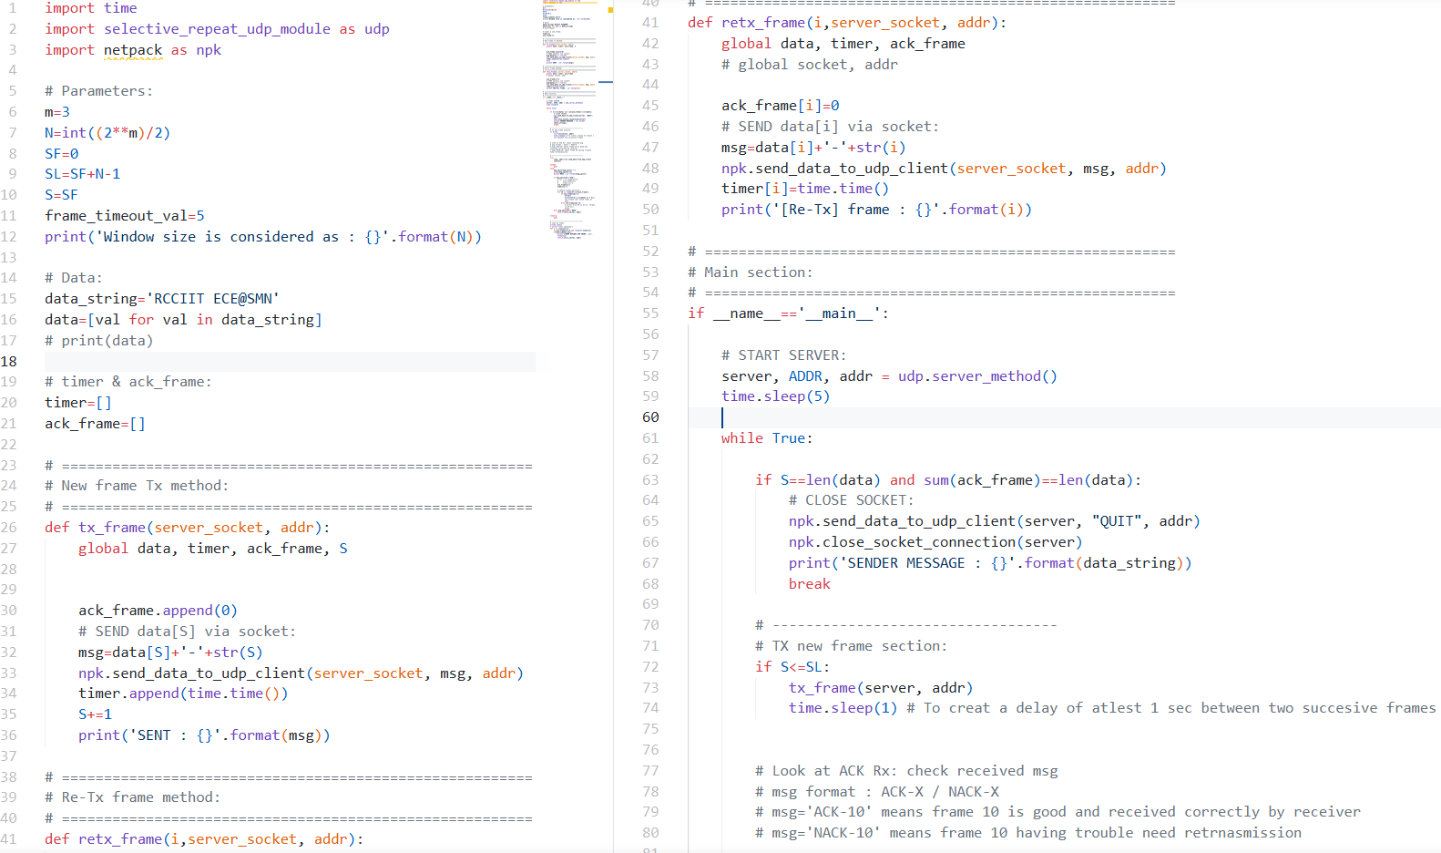
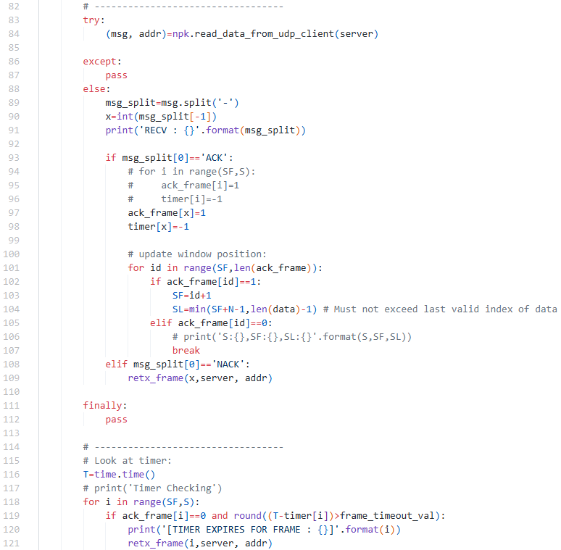
Receiver Program:

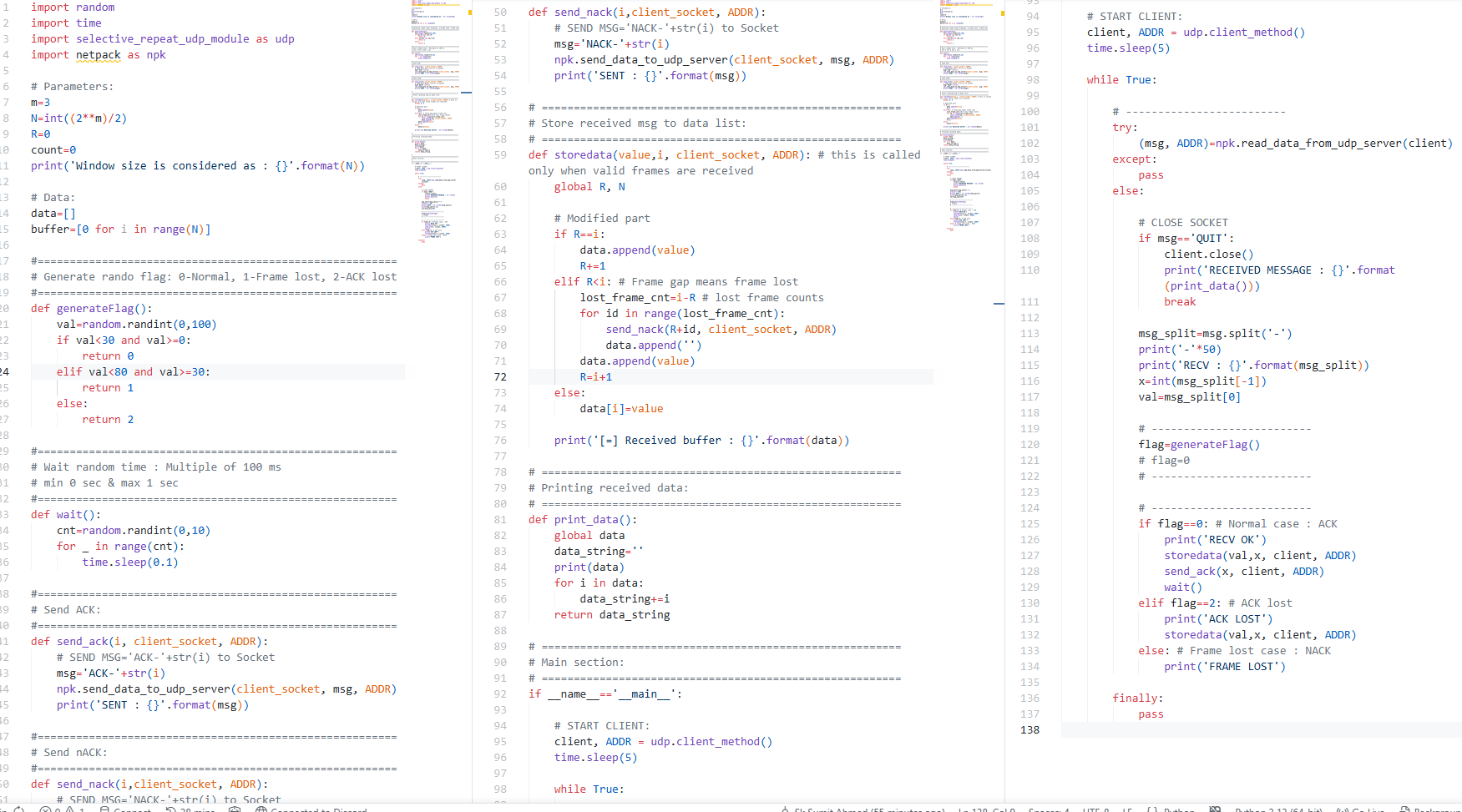

Selective Repeat Module
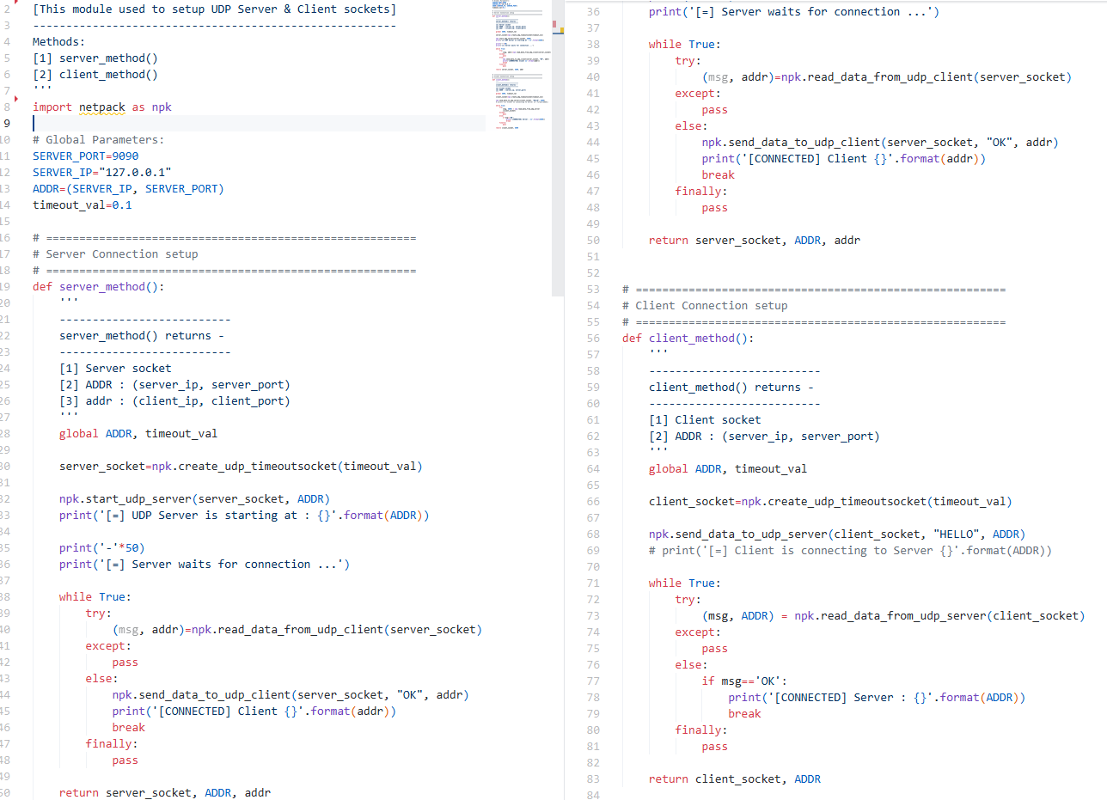

Output:
Sender Side Output
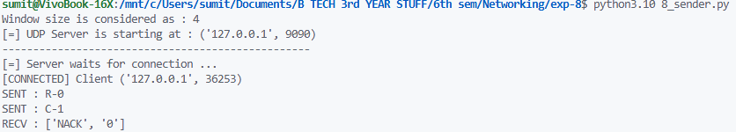
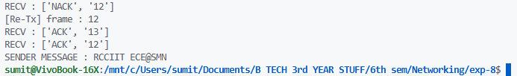
Receiver Side Output
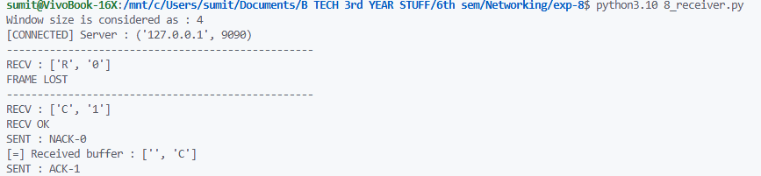
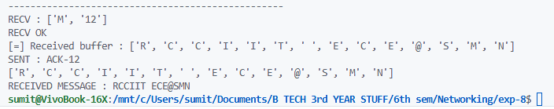
Result
The Selective Repeat ARQ protocol was implemented successfully using UDP socket programming.
Conclusion
The experiment helped to understand frame retransmission, ACK/NACK handling, and sliding window operation in noisy channels.

