EXPERIMENT – 7
Title: Implementation of Stop & Wait Mechanism

Objective:
To understand and implement stop and wait flow control mechanism in data communication.
Software / Tools Required
- Operating System: Linux
- Programming Language: Python 3
- Custom Module: netpack
Theory
Stop-and-wait is a simple flow control protocol used in the data link layer. In this method, the sender sends one frame and then waits for an acknowledgment from the receiver before sending the next frame.
If the acknowledgment is received, the sender sends the next frame. If not, it waits until the acknowledgment arrives. This ensures that data is transmitted in an orderly and reliable way.
This protocol works well in a noiseless channel, where frames and acknowledgments are not lost or corrupted.
In this experiment, the sender sends data frame by frame and the receiver sends an ACK for each frame. After receiving the ACK, the sender proceeds to send the next frame.
Protocol Concept
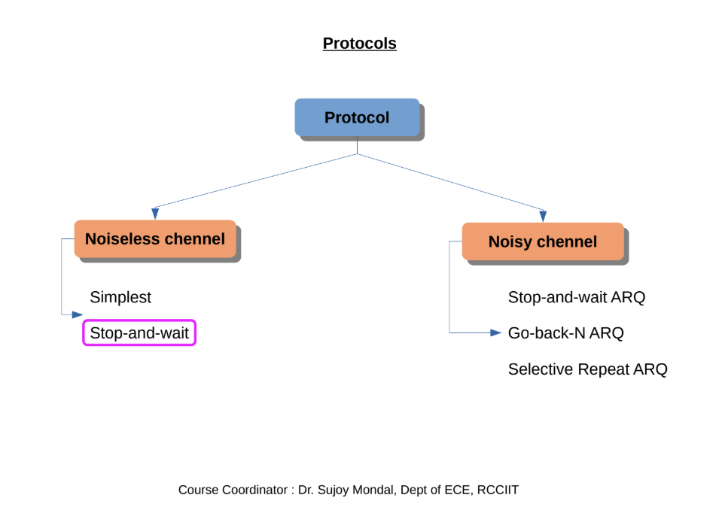
Stop-and-Wait Protocol
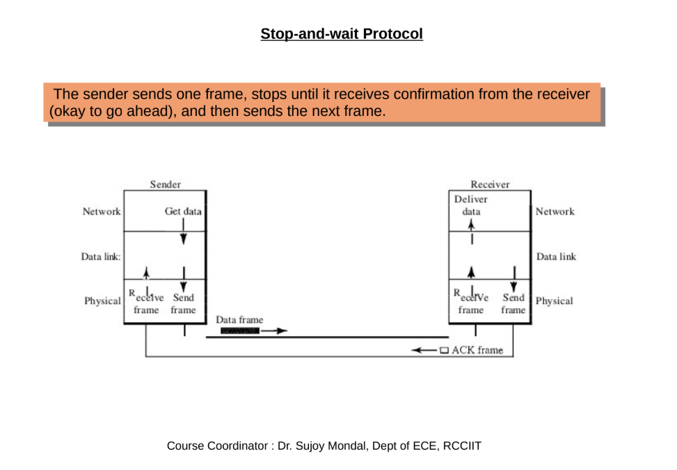
Stop-and-Wait Flow
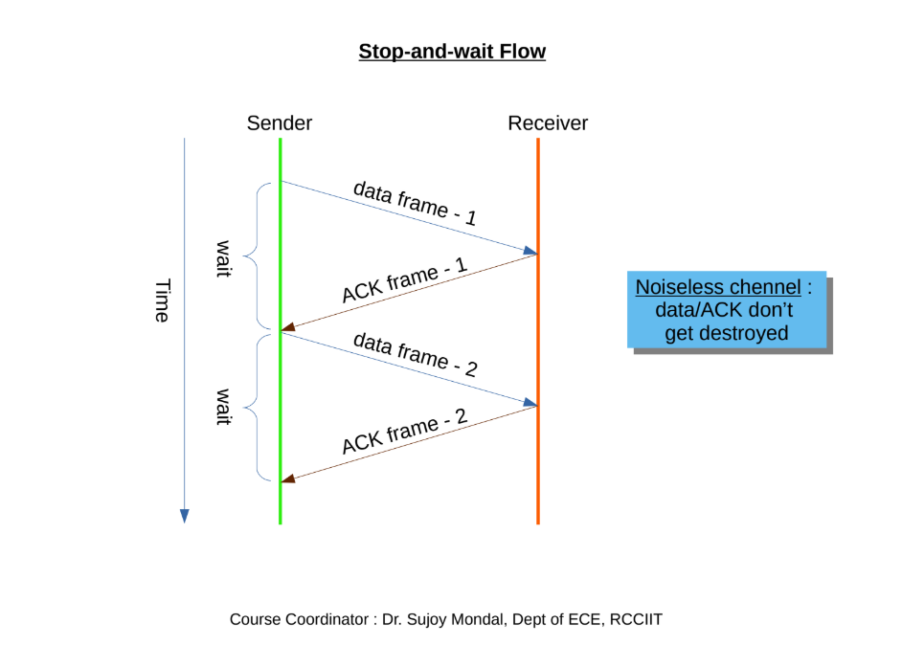
Program Flow
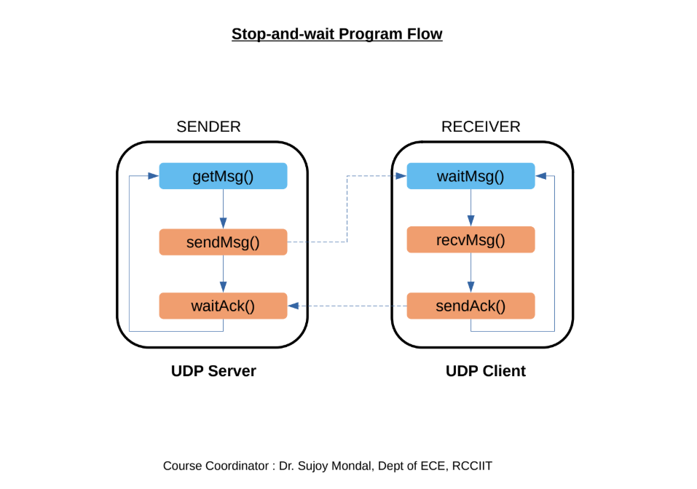
Procedure / Algorithm
Sender Side
- Import required modules and create UDP socket.
- Wait for receiver connection.
- Send one frame and wait for ACK.
- If ACK is received, send next frame.
- After sending all data, send termination signal.
Receiver Side
- Import required modules and create UDP socket.
- Connect to sender.
- Receive frame and display it.
- Send ACK for each received frame.
- Stop communication when termination signal is received.

Program Code
Sender Program:
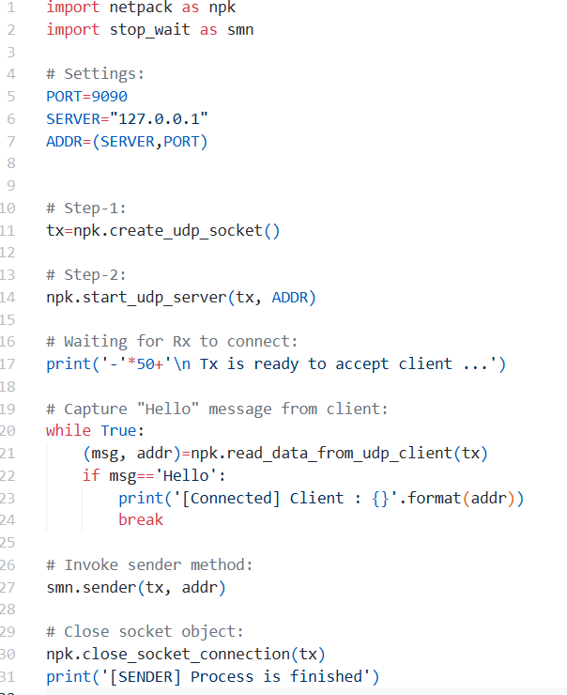
Receiver Program:
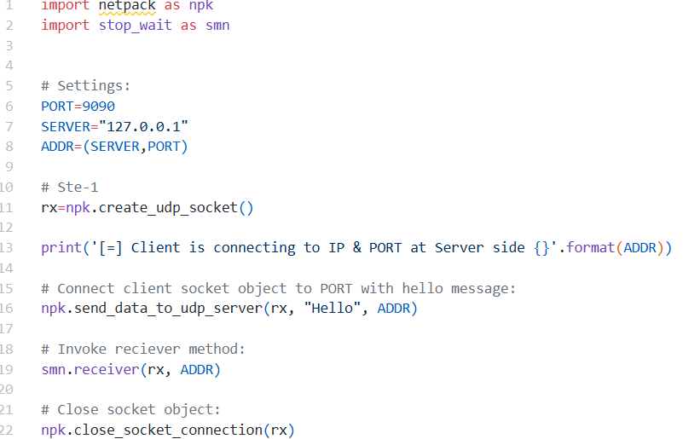

Stop & Wait Module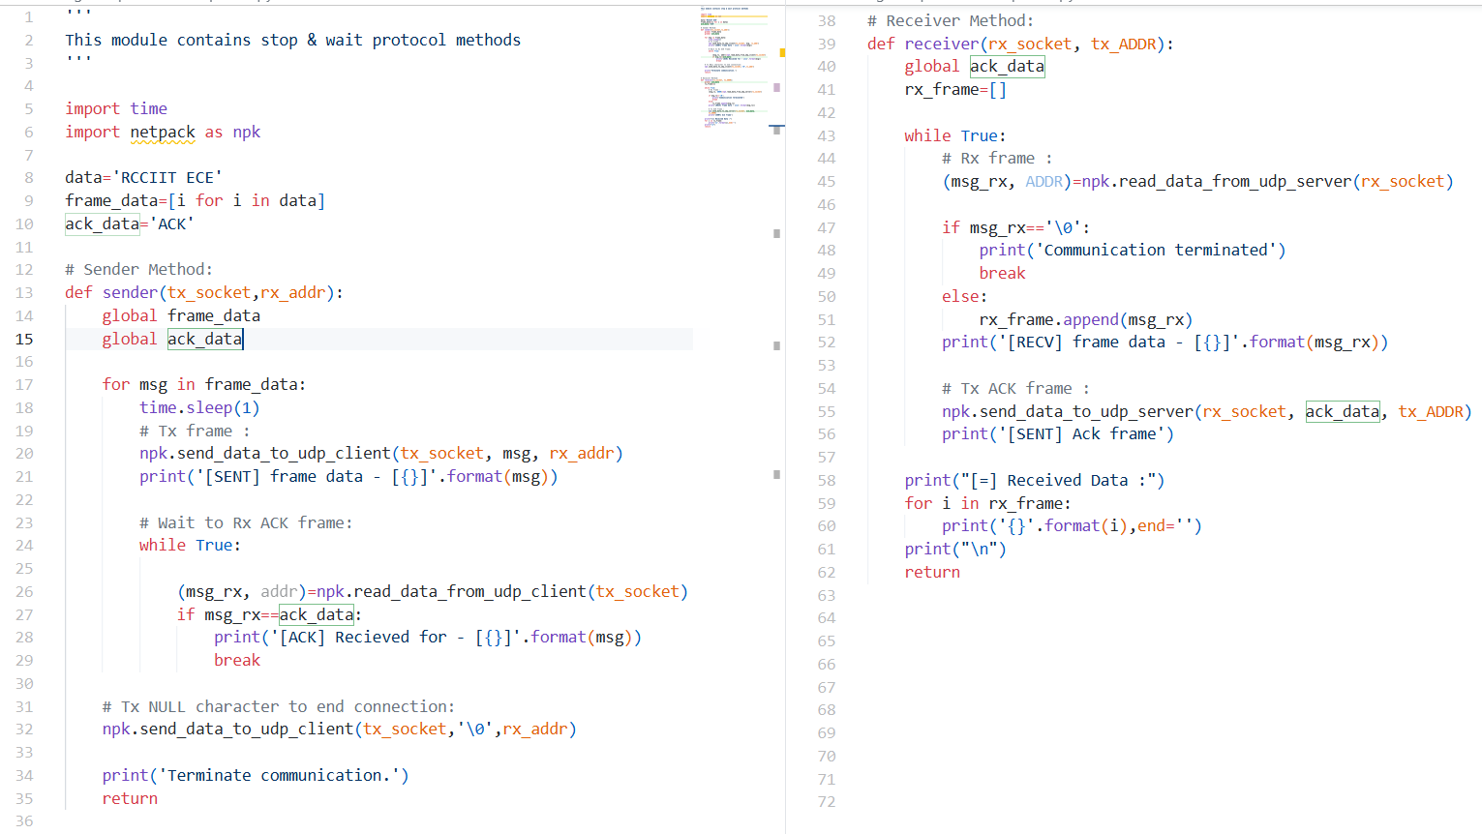

Output:
Sender Side Output 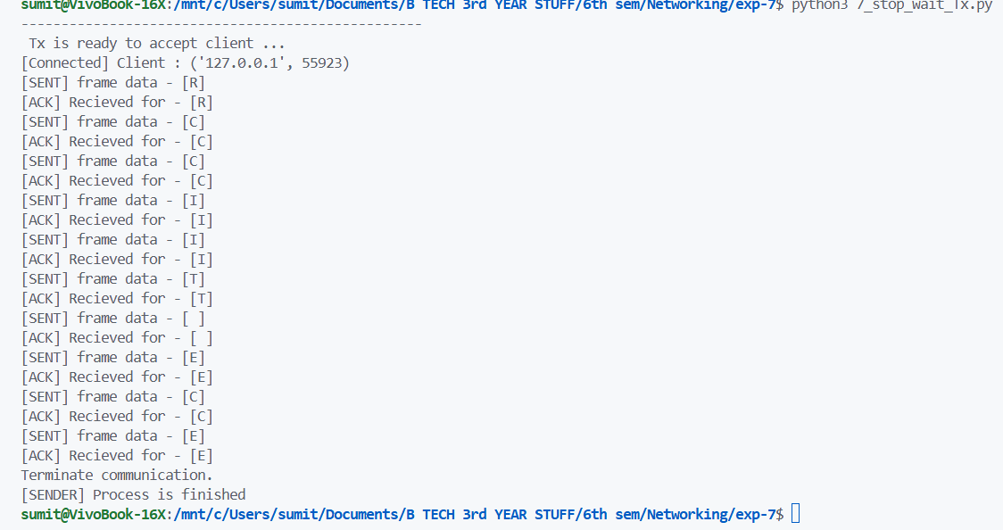
Receiver Side Output
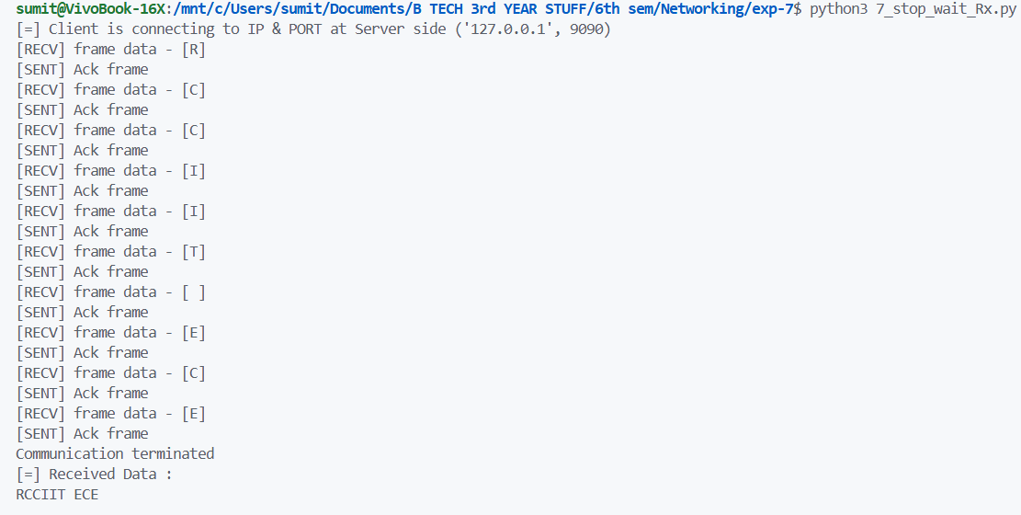
Result
The stop and wait protocol was implemented successfully and data was transmitted with proper acknowledgment.

Conclusion
From this experiment we learned how stop-and-wait ensures reliable data transfer by sending one frame at a time and waiting for acknowledgment.

