**Setting up Selenium Environment**

WebDriver provides a well-designed object-oriented API which gives you the enhanced hold up for modern advanced web-app testing problems.

Download Selenium webdriver > Configure with Eclipse > Run webdriver script

1. **Download & Install Java Development Kit (JDK):** <http://www.oracle.com/technetwork/java/javase/downloads/jdk8-downloads-2133151.html>

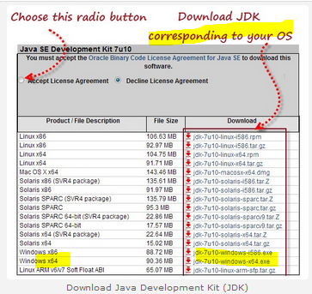

1. **Install Eclipse** (in zip file)
2. **Download Selenium Java client driver:** <http://docs.seleniumhq.org/download/>
   1. Click **Download > OK** to save file
   2. Go to **Downloads** (Selenium webdriver comes in a zip file)
   3. R-click zip file and **Extract All…**
   4. Click **Extract** (C:\Users\mimi\Downloads\selenium-java-2.53.1)
   5. Copy **selenium-java-2.53.1** from Downloads to Work file.

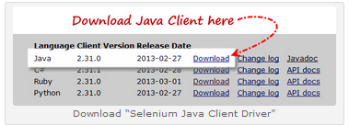

1. **Configure Eclipse with Selenium WebDriver**
   1. Go to File menu > New > Java Project.
   2. Enter Project Name as “Selenium_webdriver_project” project
   3. Click Next > Finish button.
   4. Under newly created project “Selenium_ webdriver_project” you will see the “src“ folder & right click on the “src” folder & create the new class as “Webdriver_class”.

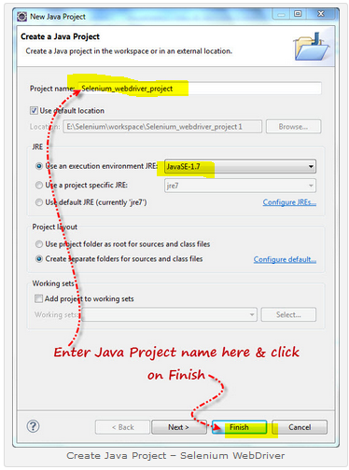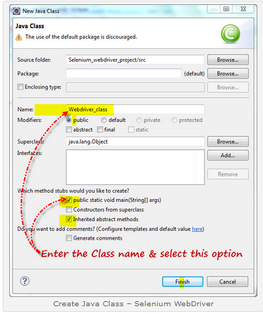

1. **Import all Selenium JARS**

* R-click “Selenium_webdriver_project” > Properties > Java Build path > Libraries > Add External Jars > select all selenium Jars and open > open libs > select all Jars and open > OK

1. **Write Java script to open URL**

**import** org.openqa.selenium.firefox.FirefoxDriver;

**public** **class** Webdriver_class {

**public** **static** **void** main(String[] args) {

FirefoxDriver d = **new** FirefoxDriver();

d.get("https://www.google.com");

}}

**Chrome:**

[**https://sites.google.com/a/chromium.org/chromedriver/**](https://sites.google.com/a/chromium.org/chromedriver/)

[**https://sites.google.com/a/chromium.org/chromedriver/downloads**](https://sites.google.com/a/chromium.org/chromedriver/downloads)

[**http://chromedriver.storage.googleapis.com/index.html?path=2.24/**](http://chromedriver.storage.googleapis.com/index.html?path=2.24/)

**Firefox:**

Choose Selenium version compatible with Firefox version.

<http://learn-automation.com/use-firefox-selenium-using-geckodriver-selenium-3/>

here I used Firefox version 49.o with Selenium 3.0