ASP.NET AJAX setup for iSell

http://www.asp.net/ajaxlibrary/act_tutorials.ashx
http://ajaxcontroltoolkit.codeplex.com/

Download the library and add it into bin folder:

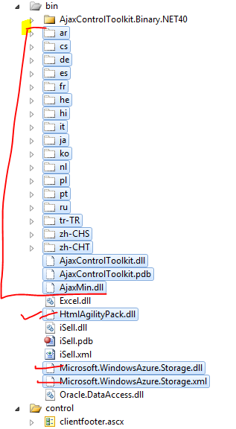

Add dlls (AjaxControlToolkit and HtmlAgilityPack) into the References

