- Open https://isea.gov.in in your browser. Click on the  icon on the top right corner.
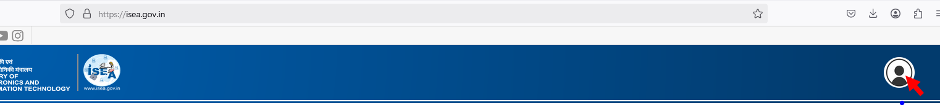

- Login using your mobile number and OTP / email and OTP.
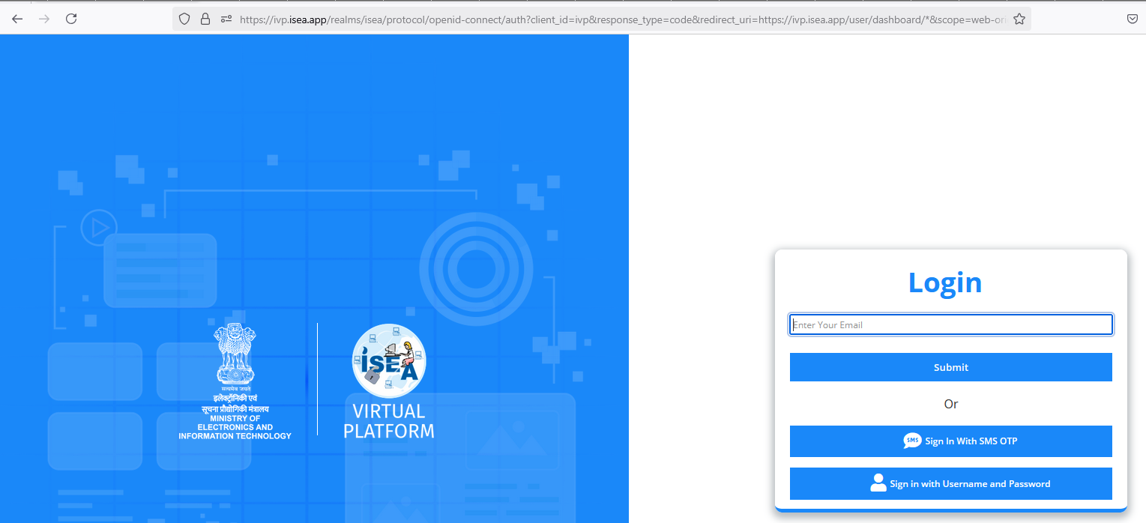

- Post login, in case you are prompted with screen like below. Click on the Login button in the top right corner.
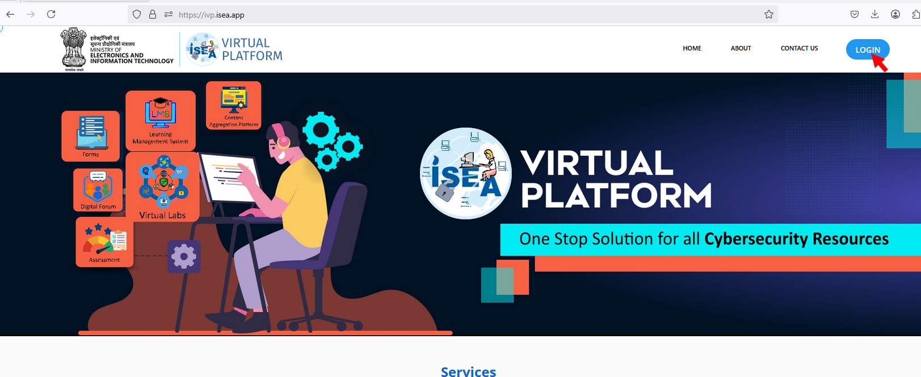

- Post successful authentication. It will take you to your dashboard. You may update your profile information by clicking on Update Your Profile link in the top left.
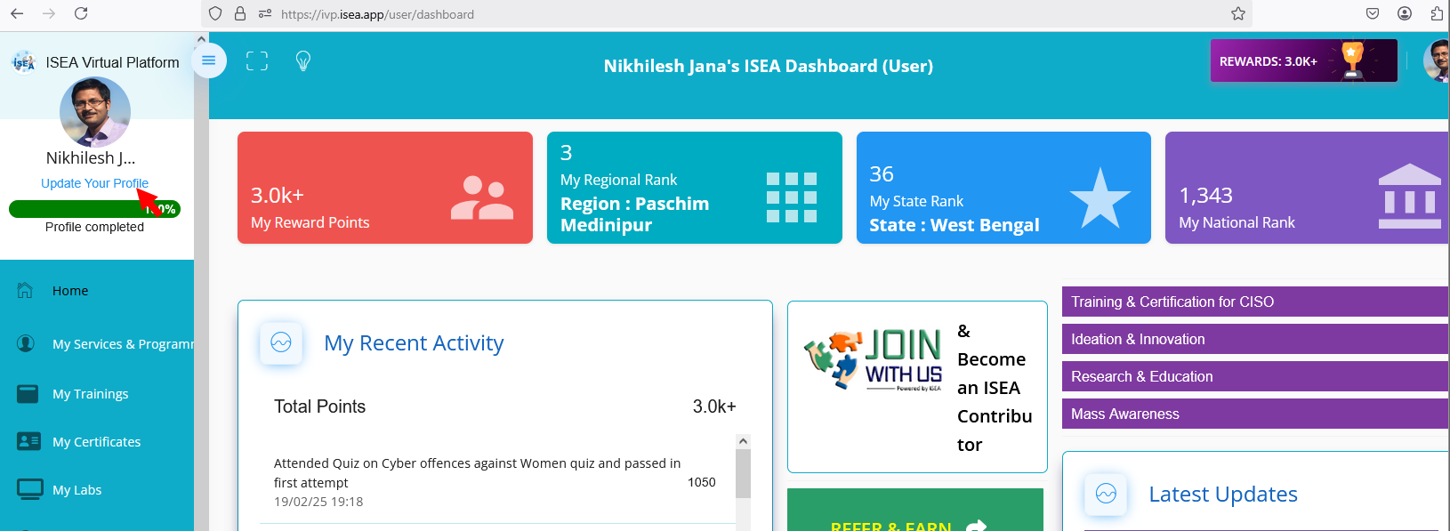

- To access the awareness materials, click on Mass Awareness link towards the right side.
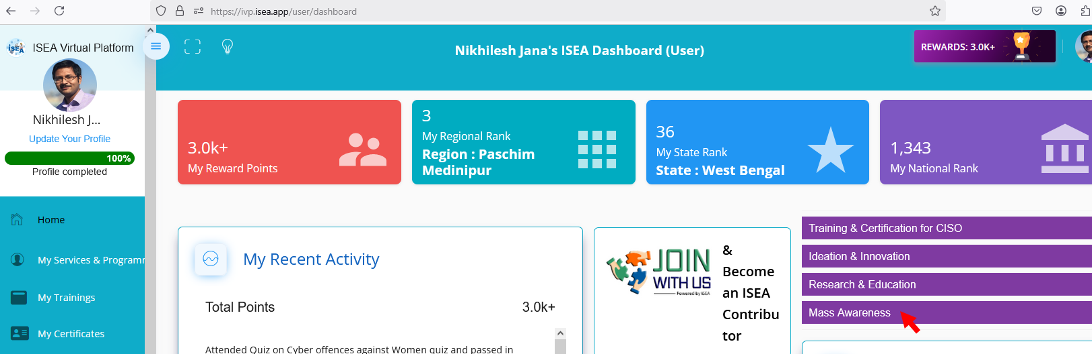

- On click you will be taken to another site. Click on the Login button on top right. It will automatically log you in and retrieve your profile information from the previous website. Once you are logged in, instead of the Login button, you will notice your name displayed.
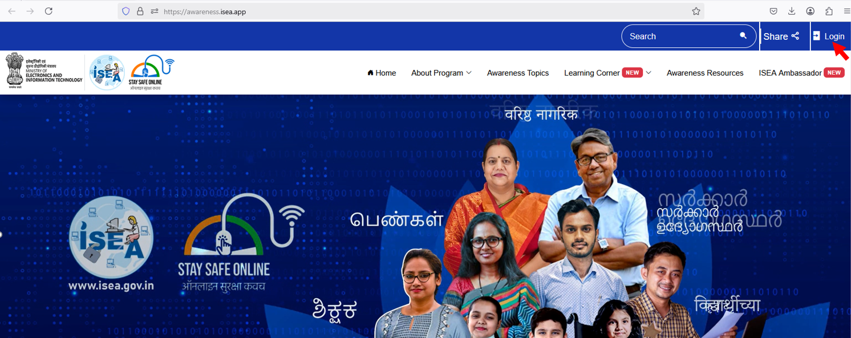
- Click on Awareness Topics link.
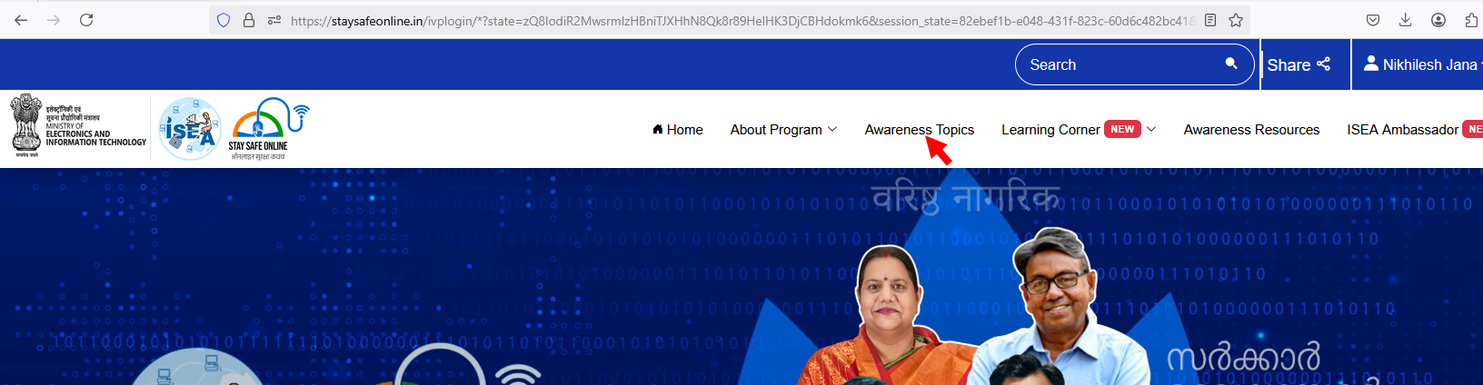

- Multiple Awareness Topics will be displayed on the screen. You may click on your desired topic from the list.
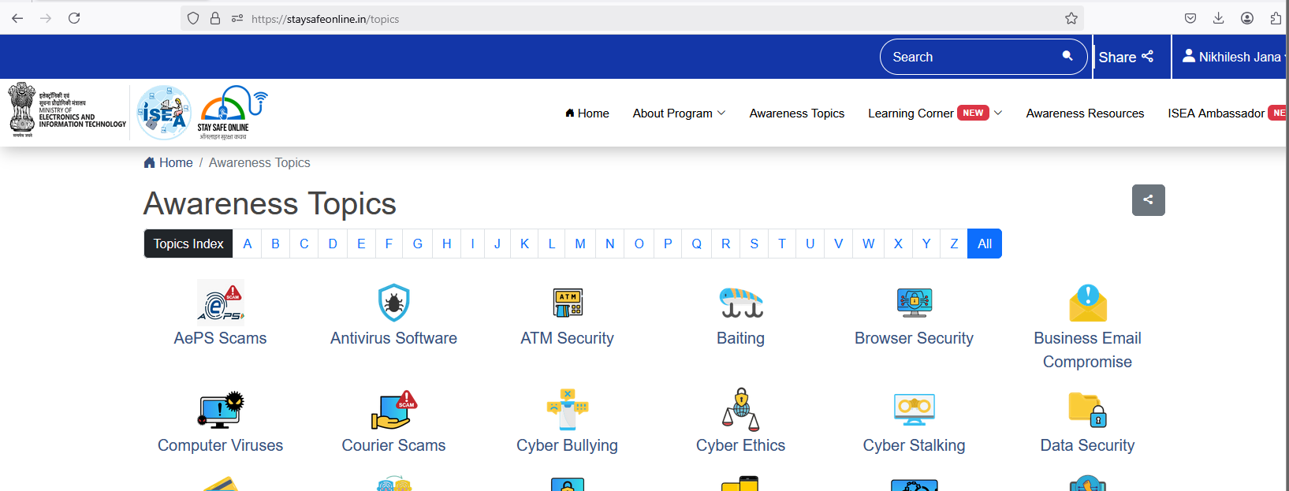

- Once you have selected a topic, it will take you a page similar to below. Click on More Info.
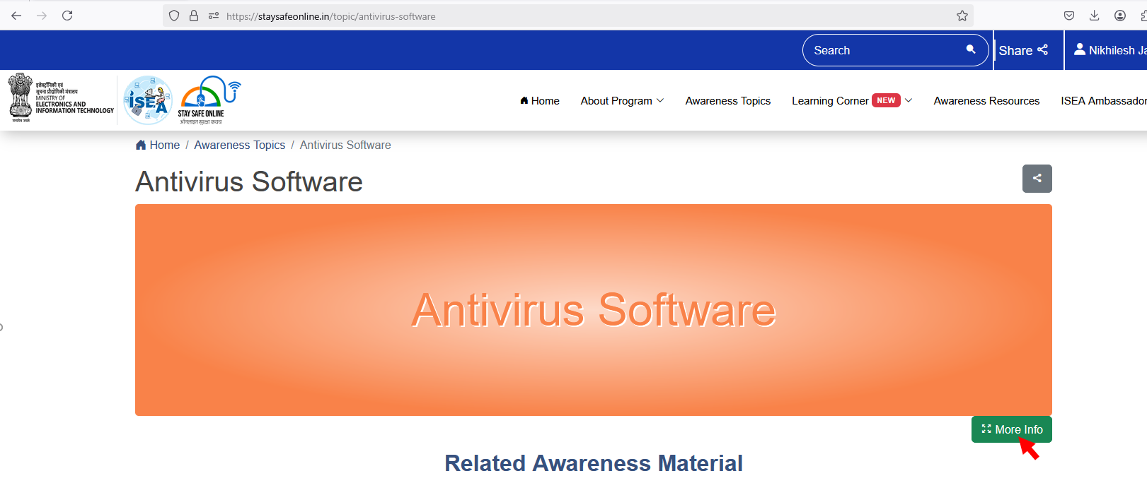

- It will take you to the course details page. Use the navigation buttons to browse the topic.
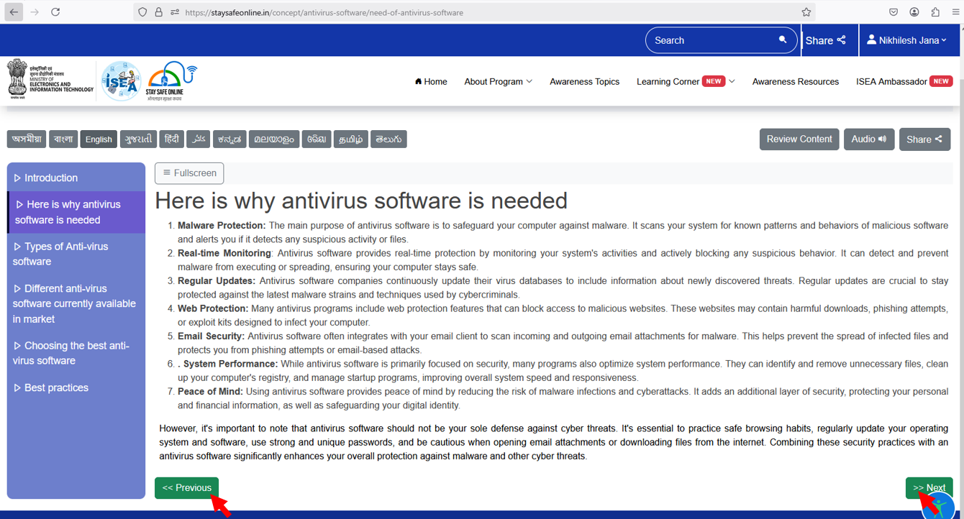

- You may also browse through the other tabs for multiple exiting resources – (Quiz, Assesments, Certificates etc.).
