**NETAJI SUBHAS UNIVERSITY OF TECHNOLOGY**

Azad Hind Fauj Marg, Dwarka Sector-3, Dwarka, Delhi, 110078



**COMPUTER HARDWARE SOFTWARE WORKSHOP**

(COURSE CODE: COCSC19)

SUBMITTED BY:

Sumit Chandra Das – 2021UCS1651

Sumit Rana – 2021UCS1658

Rose Kansal – 2021UCS1681

**PROJECT TITLE: AQI DETECTION**

**IDEA:**

Develop a machine learning model capable of forecasting the Air Quality Index (AQI) for a specific location by leveraging key atmospheric parameters such as PM2.5, PM10, NO2, and SO2 concentrations.

**TOOLS USED:**

* Google Colaboratory
* Arduino uno simulator

**FLOW DIAGRAM:**

TRAINING THE MACHINE LEARNING MODEL

PREDICTING THE AQI USING THE OBTAINED PARAMETERS

ALERTING THE USER USING RGB LIGHTS

**USE CASE SCENARIOS:**

* Health Protection: Protects public health by providing insights into potential health risks associated with poor air quality.
* Urban Planning: Informs urban planning strategies by identifying areas with higher pollution levels and guiding the development of green spaces.
* Policy Formulation: Guides policymakers in formulating effective environmental policies and regulations to mitigate air pollution.
* Research and Analysis: Supports scientific research on the correlation between air quality and health outcomes.
* Forecasting: Provides short-term and long-term forecasting of air quality conditions, aiding in proactive planning.
* Education and Awareness: Educates the public about the sources of air pollution and encourages sustainable practices.
* Emergency Response: Assists emergency response teams in managing health emergencies related to air quality, such as wildfires or industrial accidents.
* Industry Compliance: Enables industries to monitor and comply with environmental regulations, minimizing the impact of industrial activities on air quality.
* Tourism Management: Supports tourism management by providing information on air quality, making it easier for tourists to plan visits.
* Climate Change Monitoring: Contributes to monitoring and understanding the impact of climate change on air quality.

**DATASET:**

To train the machine learning model we used a dataset consisting amounts of key atmospheric parameters like PM2.5, PM10, NO2, and SO2 concentrations from various cities across India since 2015 to 2020.

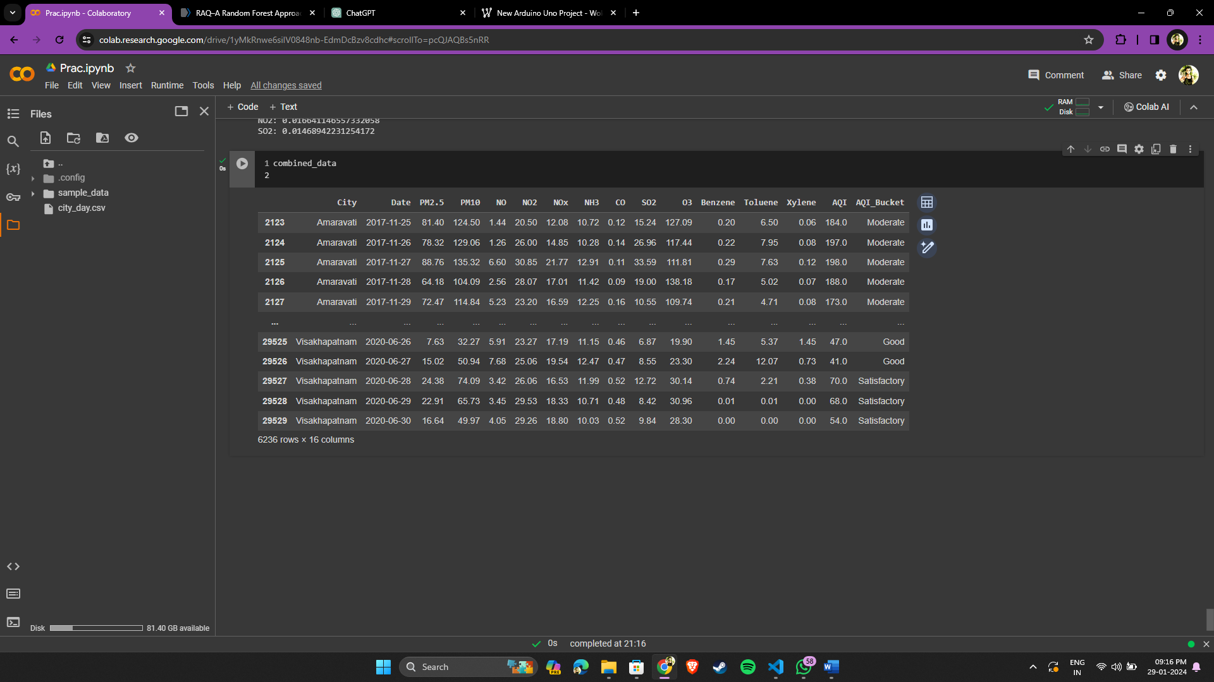

**PYTHON CODE:**

We used a ridge regression method to predict the coefficient values and the intercept in our model namely: PM2.5, PM10, NO, NO2, NOx, NH3, CO, SO2, O3, Benzene, Toluene and Xylene levels.

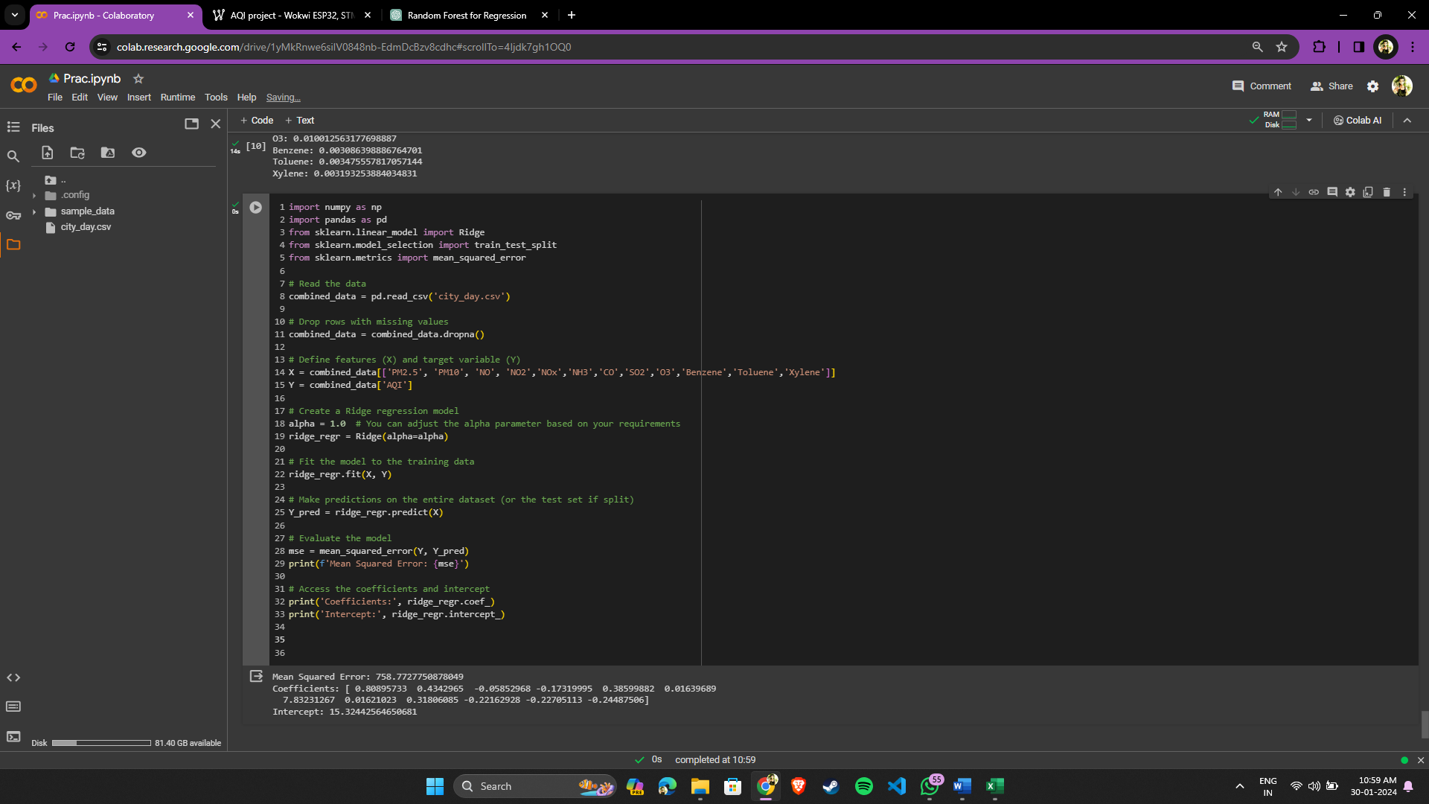

**ARDUINO CODE:**

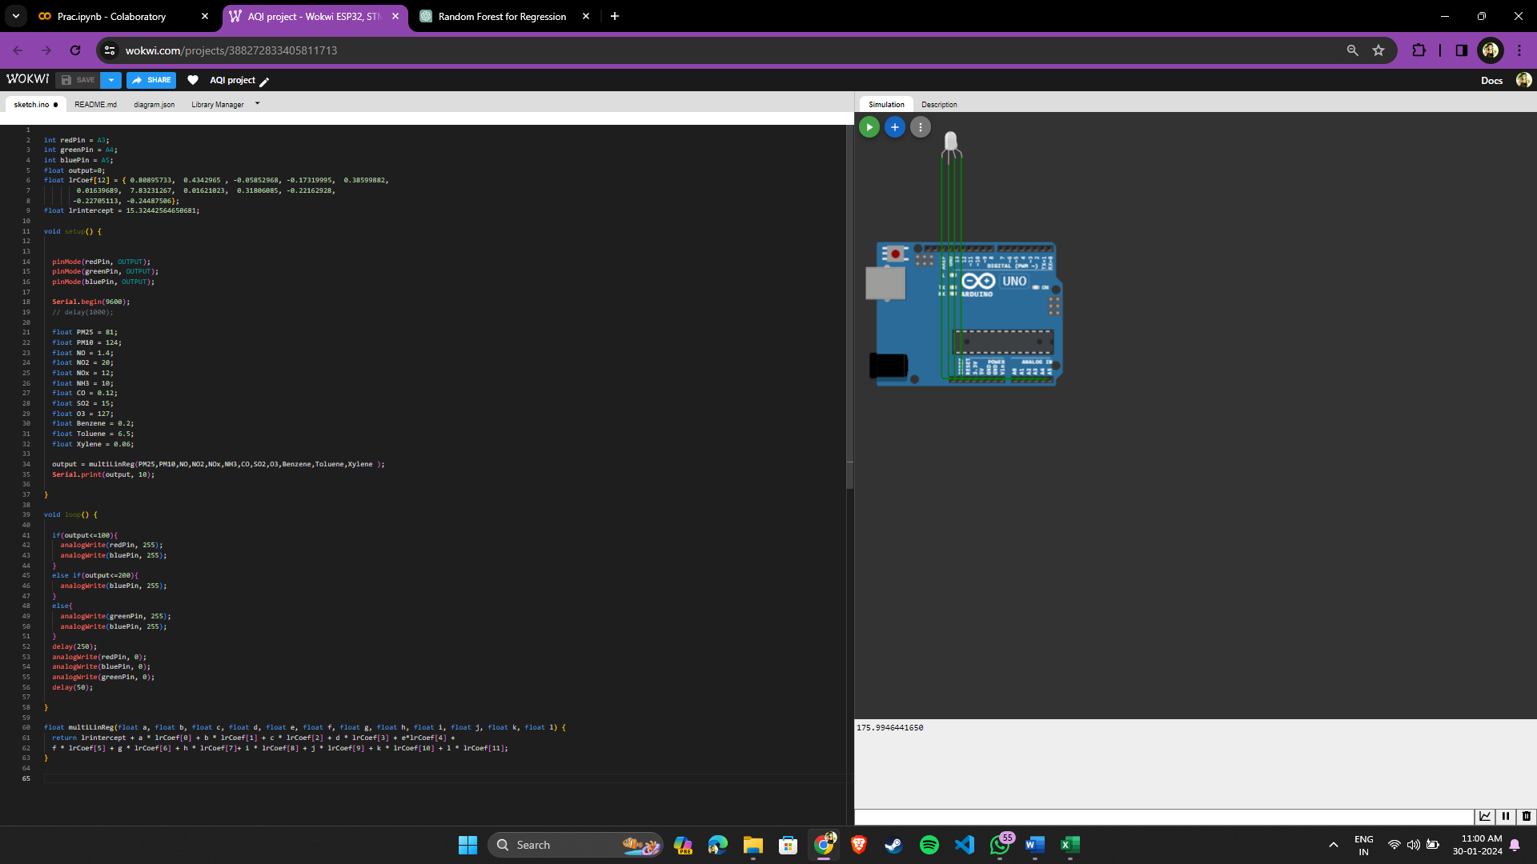

**ARDUINO SIMULATION:**

For PM2.5 =7.6, PM10 = 32.4, NO = 5.9, NO2 = 23.2, NOx = 17.19, NH3 = 11.15, CO = 0.46, SO2 = 6.87, O3 = 19.9, Benzene = 1.5, Toluene = 5.37, Xylene = 1.45.

The predicted AQI is **46.06**

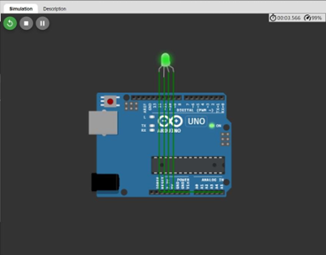

GREEN AQI RANGE: 0-100

For PM2.5 =81, PM10 = 124, NO = 1.4, NO2 = 20, NOx = 12, NH3 = 10, CO = 0.12, SO2 = 15, O3 = 127, Benzene = 0.2, Toluene = 6.5, Xylene = 0.06.

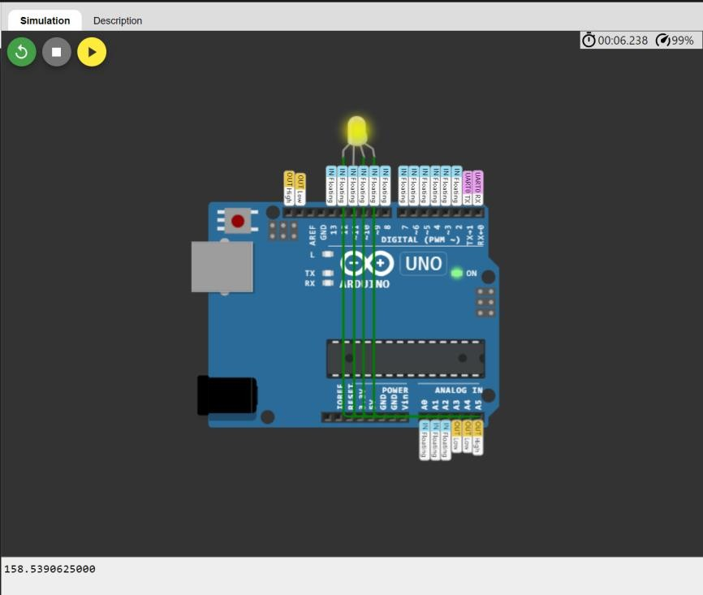The predicted AQI is **175.99**

YELLOW AQI RANGE: 100-200

For PM2.5 =81, PM10 = 250, NO = 5.9, NO2 = 15, NOx = 30, NH3 = 11.15, CO = 0.5, SO2 = 6.87, O3 = 19.9, Benzene = 1.5, Toluene = 5.37, Xylene = 1.45.

The predicted AQI is **206.70**

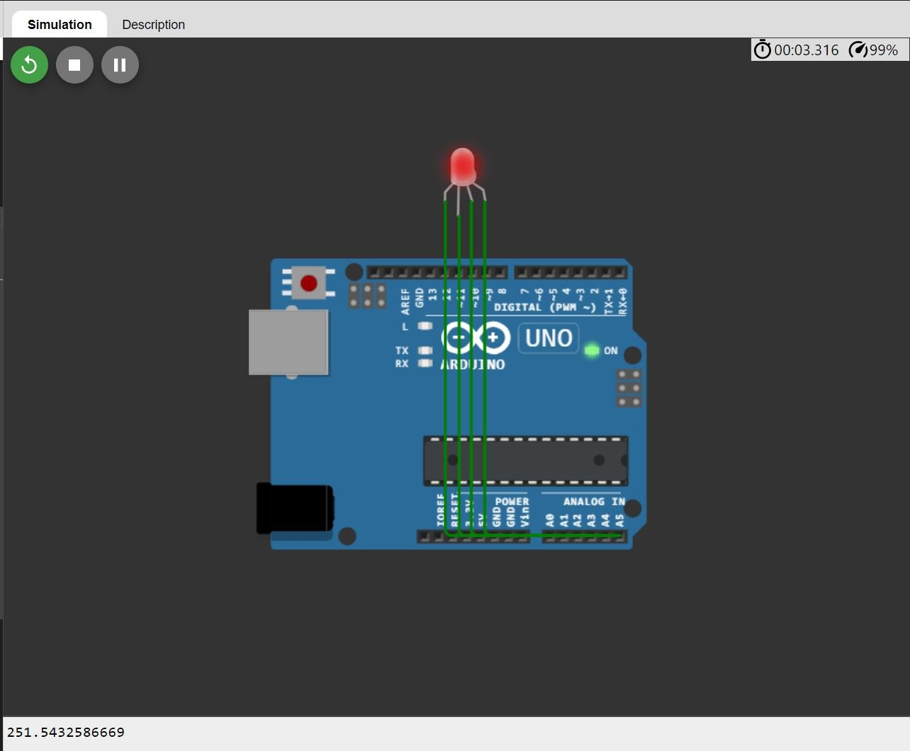

RED AQI RANGE: >200

**Shortcoming:**

Creating an air quality index (AQI) prediction model using Arduino can be a feasible approach, especially for smaller scale applications or DIY projects. However, such a model may have several shortcomings, including:

* Limited processing power and memory may constrain the complexity and size of datasets for accurate predictions.
* We have assumed the sensor values but in reality the sensor sensitivity to environmental factors like temperature and humidity could introduce inaccuracies.
* Regular calibration and maintenance of Arduino sensors are necessary to prevent drift or degradation.

**Future Scope:**

The future scope of an Air Quality Index (AQI) prediction project can involve several directions for improvement, expansion, and application. Here are some potential areas for further development:

* Advanced Features: Integrate more environmental features and Integrate data from various sources for comprehensive predictions.
* Time Series Analysis: Explore temporal patterns for more accurate predictions.
* Advanced Models: Experiment with advanced machine learning models beyond Ridge regression.
* Hyperparameter Tuning: Optimize model performance through hyperparameter tuning.
* Real-time Monitoring and Alerts: Develop a real-time monitoring system with alerts for critical AQI levels.
* IoT Deployment: Adapt the model for deployment on IoT devices for local monitoring.
* Collaboration with Agencies: Collaborate with environmental agencies for integration into monitoring frameworks.