**Introduction to HTML**

**HTML Introduction:-**

HTML stands for **Hypertext Markup Language,** and it is the most widely used language to write Web Pages. As its name suggests, HTML is a markup language.

* **Hypertext** refers to the way in which Web pages (HTML documents) are linked together. When you click a link in a Web page, you are using hypertext.
* **Markup** Language describes how HTML works. With a markup language, you simply "mark up" a text document with tags that tell a Web browser how to structure it to display.

**HTML Versions:-**

|  |  |
| --- | --- |
| **Version** | **Year** |
| HTML | 1991 |
| HTML+ | 1993 |
| HTML2.0 | 1995 |
| HTML3.2 | 1997 |
| HTML4.01 | 1999 |
| XHTML | 2000 |
| HTML5 | 2012 |

**Extension:-** .html or .htm

**Software Requirement**

* Text Editor :- Notepad or Notepad++
* Web Browser :- Chrome, Firefox, etc.

**HTML Page Structure:-**

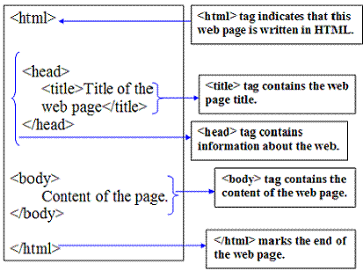

**Example with Output:-**

