BHAI GURDAS INSTITUTE OF MANAGEMENT AND TECHNOLOGY, SANGRUR



Synopsis On Education Portal

Under The guidance:- Submitted by:-
M.V SINGH Amandeep kaur
(Assistant professor BGIMT)

Under The guidance:-
Navneet Kaur

INDEX
Sno. | Particulars | Remarks
1. | Company Profile
2. | Introduction of the project
3. | Objective of the project
4. | System Requirement
5. | Modules of the project
6. | DFD(Data flow diagram)&ER diagram
7. | Conclusion
8. | References

- Introduction of the Project:-

Online Education Portal in PHP is a comprehensive tool providing information about the organizations providing educational Services. It is an online tutorial portal to find list of various tutorial videos, audio PDF format etc.
The portal provides detailed information on educational tutorial videos for different subjects. It is provides tutorial about Android, PHP, Photoshop. This site allows users to upload videos, view and share videos and notes. The User has to get registered to enjoy all the facilities in the portal.
Most of the Content on Education Portal has been uploading by trainer .The registered member can be student or any teaching faculty or anyone who is in need of the information.
In Education Portal there are two Types of Modules: User and Administrator. A User can also futher divided into Two types of User: Trainer and learner. A User can view and download videos for particular course. It offer users the ability to view its video on their website. There are two groups involved in the working of the portal. Only the administrator and registered user have a permission to edit pages, updates and delete the data.

The main objective of Education Portal Project in PHP is that
providing teaching and tutors information’s and their services to students and colleges etc. This is a totally web based educational portal, its main aim is that provide all education services details in one place, user does not need to search different sites to get information about any tutorials. Online education portal give the full details of the all educational services information etc at one system..

- Objective of the project:-

a) The statement of educational aims and objectives has several benefits:
b) To help teachers design the course - the content, the methods, and the assessment;
c) To communicate the educational intent of the course to students and to colleagues;
d) To help identify the resources needed to undertake the teaching;
e) To provide a basis for evaluating the course, and a basis for quality assurance.

- System Requirements
Software Interface:-This project is a web application that is developed in PHP having MySql as back end.
- Database design:- MySql
- Website design:- CSS
- Coding(logic):- PHP and JavaScript
- Server:- XAAMP
- Platform:- Windows
- Application:-Dream weaver CSS5

System interface: - Application would be a self-contained system. It wills not access data of any other application nor will other application have access to its data.
User interface: -Application will be access through a browser interface. The interface would be vied best application using 1024 x 786 and 800 x 600 pixels resolutions setting. The software would be fully compatible with Microsoft internet explorer for version 9 and above.

Design of Solution
While designing the solution according to the requirements of the client we make the following modules of our project:
- Web Interface
This is the menus of the project and is accessible to all. It contains the following content:
- Home– This page contains the list of different section for the student and teacher. Login and sign up for the user are also provided for the view of notes and videos regarding their subject.
- Gallery- In that part user can view all the images related to the site and study. Even can download these images for their work.
- Staff- In that part user can check the qualification of the staff and allover all the details regarding any staff member.
- End User Login
This is the end user login i.e. the content available on the end-user’s page:
- Login valid up to (life time).
- All type of notes and videos available.
- New content added (links).
- Profile picture.
- View contents (related to user added new videos).
- View results history.

- Modules of the project:-

- Admin module:-Admin of website can login and help the Users. It can manage site content. Admin can edit, delete Pages and Comments. It also manages users of website. Admin can approve or unapproved the privileges. Without the admin no one can assess the site.
- User Module:- User can easily login and signup with the website.A user can also give feedback. It also do different tasks like add notes and videos as well as gallary.

- DFD diagram:-

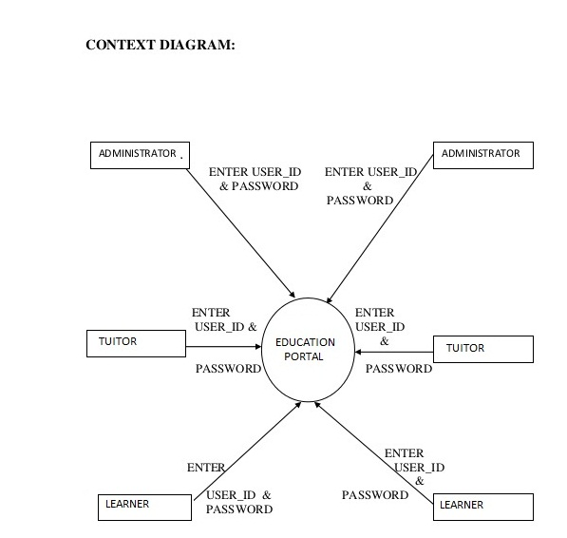
DFD

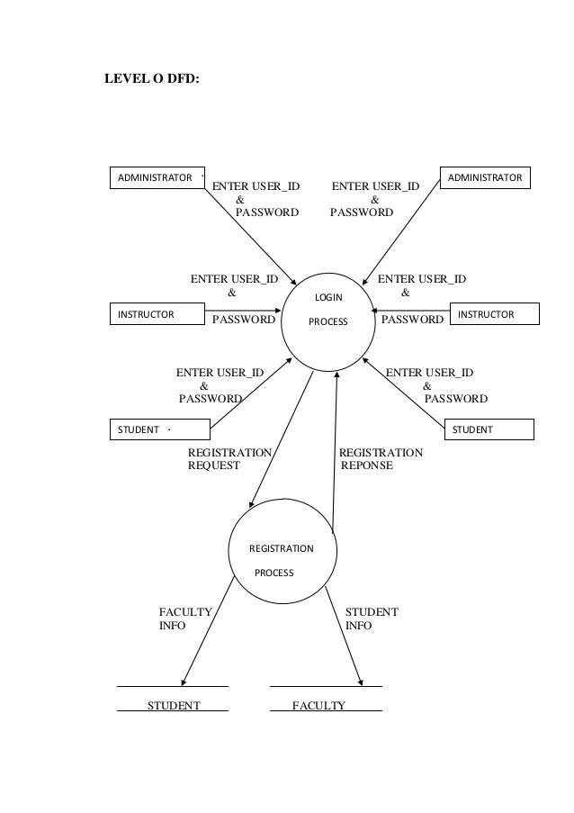

E R diagram:-
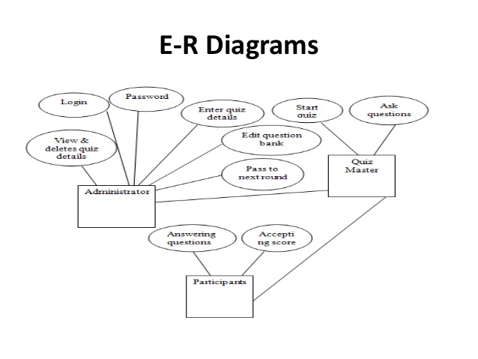
- Conclusion
This is to conclude that the project that I undertook was worked upon with a sincere effort. Most of the requirements have been fulfilled up to the mark and the requirements which have been remaining, can be completed with a short extension. At the end allover about the project is under one roof user can read, user can learn, and user can add their views to the site. It provide all tutorials and videos regarding the any technical topic listed in the list just by following simple step of the sign in

