**The 7 Layers of the OSI Model**

| **Layer** | **Layer Number** | **Main Function** | **Examples** |
| --- | --- | --- | --- |
| **Application** | 7 | Interface between user and network | HTTP, FTP, SMTP, DNS |
| **Presentation** | 6 | Data formatting, encryption, compression | SSL/TLS, JPEG, MP3 |
| **Session** | 5 | Starts, manages, and ends sessions | NetBIOS, RPC |
| **Transport** | 4 | Reliable data delivery, error checking, segmentation | TCP, UDP |
| **Network** | 3 | Routing and addressing of packets | IP, ICMP |
| **Data Link** | 2 | Node-to-node data transfer, error detection | Ethernet, MAC, PPP |
| **Physical** | 1 | Physical connection and transmission | Cables, switches, Wi-Fi signals |

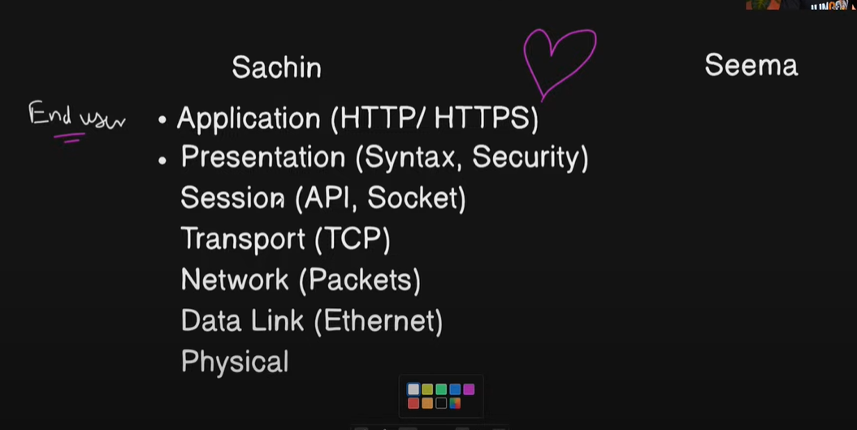

**Layers of the TCP/IP Model**

| **Layer** | **OSI Equivalent** | **Function** | **Examples** |
| --- | --- | --- | --- |
| **Application Layer** | Application, Presentation, Session | Provides services for applications to communicate over the network | HTTP, HTTPS, FTP, SMTP, DNS |
| **Transport Layer** | Transport | Ensures reliable delivery of data, error checking, flow control | TCP, UDP |
| **Internet Layer** | Network | Logical addressing and routing of data packets | IP, ICMP, ARP |
| **Network Access Layer** (or Link Layer) | Data Link + Physical | Physical transmission of data over network hardware | Ethernet, Wi-Fi, MAC addresses |

