**PROJECT SETUP DOCUMENT**

**DESCRIPTION:**

The purpose of this document is to setup whole code and environment easily and verify the result. As part of this process we are devloped for Request the library to perform API requests. Here we are using the XKCD API which allows us to fetch various XKCD comics and their metadata. After the fetching the data we are inserting into MYSQL. Also, code is develop to read comics ande provide a number/Title and read on the web.

**PRE REQUISITE**:

* Python3
* MySQL
* GIT

**SETUP:**

**GIT:**

Pull/Download the data from Git Repository.

<https://github.com/sumitg54/redhat_task>

**MySQL:** For Fresh setup.

Download latest MySQL installer from below link and follow the installation steps. After successful installation we have to change the connection string password. Either you can create the database manually from attached script or that will be handled by python code.



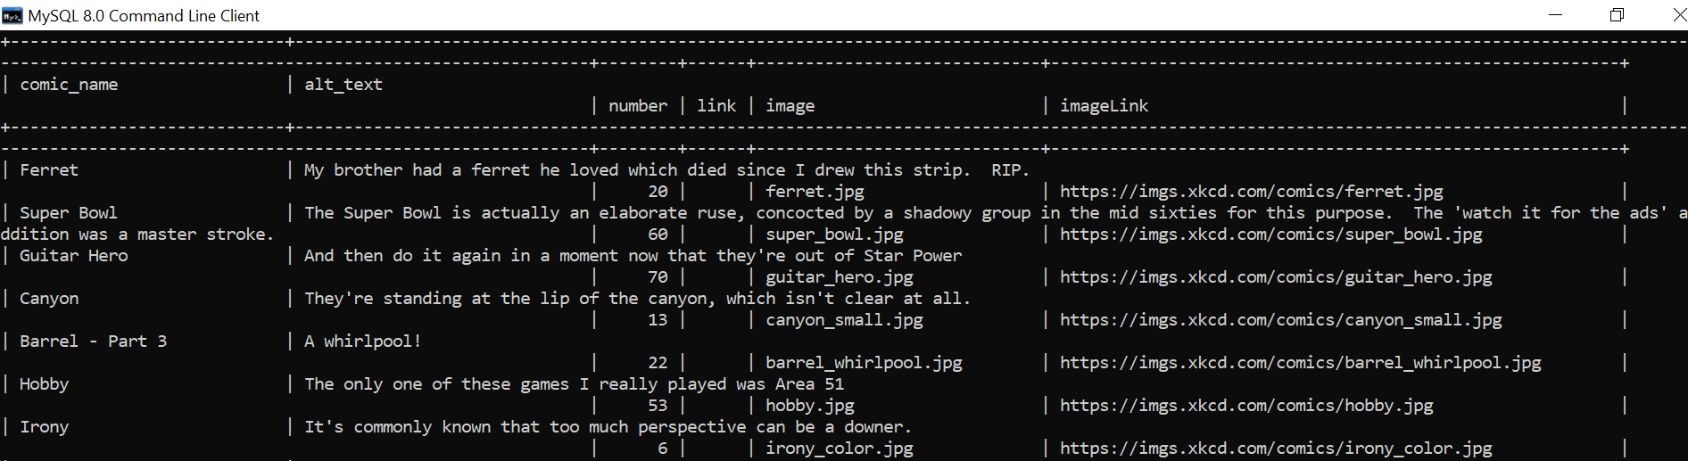

**PYTHON3:**

Download python3 and required library or Download Anaconda to see the Jupiter notebook result. After successful installation of python3 we can download the .py file from code folder and then you can run the below command to execute it.

From running CMD you have to install python3 and below library to run from command prompt.

**python3 -m pip install requests**

**python3 -m pip install mysql-connector-python**

Once all setup done run the below command:

**python3 task_one.py**

**OutPut:**

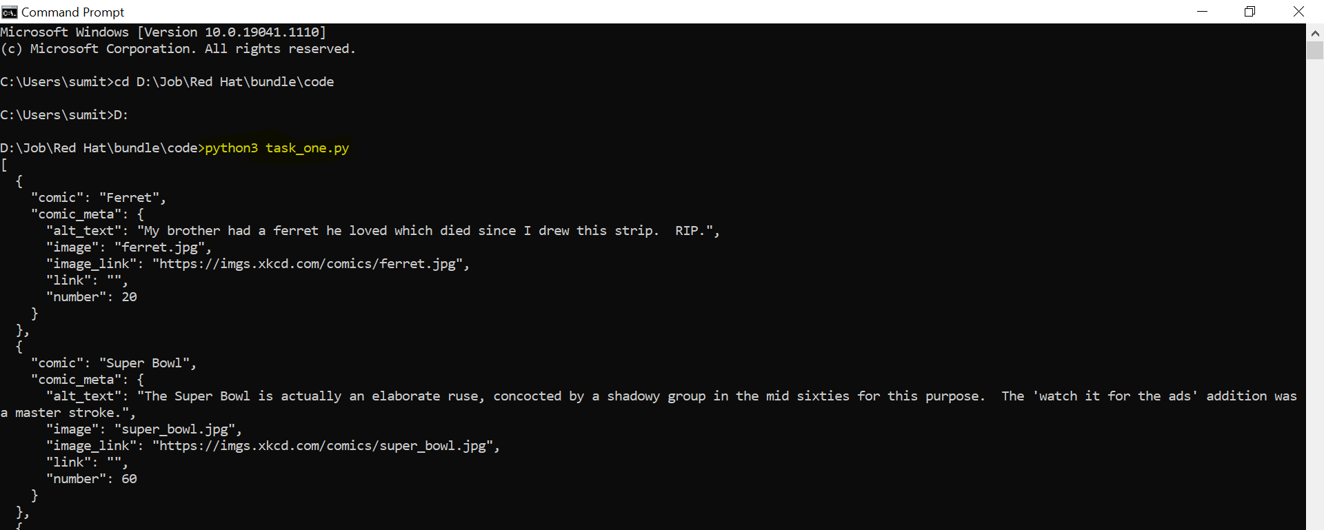

**python3 bonus_task.py**

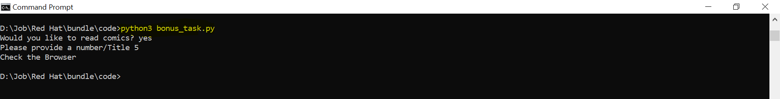

**Browser:**

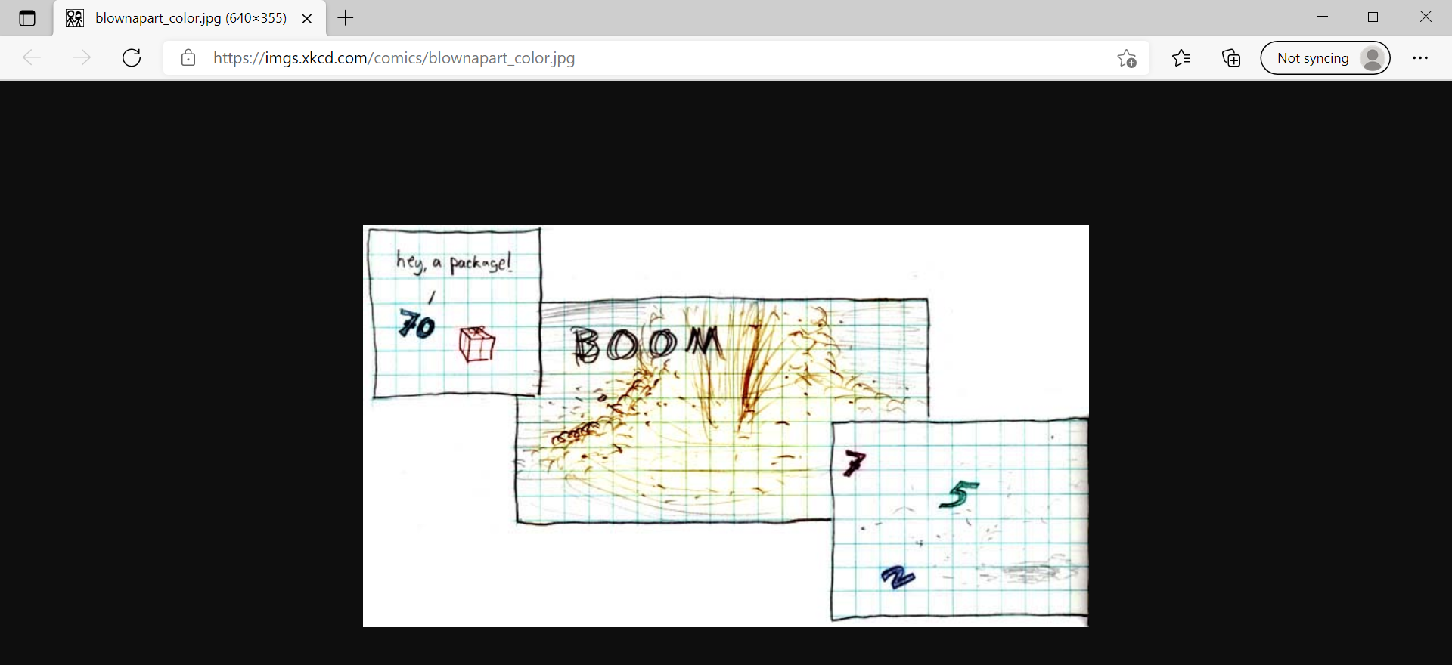

**SOURCE:**

XKCD API which allows us to fetch various XKCD comics and their metadata. Sample URL mentioned below:

<https://xkcd.com/info.0.json> (current comic)

or

<http://xkcd.com/2472/info.0.json> (comic #2472)

**TAREGET:**

MySQL comic table which stores the fetched data from API.

**Table Name:** comic_db.comic

After setup of all prerequisite you can follow the below steps.

**Step by Step:**

1. Pull the data from Git Repository given below:

<https://github.com/sumitg54/redhat_task>

1. From CLI:
   1. Open the CLI and go to downloaded path.
   2. Run the below command:

**python3 task_one.py**

**python3 bonus_task.py**

1. From Jupiter Notebook:
   1. Open the .ipynb file in JupiterNootbook
   2. Run each cell to see the output.

**TROUBLESHOOTING:**

* If you get issue to connect from MySql database check the connection string and change it accordingly.
* If you get any issue while running from CMD check the environment variable path for python all library mentioned should be installed.
* XKCD API up and running.