During Kharif Season 2025-26 Progress of sowing and agricultural crops Details.
(25.07.2025)

2025-26 Agricultural Production:

Anticipating timely and well distributed rainfall during pre-monsoon, southwest & northeast monsoon period in 2025-26 it was programmed to cover 82.50 lakh hectares, 25.50 lakh hectares and 6.40 lakh hectares during Kharif, Rabi and Summer seasons respectively, totally 114.40 lakh hectares under agricultural crops. Proposed production target for Food grains and Oilseeds were 148.48 lakh tonnes and 12.20 lakh tonnes respectively.

Sl. No. | Crops | Area (Lakh Hectares) | Production (Lakh Tonnes)
1. | Cereals | 51.35 | 125.99
2. | Pulses | 33.89 | 22.49
 | Total Food Grains | 85.24 | 148.48
3. | Oilseeds | 12.39 | 12.20
4. | Commercial Crops
i) | Cotton | 8.17 | 24.50 Lakh Bales
ii) | Sugarcane | 7.89 | 757.58
iii) | Tobacco-VFC | 0.71 | 0.62
 | Total Area | 114.40

2025-26 Kharif Agricultural Production:

During Kharif 2025 total of 82.50 lakh hectares area has been set as target for sowing under different crops.

Sl. No. | Crops | Area (Lakh Hectares) | Production (Lakh Tonnes)
1. | Cereals | 35.74 | 96.14
2. | Pulses | 23.06 | 15.27
 | Total Food Grains | 58.80 | 111.41
3. | Oilseeds | 8.59 | 8.68
4. | Commercial Crops
i) | Cotton | 7.89 | 24.03 Lakh Bales
ii) | Sugarcane | 6.51 | 637.55
iii) | Tobacco-VFC | 0.71 | 0.62
 | Total Area | 82.50

During pre-monsoon period between April to May in view of agricultural activities in the state, districts such as Chamarajanagara, Mandya, Hassan, Chikkamangaluru, Tumkur, Koppal, Ramanagara, Mysuru and Chitradurga at various places land preparation as been done. Area has been sown under jowar, greengram, blackgram, cowpea, sesamum, sunflower, cotton, etc.

In Coastal, Malnad, South Interior Karnataka and North Interior Karnataka region, after south west monsoon commenced land preparation and sowing activities have been started.

During Early Kharif 2025 total of 3.06 lakh hectares (107%) has been sown against a set target of 2.86 lakh hectares.

Pre-Monsoon Rainfall:

During 2025, normal Pre-monsoon rainfall (March-1st to May-31st) was 115 mm against actual rainfall 286 mm (149%).

South west Monsoon Rainfall:

During 2025, normal rainfall (1st June to 25th July) was 419 mm against actual rainfall 423 mm (1%).
Sowing progress and status of agricultural crops:

During Kharif 2025, total of 63.19 lakh hectares (77%) has been sown against a set target of 82.50 lakh hectares by 25.07.2025, Crop wise and district wise area sown details was provided in annexure 2 and 3.

Seeds:

For Kharif 2025-26, 4.64 lakh qtls seeds were estimated as demand for sowing and till dated:25.07.2025, 2.94 lakh qtls seeds have been distributed at Raitha Samparka Kendra (RSK). Remaining balance in RSK’s of 0.50 Lakh qtls. Residual inventory is available at the concerned institutions.

Fertilizer:

For Kharif 2025-26, total fertilizer demand was estimated at 26.77 lakh metric tonnes (April-September 2025) and available stock is 26.26 lakh metric tonnes, 18.48 lakh metric tonnes have been sold (up to 25.07.2025) and remaining stock is 7.78 lakh metric tonnes.

Annexure-1
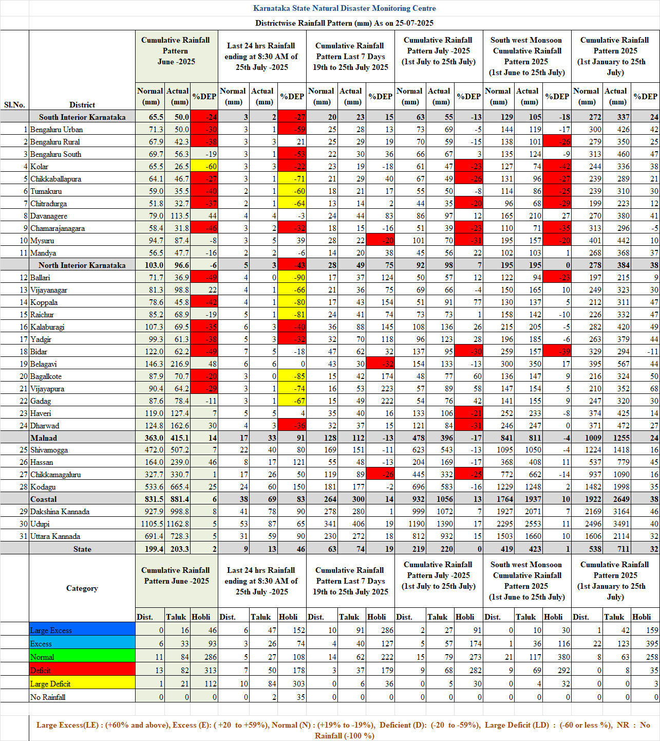
Annexure-2
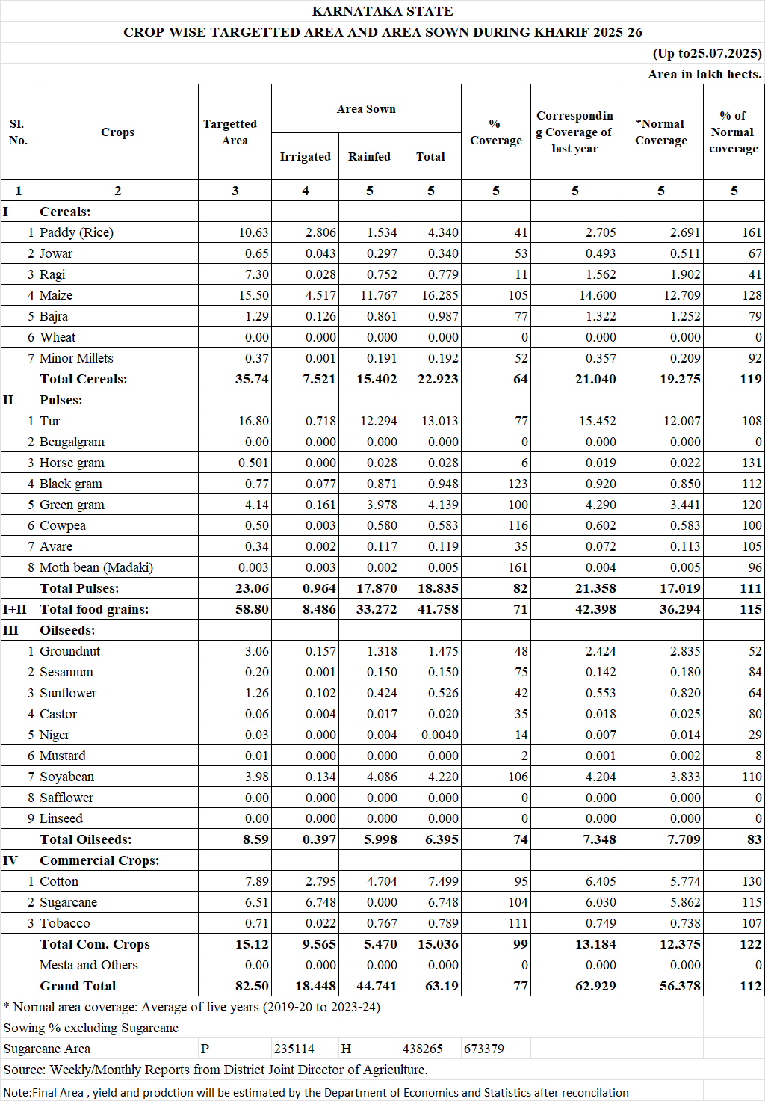
Annexure-3
