Query : **SELECT * from books;**

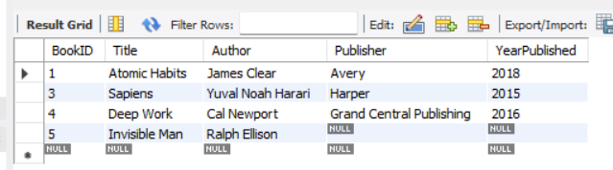

Query : **SELECT Name, Email FROM Members;**

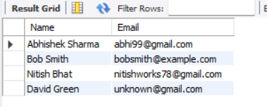

Query: **SELECT * FROM Books WHERE YearPublished > 2015;**

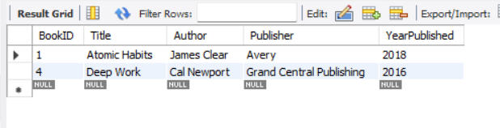

Query: **SELECT * FROM Members WHERE JoinDate > '2023-01-01' AND Email IS NOT NULL;**

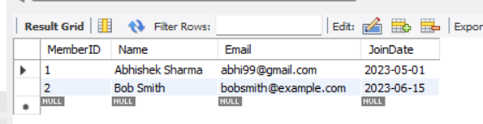

Query: **SELECT * FROM Books WHERE Author = 'James Clear' OR Publisher = 'Harper';**

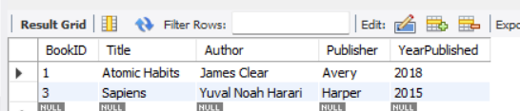

Query : **SELECT * FROM Books WHERE Title LIKE '%Work%';**

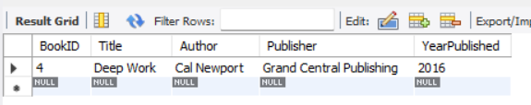

Query: **SELECT * FROM Books WHERE YearPublished BETWEEN 2010 AND 2020;**

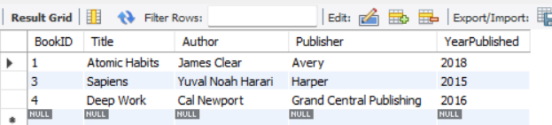

Query: **SELECT * FROM Members ORDER BY Name ASC;**

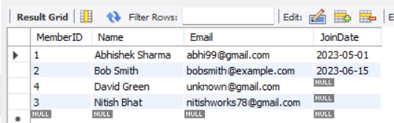

Query: **SELECT * FROM Books ORDER BY YearPublished DESC;**

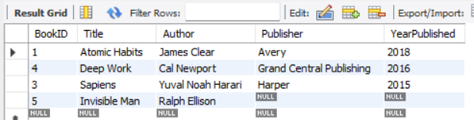

Query: **SELECT * FROM Books LIMIT 3;**

