Query : **SELECT SUM(FineAmount) AS TotalFines FROM IssuedBooks;**



Query : **SELECT COUNT(*) AS TotalBooks FROM Books;**



Query : **SELECT AVG(FineAmount) AS AvgFine FROM IssuedBooks**

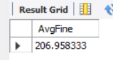

Query : **SELECT MIN(YearPublished) AS EarliestPublication, MAX(YearPublished) AS LatestPublication FROM Books;**



Query : **SELECT Publisher, COUNT(*) AS BooksCount FROM Books GROUP BY Publisher;**

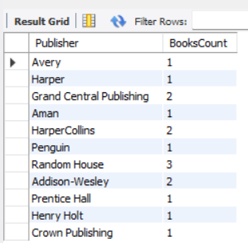

Query **: SELECT Publisher, COUNT(*) AS BooksCount**

**FROM Books GROUP BY Publisher HAVING COUNT(*) > 1;**

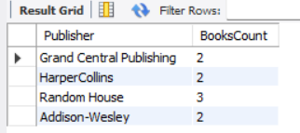

Query: **SELECT MemberID, COUNT(*) AS BooksIssued**

**FROM IssuedBooks GROUP BY MemberID;**

