**INNER JOIN - Customers who placed orders**

**Query** : **SELECT Customers.CustomerID, Customers.CustomerName, Orders.ProductName, Orders.OrderDate, Orders.Price, Orders.Quantity**

**FROM Customers INNER JOIN Orders ON Customers.CustomerID = Orders.CustomerID;**

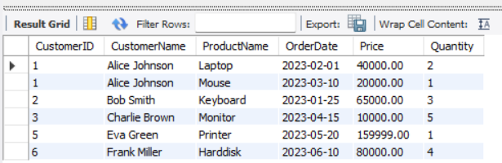

**LEFT JOIN - All customers (even if no orders)**

**Query: SELECT Customers.CustomerID, Customers.CustomerName, Customers.Country, Customers.Email, Orders.ProductName, Orders.OrderDate, Orders.Price, Orders.Quantity**

**FROM Customers LEFT JOIN Orders ON Customers.CustomerID = Orders.CustomerID;**

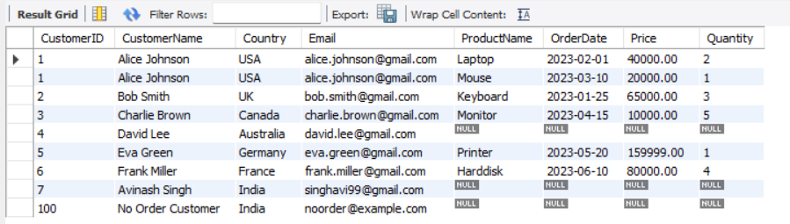

**RIGHT JOIN - All orders (even if customer info is missing)**

**Query: SELECT Customers.CustomerID, Customers.CustomerName, Orders.ProductName, Orders.OrderDate, Orders.Price, Orders.Quantity**

**FROM Customers RIGHT JOIN Orders ON Customers.CustomerID = Orders.CustomerID;**

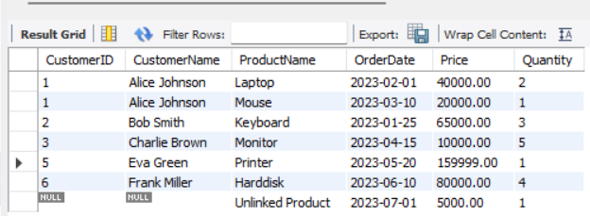

**FULL JOIN using UNION**

**Query: SELECT Customers.CustomerID, Customers.CustomerName,Customers.Country, Customers.Email, Orders.ProductName, Orders.OrderDate,Orders.Price, Orders.Quantity**

**FROM Customers**

**LEFT JOIN Orders ON Customers.CustomerID = Orders.CustomerID**

**UNION**

**SELECT Customers.CustomerID, Customers.CustomerName, Customers.Country, Customers.Email, Orders.ProductName, Orders.OrderDate,Orders.Price, Orders.Quantity**

**FROM Customers**

**RIGHT JOIN Orders ON Customers.CustomerID = Orders.CustomerID;**

