**Scalar Subquery - Find the product with the highest price**

**SELECT ProductName, Price**

**FROM Orders**

**WHERE Price = (SELECT MAX(Price) FROM Orders);**

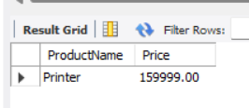

**Scalar Subquery (another example)**

**Find customers from the same country as 'Avinash Singh'**

**SELECT \***

**FROM Customers**

**WHERE Country = (**

**SELECT Country**

**FROM Customers**

**WHERE CustomerName = 'Avinash Singh'**

**);**

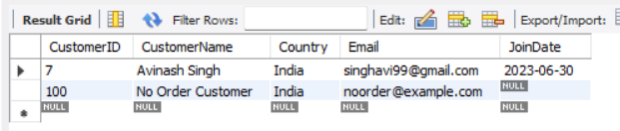

**Correlated Subquery - Find customers who have ordered more than once**

**SELECT CustomerID, CustomerName**

**FROM Customers c**

**WHERE (**

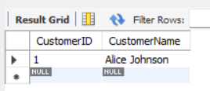 **SELECT COUNT(*)**

**FROM Orders o**

**WHERE o.CustomerID = c.CustomerID ) > 1;**

**Subquery with IN - List customers who ordered 'Laptop'**

**SELECT CustomerName, Country**

**FROM Customers**

**WHERE CustomerID IN (**

**SELECT CustomerID**

**FROM Orders**

**WHERE ProductName = 'Laptop'**

**);**

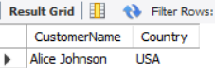

**Subquery with EXISTS - Find customers who have placed at least one order**

**SELECT CustomerName, Country**

**FROM Customers c**

**WHERE EXISTS (**

**SELECT 1**

**FROM Orders o**

**WHERE o.CustomerID = c.CustomerID**

**);**

