-- **1.** **View: CustomerOrdersView - shows each customer with their orders**

**CREATE VIEW CustomerOrdersView AS**

**SELECT c.CustomerID, c.CustomerName, c.Country, o.ProductName, o.OrderDate, o.Price, o.Quantity**

**FROM Customers c**

**INNER JOIN Orders o**

**ON c.CustomerID = o.CustomerID;**

**-- Verify the view**

**SELECT * FROM CustomerOrdersView;**

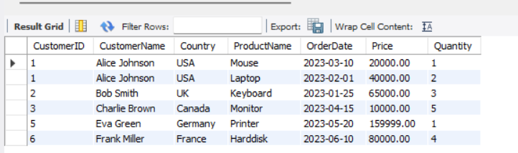

**-- 2. View: HighValueOrdersView - orders with Price > 20000**

**CREATE VIEW HighValueOrdersView AS**

**SELECT o.OrderID, c.CustomerName, o.ProductName, o.Price, o.Quantity**

**FROM Orders o**

**JOIN Customers c**

**ON o.CustomerID = c.CustomerID**

**WHERE o.Price > 20000;**

**-- Verify the view**

**SELECT * FROM HighValueOrdersView;**

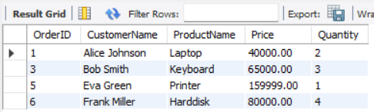

**-- 3. View: CountryWiseCustomersView - count customers per country**

**CREATE VIEW CountryWiseCustomersView AS**

**SELECT Country, COUNT(*) AS TotalCustomers**

**FROM Customers**

**GROUP BY Country;**

**-- Verify the view**

**SELECT * FROM CountryWiseCustomersView;**

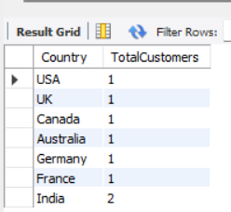

**-- 4. Updating an existing view (example using OR REPLACE)**

**CREATE OR REPLACE VIEW HighValueOrdersView AS**

**SELECT o.OrderID,c.CustomerName,o.ProductName, o.Price, o.Quantity, (o.Price * o.Quantity) AS TotalAmount**

**FROM Orders o**

**JOIN Customers c**

**ON o.CustomerID = c.CustomerID WHERE o.Price > 20000;**

**-- Verify updated view**

**SELECT * FROM HighValueOrdersView;**

