**Stored Procedures**

**1) ShowCustomerName : Show name of a Customer by ID**

DELIMITER //

CREATE PROCEDURE **ShowCustomerName**(IN cust_id INT)

BEGIN

SELECT CustomerName

FROM Customers

WHERE CustomerID = cust_id;

END //

DELIMITER ;

**To Call the procedure: CALL ShowCustomerName(3);**

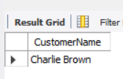

**2) CountTotalCustomers : Returns the Total Number of Customers**

DELIMITER //

CREATE PROCEDURE **CountTotalCustomers ()**

BEGIN

SELECT COUNT(*) AS TotalCustomers

FROM Customers;

END //

DELIMITER ;

**To Call the procedure : CALL CountTotalCustomers();**

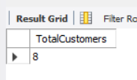

**3) GetOrdersByCustomer : Shows all orders for a given customer**

DELIMITER //

CREATE PROCEDURE **GetOrdersByCustomer** ( IN cust_id INT)

BEGIN

SELECT *

FROM Orders

WHERE CustomerID = cust_id;

END //

DELIMITER ;

**To Call the procedure : CALL GetOrdersByCustomer(5);**

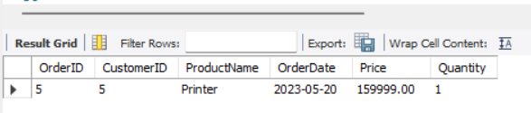

**Functions**

**1) CalculateSquare : A Function which calculates the sqaure of a given number**

DELIMITER //

CREATE FUNCTION **CalculateSquare**(input_number INT)

RETURNS INT

DETERMINISTIC

BEGIN

DECLARE result INT;

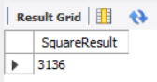 SET result = input_number * input_number;

RETURN result;

END //

DELIMITER ;

**Using the function : SELECT CalculateSquare(56) AS SquareResult;**

**2) GetTotalOrders** :**Returns the total number of orders for a given customer**

DELIMITER //

CREATE FUNCTION **GetTotalOrders** (cust_id INT)

RETURNS INT

DETERMINISTIC

BEGIN

DECLARE total_orders INT;

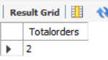 SELECT COUNT(*) INTO total_orders

FROM Orders

WHERE CustomerID = cust_id;

RETURN total_orders;

END //

DELIMITER ;

**Using the function : SELECT GetTotalOrders(1) as Totalorders;**