**Cloud Computing Methodologies – CSI3001**

**Lab Assessment**

**API – Brain Health Monitoring and Analysis**

Sumitha Murthi K G

23MIC0141

**Objective:**

The objective of this project is to develop an API that analyses and monitors brain health based on various cognitive tests, sleep data, and other related factors. The system aims to provide personalized insights into cognitive performance, mental fatigue, risk of cognitive decline, and neuroplasticity enhancement. The goal is to provide accurate and user-friendly recommendations for improving brain health.

**Tools:**

* **Frontend:** HTML, CSS, JavaScript
* **Backend:** Python, Flask
* **Postman:** For testing API endpoints

**Flow Chart:**

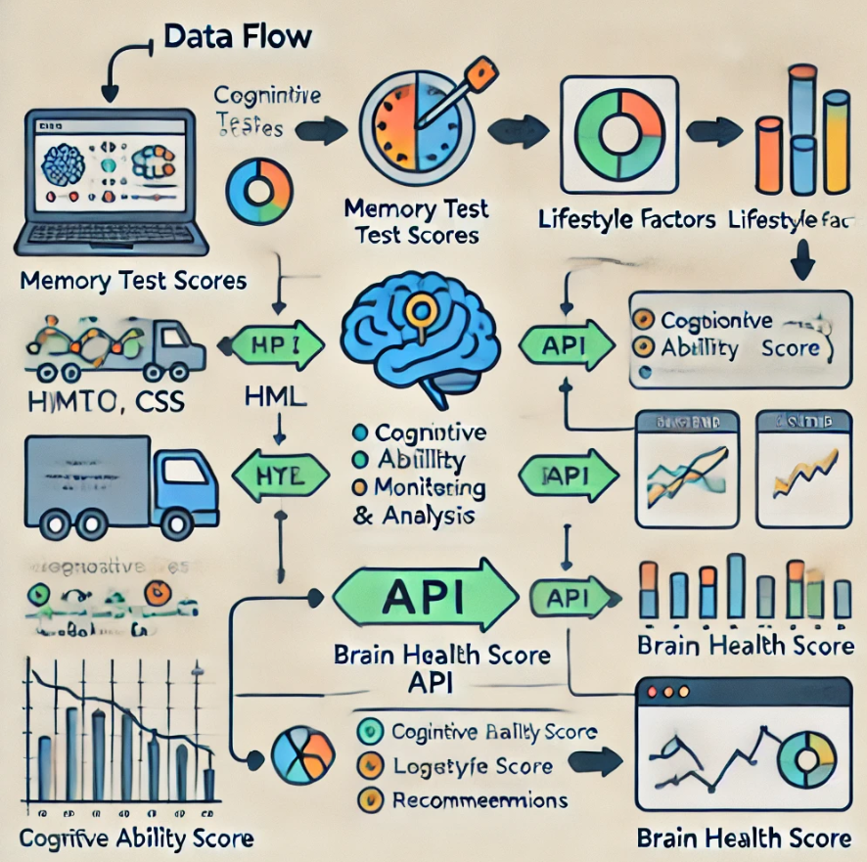

**Bottleneck:**

During the development of this project, the main bottleneck was ensuring that all endpoints provided consistent and accurate responses when tested with real user data. Additionally, converting API responses from raw JSON format to a user-friendly output for display on the frontend was a time-consuming task. Debugging asynchronous behaviour in JavaScript also posed a challenge.

**Result:**

Here are some screenshots showing the API response in a user-friendly format:

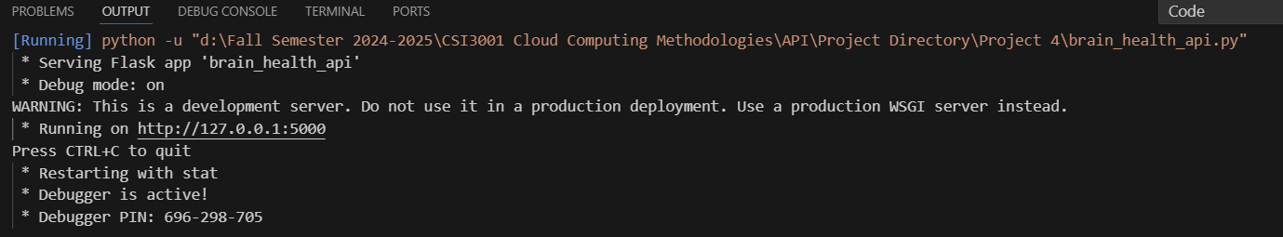

**Conclusion:**

This project successfully integrates multiple cognitive metrics to assess brain health, and provides personalized recommendations to improve mental well-being. The frontend design was user-friendly, and the backend API efficiently processed user inputs and provided insights. The project was a valuable learning experience in integrating frontend and backend technologies, testing API endpoints, and dealing with real-time data handling challenges.