**Prerequisites – Step-by-Step Guide**

**1. Access to Azure Portal**

* **Ensure you have an active Azure subscription.**
* **Sign in to the Azure Portal:** [**https://portal.azure.com**](https://portal.azure.com)

**2. Create a Resource Group**

* **In the Azure Portal, go to Resource Groups.**
* **Click on "Create".**
* **Choose your Subscription.**
* **Enter a Resource Group name.**
* **Select a Region.**
* **Click "Review + Create", then click "Create".**

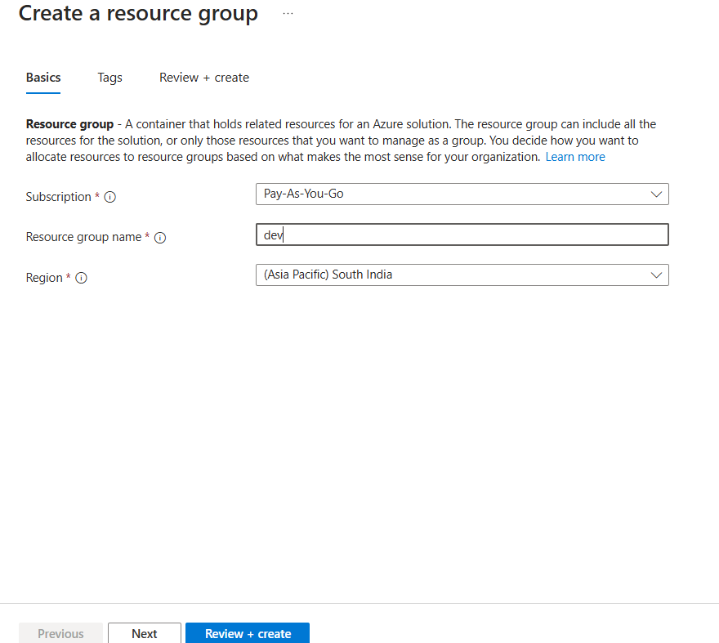

**3. Create a Container App**

* **In the Azure Portal, search for "Container Apps".**
* **Click on "Create".**
* **Select your Resource Group.**
* **Enter a Container App name and choose a Region.**
* **Configure the container image (e.g., from Docker Hub or Azure Container Registry).**
* **Complete other necessary configurations.**
* **Click "Review + Create", then click "Create".**

**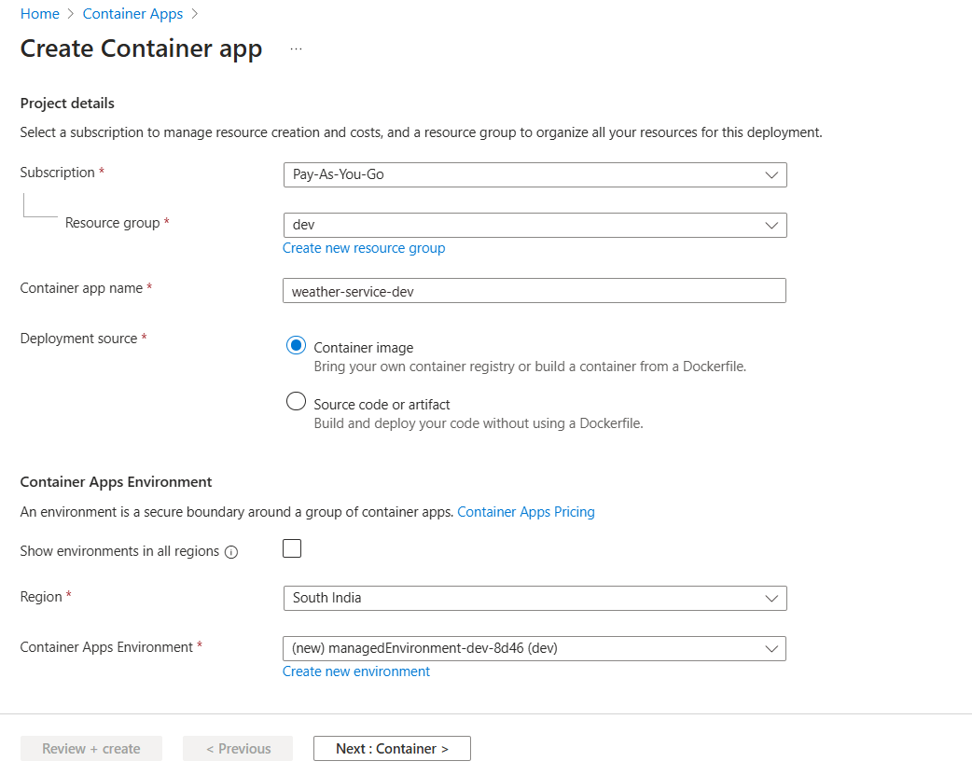  
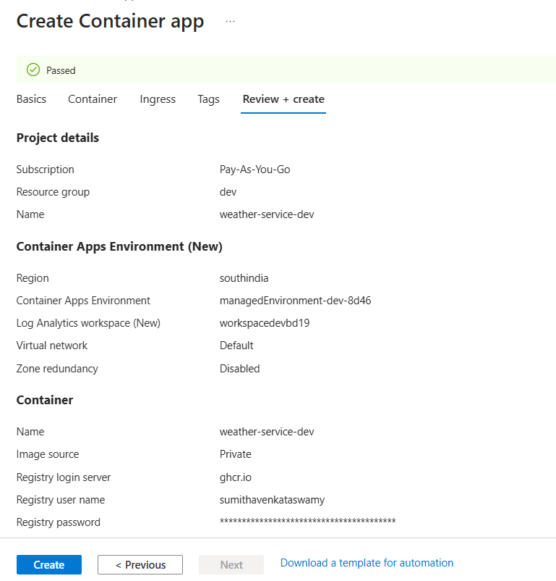**

**4. Create a Service Principal**

* **Open Azure Cloud Shell or use the Azure CLI.**
* **Run the following command:**

**bash**

**az ad sp create-for-rbac --name "<your-service-principal-name>" --role contributor --scopes /subscriptions/<your-subscription-id --sdk-auth**

**Replace:**

* + **<your-service-principal-name> with your desired name.**
  + **<your-subscription-id> with your Azure subscription ID.**
* **Save these credentials securely — they are required for authentication in automation or deployment workflows.**

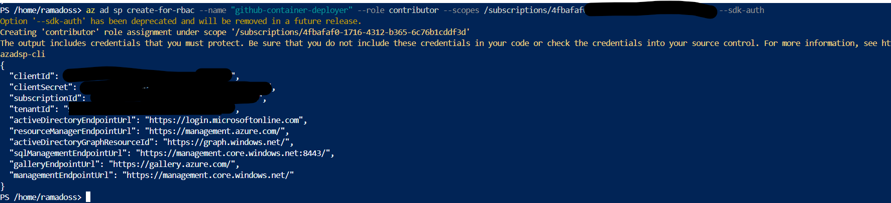

**GitHub Actions – Secrets and Variables Setup**

**Repository Name:** sumithavenkataswamy/WeatherAPIService

**Navigation Path:** Settings > Secrets and Variables > Actions

Secrets and variables allow secure management of sensitive configuration data for GitHub Actions workflows. Environment secrets are scoped to dev, test, and prod for better isolation.

**Environment Secrets**

| **Secret Name** | **Environment** | **Purpose** |
| --- | --- | --- |
| AZURE_CREDENTIALS | dev | Azure service principal credentials for Dev |
| AZURE_CREDENTIALS | test | Azure service principal credentials for Test |
| AZURE_CREDENTIALS | prod | Azure service principal credentials for Prod |
| AZURE_SUBSCRIPTION | dev | Subscription ID for Dev |
| AZURE_SUBSCRIPTION | test | Subscription ID for Test |
| AZURE_SUBSCRIPTION | prod | Subscription ID for Prod |
| CONTAINER_APP | dev | Azure Container App name for Dev |
| CONTAINER_APP | test | Azure Container App name for Test |
| CONTAINER_APP | prod | Azure Container App name for Prod |
| RESOURCE_GROUP | dev | Resource Group name for Dev |
| RESOURCE_GROUP | test | Resource Group name for Test |
| RESOURCE_GROUP | prod | Resource Group name for Prod |

**✅ Section: Repository Secrets**

| **Secret Name** | **Purpose** |
| --- | --- |
| GHCR_USERNAME | GitHub Container Registry username |
| TOKEN | GitHub token for authentication or actions |

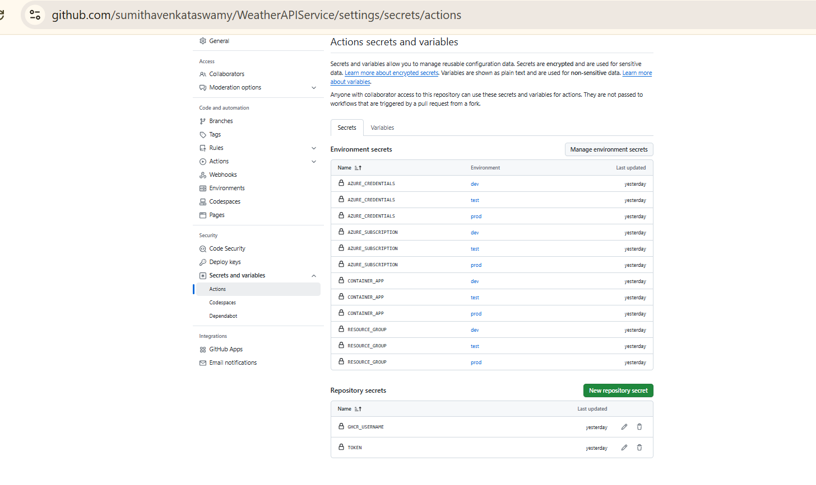

**Output:**

