DEPARTMENT OF CSE
PROJECT ABSTRACT SUBMISSION
COURSE: SOA PROGRAMMING AND MICROSERVICES – (24SDCS03) A.Y. 2026 - 2027
TITLE OF THE PROJECT
AI-Based Smart Bank Loan Comparison and Eligibility Recommendation System

S. No. | University ID | Name
1 | 2420030696 | B.Sumith
2 | 2420030779 | A.Deepak
3 | 2420090154 | Ch.Yaswanth Sai

Name of the Guide: Venkateswari Ketineni
Abstract:
Choosing the right loan can be difficult because different banks offer different interest rates, loan amounts, repayment periods, processing fees, and eligibility conditions. Many customers compare these details manually or depend on incomplete information, which can take time and may lead to a loan choice that does not suit their financial situation.
The proposed AI-Based Smart Bank Loan Comparison and Eligibility Recommendation System is designed to make this process easier. The system collects basic customer information such as income, employment details, existing financial commitments, credit-related information, and the required loan amount. It then uses this information to estimate the customer's eligibility for different loan options.
The system also compares loan products from multiple banks using important factors such as interest rate, loan tenure, estimated monthly EMI, processing charges, maximum loan amount, and eligibility requirements. Instead of simply displaying a list of loans, the system ranks suitable options and recommends those that best match the customer's profile and requirements.
Artificial Intelligence and machine learning techniques can be used to identify patterns in customer information and support eligibility prediction and personalized recommendations. The system can also provide simple explanations for its recommendations, helping users understand why a particular loan option may be more suitable for them.
Overall, the AI-Based Smart Bank Loan Comparison and Eligibility Recommendation System provides a practical and user-friendly way to explore loan options. By bringing eligibility estimation, loan comparison, and personalized recommendations into one platform, the project aims to reduce the effort involved in comparing loans and help customers make more informed financial decisions. The recommendations are intended as guidance and not as a replacement for the final decision made by a bank or financial institution.
Project Architecture/Project Overview:
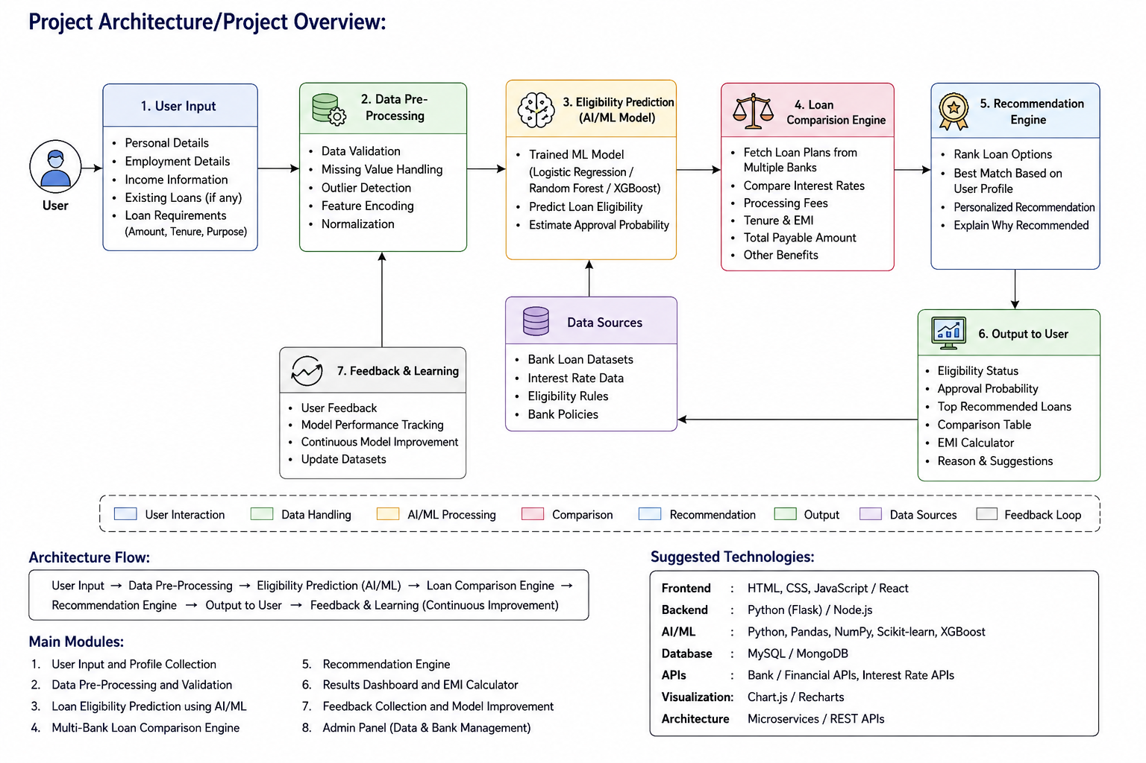
Main Modules:
Customer Details → Data Pre-Processing → Eligibility Analysis → Loan Product Database → Loan Comparison → AI-Based Recommendation → Eligible Loan Options → User Dashboard
• Bank Loan Product Management
• Loan Eligibility Analysis
• Loan Cost and EMI Comparison
• AI-Based Eligibility Prediction
• Personalized Loan Recommendation
• Recommendation Performance and User Feedback
• User-Friendly Loan Comparison Dashboard
Suggested Technologies:
Frontend: HTML, CSS, JavaScript / React
Backend: Python / Flask or Node.js
AI/ML: Python, Pandas, NumPy, Scikit-learn
Database: MySQL / MongoDB for customer and loan-product data
Analytics: Pandas, Matplotlib / Chart.js
Architecture: Microservices / REST APIs

