NorthStar Outfitters
Agentic Retail Operations Platform
Submission Pack
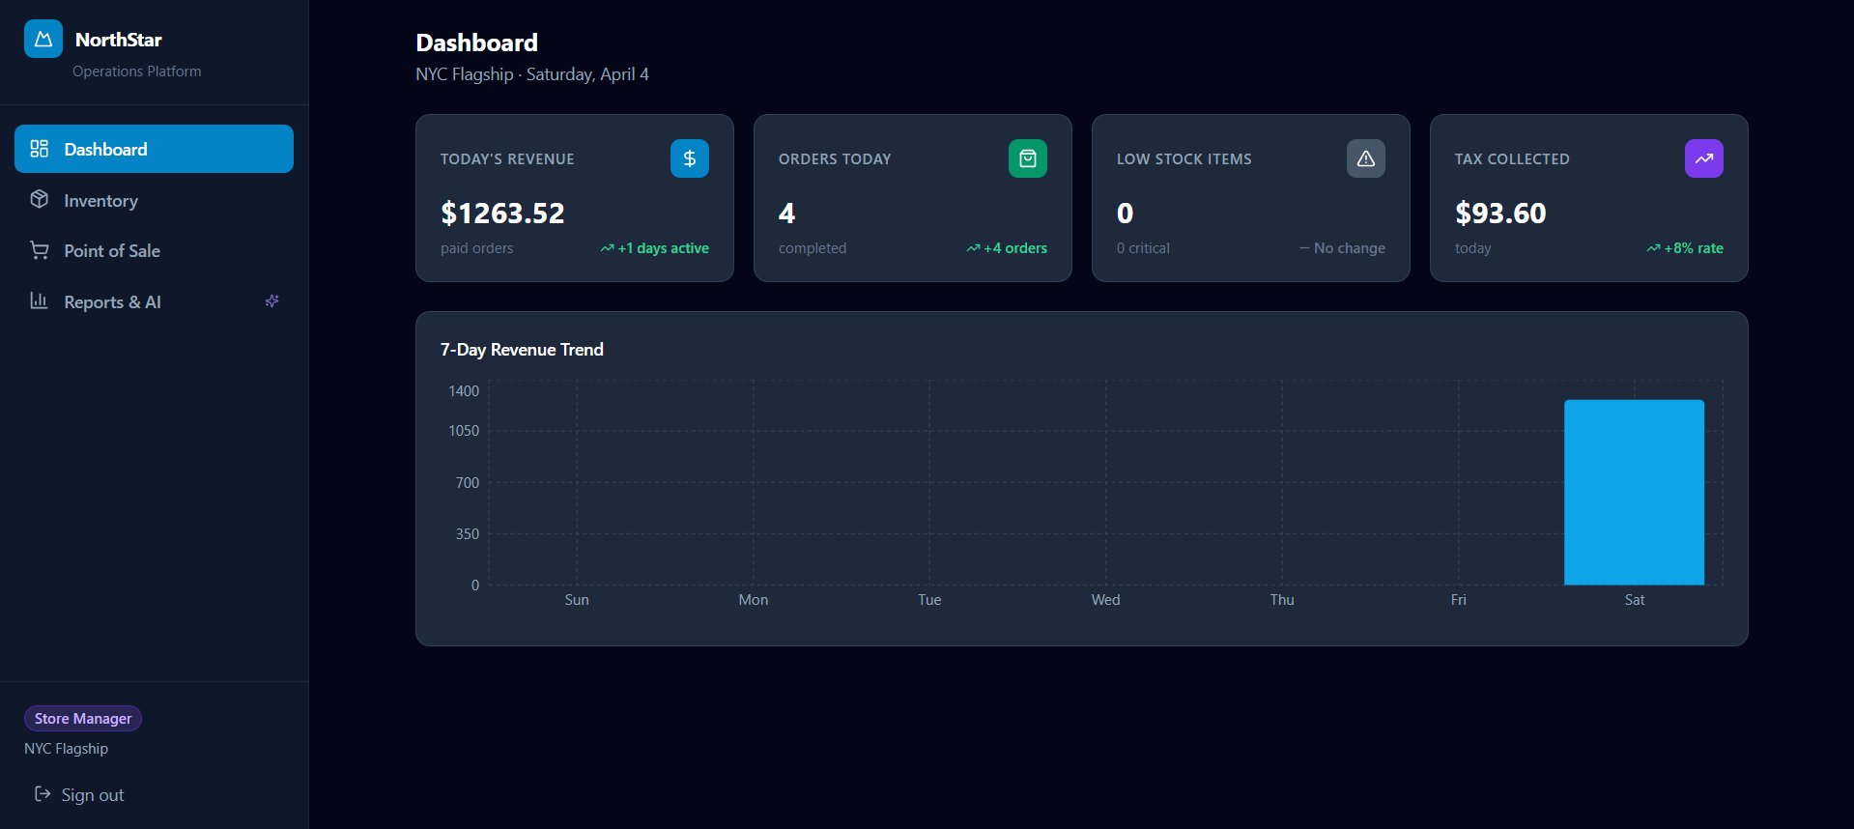
Live dashboard with AI command and audit trail

NorthStar Outfitters
Agentic Retail Operations Platform
Submitted by: Ratnala Sumith Kumar
Assessment: Centific Premier Hackathon 2.0
Case Study: Mobile-First Operations Platform for a Specialty Retail Chain
Stack: Python + FastAPI + PostgreSQL + React + LangGraph + Gemini
Live Demo: northstar-ops-sage.vercel.app (https://northstar-ops-sage.vercel.app/)
Source Code: github.com/sumithkumar123/northstar-ops (https://github.com/sumithkumar123/northstar-ops)

1. Executive Summary
NorthStar Outfitters operates 48 stores across two countries. A store manager needs one system that can:
- run checkout and billing safely
- keep inventory synchronized in near real time
- work on mobile and low-end devices
- surface anomalies, restock risks, and business insights quickly
- explain why the AI recommended an action
This submission delivers that as a microservices-based retail platform with an agentic AI layer, not just a database dashboard with a chat box attached.
The platform combines:
- Transactional services for auth, inventory, sales, and gateway routing
- A retail agent that chooses tools dynamically based on the question
- Autonomous sentinels that scan stores every 5-10 minutes
- An audit trail so managers can verify what the AI did, which tools it called, and whether the action was reasonable
The core value is simple: instead of making managers inspect five screens and connect the dots manually, the system can answer operational questions in plain English and show the tool trace behind the answer.

2. Evaluation Criteria Check
The case study asked for a mobile-first retail operations platform with microservices, secure auth, inventory and billing workflows, BI dashboards, and responsible agentic AI.
Coverage Matrix
Evaluation Criterion | Status | Notes
Clear microservices-based architecture | Met | Separate gateway, auth, inventory, sales, AI service, shared schema contracts, PostgreSQL schemas
Responsive mobile-compatible design | Met | React + Tailwind, tablet/mobile-friendly navigation, POS optimized for smaller screens
Secure auth and RBAC | Met | RS256 JWT, refresh tokens, role checks at gateway and service layer
Inventory, billing, stock monitoring, replenishment workflows | Met | Inventory service, POS checkout, low-stock alerts, replenishment recommendations
Transfer workflow | Partially met | Inventory transaction types support transfer_in / transfer_out; AI now recommends inter-store transfers, but a dedicated transfer execution UI is still phase 2
BI dashboards and operational reporting | Met | Revenue trend, top products, inventory alerts, reports page, performance summaries
Agentic AI recommendations, anomaly detection, conversational querying | Met | LangGraph retail agent, anomaly checks, merchandising insights, natural-language querying
Python + PostgreSQL with sound APIs/data design | Met | FastAPI services, SQLAlchemy async, PostgreSQL schemas, clear REST routes
Performance and scalability considerations | Met | Async services, row locks for stock consistency, stateless AI service, deployment-ready containers
Security, reliability, observability, audit logging | Met | JWT, RBAC, health endpoints, audit table, deterministic low-level service boundaries
Intermittent connectivity and low-end devices | Met | Offline-safe POS with idempotent offline_id, lightweight mobile UI
Maintainability and future ERP/payment readiness | Met | Service boundaries, documented APIs, gateway pattern, external integration path clear
Compliance with AI-assisted development guardrails | Met | AI restricted to bounded tool use, manager-only access, auditable outputs, no uncontrolled SQL generation

Honest Gap
The main gap was that transfer workflow was previously implied but not demonstrated strongly enough in the product. To close that, this version adds a new agentic tool:
- recommend_interstore_transfer
This allows the agent to reason about whether a different store can temporarily cover a stock gap before recommending a fresh supplier order.

3. What We Built
In Plain Terms
This project is a retail operations control room.
Without the AI, a store manager must:
- open inventory
- check low-stock items
- open sales reports
- estimate whether those items are actually moving fast
- check if a suspicious transaction looks real
- decide whether to reorder, transfer inventory, or ignore
With this system, the manager can ask:
"What products need restocking before the weekend?"
"Can another store transfer stock to mine instead of ordering new units?"
"Summarize my store performance and top products this week."
The agent then:
- decides what data it needs
- calls the correct retail tools
- reasons over the results
- answers in manager language
- logs the decision in Agent Activity
That is the difference between a normal DB project and an agentic retail operations platform.

4. Architecture Overview
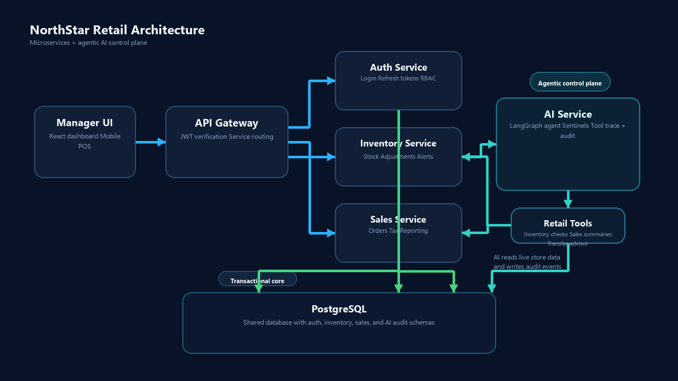
Why This Structure Matters
- Gateway keeps the client simple and centralizes auth enforcement
- Inventory and Sales remain deterministic transactional services
- AI service stays isolated, so agent logic can evolve without risking billing or stock integrity
- PostgreSQL uses separate schemas to preserve service boundaries while keeping the prototype deployable

5. Service Flow
User-Initiated Agent Query
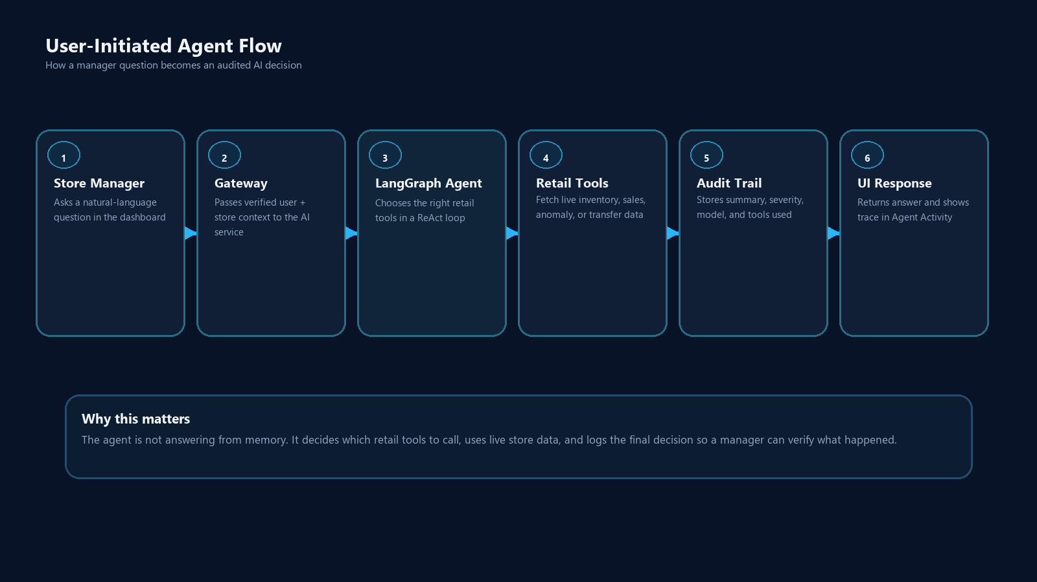
Autonomous Agent Loops
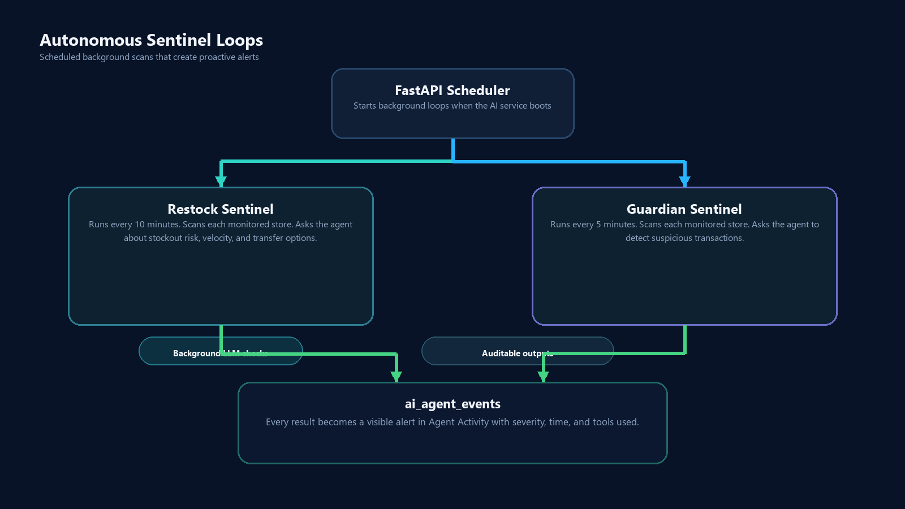
This addresses the mentor feedback about “how the services flow” and “how they function using agentic AI” much more clearly than the original document did.

6. Why This Is Actually Agentic
Many projects say "AI" but only mean:
- a chatbot wrapped around static text
- a keyword router
- a hardcoded rule like if stock < threshold then alert
This project is different.
Traditional Pattern
def low_stock_report(store_id):
return db.query("SELECT * FROM inventory WHERE quantity <= reorder_point")
That returns data, but it does not decide anything.
Our Agentic Pattern
The retail agent uses LangGraph ReAct:
- Reason: what data do I need first?
- Act: call a retail tool
- Observe: inspect the returned result
- Reason again: do I need another tool?
- Finish: synthesize a specific action for the manager
Example:
"Should I reorder Trail Running Shoes before the weekend, or can another store transfer stock to me?"
The agent can decide to call:
- check_inventory_levels
- analyze_sales_velocity
- recommend_interstore_transfer
- compute_restock_quantities
It can then answer something like:
"NYC will run short within 2 days. Boston has enough surplus to transfer 12 units immediately. After that, place a supplier order for 30 more units to cover the weekend and 14-day buffer."
That is useful because the AI is not just formatting data. It is selecting tools, chaining them, and deciding on the right operational response.

7. Agent Tooling
The current AI service exposes these retail tools:
Tool | What It Does | Why It Matters
check_inventory_levels | Current stock + reorder status | Base signal for stock questions
analyze_sales_velocity | Units sold per day + days of stock left | Converts stock numbers into urgency
detect_transaction_anomalies | Finds suspicious orders with Z-score logic | Fraud / shrinkage signal
get_seasonal_demand_forecast | Highlights products relevant to current season | Merchandising support
compute_restock_quantities | Recommends purchase quantities | Actionable replenishment
get_store_performance_summary | Revenue, AOV, daily trends, top products | Manager performance view
recommend_interstore_transfer | Suggests donor stores with safe surplus | Stronger transfer workflow story

Why the New Transfer Tool Matters
This makes the project stronger against the rubric and the mentor feedback.
It shows that the AI is not only:
- answering from one table
- generating a summary
It is now also helping with a cross-service operational decision:
- destination store demand
- donor store surplus
- timing before stockout
- transfer-before-reorder recommendation
That is a more convincing example of agentic AI in a retail context.

8. How the User Can Verify the AI
One of the strongest product improvements is the Agent Activity panel.
It now acts like an AI work log.
Each activity row can show:
- who acted: Retail Agent / Restock Sentinel / Guardian Sentinel
- what happened: business summary or alert
- which tools were used
- why it was logged
- severity
- time
This matters for trust.
A manager can now see:
"The agent answered my question by calling get_store_performance_summary"
and decide:
- yes, that was the correct tool
- or no, the agent should have also checked inventory / anomaly / transfer tools
So Agent Activity is not just decoration. It is an explainability and validation surface.

9. Screens and UX
Dashboard

Dashboard
Reports and AI
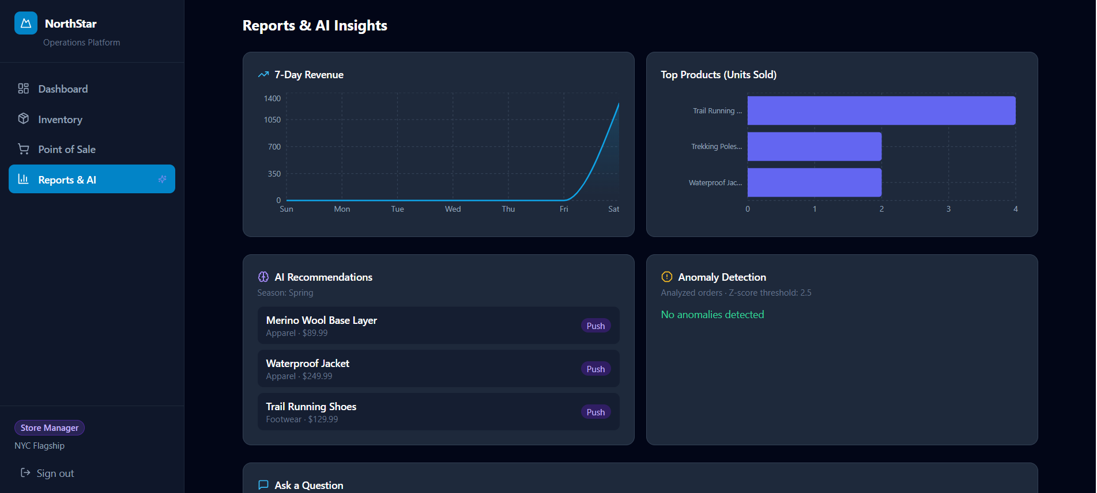
Reports
POS
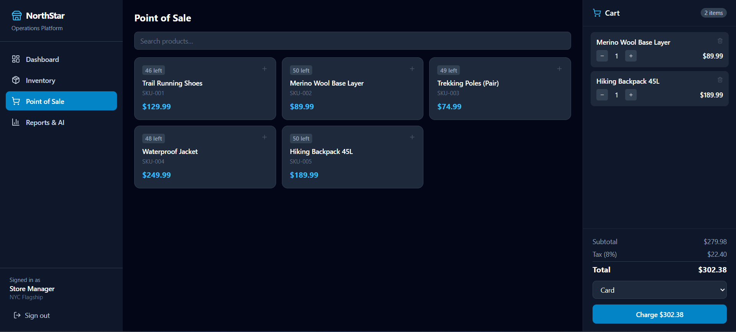
POS
UI Notes
The dashboard has been reworked to make the agent feel like the primary control surface:
- the agent command panel is now top-aligned and sticky on desktop
- the audit feed is visually separated as an explainability surface
- tool traces are visible in both the immediate response and the activity log
- the visual system now uses a more intentional command-center style instead of a generic admin template feel
This directly addresses the concern that the project should not look like a standard DB app with an AI widget bolted on.

10. Security, Reliability, and Auditability
Security
- RS256 JWT auth
- refresh tokens
- role-based access for regional admins, store managers, sales associates
- gateway-enforced and service-enforced authorization
Reliability
- health endpoints per service
- containerized deployment
- isolated transactional services for inventory and sales
- AI service failure does not break base retail workflows
Auditability
- every agent event is stored in ai_agent_events
- managers can see the event summary, severity, time, and tool trace
- this keeps the AI explainable and reviewable
Guardrails
- no open-ended agent access to mutate arbitrary DB state
- tool surface is bounded and explicit
- manager-only access to agent endpoints
- deterministic legacy endpoints remain available for fallback

11. Performance and Scalability Story
The case study asked for 1,200 concurrent users and seasonal spikes.
This prototype addresses that through design choices rather than synthetic benchmark claims:
- FastAPI async services keep I/O non-blocking
- SQLAlchemy async + asyncpg scale better under concurrent API load
- `SELECT FOR UPDATE` protects inventory consistency during concurrent checkout
- Stateless AI service can be scaled independently of auth/inventory/sales
- Gateway pattern keeps the client talking to a single public edge
- Container-based deployment keeps services independently deployable
Practical Speed Story
- transactional reads are simple REST calls
- the agent usually answers in one to a few tool calls
- the audit trail gives immediate confirmation that the AI finished the workflow
The goal is not just “use AI.” The goal is “make AI fast enough and bounded enough to be operationally useful.”

12. Offline and Low-End Device Constraints
The case study explicitly mentioned intermittent connectivity and tablets/low-end Android devices.
This prototype addresses that by:
- keeping the client lightweight
- using role-focused screens instead of overloaded workflows
- supporting offline-safe order retries through offline_id
- building a compact POS layout suitable for floor staff
Idempotent POS Retry Pattern
if offline_id already exists:
return existing_order
else:
create_order()
That prevents double-posting when a shaky connection causes the same payment attempt to retry.

13. Deployment
Local
docker compose up --build
docker compose exec auth_service python /scripts/seed.py
Hosted Prototype
- Frontend: Vercel
- Python services: Railway
- Database: PostgreSQL
This satisfies the “deployable” expectation from the mentor feedback. The system is not just designed; it is actually running across a hosted frontend and backend.

14. Mentor Feedback Check
The earlier feedback was essentially:
"The service structure is good, but it still sounds like a normal DB project. Show how it is agentic, how the services flow, how it works fast, and how it is deployable."
What Has Now Been Addressed
Feedback Theme | Current State
"Sounds like a normal DB project" | Improved: the dashboard foregrounds the agent, the document explains ReAct flow, and the tool trace is visible
"Agentic AI is not clear" | Improved: explicit tool-chaining examples, sentinels, activity audit, transfer advisor
"Architecture is not clear" | Improved: mermaid architecture + sequence flow
"How do services run?" | Improved: gateway/service/tool/database flow documented
"How fast/effective is it?" | Improved: async services, stateless AI, bounded tool calls, deployable hosted stack
"Deployable annav kada" | Met: Vercel + Railway deployment exists

Still Worth Improving Later
- full transfer execution UI instead of only AI recommendation + inventory transaction types
- richer observability such as OpenTelemetry traces
- live ERP and payment gateway integration
- richer regional admin cross-store orchestration dashboard

15. Final Positioning
This project is best described as:
A retail operations platform where microservices run the core business safely, and an agentic AI layer reasons across those services to help managers act faster.
It stands out because:
- the AI is connected to real tools, not just a prompt box
- the agent can work proactively through scheduled sentinels
- users can verify the AI through tool traces and audit logs
- the product is deployable and structured for future expansion
If judged as a case-study prototype, it is strongest in:
- architecture
- RBAC/security
- operational dashboards
- replenishment/anomaly agent workflows
- explainable agent behavior
The main area still not fully production-complete is a dedicated transfer execution workflow UI, but the new inter-store transfer advisor makes that path explicit and materially strengthens the agentic retail story.

16. Appendix: Example Agent Trace
Question
"Summarize my store performance and top products this week."
Observed behavior
- model receives manager question
- agent selects get_store_performance_summary
- tool reads paid orders and top products
- agent writes a concise summary
- Agent Activity stores the result with the tool trace
Why this is important
The user can now verify that the selected tool was appropriate. That makes the system easier to trust, debug, and demonstrate during evaluation.

*Prepared for the Centific NorthStar Outfitters case study assessment.*

