**SIMPLE_AE**

ADAMOPTIMIZER: LEARNING RATE: 0.03, STEPS: 5001

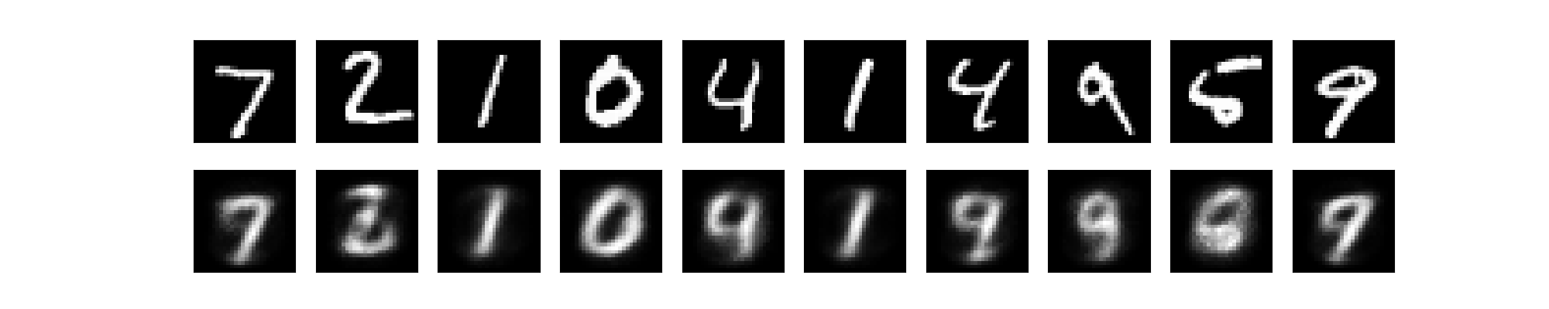

Loss = 0.216

GradientDescentOptimizer: LEARNING RATE: 0.03, STEPS: 6001

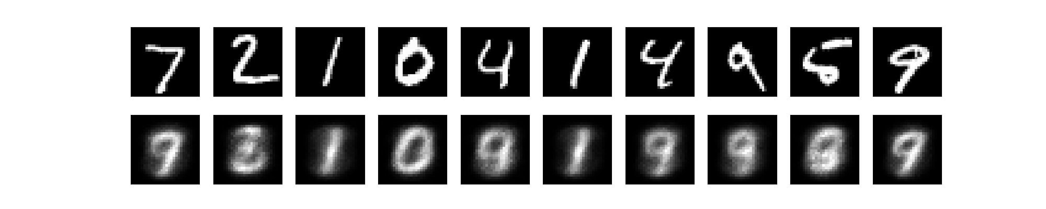

Loss= 0.226

**RMSPropOptimizer: LEARNING RATE: 0.1 STEPS: 5001**

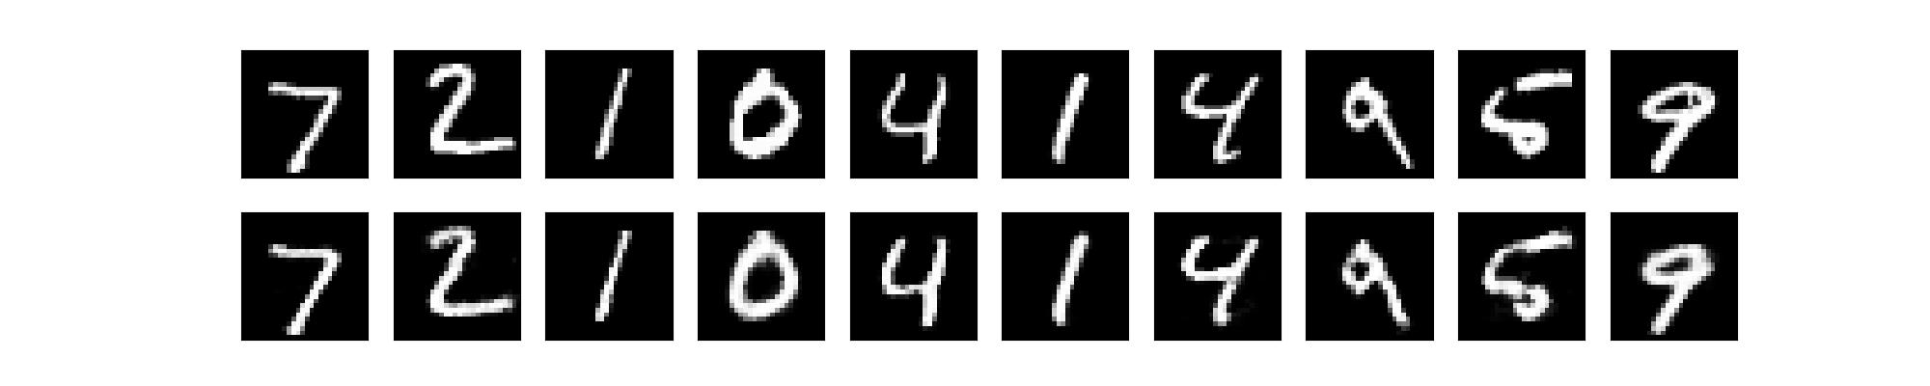

**Loss= 0.093**

AdagradOptimizer: LEARNING RATE: 0.5 STEPS: 6001

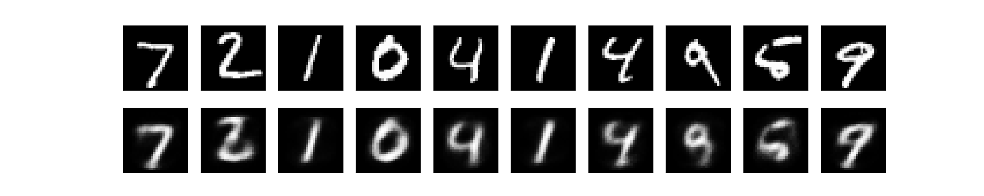

Loss = 0.141

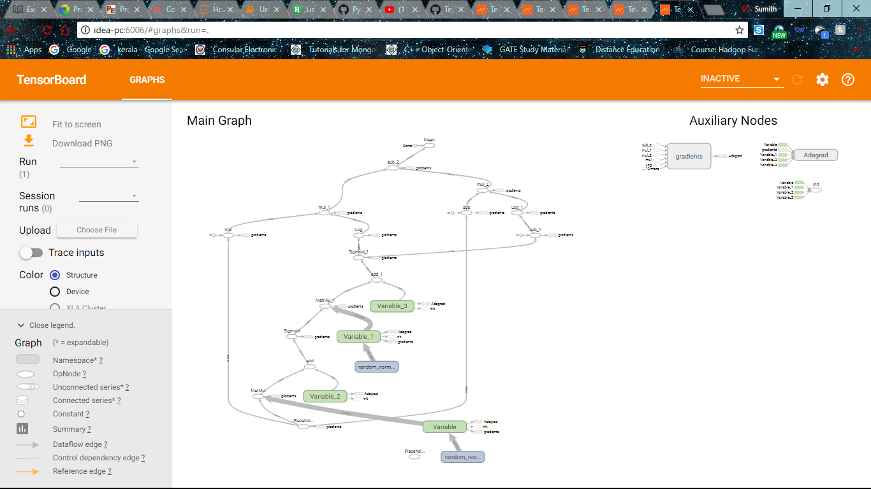

**STACKED_AE**

GradientD

L.R 0.01 STEPS 8000

Step 8000: Minibatch Loss: 0.374339

ADGRAD

L.R 0.03 STEPS 6000

Step 6000: Minibatch Loss: 0.313642

**RMS**

**L.R 0.05 STEPS 4000**

**Step 4000: Minibatch Loss: 0.157980**

AdamOptimizer

L.R 0.02 STEPS 5000

Step 5000: Minibatch Loss: 0.258530

